Contents

Project Description 2

**1.** Project Overview: 2

**2.** The Purpose of The Project: 3

**3.** The Scope of The Work: 3

**4.** Product Scenarios 3

**5.** Stakeholders 3

**6.** Mandate Constraints 3

**7.** Relevant Facts and Assumption: 3

Software Development Model 4

**Requirements** 4

**Requirement ID** 5

**F1** 5

**F1.1** 5

**F1.2** 5

**F1.3** 5

**F1.4** 5

**F1.5** 5

**Non-Functional Requirement** 5

**NF1** 5

**NF1.1** 5

**NF1.1.1** 5

**NF1.1.2** 5

**NF1.1.3** 5

**NF1.2** 5

**NF1.2.1** 5

**NF1.2.2** 5

**NF2** 5

**NF2.1** 5

**NF2.1.1** 5

**NF2.2** 5

**NF2.2.1** 5

**NF3** 5

**NF3.1** 5

**NF3.2** 5

**NF3.3** 5

**NF4** 5

**NF4.1** 5

**NF4.2** 5

**NF4.3** 5

**NF5** 5

**NF5.1** 6

**NF5.1.1** 6

**NF5.2** 6

**NF5.2.1** 6

**NF5.3** 6

**NF5.3.1** 6

**NF5.4** 6

**NF5.4.1** 6

**NF5.4.2** 6

**NF5.4.3** 6

**NF5.5** 6

**NF5.5.1** 6

**NF5.5.2** 6

**NF5.6** 6

**NF5.6.1** 6

**NF6** 6

**NF6.1** 6

**NF7** 6

**NF7.1** 6

**NF7.2** 6

**NF8** 6

**NF8.1** 6

**NF9** 6

**NF9.1** 6

**NF9.2** 6

# Project Description

## Project Overview:

The project is about a voting website. It is an online platform to vote from home for your favorite candidate. To stay safe and avoid COVID-19 infection. The voter just uses any browser he/she wants anywhere he/she is and votes.

## The Purpose of The Project:

The purpose of this project is to allow people to vote online for whoever they deem as the right candidate without the voters breaking social distancing rules and keeping their lives safe.

## The Scope of The Work:

* Milestones:

1. Finishing front end development
2. Finishing back end development
3. Testing the prototype of the website
4. Fixing any problem that still exists on the website if there is any.
5. Releasing the website

* Deliverables: they are the software program that is made according to the client’s requirement and the report that includes everything that is in the program
* Timeline:

1. 3 weeks of front-end development
2. 4 weeks back-end development
3. 1 week Testing prototype and fixing issues.
4. 1 week of collecting results and finishing report.
5. Deliver report and program software to client.

* Reports: will contain every detail about how the project is done. It will include how the software is done and why chose to do steps that we did.
* Budget: this software is going to be developed using free to access softwares such as notepad++ and sublime and MySQL.

## Product Scenarios

* 1. The voter checks if he/she has the requirements to vote.
  2. The voter enters the website.
  3. The website will provide the voter with all the info about the candidates.
  4. The voter then will choose who to vote for and submits his/her vote.
  5. The website will show that the procedure succeeded successfully.

## Stakeholders

* User: the voters who want to vote during the website
* Administration: can upload the candidates’ campaign info. They can also check the number of voters who have voted so that the results can be displayed when the election ends.

## Mandate Constraints

* The details provided about the candidates must be correct.
* Neither the voters nor the candidate must know the votes, or who voted who, until the end of the voting phase.
* The voters that do not meet the requirements, should not be able to vote (e.g.: age less than 21).
* The website should not let the voter to vote more than once.

## Relevant Facts and Assumption:

* The website will work on multiple browsers.
* The website is going to be user friendly.
* There will be a limited time to vote, before and after the “voting time” the voters cannot vote.
* The voters will not be able to change their vote after submitting.

# Software Development Model

We have chosen the iterative model, since it is the one that best suits our method of developing our software.

We have a clear view of what is required, we have a clear view of how we need to plan it, however we might have several iterations on how we could design the software. So, the iterative method is the best software development model for our project.

# **Requirements**

|  |  |
| --- | --- |
| **Requirement ID** | **Description** |
| **F1** | Functional Requirements |
| **F1.1** | Users should be able to access the website on several browsers. |
| **F1.2** | Users should be able to view the campaign goals of the candidates. |
| **F1.3** | Users should be able to enter their personal information required to be eligible to vote. |
| **F1.4** | Users should be able to vote. |
| **F1.5** | Administration should be able to input the candidates’ information. |
| **Non-Functional Requirement** | |
| **NF1** | Performance Requirements |
| **NF1.1** | Precision or Accuracy Requirements |
| **NF1.1.1** | The details of the candidates should be displayed as given from the candidates themselves. |
| **NF1.1.2** | o Every vote should count; no votes should be missed or left out. |
| **NF1.1.3** | The results must be true. |
| **NF1.2** | Capacity Requirements |
| **NF1.2.1** | A big server to hold a whole country. |
| **NF1.2.2** | Can run on different devices. |
| **NF2** | Dependability Requirements |
| **NF2.1** | Reliability Requirements |
| **NF2.1.1** | The website should not crash during the election.  No data should be lost or damaged in case of failure. |
| **NF2.2** | Availability Requirements |
| **NF2.2.1** | The website should be available until the election is done and  the votes are announced. |
| **NF3** | Security and access requirements |
| **NF3.1** | provide encryption for the data in the database. |
| **NF3.2** | limit the access for the modification of data to the admins. |
| **NF3.3** | every voter can see the results but can’t modify it. |
| **NF4** | Integrity and Privacy |
| **NF4.1** | Integrity is maintained by limiting the modification access purely for admins |
| **NF4.2** | The website will not reveal the private information of the voters neither display their choices. |
| **NF4.3** | The user is verified through the national id. |
| **NF5** | Usability and Humanity Requirements |
| **NF5.1** | Availability Requirements |
| **NF5.1.1** | The product is expected to run on any browser. |
| **NF5.2** | Scalability or Extensibility |
| **NF5.2.1** | The product shall be capable of processing a big number of users. |
| **NF5.3** | Longevity Requirements |
| **NF5.3.1** | The product shall be expected to operate within the duration of the election. |
| **NF5.4** | Ease of Use requirements |
| **NF5.4.1** | The website should be simple and easy to use. |
| **NF5.4.2** | The website should prevent people from interacting face to face to avoid COVID, and other diseases. |
| **NF5.4.3** | The website will be the safest way to vote when there is bad environment to go outdoors. |
| **NF5.5** | User Documentation Requirements |
| **NF5.5.1** | The website should be easy to understand, won’t have any hard vocabulary |
| **NF5.5.2** | The website should not show other people’s vote to anyone. |
| **NF5.6** | User Documentation Requirements |
| **NF5.6.1** | users should have necessary documentation to be have the eligibility to vote |
| **NF6** | Look and Feel Requirements |
| **NF6.1** | The program shall be user friendly. |
| **NF7** | Operational and Environmental Requirements |
| **NF7.1** | The program should operate on all browsers; no special hardware requirements are needed. |
| **NF7.2** | The program can be accessed anytime. |
| **NF8** | Cultural and Political Requirements |
| **NF8.1** | The product shall mainly work in the political surroundings. |
| **NF9** | Legal Requirements |
| **NF9.1** | Modifying the website is not allowed. |
| **NF9.2** | The anonymity of the voters and the number of votes (until the election is done) is guaranteed. |

# Project Design:

First Page:

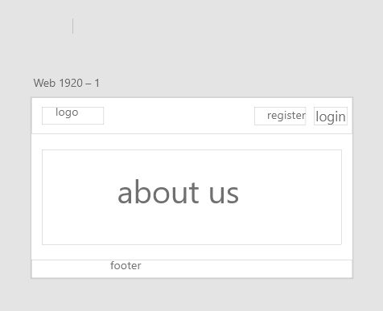

Results Page:

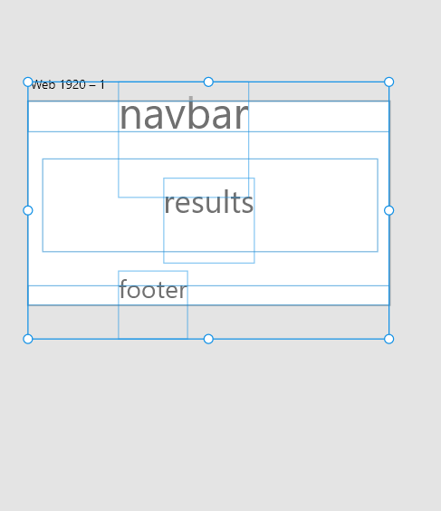

Candidates Page:

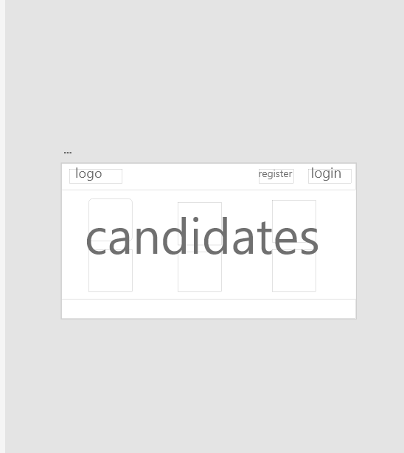

Each

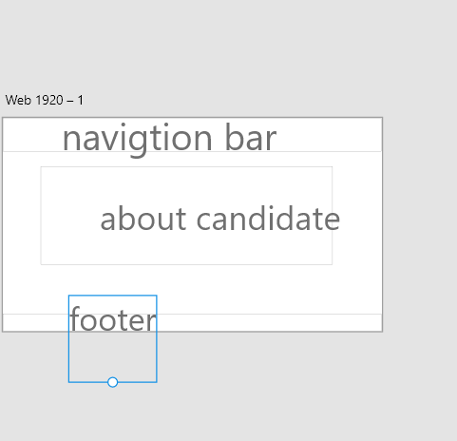

# Unified Modeling Language

Use Case:

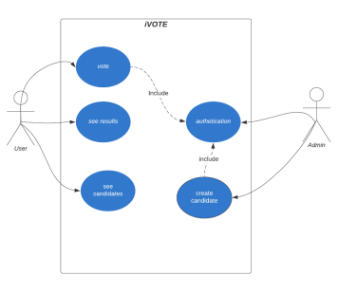

Domain Model:

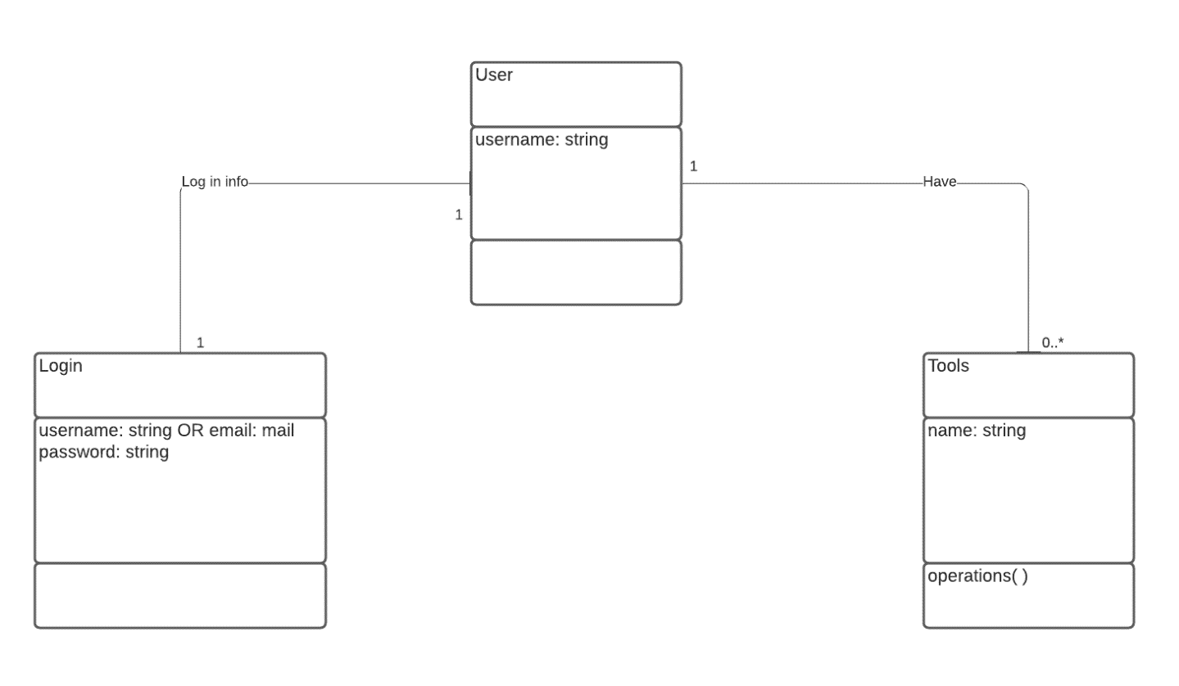

Class Diagram:

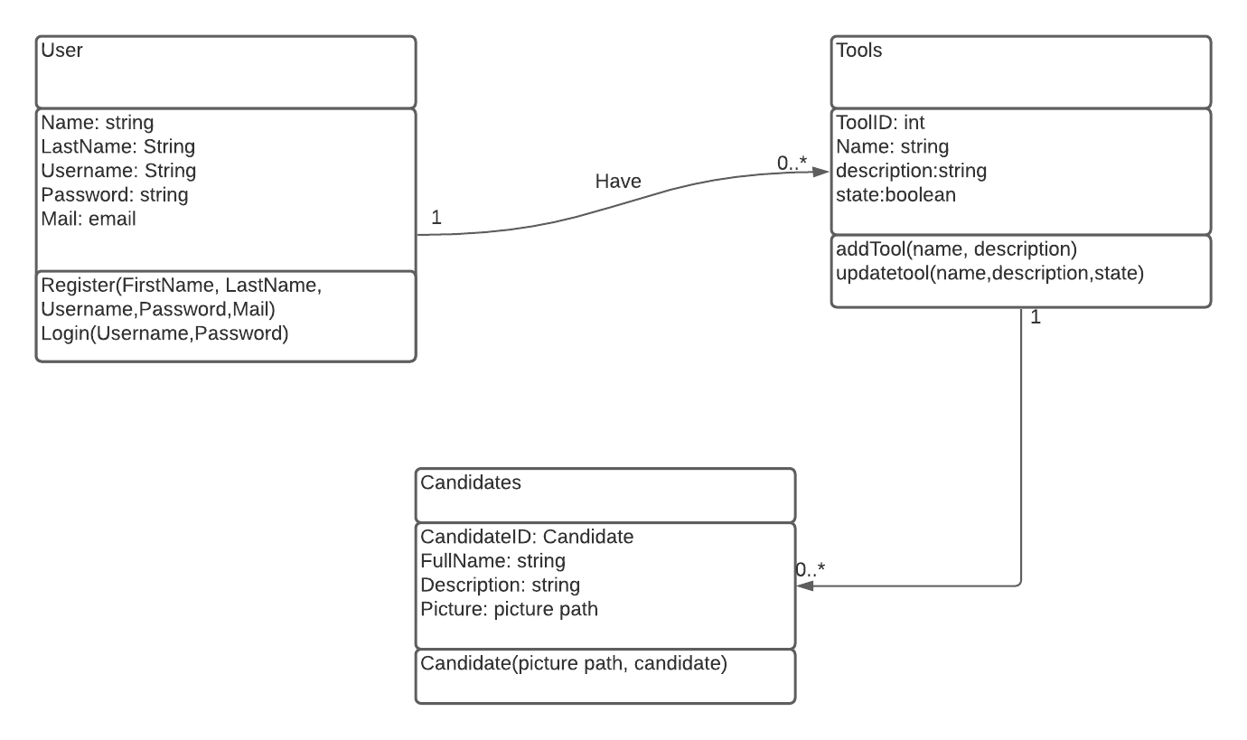

Githublink:

<https://github.com/mrlemons23/softwareengineering.git>