## Apply CSS to Previous Assignment

Use your knowledge in CSS to style the facebook task made in [week 1 assignment](https://docs.google.com/document/d/1a9tKz2I4nNskTzIVgicNTAWBtsiD5kNu/edit)

Remove any styling made in HTML and replace it with CSS for home and profile pages.

1. Add background colors for each page.
2. change the styling of each post.
3. Change the font of the user’s name and make it bold.
4. make like button blue and comment button lightgray.
5. Add any other necessary styles to make the pages look better.

**Note:** CSS must be linked as external styles not internal or inline.

## Landing Page

Using your knowledge of selectors, fonts and text styles build the following landing page.

## 

* Use different **Selectors** and **Combinators** for styling.
* Use different fonts for the header text and the subtitle text.
* Button color should change to a darker color when the user hovers on it.
* You must use the correct HTML Semantic Tags (nav,header,main,..etc).

**Hint:**

* Refer to the padding property for buttons.
* Use margin-left property for nav links.

## Shopping Website

Build the following shopping website, using HTML & CSS, you don’t have to make product cards appear on the same row.

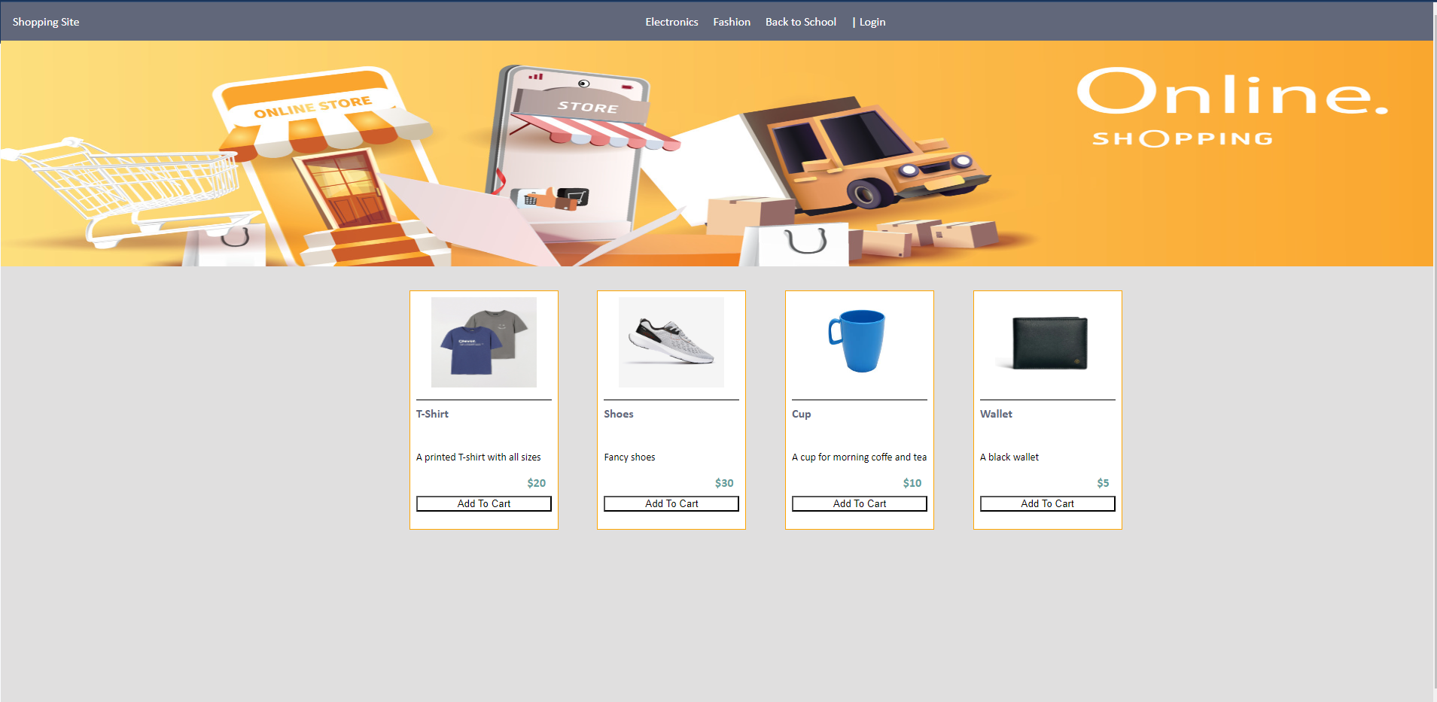

* Product title should change color to orange on user hover.
* Use width and height properties to size the product card.
* The Add to Cart button should become green when the user clicks on it.
* Use the correct Semantic tags.