ECG-Based Personal Photo Lock
HCI Project Report - Idea 4

Project Name | ECG-Based Personal Photo Lock
Team Members | Name 1:  Name 2:  Name 3:  Name 4:
Dataset | PTB Diagnostic ECG Database, PhysioNet
Application Goal | Identify one of five trained subjects from ECG segments and display the matching photo.

1. Project Overview
This project implements an ECG-based personal photo lock. The system trains an identification model for five subjects, preprocesses ECG recordings, extracts wavelet features, compares several classifiers, and unlocks a photo panel only when a subject is confidently identified.
A subject is accepted when more than 80% of ECG heartbeat segments are classified as the same trained subject. If the segment agreement is below the threshold, or the selected ECG file belongs to a patient outside the trained set, the subject is treated as unidentified.
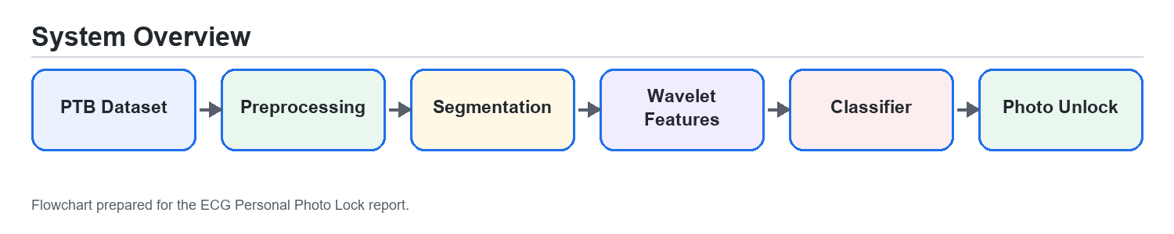
Figure 1. Overall ECG photo lock workflow.

2. Data Preparation
The data source is the PTB Diagnostic ECG Database from PhysioNet. Five subject folders are selected from the PTB patient records. In the current testing setup, the selected subjects are patient068, patient078, patient100, patient120, and patient140.
Each ECG record is read from WFDB format. Lead II is used for feature generation because it provides a clear ECG morphology and is commonly useful for R-peak detection. The extracted heartbeat feature rows are split into training and testing sets using a stratified split so each subject remains represented in both sets.
Database | PTB Diagnostic ECG Database
Subjects | Five PTB patients selected in the Training tab
Lead | Lead II, zero-based lead index 1
Sampling Frequency | 1000 Hz
Train/Test Split | 70% training, 30% testing

3. ECG Preprocessing
The preprocessing stage reduces noise and prepares stable heartbeat windows for classification. The pipeline removes baseline wander, applies bandpass filtering, suppresses powerline noise, detects R-peaks using NeuroKit2, refines each marker to the dominant local ECG peak, and cuts fixed-length heartbeat segments around each detected R-peak.
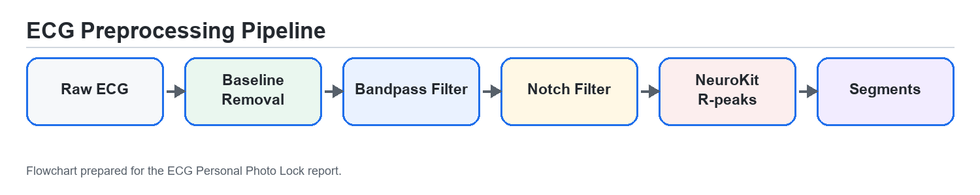
Figure 2. ECG preprocessing pipeline.
Insert screenshot: raw ECG signal from ECG Viewer tab

Insert screenshot: filtered ECG with detected R-peaks

Insert screenshot: segmented heartbeat example or preprocessing result

4. Feature Extraction
The feature extraction method uses Discrete Wavelet Transform features. Three Daubechies mother wavelets are compared: db1, db2, and db4. For each heartbeat segment, wavelet coefficients are generated and summarized with statistical descriptors.
Mother Wavelets | db1, db2, db4
Transform Type | Discrete Wavelet Transform
Decomposition Level | Level 4
Per-band Features | Mean, standard deviation, energy, maximum absolute value, minimum absolute value
Purpose | Represent each ECG heartbeat segment numerically for classifier training
Comparison | The app trains and reports classifier performance separately for each wavelet

5. Classifiers and Parameters
Three classifiers are trained and compared. SVM is included as required, and KNN and Random Forest are used as additional classifiers. Several parameters are tested for each classifier to find the best result.
Classifier | Parameters Tested | Role in Comparison
SVM | Kernel: RBF, linear, polynomial; C: 1, 10, 100; gamma: scale or auto | Primary required classifier
KNN | Neighbors: 3, 5, 7, 11; metric: Euclidean or Manhattan | Distance-based baseline
Random Forest | Trees: 50, 100, 200; max depth: None, 10, 20 | Tree ensemble baseline
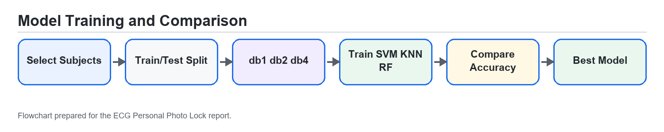
Figure 3. Training and model comparison workflow.

6. Classification Results
The table below summarizes one verified training run using the selected five patients: patient068, patient078, patient100, patient120, and patient140. If the final demo is retrained with another set of patients, replace the values with the final Results tab output.
Classifier | Best Wavelet | Best Parameters | Train Accuracy | Test Accuracy
SVM | db1 | RBF kernel, C=1, gamma=scale | 100.00% | 100.00%
KNN | db1 | k=5, Manhattan metric | 99.89% | 100.00%
Random Forest | db2 | 50 trees, max depth=None | 100.00% | 99.74%
Overall Best | db1 | SVM, RBF kernel, C=1, gamma=scale | 100.00% | 100.00%
Insert screenshot: Results tab comparison table

7. Authentication Interface
The Lock Screen provides the authentication interface. After training, the user can scan a demo ECG signal or load an ECG file. The application preprocesses the signal, extracts wavelet features using the best model's wavelet, predicts each heartbeat segment, and applies the majority-vote rule.
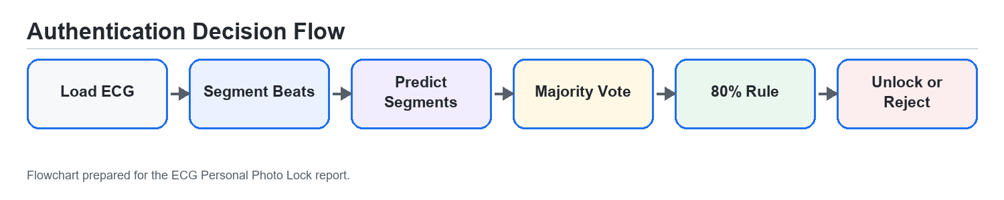
Figure 4. Authentication and unlock decision workflow.
When a known subject is identified, the matching subject photo is displayed. If the ECG belongs to a patient outside the trained five subjects, or if the confidence threshold is not met, access is denied and the subject is labeled unidentified.
Insert screenshot: Lock Screen before scan

Insert screenshot: successful unlock with subject photo

Insert screenshot: unidentified / access denied case

Insert screenshot: Subject Manager with assigned photos

8. Requirement Coverage
No. | Requirement | Implemented In Project
1 | Identification interface for five subjects | Training tab selects five PTB patients and Lock Screen performs identification
2 | Suitable ECG preprocessing | Baseline removal, bandpass filter, notch filter, NeuroKit R-peak detection, local peak refinement, segmentation
3 | Wavelet features comparing db1, db2, db4 | Feature extraction and Results tab compare all three wavelets
4 | Three classifiers including SVM with parameter tests | SVM, KNN, and Random Forest parameter grids are trained
5 | More than 80% segment agreement for identification | Majority-vote rule in authentication logic
6 | Compare classifiers by accuracy | Results tab and report table compare train/test accuracy
7 | Display photo when subject is present | Subject Manager assigns photos; Lock Screen displays identified subject photo

9. Conclusion
The ECG Personal Photo Lock demonstrates a biometric authentication interface based on ECG signals. The system integrates ECG preprocessing, wavelet-based feature extraction, classifier comparison, confidence-based identification, unknown-subject rejection, and photo presentation for identified subjects.

