Tendency of GCINO-EM Project

This document presents **wthe tendency** of our GCINO application, displaying costs according to projects, users and objects, and finally a final graph of Quantities of objects used according to time.

# Amounts by projects

This graph shows amounts by project

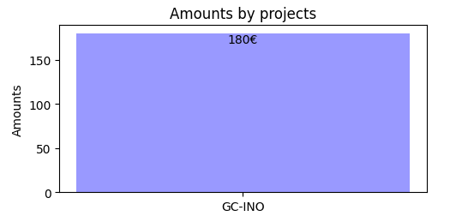

# Amounts by users

This graph shows amounts by users

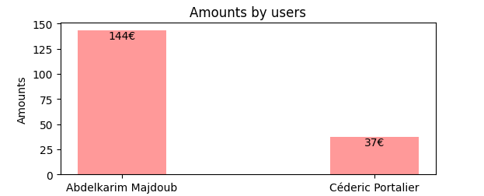

# Amounts by objects

This graph shows amounts by objects

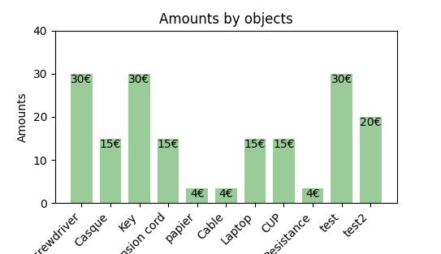

# Quantity by date

This graph shows quantity by date

