Regular solution approach for the supercritical fluid extraction of
two-component solute from ground oilseeds

Arthur A. Salamatin ^{a, b,} *, Alyona S. Khaliullina^{c}
ª Institute of Mechanics and Engineering, FRC Kazan Scientific Center, Russian Academy of Sciences, 2/31 Lobachevsky str, Kazan, 420111, Russia
^{b} World-class Research Center “Efficient development of the global liquid hydrocarbon reserves” and Institute of Computational Mathematics and Information Technologies, Kazan Federal University, 18 Kremlyovskaya str, Kazan, 420008, Russia
^{c} Institute of Fundamental Medicine and Biology, Kazan Federal University, 18 Kremlyovskaya str, Kazan, 420008, Russia

A.A. Salamatin: ORCID: 0000-0002-1099-4016
A.S. Khaliullina: ORCID: 0000-0002-9914-5554

* Mail address: 420111, Russia, Kazan, 2/31 Lobachevsky str.
E-mail: arthur.salamatin2@gmail.com; salamatin@imm.knc.ru
Fax: +7 (843) 236-52-89

Abstract
The extract obtained at the supercritical fluid extraction from plant raw material is essentially multicomponent. A multicomponent mass transfer model at the particle scale is developed to account for the non-ideality of the chemical interactions between solute components. The oil is represented by two pseudo-components, and the gradient of the chemical potential is considered as the driving force for the mass transfer. The model is based on the regular solution and Gibbs energy approaches to the thermodynamic modelling of phase equilibria that take place in the raw material with high initial oil content. The Stefan-Maxwell approach is used to balance the drag effect/chemical interactions and the driving force of diffusion in non-equilibrium multicomponent solution. It is demonstrated that the two solute components may act as “co-solvents” thus facilitating the extraction of each other, or as “anti-solvents” thus decreasing the overall extraction rates. At least a 60% relative error in the overall flux from the particle surface is observed when the developed model is compared against a simplified approach that considers the solution as an ideal system. It is found that while the flowing fluid accumulates the extracted solute, the phase separation may take place in the pore volume of the packed bed. Possible conditions of phase separation in the pores of the packed bed are discussed.

Keywords: supercritical fluid extraction; shrinking core model; multiphase equilibrium; Stefan-Maxwell approach; chemical potential; regular solution; Gibbs energy.

Introduction
The process of Supercritical Fluid Extraction (SFE) employs fluids (solvents) at temperatures and pressures above or near the corresponding critical conditions. Carbon dioxide (CO₂) is one of the most used solvents because it is environmentally friendly, non-toxic, with a moderate critical temperature, ~31°C, and can be easily separated from the extract by reducing the pressure. The new technology is widely used in pharmaceutical production, in food and biofuel industry [1,2]. The extraction of natural compounds from plant matrices (ground seeds, leaves, petals, etc.) remains one of the most common applications of SFE process [3–5]. In particular, pumpkin [6], rape [7], sunflower seeds [8,9], apricot kernels [10] and others with high oil content are sources of valuable natural compounds such as (un)saturated acids, e.g. triacylglycerols (TAGs), vitamins etc.
The extraction under supercritical conditions takes place in a cylindrical vessel (extraction column) where particles of ground raw material are placed to form a porous packed bed. The solvent is introduced into the vessel, and the operational temperature (40–70°C) and pressure (30–70 MPa) are set. Then, the fluid is pumped through the bed at a given flow rate under the applied pressure gradient. During the extraction process, the solvent diffuses along the internal transport channels inside the plant particles [11–14]. It penetrates into the oil-containing plant cells, dissolving the extractable oil components, which move to the surface of the ground material to be transported further by the fluid flow to the outlet cross-section of the extraction column. The gradients of chemical potentials of the non-uniformly distributed dissolved oil components inside individual particles are the driving forces of extraction.
Solute (extractable compounds) of the raw material (ground seeds) is a multicomponent mixture of organic molecules – TAGs [15,16]. Any TAG species is a set of three fatty acids esterified with a glycerol, C₃H₅(OH)₃. So, the species are identified by the triplet of their organic acids. The most abundant ones are palmitic (P), stearic (St), and oleic (O) acids. Consider TAGs of high-oleic sunflower oil (HOSO) and fully hydrogenated palm oil (FHPO) as typical examples. Major TAG acids of HOSO are linoleic (14–40 %) and oleic (75–85 %) ones followed by palmitic, stearic, linolenic acids etc. TAGs of FHPO are mainly comprised of stearic (~55 %) and palmitic (~42 %) acids.
The triplets of acid molecules can esterify with glycerol in various combinations. The OOO TAG with three oleic acid molecules is the most abundant species in HOSO (~61 %). Accordingly, TAG composition of HOSO can be viewed as a two-component mixture of OOO TAG and a pseudo-component representing all other fractions. Two major TAG components, PStSt (41.7 %) and PPSt (39.3 %), constitute up to ~80 % of FHPO. They are followed by StStSt (11.4 %).
Mathematical models for supercritical fluid extraction usually describe the extraction kinetics only globally, regarding the extract as a single pseudo-component. However, sophisticated SFE models are needed to better represent the multi-component nature of the solute. Such an approach has recently been developed by Sovova et al [17,18] to describe the extraction of volatile oil and cuticular waxes of Ruta graveolens. The authors incorporated local equilibrium relations of Goto et al [19] and del Valle and Urrego [20] into the thermodynamic counterpart of the model [21]. The considered type of raw material and extractable compounds are very different from the fatty oil of seeds. The volatile oil has relatively low solute content with a larger diversity of solute molecules. The desorption processes dominate in the volatile/essential oil extraction. The model [17,18] is derived for finely ground plant material with short diffusion paths inside particles and easily accessible extract. Since some of the investigated extract components, like cuticular waxes, occur only on the particle surface [22], the internal mass transfer resistance has been neglected. While the assumptions are reasonable for the volatile oil extraction, they do not correspond with the seed oil extraction, where the solute is uniformly distributed within the plant material volume. So, further theoretical investigation is needed to understand and describe the fatty oil extraction processes.
In the special case of seed oil extraction the principal mechanisms of hydrodynamic and mass transfer phenomena in the single pseudo-component approximation are fully covered in the framework of the so-called shrinking core (SC) model [14,23–26]. The model takes into account (1) dynamic multiphase oil distribution on the particle scale, (2) internal resistance to the solute mass transfer, and (3) high initial oil content in the raw material. According to the original, single-component SC approach two zones exist in the particle during extraction. The outer transport zone occupies the particle volume between the particle surface and the extraction front. Here, the oil phase is exhausted, and only solvent (or solution) phase with dissolved solute exists. The internal part of particle volume, its core, within the extraction front contains two phases at thermodynamic equilibrium: the original single-component oil phase in plant cells and the solvent phase with the equilibrium solute content in transport channels. The two zones are separated by the sharp boundary (front) where the oil dissolution takes place. Then, the oil diffuses through the transport zone to the particle surface along the transport channels. The oil concentration decreases from the equilibrium value at the core surface to the near-zero value at the particle surface, thus maintaining the gradient of its chemical potential – the driving force of the mass transfer.
It is suggested here that multiple fronts dividing the respective cores and transport zones for individual components can be introduced to describe the multi-component extraction. Each pair of core/transport zone covers the entire particle volume. Particle parts shared among multiple cores contain a mixture of corresponding oil components. Several existing approaches [25,26] follow this schematization phenomenologically, introducing two sets of apparent diffusion coefficients and saturation concentrations to be constrained in experiments.
From thermodynamic point of view the key moment here is that the joint equilibrium concentrations of dissolved components in the solvent phase are determined by the composition of the oil phase in cells. Consider a special case of a two-component solute, when a transport zone of component S₁ overlaps with the core of component S₂. While the S₂ component distributed between two phases is in a local thermodynamic equilibrium, the chemical potential of component S₁ is influenced by the presence of the second component. This situation can only be described within the framework of a rigorous thermodynamic approach. The Fick’s law is not straightforwardly applicable to this problem.
The aim of the present work is to develop a sophisticated mathematical model of fatty oil extraction at SFE conditions in the framework of SC approach. The model rigorously considers the internal resistance to the mass transfer of dissolved oil components along the inter-cell transport channels in the plant material and the multicomponent nature of the oil. The oil phase is presented as a “mechanical mixture” of two components. The size of TAG molecules prevents their self-diffusion and statistical mixing. Mathematically, neither excess terms nor statistical contributions to the thermodynamic potential are considered. Thus, equivalently, the oil phase is considered as a set of two interpenetrating phases composed of different TAG species.
The solution, i.e. solvent, phase is described as a regular solution with a pair-wise interaction parameter per each pair of components in the mixture: three parameters, Ω₁, Ω₂, and Ω, are introduced. They are explained in Sect. 2.2. A limiting scenario of ideal solution is considered as well and compared with the model based on the regular solution approach. The limiting case is considered when all three parameters tend to zero.
The Gibbs free energy is employed as a thermodynamic basis to define the equilibrium states and describe the co-existence conditions of phases [27]. Thus, the chemical potentials of solvent phase components are straightforwardly obtained. The chemical potential, i.e. its spatial gradient, is the fundamental quantity used in the non-equilibrium thermodynamics [28] to describe the diffusion fluxes on the particle scale. Another quantity is the tensor of diffusion coefficients which is a function of local solution composition in isothermal-isobaric conditions of SFE. Finally, the constitutive relations of mass fluxes of solution components with the chemical potential gradients are derived in the framework of the Stefan-Maxwell approach [29–31]. It is shown that the second component may act either as a co-solvent, facilitating the extraction rates of the first component, or as an anti-solvent decreasing the overall extraction rates. Finally, possible conditions of multiphase fluid flow existence on the packed bed scale are discussed.

Thermodynamic equilibria in the system oil + CO₂

The oil phase
The oil phase is considered as a "mechanical mixture" of two pseudo-components designated as S₁ and S₂. From thermodynamic point of view this assumes that any chemical interactions or statistical contributions to the Gibbs energy of the oil phase, as a whole, are neglected, and the oil is treated as a mixture of two interpenetrating phases of individual oil components, S₁ and S₂. Once one of these compounds is exhausted through dissolution and diffusion in the solvent phase, the oil becomes a remainder single compound phase. The thermodynamic state of each pure component at extraction conditions (temperature T and pressure p) is considered as its reference state.
Solvent molecules dissolve in the oil phase as well [32]. However, this fact is not well-studied and is typically ignored in SFE modelling. In the present article, the focus is on the description of the solution phase. It is assumed that the thermodynamic state of the oil phase S₁+S₂ is not affected by the solvent molecules dissolved in it.
Accordingly, the Gibbs energy of 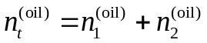 moles of the oil phase (see Nomenclature section for definitions) at the chosen reference state is zero
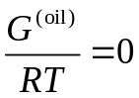,
as well as chemical potentials of each oil component S_{i}, i = 1,2
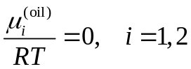.

The solvent phase
The solvent (or solution) phase is a mixture of CO₂ molecules with a limited amount of two pseudo-components of oil, S₁ and S₂, dissolved in it. The supercritical extraction conditions of the solvent (pure CO₂) are the reference state for the solution, and 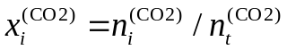, i = 1, 2 are the molar fractions of oil component S_{i} dissolved in the solvent phase, is the molar fraction of solvent molecules. The phase in thermodynamically stable state exists only at low content of dissolved oil components, 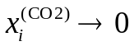, i = 1, 2. Otherwise, pure oil precipitates as a separate phase, if 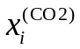 exceeds certain values; and the ternary system becomes heterogeneous.

Regular solution approach
First, let us consider a two-component system S_{i}+CO₂, assuming that the other oil component, S_{j≠i}, is absent. A typical plot of the Gibbs energy of the (S_{i}+CO₂)-solution as a function of molar concentration x_{i}^{(CO2)} is shown in Figure 1 by the black curve at different Ω-values (see caption). The energy graphs have a parabolic form with its minimum at 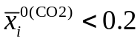.

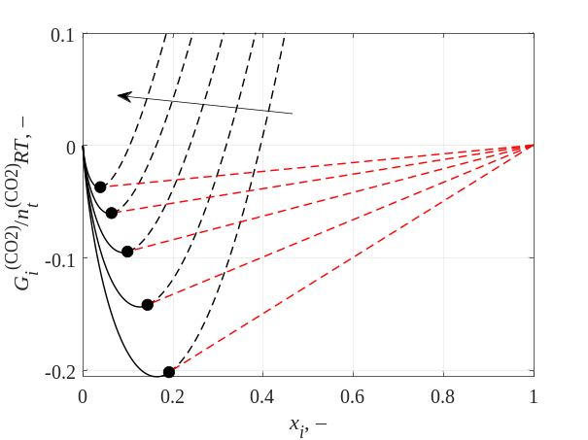
Figure 1. The schematic representation of the molar Gibbs energy of the two-component system S_{i}+CO₂ at x_{j≠i} = 0, 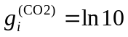, and Ω_{i} = 0. The arrow shows the increase of Ω = {–1, –0.5, 0, 0.5, 1}. The black solid curve is the assumed approximation of the Gibbs energy of the solvent (solution) phase, Eq. , with only S_{i} oil component dissolved in it [33]. The black point 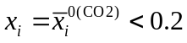 is the equilibrium solvent phase composition. The red dashed line is a tie line representing the two-phase equilibrium of the solvent phase at and a single-component oil phase S_{i}, x_{i} = 1.

The regular solution model (or Gibbs energy expansion) is aimed at representing the solid curve within the range where the phase is stable. Accordingly, the three-component system suggests the following expansion for the Gibbs energy of 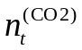 moles of the solvent phase molecules
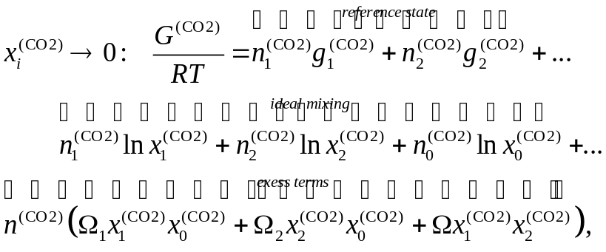
,
where the superscript (CO2) refers to the solvent phase, Ω_{i} are the solvent-S_{i} binary interaction parameters and Ω is the S₁-S₂ binary interaction parameter within the solvent medium. Finally, the transition energy 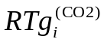 is the molar Gibbs energy that the oil molecule S_{i} gains upon transition from the oil phase (the reference state) to the solvent phase.
Corresponding chemical potentials of all three components at 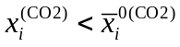 are expanded as follows as the partial derivatives of the Gibbs energy
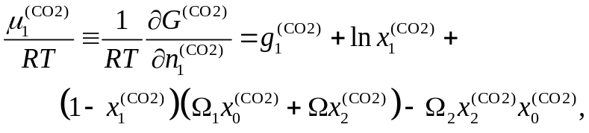
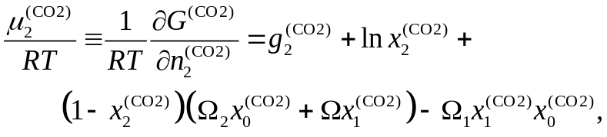
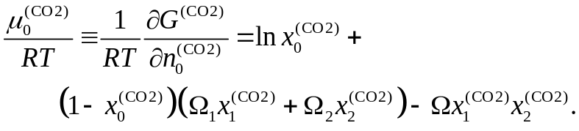
To simplify the following discussion, we set Ω_{i} = 0 (if not stated explicitly), and consider various extraction regimes, characterized with different Ω. This approach will be called the regular solution model at Ω ≠ 0.

The limiting case of ideal solution
The above thermodynamic model given by Eqs. – can be further simplified in the ideal solution limit for the solvent phase at Ω → 0
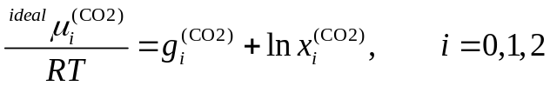.
In this case, as shown in Sect. 3.5, the mass balance equations can be solved explicitly.

General thermodynamic phase equilibria in the ternary system
Depending on the overall composition of the three-component system various sets of phases can co-exist in equilibrium at SFE conditions, i.e., (3) S₁+S₂+solution, (2) S_{i}+solution, or (1) solution. Corresponding phase diagram of the ternary system is shown in Figure 2. The Gibbs energy of the solvent phase in region 1 is described by Eq. . Pure (two-phase, two-component) oil is represented by a line x₁+x₂ = 1, and co-exists with the solution phase within region 3. The oil Gibbs energy is zero according to Eq. . The Gibbs energy of the two-phase system varies linearly along the tie (dashed) lines in regions 2, and it is a plane in region 3.

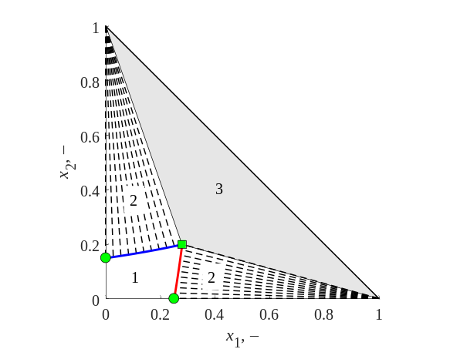
Figure 2. The phase diagram of the three-component system S₁+S₂+CO₂ with overall compositions corresponding to three (3), two (2), and single (1) phase equilibria at 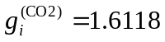, Ω₁ = –Ω₂ = –0.4, Ω = –1. The horizontal axis is the overall mole fraction x₁ of the oil component S₁ in the system [34]. The vertical axis is the overall mole fraction x₂ of the oil component S₂ in the system. The grey triangle covers the overall compositions corresponding to the oil-solvent equilibrium S₁+S₂+CO₂. The red curve is the solvent phase composition in equilibrium with the pure oil component S₁. The blue curve is the solvent phase composition in equilibrium with the pure oil component S₂. The dashed lines are tie-lines. The domain (1) represents the single phase of solvent with dissolved oil components S₁ and S₂. The square marker is the joint equilibrium concentration at saturation 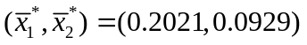 of the solvent phase in equilibrium with S₁+S₂ oil phase. The circles correspond to the equilibrium saturation concentrations 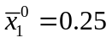 and 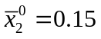 of solutes in the solvent phase in a two-component system, see Eqs. –, when the other oil component is absent.

The chemical potentials of the oil component S_{i} in different co-existing phases are equal. It is called diffusive (or material) equilibrium with respect to component S_{i}. The composition of the solvent phase in equilibrium with the corresponding oil component is shown with the blue (for S₂) and red (for S₁) curves in Figure 2. Equilibrium molar fractions of dissolved oil molecules in the solvent phase along the broken red-blue curve are designated as 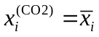, i = 1,2. Finally, the red curve in Figure 2 is determined by
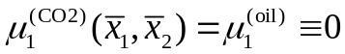,
and the blue curve corresponds to
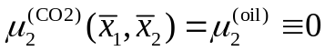.
The three-phase equilibrium, i.e. the triangular region 3 in Figure 2, is described by the unique solvent phase composition 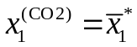 and 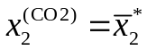, while its two other vertices represent pure oil components (or phases) S₁ and S₂. The composition 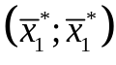 is the solution of simultaneous Eqs and . This point is shown by the square marker in Figure 2.
The interaction parameters 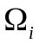 are one-to-one related to the saturation concentration 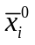 of oil component S_{i} in the solvent phase in the absence of another component S_{j≠i}. These concentrations are shown by circles in Figure 2 and can be experimentally observed. In the limit of a two-component system, the respective (CO₂+S₁)- or (CO₂+S₂)-chemical potentials and reduce to
,
.
The saturation concentration in the solvent phase corresponds to its equilibrium with the oil phase at the zero chemical potential 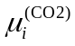 of the dissolved oil component S_{i} and in the absence of the other component S_{j≠i}
.
From Eqs. with the use of Eqs. or we obtain
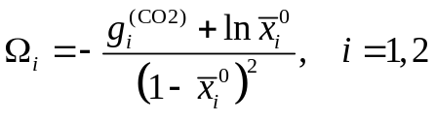.
Eqs. relate the experimentally measurable quantities – equilibrium solution concentrations – with the transition energies and interaction parameters Ω_{i}, i = 1,2.
Once it is assumed that Ω_{i}, the equilibrium concentration of the solution component directly follows from Eqs. and
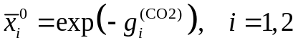.

Three-component shrinking core model

Physical description of the model
Particles of ground seeds (the raw material) are the clusters of plant cells (1) and transport channels, i.e. intercellular channels (3), as shown in Figure 3 [35]. The cells and the transport channels are separated by permeable cell membranes (6). The solvent phase with dissolved oil components occupies the transport channels. The oil phase is distributed in cells in the form of inclusions – oil bodies (4). The initial content of each pseudo-component, S₁ and S₂, of extractable oil compounds per unit volume of the raw material is designated as Θ_{i}, i = 1,2. At a given temperature and pressure, the SFE process is governed by the limiting concentration pair 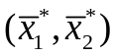 of these compounds in the solvent phase at equilibrium with the oil phase.

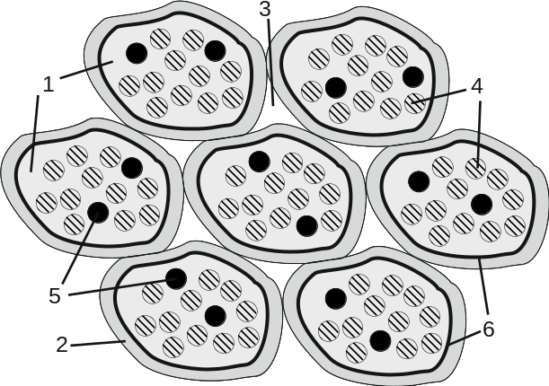
Figure 3. The schematics of oil distribution in cells and transport channels in a particle of ground raw material. (1) – plant cell, (2) – cell wall, (3) – intercellular space, (4) – oil bodies, (5) – inclusions of indissoluble components, (6) – permeable cell membrane.

The permeability of cell membranes and conductivity of transport channels control the rates of internal mass transfer in the raw material during SFE. The solvent, penetrating into the raw material, dissolves the oil molecules up to a particular saturation concentration 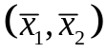 – red-blue boundary of region 1 in Figure 2. The dissolved solute diffuses out of the cell across the cell membrane into the transport channels. Following the diffusion path under the gradient of chemical potential, solute reaches the particle surface. The local solvent phase composition depends on the oil phase composition and follows the broken red-blue curve in Figure 2. In the region of the particle where the oil exists only in a dissolved form, the composition of the solvent phase 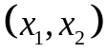 is inside region 1, see Figure 2.
In the framework of the multicomponent shrinking core (MC-SC) model, it is assumed that Θ_{i} is relatively high for every oil component with respect to 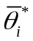 – the mass density of oil component S_{i} dissolved in the solvent in the extraction conditions, i.e., 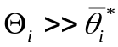, i = 1,2. The resistance of the transport channels is the principal factor limiting the internal mass transfer [14,23,36,37]. Consequently, local thermodynamic equilibrium between the oil in cells and the solvent in surrounding transport channels is reached instantaneously, and sharp concentration fronts form and move inside every particle of the raw material, as schematically shown in Figure 4. A single front exists per one oil pseudo-component.

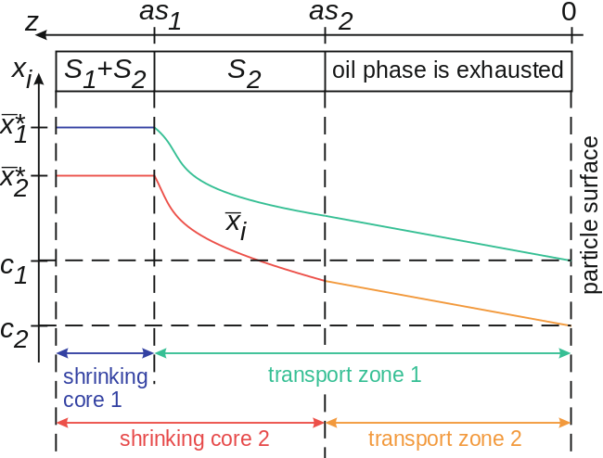
Figure 4. The schematics of the internal oil content distribution in a single particle of the ground raw material in cells and transport channels. The superscript (CO2) is omitted. For every component, a corresponding pair of a transport zone and a core is labeled. The size of the transport zone is z = as₁ and z = as₂ respectively. The blue section of the x₁ distribution is in the shrinking core 1 and is solely governed by the phase equilibrium. The green section of x₁ distribution is in the transport zone 1. Here, x₁ gradually decreases from 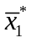 at the core boundary to the solvent concentration c₁ at the particle surface. The concentration profiles have a more complex structure in the region of shrinking core 2 since it overlaps with the transport zone 1. Therefore, 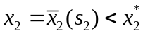 at the boundary of the transport zone 2.

For simplicity, flat (plain) particles of thickness 2a are considered in the research. The Cartesian coordinate z is introduced in every particle; z = 0 at the particle surface, and z = a at the particle plain of symmetry. In a three-component system two concentration fronts z = as₁(t) and z = as₂(t) can be distinguished. Assume, s₁ > s₂. Three intervals, (1) the shrinking core 1, a > z > as₁, (2) the overlap of the shrinking core 2 and the transport zone 1, as₁ > z > as₂, and (3) the transport zone 2, as₂ > z > 0, are distinguished. In the first interval, the oil phase is comprised of all two components, and a three-phase equilibrium, S₁+S₂+CO₂, takes place. There is no diffusion in this region since 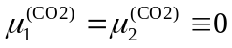 at z > as₁, and the fixed solvent phase composition 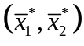 is given by the square marker in Figure 2.
In the interval (2) the oil phase is only presented by component S₂, and a two-phase equilibrium, S₂+CO₂, is observed. However, the solvent phase is a solution of all three species since the species S₁ diffuses from the surface of the shrinking core 1 through the interval (2) towards the particle surface. The local solute concentration in the solvent phase in as₁ > z > as₂ varies following the blue curve in Figure 2. Since the content of S₂ molecules dissolved in the solvent phase is governed by the equilibrium with the oil phase, one, thermodynamic, degree of freedom is fixed by 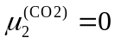. Another degree of freedom remains. It is due to non-equilibrium distribution of the dissolved oil component S₁, which is fixed by the differential mass-balance equation (to be discussed in the following sections). Apparently, the instantaneous dissolution of the oil component S₂ in the solvent in the second interval and a limited solubility of oil components in the solvent phase influence the diffusion rates of both components. This process is considered and described in the next section by relating the diffusion coefficients to the chemical potentials of dissolved species in the solvent.
In the last interval, as₂ > z > 0, all two components of the oil phase are exhausted, and both degrees of freedom are fixed by the mass-balance equations with the dependence of diffusion coefficients on the local composition of the solvent phase.

Typical values of model parameters
The measurable quantities are conventionally given in terms of the mass densities of components. Among them, Θ_{i} is the initial mass per unit volume of the raw material, – the mass of oil component S_{i} per unit volume of the solvent phase in the extraction conditions in equilibrium with the oil phase. These quantities are directly related to the molar densities of components 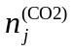, j = 0,1,2.
By definition, the fluid density is
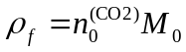,
where M₀ = 44 g/mol is the molar mass of CO₂.
Similarly, we have
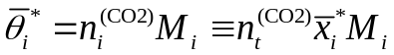,
where M_{i} ~ 850 g/mol is the molar mass of the oil component S_{i}, i = 1,2.
Typically, 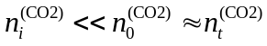, and
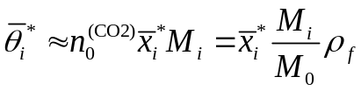.
Thus, the constraint for the MC-SC applicability can be rewritten in terms of molar concentrations
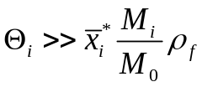.
To estimate the equilibrium molar concentrations , from Eq. one obtains
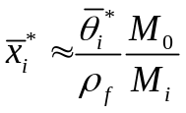.
Consequently, assuming M₀ = 44 g/mol, M_{i} = 850 g/mol, ρ_{f} = 700 kg/m³, and 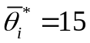 kg/m³, one arrives at typical values of 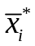 and 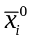 on the order of 10^{–3}.

Maxwell-Stefan approach for diffusion fluxes
In this section the superscript (CO2) is omitted, since all the derivations are related to the solvent phase and diffusion in it. Let n_{j}, j = 0,1,2, be the molar density of component j in the solvent phase. The total molar density of the solvent phase is 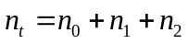. The molar flux N_{j} of the j-th species with respect to a particle-fixed coordinate reference frame is given by
,
where X_{j} is the molar diffusion flux of species j relative to the molar average reference velocity u
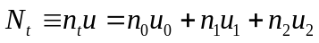
of the multicomponent solvent phase in the z-direction, and u_{j} is the velocity of the diffusing species. All fluxes and velocities are related to the overall cross-sectional area, which passes through the cells as well as the channels.
The multi-component diffusion affected by the local multiphase thermodynamic equilibrium is modelled in the framework of the Stefan-Maxwell approach [30,38,39]. To derive equations for diffusion fluxes, let us consider species 1, first. The driving force –dμ₁/dz for transport in the positive z-direction is balanced by the friction between species 1 and other two species, 0 and 2, in the system. We may expect that the frictional drag between species, i.e., 1 and 2, will be proportional to the difference of velocities (u_{l} – u₂) and to the concentration of the mixture, i.e., the mole fraction x₂ of component 2. Considering that two drag forces are exerted on each species in a three-component system
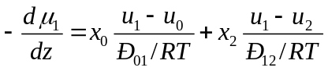,
and multiplying the force balance Eq. for species 1 by x₁/RT one obtains
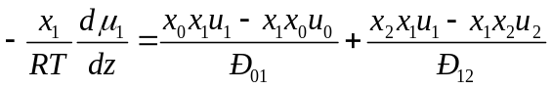,
where the factor RT/Ð_{ij} may be interpreted to be the drag coefficient between species i and j. The coefficients Ð_{ij} are apparent ones and proportional to the volume fraction of transport channels [24,40].
The set of definitions and n_{j} = x_{j}n_{t} as well as a straightforward relation
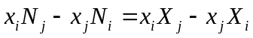
allow to rewrite Eq. in terms of molar diffusion fluxes
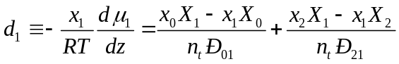.
The force balance for the other two species yields
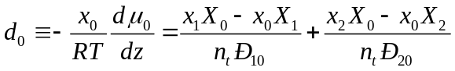,
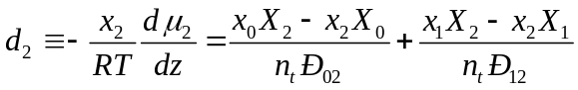.
Eqs. – are formulated in terms of molar diffusion fluxes X_{j}, j = 0,1,2. However, they are linearly dependent, and determine only the relative motion of the mixture components. Additional constraint should be imposed to fix the degree of freedom, associated with the overall motion of the mixture due to diffusion process.
With this in mind, let us consider the mass densities of the two interchanging phases in the system. The densities of oil and the solvent are very close at SFE conditions and equal to ~ 700–800 kg/m³, and replacement of the oil phase with the solvent phase occurs at practically constant mass density. The overall mass flux of the components in the system is zero
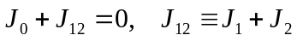.
where
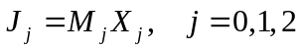,
are the mass diffusion fluxes.
Combining Eqs. and , we get
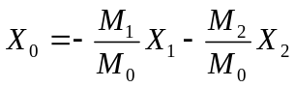,
and after substitution of X₀ into Eqs. and , we arrive at driving forces d_{i}
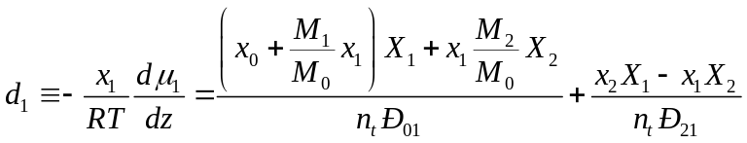,
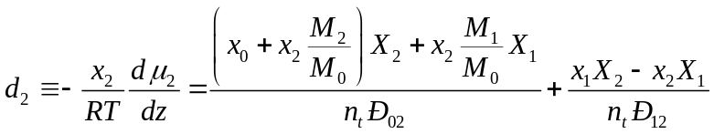.
Eqs. and can be rewritten in a matrix form
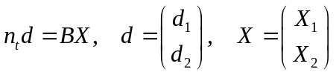,
where
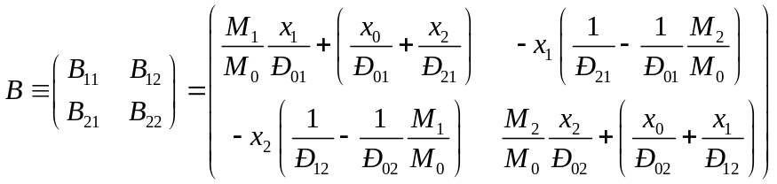.
To relate the Stefan-Maxwell approach with the Fick’s law, Fick’s diffusion coefficient, 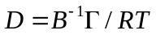, and the gradient of molar concentrations, ∂x_{i}/∂z, the vector d should be given in terms of thermodynamic factor matrix – tensor Γ of chemical potential derivatives [41,42]
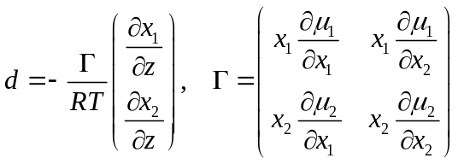.
Hence, the Stefan-Maxwell approach suggests the factorization of the Fick’s diffusion coefficient, and a distinguishing between the drag and the chemical (non-ideality) interactions between species becomes possible. The drag is described by the factor B^{–1}, while Γ controls the system non-ideality. In the simplest scenario, in the ideal system, Γ = RT, and the Ficks’s diffusion tensor is D = B^{–1}. Thus, the tensor B accounts for the species concentrations in the solvent phase and disparity of different species molecules.
Finally, the vector J = (J₁; J₂) of the mass diffusion fluxes is related to the molar concentration gradients as follows
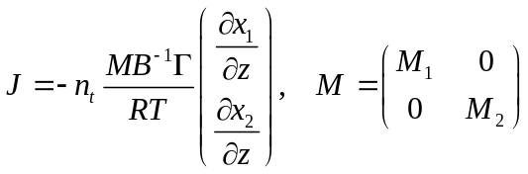.
Using Eq. it is also possible to calculate the mass diffusion flux of the solvent, J₀ = – J₁₂, opposite with respect to the net oil flux J₁₂ = J₁ + J₂.

Particle-scale mass balance equations and model assumptions
The maximum solute concentration, 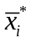, in the solvent phase at supercritical conditions remains small. Thus, assuming x₀ ≈ 1, x₁ ≈ 0, and x₂ ≈ 0, one can hereinafter consider the case of infinitely low dilution with a simplified expression for the matrix B
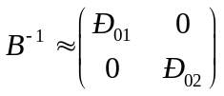.
Thus, Ð_{0i}, i = 1,2, is interpreted as the apparent binary diffusion coefficient at infinitely low dilution of species 1 or 2 in the solvent (species 0) in transport channels of the raw material. The simplified form of matrix B, Eq. , reduces two parameters, Ð₁₂ and Ð₂₁, in the problem.
The low dilution level of oil components in the supercritical fluid is typical for the SFE process. Thus, it is assumed that n_{t} ≈ n₀ = const.
Finally, the mass diffusion fluxes reduce to the following simplified form
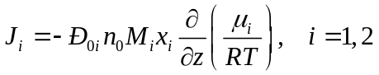,
or, equally, calculating the derivative in Eq. , we arrive at
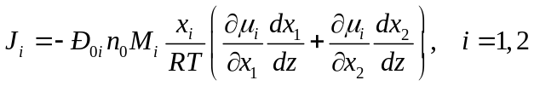.
Within the framework of the MC-SC model, spatial distributions of dissolved oil concentrations in the channels of the corresponding transport zones are assumed to be quasi-stationary at any moment t [43], i.e.
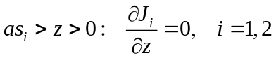.
Thus, the fluxes of both oil components remain spatially constant and vary in time only, J_{i} = J_{i}(t), i = 1,2.
Importantly, this uniquely predetermines the concentration profiles in the region where the shrinking core 2 and the transport zone 1 overlap, as₁ > z > as₂. The local composition of solvent phase is fully determined by the diffusion of the dissolved component S₁ at material equilibrium with respect to the oil component S₂. This constraint is described in the framework of the Stephan-Maxwell approach.
There is a material equilibrium with respect to component S₂ in the overlap region. Here, the local composition can be predicted explicitly
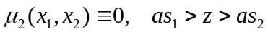.
This equation agrees with Eq. and assumes that the diffusion flux J₂ ~ dμ₂/dz of the second component is zero at as₁ > z > as₂, while J₂ > 0 at z < as₂ and J₁ > 0 at z < as₁. Thus, there exists a jump in J_{i} at z = as_{i}, i = 1,2 related to the rate of i-th core shrinking.
Finally, the problem that governs the overall spatial distributions of x₁ and x₂ in the flat particle for every oil component can be formulated explicitly as
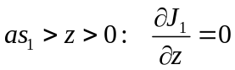,
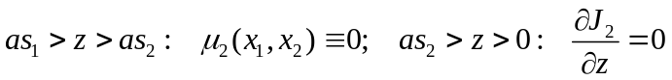.
The corresponding boundary conditions are
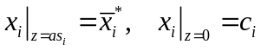,
where c_{i} is the molar fraction of oil component S_{i} at the particle boundary, in the surrounding bulk solution. These quantities are determined by the extractor-scale mass balance equations.
Once the so-called “free” oil is exhausted [44,45], the concentration of surrounding bulk solution becomes relatively low, and only the extraction of oil from large particles takes place. Outlet solute concentrations are one–two orders of magnitude smaller than the saturation concentration, and the bulk solution concentration becomes vanishingly small to affect the particle-scale extraction rates. To simplify further analysis and to ensure the numerical accuracy of the model equations solution, we consider vanishingly small solute concentrations on the macro-scale level of packed bed, c_{i}~10^{–6} << , i = 1,2.
The problem – for x_{i}(z, t, s₁, s₂) with μ_{i} given by Eqs. and for the regular solution model or Eqs. for the ideal solution limit can be solved in a closed form at any fixed values s₁ and s₂. Once the concentration distribution is obtained, one can calculate the flux J_{i}(s₁, s₂), i = 1,2 taking the gradient of x_{i}.
Another couple of equations relates the diffusion fluxes J_{i} with the rates of core shrinking, 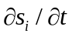. Let us consider the mass balance at the core boundaries, z = as_{i}, where the shrinking rates are balanced by the diffusion fluxes J_{i}
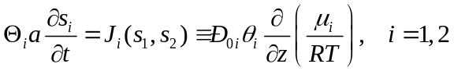.
Here, 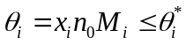 is the mass density of oil component S_{i} dissolved in the solvent phase in the transport channels.
The coupled system of Eqs. – governs the particle-scale mass transfer in the framework of the two-component shrinking core approach.

Ideal solution approach
A special limiting case, i.e., Ω₁ = Ω₂ = Ω = 0, of a regular solution model is an ideal approach. Corresponding thermodynamic relations for chemical potentials are given by Eqs. . The overall SFE model based on these simplified relations, which ignore any pairwise interactions of molecules in the solution, has been introduced earlier [25] and applied in Ref. [26] to modeling selective extraction of phosphatidylcholine. The approach allows for the closed form solution of model equations, and can be considered as a reference for the more sophisticated cases, when the species interactions are taken into account.
Substituting Eqs. into Eq. , calculating the partial derivatives 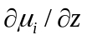, and introducing the mass density of the solute components,
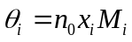,
we obtain the overall solute flux per the unit area of particle surface
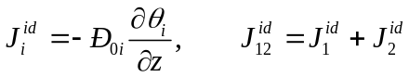.
Eq. is the Fick’s law with the diffusion coefficients of species equal to the respective Maxwell-Stefan parameters Ð_{0i}.
The analytical expression for the flux in Eq. , can be derived explicitly [36]. In the simplified approach, the diffusion of every species is independent of the other component concentration, particularly, 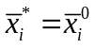 , and a linear concentration distribution sets on in the transport zone of flat particles
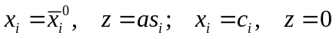,
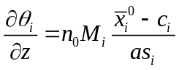.
The solute concentration is constant, 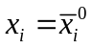, in the i-th shrinking core.
After substitution of Eq. into Eq. , one arrives at
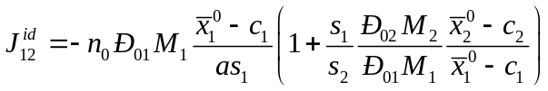.
Hereinafter in further consideration we assume Ð₀₁ = Ð₀₂ = Ð, M₁ = M₂ = M, 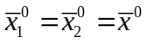, and neglect c₁ and c₂ compared to , and reduce Eq. to
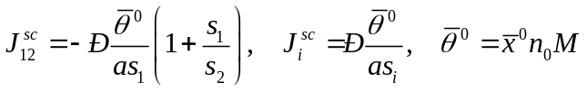.
Finally, the above simplified relations can be compared to the overall flux
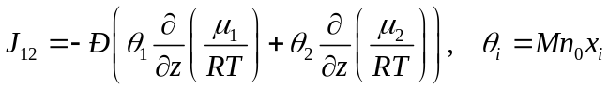
predicted in case of chemical interactions between species in the solvent phase. Accordingly, the scaled fluxes become
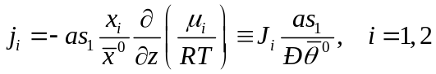,
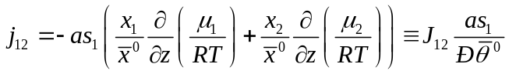.

Solute concentration in the pores of the packed bed
Two different pairs of time scales typical for SFE process can be introduced [24,40]. The first pair is associated with the time required for the depletion of component S_{i} in a particle of half-thickness a
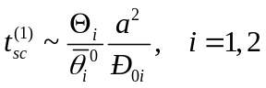.
On the other hand, the fluid flowing through the packed bed tends to reach the saturation concentration 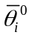. The saturation is attained for a particular component i within a typical time
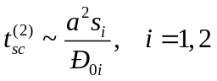.
In the framework of high initial oil content, the inequality 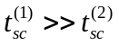 is true. So, the transport zone thickness s_{i} can not change significantly, while the solution concentration c_{i} increases from 0 to .
Finally, one can study the evolution of solute concentration in the pores of the packed in the framework of fixed value of s_{i}, and equation for the local concentration in the pores of the packed bed takes the following form
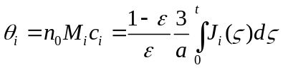
with the dimensionless time
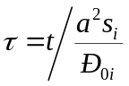.

Discussion

Particle-scale solute concentrations
The particle-scale solute concentration distribution in the transport channels is non-monotonous, significantly non-linear and depends on the solute interaction parameter , as demonstrated in Figure 5. Here, the solid curves correspond to the regular solution approach, Eqs. –, which is compared with the ideal solution approach described by Eqs. , and and shown by the dashed curves.

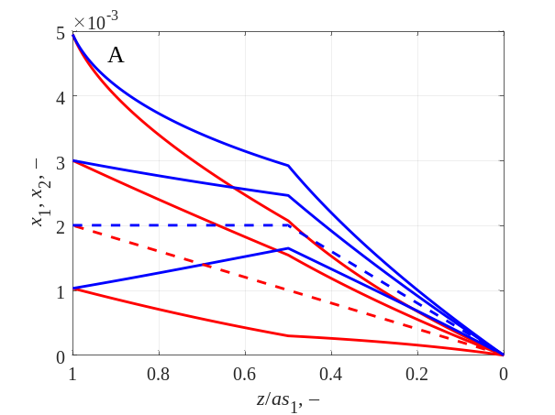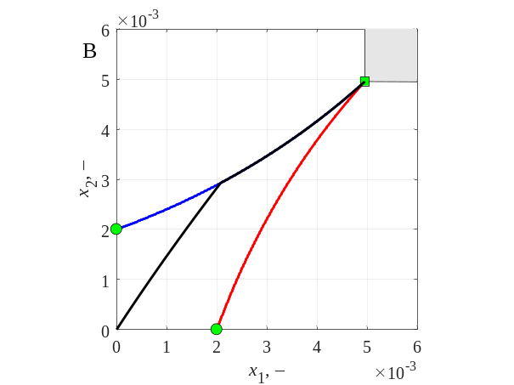
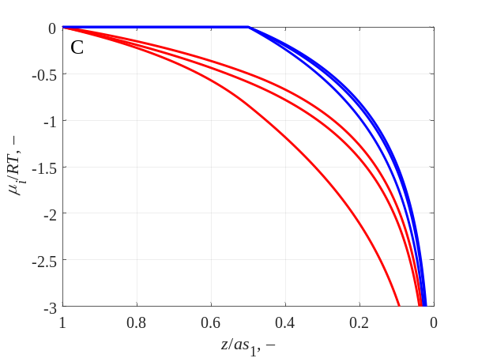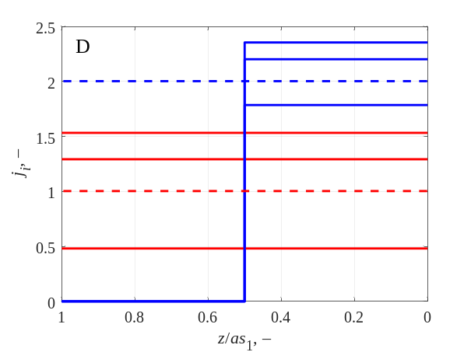
Figure 5. (A) The particle scale solute concentration distribution in the transport channels outside the inner shrinking core 1, z/as₁ < 1, during extraction. The red curves: x₁(z), the blue curves: x₂(z). The dashed curves correspond to the ideal solution model, Eqs. , and , the solid curves – general, regular solution approach, Eqs. –. The saturation concentrations are 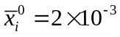, and 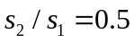. Solute interaction parameters from top to bottom 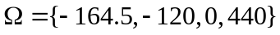. (B) The phase diagram of the three-component mixture at 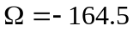. The blue curve – solvent phase composition at equilibrium with the oil component S₂, the red curve – solvent phase composition at equilibrium with the oil component S₁. The grey polygon is the three-phase equilibrium domain. The black curve is the parametric plot of {x₁(z); x₂(z)} distributions from subpanel A. Each curve has two segments. The first segment follows the blue curve and corresponds to the interval 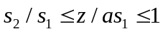 inside the particle. The second segment is inside the single-phase equilibrium domain. So, it corresponds to the outer transport zone interval 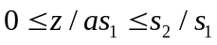. (C) The chemical potential distributions corresponding to the plots in subpanel A. (D) The dimensionless flux j_{i}, i = 1,2, as a function of position within a particle. The definition of dimensionless flux j_{i} is given by Eq. .

The composition of the solvent phase in transport channels is given by the two molar concentrations of solute components, x₁(z) and x₂(z), which are strongly interrelated in the framework of the regular solution approach. The particular distributions 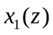 and 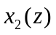 are determined by the time-dependent quantities 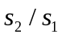, c₁, c₂, and, in the regular solution, by the fixed triple of solute interaction parameters, 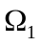, 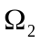, and . The two parameters, 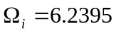, i = 1, 2, are set equal in Figure 5 and fixed so that the pairwise S_{i}+CO₂ molar saturation concentrations are . Other quantities are set as s₂ = 0.5s₁, c₁ = c₂ = 10^{–6} << . The values of the third thermodynamic parameter, Ω, are given in the caption to Figure 5.
Inside of the inner shrinking core 1, z/as₁ > 1, the three-phase equilibrium CO₂+S₁+S₂ sets on. So, x₂ = 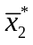 and x₁ = take constant values with respect to z. These values vary with Ω. The state of equilibrium is shown by the square marker, i.e., the region 3, in the phase diagram in Figure 2 and in Figure 5B.
The quasi-stationary distributions of solute concentrations in the transport channels take place outside the innermost core 1, 1 > z/as₁ > 0. This interval is covered by subpanels A, B, C in Figure 5. Here, a material equilibrium with respect to the oil component S₂ is observed in the cells, and two sub-intervals, (1) 1 > z/as₁> s₂/s₁ and (2) s₂/s₁ > z/as₁ > 0, can be distinguished. They are separated by the outer shrinking core surface 2 at z = as₂. The oil phase is still present in the first interval as pure S₂ component, while the phase is absent from the second interval. Thus, the x₂(z)-dependence bends sharply at the outer shrinking core surface, z = as₂, see Figure 5. This sharp bend appears in Figure 5B as well at the point where the black curve moves aside from the blue one.
In the first sub-interval, 1 > z/as₁ > s₂/s₁, the composition of the solvent phase corresponds to the two-phase equilibria. These equilibria are shown by the blue curve in Figure 2 (as a general example) and in Figure 5B for a particular . Along this curve the chemical potential 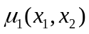 decreases taking its maximum value at 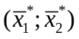, while the chemical potential 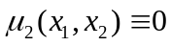. Thus, only the diffusion of oil component 1 takes place in the “two-component” medium composed of the solvent with dissolved oil component S₂. The diffusion takes place in the direction opposite to the chemical potential gradient, as prescribed by the physical laws. This suggests that x₁ monotonically decreases towards the particle surface. The oil component S₂ responses to the diffusion of component S₁ by phase transition. Once x₂ exceeds the 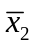-value, the solution becomes oversaturated with respect to oil component S₂. Thus, its molecules form dispersed nuclei of oil phase and precipitate from the solution phase to restore the equilibrium solvent phase composition, i.e. . The flux of the second component is zero in 1 > z/as₁ > s₂/s₁. The unidirectional diffusion of both oil components takes place in the second sub-interval, as₂ > z.
The x₂(z)-distributions shown by the blue curves in Figure 5A demonstrate different patterns in the region 1 > z/as₁ > s₂/s₁, depending on the interaction scenario of S₁ and S₂ oil components within the solvent medium. The scenario could be either co-solvent, or anti-solvent. The scenarios are typical attributes of the regular solution approach, and cannot be described in the framework of the ideal solution limit, when 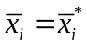 is constant along the respective (red or blue) curve in the phase diagram.
The co-solvent scenario is observed for 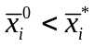 at the equilibrium solubility 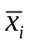 positively correlating with the other solubility 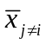 along the curve representing the solvent phase concentrations in the phase diagram, Figure 5B. For the system configuration under consideration, it is at Ω < 0, and x₂(z) decreases towards the outer shrinking core surface. And vice versa, in the anti-solvent scenario, 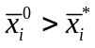, the two equilibrium concentrations 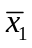 and are negatively correlated at Ω > 0, and increases towards the core surface.
Finally, x₁ and x₂ tend at the shrinking core 2 surface, z = as₂, to the values marked by circular markers in Figure 2. Thus, 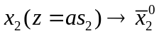, and 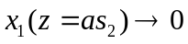. However, this composition is typically not attained within the first subinterval outside the inner shrinking core, as₁ > z > as₂. The boundary concentrations, 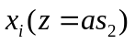, deviate from their respective limiting values.
In the second sub-interval, as₂ > z > 0, there is diffusion of both solute components under the chemical potential gradient, which is not affected by the local thermodynamic equilibrium with the oil phase. The phase is exhausted in this sub-interval. Both chemical potentials, 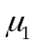 and 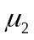, decrease towards the particle surface leading to the constant mass flux along the z coordinate. Typically, the x₁ and x₂ distributions decrease monotonously towards the particle surface where vanishingly small solute concentrations are assumed, 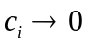.
Compare the described local solvent phase composition with the composition obtained in the framework of the ideal solution approach, Eqs. , and –. In the latter case the diffusion follows the Fick’s law and any interactions between solute components in the solvent phase are neglected. The respective distributions of solute concentration are shown in Figure 5A by dashed curves. In the transport zones, as₂ > z for the blue curve and as₁ > z for the red curve, the solute concentrations vary linearly, while they remain constant within the respective shrinking cores. The model based on the regular solution approach is significantly non-linear. Thus, the detailed particle-scale solute distribution is poorly approximated in the framework of the simplified approach.
Therefore, the solute flux at the particle surface – which is governed by the particle-scale solute concentration distribution – has to be carefully examined as well.

Oil flux at the particle surface
There are two fluxes J₁ and J₂ of individual components as well as the overall oil phase flux, J₁₂ = J₁ + J₂, in the two-component model of solute. The ratios between these three fluxes and the corresponding values predicted by the simplified (ideal solution) model, Eqs. –, are shown in Figure 6 versus relative size s₂/s₁ of outer transport zone for different Ω. The other input model parameters are same as in Figure 5.

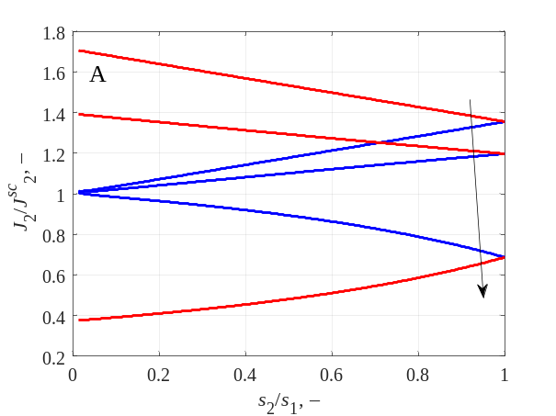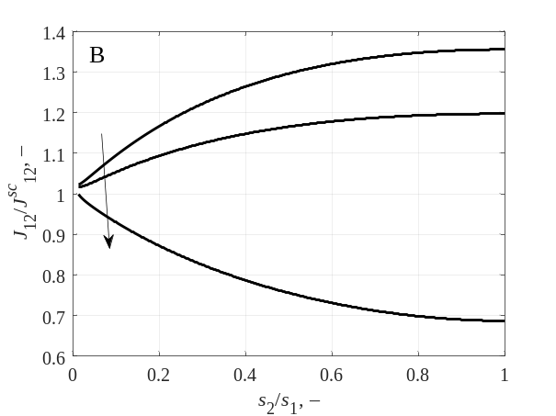
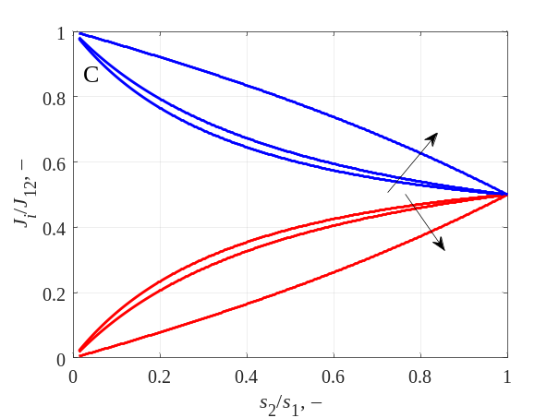
Figure 6. (A) The flux of S₁ (the red curves) and S₂ (the blue curves) oil components, and (B) the overall flux J₁₂ as functions of the outer transport zone size, s₂/s₁. (C) The fraction of the individual flux component in the overall flux. The model parameters are fixed at the same values as in Figure 5. The arrows show the direction of increase in 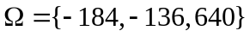.

The plots in Figure 6A present the relative fluxes J_{i} of solute components S₁ and S₂. It is important to note that the ratios deviate from unity, being uniformly larger (at the co-solvent regime, Ω < 0) or smaller (at the anti-solvent regime, Ω > 0). Thus, neglecting the chemical interactions between diffusing components, would result in over- or underestimation of the flux values. In the prescribed simulation conditions at s₂ = s₁ the corresponding fluxes become equal since all other model parameters (diffusion characteristics, molar masses etc.) are assumed identical for both components. At smaller ratios s₂/s₁, the fluxes diverge, and in the limit of s₂ → 0, the deviation from their corresponding “ideal” analogues increases up to 60%. The discrepancy level depends on the difference between and , and 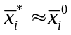 only in a special case of Ω = 0, when the fluxes become equal, 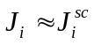.
The overall extraction rates, J₁₂, from an individual particle are depicted in Figure 6B. The flux J₁₂ is of particular importance since it is the principal characteristic of the SFE process in the framework of the one-component solute approximation. The direct intercomparison of the one- and two-component models is not straightforward and relies on the choice of apparent properties of the components. Nevertheless, one can compare the overall extraction rates predicted by the developed two-component model in its two limiting cases of the “ideal”, Eq. –, and “regular”, Eqs. –, solutions. From Figure 6B it becomes obvious that even chemical interactions between the three components in the solution can lead up to ~30% changes in the overall flux. These variations depend on the s₂/s₁-ratio but become vanishingly small at s₂ << s₁. As demonstrated by Figure 6C, the flux of the solute component S₂ prevails over the fluxes of other components scaled by ~ 1/s_{i}.

Oil precipitation in a three-component system
As a rule, it is assumed that the phase transition on the particle scale during SFE takes place only at the boundary between the shrinking core and the transport zone. This assumption is reasonable for the one-component oil approximation. In the case of the two-component oil, the phase transition also continuously occurs within the subinterval 1 > z/as₁ > s₂/s₁. This locally maintains the material equilibrium with respect to solute component S₂, , as discussed above and demonstrated in Figure 5A.
As predicted by the two-component oil model, the phase transitions can take place not only on the particle scale, but also on the scale of the packed bed. The latter phenomenon is of particular importance and means that the “fluid” leaving the extractor may be a heterogeneous mixture.
The phase separation on the packed bed scale can occur in the “anti-solvent” regime at the two additional conditions. First, if, say, S₂ is the precipitating oil component, its concentration c₂ in the solvent has to increase at a higher rate than that of the concentration c₁, i.e. dc₂/dt >> dc₁/dt, or, in other words, at J₂ >> J₁ and Ð₀₂ >> Ð₀₁. From the other side, if Θ₁ = Θ₂ then this means that s₂ >> s₁. As a result, at longer diffusion paths the constraint J₂ >> J₁ weakens, and the two fluxes become equal. Thus, as discussed below, the initial disbalance in the oil content, Θ₁ ≠ Θ₂, is needed for the phase precipitation.
The second condition of the phase separation is related to the constraint on the lengths of the diffusion paths: ds₂/dt < ds₁/dt. In accordance with Eq. , this scenario is possible at J₂/Θ₂ < J₁/Θ₁ with Θ₂ > Θ₁. The detailed values of Θ₂ and Θ₁ are not discussed here. For instance, for further analysis illustrated by Figure 7 it is assumed that Ð₀₂ = 4Ð₀₁ and s₂/s₁ = 0.5. The typical time scales of variations of concentrations c_{i} and transport zone lengths s_{i} have been deduced earlier in Sect. 3.6. In this case, a continuous disbalance in the components fluxes is maintained, with J₂ >> J₁; the composition of the solvent phase {c₁; c₂} follows the magenta curve and reaches the two-phase equilibrium in the packed bed (the triangular marker in Figure 7) at 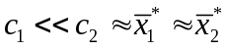 rather than at 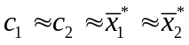. The point 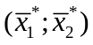 is shown by the square marker in in Figure 7A.
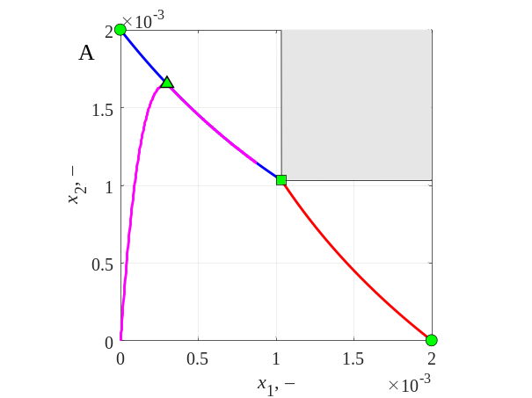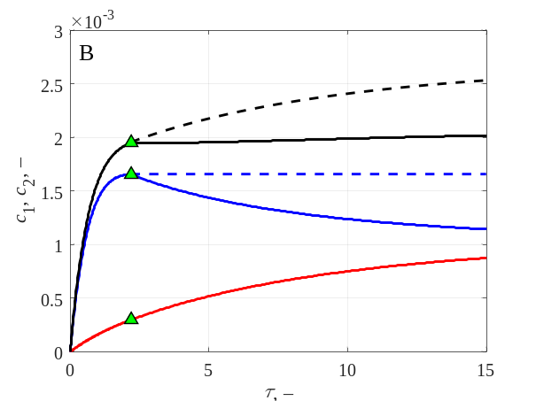
Figure 7. (A) The phase diagram of the three-component system. The magenta curve shows the trajectory of the solvent phase composition {c₁; c₂}; (B) The solvent phase solute concentration as a function of dimensionless time. The figure demonstrates the rates of solute accumulation in the pores of the packed bed while the solvent passes along the raw material particles. The red solid curve is c₁(τ), the blue solid curve is c₂(τ), and the black solid curve is the overall concentration c₁ + c₂. The dashed curves show the overall molar concentrations in the multiphase fluid.

The solvent phase composition {c₁(τ); c₂(τ)} for the described scenario is shown in Figure 7A by the solid magenta curve, where time τ is parameter along the curve. The curve starts at the point (0;0), which is the initial (inlet) condition for the solvent phase concentration at the pores of the packed bed. While the solvent travels through the porous medium along the packed bed, the concentration of the dissolved solute components increases. However, the diffusion rates of component S₂ are greater than those of S₁. A rapid initial increase of the solute component concentration c₂ is observed at reasonably small concentration c₁. And the magenta curve initially follows the x₂ coordinate axis.
Eventually the concentration trajectory in Figure 7A hits the blue curve, 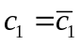, 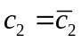, which shows the solvent phase compositions in equilibrium with the oil phase composed of pure S₂. From this moment on, the constraint 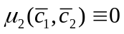 is fulfilled in the pores of the packed bed, as well as inside the particles, 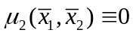. However, there is no material (diffusion) equilibrium with respect to the oil component S₁ yet, i.e., 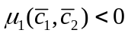, while 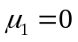 at the shrinking core surface z = as₁. The diffusion of pure oil component S₁ is still observed from the particles to the pores of the packed bed. The solvent phase composition (c₁; c₂) follows the blue curve and tends to the point shown by the green square in Figure 7A. It is a junction of the blue and the red curves, so 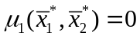 and 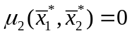 simultaneously.
To reach this equilibrium composition, the concentration of the dissolved oil molecules S₂ in the solvent phase must decrease following the blue curve. And the concentration c₁ increases accordingly due to diffusion process. However, there is no diffusion of the oil component S₂, since its chemical potential is zero in the particles as well as in the packed bed. So, the only way for the component S₂ to decrease its concentration in the pores is to precipitate as an oil phase, and the multiphase heterogeneous mixture flows through the packed bed.
Corresponding time dependence of dissolved oil components concentrations c₁ and c₂ is shown by the solid curves in Figure 7B. The concentrations in the solvent phase are shown by the solid curves, while the dashed curves show the overall molar concentrations in the multiphase flowing fluid. At τ ≈ 2.4 (introduced in Sect. 3.6) the blue and the black solid curves split into a solid and a dashed part. Interestingly, in the simulated regime, the overall concentration c₁+c₂ (shown by the black solid curve in Figure 7B) remains constant once the process reaches the two-phase equilibrium at τ ≈ 2.4. So, the amount of component S₁ that enters the packed bed pores is equal to the amount of component S₂ that precipitates from the solution.
Finally, the difference between the solid and dashed parts is the oil concentration that is precipitated as the oil phase. In this scenario, about 25% of the extracted oil component S₂ has precipitated.

Conclusions
Mathematical modeling of SFE processes based on the use of scCO₂ is very challenging. The scCO₂ as a solvent is conventionally utilized for extracting the goal components from natural products that are composed of many substances exhibiting different solubility. In this case it is of primary importance to control the content of target compounds in the extract as well as the solvent consumption by properly chosen extraction conditions. However, in practice, the SFE procedure is often adjusted simply by experience rather than on the basis of valuable and reliable information delivered by mathematical models [46]. From this point of view, the new approach proposed and analyzed in this paper is aimed at developing sophisticated mathematical models of SFE which take into account the multicomponent nature of the extract and predict the evolution of the extract composition in the course of extraction. A particular case of two-component oil extraction is considered and extends approaches of earlier publications to the regular-solution approximation.
Previously developed models did not consider interaction between different species in the solution. It is shown that the particle-scale extraction rates crucially depend on surrounding solution composition, thermodynamic properties of the oil and solute components which control the mass transfer processes. It is demonstrated that in typical SFE conditions the “regular solution” correction to the chemical potentials can lead to a 60% correction of the diffusion flux towards particle surface. The correction to the overall flux J₁₂ is not uniform with respect to the time-dependent model parameters, such as transport zone thicknesses s₁ and s₂. Thus, it is impossible to adjust the ideal and regular solution models by introducing apparent (effective) parameters.
As a rule of thumb, the effect of the regular solution correction, given by Ω, on the evolution of the solution concentrations c₁ and c₂ can be assessed through the difference of and . The greater the difference, the more important the solute components interactions.
Unfortunately, the developed approach does not directly predict conditions of selective extraction of a particular component, alternately followed by extraction of the other component. Therefore, it is expected that the optimal and efficient way to selectively extract a particular oil component is to adjust pressure and temperature variations in the course of extraction to manipulate the solubilities and .

Acknowledgments
This study was supported by the Russian Scientific Foundation through the grant No. 22-71-00080. The numerical scheme implementation as a computer program has been supported by the Kazan Federal University Strategic Academic Leadership Program ("PRIORITY-2030").

Declaration of interest
None

Nomenclature
a half thickness of the plane particle of the ground raw material;
c bulk solute concentration in the solvent phase around the particle;
Ð_{ij} Maxwell-Stefan (drag) diffusion coefficient between two species, i and j;
g molar Gibbs energy that the oil molecule S_{i} gains upon transition from the oil phase (the reference state) to the solvent phase;
G Gibbs energy of a phase;
j_{i} scaled mass diffusion flux of species i;
J_{i} mass diffusion flux of species i;
M molar mass of individual component;
n number of moles of molecules in the phase;
N_{j} molar flux of species j;
R universal gas constant;
s transport zone thickness normalized with respect to a;
S_{i} i-th oil component;
t time;
T temperature;
u velocity of the diffusing species;
x molar concentration of component in the phase;
X_{i} molar diffusion flux of species i relative to the molar average reference velocity u;
Y mass fraction of oil extracted from the packed bed to the time moment t;
z Cartesian coordinate introduced in every particle; z = 0 at the particle surface, and z = a at the particle plain of symmetry;

B factor describing the drag between diffusing species;
Γ thermodynamic factor matrix;
θ mass density of oil component S_{i} dissolved in the solvent in the extraction conditions;
Θ initial content of pseudo-component S of extractable oil compounds per unit volume of the raw material;
μ chemical potential;
τ dimensionless time;
Ω S₁-S₂ binary interaction parameter within the solvent medium;
Ω_{i} solvent-S_{i} binary interaction parameter;

BIC Broken-and-Intact Cell;
OEC Overall Extraction Curve;
MC-SC MultiComponent Shrinking Core (model);
SC Shrinking Core;
TAG TriAcylGlycerol.

Subscripts
i index of individual component;
sc characteristic scale of the process;
t total number of moles in the phase.

Superscripts
(CO2) quantity is related to the CO₂ solution phase;
(oil) quantity is related to the oil phase;
overbar quantity is related to the solution phase which is in equilibrium with the oil phase;
* three-phase equilibrium;

Bibliography
[1] G. Brunner, H. Baumgartel, E.U. Franck, W. Grumbein, Topics in physical chemistry - Gas extraction, Springer, 1994. https://doi.org/10.1007/978-3-662-07380-3.
[2] D.Y.C. Leung, X. Wu, M.K.H. Leung, A review on biodiesel production using catalyzed transesterification, Appl. Energy. 87 (2010) 1083–1095. https://doi.org/10.1016/j.apenergy.2009.10.006.
[3] M. Herrero, J.A. Mendiola, A. Cifuentes, E. Ibáñez, Supercritical fluid extraction: Recent advances and applications, J. Chromatogr. A. 1217 (2010) 2495–2511. https://doi.org/10.1016/j.chroma.2009.12.019.
[4] E. Schütz, Supercritical Fluids and Applications – A Patent Review, Chem. Eng. Technol. 30 (2007) 685–688. https://doi.org/10.1002/ceat.200600297.
[5] J.Z. Yin, Q.Q. Xu, W. Wei, A.Q. Wang, Experiments and Numerical Simulations of Supercritical Fluid Extraction for Hippophae rhamnoides L Seed Oil Based on Artificial Neural Networks, Ind. Eng. Chem. Res. 44 (2005) 7420–7427. https://doi.org/10.1021/IE049196S.
[6] U. Salgin, H. Korkmaz, A green separation process for recovery of healthy oil from pumpkin seed, J. Supercrit. Fluids. 58 (2011) 239–248. https://doi.org/10.1016/j.supflu.2011.06.002.
[7] F. Meyer, P. Jaeger, R. Eggers, M. Stamenic, S. Milovanovic, I. Zizovic, Effect of CO2 pre-treatment on scCO2 extraction of natural material, Chem. Eng. Process. Process Intensif. 56 (2012) 37–45. https://doi.org/10.1016/j.cep.2012.02.003.
[8] L. Fiori, Supercritical extraction of sunflower seed oil: Experimental data and model validation, J. Supercrit. Fluids. 50 (2009) 218–224. https://doi.org/10.1016/j.supflu.2009.06.011.
[9] U. Salgin, O. Döker, A. Çalimli, Extraction of sunflower oil with supercritical CO2: Experiments and modeling, J. Supercrit. Fluids. 38 (2006) 326–331. https://doi.org/10.1016/j.supflu.2005.11.015.
[10] S.G. Özkal, M.E. Yener, L. Bayındırlı, Mass transfer modeling of apricot kernel oil extraction with supercritical carbon dioxide, J. Supercrit. Fluids. 35 (2005) 119–127. https://doi.org/10.1016/j.supflu.2004.12.011.
[11] A.A. Salamatin, Detection of Microscale Mass-Transport Regimes in Supercritical Fluid Extraction, Chem. Eng. Technol. 40 (2017) 829–837. https://doi.org/10.1002/ceat.201600599.
[12] A.A. Salamatin, Numerical scheme for non-linear model of supercritical fluid extraction from polydisperse ground plant material: Single transport system, in: IOP Conf. Ser. Mater. Sci. Eng., Institute of Physics Publishing, 2016. https://doi.org/10.1088/1757-899X/158/1/012081.
[13] J.M. del Valle, Extraction of natural compounds using supercritical CO2: Going from the laboratory to the industrial application, J. Supercrit. Fluids. 96 (2015) 180–199. https://doi.org/10.1016/j.supflu.2014.10.001.
[14] M. Goto, B.C. Roy, T. Hirose, Shrinking-core leaching model for supercritical-fluid extraction, J. Supercrit. Fluids. 9 (1996) 128–133. https://doi.org/10.1016/S0896-8446(96)90009-1.
[15] M.A. Bootello, R. Garcés, E. Martínez-Force, J.J. Salas, Dry fractionation and crystallization kinetics of high-oleic high-stearic sunflower oil, JAOCS, J. Am. Oil Chem. Soc. 88 (2011) 1511–1519. https://doi.org/10.1007/S11746-011-1827-7.
[16] H. Sovová, Modeling of the Triacylglycerol Stereospecific Composition of Vegetable Oils: I. Comparison of Models for Triacylglycerol Assembly, Eur. J. Lipid Sci. Technol. 124 (2022) 2000392. https://doi.org/10.1002/EJLT.202000392.
[17] H. Sovová, M. Sajfrtová, R.P. Stateva, A novel model for multicomponent supercritical fluid extraction and its application to Ruta graveolens, J. Supercrit. Fluids. 120 (2017) 102–112. https://doi.org/10.1016/J.SUPFLU.2016.10.008.
[18] H. Sovova, R.P. Stateva, New approach to modeling supercritical CO2 extraction of cuticular waxes: Interplay between solubility and kinetics, Ind. Eng. Chem. Res. 54 (2015) 4861–4870. https://doi.org/10.1021/ACS.IECR.5B00741/ASSET/IMAGES/MEDIUM/IE-2015-00741R_0013.GIF.
[19] M. Goto, B.C. Roy, A. Kodama, T. Hirose, Modeling Supercritical Fluid Extraction Process Involving Solute-Solid Interaction, J. Chem. Eng. Japan. 31 (1998) 171–177. https://doi.org/10.1252/JCEJ.31.171.
[20] J.M. del Valle, F.A. Urrego, Free solute content and solute-matrix interactions affect apparent solubility and apparent solute content in supercritical CO2 extractions. A hypothesis paper, J. Supercrit. Fluids. 66 (2012) 157–175. https://doi.org/10.1016/J.SUPFLU.2011.10.006.
[21] J.M. Prausnitz, R.N. Lichtenthaler, E.G. de Azevedo, Molecular thermodynamics of fluid-phase equilibria, Prentice Hall PTR, 1999.
[22] N.E. Durling, O.J. Catchpole, J.B. Grey, R.F. Webby, K.A. Mitchell, L.Y. Foo, N.B. Perry, Extraction of phenolics and essential oil from dried sage (Salvia officinalis) using ethanol–water mixtures, Food Chem. 101 (2007) 1417–1424. https://doi.org/10.1016/J.FOODCHEM.2006.03.050.
[23] A.G. Egorov, A.A. Salamatin, Bidisperse Shrinking Core Model for Supercritical Fluid Extraction, Chem. Eng. Technol. 38 (2015) 1203–1211. https://doi.org/10.1002/ceat.201400627.
[24] A.A. Salamatin, Supercritical Fluid Extraction of the Seed Fatty Oil: Sensitivity to the Solute Axial Dispersion, Ind. Eng. Chem. Res. 59 (2020) 18126–18138. https://doi.org/10.1021/acs.iecr.0c03329.
[25] A. Tezel, A. Hortaçsu, Ö. Hortaçsu, Multi-component models for seed and essential oil extractions, in: J. Supercrit. Fluids, Elsevier, 2000: pp. 3–17. https://doi.org/10.1016/S0896-8446(00)00079-6.
[26] L. TEBERIKLER, S.S. KOSEOGLU, A. AKGERMAN, MODELING OF SELECTIVE EXTRACTION OF PHOSPHATIDYLCHOLINE FROM A COMPLEX LECITHIN MIXTURE USING SUPERCRITICAL CO ₂ /ETHANOL, J. Food Lipids. 10 (2003) 203–218. https://doi.org/10.1111/j.1745-4522.2003.tb00016.x.
[27] B. Sundman, X.-G. Lu, H. Ohtani, The implementation of an algorithm to calculate thermodynamic equilibria for multi-component systems with non-ideal phases in a free software, Comput. Mater. Sci. 101 (2015) 127–137. https://doi.org/10.1016/J.COMMATSCI.2015.01.029.
[28] I. Gyarmati, Non-equilibrium Thermodynamics: Field Theory and Variational Principles, Springer, 1970.
[29] H.L. Toor, Diffusion in three-component gas mixtures, AIChE J. 3 (1957) 198–207. https://doi.org/10.1002/AIC.690030214.
[30] R. Krishna, J.A. Wesselingh, The Maxwell-Stefan approach to mass tranfer, Chem. Eng. Sci. 52 (1997) 861–911. https://doi.org/10.1016/S0009-2509(96)00458-7.
[31] R. Taylor, R. Krishna, Multicomponent mass transfer, John Wiley & Sons, Ltd, 1954.
[32] B. Calvignac, E. Rodier, J.J. Letourneau, P.M.A. Dos Santos, J. Fages, Cocoa butter saturated with supercritical carbon dioxide: Measurements and modelling of solubility, volumetric expansion, density and viscosity, Int. J. Chem. React. Eng. 8 (2010). https://doi.org/10.2202/1542-6580.2191.
[33] R. Privat, J.-N. Jaubert, E. Berger, L. Coniglio, C. Lemaitre, D. Meimaroglou, V. Warth, Teaching the Concept of Gibbs Energy Minimization through Its Application to Phase-Equilibrium Calculation, J. Chem. Educ. 93 (2016) 1569–1577. https://doi.org/10.1021/acs.jchemed.6b00205.
[34] V.E. Alvarez-Montaño, M.H. Farías, F. Brown, I.C. Muñoz-Palma, F. Cubillas, F.F. Castillón-Barraza, Phase Relations in Ternary Systems in the Subsolidus Region: Methods To Formulate Solid Solution Equations and To Find Particular Compositions, J. Chem. Educ. 94 (2017) 1247–1254. https://doi.org/10.1021/acs.jchemed.7b00237.
[35] S. Furse, S. Liddell, C.A. Ortori, H. Williams, D.C. Neylon, D.J. Scott, D.A. Barrett, D.A. Gray, The lipidome and proteome of oil bodies from Helianthus annuus (common sunflower), J. Chem. Biol. 6 (2013) 63. https://doi.org/10.1007/S12154-012-0090-1.
[36] A.G. Egorov, A.B. Mazo, R.N. Maksudov, Extraction from a polydisperse granular layer of milled oilseeds with supercritical carbon dioxide, Theor. Found. Chem. Eng. 44 (2010) 642–650. https://doi.org/10.1134/S0040579510050027.
[37] O. Döker, U. Salgin, N. Yildiz, M. Aydoǧmuş, A. Çalimli, Extraction of sesame seed oil using supercritical CO2 and mathematical modeling, J. Food Eng. 97 (2010) 360–366. https://doi.org/10.1016/j.jfoodeng.2009.10.030.
[38] E. Leonardi, C. Angeli, On the Maxwell - Stefan approach to diffusion: A general resolution in the transient regime for one-dimensional systems, J. Phys. Chem. B. 114 (2010) 151–164. https://doi.org/10.1021/jp900760c.
[39] Y. Ma, F. Zhang, H.W. Deckman, W.J. Koros, R.P. Lively, Flux Equations for Osmotically Moderated Sorption-Diffusion Transport in Rigid Microporous Membranes, Ind. Eng. Chem. Res. 59 (2020) 5412–5423. https://doi.org/10.1021/ACS.IECR.9B05199/SUPPL_FILE/IE9B05199_SI_001.PDF.
[40] A.A. Salamatin, Estimation of the Axial Dispersion Effect on Supercritical Fluid Extraction from Bidisperse Packed Beds, Russ. J. Phys. Chem. B. 11 (2017) 1180–1187. https://doi.org/10.1134/S1990793117070156.
[41] T. Janzen, J. Vrabec, Diffusion Coefficients of a Highly Nonideal Ternary Liquid Mixture: Cyclohexane-Toluene-Methanol, Ind. Eng. Chem. Res. 57 (2018) 16508–16517. https://doi.org/10.1021/ACS.IECR.8B04385/ASSET/IMAGES/LARGE/IE-2018-04385X_0006.JPEG.
[42] W. Ren, G. Li, S. Tian, M. Sheng, L. Geng, Adsorption and Surface Diffusion of Supercritical Methane in Shale, Ind. Eng. Chem. Res. 56 (2017) 3446–3455. https://doi.org/10.1021/ACS.IECR.6B04432/SUPPL_FILE/IE6B04432_SI_001.PDF.
[43] A.A. Salamatin, A.S. Haliullina, Characteristic Scales of the Supercritical-Fluid Extraction Process, Theor. Found. Chem. Eng. 56 (2022) 742–753.
[44] A. Promraksa, C. Siripatana, N. Rakmak, N. Chusri, Modeling of Supercritical CO2 Extraction of Palm Oil and Tocopherols Based on Volumetric Axial Dispersion, J. Supercrit. Fluids. 166 (2020) 105021. https://doi.org/10.1016/j.supflu.2020.105021.
[45] H. Sovová, Broken-and-intact cell model for supercritical fluid extraction: Its origin and limits, J. Supercrit. Fluids. 129 (2017) 3–8. https://doi.org/10.1016/J.SUPFLU.2017.02.014.
[46] A.A. Salamatin, A.S. Haliullina, Evaluation of Supercritical Fluid Extraction Model Parameters by Monte-Carlo Methods, Theor. Found. Chem. Eng. 56 (2022) 69–83.

Table of Contents (TOC)/Abstract graphic

