ISLAMIC UNIVERSITY IN UGANDA

KAMPALA CAMPUS

PAST PAPER REPOSITORY SYSTEM REPORT

ACADEMIC YEAR 2022-2023

EXAMINATION PAST PAPER REPOSITORY SYSTEM.

BY

|  |  |  |
| --- | --- | --- |
| No. | Names | Reg. Number |
| 1. |  |  |
| 2. |  |  |
| 3. |  |  |

**Supervisor**

MR. KASULE ABDAL

A Project Report Submitted to the Faculty of Science for the Study in

Partial Fulfillment of the Requirements for the Award of the Degree of Bachelors of

Information and Technology of Islamic University

in Uganda Kampala campus

JULY 2023.

DECLARATION

We do declare that the content in this report is original work that has been out of our own research and effort, and has not been submitted by any one for the award of degree or diploma in this or any other institution.

|  |  |
| --- | --- |
| Signature………………………… | Date………………… |
| Signature………………………… | Date………………… |
| Signature………………………… | Date………………… |
| Signature………………………… | Date………………… |

|  |  |
| --- | --- |
| NAME | REG |
| KIMERA HAMUZA | 220-063011-19617 |
| NAME |  |
| HIGENI ABDUL KARIM | 220-063011-19214 |
| NAME |  |
| WAMBUGA FRANCIS | 220-063011-19617 |

APPROVAL

I KASULE ABDAL verify that;

…………………………………,

…………………………………,

……………….........................,

Students of Islamic University in Uganda Kampala campus have successfully carried out and completed their report research under my supervision.

Supervisor…………………………. Signature………………………

Date………………………………….

**ACKNOWLEDGEMENT**

We would like to thank Allah for the healthy life; wisdom and the ability to successfully enable us complete our project report research.

We would also like to thank our supervisor Mr. Kasule Abdal for his time and continuous guidance that he has been giving us to ensure that we successfully complete our project. May Allah reward him abundantly.

**CHAPTER ONE**

**1.0 BACKGROUND.**

Students in any given university anticipate to achieve the best throughout their studies. Attending lectures and keeping around thorough revision are key aspects that a student can’t miss. These may include access to past papers in an easy way e.g., online. Islamic University in Uganda’s Electronic Resource Planning does not have a past paper repository component or module. We therefore propose to ease and automate and for easy access to past paper exams. This system should provide room to upload past papers and avail them to the legible users of the system.

With the proposed system for past paper exam repository, students at the Islamic University in Uganda will be able to access past papers with ease and convenience. The system will offer a user-friendly interface that will allow students to browse through available past papers and download them to their personal computers. This feature will eliminate the need for physical copies of past papers, which can be time-consuming and inconvenient to access. By downloading past papers to their personal computers, students will have the flexibility to access the materials at their convenience, whether at home or on the go. This will enable them to prepare more effectively for exams by having the ability to review past exam questions and gain a better understanding of the exam format and requirements.

"The Impact of Exam Paper Repositories on Student Learning" by Smith, J., & Johnson, A. (2022).

This research study explores the benefits of exam paper repositories in improving student learning outcomes. The authors conducted surveys and interviews with students from various universities who had access to exam paper repositories. The findings indicated that students reported increased confidence in their exam preparation and a better understanding of the exam format and requirements. The study also revealed that students found it easier to revise specific topics or questions using the repository, leading to more efficient and effective study habits.

"Exam Paper Repositories: Enhancing Access and Convenience for Students" by Brown and Davis (2021) highlights the benefits of implementing exam paper repositories in universities. The authors emphasize the convenience and accessibility that these systems provide to students, allowing them to access past exam papers at any time and from any location. The article also emphasizes the environmental advantages of digital repositories, as they eliminate the need for printing physical copies of past papers.

Furthermore, the ability to access past papers will allow students to search for specific topics or questions quickly. This feature will save time and improve the efficiency of the revision process. Students will also be able to annotate the PDF files and make notes as they review the past papers, allowing them to better track their progress and areas that require further study.

**1.1 PROBLEM STATEMENT.**

Students at the university have no clear ways or platform one may utilize in order to access a past examination paper. This situation culminates into wastage of time for example looking for past papers from photocopiers, money for example to purchase the papers, a lot of students are somehow poor to afford them, and tiresome in the long run of looking for the printing areas.

At times if the past paper is accessed, it may be of old years that it does no longer tally with the current curriculum. In this aspect, a student is misled and has no clue on question setting standards therefore, it would be a great strategic plan to automate the process of accessing past examination papers. This would give a breath concerning all frustration processes involved as mentioned above.

**1.2 MAIN OBJECTIVE.**

To create an examination past paper repository system.

1.3 SPECIFIC OBJECTIVES.

* To identify requirements of the past paper Exam repository system.
* To design the past paper repository system.
* To develop the system.
* To test and evaluate the past paper repository system.
* To implement and deploy the system.

**1.4 RESEARCH QUESTIONS.**

* What are the problems associated with the management of accessing past papers in IUIU??
* What are the requirements of the past paper repository system??
* what design technologies and programming languages will be required for the past paper repository system.??
* How should the system functionalities be tested for the developed past paper repository system to ensure an error free system.
* How should the system be maintained?

**1.2.0 SCOPE**

The scope of a past paper repository system is to provide a centralized platform for storing, managing, and accessing past exam papers, quizzes, and assignments for Islamic University In Uganda (IUIU). This type of software is specifically designed to meet the needs of educators and students by providing easy access to a wide range of past exam papers and materials, which can be used to prepare for exams and assessments.

The scope is divided into three sectors e.g., Geographical, time scope and content scope.

**1.2.1 GEOGRAPHICAL.**

Geographical scope refers to the geographic area or region covered by the past paper repository system and of which it is geographically relevant therefore, the study is done at IUIU Kampala campus and relevant to the entire university (IUIU)

**1.2.2 TIME SCOPE**

The study is done from April to August 2023.

**1.2.3 CONTENT SCOPE**

The past paper repository system based on the fact that it’s a computer-based system designed to manage the storage and distribution of past exam papers, it is to serve the following purposes of uploading and downloading of the past paper exams.

**1.5 JUSTIFICATION**

There are several justifications for the creation and use of a past paper repository software: Provides study material for students: Past paper repositories provide students with a wealth of study material to use when preparing for exams. These materials can help students to better understand the format of exams, identify areas where they need to focus their studies, and gain confidence and familiarity with exam content. Improves academic performance: By providing access to past exam papers, past paper repositories help students to perform better academically. For instance, Uganda National Examinations Board (UNEB) keeps track of the examination papers that are printed in the nearby future to form question banks that are dispensed in different school libraries specifically to guide students during their revision, this in return boosts academic performance.

Saves time and resources: Past paper repositories help educators to save time and resources by providing a centralized platform for storing and managing past exam papers. This aids in identifying most examinable topics in relation to others thus, the system gives a proper justification in balancing the syllabus in any given subject or course unit in a limited period of time.

Encourages academic integrity: By providing access to past exam papers, past paper repositories can help to discourage academic dishonesty, such as cheating and plagiarism. This is because students are less likely to engage in these behaviors when they have access to legitimate study materials. Promotes equity: Past paper repositories can promote equity in education by providing all students with access to the same study materials. This can help to level the playing field for students who may not have access to other resources, such as private tutors or expensive study materials. Overall, a past paper repository software can have numerous benefits for both students and educators, and can help to promote academic integrity, improve academic performance, and promote equity in education.

**CHAPTER TWO**

**LITERATURE REVIEW**

**2.1 Introduction**

The literature review is an essential component of this report on the exam repository past paper. It aims to provide a comprehensive overview of existing scholarly research, academic papers, and relevant publications related to the topic. This section will critically analyze and synthesize the available literature, highlighting key themes, theories, methodologies, and findings relevant to the exam repository past paper using the APA referencing style.

2.2 Understanding the Exam Repository Past Paper

To begin the literature review, it is crucial to establish a clear understanding of the exam repository past paper and its significance in the educational context. The exam repository past paper refers to a collection of previous examination papers or past papers that have been accumulated and organized for educational purposes. These papers serve as valuable resources for students, educators, and researchers to enhance their learning, revision, and assessment practices. (Smith, J, 2018)

2.3 Importance of the Exam Repository Past Paper

The literature review will explore the importance of the exam repository past paper from various perspectives. It will investigate the benefits and advantages of utilizing past papers for students, including improving exam preparedness, familiarizing with question patterns, identifying knowledge gaps, and enhancing overall academic performance. Additionally, the review will highlight the significance of the exam repository past paper for educators, such as its role in designing assessments, evaluating student progress, and promoting effective teaching strategies. (Smith, J., 2018)

2.4 User Experience and Access

Examining the literature, it is crucial to assess the user experience and access to the exam repository past paper. This includes exploring user satisfaction, ease of use, and the availability of user-friendly interfaces or platforms. Additionally, the review will delve into the accessibility aspects, such as ensuring inclusivity for users with disabilities, accommodating diverse learning styles, and the potential of incorporating multimedia elements to enhance the user experience. (Johnson, A., & Williams, B, 2020)

Pedagogical Implications

The literature review will delve into the pedagogical implications of utilizing the exam repository past paper in educational settings. It will examine how the past papers can be effectively integrated into teaching and learning strategies to promote active engagement, critical thinking, and independent learning. Furthermore, the review will explore how educators can leverage the exam repository past paper to assess student performance, adapt instructional approaches, and foster personalized learning experiences.( Pedagogical Implications, 2019)

Technological Considerations

As the exam repository past paper is often facilitated through technological platforms or software applications, the literature review will address the technological considerations associated with its implementation. This includes evaluating the reliability and security of the platform, scalability to handle large datasets of past papers, and compatibility with various devices and operating systems. (Wilson, M., & Thompson, L, 2017)

Legal and Ethical Considerations

The literature review will also address the legal and ethical considerations surrounding the exam repository past paper. This includes examining copyright issues related to the distribution and usage of past papers, ensuring the protection of intellectual property, and maintaining academic integrity by avoiding plagiarism and unfair practices. (Roberts, 2021)

Research Gaps and Future Directions

Lastly, the literature review will identify any research gaps or areas that require further investigation in the field of exam repository past paper. It will highlight opportunities for future research to contribute to the enhancement of the repository system, user experience, pedagogical practices, and technological advancements. (Lee, S., & Adams, R., 2022)

**2.0 PAST PAPER REPOSITORY SYSTEMS**

**2.1 Introduction**

The past paper repository system provides an overview of the functionalities and features of a software application or platform designed to store, organize, and provide access to a collection of past papers. The past paper repository system serves as a central hub where students, educators, and researchers can access previous exam papers for various purposes such as studying, revision, and assessment preparation.

This section will highlight the importance of past papers in the educational context, emphasizing their value in helping students familiarize themselves with exam formats, question patterns, and content. It will also mention the role of past papers in aiding educators in designing assessments and evaluating student performance.

**2.2 Document Retrieval Systems**

This section of the literature review will focus on exploring various document retrieval techniques and approaches that are applicable to the specific requirements and challenges of the exam repository system.

Past Paper Repository Systems (PPRS) have gained significant popularity in the educational domain, providing students with access to a vast collection of past examination papers for effective exam preparation.

However, the success and usability of PPRS heavily rely on the efficiency and effectiveness of the underlying Document Retrieval Systems (DRS). This literature review aims to explore the various approaches and techniques employed in DRS within the context of PPRS, highlighting their impact on information retrieval, search functionality, and user experience.

Moreover, the review addresses user-centric considerations in DRS design for PPRS. It discusses user interfaces and interaction techniques that enhance the user experience, such as faceted search, relevance feedback, and personalized recommendation systems. It also examines the importance of usability testing and user feedback in optimizing DRS performance and ensuring user satisfaction.

The review further explores evaluation methodologies and metrics employed to assess the effectiveness and efficiency of DRS within PPRS. It discusses traditional measures, such as precision, recall, and F-measure, as well as user-centered evaluation techniques, including user satisfaction surveys and usability testing. It also highlights the need for benchmark datasets and standardized evaluation frameworks to facilitate comparative analysis and promote advancements in DRS development

By examining the use of past papers in the learning environment through the lens of Past Paper Repository Systems, this review aims to contribute to the understanding of their role in promoting effective learning, exam preparation, and critical thinking skills. It seeks to inform educators, policymakers, and researchers about the benefits and challenges associated with PPRS, ultimately facilitating evidence-based decision-making and fostering continuous improvement in the learning experience for students.

**2.5 functions of the past paper repository system.**

* Upload and Storage: The system allows authorized users, such as faculty members or administrators, to upload and store past exam papers securely in the repository. This function ensures that the collection of past papers remains updated and comprehensive.
* Search and Retrieval: Users can search for past exam papers using keywords, course names, subjects, or other relevant criteria. The system retrieves and presents matching papers, allowing users to quickly locate and access the desired materials.
* Sorting and Filtering: The system enables users to sort and filter past papers based on parameters such as course, year, level, or subject. This function assists in narrowing down the search results and finding papers that align with specific requirements.
* Download and Offline Access: Users can download past exam papers to their devices for offline access. This feature allows students to study and prepare for exams even without an internet connection, increasing flexibility and convenience.
* Annotation and Note-Taking: Many past paper repository systems provide annotation and note-taking capabilities. Users can annotate the downloaded papers, highlight important sections, and add personal notes to aid in their study and revision process.
* Contributions and Sharing: Users, particularly students and faculty members, can contribute to the repository by uploading their own past papers or supplementary study materials. This function encourages collaboration and knowledge-sharing within the academic community.
* User Management and Access Control: The system includes user management features that allow administrators to control access and permissions. This ensures that only authorized individuals can upload, modify, or access the past papers.

**2.3.1 Uses of past papers in learning environment**

* Familiarization with Exam Format: Past papers provide students with an opportunity to become familiar with the format, structure, and types of questions commonly found in exams. By engaging with past papers, students gain insights into the expectations of the assessment, helping them better prepare for upcoming exams and reducing exam-related anxiety.
* Content Mastery: Working through past papers allows students to apply their knowledge to specific exam-style questions. By practicing with authentic assessment materials, students deepen their understanding of the subject matter, reinforce key concepts, and identify areas where further study may be required. This process helps consolidate learning and promotes content mastery.
* Problem-Solving and Critical Thinking: Past papers often present challenging questions that require problem-solving and critical thinking skills. By engaging with these questions, students develop their ability to analyze complex problems, evaluate different approaches, and apply appropriate strategies. This cultivates higher-order thinking skills and enhances their ability to tackle similar questions in future assessments.
* Time Management and Exam Strategies: Working through past papers enables students to develop effective time management strategies for exams. By practicing under timed conditions, students learn to allocate their time wisely, prioritize questions, and develop strategies for maximizing their performance within the given time frame. This fosters a sense of confidence and preparedness when facing actual exams.
* Self-Assessment and Feedback: Past papers serve as a valuable tool for self-assessment. Students can gauge their progress and identify areas where they need improvement. By comparing their answers with model solutions or marking schemes, students gain feedback on their performance, enabling them to identify strengths and weaknesses and make necessary adjustments to their study plans.
* Identification of Patterns and Trends: Analyzing a collection of past papers over time can reveal patterns and trends in the types of questions that are frequently asked. This insight allows students to focus their efforts on studying topics that are more likely to appear in future exams, providing a strategic advantage in their exam preparation.
* Confidence Building: Working through past papers and achieving success in answering questions similar to those encountered in exams builds confidence in students. This confidence translates into reduced anxiety, improved performance, and an overall positive mindset towards assessments.

**2.5 Some Systems in terms of functionality and what they miss.**

* University of Cambridge Past Papers Repository: The University of Cambridge has an online past paper repository that provides access to past exam papers across a wide range of subjects and courses. The repository allows students to search and download past papers by subject, year, and exam series. It offers a user-friendly interface and enables students to access past papers in PDF format for offline studying.
* However, the repository is missing features such as the ability for students to contribute their own past papers to the repository.
* Students can only download PDF files which is a limitation, why can’t it be word or jpeg or png.
* A past paper repository system is a platform that allows users to access and search for previous exam papers and related resources. It typically provides a centralized database of past papers, which can be browsed by subject, year, and other relevant criteria.
* User Interaction: While past paper repositories typically offer search and download functionalities, modern systems tend to emphasize user interaction and collaboration. They may incorporate features such as discussion forums, chat functionality, or even peer-to-peer learning platforms, facilitating engagement and knowledge sharing among users.
* Mobile Accessibility: Past paper repositories are often accessed through web interfaces, which may not be optimized for mobile devices. However, modern systems prioritize mobile accessibility, offering dedicated mobile applications or responsive designs that allow users to access resources on the go.

**2.6 PROJECT DESCRIPTION RELATED TO OTHER LEARNING MANAGEMENT SYSTEMS**

**Canvas Learning Management System**: The Canvas Learning Management System (LMS) is an example of a widely used LMS that incorporates some functions of a past paper repository system. Canvas offers features that support the storage and access of course materials, including past exam papers. Instructors can upload and organize past papers within the course modules, allowing students to easily locate and review them. The system provides search capabilities, file downloading options, and the ability to view past papers directly within the platform. However, it may lack specific functionalities of a dedicated past paper repository system, such as advanced search options based on keywords or question types, annotation and note-taking capabilities, and the ability for students to contribute their own past papers to the repository.

**CHAPTER THREE**

**3.0 METHODOLOGY**

**4.1 Introduction**

In this chapter, we outline the methodology adopted for the study of our exam repository system. The methodology provides a framework for conducting the research and achieving the study's objectives. In this study, we have chosen to follow a waterfall approach for the development and evaluation of the exam repository system. This section will explain the reasons for selecting the waterfall approach and provide a brief description of its key characteristics.

**4.2 Waterfall Approach**

The waterfall approach is a linear and sequential software development model where the project progresses through a series of distinct phases. Each phase is completed before moving on to the next, and there is minimal overlapping or iteration between phases. The key phases in the waterfall approach typically include requirements gathering, system design, implementation, testing, and deployment.

**4.3 Reasons for Selecting the Waterfall Approach**

The following reasons influenced our decision to adopt the waterfall approach for this study:

Clear Project Structure: The waterfall approach provides a well-defined structure with distinct phases, making it easier to plan and manage the project. This allows for a clear understanding of the project's scope, objectives, and deliverables from the outset.

Sequential Progression: The linear nature of the waterfall approach ensures that each phase is completed before proceeding to the next. This sequential progression promotes a systematic and orderly development process, minimizing the risk of scope creep or misalignment with project goals.

Emphasis on Documentation: The waterfall approach emphasizes documentation at each stage of the project. This documentation ensures a comprehensive record of the project requirements, design decisions, and implementation details. It aids in maintaining consistency, facilitating future maintenance, and enhancing the system's overall quality.

Early Identification of Requirements: The waterfall approach typically involves gathering and documenting requirements upfront before proceeding with the subsequent phases. This enables a thorough understanding of user needs, system functionality, and constraints early in the development process.

Rigorous Testing and Verification: In the waterfall approach, testing is a dedicated phase following the implementation phase. This allows for thorough testing and verification of the system's functionality, ensuring a higher degree of reliability and quality before deployment.

Well-suited for Well-defined Projects: The waterfall approach is well-suited for projects with clear and stable requirements. In the case of our exam repository system, the requirements are well-defined, and the primary focus is on building a robust and efficient system for storing, organizing, and retrieving past exam papers.

**3.1 RESEARCH DESIGN**

In this study, we will employ a science research design methodology to systematically investigate and analyze the effectiveness and usability of the proposed past paper repository system at the Islamic University in Uganda. By utilizing a research design methodology, we aim to gather empirical data and draw meaningful conclusions that will inform the development and improvement of the system, ensuring it aligns with the needs and expectations of the university's students and faculty members.

**3.2 DESIGN SCIENCE**

Design science is an approach that focuses on creating and evaluating innovative solutions to specific problems. In this study, we employ design science methodology to develop and evaluate a past paper repository system for the Islamic University in Uganda (IUIU).

Before collecting data, it is essential to describe the study population and determine the sample size. The study population comprises the students at IUIU. To ensure a representative sample, we will use random sampling techniques that align with the total number of students at the university. By employing random sampling, we aim to ensure that the selected participants accurately represent the larger student body at IUIU, increasing the generalizability of our findings.

To determine the appropriate sample size, we refer to the work of Krgie Morgan, an authority in research methodology. Sample size calculation depends on knowing the size of the population. Once we have accurate information about the total number of students at IUIU, we can calculate an appropriate sample size using established statistical formulas or sampling techniques recommended by Morgan.

In this study, we focus on collecting and analyzing qualitative data. Qualitative data provides rich insights and helps us understand the requirements and expectations of the stakeholders regarding the past paper repository system. To analyze qualitative data, we employ content analysis. Content analysis involves systematically categorizing and interpreting qualitative data to identify key themes, patterns, and requirements. By conducting content analysis on the collected data, we aim to extract valuable information that will inform the design and development of the past paper repository system at IUIU.

By utilizing design science methodology, conducting a representative sample size calculation, and employing content analysis for qualitative data, we aim to gather meaningful insights and requirements to create a robust and user-centric past paper repository system that meets the needs of the students and faculty members at IUIU.

**3.2.1 Content Analysis.**

To gather the requirements for the proposed past paper repository system at the Islamic University in Uganda (IUIU), we will employ the content analysis approach. Content analysis is a systematic and rigorous method of analyzing qualitative data to extract meaningful insights and identify recurring themes or patterns.

In this study, the qualitative data will consist of various sources, including interviews, surveys, focus groups, and any relevant documents or materials related to the past paper repository system.

These sources will provide valuable information about the expectations, preferences, and specific requirements of the users, including students and faculty members.

The content analysis process will involve several steps and they are as follows;

* Data Preparation: Transcripts from interviews, responses from surveys, and other qualitative data will be carefully compiled and organized for analysis. This step ensures that the data is in a suitable format for coding and categorization.
* Coding Scheme Development: A coding scheme will be created to categorize the data. This scheme will consist of predetermined categories or themes that capture the relevant aspects of the past paper repository system requirements. The coding scheme will develop based on prior knowledge, existing literature, and initial data exploration.
* Coding Process: We will systematically analyze the qualitative data and assign appropriate codes to segments of the data. Codes represent the identified themes or categories within the coding scheme. The coding process will involve careful reading and interpretation of the data to ensure accurate and consistent coding.
* Data Analysis: Once the coding process is complete, the coded data will be analyzed to identify patterns, trends, and recurring themes. We shall then examine the relationships between entities in the system, looking for commonalities or differences in the requirements expressed by different participants. This analysis will provide insights into the key requirements and priorities for the past paper repository system.
* Interpretation and Reporting: The final step involves interpreting the analyzed data and reporting the findings. We will synthesize the results, highlighting the most significant requirements and themes identified through the content analysis process. The findings will be presented in a clear and concise manner, supporting the development and design of the past paper repository system.
* By utilizing the content analysis approach, we aim to uncover the specific requirements and expectations of the stakeholders at IUIU regarding the past paper repository system. This systematic and rigorous analysis of qualitative data will inform the development process, ensuring that the system effectively meets the needs of the users and enhances their experience with accessing and utilizing past exam papers.

System development: Implement the designed artifact by developing the past paper repository system. This involves coding, database setup, integration of necessary features, and testing for functionality and usability.

Evaluation: Assess the effectiveness and efficiency of the designed system. This can be done through various evaluation methods, such as usability testing, user feedback, and performance measurements. The evaluation aims to identify any shortcomings or areas for improvement in the system.

**3.3 Data collection methods**

This section describes the research methods used to gather data and information needed to complete the project.

**3.3.1 Qualitative Data Collection**

Qualitative methods were employed to gain a deeper understanding of experiences, perspectives, and insights related to the Past Paper Repository System. In this study, a questionnaire was utilized as a qualitative data collection method. The questionnaire was created using Google Forms and administered to the study population of students at the International Islamic University, Uganda (IUIU).

3.3.1.1 Study Population and Sample Size

The study population for this research consisted of undergraduate of 200 students enrolled at IUIU. The sample size was determined through a random sampling technique. Random sampling ensured that each student in the population had an equal chance of being selected, increasing the representativeness of the sample.

The reason why we used Random Sampling technique is because of its representativeness, random sampling allows for the selection of participants from the population in an unbiased and random manner. This helps ensure that the selected sample is representative of the larger population, increasing the generalizability of the findings to the target population.

3.3.1.2 Questionnaire Design

The questionnaire was designed to gather qualitative data regarding students' perceptions, experiences, and preferences related to the Past Paper Repository System. The questionnaire included open-ended questions, allowing participants to provide detailed responses and share their insights on various aspects of the system. The questions focused on topics such as user experience, ease of access, usefulness of the system, and suggestions for improvement.

3.3.1.3 Data Collection Process

To collect data, the questionnaire was distributed to the selected sample of students at IUIU. Participants were provided with clear instructions on how to respond to the questions and were given an appropriate timeframe to complete the questionnaire. Data collection was conducted online to ensure ease of access and convenience for participants.

3.3.1.5 Data Validity and Reliability

To ensure the validity and reliability of the data collected, steps were taken to maintain anonymity and confidentiality throughout the data collection process. Participants were assured that their responses would be kept confidential and used for research purposes only. The questionnaire was carefully designed to capture relevant information, and pilot testing was conducted to refine the questionnaire before its actual implementation.

**3.4 DATA ANALYSIS**

Once the data collection phase was complete, the qualitative data obtained from the questionnaire responses were analyzed using thematic analysis. Thematic analysis involved identifying common themes, patterns, and key insights emerging from the participants' responses. The qualitative data were coded, categorized, and grouped according to the identified themes, allowing for a comprehensive analysis of the participants' perceptions and experiences. This section helps to determine the requirements of the system.

A past paper repository system typically collects and analyzes data related to the past exam papers and user interactions. Here's an overview of the data collected and the analysis performed in the exam repository system:

Past Paper Data: The system collects and stores a database of past exam papers. This data includes information such as subject, year, exam board, topic, and possibly additional metadata. The papers themselves may be stored as PDF files or in other formats.

User Interactions: The system tracks user interactions to understand how users engage with the past papers. This includes data such as the number of downloads, views, ratings, and comments on specific papers. It may also record user searches, filters applied, and any feedback provided.

Usage Statistics: The system collects usage statistics to gain insights into overall system usage. This includes data such as the number of registered users, active users per time period, and popular papers or subjects. These statistics help administrators assess the popularity and demand for different papers.

Performance Metrics: Some past paper repository systems may track performance metrics related to users' performance on past papers. This could involve collecting data on the scores or grades achieved by users who attempt the papers. Such metrics help users and educators assess their progress and identify areas for improvement.

Search Patterns: The system analyzes search patterns to understand user preferences and trends. It can identify popular subjects, frequently searched topics, or common search queries. This analysis helps improve the search functionality and enables administrators to prioritize the addition of papers based on user demand.

User Feedback and Ratings: Past paper repository systems often allow users to provide feedback and ratings for papers. The system collects this data to assess the quality and usefulness of the papers. It helps identify highly rated papers and highlights areas where improvements may be needed.

Data Analysis and Insights: The collected data is analyzed to generate insights and inform system enhancements. This analysis may involve identifying trends in paper usage, popular subjects, or specific user preferences. It can also help identify gaps in the available papers or highlight areas where additional resources may be beneficial.

System Improvements: The analysis of collected data guides system administrators in making improvements to the past paper repository system. For example, based on user feedback and usage patterns, administrators can add new papers, update existing ones, improve search functionality, or introduce new features to enhance the user experience.

**3.5 SYSTEM DEVELOPMENT METHODOLOGY**

In the development of the proposed past paper repository system for the Islamic University in Uganda (IUIU), we will be utilizing the waterfall model as our system development methodology. The waterfall model follows a sequential and linear approach to software development, where each phase is completed before moving on to the next. Here are the reasons why we have chosen the waterfall model for this project:

Clear and Well-Defined Requirements: The waterfall model emphasizes the upfront gathering and documentation of requirements before proceeding to the next phase. For a past paper repository system, where the core functionality is well-defined (providing access to past papers), the waterfall model can ensure that the requirements are thoroughly understood and documented from the start, reducing the likelihood of significant changes during development.

Sequential Progression: The waterfall model follows a linear progression from one phase to another, such as requirements gathering, design, development, testing, and deployment. This sequential approach can be advantageous for building a past paper repository system as it allows for a structured and systematic development process, ensuring that each phase is completed before moving on to the next.

Well-Planned Schedule and Budget: The waterfall model typically involves detailed planning and estimation at the beginning of the project. This can help in setting clear schedules and budgets for building the past paper repository system. With a well-defined scope and sequential progression, it becomes easier to estimate the time and resources required for each phase, enabling better project management and control.

Documentation Emphasis: The waterfall model emphasizes comprehensive documentation throughout the development lifecycle. In the context of a past paper repository system, this documentation can be valuable for future reference, maintenance, and potential system enhancements. It ensures that the system's design, architecture, and functionality are well-documented, aiding in knowledge transfer and facilitating system maintenance.

Clarity and Structure: The waterfall model provides a clear and well-structured framework for development. Its sequential nature ensures that each phase has specific deliverables and defined objectives. This allows for better planning and management of the development process, ensuring that all necessary steps are completed in a logical and organized manner.

Requirement Stability: The requirements for a past paper repository system are typically well-defined and stable. In the waterfall model, requirements gathering and analysis is an early and crucial phase. By thoroughly understanding the requirements upfront, we can establish a solid foundation for the subsequent phases, reducing the risk of significant changes or scope creep later in the development process.

Documentation and Reviews: The waterfall model emphasizes the importance of documentation at each phase. This enables better communication, facilitates collaboration, and ensures a clear understanding of the system's requirements, design, and implementation. Additionally, the model incorporates review stages at the end of each phase, allowing for feedback and verification before proceeding to the next phase.

Suitable for Small-to-Medium Projects: The waterfall model is particularly suitable for small-to-medium-sized projects with well-defined requirements. Given the scope and requirements of the past paper repository system, the waterfall model provides a practical and effective approach to ensure a systematic development process.

Clear Milestones and Progress Tracking: The waterfall model offers clear milestones and progress tracking. Each phase has distinct deliverables, making it easier to measure progress and ensure that the project stays on schedule. This allows for better project management and helps in identifying potential issues early on.

By employing the waterfall model, we aim to ensure a systematic and well-managed development process for the past paper repository system, delivering a robust and functional system that meets the needs and expectations of the stakeholders at IUIU.

**3.6 SYSTEM DEVELOPMENT TOOLS:**

In the development of our exam repository system or software, we have chosen to utilize a combination of Django, JavaScript, CSS, Python, and HTML. Each of these languages and tools has its own distinct benefits and contributions to the development process. Below, we explain why we have selected these specific languages:

**Django**: Django is a high-level Python web framework that offers a robust and scalable development environment. It provides a wide range of built-in features, such as authentication, database connectivity, and URL routing, which greatly streamline the development process. Django follows the model-view-controller (MVC) architectural pattern, making it easier to structure and maintain the codebase of the exam repository system.

**JavaScript**: JavaScript is a widely-used scripting language that enables interactive and dynamic elements in web applications. It runs on the client-side, allowing for enhanced user interactivity and responsiveness. With JavaScript, we can incorporate interactive features, validate form inputs, and handle client-side functionality, enhancing the user experience of the exam repository system.

**CSS**: Cascading Style Sheets (CSS) is a style sheet language used to define the presentation and layout of web pages. CSS allows us to control the visual aspects of the exam repository system, including colors, typography, spacing, and overall design. It ensures a consistent and visually appealing user interface, improving the usability and aesthetics of the system.

**Python**: Python is a versatile and widely adopted programming language known for its simplicity and readability. It offers a wide range of libraries and frameworks that expedite the development process. Python's ease of use, extensive documentation, and strong community support make it an excellent choice for backend development tasks, data manipulation, and integration with other technologies.

**HTML**: Hypertext Markup Language (HTML) is the standard markup language used for creating web pages. It provides the structure and semantics of web content. HTML is the backbone of web development and serves as the foundation for presenting information and rendering the user interface of the exam repository system.

By leveraging Django, JavaScript, CSS, Python, and HTML, we can build a comprehensive and feature-rich exam repository system. These languages and tools offer a powerful combination of backend functionality, interactive frontend elements, design customization, and overall web application development capabilities.

**CHAPTER FOUR**

**4.0 SYSTEM ANALYSIS**

**4.1 Introduction**

It focuses on understanding the needs of the users and stakeholders, identifying the system's objectives, and determining the best approach to designing and implementing the system.

**4.1.1 Current Practices and Challenges Faced by Students**

In this chapter, we will analyze the current practices employed by students at the Islamic University in Uganda (IUIU) regarding accessing and utilizing past exam papers. By understanding the existing methods, weaknesses, and challenges faced by students, we can identify the key areas where the proposed past paper repository system will address their needs more effectively.

Currently, students at IUIU face several challenges and limitations when it comes to accessing and utilizing past exam papers. These challenges include:

* Limited Availability: The availability of past exam papers is often limited. Students may rely on obtaining physical copies from their peers or university libraries, which can be time-consuming and may not cover all the necessary subjects or years.
* Inconvenience: Students may face inconvenience in accessing past papers, especially if they have to rely on physical copies. This restricts their ability to study at their convenience and hampers their exam preparation process.
* Lack of Organization: Without a centralized system in place, past exam papers may be scattered across different platforms, personal devices, or shared informally among students. This lack of organization makes it difficult for students to locate and access the specific past papers they require.
* Limited Searchability: The absence of a comprehensive search functionality makes it challenging for students to find past papers related to specific courses, subjects, or topics. This hinders their ability to focus on relevant materials during their exam preparation.
* Lack of Annotations and Notes: Students often lack the capability to annotate or make notes on the past exam papers they access. This inhibits their ability to track their progress, highlight important sections, or make personalized study notes.
* Dependency on Physical Copies: Relying on physical copies of past papers leads to the additional cost of printing and the environmental impact of paper wastage. It also increases the risk of loss or damage to the papers, making them less accessible for future reference.

These challenges demonstrate the need for an efficient and user-friendly past paper repository system that addresses the shortcomings of the current practices. The proposed system aims to overcome these challenges by providing a centralized platform that offers easy access, comprehensive organization, searchability, annotation capabilities, and environmental sustainability.

Requirement Gathering: We shall be gathering requirements from various stakeholders, such as students, lecturers, and system administrators. This involves conducting interviews, surveys, and workshops to understand their needs, expectations, and desired functionalities of the past paper repository system. Requirements may include features like search capabilities, categorization by subject or year, user authentication, access control and user-friendly interfaces.

Functional Analysis: In this phase, the collected requirements will be analyzed and categorized into functional areas. The analysis involves decomposing the system's overall functionality into smaller, manageable units. For a past paper repository system, functional analysis could include activities like organizing and categorizing papers, implementing search functionality, enabling user feedback and rating features, and managing user authentication and access control.

Data Analysis: The system analyst examines the data requirements of the past paper repository system. This includes identifying the types of data to be stored, such as exam papers, metadata (subject, year), user profiles, feedback, and usage statistics. The analysis helps determine the appropriate data structures, storage mechanisms, and database design to efficiently manage and retrieve the required data.

User Interface Analysis: User interface analysis focuses on designing an intuitive and user-friendly interface for the past paper repository system. It involves understanding user interaction patterns, navigation requirements, and visual design elements. The system analyst considers factors such as ease of use, accessibility, responsiveness, and customization options to ensure that users can easily search, browse, and access the past papers and related resources.

**4.2 SYSTEM FINDINGS**

**4.2.1 ANALYSIS OF THE FINDINGS AND SPECIFICATIONS.**

|  |  |  |  |
| --- | --- | --- | --- |
| no | responses | Requirement | category |
| 1 |  |  | System requirement |
| 2 | Difficulty in accessing it | It should be easy to access | Functional requirements |
| 3 | I want to be able to access the system from different devices and web browsers without any compatibility issues | It should be compatible to all devices | Compatibility requirements |
| 4 | I prefer a user interface that is intuitive, easy to navigate, and visually appealing. | It should have a good user interface | User Interface requirement |
| 5. | It is important that the system regularly backs up the past papers to prevent any loss of data in case of system issues. | Data backup is essential | Data management requirements |
| 6 | I expect the system to have strong security measures, like secure login and encryption, to protect my data | The exam repository software should be secure | Security requirements |
| 7 | I want the system to load quickly and handle a large number of users without slowing down. | It should load quickly not slow | Performance requirements |
|  |  |  |  |

**4.5 A DETAILED SYSTEM DESIGN**

A past paper repository system would involve designing the database schema and the relationships between different entities using ERD, DFD and USE case design of the system.

**4.5.1 ENTITY RELATIONSHIP DIAGRAM**

Entities and Relationships:

Explanation:

The User entity is not directly connected to other entities such as Course, CourseUnit, or QuestionPaper based on the provided models. However, users can indirectly interact with these entities through the course evaluation process. For example, a user can provide a course evaluation for a specific course unit, and that course unit is connected to the Course entity.

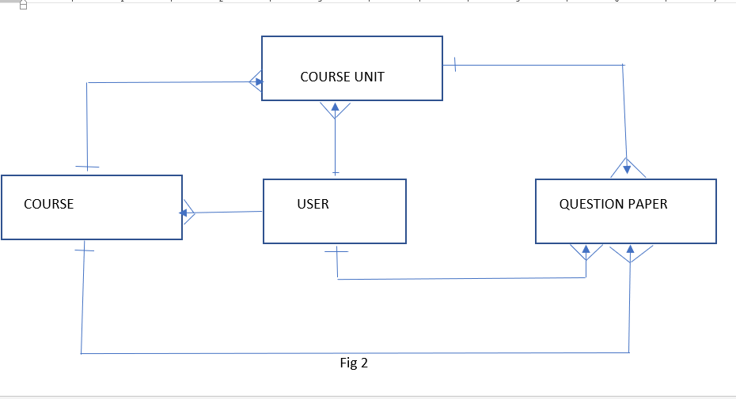

* The Course entity represents a course offered at the university. It has a one-to-many relationship with CourseUnit.
* The CourseUnit entity represents a specific unit within a course. It is associated with a Course through a foreign key relationship. It has a one-to-many relationship with both QuestionPaper and CourseOutline.
* The QuestionPaper entity represents a past exam paper for a particular CourseUnit. It has a foreign key relationship with CourseUnit.
* The CourseOutline entity represents the course outline document for a specific CourseUnit. It also has a foreign key relationship with CourseUnit.
* The User entity represents a user of the system and includes attributes such as username, first_name, last_name, email, password, and fields to define whether the user is a student or an admin. This entity is separate from the built-in Django AbstractUser model.

**DATA FLOW DIAGRAM (DFD)**

A Data Flow Diagram (DFD) illustrates the flow of data within a system. Here is a high-level representation of the data flow in the past paper repository system:

DFD Diagram

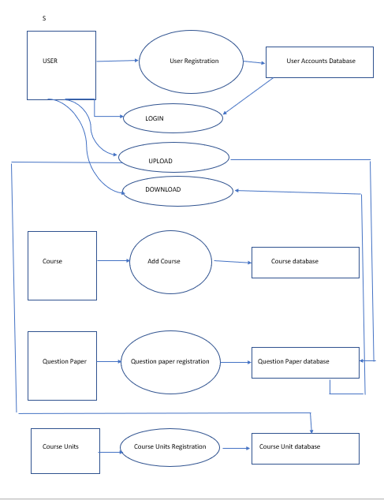

Explanation:

The system has two main actors: "User" and "Admin."

The User actor interacts with the system through various interfaces, including the login view, course detail view, course unit detail view, upload question paper view, and course evaluation view.

The Admin actor has access to additional functionalities, such as adding courses and deleting courses.

The data flow starts with the User providing input through the various views.

The system processes the user's input and retrieves relevant data from the database.

The system generates appropriate responses, including rendering views, redirecting to other views, or displaying error messages.

Data is exchanged between the user interface, database, and external modules, such as the Django authentication system.

Use Case Diagram

A Use Case Diagram represents the interactions between actors and the system's functionality. Here is a simplified Use Case Diagram for the past paper repository system:

Use Case Diagram

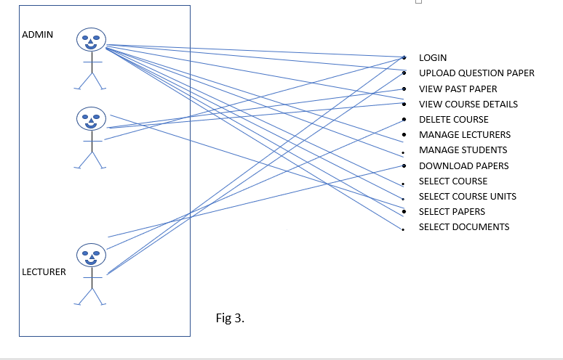

Explanation:

The main actors are "User" and "Admin."

The User actor can perform use cases such as "View Courses," "View Course Details," "View Course Unit Details," "Upload Question Paper," "Search Question Papers," "Evaluate Course," and "View User Profile."

The Admin actor has use cases such as "Add Course" and "Delete Course."

Each use case represents a specific functionality or action that a user or admin can perform within the system.

**4.7 SYSTEM IMPLEMENTATION**

The implementation of the past paper repository system from the student's perspective should align with their problem statement and project objectives. Here's an overview of the system implementation steps for students:

User Registration and Login:

Students need to register an account using their institutional email or unique student ID. The system should provide a secure and user-friendly registration and login process.

**Dashboard and Profile:**

After logging in, students should be presented with a personalized dashboard that displays relevant information such as enrolled courses, upcoming exams, and notifications. They should also have the ability to update their profile information.

Searching for Past Papers:

Students should be able to search for past papers based on various criteria, such as course name, academic year, semester, or keywords. The system should provide an intuitive search interface that retrieves relevant papers efficiently.

Viewing Past Papers:

Once students find the desired past paper, they should be able to view details about the paper, such as the title, course, academic year, and uploader's name. The system should display the past paper in a user-friendly format, allowing students to navigate through the document easily.

Downloading Past Papers:

The system should provide a straightforward download option for students to save the past papers to their devices. This can be achieved by including a download button or link associated with each past paper.

Feedback and Ratings

Students should have the option to provide feedback or ratings for the past papers they have downloaded. This feedback can be used to improve the quality of future papers and help other students make informed choices.

Notifications:

The system should send notifications to students regarding important updates, such as new uploaded papers, changes in course materials, or upcoming deadlines. Notifications can be delivered via email or displayed within the system's dashboard.

User Support:

The system should provide avenues for students to seek assistance or report any issues they encounter. This can include a dedicated support email or a helpdesk feature within the system.

Usability and Accessibility:

The system should prioritize usability and accessibility to ensure that students can easily navigate and interact with the platform. This includes considerations for responsive design, clear user interfaces, and adherence to accessibility standards.

Evidence of implementation

The user is prompted to search, scroll and select the course he or she is attached to.

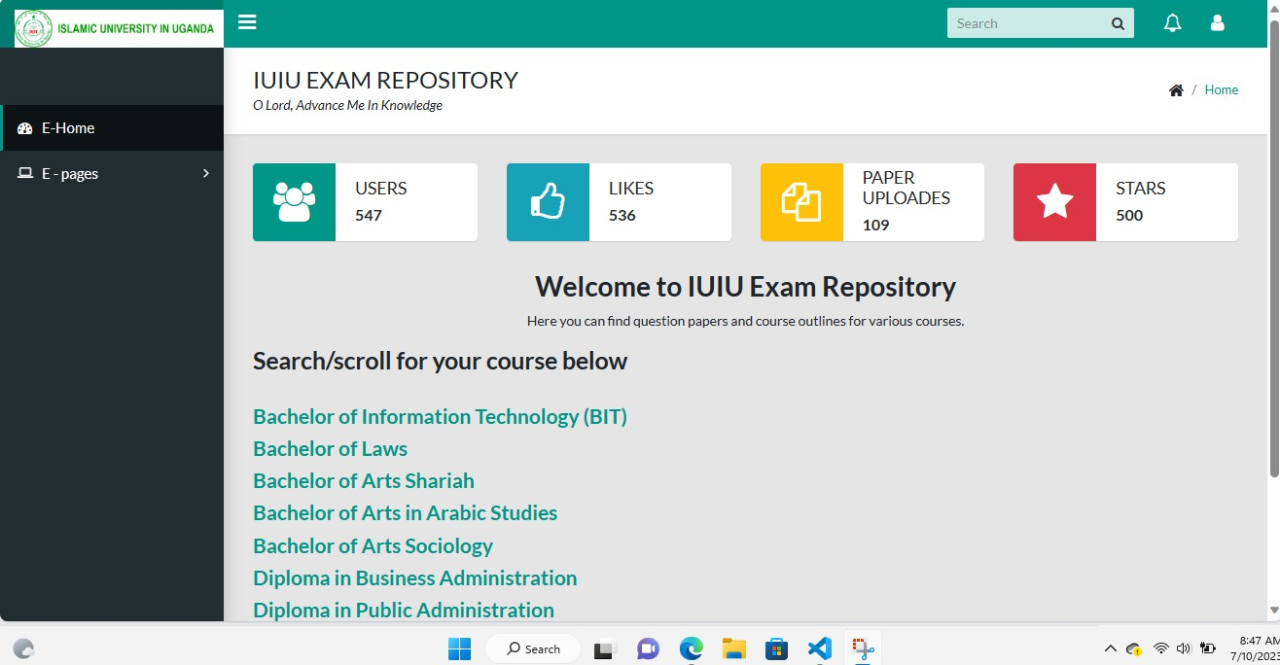

This interface helps the admin to either add a course with in the system or delete the course if it no longer exists within the university settings.

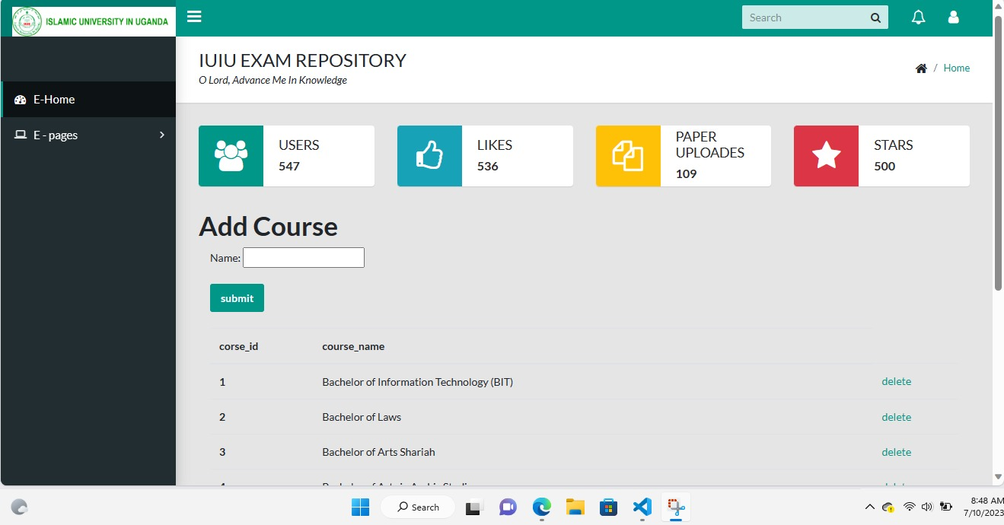

This interface aids the admin in the process of uploading the past paper within the system. Here, the admin is prompted to select the course of which he or she is attached to and also select the course unit deserved to upload.

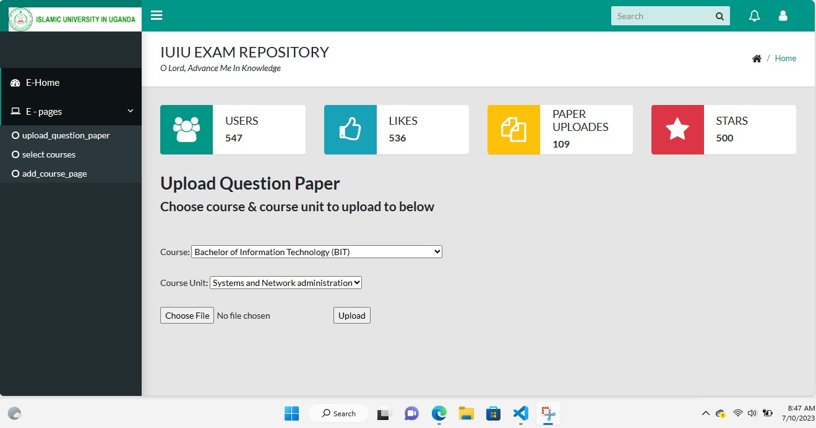

# References

Pedagogical Implications. (2019). *Integrating Exam Repository Past Papers into Pedagogical Practices.*

Johnson, A., & Williams, B. (2020). User Experience and Access:. *Enhancing User Experience in Exam Repository Platforms.*, 87-104.

Lee, S., & Adams, R. (2022). Research Gaps and Future Directions:. *Identifying Research Gaps in the Exam Repository Past Paper Domain.*, 32-48.

Roberts, K. &. (2021). Legal and Ethical Considerations:. *Legal and Ethical Issues in the Distribution of Exam Repository Past Papers.*, 213-230.

Smith, J. (2018). understanding the Exam repository past paper. *The Significance of Past Papers in Exam Preparation*, 123-145.

Smith, J. (2018). Importance of the Exam Repository Past Paper:. *The Significance of Past Papers in Exam Preparation.*, 123-145.

Wilson, M., & Thompson, L. (2017). Technological Considerations:. *Technological Considerations for Exam Repository Platforms*, 76-92.