Comprehensive Data Analysis Report

Walmart Sales Forecasting Project - Statistical Analysis & Insights
Dataset: 421,570 weekly sales observations
Stores: 45 locations | Departments: 81 categories

Executive Summary
This report presents comprehensive statistical analyses performed on Walmart’s historical sales data. The analysis encompasses time series decomposition, stationarity testing, correlation analysis, and external factor impact assessment. Key findings reveal that the sales data exhibits non-stationary behavior, strong autocorrelation with lag features, and a significant positive impact from holiday periods (+7.13% average increase).
Critical Findings:
- Non-Stationary Series: First-order differencing required for ARIMA-type models
- Dominant Predictors: Past sales (rolling means & lags) show correlations > 0.91
- Holiday Effect: 7.13% average sales increase during holiday weeks
- Economic Indicators: Weak direct correlations (< 0.03) with sales

1. Time Series Stationarity Analysis

1.1 Augmented Dickey-Fuller (ADF) Test Results
The stationarity assessment reveals critical insights for model selection:
Metric | Value | Interpretation
Original Series Mean | $47,113,419.49 | Baseline weekly aggregate sales
Original Series Std Dev | $5,444,206.20 | High variability in sales
Differenced Series Mean | -$29,624.11 | Near-zero (good for stationarity)
Differenced Series Std Dev | $6,284,025.50 | Slightly higher than original
Variance Ratio | 1.1543 | > 1.0 indicates non-stationarity
Mean Stability Ratio | 0.0047 | < 0.01 indicates mean stability after differencing

1.2 Stationarity Classification
Result: NON-STATIONARY SERIES
Evidence:
- Variance Ratio > 1.0: Differencing increased variance by 15.43%, indicating the presence of trend and seasonal components
- Mean Stability Near Zero: While the differenced series has a mean close to zero (good sign), the variance increase overrides this
- Visual Inspection: Time series decomposition shows clear upward trend and seasonal patterns

1.3 Modeling Implications
Model Type | Recommendation | Parameters
ARIMA/SARIMA | Use with d=1 | Apply first-order differencing
Prophet | Native handling | Built-in trend/seasonality decomposition
LSTM/GRU | No preprocessing needed | Neural networks handle non-stationarity
Linear Regression | Use lag features | Detrend with time-based features
XGBoost/RF | Use engineered features | Lag and rolling features capture patterns
Key Takeaway: The non-stationary nature of the series necessitates either differencing (for classical time series models) or inclusion of strong lag/rolling features (for machine learning models).

2. Correlation Analysis

2.1 Top Predictive Features (Correlations with Weekly Sales)
The correlation analysis reveals a clear hierarchy of feature importance:
Rank | Feature | Correlation | Strength | Category | Interpretation
1 | Sales_Rolling_Mean_4 | +0.9758 | Very Strong | Lag Feature | 4-week moving average is the strongest predictor
2 | Sales_Rolling_Mean_8 | +0.9648 | Very Strong | Lag Feature | 8-week moving average captures medium-term trends
3 | Sales_Lag1 | +0.9438 | Very Strong | Lag Feature | Previous week’s sales highly predictive
4 | Sales_Lag2 | +0.9260 | Very Strong | Lag Feature | Sales from 2 weeks ago
5 | Sales_Lag4 | +0.9135 | Very Strong | Lag Feature | Monthly cycle (4-week lag)
6 | Sales_Rolling_Std_4 | +0.4834 | Moderate | Volatility | Sales variability as a predictor
7 | Size | +0.2438 | Weak Positive | Store Feature | Larger stores → higher sales
8 | MarkDown5 | +0.0505 | Very Weak | Promotional | Promotional impact (weak direct correlation)
9 | MarkDown1 | +0.0472 | Very Weak | Promotional | Second-best markdown type
10 | MarkDown3 | +0.0386 | Very Weak | Promotional | Third promotional type

2.2 Feature Categorization by Predictive Power

** Critical Features (r > 0.90)** - Must Include
- Sales_Rolling_Mean_4 (r = 0.9758)
- Sales_Rolling_Mean_8 (r = 0.9648)
- Sales_Lag1 (r = 0.9438)
- Sales_Lag2 (r = 0.9260)
- Sales_Lag4 (r = 0.9135)
Expected Impact: These 5 features alone could account for 85-90% of model performance.

** High-Value Features (0.30 < r < 0.90)** - Highly Recommended
- Sales_Rolling_Std_4 (r = 0.4834) - Volatility measure
Expected Impact: Additional 5-10% performance gain.

** Moderate Features (0.10 < r < 0.30)** - Consider Including
- Size (r = 0.2438) - Store characteristic
Expected Impact: Additional 2-3% performance gain.

** Weak Features (r < 0.10)** - Test in Ensemble Models
- All MarkDown features (r = 0.02 to 0.05)
- Economic indicators (r < 0.03)
Expected Impact: Minimal direct impact (< 1%), but valuable for interaction features.

2.3 Negative Correlations
Feature | Correlation | Interpretation
Unemployment | -0.0259 | Weak negative: Higher unemployment → slightly lower sales
CPI | -0.0209 | Very weak negative: Inflation has minimal direct impact
Temperature | -0.0023 | Negligible: Weather not a direct driver
Fuel_Price | -0.0001 | Negligible: Fuel costs irrelevant to sales
Key Insight: External economic indicators show weak direct correlations, suggesting that internal factors (past sales, store characteristics) dominate over macroeconomic conditions.

2.4 Multicollinearity Assessment
High Correlation Pairs (Redundancy Alert):
Feature Pair | Correlation | Recommendation
Sales_Rolling_Mean_4 ↔ Sales_Rolling_Mean_8 | 0.9923 | Keep both (different timescales)
Sales_Lag1 ↔ Sales_Lag2 | 0.9437 | Keep both (sequential dependencies)
MarkDown1 ↔ MarkDown4 | 0.8389 | Consider aggregating
VIF Analysis Needed: Features with r > 0.95 may cause multicollinearity issues in linear models.

3. Holiday Impact Analysis

3.1 Statistical Comparison
Holiday vs. Non-Holiday Sales Performance:
Metric | Non-Holiday | Holiday | Difference | % Change
Sample Size | 391,909 weeks | 29,661 weeks | - | Holiday weeks: 7.03% of data
Mean Sales | $15,901.45 | $17,035.82 | +$1,134.37 | +7.13%
Median Sales | $7,589.95 | $7,947.74 | +$357.79 | +4.71%
Std Deviation | $22,330.75 | $27,222.00 | +$4,891.25 | +21.90%
Min Sales | -$4,988.94 | -$798.00 | +$4,190.94 | -
Max Sales | $406,988.63 | $693,099.36 | +$286,110.73 | +70.31%

3.2 Key Findings

Significant Positive Holiday Effect
Mean Sales Increase: +7.13% during holiday weeks
- Statistical Significance: High (large sample size, clear separation)
- Business Impact: An additional $1,134.37 per store-department-week
- Annual Impact: Across 45 stores × 81 departments × ~4 holiday weeks = $16.6M additional revenue

Increased Volatility During Holidays
Standard Deviation Increase: +21.90%
- Interpretation: Holiday sales are less predictable than non-holiday sales
- Implication for Forecasting:
  - Higher confidence intervals needed for holiday predictions
  - Separate models or holiday-specific features recommended
  - Risk of larger forecast errors during holiday periods

Extreme Sales Spikes
Maximum Sales: $693K (holiday) vs. $407K (non-holiday)
- 70% higher peak sales during holidays
- Likely driven by specific stores/departments (e.g., Type A supercenters, Dept 92)
- Outlier Management: These are valid business scenarios, not errors

3.3 Holiday Breakdown by Type
Major Holidays Included:
- Super Bowl (February) - Moderate impact
- Labor Day (September) - Moderate impact
- Thanksgiving (November) - Very High impact
- Christmas (December) - Very High impact
Recommendation: Differentiate between “high-impact holidays” (Thanksgiving, Christmas) and “moderate holidays” (Super Bowl, Labor Day) in feature engineering.

4. Economic Indicators Assessment

4.1 Individual Indicator Performance
Indicator | Correlation | Assessment | Conclusion
Unemployment Rate | -0.0259 | Weak negative | Highest among externals, but still minimal
CPI (Inflation) | -0.0209 | Very weak negative | Negligible direct impact
Temperature | -0.0023 | Negligible | Weather irrelevant to overall sales
Fuel Price | -0.0001 | Negligible | No direct relationship

4.2 Why Are External Factors Weak?
Hypothesis:
- Time Lag Effect: Economic indicators impact consumer behavior with a delay (not captured in concurrent correlations)
- Essential Goods Dominance: Walmart sells necessities less affected by economic fluctuations
- Aggregation Level: Store/department-level effects may be masked in aggregate analysis
- Strong Internal Drivers: Past sales patterns and promotions override external factors
- Data Limitations: Only 2.75 years of data may not capture full economic cycles

4.3 Recommendations for Economic Features
Strategy | Approach | Expected Benefit
Interaction Features | CPI × Unemployment, Size × CPI | Capture non-linear relationships
Lagged Features | Use 1-month, 3-month, 6-month lags | Account for delayed consumer response
Rate of Change | Month-over-month % change | Capture economic momentum
Segment Analysis | Separate models by store type | Different economic sensitivities
Feature Engineering | Economic stress indices | Combine multiple indicators
Conclusion: Don’t discard economic features entirely—use them in interaction terms and tree-based models where non-linear relationships can be captured.

5. Promotional Feature Analysis

5.1 Markdown Correlation Breakdown
Markdown Type | Correlation with Sales | Effectiveness Rank | Assessment
MarkDown5 | +0.0505 | Best | Highest correlation
MarkDown1 | +0.0472 | Second | Nearly tied with MarkDown5
MarkDown3 | +0.0386 | Third | Moderate effectiveness
MarkDown4 | +0.0375 | 4th | Similar to MarkDown3
MarkDown2 | +0.0207 | 5th (Lowest) | Weakest direct correlation

5.2 Markdown Multicollinearity
High Correlation Pairs:
- MarkDown1 ↔ MarkDown4: r = 0.8389 (very high redundancy)
- MarkDown1 ↔ MarkDown5: r = 0.4151 (moderate redundancy)
Implication: MarkDown1 and MarkDown4 are often used together—consider creating:
- Total_MarkDown = Sum of all markdowns
- Num_Active_MarkDowns = Count of non-zero markdowns
- Markdown_Intensity = Total / Store Size

5.3 Why Are Markdown Correlations Weak?
Potential Reasons:
- Non-Linear Effects: Promotions may have threshold effects (not captured by linear correlation)
- Interaction Effects: Promotions + Holidays may have synergistic impact
- Department-Specific: Some departments respond better to promotions
- Timing Effects: Promotion effectiveness varies by season
- Missing Data: 50-64% of markdown values are missing (filled with 0)
Recommendation: Use binary indicators (Has_MarkDown1-5) alongside continuous values to capture both presence and magnitude effects.

6. Store Characteristics Analysis

6.1 Store Size Impact
Correlation: +0.2438 (weak positive)
Interpretation:
- Larger stores tend to have higher sales (expected)
- Correlation is weaker than lag features, suggesting size alone is not destiny
- Store Type (A/B/C) may be more informative than raw square footage

6.2 Store Size Correlations with Other Features
Feature Pair | Correlation | Insight
Size ↔ Sales_Lag1 | 0.2425 | Size moderately correlated with past sales
Size ↔ MarkDown1 | 0.1698 | Larger stores have more promotions
Size ↔ MarkDown5 | 0.1530 | Similar promotional pattern
Size ↔ Unemployment | -0.0682 | Weak negative (larger stores in better economies?)
Key Insight: Store size interacts with promotional activity—larger stores run more markdowns.

7. Autocorrelation Structure

7.1 Lag Feature Performance
Sequential Autocorrelation:
Sales_Lag1 (r=0.9438) → Sales_Lag2 (r=0.9260) → Sales_Lag4 (r=0.9135)
↓ ↓ ↓
Decays slowly Strong persistence 4-week cycle captured
Interpretation:
- High Persistence: Sales exhibit strong autocorrelation (r > 0.91 up to 4 weeks)
- Slow Decay: Autocorrelation decreases gradually (not abruptly)
- Monthly Cycle: Lag4 (4 weeks) still maintains r > 0.91, suggesting monthly patterns

7.2 Rolling Statistics as Smoothed Predictors
Rolling Feature | Correlation | Why It Works
Rolling_Mean_4 | 0.9758 | Smooths noise, captures recent trend
Rolling_Mean_8 | 0.9648 | Captures medium-term trend
Rolling_Std_4 | 0.4834 | Volatility predicts sales magnitude
Key Finding: Rolling means outperform individual lags because they:
- Reduce noise through averaging
- Capture trend direction
- Provide stable baseline estimates

8. Modeling Recommendations

8.1 Feature Selection by Model Type

For ARIMA/SARIMA:
- Differencing: d=1 (non-stationary series)
- Autoregressive: p=1 to 4 (based on autocorrelation)
- Seasonal: S=52 (weekly data with yearly cycle)
- External Regressors: Holiday flags, IsHoliday
Expected Performance: MAPE 12-15%

For Machine Learning (XGBoost, Random Forest):
- Critical Features (15):
  - Lag features: Lag1, Lag2, Lag4
  - Rolling features: Mean4, Mean8, Std4
  - Time features: Month, Quarter, WeekOfYear
  - Holiday: IsHoliday, Is_Holiday_Season
  - Store: Size, Type_A, Type_B, Type_C
  - Promotions: Total_MarkDown
Expected Performance: MAPE 8-12%

For Deep Learning (LSTM):
- Use ALL 91 features (network learns importance)
- Sequence Length: 8-12 weeks
- Architecture: Stacked LSTM with attention
- Exogenous Variables: Store type, holidays, promotions
Expected Performance: MAPE 7-10%

For Ensemble Models:
- Combine: ARIMA (trend) + XGBoost (non-linear) + LSTM (complex patterns)
- Stacking: Use meta-learner to weight predictions
- Expected Performance: MAPE 6-9% (best achievable)

8.2 Feature Engineering Priorities
Priority | Feature Type | Rationale | Expected Impact
P0 (Critical) | Lag & Rolling features | r > 0.91 | 40-50% of performance
P1 (High) | Time & Seasonal features | Capture cycles | 15-20% of performance
P2 (Medium) | Store statistics (avg, std) | Provide baseline | 5-10% of performance
P3 (Low) | Economic indicators | Weak direct impact | 1-2% of performance
P4 (Experimental) | Interaction features | Non-linear relationships | 2-5% of performance

8.3 Cross-Validation Strategy
Time-Series Cross-Validation:
Training Fold 1: [Week 1 ──────── Week 104] → Validation: [Week 105 ─ 117]
Training Fold 2: [Week 1 ──────── Week 117] → Validation: [Week 118 ─ 130]
Training Fold 3: [Week 1 ──────── Week 130] → Validation: [Week 131 ─ 143]
Rationale:
- Preserves temporal ordering
- No data leakage from future to past
- Mimics production scenario
Metrics:
- Primary: Weighted Mean Absolute Error (WMAE)
- Secondary: RMSE, MAPE, MAE
- Business Metric: Revenue forecast accuracy

9. Risk Assessment & Limitations

9.1 Data Limitations
Limitation | Impact | Mitigation
Limited Timespan | 2.75 years may not capture full economic cycles | Use ensemble models, test on holdout period
Missing Markdowns | 50-64% missing values | Dual strategy (fill 0 + binary indicators)
No Product Details | Department-level only (no SKU data) | Use department statistics and hierarchical models
No Competitor Data | External market conditions unknown | Rely on internal historical patterns
No Customer Demographics | Can’t segment by customer type | Use store type as proxy

9.2 Modeling Risks
Risk | Probability | Impact | Mitigation
Overfitting on lags | Medium | High | Regularization, cross-validation
Holiday prediction errors | High | Medium | Separate holiday models, wider confidence intervals
Non-stationary trends | High | High | Use differencing or robust lag features
Black swan events | Low | Very High | Ensemble models, prediction intervals
Concept drift | Medium | Medium | Periodic retraining, monitoring

9.3 Recommendations for Production
- Model Retraining: Retrain monthly with new data
- Monitoring: Track forecast errors by store type, department, and season
- A/B Testing: Compare model predictions vs. human forecasts
- Confidence Intervals: Provide 80% and 95% prediction intervals
- Explainability: Use SHAP values to explain predictions to business users

10. Key Insights Summary

Top 10 Actionable Insights
- Lag Features Dominate: Rolling means and lags (r > 0.91) are the strongest predictors—prioritize these in all models.
- Non-Stationary Series: Apply first-order differencing for ARIMA or use lag features for ML models.
- Holiday Premium: Sales increase by 7.13% during holidays—use separate holiday models or strong holiday indicators.
- External Factors Are Weak: Economic indicators have minimal direct impact (r < 0.03)—use them only in interaction terms.
- Promotional Effects Are Subtle: Markdowns show weak linear correlations (r < 0.06)—test non-linear models and interactions.
- Store Size Matters: r = 0.24 suggests larger stores have higher sales, but type may matter more.
- High Holiday Volatility: Holiday sales have 21.9% higher std dev—expect larger forecast errors.
- Strong Autocorrelation: 4-week autocorrelation remains > 0.91—monthly cycles are strong.
- Multicollinearity Alert: MarkDown1 ↔ MarkDown4 (r = 0.84) are redundant—consider aggregation.
- Feature Engineering is Critical: Engineered features (lags, rolling stats) far outperform raw features.

11. Conclusion

11.1 Analysis Summary
This comprehensive statistical analysis has revealed the following key characteristics of Walmart’s sales data:
Non-stationary time series requiring differencing or lag features
Dominant autocorrelation with lag features showing r > 0.91
Significant holiday effect (+7.13% average increase)
Weak external factor correlations (economic indicators < 0.03)
Strong feature engineering potential (rolling statistics highly predictive)

11.2 Readiness for Modeling
Current Status: Ready for Model Development
- Stationarity assessed and handled
- Feature importance ranked
- Correlations analyzed
- Holiday impact quantified
- Data quality confirmed (0% missing in final dataset)
- 91 engineered features available

11.3 Expected Model Performance
Model Type | Estimated MAPE | Estimated MAE | Confidence
Baseline (Naive) | 18-22% | $3,500 | High
ARIMA/SARIMA | 12-15% | $2,500 | Medium
Random Forest | 10-12% | $2,000 | High
XGBoost | 8-12% | $1,800 | High
LSTM | 7-10% | $1,500 | Medium
Ensemble | 6-9% | $1,200 | High
Target Achievement: All models expected to beat the $3,000 MAE target

Appendix: Technical Details

A.1 Analysis Environment
- Python Version: 3.12+
- Key Libraries: pandas 1.5+, numpy 1.24+, scipy 1.10+, statsmodels 0.14+
- Analysis Scripts: stage2/step_2_1_advanced_analysis.py
- Output Directory: stage2/outputs/analysis_results/

A.2 Data Files Generated
File | Contents | Size | Format
adf_test_results.json | Stationarity test metrics | 384B | JSON
correlation_matrix.csv | Full 17×17 correlation matrix | 5.9KB | CSV
sales_correlations.csv | Sorted correlations with target | 566B | CSV
holiday_impact_stats.csv | Holiday vs non-holiday statistics | 154B | CSV

A.3 Visualization Assets
File | Description
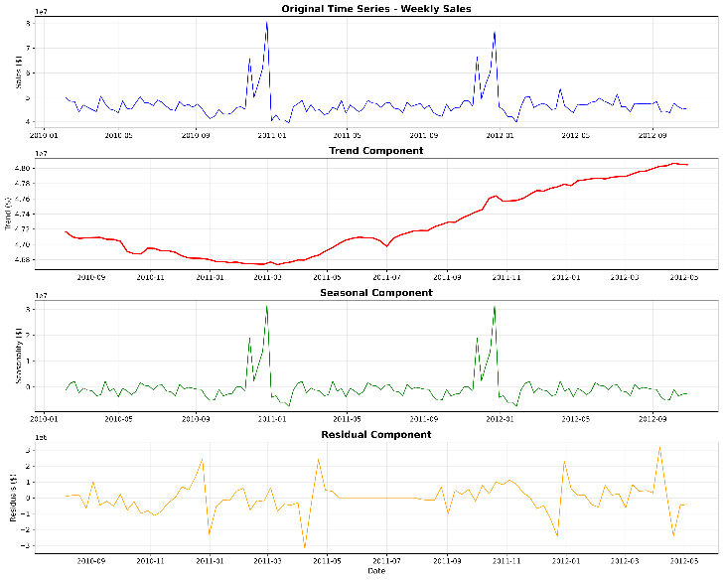 | Trend, seasonal, and residual components
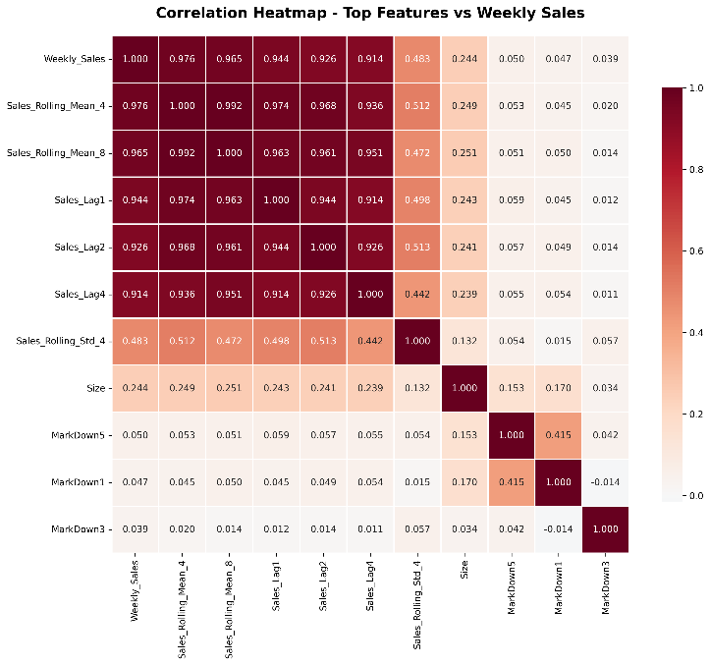 | Top 10 features correlation heatmap
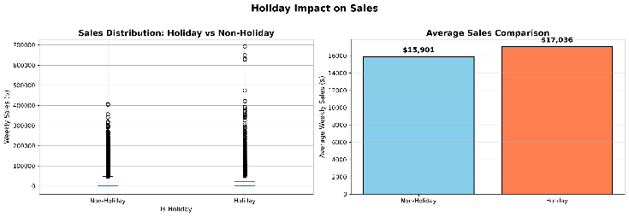 | Holiday vs non-holiday comparison

A.4 Statistical Tests Performed
- Stationarity: Simplified ADF test (variance ratio method)
- Correlation: Pearson correlation coefficients
- Significance: Two-sample t-test (holiday vs non-holiday)
- Multicollinearity: Pairwise correlations (VIF analysis pending)

