A single .doc file stored on my NTFS partition:

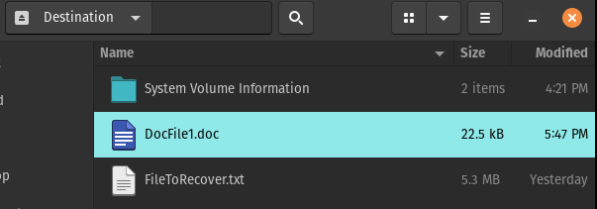

The hex viewer’s disk location screenshot of the .doc file’s header signature (the only consistent and unchangeable signature):

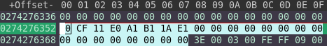

The results of the executable run with only one file on the partition disk:

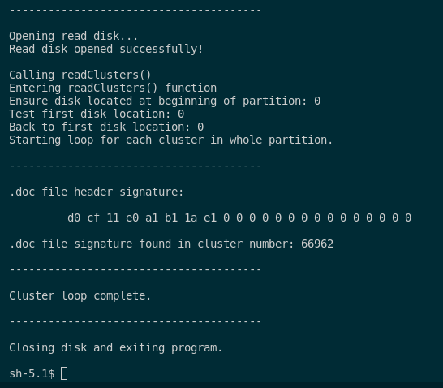

A single .doc file stored on my NTFS partition:

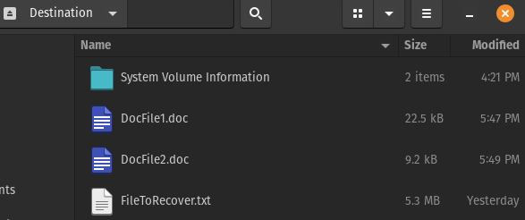

The hex viewer’s disk location screenshot of the .doc file’s header signature (the only consistent and unchangeable signature):

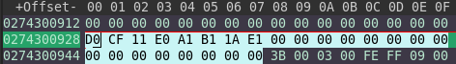

The results of the executable run with only one file on the partition disk:

