Karin dahan
204365126

Parameters :
First, my parameters:
AdamTrainer
Word embedding = 50
Char embedding = 50
Mlp on top of lstm
Hidden dim = 200
LAYERS = 1 hidden layen
word-level LSTMs: input: 50 output: 10
char-level LSTMs: input: 50 output: 25
num_epochs = 5
I used dynet and AdamTrainer
I used mlp with one tanh layer.
Output- softmax
Loss- neg log loss
Results :
- NER:
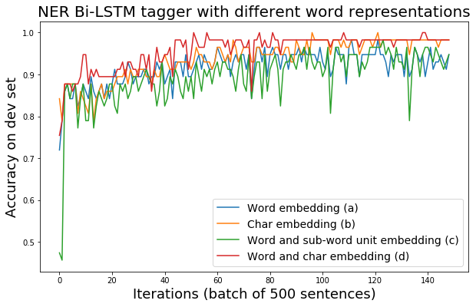
- POS:
