Prospective assessment of the role of Advanced Geothermal Systems (AGS) in Net-zero electricity: Integrated Techno-Economic, Environmental, and System Perspectives

Treyer, Karin¹; Hefny, Mahmoud^{2,3}, Alfermann, Dirk²; Panos, Evangelos¹, Saar, Martin², Ramachandran, Kannan¹
¹ PSI Centers for Nuclear Engineering and Sciences & Energy and Environmental Sciences, Laboratory for Energy Systems Analysis, Paul Scherrer Institute, Villigen PSI, Switzerland
² Geothermal Energy and Geofluids group, Institute of Geophysics, Department of Earth and Planetary Sciences, ETH Zurich (ETHZ), Switzerland
³ Geology Department, Qena University, Egypt
Corresponding Author: Treyer, Karin, karin.treyer@psi.ch

Abstract
Advanced Geothermal Systems (AGS) are a novel deep geothermal technology that extracts heat via closed-loop heat exchanger at depths >2 km, offering stable, flexible, dispatchable power beyond conventional geothermal sites. This study investigate the role of this innovative technology in future defossilised energy systems, using Switzerland as a case study – a country facing seasonal electricity imports, rising electrification, a planned nuclear phase-out, and a strong expansion of variable renewables.
We apply an integrated framework combining techno-economic analysis (TEA), prospective life cycle assessment (pLCA), and the Swiss TIMES Energy System Modelling (STEM) to assess the feasibility and system value of AGS in a 2050 net-zero electricity system. TEA shows that current capital costs (~120,000 CHF/kWe) could fall to ~24,000 CHF/kWe with advanced drilling such as Plasma-Pulse Geo-Drilling. STEM results indicate, however, that competitiveness requires dispatchable operation and capital costs below ~18,000 CHF/kWe for moderate deployment (5–10 TWh) and ~12,000 CHF/kWe for higher penetration (15–17 TWh, ≈15% of Swiss supply).
pLCA results reveal very low climate impacts (2–15 g CO₂-eq/kWh) and lower reliance on critical materials than solar PV, wind, or battery storage. In STEM net-zero scenarios, flexible AGS plants enhance system deployment, reduce imports, substitute PV and storage capacity, while also providing grid balancing and reserve services.
Overall, the comprehensive framework applied to this Swiss case study shows AGS as a promising firm renewable option, with environmental impacts comparable to or lower than other renewables. Yet, its future role hinges on major drilling cost reductions, technology maturation, and supportive policy and market frameworks. The combined methodology of this analysis can be applied to other regions to assess the sustainability and system value of emerging energy solutions.
Highlights
- Integrated TEA-LCA-STEM framework to evaluate Advanced Geothermal Systems (AGS).
- AGS electricity causes low impacts on climate change and the environment.
- AGS Capital cost (kCHF/kW) must drop from ~120 to <18 for large-scale deployment.
- Advanced drilling, CO₂ working fluid, and flexibility enable AGS viability.
- System value of AGS comes mainly from flexibility and grid services.

Graphical abstract
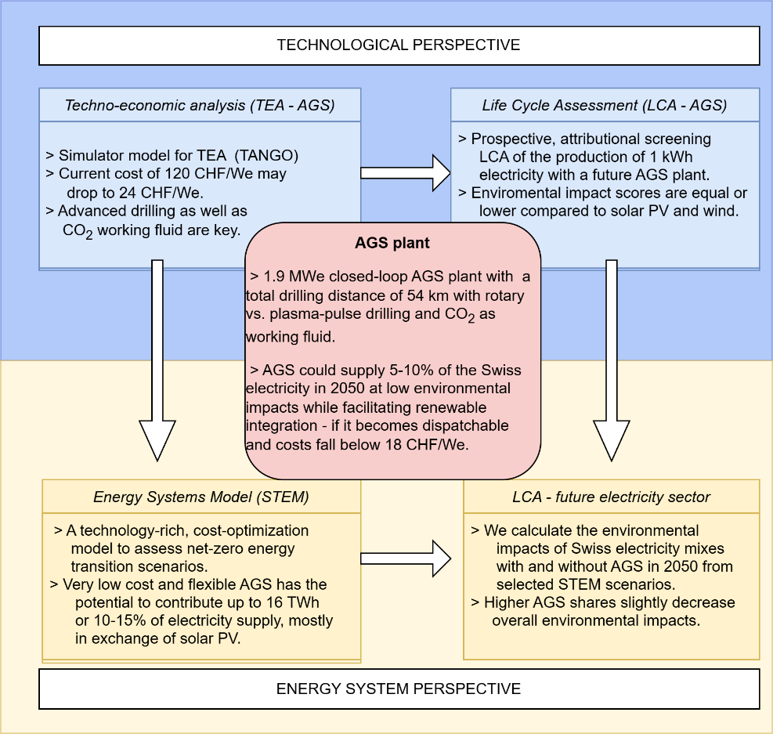

Keywords:
Advanced Geothermal System; Techno-economic-environmental assessment; TIMES Energy systems modelling

Abbreviations:
ADP | Abiotic Depletion Potential
AGS | Advanced Geothermal System
CAPEX | Capital expenditures
CC | Climate Change
EGS | Enhanced Geothermal System
GHG | Greenhouse Gas
LCA | Life Cycle Assessment
LCI | Life Cycle Inventory
LCIA | Life Cycle Impact Assessment
LCOE | Levelised Cost of Electricity
NCG | Non-condensable gases
ODP | Ozone Depletion Potential
OPEX | Operating expenses
ORC | Organic Rankine Cycle
PM | Particulate Matter
PPGD | Plasma-Pulse Geo-Drilling
PV | Photovoltaics
SpCC | Specific capital costs
STEM | Swiss TIMES Energy system Model
TANGO | Techno-economic analysis of geothermal power simulator
TEA | Techno-economic analysis
TIMES | The Integrated MARKAL-EFOM System model generator

Introduction
Global current and future energy demand is substantially fossil-based, leading to continued greenhouse gas (GHG) emissions and rising global temperatures [1]. Achieving national and regional net-zero targets will require large-scale electrification supplied by low-carbon technologies together with storage and flexibility generation (e.g.[2], [3], [4], [5]). As solar photovoltaics (PV) and wind power are expected to provide 18–41% of global electricity by 2050 [6], their variability increases the need for energy storage and dispatchable, low-carbon alternatives [7], [8], [9]. Biomass potential is limited, and conventional geothermal power is geographically limited due to underground permeability and heat flow. Enhanced Geothermal Systems (EGS) expand the geographical potential but face challenges related to drilling success, induced seismicity, and social acceptance [10], [11], [12]. Advanced Geothermal Systems (AGS) aim to overcome these limitations through closed-loop heat exchangers and conductive heat transfer, enabling deployment in a wider range of geological settings [13], [14]. AGS could offer decentralised, dispatchable, zero-direct-emission heat and electricity with reduced dependence on energy storage. However, high drilling costs for deep vertical and horizontal wells in crystalline formations remains the main barrier for deployment [15], [16], [17].
Techno-Economic Analysis (TEA) provides a structured framework to assess system performance and cost-effectiveness of low-Technology Readiness Level (TRL) technologies. TEA studies on AGS typically include thermo-hydraulic modelling of the subsurface heat extraction system; simulation of surface plant design, and cost models linking technical parameters to capital and operational expenditures, enabling estimation of Levelized Cost of Electricity (LCOE) and Specific Capital Cost (SpCC) [14]. Existing TEA studies on AGS have explored thermo-hydraulic behaviour [18], general plant design and costs [14], and specific AGS concepts such as the Eavor-Loop [19]. Environmental aspects beyond direct CO₂ emissions are equally critical for a sustainable energy transition. Life Cycle Assessment (LCA) quantifies environmental impacts across all life cycle stages and the whole the supply chain. Previous LCA studies of conventional (flash, dry steam, and binary plants) and EGS deep geothermal plants (reviewed in [20]) show wide climate impact ranges depending on reservoir characteristics and non-condensable gas emissions, underscoring the need to evaluate environmental impacts of AGS systematically.
Energy system models (ESMs) are widely used to analyse long-term decarbonisation pathways and to determine the cost-optimal mix of technologies under climate targets. Yet, geothermal technologies—especially emerging ones—are typically represented only in simplified or generic forms [21]. To date, no ESM study has integrated AGS with technology-specific performance, cost trajectories, and operational flexibility. Consequently, the potential system value and role of AGS in decarbonised energy systems remain unexplored.
The Swiss TIMES energy system model (STEM) is a cost-optimisation model built on the IEA-ETSAP's TIMES framework [22], [23]. It represents the full Swiss energy sector with detailed sector coupling, enabling interactions between technologies and capturing interdependencies across sectors and energy commodities – and it already includes a generic geothermal technology. Thus, Switzerland is used to serve as informative case study for AGS integration in an ESM and the energy sector because it has legally binding net-zero targets [24], rising electricity demand from electrification of heating and mobility, and to date a ban on new nuclear capacity. Additional hydropower is limited, so that future electricity supply is expected to rely heavily on solar photovoltaic (PV) or imports [24], [25], [26]. Growing uncertainties in cross-border electricity trade create a high value for flexible, dispatchable, low-carbon generation. At the same time, Switzerland’s crystalline and sedimentary formations are largely unsuitable for conventional deep geothermal but potentially exploitable by closed-loop AGS. These characteristics make Switzerland a relevant testbed for assessing AGS as a dispatchable, zero-direct emission technology and for deriving insights applicable to other regions with similar constraints.

To date, AGS has not yet been evaluated through an integrated framework that combines techno-economic performance, life-cycle environmental impacts, and system-level value. This study addresses this gap with a first comprehensive integrated assessment of AGS to quantify AGS’s potential role in Switzerland and provide insights transferable to similar regions.
The analysis is guided by three research questions
- Techno-economic performance: How might AGS develop, and how economically competitive could they become?
- Environmental sustainability: What are the direct and indirect life-cycle environmental impacts of AGS electricity?
- System-level integration: Under which conditions could AGS contribute to net-zero direct GHG emissions electricity systems, and what are the broader environmental trade-offs?
Section 2 describes the integrated assessment framework and the methods used for TEA, LCA, and energy system modeling. Section 3 presents the results for each part of the framework, supported by supplementary materials. Section 4 discusses the implications of AGS deployment in Switzerland, and Section 5 concludes. The Supplementary Information (SI) complements the information given in these sections.

Methods

Integrated, multi-model framework for AGS assessment
We assess AGS using a multi-model framework integrating three perspectives: techno-economic performance, environmental sustainability, and system-level deployment. This links component-level design to electricity system integration in the Swiss context (Figure 1). The framework combines: (i) Techno-Economic Analysis (TEA): Optimizes AGS plant configurations and estimates specific capital costs (SpCC); (ii) Prospective Life Cycle Assessment (LCA), technology and system level: Quantifies future environmental impacts along the complete life cycle across multiple indicators beyond climate change, and captures system-wide environmental trade-offs; (iii) Swiss TIMES Energy System Model (STEM): Identifies cost-optimal deployment under net-zero scenarios, capturing competition with other technologies and system constraints.
TEA provides consistent technical and cost inputs for LCA and STEM. Together, all three models link plant-level design with national-scale system impacts, combining bottom-up cost and impact modeling with top-down energy system optimization to capture both technology-specific and systemic implications of deploying AGS under stringent climate goals.
This approach addresses several key gaps in AGS research. First, detailed techno-economic characterization of AGS installations remains underdeveloped. Our “TEA-AGS” optimizes heat extraction efficiency, explores innovative wellbore configurations, uses CO₂ as working fluid, and evaluates drilling technologies, providing trajectories for system deployment and guidance for investment pathways of performance targets. The cost and AGS technical parameters trajectories are passed to STEM to determine AGS deployment under cost thresholds. Second, no (comprehensive) LCA of AGS electricity exists. Our prospective LCA quantifies multicriteria environmental impacts of AGS, which are integrated with STEM to assess system-level effects. Third, while energy system models can assess net-zero scenarios, AGS performance data and operational constraints have not been systematically integrated. Here, STEM is used to bring in a technology-rich, bottom-up energy system model that uses linear programming to identify least-cost solutions tailored for the Swiss context. We integrate AGS into STEM and conduct a systematic parametric assessment to benchmark its potential role in achieving a net-zero energy transition. To our knowledge, no comprehensive framework integrates TEA and LCA consistently into an energy systems model to evaluate AGS both at technology and system levels.

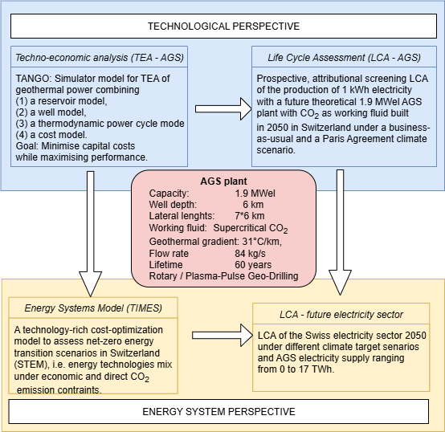
Figure 1: Modelling structure for the comprehensive technological and systems assessment for AGS plants. TEA and LCA are performed on a technology level first, and the results are then integrated into a system perspective with STEM and LCA.

Technology and cost model: Techno-economic analysis (TEA)
The TEA of AGS is implemented in our in-house TANGO (Techno-Economic analysis of geothermal power) simulator [27], featuring a modular architecture that captures complex interactions among AGS parameters. It integrates (1) a reservoir model for working fluid energy and pressure evolution; (2) wellbore fluid dynamics; (3) a thermodynamic power cycle model; and (4) a capital expenditure cost model [28]. The reservoir simulator captures heat transfer and fluid flow interactions within the geological reservoir. The surface plant simulator designs and evaluates power conversion, including net output, turbine and heat exchanger design, and auxiliary components. At the highest level, the AGS optimizer implements a hybrid optimization combining grid search and constrained nonlinear solvers [29].
AGS employs closed-loop configurations relying on conductive heat transfer, replacing the traditional reservoir module by a conduction-based model that simulates subsurface temperature distribution, thermal depletion, and heat extraction potential over extended operational periods [30]. High-resolution subsurface geology is integrated with surface infrastructure constraints, notably the spatial mapping of high-voltage electrical nodes from the NEXUS-E database [31], enabling identification of optimal AGS plant locations, grid connection points, and estimation of power capacity and construction costs for each geographical polygon.
Optimization tailored to AGS targets maximized performance (1.2 – 1.9 MWe per plant) while minimizing capital costs, exploring supercritical CO₂ (sCO₂) or water as working fluid. Deep and long drilling dominates costs, accounting for 75% of the total project costs and as much as 90% of the capital expenditures in AGS developments [14]. Novel drilling technologies such as Plasma-Pulse Geo-Drilling (PPGD), microwave, and pulsed-laser drilling (see SI for details) could reduce costs and time ([32], [33], [34], [35], [36], [37]). This study uses conventional rotary drilling as a baseline while assessing PPGD for deep geothermal applications.
The primary economic metric is the specific capital cost (SpCC, CHF/kWe), covering direct investments in drilling, casing, sensors, surface heat exchangers, and control systems. It excludes permitting, insurance, well failure contingencies, and water/CO₂ procurement. SpCC avoids assumptions required for Levelized Cost of Electricity (LCOE) (e.g. discount rates, capacity factors, plant lifetime) and allows assumption-independent comparison for low-TRL technologies [38]. LCOE are not appropriate for comparing dispatchable technologies like AGS with intermittent resources such as wind and solar, given their fundamentally different roles in grid operation and reliability [39]. The SpCC methodology builds on [14], adapted for closed-loop conductive heat transfer, lateral wells, and sCO₂. Optimisation results are shown in Table 1, with detailed technical and cost parameters/methodology in the SI.

Multi-scale Life Cycle Assessment: AGS technology and electricity systems impacts
This LCA follows ISO Standards 14040/14044 [40], [41] and the “LCA Guidelines for Geothermal Installations” [19] to ensure comparability with other LCA studies in the geothermal sector. This attributional, screening, prospective LCA addresses three objectives: (a) Quantify environmental impacts of future AGS electricity at technology level; (b) Compare AGS to other renewables; and (c) Assess AGS contributions to a sustainable Swiss electricity system in 2050. The functional unit (FU) for objectives (a) and (b) is “the production of 1 kWh net electricity in 2050 in Switzerland”, namely for (a) “[…] at the busbar of a AGS plant with a capacity of 1.9 MW electrical with variable well depth and rock type and with CO₂ as working fluid, built in 2050 and operating for 60 years. Heat co-production is not considered.”; and (b) “[…] produced by a specific renewable technology”. The FU for (c) is “the supply of 1 kWh of electricity in Switzerland in 2050 fulfilling the Swiss electricity demand under various climate target scenarios.”. Technical specifications of the AGS plant are taken from the TEA (Table 1, SI). System boundaries exclude exploration, but include construction (well, surface plant), simplified operation and maintenance (O&M) and end of life (EoL) (see SI). Upstream supply-chain processes are included, grid distribution is not.
Foreground life cycle inventory (LCI) is based on TEA AGS design parameters, expert inputs and literature. The base case assumes a 1.9 MWe plant built in 2050 in Switzerland, drilled with PPGD, using sCO₂, at 6 km well depth, and operating for 60 years. As AGS and PPGD are low-TRL technologies, data quality is intermediate. The LCA is performed with the Brightway (BW) LCA software [42] using background datasets from the ecoinvent database v3.10.1, system model cut-off and future instances of it created with the open source “premise” python package [43] by coupling the LCI to Socio-Economic Pathway 2 (SSP2) scenarios from the Integrated Assessment Model (IAM) “REMIND”. Two global scenarios are chosen: a business-as-usual pathway (“BAU-GLO”, ~3.5°C global mean temperature rise), and a 1.5°C scenario “LOW-GLO” (details see SI).
Building on the technology-level LCA, we assess how AGS deployment influences system-level environmental impacts. STEM results for Switzerland as described in section 2.4 (BAU-STEM and Net0-STEM without AGS; six chosen scenarios from Net0-AGS-STEM modellings) are combined with the two global background projections above using our in-house “premise” community framework . The six selected Net0-AGS-STEM scenarios are for dispatchable load, with AGS electricity provision of 2/4/6/10/14/17 TWh, resulting in 16 scenario combinations.
The impact assessment uses the “Environmental Footprint” method v3.1, no long-term effects”. Sensitivity analyses vary key parameters: Drilling electricity source climate impact: run-of-river, solar PV, natural gas (default: Swiss electricity mix according to STEM results); well depth: 4.5/8 km (default: 6 km); plant lifetime: 30/100 years (default: 60); drilling method: rotary/PPGD; capacity factor: 0.7/0.8 (default: 0.9).

Energy systems modelling
To assess system-level implications, AGS is integrated into the Swiss TIMES Energy System Model (STEM) [23], a technology-rich, partial-equilibrium framework aiming for a minimum cost Swiss energy system up to 2050 with high temporal resolution (4 seasons x 3 day types x 24 hours). STEM explicitly represents the storage, transport, and distribution required for secondary energy carriers and includes electricity grid representation across four voltage levels and a direct current (DC) load-flow model (15 nodes, 319 bi-directional lines), enabling detailed analysis of flexibility and grid constraints.
Figure 2: Geothermal module in STEM showing its links to other energy supply and distribution modules
We develop a detailed geothermal STEM submodule incorporating Switzerland’s geothermal resource potential, two drilling technologies (rotary, PPGD), and AGS plants using CO₂ or water as working fluid (see Figure 2). Technical operating constraints for the AGS plants are approximated via a continuous relaxation of unit commitment constraints, including ramping limits, minimum stable operating levels, part-load efficiency losses, minimum online/offline times, and start-up costs. Two “what-if” reference scenarios are used: BAU-STEM (Business-As-Usual) and Net0-STEM (aligned with Swiss and global climate ambitions). A detailed description of these scenarios and their underlying assumptions is provided in Panos et al. [26]. To explore AGS feasibility under uncertainty, we run over 300 parametric Net0-AGS-STEM scenarios, varying key AGS techno-economic and operational characteristics (e.g. capital cost, lifetime, technical availability, operational flexibility) and assessing AGS contributions to grid balancing services. Given AGS's potential potential as flexible but not intermittent renewable resource, two flexibility regimes are assessed: “High flexibility” (dispatchable, peaker-type behaviour); “Low flexibility” (baseload unit, limited ramping and start-stop capability). The complete set of parametric scenarios is provided in the SI, results are presented in section 3.3.

Results

Techno-Economic Analysis
The TEA results show that optimized AGS configurations achieve 1.2-1.9 MWe net electrical output, primarily driven by local geological conditions and mass flowrate. While the lateral well layout remains fixed (six 7 km laterals, 8-inch tubing), vertical depth varies between 4.4 km and 8.0 km to reach required production temperature for target power output (details see SI). Local geothermal gradients range from 25-45 °C/km, averaging 30 °C/km.
Using sCO₂ instead of water as working fluid increases heat extraction efficiency and exploits the thermosyphon effect, reducing or eliminating parasitic pumping required for fluid circulation - a key breakthrough in geothermal system design [45]. TANGO optimizes working fluid circulation mass flow rates to maximize power output, limit reservoir thermal depletion to sustain operation lifetime, and minimize SpCC (Figure 3 and Table 1).
Table 1: Summary of technical and cost results from the TEA base model optimization.
Parameters |  | Unit | Range | Base case
Net capacity, steady state | Electrical | MWe | 1.2 – 1.89 | 1.9
 | Thermal | MWth | 1.2 – 2.81 | 2.8
Lifetime production (60 years, and 0.9 capacity factor) | Electricity | GWh |  | ~898
 | Heat | GJ |  | ~4,767 665
Flow rate (Average) |  | kg/s | 52 – 87.4 | 84
Average SpCC | Rotary | CHF/We | 89.7 – 111.8 | 100
 | PPGD | CHF/We | 21.6 – 29.5 | 24

Table 1 shows the parameter ranges received from the optimization runs of the model, representing future, high TRL AGS plants. The base case for LCA and STEM input corresponds to the configuration with the highest net electrical capacity. Rotary drilling yields in average SpCC values around 100 CHF/We, whereas PPGD reduces this to ~24 CHF/We, demonstrating the dominant influence of drilling technology on AGS economics. The assumed well trajectory (providing an optimal cost balance while improving operational heat transfer) is compatible with current rotary drilling capabilities.

Figure 3 illustrates long-term performance: sCO₂ systems achieve higher and more stable net electrical capacity (declining from ~1.4 MWe to 1.2 MWe over 60 years) at production temperatures of ~100 °C, with thermal output around 4.2 MWth. Water-based systems, despite higher initial production temperatures (120-130 °C), decline faster, dropping from 1.45 MWe to 1.2 MWe in 10 years, and approaching 1 MWe after 60 years. Thermal capacity remains stable (~10.4 MWth). Note that the implications of the choice of the working fluid on operational cost were excluded from this research. The figure further illustrates that reservoir thermal depletion under optimal mass flow (i.e. maximized power output while controlling the rate of reservoir heat extraction) stabilizes after ~10 years (achieving a quasi-steady thermal regime), enabling extended operational lifetime of up to 60 years with routine wellbore maintenance and periodic surface infrastructure refurbishments (~25 years technical and economic lifetime). Extending plant lifetime significantly improves energy output per unit of capital investment, enhancing long-term economic competitiveness [46].
Figure 3: Long-term performance of a CO₂-based AGS system operating at an optimized mass flow rate (left) vs the water-based system (right). The plot shows the decline in electrical power output (black), thermal energy extraction (green), and production fluid temperature (blue) over 60 years of operation, highlighting thermal depletion effects in the reservoir and their impact on system efficiency.
Figure 4 shows that increasing lateral well length raises net electric output, though gains diminish over time as the reservoir cools.

Figure 4: Net electric power output as a function of total lateral wellbore length for three-time snapshots: year 1, year 30, and year 59 of system operation.

LCA – data and impact results

Life Cycle Inventory (LCI)
The LCI covers the 1.9 MW AGS base case with well construction, surface plant, O&M, EoL. Detailed inventories for all components and for the 4.5 km, 6 km, and 8 km well-depths designs are provided in the SI. Table 2 summarises well distances, material/energy consumption and infrastructure needs for each design.
Table 2: Summary of total well distance and volume as well as of main consumption of materials, energy and infrastructure within the life cycle of an AGS plant, shown for the three different well designs as presented in the supplementary information.
Plant characterization |  | Unit | Well depth
 |  |  | 4.5 km | 6 km | 8 km
Total well distance | 2 vertical wells, horizontal loops | km | 51 = 2*4.5 km + 42 km | 54 = 2* 6 km + 42 km | 58 =2*8 km +42 km
Well construction | Energy use, vertical | kWh/m | 178 | 135 | 274
Well construction | Energy use, horizontal | kWh/m | 200 | 200 | 200
Well construction | Casing, vertical, steel | kg/m | 73 | 67 | 75
Well construction | Casing, vertical, cement slurry | m³ | 593 | 514 | 1621
Well construction | Casing, vertical, cement slurry, cement | kg/m | 69 | 71 | 145
Well construction | Casing, vertical, cement slurry, water | kg/m | 28 | 28 | 58
Well construction | Extracted material (well volume) | m³ | 3648 | 3837 | 7369
Well construction | Drilling equipment | unit | 1 | 1 | 1
CO₂ | Tubing and open hole inside volume | m³ | 1013 | 1051 | 1740
 | Supercritical CO₂ | t/well | 524 | 544 | 901
Surface plant |  | Unit | 1 |  | 1
Maintenance |  | Unit | 1 |  | 1
EoL | Well sealing, cement bridges | kg/m | 1 | 1 | 2

Well construction dominates material and energy demand, driven mainly by steel casing and cement slurry. Cuttings disposal is modelled using a generic proxy dataset due to lack of information both on the rock type and on the disposal method of future potential AGS plants construction. Data gaps for PPGD (e.g. replacement rate of equipment, handling downhole materials, material requirements) were filled through expert judgment. Rotary drilling energy and material consumption were also simplified to follow the same logic by the same experts to ensure consistency.
Drilling energy demand depends mainly on well diameter, depth and geology (estimations shown in SI). PPGD is assumed 10x faster (20-50 m/h depending on the section depth) than rotary drilling, reducing active drilling time from ~1100 days (rotary drilling) to ~170 days (PPGD). Simplified electricity consumption calculations equal ~191 kWh/m (0.01 kWh/net plant kWh) (PPGD) and ~1846 kWh/m (0.11 kWh/net plant kWh) (rotary drilling) (see SI). Drilling electricity demand uses the average Swiss electricity mix 2050 projected by STEM (section 3.3) with 2% diesel backup at 40% efficiency.
The AGS wellbores are filled with supercritical CO₂ (600 kg/m³ at ~90 bar), assuming 15 vol% CO₂ loss over the plant’s lifetime. The CO₂ supply chain from capture at a municipal waste incineration plant over conditioning, temporary storage, transport to injection originate from a detailed recent study [47]. The carbon capture unit and operation is fully allocated to the CO₂ product (and thus in this case to the AGS plant). The surface plant (turbines, pumps, pipes, land use) is represented by an ecoinvent proxy for a heat and power co-generation unit of 1 MWel / 6.4 MWt. It occupies ~500 m² with a 25 year lifetime, replaced once or twice in plant lifetime sensitivity analysis.

Life Cycle Impact Assessment (LCIA)
Full LCIA results across all impact categories are reported in the SI. Here, we emphasise climate change impacts because of climate emergency and policy targets. Figure 5 and Figure 6 show contribution analysis results for the 2050 6 km base case (PPGD, sCO₂, 60 years lifetime) using BAU-GLO or LOW-GLO global supply chains.
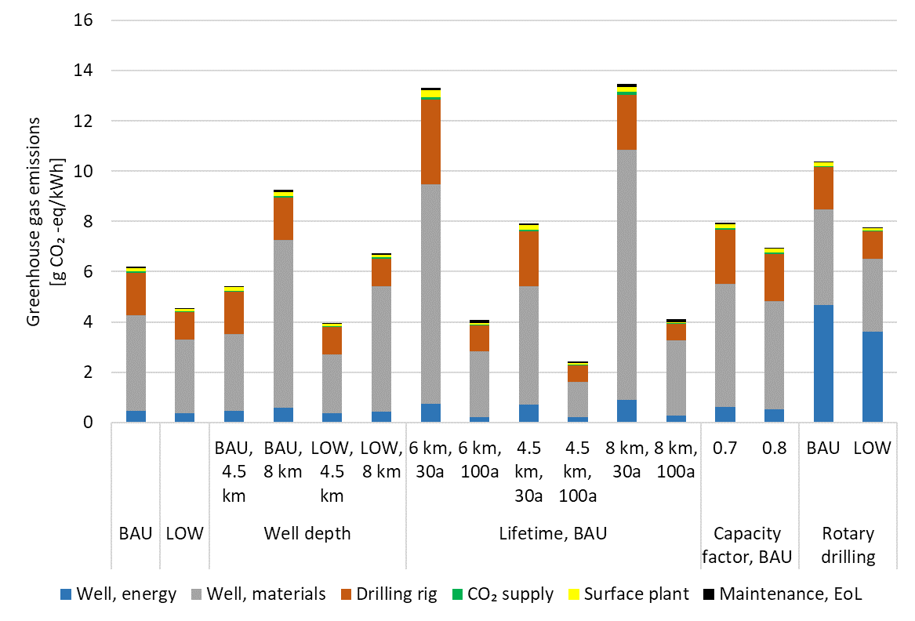
Figure 5: Contribution analysis of impacts on climate change from the production of 1 kWh net electricity with a variety of chosen AGS plant designs in the year 2050 in Switzerland. BAU and LOW supply chains relate to global climate scenarios. The electricity mix used for drilling is valid for a Net0STEM scenario with no AGS electricity supply. EoL = End-of-life
Across assessed cases, the projections for future AGS plants climate impacts range from 2-14 g CO₂-eq/kWh. Well construction dominates due steel and cement consumption, while impacts from drilling electricity remain low under a clean Swiss grid. Steel and cement supply chains also drive most non-climate change impacts (Figure 6), while ecotoxicity scores remain highly uncertain due to the proxy dataset used for drilling-cuttings treatment.
Key sensitivities:
- Drilling technology: PPGD yields ~4-6 g CO₂-eq/kWh, substantially lower than rotary drilling (~8-10 g CO₂-eq/kWh) due to reduced electricity consumption.
- Well depth: Varying depth for a fixed net electrical output changes impacts by few grams CO₂-eq/kWh: BAU runs ~5-9 g CO₂-eq/kWh; LOW runs ~4-7 g CO₂-eq/kWh.
- Lifetime: Halving lifetime from 60 years to 30 doubles climate change impacts.
- Capacity factor: Not reaching a capacity factor of 0.9 only adds 1-2 g CO₂-eq/kWh.
- Drilling energy source (see Figure S3 in SI): Rotary drilling in combination with greenhouse gas intense electricity sources or even diesel generator is not a preferable choice for the drilling process, as it leads to GHG emissions around 50-80 g CO₂-eq/kWh. PPGD is not sensitive to energy sources as all scores remain on a very low absolute level (up to 13 g CO₂-eq/kWh).

The overall sensitivity range of assessed cases goes from ~2 g CO₂-eq/kWh (4.5 km, 100 years) up to ~14 g CO₂-eq/kWh (8 km, 30 years) or even up to ~80 g CO₂-eq/kWh for diesel-based rotary drilling. Drilling material intensity, electricity source, lifetime, and cuttings handling are the dominant levers. Supply-chain decarbonization represented by LOW-GLO plays a comparatively minor role for PPGD cases. Overall, these results reflect rather low sensitivity on an absolute scale, and the variations lie within the inherent uncertainties of LCA studies in general and low-TRL technologies specifically.

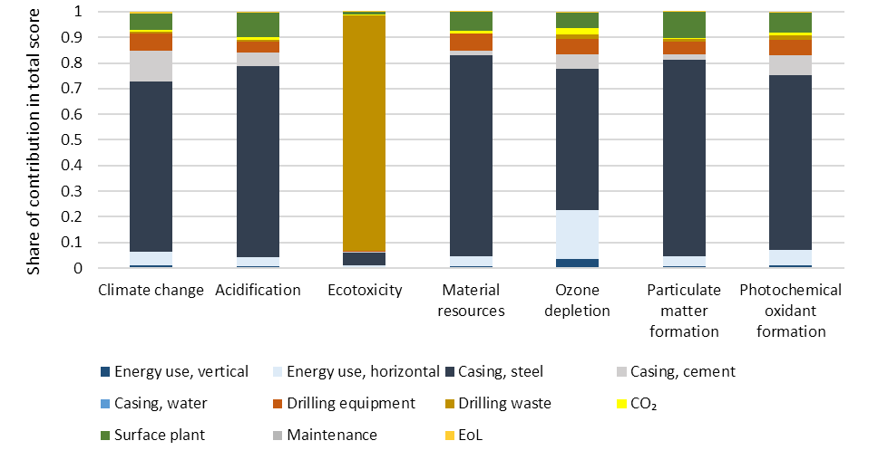
Figure 6: Contribution analysis for the 6 km BAU-GLO Net0Stem base case for chosen impact categories. EoL = End of life.
Because drilling material and energy intensity is high in absolute terms but amortised over decades of electricity production, their influence on climate results is small for PPGD scenarios. The timing of PPGD availability and supply of reliable low-carbon electricity at remote drilling sites is an important factor for real-world deployment. Switching the drilling electricity to low-carbon sources has a modest effect on the climate indicator, but will be more visible in other environmental impact categories such as material consumption.

Benchmarking and interpretation:
AGS fall at the low end of geothermal climate impacts reported in literature [20]: Climate change impacts of binary plants (hydrothermal plants, Enhanced Geothermal System (EGS) plants) are around 49 (6-97) g CO₂ -eq/kWh (hydrothermal) or 32 (8-52) g CO2-eq/kWh (EGS). Wide ranges are reported for flash and dry steam geothermal electricity (26 up to 795 g CO₂-eq/kWh) due to emissions of non-condensable gases (NCG) over the whole plant lifetime These are heavily site-specific and time-specific with regards to the geofluid composition and the abatement system in place.

AGS lies within same low-GHG bin as electricity from other renewables (~2-20 g CO₂-eq/kWh) (Figure 7). Relative to PV and wind, AGS shows advantages in several non-climate categories due to lower use of copper and critical minerals, while impacts in ecotoxicity remain uncertain. Note that the impact score of an individual technology depends on the local conditions (e.g. wind load hours, solar irradiation, geothermal gradient), and the exact design. Storage needs for intermittent solar and wind are not included in the environmental impacts in Figure 7.

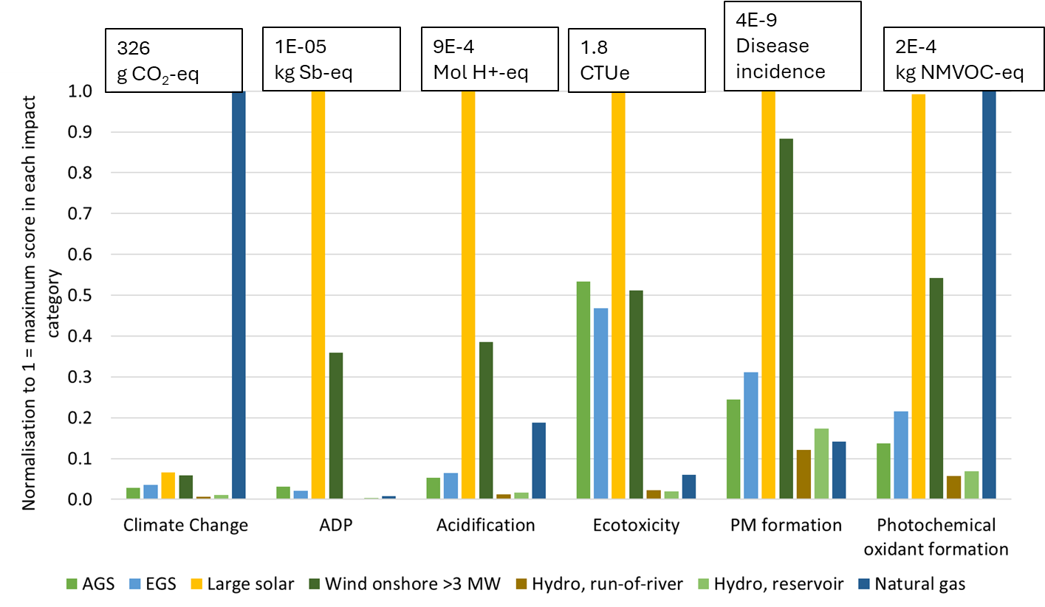
Figure 7: Comparison of selected electricity producing technologies in Switzerland in 2050 under the LOW scenario with regards to selected environmental impacts. Absolute scores per kWh net electricity are normalized to compare to the maximum score (shown together with the unit per kWh net electricity at the busbar in the top box) in each impact category.
Limitations and implications: The LCA results indicate that drilling material intensity, electricity source and plant lifetime are the principal levers to reduce environmental impacts. Targeted measures – novel drilling techniques, reduced casing requirements, lifetime extension and appropriate cuttings management provide the largest gains. Key data limitations remain: PPGD energy and material use are based on limited evidence and the well/tubing designs yet need to be tested in practice. These uncertainties should be addressed in future pilot demonstrations.

STEM
We analyze the STEM results focusing on AGS deployment in the electricity sector, its impact on the electricity mix, and its role in system flexibility and ancillary services (primary and secondary reserves), along with related system-level impacts. Figure 8 shows electricity supply in the BAU-STEM, Net0-STEM, and Net0-AGS-STEM) over time. In the Net0-STEM (no AGS), Swiss electricity generation grows from 60 TWh in 2020 to 82 TWh in 2050, with solar PV and wind replacing retired nuclear capacity, while hydropower remains stable. Conventional geothermal remains minimal (~0.3 TWh/a) due to high costs. Electricity demand is expected to grow in the future - electrification of personal mobility alone adds ~7 TWh. In low-cost Net0-AGS-STEM scenarios, deployment can reach 15 TWh (~15% of the total electricity supply), depending on operational flexibility.
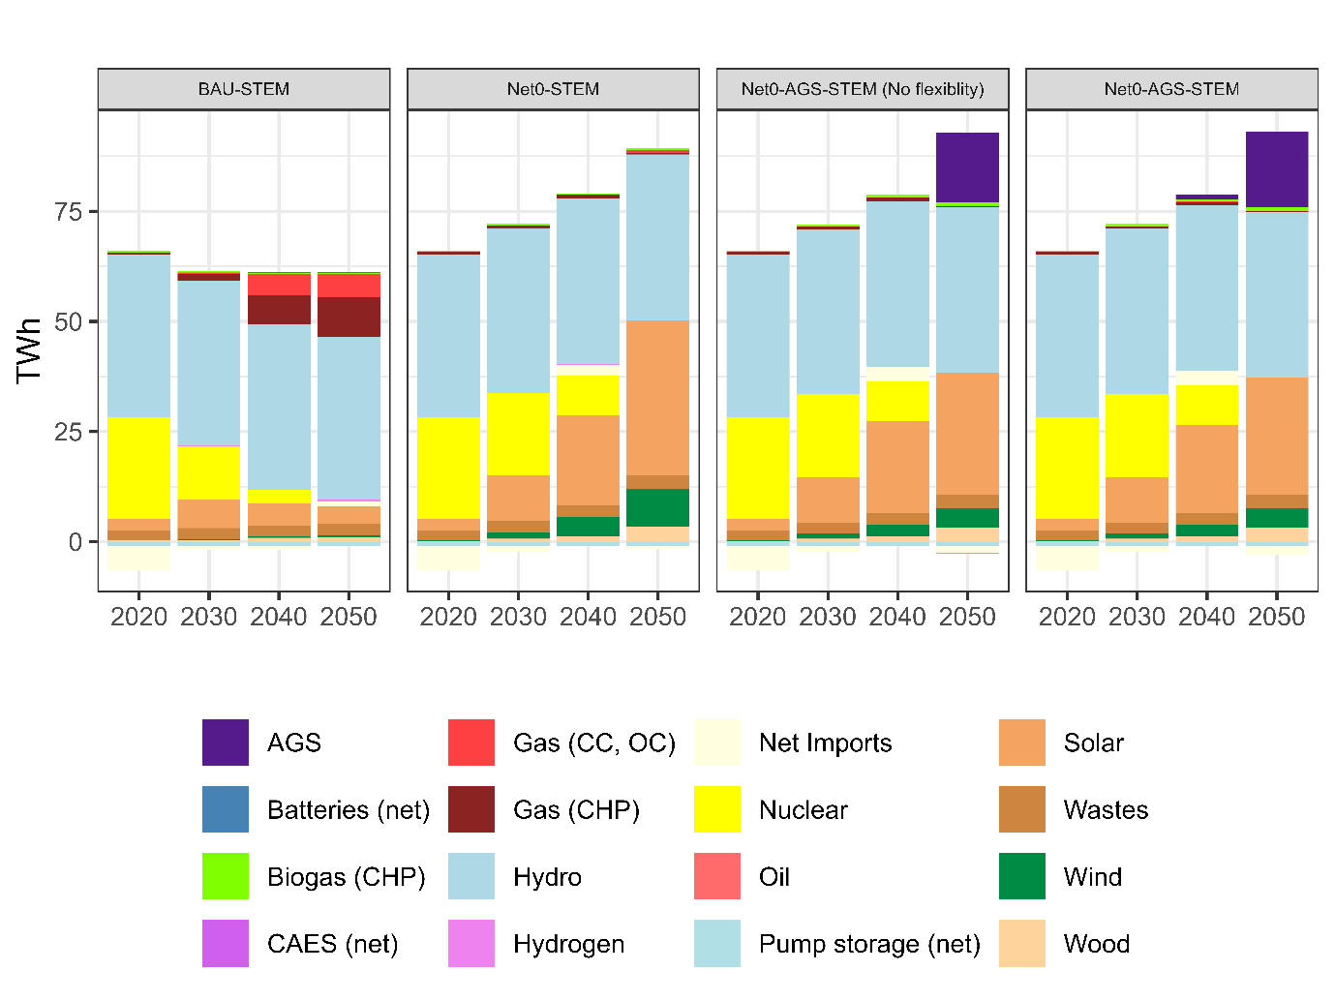
Figure 8: Electricity supply mix in reference scenarios and scenario with AGS.
Figure 9 compares AGS deployment across parametric scenarios. Capital cost, plant lifetime, and operational flexibility are decisive. High flexibility (dispatchable operation) increases deployment by 18-22% versus baseload-type operation (low flexibility). Flexibility becomes more significant in the high-cost scenario: although AGS may not be cost-effective at high capital costs (current TEA estimates ~120’000 CHF/W), it can still contribute to the integration of renewable electricity. Maximum contribution (~16 TWh, 10-15% of electricity supply by 2050) requires capital costs below 12,000 CHF/kW; 5–10 TWh is achievable at 14,000-18,000 CHF/kW, assuming an average plant lifetime of 30 years. Without flexibility comparable to open-cycle gas turbines (see BAU-STEM scenario), AGS deployment falls by about 20%.

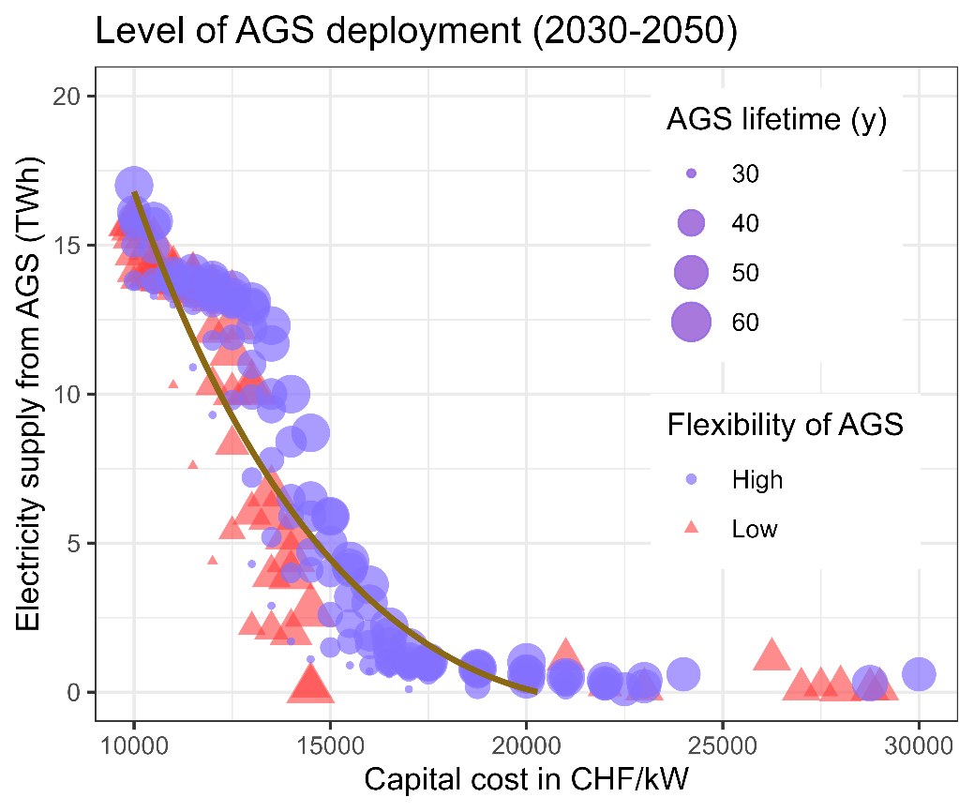
Figure 9: Trend in AGS deployment in Swiss Net-zero scenarios with respect to parametric capital cost and lifetime assumptions.

In an energy-only electricity market, AGS competes directly with solar PV and imports. Higher AGS adoption reduces the demand for both. In addition, its flexibility adds value through ancillary services, particularly secondary reserves, reducing battery storage needs. The scenario spread in Figure 8 also highlights the relative importance of different design levers at varying cost levels. Flexibility is increasingly decisive at high capital costs (above ~15,000 CHF/kW), while lifetime plays a secondary role, helping to sustain competitiveness but unable to offset the absence of dispatchability. At lower costs (<15,000 CHF/kW), lifetime and flexibility act in combination: only plants that are both long-lived and flexible reach the higher contribution levels, while those lacking either feature remain niche. Thus, when deep cost reductions are hard to achieve, improving operational flexibility and extending plant lifetimes become the most effective levers to enhance AGS competitiveness.
Figure 10 illustrates technology trade-offs across 300 Net0-AGS-STEM scenarios.. AGS penetration - driven by cost reductions, extended lifetimes, or enhanced flexibility—significantly affects end-use sector electrification, production of secondary energy carriers, and demand for other low-carbon electricity generation technologies. Primary electricity supply competitors to AGS are solar PV and wind. The competition with these intermittent renewables is influenced not only by AGS cost reductions but also by its inherent system flexibility—a crucial advantage. Unlike solar PV and wind, which require additional investments in reserve capacity to ensure reliability, AGS inherently provides capability for balancing services. As a result, even in high-cost AGS scenarios, the deployment of solar PV can indirectly lead to a certain degree of AGS adoption.

- (b)
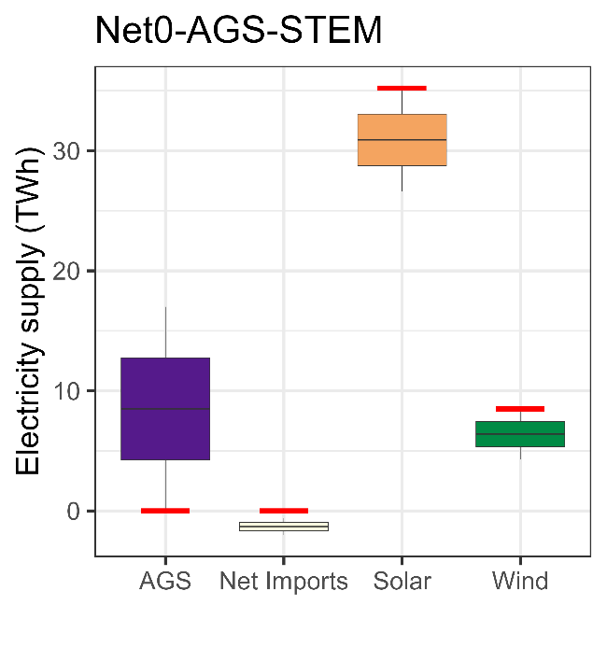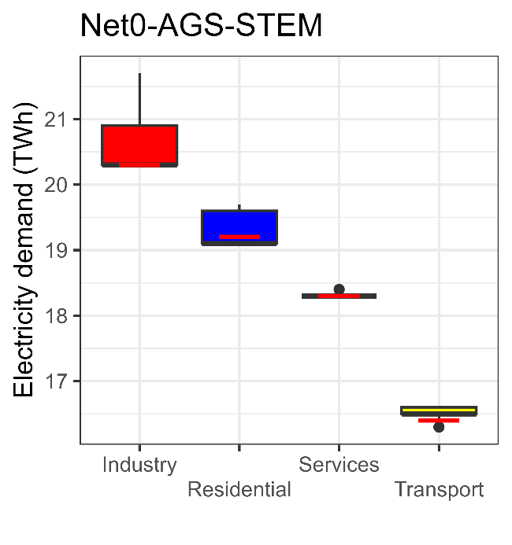
(c) d)
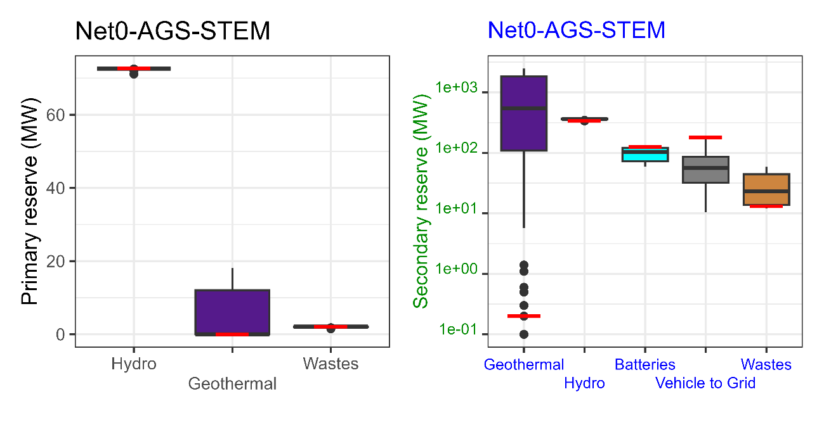

Figure 10: Trade-offs of AGS with flexibility, from a system perspective. The boxplots represent variation, while the horizontal red bar indicates the reference scenario (Net0-STEM). a) competing electricity supply technologies at the time of AGS entry, b) changes in end-use electrification due to AGS, c) and (d) distribution in the primary and secondary reserve balancing market alongside competing technologies .
Electricity demand impacts are moderate, as the sector is already highly electrified, leaving limited room for further transformation. The top right panel in Figure 10 shows the variations across scenarios in both end-use and conversion sectors—the latter referring to the use of electricity to produce other energy carriers, such as hydrogen. Cheap AGS increases end-use electricity by <1 TWh (<1%), while hydrogen production from electricity adds 2–3 TWh (not shown). Hence, AGS primarily influences the supply side rather than accelerating overall electrification.
AGS also provide grid balancing. Primary reserves demand (seconds response to stabilize grid frequency imbalances) are mainly defined by ETNSO-E and are mostly supplied by hydropower (~60-70 MW) and to a much lesser extend by AGS. The secondary reserves demand (minutes adjustment to restore frequency and relieve primary reserves) is endogenous in STEM, depending on the forecast errors of solar and wind electricity, the forecast error in demand and the probability of losing the largest grid element. AGS plays a larger role in the secondary reserve market, partly substituting battery and waste incineration supply. Variability in solar PV and wind drives demand. AGS plays a dual role: it offsets variable solar PV generation (and imports), thereby reducing the need for secondary reserves, and it directly supplies reserves.

Integrated assessment/ Systemic assessment (256 words)
While AGS costs remains prohibitively high (Figure 9), their environmental performance indicates potential benefits justifying further development of this technology (section 3.2.2). AGS can support decarbonization strategies by replacing electricity generation technologies with similar or higher life cycle greenhouse gas emissions, without adverse trade-offs in other environmental impacts (Figure 7). Figure 11 shows selected 2050 environmental impact results from the supply of 1 kWh electricity in 2050 in Switzerland according to the various net-zero STEM electricity mixes under BAU-GLO supply chain assumptions, for AGS penetration between 0 and 17 TWh.
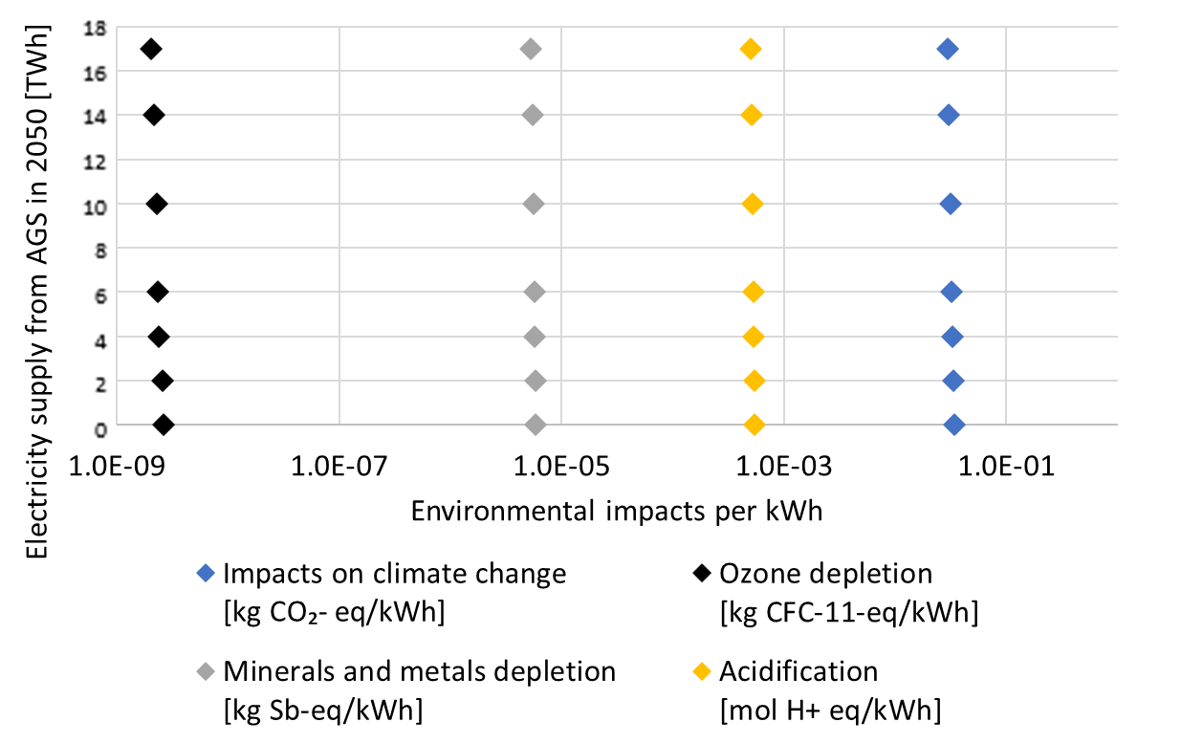
Figure 11: Selected environmental impacts calculated for the seven chosen net zero STEM scenarios from 0 to 17 TWh AGS supply, shown here for a BAU-GLO supply chain world.
With AGS integration, average climate change impacts show minor decline from ~34 g CO₂-eq/kWh (no AGS) to 30-33 g CO₂-eq/kWh (2-17 TWh). For an overall 2050 electricity demand of ~60 TWh, this represents a ~12% system-wide emissions reduction. These reductions in GHG emissions occur mostly outside Swiss borders (e.g., materials production) and therefore only partially contribute to national territorial direct net-zero CO₂ emission targets. Similar modest declines are observed across other impact categories:~10% lower minerals and metals depletion, ~23% lower ozone depletion, and ~7% lower acidification.
Not all of these reductions are caused directly by AGS. For instance, ozone depletion decrease is related to lower shares of natural gas electricity, which reflects net zero goals. Figure 12 illustrates this by showing the contribution of individual technologies to the selected total impact scores of 1 kWh electricity supply in 2050 in Switzerland. As AGS expands (0-17 TWh), STEM typically selects it as a substitute for solar PV. While AGS and PV offer comparable GHG savings, AGS reduces demand for materials, enabling reductions in resource-related and ozone depletion impacts. LOW-climate supply chains typically rely on more renewables, which drives minerals and metals depletion slightly up.

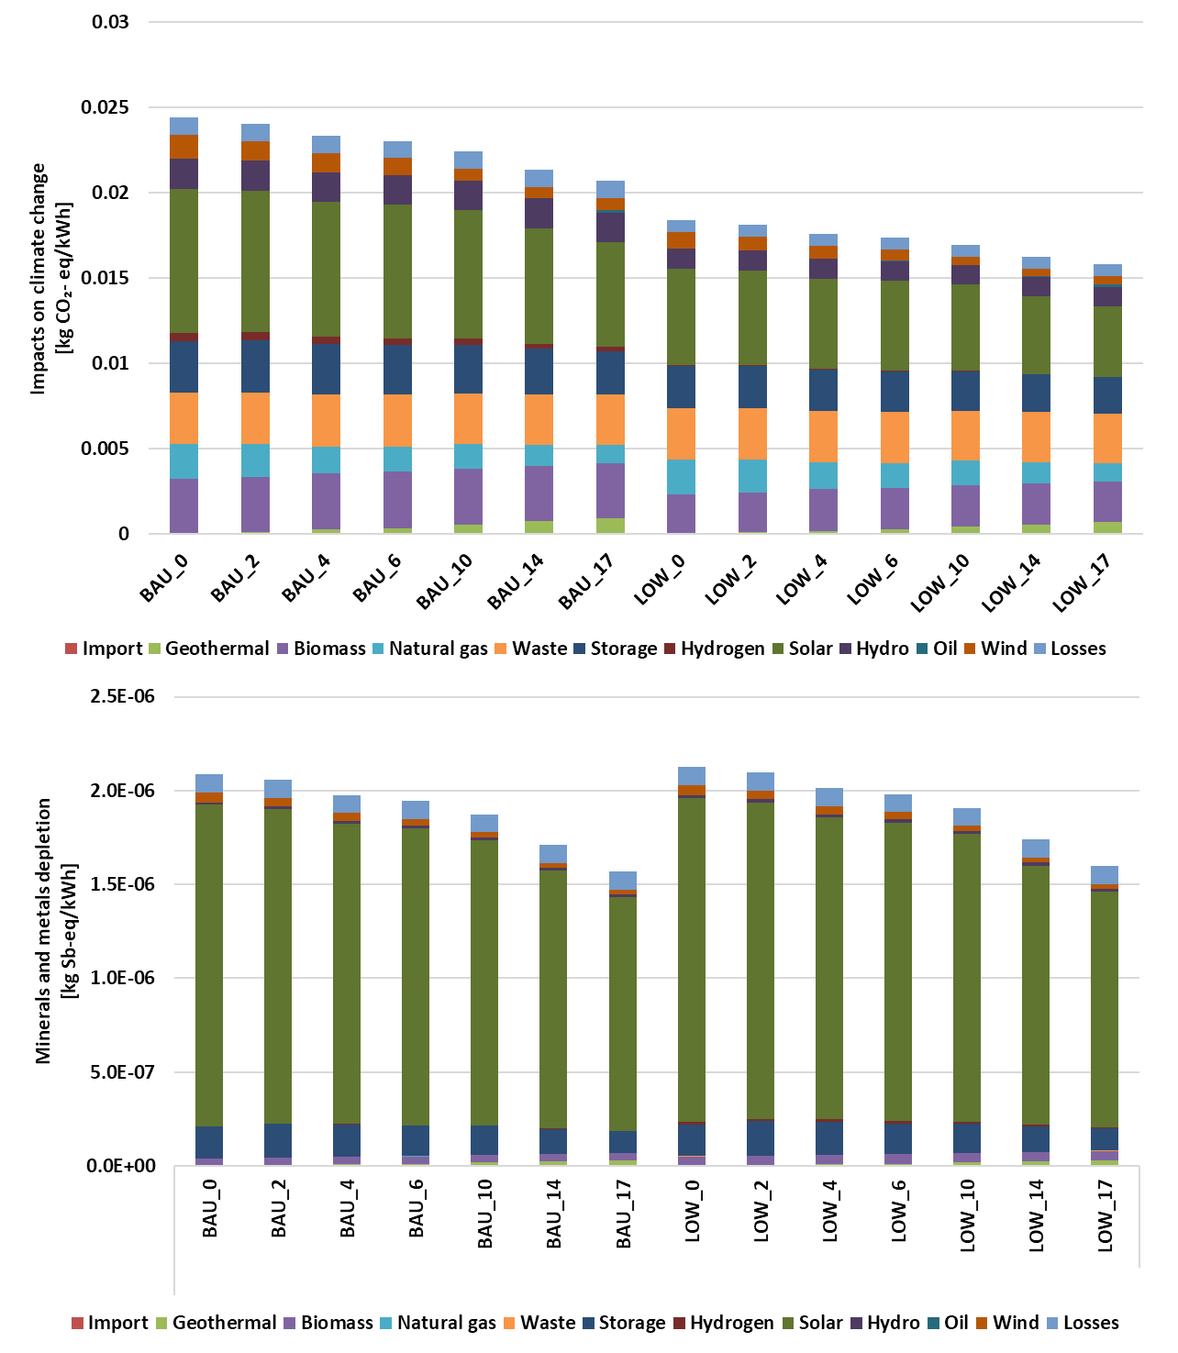
Figure 12: Contribution analysis of technologies supplying the Swiss electricity market in 2050 according to various scenarios with increasing share of AGS electricity, ranging from 0 TWh to 17 TWh and linked to BAU-GLO and LOW-GLO supply chains. The functional unit is the supply of 1 kWh electricity with the technology mixes as shown in Figure 8.

Discussion
This study addresses three questions: (1) How can AGS evolve technologically and economically; (2) What are life cycle environmental impacts of future AGS electricity; (3) Under which conditions can AGS support system-level net-zero targets and what are broader environmental implications. Our integrated TEA–LCA–STEM framework links plant-level performance to system-level deployment, providing comprehensive and novel insights that could not be derived from any of the three methods alone.
Technological and economic prospects: Optimised AGS configurations reach 1.2–1.9 MWe net electrical capacity, constrained by reservoir thermal limits and flow in deep, long horizontal laterals. Compared to EGS, AGS demands deeper, extreme-precision directional drilling and more complex subsurface control, increasing upfront costs and logistical complexity [14], [48]. Scaling by adding wells intensifies infrastructure needs and requires rapid, parallelized drilling and stringent project coordination.
First-of-a-kind SpCCs are high (90-112 CHF/W), 50–100% above wind or PV. Well construction dominates CAPEX (up to 90%). Contactless technologies such as PPGD could reduce costs to 22-30 CHF/W by minimizing mechanical wear and trip time. However, STEM results show that competitiveness in Switzerland would likely require costs near ~18 CHF/W for modest deployment (5–10 TWh), and <12 CHF/W for 16–17 TWh by 2050 (~10–15% of total supply) – targets that require transformative improvements in drilling productivity, reliability and automation.

Overall, AGS technological evolution is possible but hinges on technical breakthroughs. Technical bottlenecks include the practical ~6 km depth limit for precise steering, reliable operation of electronics above 250°C, and maintaining trajectory accuracy in crystalline rocks over multi-kilometer laterals. Recent advances include 300°C-rated measurement-while-drilling (MWD) systems, active mud cooling reducing tool failures by 40%, data-, robotics- and AI-driven drilling optimization [49], [50], [51], advanced measurement-/logging-while-drilling (MWD/LWD) technologies for precise geosteering and early detection of drilling hazards, and contactless drilling methods as mentioned in the SI. These improve efficiency, reduce human error, enable real-time analytics, standardize drilling process, optimize bit performance, and enable continuous operation.

Environmental performance and life cycle insights: Across 2050 Swiss scenarios, AGS electricity life-cycle climate impacts are low (2–14 g CO₂-eq/kWh), comparable to PV and wind and at the lower end of geothermal technologies. A strength of this study is using prospective 2050 supply-chain scenarios. Well construction (steel, cement) dominate most impact categories; lifetime and drilling methods strongly influence results. Nevertheless, AGS generally exhibits lower materials-related burdens than wind and PV due its comparatively modest use of copper and critical materials per kWh produced. At these impact levels, environmental performance is not a deployment barrier.
System integration and role in net-zero scenarios: STEM shows that high-flexibility AGS achieve 18–22% higher deployment than baseload configurations, primarily replacing imports and PV. Dispatchability provides secondary reserves and reduces battery storage demand. In the highest-deployment scenario, ~2.1 GW capacity (~1,000 plants) would be installed between 2040–2050, with plant requiring ~0.5 years of drilling when using PPGD (see section 3.2.1). Associated resource demands – CO₂, electricity, steel, cement - are not limiting, but drilling time and infrastructure availability are the main bottlenecks for fast deployment.
Coupling STEM outputs with prospective LCA reveals system-level climate impacts of ca. 30 g CO₂-eq/kWh, with slightly noticeable variations even at high AGS penetration. When cost-competitive, AGS improves environmental performance of the electricity system without burden-shifting. Land use implications were not assessed in this work. Future comparisons should apply harmonized methodologies as suggested in [52], with consistent definitions of land use types (e.g. sealed land, agricultural use, indirect land use changes) and fair comparison of technological developments of PV, wind and AGS by 2050. Overall, the integration shows that AGS offers co-benefits beyond emissions reduction, particularly in diversifying the supply mix and reducing system reliance on materials-intensive renewables and storage.
Policy, market and deployment levers: Drastic capital cost reductions are the primary prerequisite for significant AGS deployment. If cost declines lag, AGS can meaningfully contribute if designed as dispatchable, long-lived capacity. Flexibility is a central value driver and can be pursued via plant designs (fast ramping, reserve provision), or policy and market instruments (remunerating flexibility, drilling-risk insurance, long-term contracting). Extending plant lifetime via robust well integrity and modular refurbishments strengthen competitiveness. Efficiency improvements and drilling scale-up provide additional benefits, and AGS can also capture niche value in reserve markets and contribute to supply security and system balancing, offsetting dependence on storage and cross-border trade. For Switzerland – facing nuclear phase-out, limited hydropower expansion, high import dependence, and a PV-dominated net-zero pathway – AGS deployment depends not only on technological breakthroughs but also on aligning market design, policy support, coordinated supply-chain management, and infrastructure with AGS strengths: flexibility, reliability, and low environmental footprint.

Key limitations of this study include (i) low TRL of AGS and corresponding data uncertainty, (ii) limited quantitative evidence for achieving drastic drilling cost reductions, and (iii) exclusion of co-produced heat, which could significantly improve system economics and environmental performance. Additional research should quantify AGS flexibility benefits under high-renewables penetration, explore heat–power hybridization, and develop region-specific infrastructure expansion scenarios.

Conclusion
This study demonstrates the value of an integrated analytical framework combining techno-economic assessment, life cycle analysis, and energy system modelling to comprehensively evaluate AGS from plant-level performance to system-wide deployment potential. The approach provides a consistent basis for benchmarking AGS against other low-carbon technologies and for assessing its role in future electricity systems.
Our results show that flexible AGS could supply 10–15% of Swiss electricity demand by 2050, reducing reliance on imports and decreasing the need for additional PV deployment in low-irradiation regions if transformative techno-economic progress is made. By providing dispatchable capacity and reserve services, AGS helps stabilize a renewables-dominated system and reduces dependence on battery storage. Life cycle results show low environmental impacts across multiple categories, making it an environmentally competitive option within a long-term decarbonized energy mix.
Uncertainties remain due to the low TRL of AGS, the anticipated evolution of drilling technologies, and prospective assumptions in both background and foreground datasets. From a Swiss perspective, AGS could offer an alternative where public opposition to large-scale wind and PV installations is significant. It diversifies the national energy mix portfolio and strengthens long-term supply security.
The key challenge is reducing capital cost below competitiveness thresholds. This requires substantial decreases in drilling costs and times through technological innovation, high-temperature downhole tools, automation, and contactless drilling. Scaling drilling infrastructure will be crucial to enable rapid roll-out of the large number of small-capacity plants implied by high deployment scenarios. If deep cost reductions progress more slowly than expected, flexibility and long operational lifetimes become the strongest levers for competitiveness. In parallel, policy instruments such as drilling risk insurance, long-term contracts, and remuneration for reserve services can compensate for slower technological progress.
Realizing AGS potential therefore requires not only advancements in drilling technology but also supportive policy, regulatory, and market frameworks, including clear subsurface access rules, insurance mechanisms, and public communication strategies. Ensuring coordinated development of supply chains and drilling capacity will be essential to avoid deployment bottlenecks.
Overall, AGS can become a valuable contributor to a resilient and diversified low-carbon electricity system in Switzerland. Its long-term role will depend on aligning technological innovation with enabling policy frameworks, infrastructure readiness, and societal acceptance.

Data /code availability

Acknowledgements
This work was funded by an Innosuisse Flagship Initiative research grant for the project “Advanced geothermal systems to improve the resilience of the energy supply of Switzerland” (AEGIS-CH). We thank Romain Sacchi for his support in using the premise STEM integration and for the development of this useful python library.
Contributions
Karin Treyer: Conceptualisation, methodology, investigation, writing-original draft, writing- review&editing, visualisation
Kannan Ramachandran: Conceptualisation, methodology, investigation, writing-original draft, writing- review&editing
Mahmoud: Methodology, software, investigation, writing-original draft, writing- review&editing
Dirk Methodology, verification, investigation, resources, writing- review&editing, project administration
Evangelos Panos: Methodology, software, writing – original draft; Writing – review & editing
Martin Saar: methodology, supervision, project administration, funding acquisition

Ethics declaration
The authors declare no competing interests.
Declaration of generative AI and AI-assisted technologies in the manuscript preparation process
During the preparation of this work the author(s) used chat GPT in order to improve language and support shortening the manuscript. After using this service, the author(s) reviewed and edited the content as needed and take(s) full responsibility for the content of the published article.

References

[1] IEA, “World Energy Outlook 2025,” 2025.
[2] T. Brown, D. Schlachtberger, A. Kies, S. Schramm, and M. Greiner, “Synergies of sector coupling and transmission reinforcement in a cost-optimised, highly renewable European energy system,” Energy, vol. 160, pp. 720–739, Oct. 2018, doi: 10.1016/j.energy.2018.06.222.
[3] J. D. Jenkins, M. Luke, and S. Thernstrom, “Getting to Zero Carbon Emissions in the Electric Power Sector,” Joule, vol. 2, no. 12, pp. 2498–2510, Dec. 2018, doi: 10.1016/j.joule.2018.11.013.
[4] N. A. Sepulveda, J. D. Jenkins, A. Edington, D. S. Mallapragada, and R. K. Lester, “The design space for long-duration energy storage in decarbonized power systems,” Nat Energy, vol. 6, no. 5, pp. 506–516, Mar. 2021, doi: 10.1038/s41560-021-00796-8.
[5] IEA, “Net Zero Roadmap: A Global Pathway to Keep the 1.5 °C Goal in Reach,” Paris, 2023. [Online]. Available: https://www.iea.org/reports/net-zero-roadmap-a-global-pathway-to-keep-the-15-0c-goal-in-reach
[6] IEA, World Energy Outlook 2024 Extended Dataset. Paris: International Energy Agency (IEA), 2024. [Online]. Available: https://www.iea.org/data-and-statistics/data-product/world-energy-outlook-2024-extended-dataset
[7] J. D. Jenkins, M. Luke, and S. Thernstrom, “Getting to Zero Carbon Emissions in the Electric Power Sector,” Joule, vol. 2, no. 12, pp. 2498–2510, Dec. 2018, doi: 10.1016/j.joule.2018.11.013.
[8] N. A. Sepulveda, J. D. Jenkins, F. J. de Sisternes, and R. K. Lester, “The Role of Firm Low-Carbon Electricity Resources in Deep Decarbonization of Power Generation,” Joule, vol. 2, no. 11, pp. 2403–2420, Nov. 2018, doi: 10.1016/j.joule.2018.08.006.
[9] J. H. Williams et al., “Carbon‐Neutral Pathways for the United States,” AGU Advances, vol. 2, no. 1, Mar. 2021, doi: 10.1029/2020AV000284.
[10] N. Deichmann and D. Giardini, “Earthquakes Induced by the Stimulation of an Enhanced Geothermal System below Basel (Switzerland),” Seismological Research Letters, vol. 80, no. 5, pp. 784–798, Sep. 2009, doi: 10.1785/gssrl.80.5.784.
[11] T. Diehl, T. Kraft, E. Kissling, and S. Wiemer, “The induced earthquake sequence related to the St. Gallen deep geothermal project (Switzerland): Fault reactivation and fluid interactions imaged by microseismicity,” J Geophys Res Solid Earth, vol. 122, no. 9, pp. 7272–7290, Sep. 2017, doi: 10.1002/2017JB014473.
[12] S. Hirschberg and S. Wiemer, Energy from the Earth Energy from the Earth Deep Geothermal as a Resource. 2015. doi: 10.3218/3655-8.
[13] S. Liu, A. Dahi Taleghani, and K. Ji, “An advanced closed-loop geothermal system to substantially enhance heat production,” Energy Convers Manag, vol. 322, p. 119168, 2024, doi: https://doi.org/10.1016/j.enconman.2024.119168.
[14] A. E. Malek, B. M. Adams, E. Rossi, H. O. Schiegg, and M. O. Saar, “Techno-economic analysis of Advanced Geothermal Systems (AGS),” Renew Energy, vol. 186, pp. 927–943, Mar. 2022, doi: 10.1016/J.RENENE.2022.01.012.
[15] A. Darzi et al., “Biofuel processing in a closed-loop geothermal system,” Appl Energy, vol. 376, p. 124188, 2024, doi: https://doi.org/10.1016/j.apenergy.2024.124188.
[16] D. Xiao et al., “Techno-economic coupling model of U-shaped closed-loop geothermal system,” Geothermics, vol. 105, p. 102540, 2022, doi: https://doi.org/10.1016/j.geothermics.2022.102540.
[17] Q. Zhang, A. Dahi Taleghani, and D. Elsworth, “Underground energy storage using abandoned oil & gas wells assisted by geothermal,” J Energy Storage, vol. 110, p. 115317, 2025, doi: https://doi.org/10.1016/j.est.2025.115317.
[18] K. F. Beckers, N. Rangel-Jurado, H. Chandrasekar, A. J. Hawkins, P. M. Fulton, and J. W. Tester, “Techno-Economic Performance of Closed-Loop Geothermal Systems for Heat Production and Electricity Generation,” Geothermics, vol. 100, p. 102318, Mar. 2022, doi: 10.1016/j.geothermics.2021.102318.
[19] M. and T. M. and J. J. and S. N. Holmes, “Multilateral Closed-Loop Geothermal Systems as a Zero-Emission Load-Following Resource,” GRC Transactions, vol. 45, pp. 25–52, 2021.
[20] S. Gkousis, K. Welkenhuysen, and T. Compernolle, “Deep geothermal energy extraction, a review on environmental hotspots with focus on geo-technical site conditions,” Renewable and Sustainable Energy Reviews, vol. 162, no. April, p. 112430, 2022, doi: 10.1016/j.rser.2022.112430.
[21] J. M. Weinand et al., “The Role of Geothermal Plants in the Global Energy Transition: Raw Material Extraction and Flexibility as Game Changers,” Nexus, vol. 2, no. 4, pp. 0–26, 2025, doi: 10.1016/j.ynexs.2025.100099.
[22] R. Loulou, U. Remme, A. Kanudia, A. Lehtila, and G. Goldstein, “Documentation for the TIMES Model, Energy Technology Systems Analysis Programme,” 2005, [Online]. Available: http://www.etsap.org/Docs/TIMESDoc-Intro.pdf
[23] T. K. Ramachandran Kannan, Evangelos Panos, Stefan Hirschberg, “A net-zero Swiss energy system by 2050: Technological and policy options for the transition of the transportation sector,” Futures & Foresight Science, 2023, doi: https://doi.org/10.1002/ffo2.126.
[24] SFOE, “Energieperspektiven 2050+: Technischer Bericht Gesamtdokumentation der Arbeiten,” Bern, 2021. [Online]. Available: https://www.bfe.admin.ch/bfe/en/home/policy/energy-perspectives-2050-plus.html/
[25] I. Kolo et al., “A comprehensive review of deep borehole heat exchangers (DBHEs): subsurface modelling studies and applications,” Geothermal Energy, vol. 12, no. 1, p. 19, 2024, doi: 10.1186/s40517-024-00297-3.
[26] JASM, “Energy conversion technologies in STEM.” [Online]. Available: https://data.sccer-jasm.ch/energy-conversion-technologies-stem/2020-03-05/
[27] T. Onishi, M. Esmaeilpour, A. Leal, P. Huang, and M. Saar, “Techno-economic Analysis of Geothermal Operations Utilizing Carbon Dioxide,” Jan. 20, 2025. doi: 10.5194/egusphere-egu24-21517.
[28] B. M. Adams, J. D. Ogland-Hand, J. M. Bielicki, P. Schädle, and M. O. Saar, “Estimating the Geothermal Electricity Generation Potential of Sedimentary Basins using genGEO (the generalizable GEOthermal techno-economic simulator),” ChemRxiv, vol. preprint, 2021.
[29] T. F. Coleman and Y. Li, “An Interior Trust Region Approach for Nonlinear Minimization Subject to Bounds,” SIAM Journal on Optimization, vol. 6, no. 2, pp. 418–445, May 1996, doi: 10.1137/0806023.
[30] A. E. Malek, B. M. Adams, E. Rossi, H. O. Schiegg, and M. O. Saar, “Techno-economic analysis of Advanced Geothermal Systems (AGS),” Renew Energy, vol. 186, pp. 927–943, 2022, doi: https://doi.org/10.1016/j.renene.2022.01.012.
[31] B. Gjorgiev et al., “Nexus-e: A platform of interfaced high-resolution models for energy-economic assessments of future electricity systems,” Appl Energy, vol. 307, p. 118193, Feb. 2022, doi: 10.1016/j.apenergy.2021.118193.
[32] E. Anders, F. Lehmann, and M. Voigt, “Electric Impulse Technology: Long Run Drilling in Hard Rocks,” in Volume 10: Petroleum Technology, American Society of Mechanical Engineers, May 2015. doi: 10.1115/OMAE2015-41219.
[33] E. Anders, M. Voigt, F. Lehmann, and M. Mezzetti, “Electric Impulse Drilling: The Future of Drilling Technology Begins Now,” in Volume 8: Polar and Arctic Sciences and Technology; Petroleum Technology, American Society of Mechanical Engineers, Jun. 2017. doi: 10.1115/OMAE2017-61105.
[34] H. O. Schiegg, A. Rødland, G. Zhu, and D. A. Yuen, “Electro-pulse-boring (EPB): Novel super-deep drilling technology for low cost electricity,” Journal of Earth Science, vol. 26, no. 1, pp. 37–46, Feb. 2015, doi: 10.1007/s12583-015-0519-x.
[35] M. Ezzat, D. Vogler, M. O. Saar, and B. M. Adams, “Simulating Plasma Formation in Pores under Short Electric Pulses for Plasma Pulse Geo Drilling (PPGD),” Energies (Basel), vol. 14, no. 16, p. 4717, Aug. 2021, doi: 10.3390/en14164717.
[36] V. Ya. Ushakov, V. F. Vajov, and N. T. Zinoviev, Electro-discharge Technology for Drilling Wells and Concrete Destruction. Cham: Springer International Publishing, 2019. doi: 10.1007/978-3-030-04591-3.
[37] A. Luft, U. Franz, L. Emsermann, and J. Kaspar, “A study of thermal and mechanical effects on materials induced by pulsed laser drilling,” Appl Phys A Mater Sci Process, vol. 63, no. 2, pp. 93–101, Aug. 1996, doi: 10.1007/BF01567635.
[38] R. C. Lind et al., Discounting for Time and Risk in Energy Policy. RFF Press, 2013. doi: 10.4324/9781315064048.
[39] P. L. Joskow, “Comparing the Costs of Intermittent and Dispatchable Electricity Generating Technologies,” American Economic Review, vol. 101, no. 3, pp. 238–241, May 2011, doi: 10.1257/aer.101.3.238.
[40] ISO, “ISO 14044. Environmental management - life cycle assessment - requirements and guidelines,” 2006, International Organisation for Standardisation (ISO).
[41] ISO, “ISO 14040. Environmental management - life cycle assessment - prinicples and framework,” 2006, International Organisation for Standardisation (ISO).
[42] C. Mutel, “Brightway: An open source framework for Life Cycle Assessment,” The Journal of Open Source Software, vol. 2, no. 12, p. 236, 2017, doi: 10.21105/joss.00236.
[43] R. Sacchi et al., “PRospective EnvironMental Impact asSEment (premise): A streamlined approach to producing databases for prospective life cycle assessment using integrated assessment models,” Renewable and Sustainable Energy Reviews, vol. 160, no. April 2021, p. 112311, 2022, doi: 10.1016/j.rser.2022.112311.
[44] E. Panos, R. Kannan, S. Hirschberg, and T. Kober, “An assessment of energy system transformation pathways to achieve net-zero carbon dioxide emissions in Switzerland,” Commun Earth Environ, vol. 4, no. 1, p. 157, 2023, doi: 10.1038/s43247-023-00813-6.
[45] B. M. Adams, T. H. Kuehn, J. M. Bielicki, J. B. Randolph, and M. O. Saar, “A comparison of electric power output of CO₂ Plume Geothermal (CPG) and brine geothermal systems for varying reservoir conditions,” Appl Energy, vol. 140, pp. 365–377, Feb. 2015, doi: 10.1016/J.APENERGY.2014.11.043.
[46] M. Hefny and M. O. Saar, “Pathways to national-scale adoption of CO2-based Advanced Geothermal Systems (AGS) – A Techno-Economic Assessment Example in Switzerland ,” in Proceedings of the European Geothermal Congress, Zurich: European Geothermal Congress (EGC), Oct. 2025.
[47] J. Burger et al., “Environmental impacts of carbon capture, transport, and storage supply chains: Status and the way forward,” International Journal of Greenhouse Gas Control, vol. 132, Feb. 2024, doi: 10.1016/j.ijggc.2023.104039.
[48] C. A. Brown, M. Holmes, V. Zatonski, and M. Toews, “Enablement of High-Temperature Well Drilling for Multilateral Closed-Loop Geothermal Systems,” in Proceedings: 48th Workshop on Geothermal Reservoir Engineering, Stanford University, Stanford, California, 2023.
[49] A. Stefánsson et al., “A 300 Degree Celsius Directional Drilling System,” in IADC/SPE Drilling Conference and Exhibition, SPE, Mar. 2018. doi: 10.2118/189677-MS.
[50] B. L. Gingerich, P. G. Brusius, and I. M. Maclean, “Reliable Electronics for High-Temperature Downhole Applications,” in SPE Annual Technical Conference and Exhibition, SPE, Oct. 1999. doi: 10.2118/56438-MS.
[51] K. El-Sadi, B. Gierke, E. Howard, and Gradl. Christian, “Review Of Drilling Performance In A Horizontal EGS Development,” in PROCEEDINGS, 49th Workshop on Geothermal Reservoir Engineering, Stanford University, Stanford, California, Feb. 2024.
[52] O. Turkovska et al., “Methodological and reporting inconsistencies in land-use requirements misguide future renewable energy planning,” One Earth, vol. 7, no. 10, pp. 1741–1759, 2024, doi: 10.1016/j.oneear.2024.09.010.
[53] T. S. Lowry et al., “GeoVision analysis: reservoir maintenance and development task force report (geovision analysis supporting task force report: reservoir maintenance and development),” Sandia National Lab.(SNL-NM), Albuquerque, NM (United States), 2017.
[54] K. F. Beckers and K. McCabe, “GEOPHIRES v2. 0: updated geothermal techno-economic simulation tool,” Geothermal Energy, vol. 7, pp. 1–28, 2019.
[55] H. S. Carslaw, J. C. Jaeger, and H. Feshbach, “Conduction of Heat in Solids,” Phys Today, vol. 15, no. 11, pp. 74–76, Nov. 1962, doi: 10.1063/1.3057871.
[56] L. A. Silva, “Wellbore Positioning in Directional Drilling by Geopotential Field Anomalies,” 2024.
[57] J. Weston, A. Ledroz, and R. Ekseth, “New gyro while drilling technology delivers accurate azimuth and real-time quality control for all well trajectories,” SPE Drilling & Completion, vol. 29, no. 03, pp. 295–303, 2014.
[58] V. Ya. Ushakov, V. F. Vajov, and N. T. Zinoviev, Electro-discharge Technology for Drilling Wells and Concrete Destruction. Cham: Springer International Publishing, 2019. doi: 10.1007/978-3-030-04591-3.
[59] K. Oglesby, P. Woskov, H. Einstein, and B. Livesay, “Deep Geothermal Drilling Using Millimeter Wave Technology (Final Technical Research Report),” Golden, CO (United States), Dec. 2014. doi: 10.2172/1169951.
[60] A. Luft, U. Franz, L. Emsermann, and J. Kaspar, “A study of thermal and mechanical effects on materials induced by pulsed laser drilling,” Appl Phys A Mater Sci Process, vol. 63, no. 2, pp. 93–101, Aug. 1996, doi: 10.1007/BF01567635.
[61] S. Longfield et al., “Eavor LoopTM Commercial Project at Geretsried, Molasse Basin, Germany,” in Proceedings of the European Geothermal Congress, Berlin, Germany, 2022, pp. 17–21.
[62] K. F. Beckers and H. E. Johnston, “Techno-economic performance of Eavor-Loop 2.0,” in Proceedings 47th workshop on geothermal reservoir engineering, Stanford, California, 2022.
[63] M. Khodayar and S. Björnsson, “Conventional geothermal systems and unconventional geothermal developments: An overview,” Open Journal of Geology, vol. 14, no. 02, pp. 196–246, 2024.
[64] T. Bilić et al., “Overview of techno-economic issues of enhanced geothermal systems implementation and integration,” in Mediterranean Conference on Power Generation, Transmission, Distribution and Energy Conversion (MEDPOWER 2018), 2018, pp. 1–5. doi: 10.1049/cp.2018.1872.

Supplementary Information
Prospective assessment of the role of Advanced Geothermal Systems (AGS) in Net-zero electricity: Integrated Techno-Economic, Environmental, and System Perspectives

Treyer, Karin¹; Hefny, Mahmoud^{2,3}, Alfermann, Dirk²; Saar, Martin², Panos, Evangelos¹, Ramachandran, Kannan¹
¹ PSI Centers for Nuclear Engineering and Sciences & Energy and Environmental Sciences, Laboratory for Energy Systems Analysis, Paul Scherrer Institute, Villigen PSI, Switzerland
² Geothermal Energy and Geofluids group, Institute of Geophysics, Department of Earth and Planetary Sciences, ETH Zurich (ETHZ), Switzerland
³ Geology Department, Qena University, Egypt

Techno-Economic Assessment (TEA)

Technical and cost parameters of TANGO
The detailed technical parameters used in the TEA are comprehensively listed in Table S1. For the economic analysis, two distinct drilling cost scenarios were assessed: a baseline scenario employing conventional rotary drilling and an alternative scenario incorporating cost reductions through non-conventional contactless drilling methods. In the baseline rotary drilling scenario, drilling cost assumptions were based on industry-standard benchmarks and literature ([53], [54]), accounting for typical tool wear, maintenance, and rate of penetration (ROP) associated with deep geothermal wells both in sedimentary and crystalline rocks. The non-conventional drilling scenario was demonstrating significant drilling cost reductions under laboratory conditions due to its remarkably high rate of penetration and depth-independent performance, with further potential savings anticipated under optimized field operations. Current rate of penetration of approximately 3 m/hour are projected to increase to up to 50 m/hour, enabling drilling of large-diameter boreholes (up to 20″, ~50 cm) in crystalline rocks such as granite at estimated costs as low as 100 CHF/m [34]. Our TEA utilized Specific Capital Cost (SpCC) as the primary economic performance metric to compare the two drilling technologies clearly and systematically, calculated as per Equation 1.
$$SpCC= \frac{Total Capital Cost of AGS}{Net Electrical Power Output}$$ |  | (1)

Table S1: Base-case AGS model parameters as applied in TANGO.
Subsurface Parameters
- Geothermal gradient [°C/km] | 30 (min: 25, max. 45)
- Thermal conductivity [W/m·K] | 2.5 ()
- Rock heat capacity [J/kg·K] | 1000 ()
- Working fluids | CO2
Well Design and Drilling Parameters
- Production inner Well diameter [inches] | 8
- Lateral well length [km/loop] | 7.0
- Number of lateral legs / loops | 6 (Optimized variables)
- Drilling cost per meter [$/m] | 1500 (rotary), 100 (PPGD)
- Drilling technology | Mechanical Rotary, or PPGD
- Well success rate | 0.95
- Well pipe roughness [μm] | 55
- Drilling energy supply | Electricity, diesel generator as backup
Surface Plant Parameters
- Conversion technology | Surface direct expansion turbine
- Turbine isentropic efficiency | 0.78
- Pump efficiency | 0.9
- Capacity Factor | 0.9
- Cooling method | Wet
Economic Parameters
- Plant lifetime [years] | 60
- Discount rate [%] | 5

Working Fluid Parameters
- Type of working fluids | CO2
- Mass flow rate [kg/s]
- Inlet/Outlet temperatures [°C]
- Pumping power requirements [kW]

Well design
The proposed AGS well design employs a multi-lateral closed-loop configuration optimized for deep geothermal heat extraction. It also aims to minimize engineering and implementation risks associated with directional drilling and well construction at great depths using current technologies.
As illustrated in Figure S1, the proposed AGS well trajectory consists of two vertical wells, each deviating into horizontal lateral sections to form 3.5 km closed half-loops that interconnect at depth. The Kickoff Point (KOP) marks the depth at which the well begins to deviate from vertical. A low dog leg severity (DLS) build-up rate (e.g., 3° per 30 meters) is applied to gradually curve the well trajectory until it reaches a 90° horizontal orientation, typically after ~900 meters of directional drilling. This process is repeated at various depths to create several horizontal half-loops that are connected to form a total horizontal loop length of approximately 7 km. The surface section begins with a 20-inch conductor casing to stabilize near-surface formations, followed by progressively smaller casing diameters to withstand increasing subsurface pressures and temperatures. The 8-inch inner tube was used as a reference diameter for the production tube in the in the TEA analysis. This layout optimizes the heat exchange surface area while minimizing flow resistance. A minimum spacing of 76 meters between wells is maintained to avoid thermal breakthrough and ensure optimal heat exchange [55].
The number of horizontal loops is considered as a key optimization variable within the TEA, as it directly influences the economic viability of AGS-based power generation over a projected 60-year operational lifetime. Using the TANGO framework, the TEA optimization simultaneously evaluates the number of horizontal loops alongside the working fluid mass flow rate as coupled design variables. The objective is to maximize net electrical power output while minimizing the specific capital cost (SpCC), subject to defined geological and operational constraints. This multi-variable optimization approach ensures that both thermal performance and long-term economic feasibility are captured in the system design process.
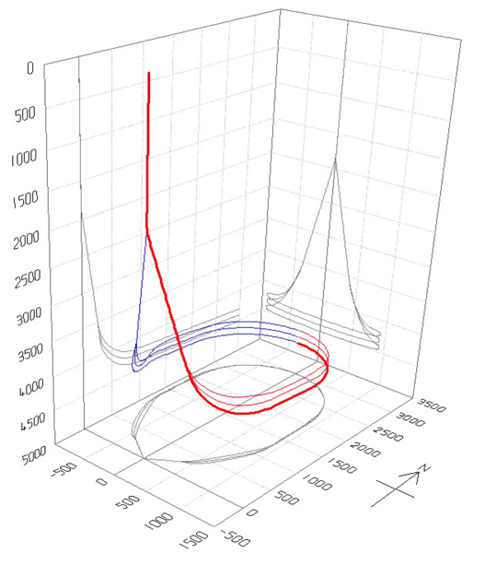
Figure S1: Schematic 3D visualization of the well design showing the vertical section, build section, and final transition to horizontal drilling. This AGS’s well design aims to optimize heat exchange area while maintaining mechanical integrity of the well trajectory.

Drilling advancements
Precision requirements for AGS wells include ±5 m vertical control over 3.5 km, <1° azimuthal error, and <3°/30 m dogleg severity. Gyro-while-drilling systems can now achieve 0.04° azimuth accuracy in 250°C environments, and fiber-optic gyroscopes enable ±3 m positional uncertainty at 6 km depth without magnetic interference [56], [57] However, granite’s anisotropic stress fields can induce bit walk rates up to 5°/100 m, necessitating frequent trajectory corrections. Although field data demonstrate 98% first-attempt success rates in connecting 4 km laterals at 230°C with 300°C-rated steerable systems, these technologies remain cost-prohibitive, with day rates exceeding $50,000. These findings underscore the urgent need for continued innovation to reduce costs and enhance the technical reliability of AGS at scale.

Scalability thus remains limited for AGS demanding for extensive well depths and lengths. Plasma-Pulse Geo-Drilling (PPGD) is a novel, non-contact drilling method that generates high-voltage electric pulses (>200 kV) to induce plasma within rock pores, causing localized fragmentation without mechanical abrasion [58]. This technique significantly reduces bit wear and eliminates the need for frequent tripping. Experimental and numerical studies under ambient conditions suggest that PPGD can lower drilling costs by 17–23% compared to conventional rotary drilling [32], [33], [34], [35] and decrease drilling time significantly. Microwave drilling is an emerging thermal drilling technique that uses high-frequency electromagnetic waves to heat and weaken rock formations ahead of the drill bit. The absorption of microwave energy induces thermal expansion and microfracturing, particularly effective in dry, hard, and low-conductivity rocks such as granite [59]. Pulsed-Laser drilling is another contactless rock penetration technique that uses high-power laser beams to thermally shatter and vaporize rock material. The approach works especially well in hard and brittle rocks, providing fine control over drilling geometry and potentially high rate of penetration [60].

Saliant features of AGS
For the thermo-hydraulic evaluation, Beckers et al. [18] conducted a comprehensive analysis using a Slender-Body Theory model, evaluating various scenarios including reservoir temperatures (100 to 500 °C), well depths (2 to 4 km), and fluid types (liquid water vs. supercritical CO₂). Their findings indicate average heat production rates ranging from 2 to 15 GWh/year for coaxial designs and 9 to 67 GWh/year for U-loop designs. The levelized cost of heat (LCOH) was estimated between $20 to $110 per MWh, under scenarios that combine moderate well depths (2-3 km), high geothermal gradients, and using supercritical CO₂ as the working fluid at optimized flow rates. Additionally, the levelized cost of electricity (LCOE) for deep setting (> 6km) ranged from $83 to $2200 per MWh, emphasizing the significant influence of drilling costs on economic viability. Their study indicated that competitive LCOH could be achieved; however, the LCOE remained challenging without substantial reductions in drilling costs.Despite these economic challenges, the development of closed-loop technologies, such as the Eavor-Loop, indicates promising advancements. Holmes et al. [19] modelled an Eavor-Loop™ 2.0 drilled in rock temperatures exceeding 200 ºC operating temperature over a period of 20 years. It was determined that the system could operate with a constant flowrate to produce a cumulative 1669 GWh at an average rate of 9.53 MW or alternatively operate at a variable flowrate to generate constant power for baseload supply, producing a cumulative 1640 GWh at an average rate of 9.36 MW. Under the constant flowrate scenario, power production of the Eavor-Loop™ declined approximately 6 MW during the first 4 years of operation but stabilized between year 4 and year 20, only declining between 1-2 MW in the latter years [19]. The sustained level of production in the model supports the notion that Eavor-Loop™ can provide long-term, reliable energy over at least 20 years with the potential for a longer operational life. Additionally, a demonstration facility in Alberta, Canada, built in 2019, has already proven the technical feasibility of this system, leading to the construction of a commercial 8.2-MWe implementation in Bavaria, Germany, which began in October 2022 ([61], [62], [63]). Companies like GreenFire Energy are also contributing to this innovative AGS technologies landscape by, part of the Wells2Watts consortium, aiming to establish a groundbreaking closed-loop geothermal laboratory in Oklahoma City [64].

LCA

Prospective LCA
The LCA was implemented in Brightway (BW) [42] using background datasets from the ecoinvent database v3.10.1, system model cut-off and future instances of it created with the open source “premise” python package [43] by coupling the LCI to Socio-Economic Pathway 2 (SSP2) scenarios from the Integrated Assessment Model (IAM) “REMIND”. Two global scenarios are chosen: a business-as-usual pathway (“BAU-GLO”, ~3.5°C global mean temperature rise), and a 1.5°C scenario (“SSP2-PkBudg1150”, representing the Paris Agreement objective, here called “LOW-GLO”), respectively. The results from these IAM scenarios can be explored on an interactive dashboard. IAMs numerically model future economic and technological evolution of economic sectors under given constraints. They guide scenario-based decisions by showing implications of choices and interplay of key parameters. For instance, IAMs include population growth, resource use, technology mixes or implementation of policies. Historically, most IAMs have focused on climate change effects (and thus on the energy sector), and several have been used by the Intergovernmental Panel for Climate Change (IPCC) to explore scenarios under various climate change reduction pathways. The interpretation of LCIA categories not related to greenhouse gas or other emissions stemming from the use of fossil fuels has to be made with care, as current IAMs typically don’t adjust yet future data e.g. for the Montreal Protocol regarding ozone depletion or for availability of critical raw materials.

Details on Life Cycle Inventory modelling

CO₂ working fluid supply chain:
The complete well tubing and horizontal well volume is filled with supercritical CO₂ as working fluid. The density at the injection point is assumed to be 600 kg/m3 at a pressure of ca. 90 bar, thus injection happens at high pressure and relatively lower temperature. In the reservoir, the CO₂ might heat up to an average temperature of 310 K and be present at a pressure of 80 bar, thus maintaining more or less the pressure due to the depth and the closed-loop configuration, which corresponds to an assumed average density in the well of 450 kg/m³. Note that supercritical CO₂, density varies largely with T and p, ranging between ca. 300 to 600 kg/m³. At the production points, when CO₂ reaches the surface, it expands and cools, especially as it passes through the turbine. From a temporal point of view, the majority of the CO₂ is required at the point in time when the plant is being built. Over the whole lifetime of the plant, a loss of 15% of the total required CO₂ volume is assumed to cause refill activities.
The technical modelling of the CO₂ supply chain is taken from Burger et al. [47], who model the full supply chain from carbon capture at a municipal waste incineration plant (MWI) over conditioning, temporary storage, transport, compression and injection. All processes related to the waste collection and incineration are fully allocated to the waste treatment plant. The origin of the CO₂ used in the modelled AGS as working fluid is assumed to be a carbon capture unit at the municipal waste incineration (MWI) plant in Niederurnen, Glarus, Switzerland. This MWI is evaluating the integration of a carbon capture unit in parallel to necessary MWI retrofit activities in the coming years, pursuing the goal to become climate neutral or even net negative in future. The MWI currently has a treatment capacity of 110 kt waste per year. Each ton of waste emits ca. 1 ton of CO₂. Roughly half of this is biogenic CO₂ from biogenic waste (e.g. wood, household biogenic waste), while ca. 55 kt are of fossil origin.
Carbon capture is modelled in [47] with an amine-based capture process with a rather conservative capture rate of 90%. The outflow of the capture unit already provides a high-concentration of CO₂ with ca. 98% mol% CO₂, which is even increased with conditioning. The heat and electricity required for the capture process are assumed to be supplied directly from the MWI, and are thus assumed to come without environmental impacts allocated to the CO₂ product. Conditioning (liquefaction) happens to 15 bar to prepare for a temporary storage during 5 days at 15 bar directly at the MWI, before the CO₂ is assumed to be picked up. As the locations of the potential AGS plants will be spread over Switzerland, it is not realistic that the CO₂ would be transported in pipelines. Trucks used for standardized cargo containers (20 t capacity) are most flexibly purchased or rented for transport of the captured CO₂ at Niederurnen to the respective AGS well drilling site. Possible distances from Niederurnen are for instance 60 km to Kreuzlingen, 117 km to Poschiavo, 144 km to Chiasso or Visp, and 244 km to Geneva. An average transport distance of 120 km (one way) is assumed, with a full container on the outward trip and empty on the return trip. It is assumed that 4 wt% of the CO₂ remain in the transport container.
At the well site the CO₂ is brought from liquid 15 bar to a supercritical state at 90 bar, ambient temperature and a density of 600 kg/m³ with an assumed electricity consumption of 0.1 kWh/kg for this step. Then, another 0.1 kWh/kg of electricity are assumed for the pumping of the supercritical CO₂ into the well. Both are rough assumptions, and the infrastructure for the compression and injection pumping is neglected.
The resulting calculated climate change impacts of 1 kg CO₂ used for the AGS system are shown in Figure S2. Both a business-as-usual global supply chain and a ~1.5°C related supply chain (see main part of manuscript) are shown.
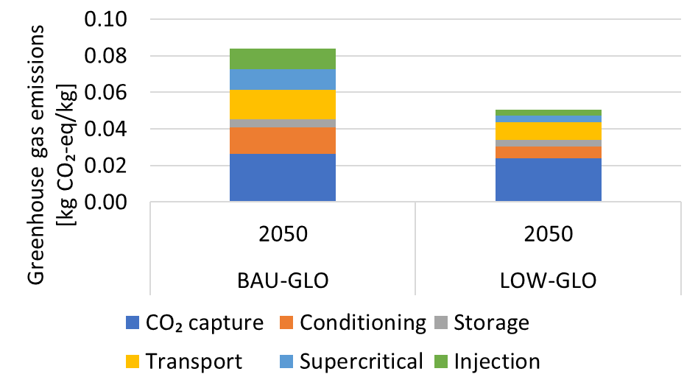
Figure S2: Impacts on climate change from the CO₂ supply chain, from capture at the MWI Linth to injection into the well at supercritical stage.
The results range between 50 g CO₂-eq/kg (LOW-GLO) to 84 g CO₂-eq/kg (BAU-GLO). The impacts from the capture process itself stem from the production of the necessary chemicals. The impacts from the other supply chain stages are dominated by electricity use or, for the transport, the driving of the truck.

Well design

Table S2: Overview on well designs for a total well depth of 4.5 km, 6 km, and 8 km, respectively.
 | Section | Hole Size (inches)  (4.5 km / 6 km / 8 km) |  |  | Casing Diameter (inches)  (4.5 km / 6 km / 8 km) |  |  |  | Section length (km)  (4.5 km / 6 km / 8 km)
Vertical wells: Production and injection | Surface Conductor | 24 | 24 | 36 | 20 | 20 |  | 30 | 0.25 | 0.25 | 0.25
Vertical wells: Production and injection | Surface Casing | 17 ½ | 17 ½ | 26 | 13⅜ | 13⅜ |  | 18⅝ | 1.75 | 1.75 | 1.75
Vertical wells: Production and injection | Intermediate Casing | 12 ¼ | 12 ¼ | 17 ½ | 9 ⅝ |  | 9 ⅝ | 13⅜ | 1 | 2 | 2
Vertical wells: Production and injection | Production Casing | 8 ½ | 8 ½ | 12 ¼ | 7 |  | 7 | 9⅝ | 1.5 | 2 | 4
Horizontal loops | Horizontal Section | 6 ½ | 6 ½ | 8 ½ | Open Hole or Liner |  |  |  | 7000 lateral lengths
Tubing diameter |  | 5 | 5 | 7 ⅝

The wall thickness of the casing is estimated to be 0.5 inch (surface conductor), 0.4 inch (surface casing), 0.38 inch (intermediate casing), and finally 2 inches (production casing), so that the final tubing diameter amounts to 5 inch (4.5 km and 6 km) or 7 5/8 inch (8 km), respectively.

Well drilling and completion
Material consumption for the well construction phase (well drilling and well completion) is modelled with the use of cement slurry for filling (water and cement class G, additives neglected) and steel for casing (various casing grades all modelled with the same steel dataset due to lack of data). The empty space between the drilled hole and the casing is filled with cement slurry on both sides of the casing, which is modelled as a mixture of water and cement class G (ratio 0.4:1). Additives are neglected due to lack of data. The disposal of the extracted well material was only modelled with a generic proxy dataset due to lack of information both on the rock type and on the disposal method to be used for future potential AGS plants.
Drilling equipment and material use: As literature data on PPGD are scarce, technical input information for the LCA modelling are derived from the little available information as presented in the TEA section in the main body of this manuscript. Main data gaps concern the removal and treatment of substances from the well including rinsing and the exchange rate of the PPGD equipment. No information were available on the use of drilling mud or rinsing materials for PPGD. The dataset neglects the removal and eventual treatment of substances from the well drilling, e.g. CO₂ from carbonate rocks, metal oxides, trace elements, solid residues; in case of wet scrubbers: slurry with dissolved minerals/suspended particles; radioactive materials; water use for cooling or dust suppression; dust collection/gas flow control. No assumptions on the exchange rate of the PPGD equipment in the borehole could be taken. A stationary drilling rig is assumed with a total weight of 500 tons (assumed to be 70% steel and 30% electronics) and a reuse for 50 AGS wells in total. The number of reuses of the drilling rig was roughly estimated in discussion the TEA experts. It is estimated that the drilling rig has a lifetime of 20 years with ca. two drillings per year, so that it can be used for a total of 50 wells. The material amount is thus distributed over these estimated 50 wells in the LCA, so that each well only uses 1/50 of the required material to build and maintain the rig.
The dimensions of the drill site have been estimated based on reports of existing geothermal drillings, namely the Eavor-LoopTM drilling in Geretsried (Germany) [37] and the unsuccessful geothermal drilling in St. Gallen. Especially the Eavor report is extensive, with a comparable drilling setting as for a potential AGS, so that this information were valuable inputs for the drilling rig dimensioning for this LCA. Still, it should be kept in mind that these are all theoretical estimates applied to the case of future AGS. The drilling place area is estimated to have an area of 5000 m², of which 50% are paved and the rest is drivable gravel. It is assumed that the base plate has a thickness of 0.5 m. The pavement composition is assumed to be 70vol% sand, 15vol% cement CEM I, 14vol% water, and 1vol% reinforcing steel, leading to a density of 2.5 t/m³.
Drilling energy consumption: The final energy consumption for the well drilling depends mainly on the time demand and energy consumption during the drilling phase from the drilling rig itself, mud circulation and pumping, or auxiliary systems. Well diameter, well depth and rock type are most influential for the energy consumption. Well completion (cementing and running the steel casing into the well) is less energy intensive, while logging is only responsible for a minimal energy demand. This study adopts a simplified calculation of energy consumption due to the lack of information on rotary vertical and horizontal, small-diameter well drilling in crystalline rock and on PPGD energy consumption. The actual drilling time is a function of the rate of penetration (ROP), which is the average speed at which the drill bit penetrates the formation. In this case, the ROP includes aspects such as time for tripping, reaming, mobilization and demobilization of the drilling rig. A summary of the drilling time estimates is given in the supplementary information in Table S3, with PPGD assumed to be a factor 10 faster than rotary drilling. From the ROP, the drilling time per section is derived. Total drilling time for the well designs as shown above amounts to ca. 1100 days for a 6 km well with rotary drilling, and ca. 170 days with PPGD, respectively. 90% of the time is used by the horizontal drilling.
Installed drilling rig capacity is estimated to be 4 MW for PPGD, and 5 MW for rotary drilling, respectively. The installed capacity for the completion is estimated to be a factor ten lower, i.e. 0.4 MW (PPGD) and 0.5 MW (rotary drilling). The load factor for both is assumed to be 0.8. In combination with the above drilling duration information, the energy consumption has been calculated as shown Error! Reference source not found..

Table S3: Estimation of the rate of penetration of rotary drilling vs. PPGD. PPGD is assumed to be 10 times faster. Assumptions provided by the authors of the TEA in this publication. Table shown for the 6 km default case. The 4.5 km and 8 km case differ from this default case by the vertical section lengths.
 | Measured depth [m] |  | Rate of penetration (ROP) [m/h] |  | Duration drilling [d] |  | Completion [d] | Logging [d]
 | Start | End | Rotary | PPGD | Rotary | PPGD | Rot&PPGD | Rot&PPGD
Section 1 | 0 | 1000 | 5 | 50 | 8 | 1 | 3 | 2
Section 2 | 1000 | 2500 | 4 | 40 | 16 | 2 | 3 | 2
Section 3 | 2500 | 4000 | 3 | 30 | 21 | 2 | 4 | 2
Section 4 | 4000 | 5000 | 3 | 30 | 14 | 1 | 5 | 3
section 5 | 5000 | 6000 | 2 | 20 | 21 | 2 | 6 | 3
section horizontal | n.a. | n.a. | 2 | 20
Total, one vertical well |  |  |  |  | 80 | 8 | 21 | 12
Total, horizontal section |  |  |  |  | 875 | 88
Total days, complete well |  |  |  |  | 1100 | 169

Table S4 shows the split into drilling, completion and logging for installed capacity, time demand and energy consumption each.
Table S4: Energy consumption calculation parameters for the 6 km default case.
 |  |  | Rotary drilling | PPGD
Installed capacity | Drilling rig | MW | 5 MW | 4 MW
 | Completion | MW | 0.5 MW | 0.4 MW
Load factor |  | - | 0.8 | 0.8
Time demand | Drilling | Days | 1034 | 103
 | Completion | Days | 42 | 42
 | Logging | Days | 24 | 24
Energy consumption | Drilling | kWh/m | 1838 | 184
 | Completion | kWh/m | 7 | 7
 | Total | kWh/m | 1846 | 191
Energy payback |  | kWh used/net kWh | 0.11 | 0.01

Figure S3 examines the sensitivity of the drilling energy source on climate change impact scores for PPGD and rotary drilling and the BAU or LOW global supply chain 2050 scenarios. The Swiss electricity mix from STEM is the baseline, and electricity from natural gas acts as a sensitivity parameter to reflect high greenhouse gas emissions from an electricity source (372 g CO₂-eq/kWh for BAU-GLO and 326 g CO₂-eq/kWh for LOW-GLO). Further the case of diesel generator driven drilling is assessed with a dataset for diesel burning in a 10 MW generator for oil and gas extraction, assuming 44% efficiency.
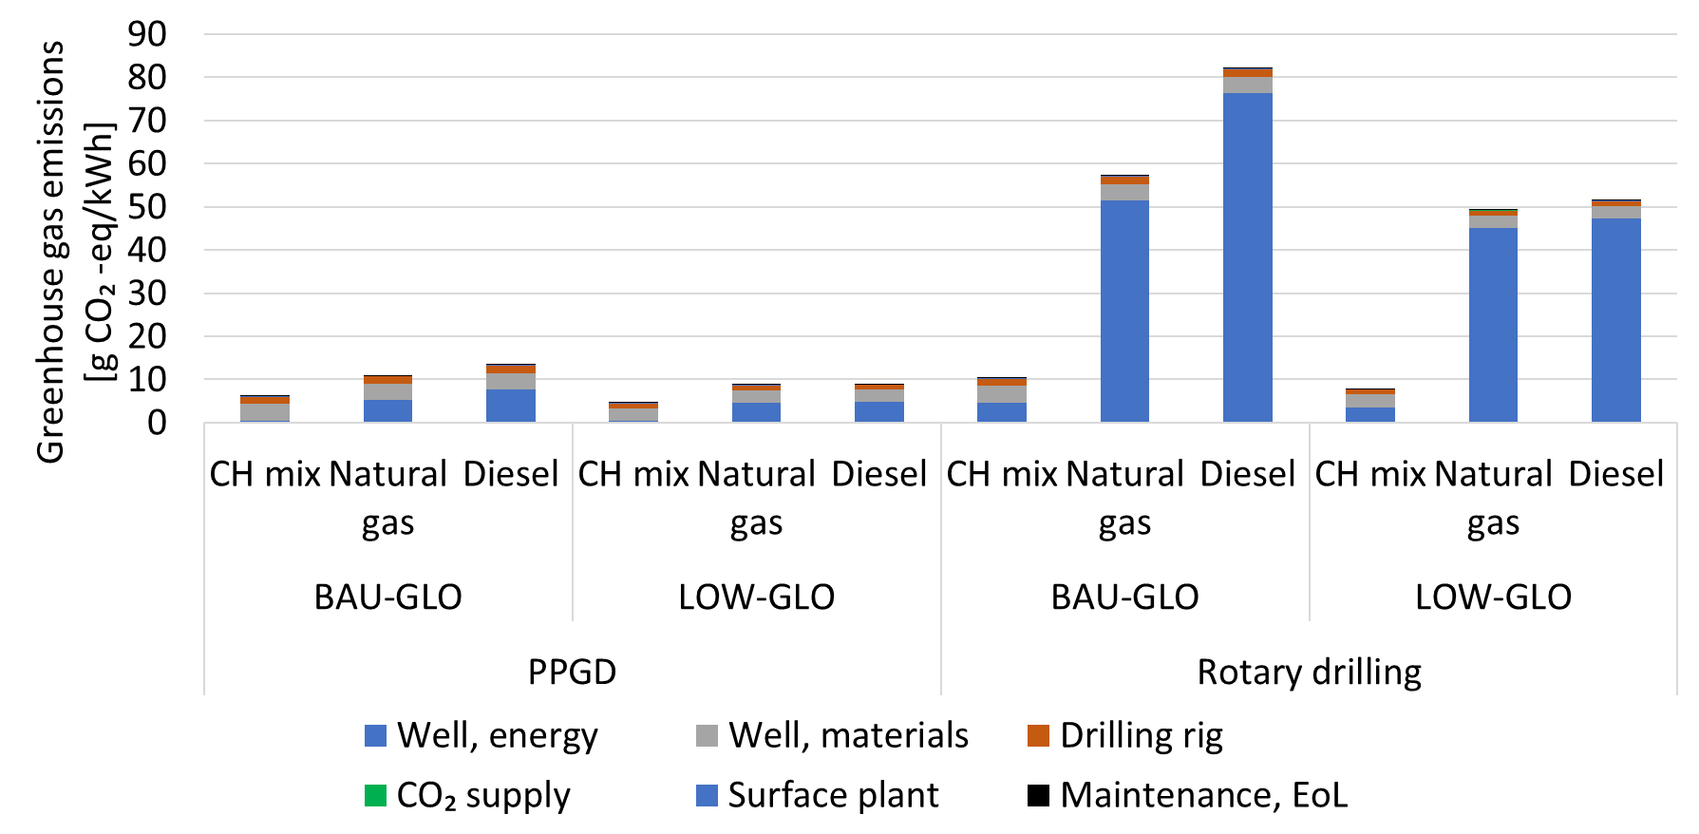
Figure S3: Sensitivity analysis of drilling energy source for drilling technology (PPGD/rotary drilling) and global supply chain scenarios 2050 (BAU/LOW).
The use of electricity from natural gas nearly doubles climate impacts for PPGD cases, but on a very low absolute scale (between 5 – 11 g CO₂-eq/kWh). This is different for rotary drilling, where the scores rise from 8 to 49 g CO₂-eq/kWh for a decarbonized supply chain and from 10 to 57 g CO₂-eq/kWh for business-as-usual. This also reflects the benefits from global decarbonization efforts. The same pattern can be observed for the diesel supply, where a 37% GHG emissions reduction is achieved through climate mitigating efforts. Still, rotary drilling with a diesel generator brings climate change impacts of AGS electricity up to 51 g CO₂-eq/kWh (LOW-GLO) and 82 g CO₂-eq/kWh (BAU-GLO), and thus widely out of the range of other renewables. In contrast, PPGD could even be applied via diesel generator energy, as the scores stay as low as 9-13 G CO₂-eq/kWh.

End of life modelling, well sealing
EoL is approximated with well sealing with cement bridges, bridge-plug and some bentonite (see table S5), and temporarily stored CO₂ is assumed to be released back to atmosphere.
Table S5: Modelling of cement bridges for the well sealing. Based on information from St. Gallen planned well sealing.
 | Diameter [cm] | Length [m] | Volume [m³]
Bridge 1 | 50.8 | 100 | 20.3
Bridge 2 | 33.9725 | 50 | 4.5
Bridge 3 | 24.4475 | 50 | 2.3
Total volume |  |  | 27.1

Extended set of LCIA results, default 6 km plant in 2050
Table S6: Extended set of LCIA results for the 6 km well depth plant in 2050 with the LOW background scenario and the comparison with other renewable electricity technologies.
 | EF v3.1 | climate change | global warming potential (GWP100) | EF v3.1 | material resources: metals/minerals | abiotic depletion potential (ADP): elements (ultimate reserves) | EF v3.1 | acidification | accumulated exceedance (AE) | EF v3.1 | ecotoxicity: freshwater | comparative toxic unit for ecosystems (CTUe) | EF v3.1 | particulate matter formation | impact on human health | EF v3.1 | photochemical oxidant formation: human health | tropospheric ozone concentration increase
AGS | 0.009419356 | 4.00E-07 | 4.97E-05 | 0.95051 | 9.55E-10 | 3.32E-05
Solar | 0.021746171 | 1.26E-05 | 0.0009349 | 1.7802162 | 3.90E-09 | 0.000241
EGS | 0.011420033 | 2.61E-07 | 6.00E-05 | 0.833317 | 1.21E-09 | 5.22E-05
Hydro, reservoir | 0.003536247 | 4.73E-08 | 1.62E-05 | 0.0337212 | 6.79E-10 | 1.67E-05
Hydro, run-of-river | 0.00212064 | 3.18E-08 | 1.21E-05 | 0.039721 | 4.71E-10 | 1.41E-05
Natural gas | 0.326322815 | 1.01E-07 | 0.000176 | 0.1063863 | 5.50E-10 | 0.0002431
Wind onshore | 0.019219243 | 4.53E-06 | 0.0003598 | 0.9107197 | 3.45E-09 | 0.0001318

Details on STEM
To assess system-level implications, AGS is integrated into the Swiss TIMES Energy System Model (STEM) [23]. STEM is based on the open source modelling framework “Integrated MARKAL-EFOM System (TIMES)” of IEA [22]. It is a partial equilibrium framework representing the entire Swiss energy system by all essential current and future energy technologies from the primary energy supply over the processing, conversion, transport, distribution of energy carriers (e.g. gas, electricity, hydrogen, biofuels, e-fuels) to the end-use sectors’ energy service demands (heating, mobility, industrial process heat, etc.) (Figure S3). The demands are linked to exogenous underlying drivers like population and GDP growth. STEM includes more than 90 energy service demands for industry, services, residential and transport sectors. STEM identifies the least-cost combination of technologies and fuels to meet the energy service demands in future, while fulfilling other technical, environmental and policy constraints (e.g. CO₂ mitigation policy). STEM aims to supply energy services at a minimum energy system cost. It has a long-term horizon (2050) and high intra annual resolution (4 seasons x 3 day types x 24 hours). STEM explicitly represents the storage, transport, and distribution required for secondary energy carriers. Emphasis was given to the electricity sector in addressing systems with high shares of variable renewable energy. Four electricity grid transmission and distribution levels are represented, from very high to low voltage. STEM includes a direct current (DC) power flow model for modelling the electricity transmission grid with 15 nodes and 319 bi-directional lines.
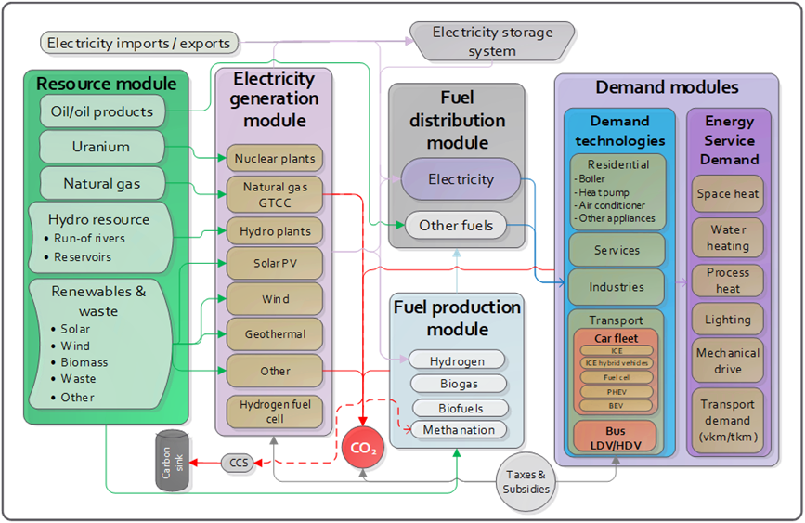
Figure S3: Swiss TIMES Energy system Model (STEM) at a glance
STEM has a high level of technology detail to ensure feasibility of future energy pathways from an engineering perspective. It has a century-long horizon to analyse long-term goals. It also has a high intra-annual resolution to account for temporal variations in energy demand and supply. The model incorporates a range of energy and climate policies, including energy efficiency directives and standards (e.g., eco-designs, building codes, labeling), financial support for renewable technologies (e.g., subsidies), emissions trading schemes and carbon markets, sector-specific emissions standards (e.g., for buildings and vehicles), and biofuel directives and standards. Table S7 gives an overview on the most important STEM parameters including the AGS technology.

Table S7: List of represented techno-economic parameters of AGS technology in STEM
Technical parameters | TIMES Attribtues | Unit | AGS reference value | Parametric values*
Capital investment cost | NCAP_Cost | CHF/kW | 128,000 | 62,500# - 10000
Technology lifetime | NCAP_TLIFE | Years | 30 | 30 - 60
Annual fixed O&M cost | NCAP_FOM | CHF/kW/year | 10% of capital cost | In line with capital cost
Variable operational cost | ACT_COST | CHF/GJ | 0.12 - 0.29 | As in reference
Decommissioning cost | NCAP_DCOST | CHF/kW | 700 | As in reference
Discount rate | NCAP_DRATE | % | 5.5% | As in reference
Annual availability factor | NCAP_AFA | % | 80% | As in reference
Operational condition (dispatchable /non-dispatchable) | RL-DISP/RL-NDISP | Binary | RL-NDISP | RL-DISP
Maximum ramp-rate (down/up) | ACT_UPS | as a fraction of nominal online capacity per hour | 2% | 2% - 9%
Minimum stable operating level | ACT_MINLD | % of installed capacity | 45% | 45% - 25%
Minimum online / offline hours (or Maximum number of start-up cycles) | ACT_TIME~UP ACT_TIME~LO | Hours | 12 | 12 - 0
Cost of start-up | ACT_CSTUP | CHF/start-up | .02 | As in reference
Contribution to provision of reserve (primary: positive and negative) | BS_RMAX~UP  BS_RMAX~LO | as a fraction of capacity | 1.25% | 1.25% - 3%
Contribution to provision of reserve (secondary) | BS_RMAX~UP BS_RMAX~LO | as a fraction of capacity | 5% | 5% - 100%
Subsidy on electricity generation | FLO_SUB | CHF/GJ | Nil | Nil
Subsidy for new installed capacity | NCAP_ISUB | CHF/kW | Nil | Nil
First available year | NCAP_START | Year | 2030 | As in reference
Conversion efficiency | EFF | % | 100% | As in reference
* The operational flexibility of AGS is assumed to be similar to an open gas turbine power plant. # Cost above 63,000 CHF/kW, there is no deployment of AGS

Scaling up AGS in CH
Table : Summary of materials and energy used for the construction per meter well and the complete well (2 vertical wells with 6 km each, horizontal loops over a total distance of 42 km), upscaled to reach 2 GWe installed capacity in 2050. Mind that capacity scaling to 2 GW would happen over several years, so that the material and energy consumption would spread over that time period.
 |  | Per m well | Per complete well (1.89 MW plant) | 2 GWe installed capacity
Well construction | Energy use | 191 kWh | 10 GWh | 10 TWh
 | Casing, steel | 67 kg | 401 t | 0.401 Mt
 | Casing, cement slurry |  | 593 m³
 | Casing, cement slurry, cement | 71 kg | 424 t | 0.424 Mt
 | Casing, cement slurry, water | 28 kg | 169 t | 0.169 Mt
 | Extracted material (well volume) |  | 3837 m³
CO₂ | Tubing and open hole inside volume |  | 1051 m³
 | Supercritical CO₂ | 10 kg | 544 t | 0.544 Mt

Journal specifications

https://www.sciencedirect.com/journal/renewable-energy
Renewable Energy, Science Direct, IF 9.1

The journal, Renewable Energy, seeks to promote and disseminate knowledge on the various topics and technologies of renewable energy systems and components. The journal aims to serve researchers, engineers, economists, manufacturers, NGOs, associations and societies to help them keep abreast of new developments in their specialist fields and to apply alternative energy solutions to current practices.
Renewable Energy is an international, multi-disciplinary journal in renewable energy engineering and research. The journal aims to be a leading peer-reviewed platform and an authoritative source of original research and reviews related to renewable energy.
Renewable Energy covers research in the following areas:
Geothermal Technology
The journal also welcomes papers on other related topics provided that such topics are within the context of the broader multi-disciplinary scope of Renewable Energy. It should be noted, however, that papers are within scope only if they are concerned with power generation and that the power is generated in a renewable or sustainable way. For instance, a paper concerning development and characterisation of a material for use in a renewable energy system, without any measure of the energy that this new material will convert, would be out of scope.
Renewable Energy accepts original research papers and review papers (the latter by invitation of the Editor-in-Chief only). Interested authors of review papers need to send the outline of the review together with a short CV of the main author/s to the Editor-in-Chief before submission of the paper.

Article Publishing Charge (APC) open access: USD 4270 (excl. Taxes). No publication fee charged to authors, and published articles are immediately available to subscribers.

Paper Length - As a guide, original papers should be between 4000 and 6000 words (excluding table/figure captions and references), and review articles should be up to 10,000 words. Authors must state the number of words in their manuscript at submission stage.

Cover letter of your submission in Editorial Manager.

Karin Treyer
Forschungsstrasse 111
5232 Villigen PSI
Paul Scherrer Institute

Renewable Energy
Springer (Address)

23.10.2025 (suibmission date)
Dear editor,
We wish to submit an original research paper entitled “Prospective assessment of the role of Advanced Geothermal Systems (AGS) in Net-zero electricity: Integrated Techno-Economic, Environmental, and System Perspectives” to be published by “Renewable Energy”.

This paper addresses the problem of [main questions]. Studies have shown that [background of study]. However, no TEA/LCA/integrated assessment of AGS exists. [problem statement]. Using a combined approach [method], we show that [key findings].Our findings are significant because [impact of study].

Since our study deals with [main focus of study aligning with the journal’s scope], we believe it may be a good fit ro publication in Renewable Energy. We feel that the findings of our study will be highly relevant to your audience sinde [research contribution/practical implications].
The article “ “ has not been published elsewhere, and it reflects original research conducted by its authors. None of the authors have any conflicts of interest to disclose concerning this study.

Thank you for your valuable time.

Sincerely,
Karin Treyer
Senior Scientist, Laboratory for Energy Systems Analysis, Paul Scherrer Institute

Karin.treyer@psi.ch

Include a cover letter with your submission to introduce your manuscript to the editor and encourage its peer review.
- Keep it short (ideally less than one page) and focused.
- Be concise. Clearly articulate the study's aim and main findings without unnecessary details
- Explain how your study fits the journal’s aim and scope.
- Emphasize the research's novelty and broader implications to demonstrate its potential impact on the field.
- If you have been invited to submit, acknowledge this in the letter.
- Brief background regarding the research involvd or how the data was collected.

A cover letter should not include funding information, author declarations, or suggested or opposed reviewers. If these details are needed, they will be requested separately.

Preprint: During submission to Editorial Manager, you can choose to release your manuscript publicly as a preprint on the preprint server SSRN once it enters peer-review with the journal. à Suggest not to do that.

Referee suggestions
LCA: Andrea Paulillo, Isabelle Blanc, Mélanie Douziech
TEA
STEM
Sandrine Selosse sandrine.selosse@minesparis.psl.eu
Centre de Mathématiques Appliquées (CMA) Mines Paris - PSL (École nationale supérieure des mines de Paris)

Patrícia FORTES p.fs@fct.unl.pt
DCEA FCT NOVA Campus de Caparica 2829-516 Caparica Portugal

Name, institution, e-mail, reason

Authors:
Full name, academic degree, e-mail address, orcid, institution, country/region, contributor roles

https://github.com/premise-community-scenarios/sweet_sure-2050-switzerland
Achieving <0.5° azimuthal accuracy at 232°C using silicon-on-insulator circuits
https://github.com/premise-community-scenarios/sweet_sure-2050-switzerland
https://premisedash-6f5a0259c487.herokuapp.com/
https://www.kva-linth.ch/energie-umwelt/ccs

