**July 30, 2021**

Added password update for the user that already logged in. Only the new password is required to enter, but as I’ve usually seen it – enter it twice to confirm that it is correct:

* From the previous lab the complexity check, just I limit length to 20 characters, not 64 as it was in the readings.
* The comparison is done with the provided list, but since it is all made in one function, and all passwords in the list are anyway not complex enough, for testing I’ll add one line there with my complex password, that should be caught as inappropriate.
* Also, I made it invalid to update password that is the same as the previous, which I also usually had as user.

To update the password, the csv file is written to temp file with one new entry, than the old version is removed. To find CommonPasswords – just read the file with comparison.

While testing the password update page, unexpected behavior happened: only the first time visiting this page was redirecting to login page, next were fine even if it was other user. So, I had to fix not very correct solution that worked in lab7: the global variable Logged to show if user logged in, and used session instead. It was working fine after.

Log is added from logging library, and to filter records in the file record.txt – I use logging.disable(logging.WARNING) – since the level of messages that were also there was maximum Warning. To the messages I want to save I assign level ‘error’. To get IP I use request.environ.get('HTTP_X_REAL_IP', request.remote_addr) – but only checked it on my computer.

**Testing.**

All functions were tested separately, and for the final testing the scenarios are:

*1. Logging:* failed to login several users, login existing and non-existing users. Check the format of the output, time.

*2. Password update:*

2.1. Valid password update – too long password, because checked in the same regex, is giving the message that ‘not complex’, while it is complex but too long. So, add the complexity description on the page and put the message as 'The password complexity is wrong'

2.2. Try to input different invalid passwords (password complexity validation vas checked in lab7, it is performed by a separate function, so one case is enough): complexity, equal to previous, password from the blacklist – I added one there, so that one should be detected.

Failed login attempts, and successful:

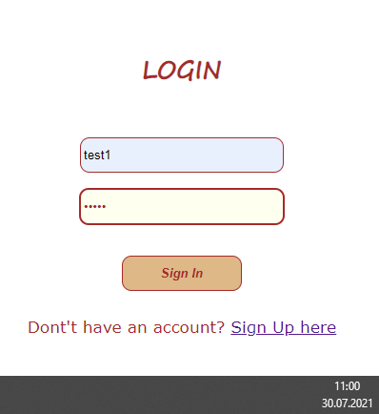

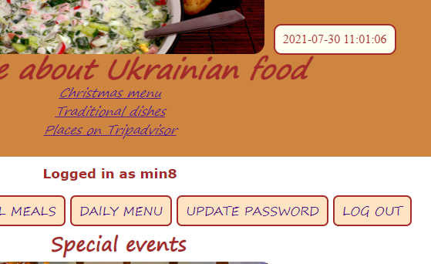

Some more logging in, and the user gg that doesn’t exist:

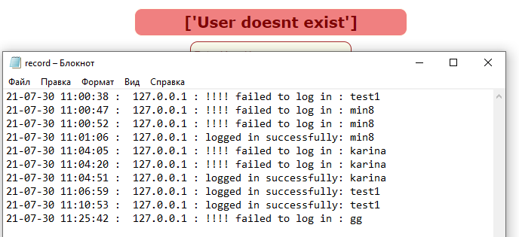

2. Update password:

Login with the old password:

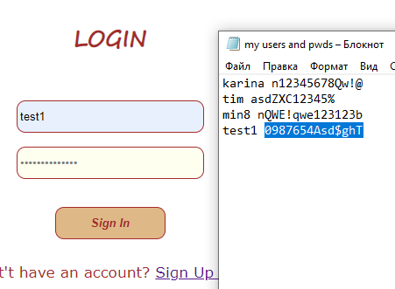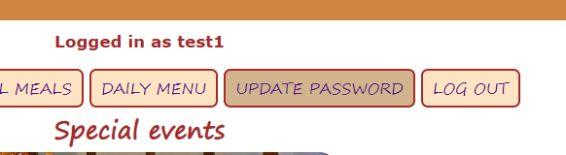 Go to update

The page also has decoration image on top, and while first visited, this empty message box appears:

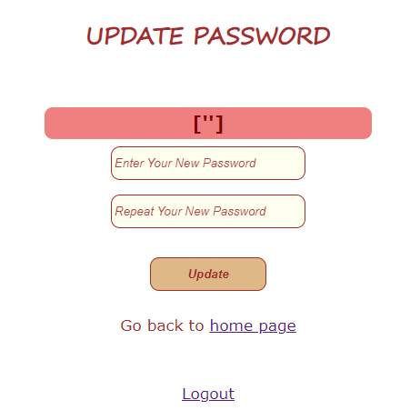

If reload page, it looks as supposed:

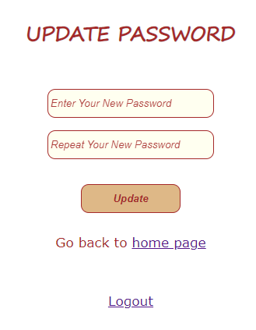

Found that the error message is confusing (on the screen capture – the message after trying to save too long password), but the password update works correctly:

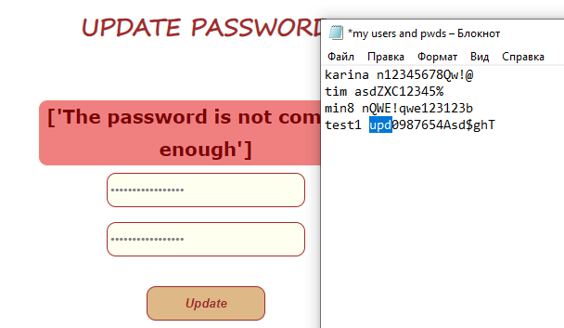

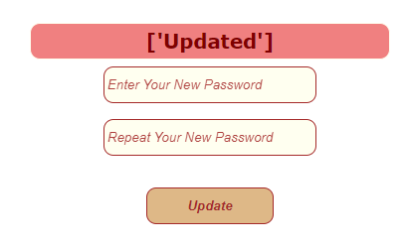

And check that user can login with new password:

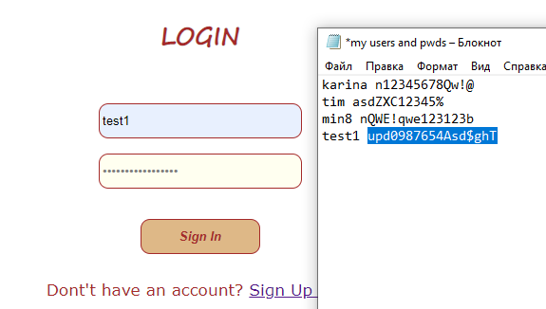

Try with the invalid password options. New view of the page, and the additional entry in the blacklist that will be put as password:

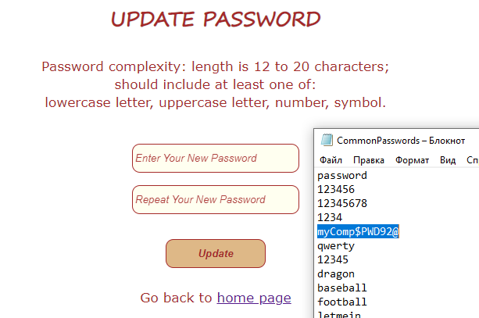

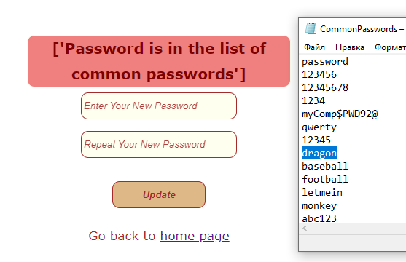

Put not complex – the one from the list ‘dragon’ – and see updated message:

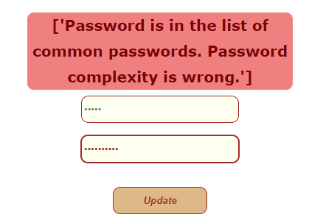🡨Different passwords in fields:

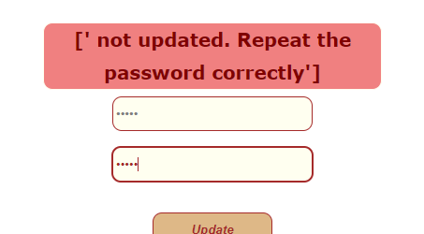 🡨 This is too short, output:

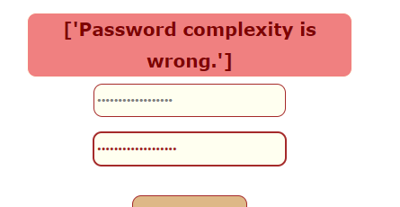 🡨 And too long

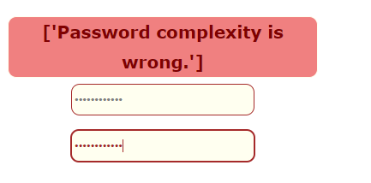🡨 Here is the previous (old) password and output:

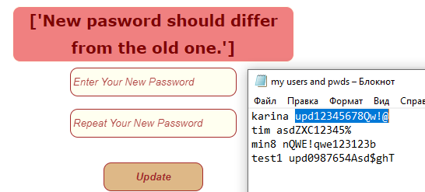 Correct:

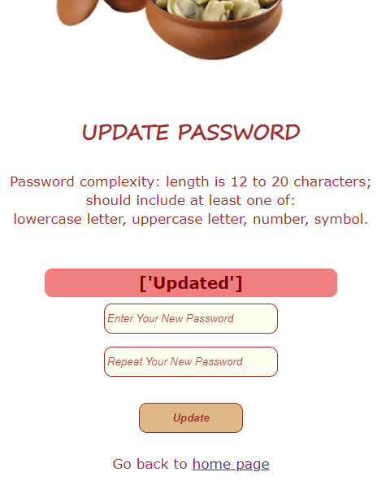 And login with the new password.

Clock on the screen capture shows the difference in seconds:

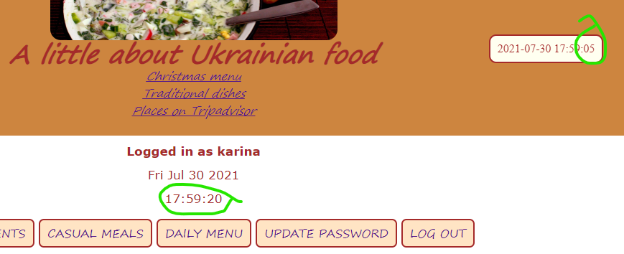

This doesn’t look as a good design, but has both elements, implemented in HTML, JS and inside the application in .py file.