**IT Help Desk Ticketing System**

**Test Plan and User Guide**

04 April 2022

Team: Dalton Coughlin

Grant Collins

Karina D'Abbraccio

Jared Rice

James Sweatt

Kobi-yoshi Hsu

**Contents**

1.Test Scope..........................................................................................................3

2. Out of Scope......................................................................................................3

3. Risks and Issues................................................................................................3

4. Test Objectives……………………………………………………………………….4

5. Software Features That Need to be Tested ……………………...…...……….....4

6. Testing Schedule……………………………………………………………………..4

7. Resource Planning….........................................................................................5

8. Test Cases……………………............................................................................5

9. Suspension Criteria............................................................................................6

10. Exit Criteria…………..………………………………………………………………6

11. Test Deliverables……………………………………………………………………6

12. User’s Guide………...………………………………………………………………7

1. **Test Scope**

As required by the Product Specifications, the project only focus on testing all the **functions** and external interface of website**IT Help Desk Ticketing System**.

In-scope items: functional testing.

Testing will be focused on:

* API created for the application;
* Integration test;
* System test.

1. **Out of** **scope**

Nonfunctional testing such as**stress, performance**or**logical database** currently will not be tested.

Out-of-scope items: hardware, and other external interfaces.

1. **Risks and issues**

|  |  |
| --- | --- |
| **Risk** | **Mitigation** |
| Lack the required skills for testing | allocate additional time for additional research on testing methods |
| Lack of time for appropriate testing due to tight schedule | Set priority to each test activity |
| A lack of cooperation negatively affects your employees’ productivity | Encourageeach team member in their task, and inspire them to greater efforts |
| Financial risks | Doesn’t apply |

1. **Test Objectives**

Final goal is to deliver bug free product that is required by Product Specifications by the due date of a project.

1. **Software features that need to be tested**

Check whether functionality is working as expected without any errors or bugs. The testing should cover following: account (sign in, login, logout), add ticket, sort tickets, close ticket, update status on ticket, ticket attributes,

Check that only authorized users may use the product. This includes testing the login of tech and end users and their access to the correct functionality as result.

Check that the external interface of the website such as **UI** is working as expected and meet the customer need. The testing should cover all web elements (button, menu, text), HTML/CSS.

Verify usability for convenience for the user.

1. **Testing Schedule**

|  |  |
| --- | --- |
| **Date** | **Task** |
| April 3 | - Develop test data for tables with group |
| April 7 | * check login and registration process * check that database is reflecting all needs of the project |
| April 14 | * check home page |
| April 17 | * check database tables and columns * check proper backend/database queries |
|  | * setup E2E tests * check front end designs and functionality * system test |
| April 21 | - Insert test data into tables for testing   * Check proper backend/database queries |
| **May 5** | Fully tested project |

1. **Resource Planning**

Unit/ Code Functional Testing will be done by the development team.

The final testing will include all scenarios from the user guide, from perspective of end user and tech user.

Test data will be loaded directly into the database: 15 users and 5 techs, with 50 tickets total and 100 comments. The data will be exported to an excel sheet and sorted, and the testing results will be validated.

1. **Test Cases**

|  |  |  |  |  |  |
| --- | --- | --- | --- | --- | --- |
| # | Functionality being tested | Input | Expected Output | Actual Output | Pass |
| 1 | Login |  |  |  |  |
| 1.1 | User logs in with valid password |  |  |  |  |
| 1.2 | User logs in with invalid password |  |  |  |  |
| 1.3 | User leaves empty fields on login page |  |  |  |  |
| 2 | Create Ticket |  |  |  |  |
| 2.1 | By end user |  |  |  |  |
| 2.1.1 | Valid input |  |  |  |  |
| 2.1.2 | Invalid input (empty fields) |  |  |  |  |
| 2.2 | By tech user |  |  |  |  |
| 2.2.1 | Valid input |  |  |  |  |
| 2.2.2 | Invalid input (empty fields) |  |  |  |  |
| 3 | Sort tickets |  |  |  |  |
| 3.1 | All tickets, sorted by date |  |  |  |  |
| 3.2 | Open tickets, sorted by date |  |  |  |  |
| 3.3 | Closed tickets, sorted by date |  |  |  |  |
| 4 | See ticket data |  |  |  |  |
| 5 | Change ticket status |  |  |  |  |
| 5.1 | By end user |  |  |  |  |
| 5.2 | By tech user |  |  |  |  |
| 6 | Add and read comments |  |  |  |  |
| 6.1 | By end user |  |  |  |  |
| 6.2 | By tech user |  |  |  |  |
| 7 | Change tickets’ completion date |  |  |  |  |

1. **Suspension criteria**

If there are over 30% of tests failed, the testing is suspended until the development team fixes all the failed test cases.

1. **Exit criteria**

Run rate = number of test cases executed / total test cases. Must be 100% unless a clear reason is given.

Pass rate = number of test cases passed / total test cases. Must be 95% with 5% of not crucial defects.

The Project Manager is to confirm that testing is successfully completed.

1. **Test Deliverables**

Test Data

|  |  |  |
| --- | --- | --- |
| Test Case # | What Is being Tested | Input values |
|  |  |  |

Execution Reports

Test Case # - Short Description (from section 8)

…..Screen captures…..

Test Case # - Short Description

…..Screen captures…..

Test Case # - Short Description

…..Screen captures…..

Test Results

|  |  |  |  |
| --- | --- | --- | --- |
| Test Case # | Short Description | Total tests number | Total passed |
|  |  |  |  |

Defect Reports

|  |  |  |  |
| --- | --- | --- | --- |
| Test Case # | Defect description | How to reproduce | Fixed? |
|  |  |  |  |

1. **User’s Guide**

The application includes end-user and tech user interface, they may submit and check tickets, leave comments on specific tickets.

1. *Go to* <https://ithelpticket.net/> in your internet browser. You should have internet access.
2. ***Login***with the valid username and valid password, typing them in corresponding text fields of the login page, and press the button “Submit”. The user will be directed to home page of end user or tech user.

The link in the footer GitHub Repository will open the page on the GitHub where the source for the project is located.

1. ***This section is for the Tech user.*** Tech userwould see the home page with the available menu options on the left side: My Tickets, All Tickets, Create Ticket, Filter (Search, Status, Assigned, Priority), and preview for all tickets.

3.1. Mouse hover over the ticket will highlight the ticket in light blue color, mouse click on highlighted ticket will show the *details on this ticket*:

Along with details, there are comments or a message if the ticket does not have any comments, links to add comment, close ticket, assign to ticket.

3.2. To *Add comment*, user need to fill the text area and click the “Submit” button:

Then the comment will appear in the Ticket details:

3.3. If the ticket is not assigned to anyone, the tech may *assign himself* a ticket by clicking Assign to ticket in the Ticket Details:

The ticket’s status will be Assigned, and the link on the bottom will change to *Unassign from Ticket:*

3.4. To unassign from ticket, the tech user needs to click the link *Unassign From Ticket* and click Yes:

3.5 The Tech User may *close* ticket by clicking the link on the bottom of the ticket details and clicking “Yes” button:

The status of the ticket will change to Closed.

3.6. Clicking *My Tickets*, the tech will see the tickets assigned to them, All Tickets will show all tickets (as on the Home page).

Home Page – shows all tickets sorted by priority in descending order.

All tickets – shows all tickets sorted by their number.

3.7. To *search* for ticket input the ticket number (as on screen capture above) or the key words (as on the screen capture below):

*3.8. Create ticket.* Tech user can create ticket for the user by clicking the “Create Ticket” from the menu. In the new window/page the text areas must be not empty and describe the short summary of the problem and provide description. The dropdown menu allows to set priority on routine / urgent / emergency, and choose the User for this ticket. After this, press the button “Submit”. Tech user also must set the status, user to be assigned to.

3.9. *Filter tickets.* Press the menu option “All”, “Open”, “Closed” to see corresponding tickets.

If in the other fields for sorting the criterion is selected instead of “All”, the tickets will be filtered to satisfy all selected criteria.

1. ***This section is for the End user.*** End userwould see the home page with the available menu options on the left side: My Tickets, All Tickets, Create Ticket, Filter (Search, Status, Assigned, Priority), and preview for all tickets. The All Tickets option is disabled for the end user.

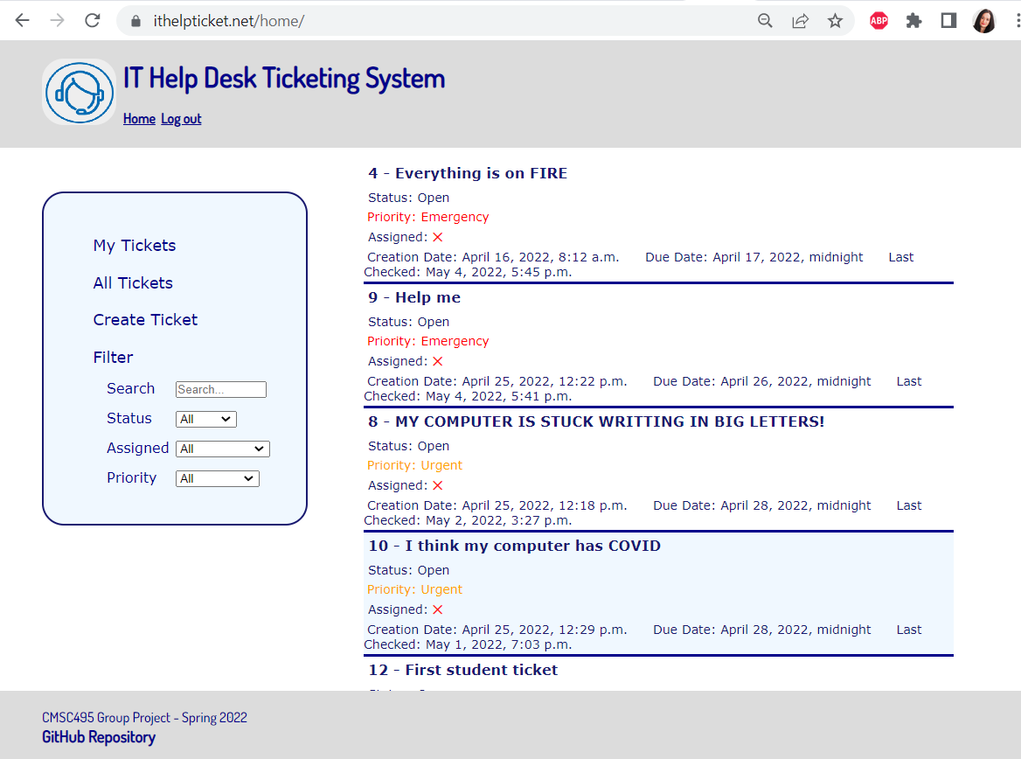

3.1. Mouse hover over the ticket will highlight the ticket in light blue color, mouse click on highlighted ticket will show the *details on this ticket*:

Along with details, there are comments or a message if the ticket does not have any comments, links to add comment, close ticket, assign to ticket.

3.2. To *Add comment*, user need to fill the text area and click the “Submit” button:

Then the comment will appear in the Ticket details:

3.6. Clicking *My Tickets*, the end will see the tickets submitted by them sorted by their number. Home Page – shows all tickets sorted by priority in descending order.

3.7. To *search* for ticket input the ticket number (as on screen capture above) or the key words (as on the screen capture below):

(This User does not have ticket number 5).

*3.8. Create ticket.* Tech user can create ticket for the user by clicking the “Create Ticket” from the menu. In the new window/page the text areas must be not empty and describe the short summary of the problem and provide description. The dropdown menu allows to set priority on routine / urgent / emergency. After this, press the button “Submit”.

3.9. *Filter tickets.* Press the menu option “All”, “Open”, “Closed” to see corresponding tickets.

If in the other fields for sorting the criterion is selected instead of “All”, the tickets will be filtered to satisfy all selected criteria.

4. At the end of working, click ***Logout*** in the page header

