

# CA5: R Data Interpretation - 10 %

Module Title: Programming for Big Data

Module Code: B8IT105

Module Leader: Darren Redmond

Student Name: Karina Jonina

Student Code: 10543032

Github: <https://github.com/KarinaPS11/B8IT105>

Contents

CA4: R Data Interpretation - 10 % 1

1. Dataset 3

2. Investigative Questions 4

3. Number of Reservations in Each Hotel 5

4. Reservations Status by Hotel Types 6

5. Reservation Status by Year 7

6. Reservation Status for Each Month 8

7. Reservation Status for Each Month 9

8. Average Daily Rate 10

1. Average Daily Rate by Reservation Status 10

2. Average Daily Rate By Year 11

3. Average Daily Rate By Month 12

4. Average Daily Rate By Month for Each Hotel 14

9. Logistic Regression 15

Prediction 16

10. Conclusion 17

11. Appendix 18

Chi-Square Analysis for Hotel and Cancelations 18

Chi-Square Analysis Reservation Status and Year 18

Two-Way ANOVA Analysis between hotels and reservation status 18

Two-Way ANOVA Analysis between each hotel and year 19

One-Way ANOVA Analysis - price in each month 19

TukeyHSD price in each month 20

Logistical Regression Output 22

# Dataset

The dataset used was collected from the following website:

<https://www.sciencedirect.com/science/article/pii/S2352340918315191>

This dataset was collected by two hotels. Both hotels are located in Portugal. The dataset has 31 variables with 40,060 observations for resort hotel in Algarve and 79,330 observations of city hotel in Lisbon. The dataset was collected between 1st of July 2015 and 31st August 2017.

The following are column names:

'hotel', 'is_canceled', 'lead_time', 'arrival_date_year', 'arrival_date_month', 'arrival_date_week_number', 'arrival_date_day_of_month', 'stays_in_weekend_nights', 'stays_in_week_nights', 'adults', 'children', 'babies', 'meal', 'country', 'market_segment', 'distribution_channel', 'is_repeated_guest', 'previous_cancellations', 'previous_bookings_not_canceled', 'reserved_room_type', 'assigned_room_type', 'booking_changes', 'deposit_type', 'agent', 'company', 'days_in_waiting_list', 'customer_type', 'adr', 'required_car_parking_spaces'.

Following ‘CA4: Panda Data Interpretation’ – the filtered data named ‘data_top10’ for CA5 was used.

# Investigative Questions

The following are the questions that will be answered

* Most popular months and years
* Number of guests per reservation
* Number of nights per reservation
* Number of Reservations in each hotel type
* Average daily rate by month, year, type hotel.
* Price of a room per person per night for each month for both hotels
* Machine Learning: Logistic Regression.
* Prediction using Machine Learning on Test Data

# Number of Reservations in Each Hotel

Graph 1: It is clear that there are more reservations in City Hotel than Resort Hotel.

|  |  |
| --- | --- |
| City Hotel | Resort Hotel |
| 65, 568 | 35, 232 |

Table 1: The figures show the number of reservations for the Top10 countries.

# Reservations Status by Hotel Types

Graph 2: Although City Hotel has the greatest number of reservations, it is clear that City Hotel also has the greatest number of cancelations.

|  |  |  |
| --- | --- | --- |
|  | City Hotel | Resort Hotel |
| Not Canceled | 36 676 | 24967 |
| Canceled | 28 892 | 10 265 |

Table 2: Table shows the figures for city hotel and resort hotel by canceled and not canceled.

Chi-Square Analysis

Shows that there is significant difference between the hotels and reservation status, *X*2 (1, *N* = 100 800) = 2150, p < .05.

# Reservation Status by Year

Graph 3: The

|  |  |  |  |
| --- | --- | --- | --- |
|  | Not cancelled | Cancelled | Total |
| 2015 | 11 973 | 8 086 | 20 059 |
| 2016 | 29 813 | 17 838 | 47 651 |
| 2017 | 19 857 | 13 233 | 33 090 |

Table 3: Although, 2016 had the greatest number of reservations, followed closely by 2017.

Chi-Square Analysis

A Chi-Square was run to examine the relationship between the year and reservation status.

The result shows that there is significant difference between the year and reservation status , *X*2 (2, *N* = 100 800) = 76.34, p < .05.

# Reservation Status by Countries

Graph 4: The graph shows the Portugal has the most cancelations than any other country. It is also the only country that has more cancelations than check-outs.

|  |  |  |
| --- | --- | --- |
|  | Not Cancelled | Cancelled |
| Bel | 1 868 | 474 |
| bra | 1 394 | 830 |
| deu | 6 059 | 1 218 |
| esp | 6 391 | 2 177 |
| fra | 8 481 | 1 934 |
| gbr | 9 676 | 2 453 |
| ita | 2 433 | 832 |
| NLD | 1 717 | 387 |
| PRT | 21 071 | 27 519 |

*Table 4*: The table shows the breakdown of countries and reservation status.

Chi-Square Analysis

A Chi-Square was run to examine the relationship between country and reservation status.

The result shows that there is significant difference between the country and reservation status, *X*2 (2, *N* = 100 800) = 13218, p < .05.

# Reservation Status for Each Hotel in every Month

Graph 5: City Hotel shows an increase in booking for the spring and summer months. The Resort shows a slight increase and a tiny dip in bookings in June and picks up again for July and August. Both hotels see a decrease in bookings for the winter months.

|  |  |  |
| --- | --- | --- |
|  | City Hotel | Resort Hotel |
| January | 2 996 | 1 957 |
| February | 4 150 | 2 859 |
| March | 5 243 | 3 013 |
| April | 6 033 | 3 227 |
| May | 6 634 | 3 158 |
| June | 6 421 | 2 569 |
| July | 6 585 | 3 732 |
| August | 7 565 | 4 296 |
| september | 6 369 | 2 968 |
| October | 6 470 | 3 129 |
| November | 3 547 | 2 140 |
| December | 3 555 | 2 454 |

Table 5: The table shows the figures for cancellations for each month.

# Reservation Status for Each Month

Graph 6: Overall, the trend shows that there are more reservations during the spring and summer months. However, there are a lot more cancelations during those moths than in the winter.

|  |  |  |
| --- | --- | --- |
|  | Not cancelled | Cancelled |
| January | 3 411 | 1 542 |
| February | 4 620 | 2 389 |
| March | 5 519 | 2 737 |
| April | 5 325 | 3 935 |
| May | 5 699 | 4 093 |
| June | 4 977 | 4 013 |
| July | 6 277 | 4 040 |
| August | 7 234 | 4 627 |
| september | 7 234 | 3 867 |
| October | 5 744 | 3 855 |
| November | 3 771 | 1 916 |
| December | 3 861 | 2 148 |

Table 6: The table shows the figures for cancellations for each month.

# Average Daily Rate

## Average Daily Rate by Reservation Status

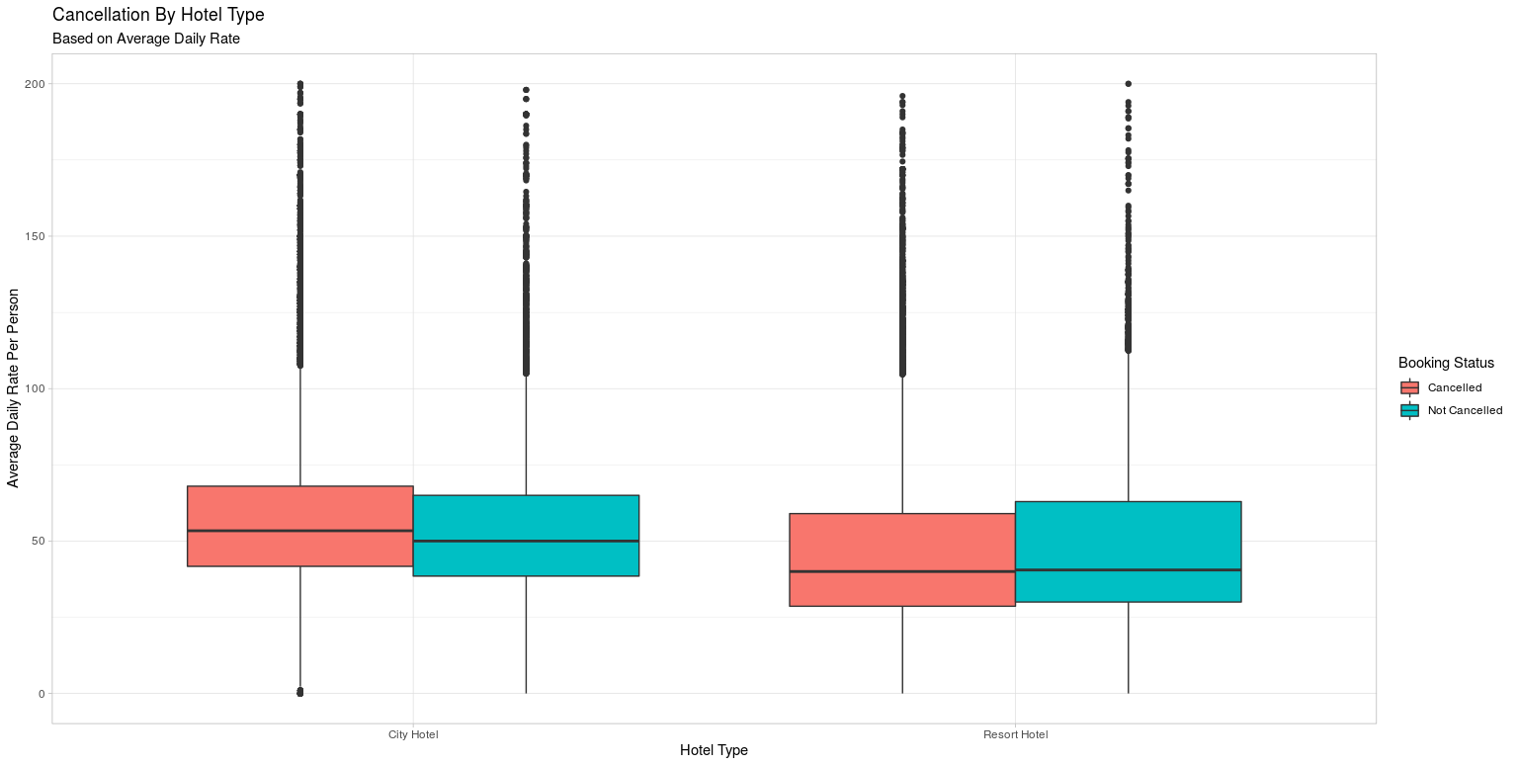

Graph 7: Graphs shows that Average Daily Rate by Reservation Status for each Hotel. Unfortunately, the graph shows no difference in price between cancelled and not cancelled bookings.

Two-Way ANOVA Analysis

Two-Way ANOVA was run to examine the difference in price between hotels and reservation status. City Hotel (*M* = 102, *SD* = 48.0) which were not cancelled had a higher price than City Hotels (*M* = 104, *SD* = 40.6) that were cancelled. However, Resort Hotel (*M* = 89.2 , *SD* = 59.2) which were not cancelled had a lower price than City Hotels (*M* = 103.0, *SD* = 63.5) that were cancelled. There was a statistically significant differences between hotels as determined by two-way ANOVA, *F* (2, 100 796) = 916.76 , *p* < 0.05, and reservation status, *F* (2, 100 796) = 67.02, *p* < 0.05. There is also an interaction between hotel and reservation status, *F* (2, 100 796) = 466.73, *p* < 0.05.

## Average Daily Rate By Year

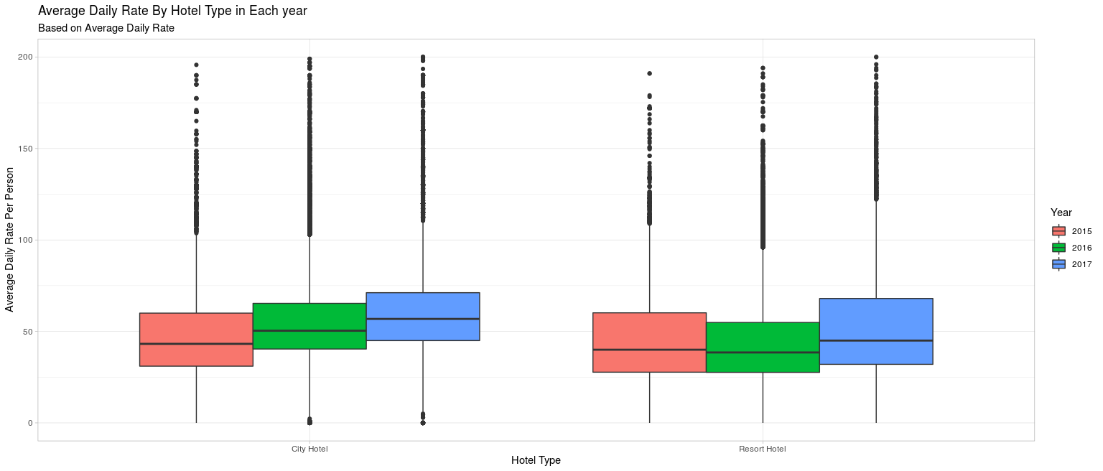

Graph 8: The graph shows that City Hotel increased their price slightly each year, while Resort Hotel had a slight dip of price in 2016.

Two-Way ANOVA Analysis

Two-Way ANOVA was run to examine the difference in price between each hotel and year. There is significant difference between each hotel, F (1, 100 796) = 944.3, p < 0.05, each year, F (1, 100 796) = 33 415.9, p < 0.05. City hotel has steady put up their prices for each year, 2015 (*M* = 84.8, *SD* = 34.2), 2016 (*M* = 102.0, *SD* = 46.8) and 2017 (*M* = 115.0, *SD* = 40.9). Resort hotel has hiked their prices less each year, 2015 (*M* = 89.3, *SD* = 54.1), 2016 (*M* = 86.4, *SD* = 56.8) and 2017 (*M* = 105.0, *SD* = 68.4) and a dip in prices for 2016 is visible.

## Average Daily Rate By Month

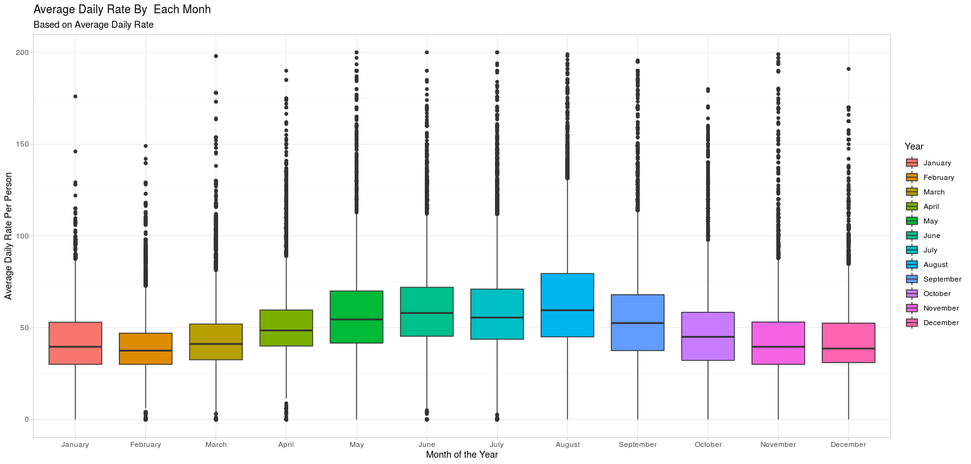

*Graph 9:* This graph shows the price for each moth. It shows a slight increase for the summer months and gentle decrease for the winter months.

|  |  |  |  |
| --- | --- | --- | --- |
|  | *N* | *M* | *SD* |
| January | 4 953 | 68.9 | 28.1 |
| February | 7 009 | 72.5 | 29.8 |
| March | 8 256 | 79.3 | 67.1 |
| April | 9 260 | 98.1 | 37.9 |
| May | 9 792 | 106.0 | 42.8 |
| June | 8 990 | 114.0 | 38.0 |
| July | 10 317 | 123.0 | 51.5 |
| August | 11 861 | 139.0 | 62.5 |
| September | 9 067 | 10.30 | 43.2 |
| October | 9 599 | 86.0 | 35.9 |
| November | 5 987 | 71.8 | 32.1 |
| December | 6 009 | 80.4 | 43.4 |

*Table 7:* Table shows the mean and standard deviation for price of a reservation.

One-Way ANOVA Analysis

One-Way ANOVA was run to examine the difference in price in each month. There is significant difference between months, F (11, 2 075) = 944.3, p < 0.05. Tukey HSD was used to find the difference between the months. There was no significant difference between (1) November-January, (2) November-February, and (3) December-March. However, all the other months were significantly different from each other.

## Average Daily Rate By Month for Each Hotel

Graph 10: Using Graph 8, it is clear that the city hotel has a slight increase for the summer months. However, the Resort hotel hikes up their prices for the summer months.

# Logistic Regression

Data was split into training and test data.

Training data had 20.

The following variables are significant

The following variables did not contribute to the cancelation rate in significant way: March, May, October, November, GBR, NLD

Having reservation in Resort Hotel, versus City Hotel, changes the log odds of cancelations by -0.509.

The following increase the log odds of cancelation (versus no cancelation)

* every extra day in lead time - by 0.007.
* every night reserved - by 0.05.
* every Euro (ADR) spent - by 0.006.
* every reservation previously cancelled - by 1.14
* every time the reserved room and assigned room don’t match – by 2.31
* every year by 0.145

The following decrease the log odds of cancelation (versus no cancelation)

* Every extra day on the waiting list - by -0.003

Having reservation in Full Board, versus Bed and Breakfast, changes the log odds of cancelations:

* Full Board by -0.4392
* Half Board by - 0.4621,
* Self-Catering by 0.486,
* Undefined by - 0.8369.

Having reservation in February, versus January, changes the log odds of cancelations by 0.921,

* April by 0.303,
* June by -0.132,
* July by -0.5220.
* August by 0.461
* September by -0.17
* December by 0.163

Having reservation in Brazil, versus Belgium, changes the log odds of cancelations by 1.01,

* Germany by -0.3683,
* Spain by 1.028,
* France by -1.02.
* Ireland by 0.461
* Italy by 1.041
* Portugal by 2.216

## Prediction

Using the logistic regression model, test data was used to make a prediction.

Our model’s prediction accuracy is 76% which is not a great score. This would not help the two hotels to narrow down the reasons for cancelations.

*Confusion Matrix*

|  |  |  |
| --- | --- | --- |
|  | actual |  |
| Predicted | **Not Cancelled** | **Canceled** |
| Canceled | 15 877 | 4 397 |
| Not Cancelled | 2 598 | 7 367 |

# Appendix

## Chi-Square Analysis for Hotel and Cancelations

Number of cases in table: 100800

Number of factors: 2

Test for independence of all factors:

Chisq = 2150, df = 1, p-value = 0

> # showing the tableq

> tbl

0 1

City Hotel 36676 28892

Resort Hotel 24967 10265

## Chi-Square Analysis Reservation Status and Year

Number of cases in table: 100800

Number of factors: 2

Test for independence of all factors:

Chisq = 76.34, df = 2, p-value = 2.653e-17

> # showing the tableq

> tbl

0 1

2015 11973 8086

2016 29813 17838

2017 19857 13233

## Two-Way ANOVA Analysis between hotels and reservation status

Df Sum Sq Mean Sq F value Pr(>F)

hotel 1 2328091 2328091 916.76 < 2e-16 ***

is_canceled 1 170191 170191 67.02 2.72e-16 ***

hotel:is_canceled 1 1185257 1185257 466.73 < 2e-16 ***

Residuals 100796 255969362 2539

---

Signif. codes: 0 ‘***’ 0.001 ‘**’ 0.01 ‘*’ 0.05 ‘.’ 0.1 ‘ ’ 1

hotel is_canceled count mean sd

*<fct>* *<dbl>* *<int>* *<dbl>* *<dbl>*

1 City Hotel 0 36676 104. 40.6

2 City Hotel 1 28892 102. 48.0

3 Resort Hotel 0 24967 89.2 59.2

4 Resort Hotel 1 10265 103. 63.5

## Two-Way ANOVA Analysis between each hotel and year

|  |
| --- |
| Df Sum Sq Mean Sq F value Pr(>F)  hotel 1 2328091 2328091 944.3 <2e-16 ***  arrival_date_year 1 8421409 8421409 3415.9 <2e-16 ***  hotel:arrival_date_year 1 408605 408605 165.7 <2e-16 ***  Residuals 100796 248494797 2465  ---  Signif. codes: 0 ‘***’ 0.001 ‘**’ 0.01 ‘*’ 0.05 ‘.’ 0.1 ‘ ’ 1 |
|  |
| |  | | --- | | hotel arrival_date_year count mean sd  *<fct>* *<dbl>* *<int>* *<dbl>* *<dbl>*  1 City Hotel 2015 12470 84.8 34.2  2 City Hotel 2016 31264 102. 46.8  3 City Hotel 2017 21834 115. 40.9  4 Resort Hotel 2015 7589 89.3 54.1  5 Resort Hotel 2016 16387 86.4 56.8  6 Resort Hotel 2017 11256 105. 68.4 One-Way ANOVA Analysis - price in each month Df Sum Sq Mean Sq F value Pr(>F)  arrival_date_month 11 47950518 4359138 2075 <2e-16 ***  Residuals 100788 211702384 2100  ---  Signif. codes: 0 ‘***’ 0.001 ‘**’ 0.01 ‘*’ 0.05 ‘.’ 0.1 ‘ ’ 1  arrival_date_month count mean sd  *<fct>* *<int>* *<dbl>* *<dbl>*  1 January 4953 68.9 28.1  2 February 7009 72.5 29.8  3 March 8256 79.3 67.1  4 April 9260 98.1 37.9  5 May 9792 106. 42.8  6 June 8990 114. 38.0  7 July 10317 123. 51.5  8 August 11861 139. 62.5  9 September 9067 103. 43.2  10 October 9599 86.0 35.9  11 November 5687 71.8 32.1  12 December 6009 80.4 43.4 | | TukeyHSD price in each month | | |  | | --- | |  | | |

$arrival_date_month

diff lwr upr p adj

February-January 3.6009529 0.82072287 6.3811830 0.0013874

March-January 10.3849685 7.69308042 13.0768565 0.0000000

April-January 29.1795677 26.54296767 31.8161677 0.0000000

May-January 37.0847637 34.47324250 39.6962849 0.0000000

June-January 45.2915453 42.64118364 47.9419069 0.0000000

July-January 54.1418068 51.55270175 56.7309118 0.0000000

August-January 69.9132356 67.37938075 72.4470905 0.0000000

September-January 34.3172020 31.67084118 36.9635629 0.0000000

October-January 17.1240192 14.50369385 19.7443445 0.0000000

November-January 2.8989858 -0.01197306 5.8099446 0.0521081

December-January 11.5542182 8.67979535 14.4286411 0.0000000

March-February 6.7840155 4.35138272 9.2166484 0.0000000

April-February 25.5786148 23.20730692 27.9499226 0.0000000

May-February 33.4838107 31.14041917 35.8272023 0.0000000

June-February 41.6905923 39.30399267 44.0771920 0.0000000

July-February 50.5408538 48.22246948 52.8592382 0.0000000

August-February 66.3122827 64.05576730 68.5687981 0.0000000

September-February 30.7162491 28.33409315 33.0984051 0.0000000

October-February 13.5230662 11.16986715 15.8762653 0.0000000

November-February -0.7019671 -3.37500336 1.9710691 0.9994496

December-February 7.9532653 5.32006419 10.5864664 0.0000000

April-March 18.7945992 16.52751234 21.0616861 0.0000000

May-March 26.6997952 24.46192432 28.9376661 0.0000000

June-March 34.9065768 32.62349992 37.1896536 0.0000000

July-March 43.7568383 41.54516742 45.9685092 0.0000000

August-March 59.5282671 57.38153854 61.6749957 0.0000000

September-March 23.9322336 21.65380230 26.2106648 0.0000000

October-March 6.7390507 4.49091191 8.9871895 0.0000000

November-March -7.4859827 -10.06701051 -4.9049549 0.0000000

December-March 1.1692498 -1.37050026 3.7089998 0.9398006

May-April 7.9051960 5.73414451 10.0762475 0.0000000

June-April 16.1119776 13.89435759 18.3295975 0.0000000

July-April 24.9622391 22.81820399 27.1062742 0.0000000

August-April 40.7336679 38.65668884 42.8106470 0.0000000

September-April 5.1376344 2.92479738 7.3504713 0.0000000

October-April -12.0555485 -14.23718240 -9.8739146 0.0000000

November-April -26.2805819 -28.80389383 -23.7572700 0.0000000

December-April -17.6253494 -20.10642353 -15.1442754 0.0000000

June-May 8.2067816 6.01903809 10.3945251 0.0000000

July-May 17.0570431 14.94392462 19.1701616 0.0000000

August-May 32.8284719 30.78342296 34.8735209 0.0000000

September-May -2.7675616 -4.95045665 -0.5846666 0.0020295

October-May -19.9607445 -22.11200219 -17.8094868 0.0000000

November-May -34.1857779 -36.68287346 -31.6886823 0.0000000

December-May -25.5305454 -27.98495205 -23.0761388 0.0000000

July-June 8.8502615 6.68932571 11.0111973 0.0000000

August-June 24.6216904 22.52726940 26.7161113 0.0000000

September-June -10.9743432 -13.20355933 -8.7451271 0.0000000

October-June -28.1675261 -30.36577163 -25.9692805 0.0000000

November-June -42.3925595 -44.93024742 -39.8548715 0.0000000

December-June -33.7373270 -36.23302044 -31.2416336 0.0000000

August-July 15.7714288 13.75508379 17.7877739 0.0000000

September-July -19.8246047 -21.98063180 -17.6685777 0.0000000

October-July -37.0177876 -39.14177717 -34.8937981 0.0000000

November-July -51.2428210 -53.71646371 -48.7691783 0.0000000

December-July -42.5875885 -45.01813042 -40.1570467 0.0000000

September-August -35.5960336 -37.68538951 -33.5066776 0.0000000

October-August -52.7892164 -54.84549638 -50.7329365 0.0000000

November-August -67.0142498 -69.43000309 -64.5984966 0.0000000

December-August -58.3590174 -60.73061797 -55.9874168 0.0000000

October-September -17.1931829 -19.38660316 -14.9997626 0.0000000

November-September -31.4182163 -33.95172553 -28.8847070 0.0000000

December-September -22.7629838 -25.25442811 -20.2715395 0.0000000

November-October -14.2250334 -16.73133508 -11.7187317 0.0000000

December-October -5.5698009 -8.03357319 -3.1060287 0.0000000

December-November 8.6552325 5.88435708 11.4261078 0.0000000

## Chi-square Country and reservation status

0 1

BEL 1868 474

BRA 1394 830

DEU 6069 1218

ESP 6391 2177

FRA 8481 1934

GBR 9676 2453

IRL 2543 832

ITA 2433 1333

NLD 1717 387

PRT 21071 27519

> tbl1 = table(data_top10$country, data_top10$is_canceled)

> chis.test(tbl1)

> summary(tbl1)

Number of cases in table: 100800

Number of factors: 2

Test for independence of all factors:

Chisq = 13218, df = 9, p-value = 0

## Logistical Regression Output

Coefficients:

Estimate Std. Error z value Pr(>|z|)

(Intercept) -2.968e+02 3.723e+01 -7.972 1.56e-15 ***

hotelResort Hotel -5.088e-01 2.354e-02 -21.617 < 2e-16 ***

lead_time 7.098e-03 1.181e-04 60.127 < 2e-16 ***

total_guests 1.601e-01 1.636e-02 9.782 < 2e-16 ***

mealFB 4.392e-01 1.038e-01 4.231 2.33e-05 ***

mealHB -4.621e-01 3.017e-02 -15.316 < 2e-16 ***

mealSC 4.867e-01 3.501e-02 13.903 < 2e-16 ***

mealUndefined -8.369e-01 9.566e-02 -8.749 < 2e-16 ***

arrival_date_monthFebruary 1.921e-01 5.674e-02 3.386 0.00071 ***

arrival_date_monthMarch 8.930e-02 5.529e-02 1.615 0.10629

arrival_date_monthApril 3.038e-01 5.425e-02 5.600 2.14e-08 ***

arrival_date_monthMay 5.288e-02 5.495e-02 0.962 0.33583

arrival_date_monthJune -1.326e-01 5.618e-02 -2.361 0.01823 *

arrival_date_monthJuly -5.222e-01 5.743e-02 -9.092 < 2e-16 ***

arrival_date_monthAugust -4.610e-01 5.785e-02 -7.969 1.60e-15 ***

arrival_date_monthSeptember -1.706e-01 6.130e-02 -2.783 0.00539 **

arrival_date_monthOctober 3.060e-02 5.928e-02 0.516 0.60574

arrival_date_monthNovember 9.174e-02 6.398e-02 1.434 0.15161

arrival_date_monthDecember 1.163e-01 6.231e-02 1.866 0.06205 .

arrival_date_year 1.445e-01 1.846e-02 7.825 5.08e-15 ***

total_nights 5.070e-02 4.182e-03 12.124 < 2e-16 ***

previous_cancellations 1.142e+00 4.476e-02 25.514 < 2e-16 ***

countryBRA 1.016e+00 8.909e-02 11.409 < 2e-16 ***

countryDEU -3.683e-01 7.937e-02 -4.640 3.48e-06 ***

countryESP 1.028e+00 7.592e-02 13.542 < 2e-16 ***

countryFRA 1.737e-01 7.520e-02 2.310 0.02089 *

countryGBR 8.740e-02 7.466e-02 1.171 0.24172

countryIRL 4.065e-01 8.608e-02 4.722 2.34e-06 ***

countryITA 1.041e+00 8.144e-02 12.789 < 2e-16 ***

countryNLD 1.377e-01 9.779e-02 1.408 0.15901

countryPRT 2.216e+00 7.036e-02 31.498 < 2e-16 ***

days_in_waiting_list -2.898e-03 5.393e-04 -5.375 7.67e-08 ***

adr 5.750e-03 2.696e-04 21.330 < 2e-16 ***

data_booleanTrue 2.312e+00 4.964e-02 46.580 < 2e-16 ***

---

Signif. codes: 0 ‘***’ 0.001 ‘**’ 0.01 ‘*’ 0.05 ‘.’ 0.1 ‘ ’ 1

(Dispersion parameter for binomial family taken to be 1)

Null deviance: 94254 on 70556 degrees of freedom

Residual deviance: 68605 on 70523 degrees of freedom

(3 observations deleted due to missingness)

AIC: 68673

Number of Fisher Scoring iterations: 6