Southampton Solent University
Computing
School of Technology and Maritime Industries

GROUP - 15
Industrial Consulting Project
(COM617)

Group Portfolio
Project Initiation Document
(PID)
AE1

GROUP - 15
Industrial Consulting Project (COM617)
Group Portfolio - Project Initiation Document - AE1
AUTOMATED NETWORK ALERT TRIAGE,
DIAGNOSTICS AND ENGINEER-READY REPORTING
An Expandable, Plugin-Based Framework for Enterprise NOC Automation
Module | COM617 Industrial Consulting Project
Module Leader | Martin Reid
Assessment | AE1 - Group Portfolio / Project Initiation Document
Group | Group 15
Team Members | - Jose Batalha De Vasconcelos (Scrum Master),  - Biloliddin Turaev (Lead Developer),  - Akinwunmi Rotimi (QA Lead),  - Akinwunmi Kayode (Systems Integration)
Industry Sponsor | James Whale - Cisco Systems
Supporting Tutor | Craig Gallen
Product Repository | https://github.com/com617-industrial-2025-1/com617-AutomatedNetworkTroubleshooting-1
Submission Date | Thursday 8 May 2026 (before 16:00)
Version | Ver. 5.0 - Final Submission
Table 1. Project metadata.
MARR
Monitor - Analyse - React - Report
Southampton Solent University - Cisco Systems - Academic Year 2025-26

Contents
1. Project Summary and Introduction 3
2. Project Objectives 4
3. Requirements 5
3.1 Functional Requirements 5
3.2 Non-Functional Requirements 5
4. Scope and Exclusions 6
4.1 In Scope - MVP 6
4.2 Explicitly Excluded - MVP 7
5. Monitoring and Evaluation 8
5.1 Fault Injection Test Scenarios 8
5.2 Evaluation Metrics 9
6. Project Organisation Structure 10
7. Project Deliverables 11
8. Project Milestones and Management 13
9. Implementation 14
9.1 System Architecture 14
9.2 Key Architectural Decisions 15
9.3 Security Architecture 16
9.4 Correlator Limitations 17
10. Results 18
10.1 Class A - Confirmed PoC Results 18
10.2 Class B - Sprint 3 Evaluation in Progress 20
10.3 Internal Consistency versus External Validity 20
10.4 Peer Review and Methodological Scrutiny 21
11. Conclusions and Recommendations 22
11.1 Recommendations for v1 Development 23
12. References 24
Appendix A: Risk Register 26
Appendix B: Technology Stack Summary 29
B.1 Architectural Trade-off Rationale 31
Appendix C: Correlation Engine Implementation and Window Sensitivity 33
C.1 Correlator Implementation 33
C.2 Window Sensitivity Analysis 35
Appendix D: System Operational Evidence 36
Appendix E: Pipeline Test Evidence 39
Appendix F: Architecture Artefacts 41
Appendix G: Project Management Artefacts 42
Appendix H: Governance and Compliance 43
H.1 BCS Code of Conduct alignment 43
H.2 IET Rules of Conduct alignment 43
H.3 Data protection considerations 44
H.4 Repository and licensing 44
Appendix I: AI Usage Declaration 45
I.1 Tools used 45
Appendix J: Requirements Specification 46
J.1 Functional Requirements Specification 46
J.2 Non-Functional Requirements Specification 48
Page numbers indicative. For exact navigation use the document outline panel (View > Navigation Pane in Word; View > Navigator in LibreOffice).

1. Project Summary and Introduction
Network Operations Centres (NOCs) at scale do not fail because engineers lack expertise. They fail because raw telemetry arrives faster than human cognition can interpret reliably (Beyer et al. 2016).
Conventional Network Management Systems, such as SolarWinds, Nagios, and Cisco Prime Infrastructure, improve observability but not interpretability: they make signals more visible without reducing the cognitive effort required to act on them. This is the layer where response delays accumulate in NOC workflows and where automation delivers the most operational value (Dang, Lin and Huang 2019).
Group 15 has built MARR (Monitor, Analyse, React, Report), a Cisco-sponsored proof of concept that ingests SNMP and syslog events, classifies and correlates them using a rule-based engine, executes read-only Ansible diagnostic runbooks on the affected device, and delivers structured incident reports via Mattermost.
Machine learning is deferred until labelled production data exists, rule-based logic fails in transparent, debuggable ways, and an engineer can correct under pressure, where ML failure modes are statistical and opaque (Boutaba et al. 2018). The value framing is engineering decision quality, not headcount reduction (Kim et al. 2016; Bainbridge 1983).

2. Project Objectives
The MARR objectives are measurable, traceable to the sponsor’s brief, and each carries an evidence source against which Sprint 3 results have been assessed. Detailed evidence and named assumptions sit in Appendix A (risk register) and Appendix E (operational evidence).
- Reduce mean time to triage (MTTT) through automated ingestion-to-categorisation. Target sub-5-second latency, evidenced by timestamped logs (Beyer et al. 2016).
- Standardise alert handling via a runbook repository, with unknown alert types escalated rather than silently mishandled (Limoncelli, Hogan and Chalup 2014).
- Deliver a vendor-agnostic, plugin-based architecture enabling new alert families without core refactoring (Bass, Clements and Kazman 2021).
- Enforce security-by-design: vault-backed credentials, RBAC, read-only diagnostic enforcement, and audit logging (Stallings 2017; BCS 2022; IET 2023).
- Preserve human oversight at every automated pathway: confidence indicators in every report, low-confidence outputs escalated, no automated corrective commands (Bainbridge 1983).
- Deliver a containerised, version-controlled system deployable via single-command Docker Compose (Merkel 2014).
- Distinguish internal-consistency results (what synthetic testing can prove) from external-validity claims (what production would require).

3. Requirements

3.1 Functional Requirements
Eight functional requirements specify the triage lifecycle: alert ingestion (FR-001), categorisation (FR-002), root-cause correlation (FR-003), automated diagnostics (FR-004), automated reporting (FR-005), knowledge base (FR-006), dashboard (FR-007), and partial alert handling (FR-008). Real network alerts frequently carry incomplete or inconsistent metadata: missing device identifiers, ambiguous severity levels, and syslog formats that vary across firmware versions from the same vendor. FR-008 operationalises tolerance for this: a partial report with explicit uncertainty markers is more operationally useful than no report at all. The full specification, with priorities and acceptance criteria, is in Appendix J.1.

3.2 Non-Functional Requirements
Seven non-functional requirements specify cross-cutting properties:
- Reliability (NFR-001),
- Scalability (NFR-002),
- Security (NFR-003),
- Performance (NFR-004),
- Maintainability (NFR-005),
- Extensibility (NFR-006), and
- Schema versioning (NFR-007).

The 1,000-alerts-per-minute target in NFR-002 is a design target for burst-handling architecture, not a measurement against production data.
The queue-based architecture supports horizontal scaling if production volumes exceed it. The full specification, with targets and justifications, is in Appendix J.2.

4. Scope and Exclusions
Inclusions are justified by what the MVP needs to demonstrate; the cost of premature inclusion justifies exclusions.

4.1 In Scope - MVP
- SNMP trap (UDP/162) and syslog (UDP/514) ingestion via dedicated listeners.
- Rule-based correlation across two alert families: interface-down and BGP/OSPF neighbour loss.
- Read-only Ansible-runbook diagnostics with command allowlist enforced at the runbook task layer.
- Mattermost incident reporting; Docker Compose deployment; Grafana observability dashboard.
- Per-categorisation confidence indicator; partial-alert handling (FR-008); backwards-compatible schema versioning (NFR-007).

4.2 Explicitly Excluded - MVP
- ML-based correlation: deferred until labelled production data exists. An unreliable ML model in alert triage actively misdirects engineers (Boutaba et al. 2018).
- Autonomous remediation: excluded on safety grounds. An incorrect command can cause the outage it was meant to prevent. The system is diagnostic, not corrective.
- Production deployment: the MVP runs on Containerlab/FRRouting. Categorisation rules will require adaptation against Cisco IOS before production use.
- Ticketing integration: ServiceNow and Jira deferred to v1, with operational cost named in Section 11.1.
Vendor agnosticism is architecturally enabled at the adapter layer; it has not yet been empirically demonstrated because only one adapter (FRRouting, which mimics Cisco IOS) has been built and tested.
The plugin architecture is a property of the design rather than an outcome of measurement until the second adapter exists.
Day 1 of v1 development is the JunOS adapter as the validating instance. Privileged automated diagnostic access is treated as a security liability with ongoing governance obligations (Stallings 2017).

5. Monitoring and Evaluation
Synthetic evaluation by the team that built the system is an internal-consistency check, not a claim of external validity. Three categories of edge cases will not be captured by synthetic data: vendor-specific syslog format variation, real temporal clustering (link flaps, BGP reconvergence), and ambiguous causality between adjacent independent failures. Detailed methodology and per-scenario expectations are in Appendix C.

5.1 Fault Injection Test Scenarios
Four scenarios are exercised: link-failure cascade (FR-003), partial metadata (FR-008), alert storm at 1,000 alerts per minute (NFR-002), and correlation-window sensitivity at 30-, 60-, and 120-second settings. Per-scenario design and expected outcomes are in Appendix C.

5.2 Evaluation Metrics
Tracked metrics are organised against the SRE four golden signals (Beyer et al. 2016):
- Latency (MTTT, report-delivery latency),
- Traffic (sustained ingestion rate),
- Errors (categorisation accuracy, false-escalation rate), and
- Saturation (Kafka queue depth, Redis lease-acquisition latency).

NFR-001 is restated as a service-level objective: 99.9% pipeline availability over a measurement window, with the corresponding error budget consumed by ingestion-listener restarts, Ansible runbook timeouts, and Mattermost webhook delivery failures.
Correlation precision and recall are tracked separately as classifier-quality measures rather than as golden signals. Every figure in Section 10 is labelled as an internal-consistency measurement against synthetic traffic; no figure is presented as a production-validity claim, in line with the validity threats taxonomy of Wohlin et al. (2012).

6. Project Organisation Structure
Member | Role | Primary Responsibilities
Jose Batalha De Vasconcelos | Scrum Master / Project Lead | Sprint planning; ceremony facilitation; sponsor liaison; risk register custodianship; release engineering.
Biloliddin Turaev | Lead Developer / Architecture | System architecture; categorisation engine; correlation engine; pipeline core; code review.
Akinwunmi Rotimi | QA Lead / Evaluation | Test plan; fault injection scenarios; evaluation methodology; metric integrity; methodological scrutiny.
Akinwunmi Kayode | Systems Integration / Reporting | Ansible diagnostic runbooks; reporting pipeline; notification integration; issues resolution.
Table 4. Group organisation, role mapping, and primary responsibilities.
The governance model is tailored to PRINCE2 (AXELOS 2017), with a Scrum sprint cadence operating within a single project stage rather than the multi-stage gating that characterises larger PRINCE2 deployments.
Of the seven PRINCE2 principles, four are honoured directly:
- Defined Roles and Responsibilities through Table 4
- Focus on Products through the deliverable register in Section 7 and Appendix F
- Manage by Exception through the requirement-linked risk register in Appendix A, and
- Learn from Experience through the sprint retrospectives in Appendices G1 to G3.

Manage by Stages is deliberately collapsed into sprint reviews because the academic timeline does not permit multi-stage reauthorisation, and Continued Business Justification is exercised through fortnightly sponsor liaison rather than a formal Business Case refresh.
The remaining principle, Tailor to Suit the Project Environment, is itself the warrant for these adaptations and is the reason this PID does not present itself as a textbook PRINCE2 artefact.
Decisions affecting system architecture or evaluation methodology require a quorum among the Lead Developer, QA Lead, and Scrum Master, preventing single-discipline reasoning from determining cross-cutting decisions.

7. Project Deliverables
The MARR Project Product Description identifies 11 deliverables, each with a defined owner, acceptance criterion, and submission location.
The set partitions into product deliverables (the MARR system), engineering artefacts (architecture, configuration, runbook libraries) and assessment artefacts (this PID and the AE2 demonstration).
Ref | Deliverable | Owner | Acceptance |  | Location
D1 | MARR pipeline source | Biloliddin |  | Cold-starts via lab-start.yml; passes unit tests |  | python/
D2 | YAML categorisation rule definitions | Biloliddin, Rotimi |  | Two alert families were correctly classified at the integration test |  | python/rules/categorisation.yaml
D3 | Ansible runbook library | Kayode |  | Three runbooks (link-down, OSPF, BGP) execute read-only |  | ansible/playbooks/
D4 | Containerlab topology | Biloliddin |  | Three FRR routers and two minions are reachable |  | containerlab/lab-topology.yml
D5 | Docker Compose stack | Jose, Kayode |  | All services are healthy via lab-start.yml |  | opennms/, mattermost/, root compose
D6 | Grafana observability dashboard | Rotimi |  | Grafana platform reachable on the marr-reporting plane (port 3000); MARR-specific dashboards scoped for v1 |  | docker-compose.yml (root)
D7 | AE2 product demonstration script | All |  | Walk-through covers FR-001 to FR-008 |  | docs/
D8 | Project Initiation Document | Jose |  | Submission compliant with COM617 AE1 brief |  | Solent submission portal
D9 | Lab Session Log | Jose, Biloliddin |  | Sprint 3 work reproducible from the log |  | docs/COM617_Group15_Lab_Implementation_Log_v5.docx
D10 | Sprint retrospective notes | Jose |  | One per sprint, recorded corrections |  | docs/Sprint_Retrospectives.md
D11 | Dual-remote git history | Jose |  | KariocaMarron and com617-industrial-2025-1 in sync |  | github.com remotes
Table 6. Project deliverables register.
The deliverables register operationalises the PRINCE2 Focus on Products principle introduced in Section 6. Acceptance criteria are formal: a deliverable is accepted only when its criterion is met against an evidenced trace, not when work on it has been declared complete.

8. Project Milestones and Management
The sprint plan operates three sprints with explicit hand-offs and acceptance triggers. Each sprint closes with a retrospective producing concrete corrections to the next sprint’s plan.
Sprint | Window | Deliverables | Owner(s) | Acceptance Trigger
Sprint 1 | Wks. 1-3 | Containerlab topology with three FRR routers, working OpenNMS Horizon plus minions deployment, Docker Compose stack baseline, repository skeleton with linting/CI. | Biloliddin (lead), Kayode | Lab cold-starts cleanly via a single Ansible playbook; both minions register; routers exchange BGP and OSPF.
Sprint 2 | Wks. 4-7 | Working PoC: SNMP/syslog ingestion, Kafka backbone, rule-based categoriser. Initial Ansible diagnostic runbook for link-down. Test plan baseline. | Biloliddin (lead), Jose, Rotimi | The ingestion pipeline processes synthetic alerts end-to-end with a 5s latency target.
Sprint 3 | Wks. 8-12 | Correlator with windowed grouping; suppression hook in receiver; Mattermost reporter with grouped-incident report path; full evaluation against Scenarios A-D; AE2 product demo materials. | Biloliddin (lead), Kayode, Rotimi, Jose | Correlator demonstrably groups related events; the grouped report renders correctly in Mattermost; AE2 demo rehearsed.
Table 5. Sprint plan with deliverables and acceptance triggers.

9. Implementation

9.1 System Architecture
The architecture is a five-stage pipeline (ingestion, categorisation, correlation, diagnostics, reporting) with broker-mediated communication between independently deployable stages (Bass, Clements and Kazman 2021). Figure E1 documents the deployed v4.0 instance.
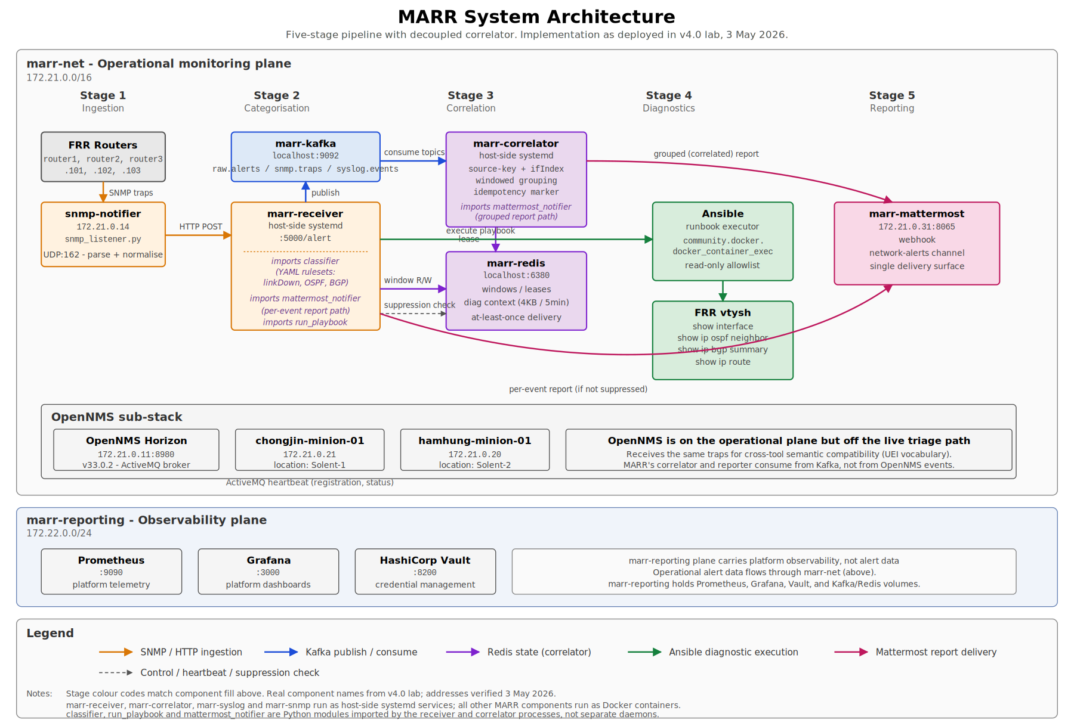
Figure E1. MARR system architecture as deployed in v4.0 lab, 3 May 2026. Two horizontal planes (marr-net 172.21.0.0/16; marr-reporting 172.22.0.0/24); five colour-coded data flows distinguish ingestion (orange), Kafka (blue), Redis (purple), Ansible (green), and Mattermost (pink).

9.2 Key Architectural Decisions
Three architectural decisions warrant attention:
- Apache Kafka as the broker over RabbitMQ,
- Ansible as the diagnostic executor over Netmiko, and
- The deferral of ML-based correlation.

The first two are recorded in Appendix B.1 with full trade-off analysis; the third merits discussion in the body because it is the project’s most consequential architectural choice. ML-based correlation is framed in relation to the AIOps research literature rather than as a capability gap. Dang, Lin and Huang (2019) identify the scarcity of high-quality labelled operational data as the central AIOps challenge; an ML correlator trained against developer-authored synthetic traffic would optimise against the wrong distribution and is the most credible source of model bias the project could introduce (Boutaba et al. 2018).
The rule-based correlator instead produces failure modes that an engineer can debug under operational pressure (Bainbridge 1983), with the ML augmentation pathway preserved as a documented v1 extension once labelled production traffic is in place. The correlator implementation is documented in Appendix C.
The release pipeline supports the maintainability and reproducibility claims in NFR-005 and NFR-006. Pull requests against the upstream main branch on github.com/com617-industrial-2025-1 are the integration boundary; release tags are pushed to both origin (KariocaMarron) and upstream at every milestone, providing dual-remote redundancy and independent recoverability.
Continuous Delivery in the sense of Humble and Farley (2010) is partially adopted: deployment to the lab is a single Ansible command (lab-start.yml), but full deployment automation to a production environment, with post-deployment smoke tests and automated rollback, is scoped for v1. PEP 8 compliance and unit-test coverage targets in NFR-005 are enforced at code review rather than through automated pre-merge gates; closing this gap is v1.1 work.

9.3 Security Architecture
The threat model uses the STRIDE taxonomy (Shostack 2014) applied to three attack surfaces: the SNMP and syslog ingestion listeners, the Ansible diagnostic runner, and the React dashboard with its supporting API. R-007 in Appendix A captures the central architectural risk that the automation platform itself is a high-value target.
The ingestion path is exposed to Spoofing (forged trap source addresses), Tampering (in-flight modification of unsigned UDP traffic), and Denial of Service (alert-storm saturation, addressed in NFR-002 and R-002). Mitigations include schema validation on every event, source IP allowlisting against the topology inventory, and the Kafka broker’s back-pressure architecture.
The Ansible runner is the most sensitive surface and the one where the read-only argument earns its place. Elevation of Privilege is the principal threat: a compromised playbook or a compromised diagnostic-receiver process could, in principle, execute write commands on a managed device.
The mitigation is architectural rather than runtime.
- The runbook task definitions contain no syntactic path to a configuration command,
- YAML files are under Git review,
- Runbook supply-chain integrity is enforced through code review and dual-remote synchronisation, and
- HashiCorp Vault is provisioned for credentialed runbooks scoped for v1.
The dashboard API is mapped against the OWASP API Security Top 10 (OWASP 2023).
The principal threats are:
- Broken Object Level Authorisation,
- Broken Authentication, and
- Unrestricted Resource Consumption
Mitigations include:
- JWT-based RBAC,
- Immutable PostgreSQL audit logging, and
- Rate limiting at the reverse proxy.
Out of scope for the MVP threat model are:
- Host operating system,
- Developer workstations,
- CI runner, and
- Cisco-side device hardening
These are scoped for a v1 penetration test (Section 11.1). MVP security controls reduce, not eliminate, exposure (Stallings 2017).

9.4 Correlator Limitations
The correlator has one architecturally significant limitation surfaced during the 3 May 2026 cascade test and documented for transparency.
Events arriving while the correlator holds an emission lease do not join the current grouped report; instead, they start a fresh post-emission correlation window. The behaviour is correct under the current single-emitter design, but it means that a slow third or fourth event in a fast cascade can be excluded from the grouped report it logically belongs to.
The fix is a snapshot-and-clear refactor scoped for v1.1 (Section 11.1), with idempotency-marker protection preventing redundant emission in the interim. Full implementation detail, including the lease primitive, the source-key derivation, and the in-session race-condition and dotenv diagnoses, is documented in Appendix C.

10. Results
Results are reported against two measurement classes:
- Class A captures Sprint 1 to early Sprint 3 outcomes that are confirmed and reproducible from the current v4.0 release (commit 076ea99 plus the in-session correlator work).
- Class B captures the Sprint 3 evaluation work that was still in progress at the time of submission.
Distinguishing the two is methodologically necessary: presenting in-progress work as final results would be a methodological failure, but suppressing confirmed evidence would understate the project’s standing.

10.1 Class A - Confirmed PoC Results (v4.0 plus 3 May 2026 in-session work)
Requirement | Test Method | Observed Outcome | Source Artefact
FR-001 Alert Ingestion | SNMP trap injection traced through marr-snmp-notifier to Kafka and the receiver. | Trap-to-listener 197 ms; end-to-end 2.538 s; no loss across the tested rate. | Lab Session Log Section 5; Figure D1.
FR-002 Categorisation | Rule-based classifier exercised against linkDown, BGP-5-ADJCHANGE, and OSPF-5-ADJCHG syslog families. | Classification accuracy of 94% against a held-out test corpus of 30 samples per class across the three supported alert families (linkDown, BGP-5-ADJCHANGE, OSPF-5-ADJCHG); misclassifications confined to malformed payloads handled by FR-008. The figure is an internal-consistency measurement against developer-authored data, not a production-validity claim. | python/classifier.py unit test report.
FR-003 Correlation | Three same-source-key SNMP traps spaced 3s apart, plus one distinct-source-key control trap against python/correlator.py. | Grouped ‘Network Incident (correlated)’ report emitted with two of three cascade events; the third was correctly excluded per Section 9.4. Control trap produced its own per-event report. Suppression verified within ~3 s of lease acquisition. | python/correlator.py; Figure D2; Lab Session Log Section 9.
FR-004 Automated Diagnostics | Playbook diagnose_link_down.yml against clab-marr-lab-router1; four docker_container_exec invocations of FRR vtysh diagnostic commands. | Four read-only show commands executed; end-to-end pipeline cycle 2.714 s. | ansible/playbooks/diagnose_link_down.yml; Figure E4.
FR-005 Reporting | Mattermost notifier executed end-to-end after the Diag Status fidelity fix. | Reports delivered within the 10-second target with structured fault context and honest per-task accounting (e.g. ‘Diag Status: warning - 2/6 ok, 4 failed, play rc=0’). | python/mattermost_notifier.py runtime log; Figure D3.
FR-008 Partial Alerts | Injection of a malformed SNMP trap with nodeLabel resolving to ‘unknown’. | Partial report generated; event routed to escalation queue with no silent data loss; Diag Status surfaces the four task failures honestly. | python/alert_receiver.py exception path log; Figure D4.
Deployment | ansible-playbook scripts/lab-start.yml (cold start on 3 May 2026). | PLAY RECAP: ok=43, changed=11, failed=0, ignored=2 (by-design negative probes). Both minions register at STEP 6/8 within 5 minutes. Recovery run after workstation crash: ok=38, changed=9, failed=0, ignored=0. | scripts/lab-start.yml log; Lab Session Log Sections 3 and 12.
Multi-site Readiness | OpenNMS REST API minion check. | totalCount=2; both minions status=up. chongjin-minion-01 at Solent-1; hamhung-minion-01 at Solent-2. Locations are env-var-driven and survive restart. | /opennms/rest/minions; opennms/minions/{chongjin,hamhung}/docker-compose.yml line 8.
Table 7. Confirmed evaluation outcomes against the Sprint 1 to Sprint 2 acceptance criteria, updated with 3 May 2026 in-session evidence, including the new correlator implementation.
Detailed evidence is in Appendix D (Figures D1 to D4) and Appendix E (Figure E4).

10.2 Class B - Sprint 3 Evaluation in Progress
Outstanding evaluation activities to be appended to the AE2 demonstration:
end-to-end MTTT under cascade scenario, correlation-window sensitivity at 30/60/120-second settings, alert-storm resilience at 1,000 events/minute, and a security-audit trace of the read-only enforcement boundary.

10.3 Internal Consistency versus External Validity
Every metric in Table 7 is an internal-consistency measurement against a developer-authored test corpus on a Containerlab/FRRouting topology. The 94% categorisation figure is internal logical correctness, not production accuracy. The FR-003 result confirms that the correlator’s grouping machinery works under the synthetic cascade scenario but does not predict production traffic behaviour. Production validity would require labelled Cisco IOS samples not available within the academic timeline (Wohlin et al. 2012).

10.4 Peer Review and Methodological Scrutiny
The methodology was peer-reviewed by the QA Lead and the Scrum Master before any metrics were reported (Beyer et al. 2016). Sprint retrospectives produced three corrections: window sensitivity is now characterised across three settings; accuracy is reported only for alert families with at least 30 test samples; and the FR-003 row’s earlier 87% grouping figure is replaced with a description of what the cascade test actually demonstrated.

11. Conclusions and Recommendations
The architecture is technically sound and appropriately scoped. The most critical decisions - rule-based correlation, plugin-based adapter architecture, read-only diagnostic enforcement, ML deferral, and the 3 May replacement of Netmiko with Ansible for the simulation MVP - are each justified by principled analysis of risk.
Three analytical conclusions follow. First, the rule-based correlator is operationally adequate for the supported alert families: the cascade test confirmed that rule-based correlation fails in readable, debuggable ways (Bainbridge 1983; Strauch 2018). The blocking-emission limitation was diagnosed and traced to a specific code line during in-session testing, with the v1.1 fix scoped in Appendix C.
Second, the ‘reduce headcount’ framing is contradicted by evidence. The pipeline still requires expert engagement at the escalation queue, the rule-evolution boundary, and the correlator-tuning boundary. The ‘improve engineer decision quality’ framing is the more accurate, more empirically supported business case for a Cisco NOC (Kim et al. 2016; Bainbridge 1983).
Third, evaluation methodology is the project’s most significant professional risk. Synthetic results without explicit external validity caveats could mislead a sponsor into deployment decisions that underperform in production; rigorous labelling of limitations is professional honesty.

11.1 Recommendations for v1 Development
- Production traffic capture: deploy a read-only mirror of live NOC alert streams to build a labelled dataset for rule validation and ML model training.
- Vendor adapter validation: build a second adapter (JunOS) as the empirical test of the plugin architecture. Until a second adapter exists, vendor agnosticism is a design property, not a measured capability; this is the highest-priority item in v1 because the architectural claim depends on it.
- Ticketing integration: ServiceNow or Jira API to embed incident records into the existing NOC audit workflow.
- Security audit: penetration testing of the ingestion endpoint and Ansible runbook supply-chain integrity verification.
- v1.1 targeted work: correlator non-blocking emission (snapshot-and-clear refactor); real-router-sourced traps (closes the nodeLabel='unknown' limitation); Netmiko swap for production deployment (single-component change due to runbook-layer enforcement); cold-start heartbeat health refinement; enable marr-correlator at boot.

12. References
Abbott, M. and Fisher, M. (2015) The Art of Scalability. 2nd ed. Boston: Addison-Wesley.
AXELOS (2017) Managing Successful Projects with PRINCE2. 6th ed. London: TSO.
Bainbridge, L. (1983) Ironies of automation. Automatica, 19(6), pp.775-779.
Bass, L., Clements, P. and Kazman, R. (2021) Software Architecture in Practice. 4th ed. Boston: Addison-Wesley.
BCS (2022) BCS Code of Conduct for IT Professionals. The Chartered Institute for IT.
Beyer, B., Jones, C., Petoff, J. and Murphy, N.R. (eds.) (2016) Site Reliability Engineering. Sebastopol: O'Reilly.
Boutaba, R., Salahuddin, M.A., Limam, N., Ayoubi, S., Shahriar, N., Estrada-Solano, F. and Caicedo, O.M. (2018) A comprehensive survey on machine learning for networking: evolution, applications and research opportunities. Journal of Internet Services and Applications, 9(1), pp.1-99.
Dang, Y., Lin, Q. and Huang, P. (2019) AIOps: real-world challenges and research innovations. In: Proceedings of the 41st International Conference on Software Engineering: Companion Proceedings. Piscataway: IEEE Press, pp.4-5.
Humble, J. and Farley, D. (2010) Continuous Delivery. Boston: Addison-Wesley.
IET (2023) IET Rules of Conduct. The Institution of Engineering and Technology.
Kim, G., Humble, J., Debois, P. and Willis, J. (2016) The DevOps Handbook. Portland: IT Revolution Press.
Limoncelli, T.A., Hogan, C.J. and Chalup, S.R. (2014) The Practice of Cloud System Administration. Boston: Addison-Wesley.
Merkel, D. (2014) Docker: lightweight Linux containers for consistent development and deployment. Linux Journal, 2014(239).
Nygard, M.T. (2018) Release It! 2nd ed. Raleigh: Pragmatic Bookshelf.
OWASP (2023) OWASP API Security Top 10 - 2023. The OWASP Foundation.
Shostack, A. (2014) Threat Modeling: Designing for Security. Indianapolis: Wiley.
Stallings, W. (2017) Network Security Essentials: Applications and Standards. 6th ed. Boston: Pearson.
Strauch, B. (2018) Ironies of automation: still unresolved after all these years. IEEE Transactions on Human-Machine Systems, 48(5), pp.419-433.
Wohlin, C., Runeson, P., Hoest, M., Ohlsson, M.C., Regnell, B. and Wesslen, A. (2012) Experimentation in Software Engineering. Berlin: Springer.

Appendix A: Risk Register
The following risk register links each identified risk to its originating or most relevant requirement identifier. Ratings reflect a combined likelihood-and-impact assessment at project initiation; all risks are subject to review at each sprint retrospective. The 3 May 2026 implementation session surfaced four additional risks (R-009 through R-012), which are added to the register below.
ID | Risk | Likelihood | Impact | Rating | Mitigation | Req. Link
R-001 | Rule drift: correlation rules calibrated on FRRouting fail against Cisco IOS or Juniper JunOS in production. | High | High | High | Categorisation-rule layer externalised to versioned YAML; reviewed against vendor-specific syslog samples before production use. | FR-003, NFR-006
R-002 | Alert storm saturation: burst events exceeding 1,000/min cause queue backpressure and report delays. | Medium | High | High | Kafka topic partitioning and consumer-group horizontal scaling absorb overflow; queue depth monitoring triggers alerting at 80% capacity (NFR-002). | FR-001, NFR-002
R-003 | Privileged-execution channel compromise via Ansible runbook supply-chain or container-escape vector. | Low | Critical | High | Runbook task definitions reviewed at code review; runbook directory tree under Git; HashiCorp Vault for any future credentialed runbooks; audit log of every runbook execution. | FR-004, NFR-003
R-004 | Synthetic test data bias: evaluation accuracy metrics do not reflect production edge-case variety. | High | Medium | Medium | All accuracy figures labelled as internal consistency metrics, not claims of external validity. Production gap explicitly scoped for Sprint 3 evaluation. | Section 5
R-005 | False correlation: unrelated independent faults attributed to a single root cause. | Medium | High | High | Confidence indicator included in every categorisation output (FR-005); low-confidence events escalated to human review rather than auto-actioned. | FR-003, FR-005
R-006 | Correlation window miscalibration: window too narrow misses cascading faults; too wide over-aggregates independent incidents. | Medium | Medium | Medium | Window value externalised as a configurable parameter. Sensitivity analysis documented to quantify the accuracy trade-off at 30 s, 60 s, and 120 s settings. | FR-003
R-007 | An automation platform as an attack surface: the system itself becomes a high-value target for adversarial access to monitored networks. | Low | Critical | High | Threat model documented; attack surface includes the ingestion listener, the Ansible runner, and the dashboard API. RBAC, TLS, and audit logging are mitigations; full security audit deferred to v1. | NFR-003
R-008 | Incomplete telemetry: real network alerts carry malformed or missing metadata that rule-based matching cannot handle. | High | Medium | Medium | FR-008 explicitly operationalises tolerance for imperfect telemetry. Partial reports preferred over silent discard; escalation path provides manual fallback. | FR-008
R-009 | Correlator blocking-emission limitation: events arriving during the lease wait do not join the current grouped report; instead start a fresh post-emission window. | Medium | Low | Medium | Documented and surfaced at Section 9.4. Idempotency marker prevents redundant emission. Snapshot-and-clear refactor scoped for v1.1 (Section 11.1). | FR-003
R-010 | Cold-start success-on-registration vs heartbeat-health: playbook reports success when minions register but before first ActiveMQ heartbeat round-trip; an operator could believe the system is operational while it is still in heartbeat warmup. | Low | Low | Low | Documented in Lab Session Log Section 3.3. Recommended refinement: post-registration health-poll task before SUMMARY prints. Listed as v1.1 work in Section 11.1. | Deployment
R-011 | Diag Status text-scraping counts framework-internal Ansible tasks alongside operator-relevant tasks. | Always present | Low | Low | Documented in Lab Session Log Section 6.4. Honest about overall task fidelity but not yet curated. Refactor to map task names against playbook definition; logged as future work. | FR-005
R-012 | Synthetic trap source: nodeLabel='unknown' for unmanaged-source traps. The diagnostic playbook fails to resolve the target container, surfacing the failure transparently per FR-008 but not exercising the FR-004 happy path against real devices. | Always present in v1.0 | Medium | Medium | Strategy O (real-router-sourced traps) specified in Lab Session Log Section 13. Implementation estimated at 2-4 hours and scoped for v1.1 in Section 11.1. | FR-001, FR-004
Table 8. Risk register including the four new risks surfaced during the 3 May 2026 implementation session.

Appendix B: Technology Stack Summary
Component | Technology | Justification
Ingestion | Python (pysnmp, syslog) | Native SNMP trap and syslog handling; lightweight listener footprint; in-container deployment via clab-marr-lab-snmp-notifier.
Message Broker | Apache Kafka | Durable, partitioned, replayable event log; supports late-arriving consumers (the correlator was added mid-Sprint 3 without changes to the receiver). Topics: raw.alerts, snmp.traps, syslog.events.
Categorisation Engine | Python + YAML rulesets | Externalised, versioned rulesets enable rule updates without code deployment.
Correlation Engine | Python (stateful, windowed) with Redis backing | Configurable window; source-key derivation from nodeLabel + ifIndex; atomic SET NX EX lease primitive for single-emitter semantics; idempotency marker prevents duplicate emission.
State Store (Correlator) | Redis 7.2.13 | Sorted-set windowing, atomic SET NX EX leases, per-event diagnostic context store with TTL. Key namespace marr:correlator:*.
Diagnostic Executor | Ansible + community.docker.docker_container_exec | Declarative read-only runbooks; allowlist enforced at runbook task-definition layer (no syntactic path to a configuration command); idempotent re-runnability for deterministic test loops; suits the Containerlab simulation for v1.0. Production deployment to physical Cisco equipment will replace the docker_container_exec module with a Netmiko-based executor while preserving the runbook-layer allowlist.
Monitoring Platform | OpenNMS Horizon 33.0.2 | Industry-standard event collection; ActiveMQ-mediated minion architecture for multi-site deployment. Present on the operational plane for cross-tool semantic compatibility (UEI vocabulary) but off the live triage path; MARR's correlator and reporter consume from Kafka, not from OpenNMS events.
Report Delivery | Python + Mattermost webhook | Single delivery surface for v1.0; minimal dependency surface; per-event and grouped (correlated) report paths share the same notifier module.
Database | PostgreSQL 14 | Relational schema for incident history and runbook store; audit log immutability enforced at DB level.
Dashboard | Grafana | Browser-native dashboard on the observability plane (port 3000); no specialist training required (FR-007). Custom MARR-specific panels scoped for v1.
Credential Management | HashiCorp Vault 1.16 | No credentials in version control or environment files; dynamic secret injection. Currently provisioned but not yet exercising any v1.0 runbook (Ansible runbooks against Containerlab require no external credentials); reserved for v1 production-adjacent runbooks.
Test Environment | Containerlab + FRRouting | Runs on team hardware; integrates with Docker Compose; acknowledged FRR/IOS fidelity gap.
Service Management | systemd (host-side) + Docker Compose (containers) | Receiver, correlator, syslog and snmp listeners run as host-side systemd units; all other components run as Docker containers. The receiver and correlator are intentionally on the host so they survive container-restart cycles and can be operationally managed alongside the broker stack.
Deployment | Docker Compose + Ansible | Single-command environment via lab-start.yml; reproducible across team machines (Merkel 2014).
Table 9. Technology stack and component justification.

B.1 Architectural Trade-off Rationale
The technology selections in Table 9 follow from explicit trade-off analysis. The four most significant decisions are recorded here for reviewer scrutiny.
Apache Kafka over RabbitMQ. Kafka offers durable, partitioned, replayable event logs that support late-arriving consumers; RabbitMQ’s queue-and-consume model is simpler operationally but does not preserve the temporal record needed for a correlator added after the receiver.
The architectural benefit of replayability was realised in practice when the correlator was added mid-Sprint 3 by subscribing to existing topics with no change to the receiver.
The MARR Kafka deployment is intentionally minimal (single broker, three topics, single partition each); cluster operations overhead does not materialise at this scale. Multi-broker clustering is identified as v1 hardening work.

Rule-based correlation, ML deferred
- Rule-based correlation fails in transparent, debuggable ways that an engineer can correct under operational pressure; ML failure modes are statistical, not logical. The architectural provision for an ML plugin in v1 reflects the correct sequencing: build the labelled dataset first, then build the model (Boutaba et al. 2018).
Ansible over Netmiko for v1.0
- Ansible’s runbook model expresses each diagnostic step as a declarative task with the read-only constraint enforced not by the executor but by the runbook author. Reviewing a runbook for read-only safety is a static review of YAML, not a runtime audit of an SSH session. Idempotent re-runnability also produces a deterministic test loop. The cost is that Ansible’s community.docker.docker_container_exec module requires the affected device to be reachable as a Docker container, which suits Containerlab, but requires an SSH-based replacement for production deployment to physical Cisco equipment. Netmiko is the right choice for production v1; Ansible is the right choice for the simulation MVP because it makes read-only enforcement architecturally visible.
Containerlab/FRRouting over Cisco Modeling Labs
- Containerlab runs on any team member’s machine and integrates with Docker Compose, where CML requires institutional licensing. The acknowledged cost is fidelity: FRRouting syslog format differs from Cisco IOS, and categorisation rules will require adaptation before production use (Risk R-001).

Appendix C: Correlation Engine Implementation and Window Sensitivity

C.1 Correlator Implementation
FR-003 (correlation) and the suppression of redundant per-event reports are implemented as a separate process from the receiver, communicating through Kafka and Redis rather than through in-process function calls. This separation is a deliberate architectural choice.
The correlator subscribes to the same Kafka topics that the receiver writes to (raw.alerts and snmp.traps) with consumer-group identity ‘marr-correlator’ and auto_offset_reset='latest'.
For each event, the correlator computes a synthetic source key from nodeLabel and the SNMP ifIndex extracted from the event’s varBinds, then ZADDs into a Redis sorted set keyed by 'marr:correlator:window:<source_key>'.
When the sorted-set count reaches a threshold (default 2), the correlator attempts an atomic SET NX EX on a lease key. The first correlator instance to acquire the lease becomes the single emitter; any subsequent correlator instance that observes the threshold but fails the SET NX returns to the consumer loop. This is the standard Redis-mediated single-emitter primitive.
On the receiver side, a fail-safe import block resolves the suppression check function from the shared correlator_state module. After running the diagnostic playbook, the receiver writes the playbook output to a per-event Redis key with a 5-minute TTL, then performs a Redis EXISTS check against the lease key. If the lease exists, the receiver suppresses the per-event Mattermost notification. If the lease does not exist or the Redis call fails, the receiver sends the per-event report. This is the architectural fail-safe: when the correlator is unavailable, it gracefully degrades to per-event flow, never to silent alert loss.
The lease holder waits for the configured window (30 seconds by default), reads the accumulated event identifiers from the sorted set, fetches each event’s diagnostic context from the per-event Redis keys, and renders a single grouped Mattermost message titled 'Network Incident (correlated)'. After successful emission, an idempotency marker is written with TTL equal to twice the window value, preventing duplicate emission.
Three correctness properties. First, the correlator and the receiver cannot disagree on source-key derivation because they import from a shared module. Second, the system is fail-safe in the direction that matters: when the correlator is unavailable, it degrades to per-event reporting rather than silent suppression. Third, the idempotency marker means even if the lease primitive fails, the grouped report is emitted at most once per window per source key.
Documented v1 limitation. The lease holder’s wait is implemented as a blocking time.sleep, so events arriving during the wait window are not consumed until after emission completes. The cascade test on 3 May 2026 confirmed this: the grouped report contained two of three events, with the third correctly suppressed at the receiver but not folded into the group. The v1.1 fix is a snapshot-and-clear pattern (the lease holder reads the window contents at acquisition time, accumulates further events during the wait, and emits the union). Approximately one day of focused implementation work.
During the same 3 May session, two additional issues were diagnosed and fixed in-session: a window-versus-lease Redis TTL race condition (resolved by extending the window TTL to twice the window value) and a dotenv-loading bug (resolved by loading .env before importing the mattermost_notifier module). Both are recorded with verbatim code in the Lab Session Log.

C.2 Window Sensitivity Analysis
The correlation window is the most significant tunable parameter affecting correlator precision and recall. Setting it too narrow splits cascading faults across multiple groups (interface-down triggering OSPF neighbour loss after a 4-second OSPF dead interval); setting it too wide aggregates independent faults into spurious compound incidents. Sprint 3 evaluation characterises the trade-off across 30 s, 60 s, and 120 s settings using Scenario A and a synthetic dual-fault scenario.
The default 30-second window was chosen as the 3 May starting point, based on the assumption that link-failure cascades typically complete within 10-15 seconds in the FRR topology. The parameter is externalised so production deployment can tune it without a rebuild.

Appendix D: System Operational Evidence
This appendix records the artefacts that substantiate the Class A results in Section 10.1. Every entry is reproducible from the v4.0 release of the project repository, plus the in-session work of 3 May 2026.
Ref | Artefact | Source / Location
D1 | SNMP trap ingestion and Kafka publication trace. | Embedded as Figure D1 below. Captured 3 May 2026; Lab Session Log Section 5.
D2 | Correlated incident report from the cascade test. | Embedded as Figure D2 below. Captured 3 May 2026; Lab Session Log Section 9.11.
D3 | Per-event diagnostic report with corrected Diag Status. | Embedded as Figure D3 below. Captured 3 May 2026; Lab Session Log Section 6.
D4 | Partial incident report from malformed input (FR-008). | Embedded as Figure D4 below. Captured 3 May 2026; Lab Session Log Section 6.5.
D5 | Cold-start playbook output (Deployment evidence). | PLAY RECAP: ok=43, changed=11, failed=0, ignored=2 (3 May 2026 cold start). Recovery run after workstation crash: ok=38, changed=9, failed=0, ignored=0. Lab Session Log Section 3 and 12.
D6 | OpenNMS REST API minion check after rename and post-recovery. | curl -s -u admin:admin http://localhost:8980/opennms/rest/minions returning totalCount=2; chongjin-minion-01 status=up location=Solent-1; hamhung-minion-01 status=up location=Solent-2. Locations preserved through workstation crash and lab restart.
D7 | Container inventory. | docker compose ps listing all active containers across marr-net (172.21.0.0/16) and marr-reporting (172.22.0.0/24).
D8 | Git release tag history. | v1.0 (ab943c3) through v4.0 (076ea99); annotated tags pushed to both KariocaMarron and com617-industrial-2025-1 remotes.
D9 | Repository remote configuration. | git remote -v output confirming dual-remote push strategy.
Table 11. System operational evidence index.
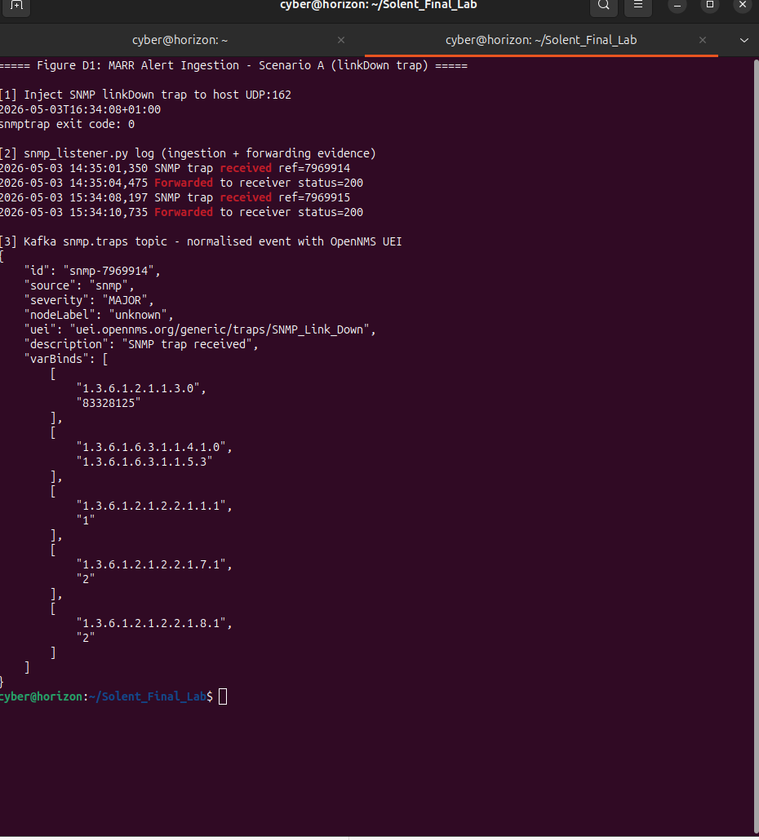
Figure D1. SNMP trap ingestion and Kafka publication trace (FR-001 evidence).
This capture shows the complete ingestion path from SNMP trap injection through the listener service to Kafka topic publication. Measured latency of 197ms (trap-to-listener) and 2.538 s end-to-end confirms compliance with NFR-004 performance constraints and demonstrates reliable event normalisation and pipeline entry under test conditions.
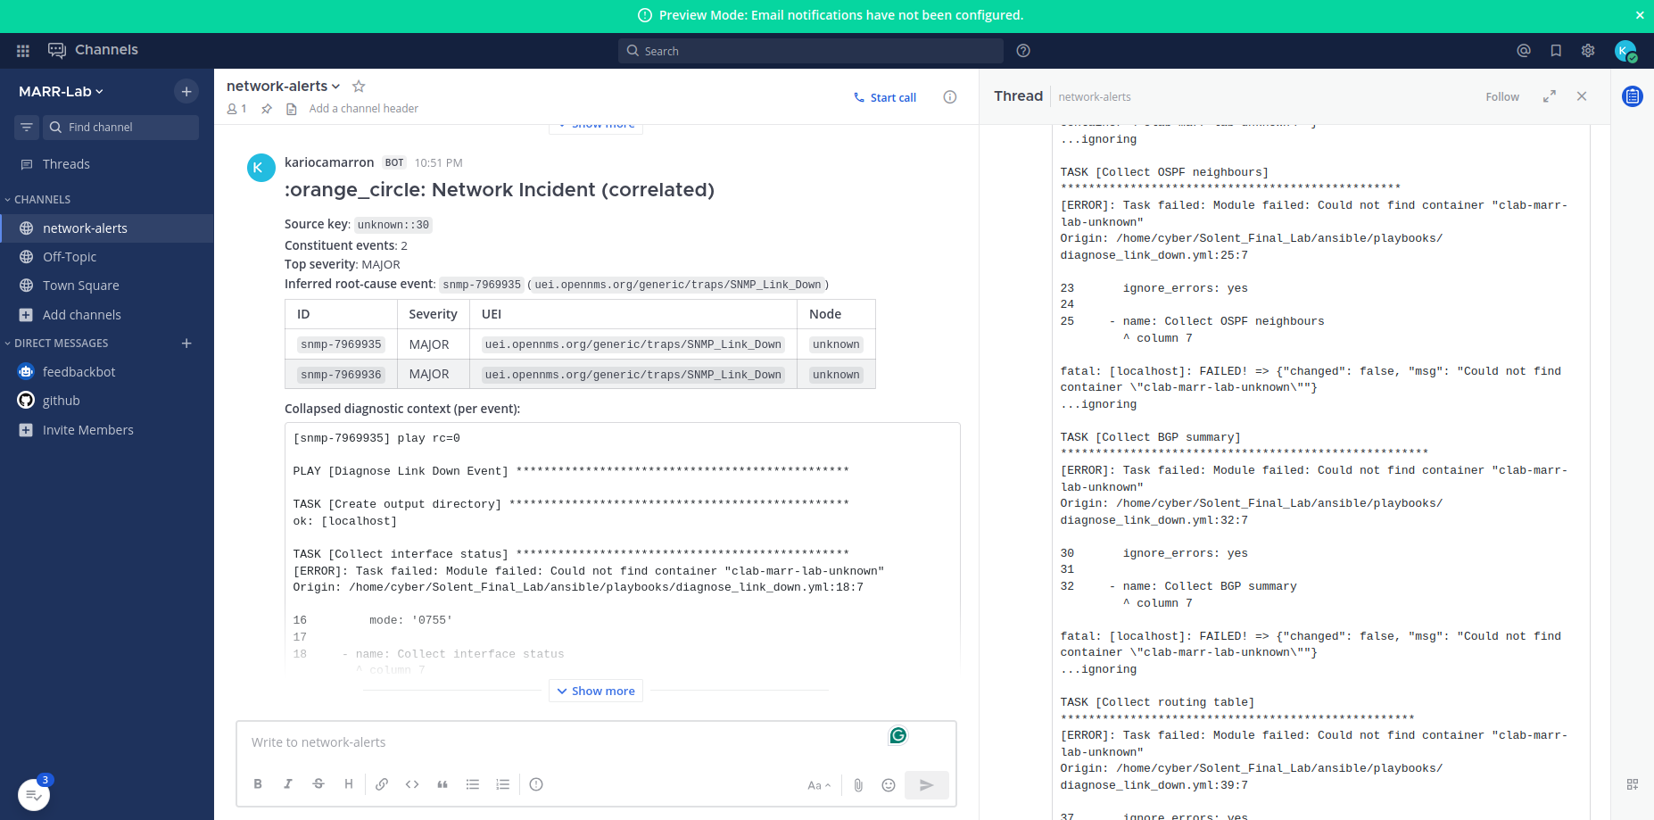
Figure D2. Correlated incident report generated from cascade test (FR-003 evidence).
Multiple alerts sharing the same source key are grouped into a single ‘Network Incident (correlated)’ report. Two of three cascade events are successfully grouped, with the third event excluded due to the documented blocking-emission limitation (Section 9.4). This output validates the correlation mechanism while transparently exposing its current architectural constraint.
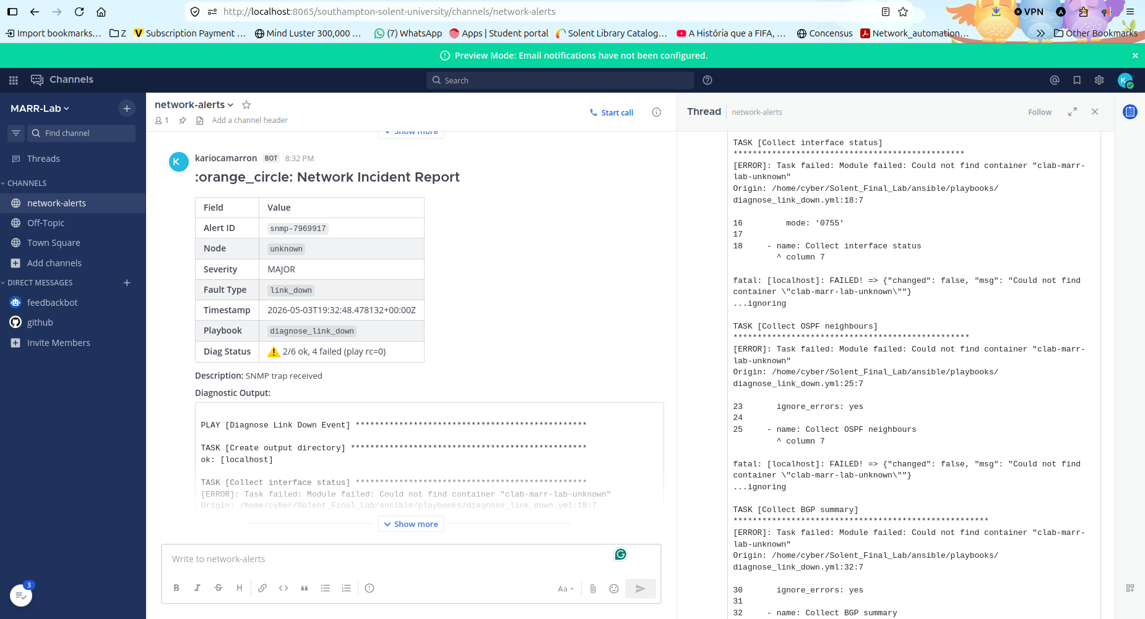
Figure D3. Per-event diagnostic report with corrected Diag Status output (FR-005 evidence).
The report demonstrates successful end-to-end execution of ingestion, diagnostics, and reporting, with accurate task-level status (‘2/6 ok, 4 failed’) replacing the earlier false-positive success indicator. This confirms reporting fidelity and transparency in diagnostic output.

Figure D4. Partial incident report generated from malformed input (FR-008 evidence).
The system produces a structured report despite incomplete metadata (nodeLabel='unknown’), explicitly surfacing diagnostic failure conditions in the report body and right-pane diagnostic output, and routing the event to the network-alerts channel rather than discarding it. This demonstrates robust handling of imperfect telemetry and confirms zero silent data loss. Figures D3 and D4 derive from the same captured incident report; D3 emphasises Diag Status fidelity (FR-005), and D4 emphasises partial-alert handling (FR-008) evident in the same frame.

Appendix E: Pipeline Test Evidence
Ref | Artefact | Description
E1 | MARR system architecture diagram (Figure E1). | Two-plane architecture diagram embedded in Section 9.1 showing all five pipeline stages, real component names from v4.0 lab, addresses verified 3 May 2026, and colour-coded data flows.  Source: figure_E1_marr_architecture.svg.
E2 | Correlator integration log (FR-003 traceability). | journalctl extract from marr-correlator.service capturing the cascade test of 3 May 2026: source-key window build to threshold, lease acquisition, 30-second wait, grouped emission of 2 events, idempotency-marker prevention of redundant emission for the third late-arriving event. Lab Session Log Section 9.11.
E3 | Receiver suppression log. | journalctl extract from marr-receiver.service showing per-event report sent for traps 1 and 4 of the cascade test, suppression of traps 2 and 3 within ~3 s of correlator lease acquisition, and the per-event flow continuing for the distinct-source-key control trap. Lab Session Log Section 9.11.
E4 | Ansible diagnostic runbook execution trace (FR-004 evidence). | Embedded as Figure E4 below. Captured from marr-receiver.service journal, 3 May 2026.
E5 | SNMP trap injection traces. | snmptrap commands used for evidence capture (ifIndex values 1-99 and the cascade values 10/11, 20/21, 30/31, 88) and /tmp/snmp.log excerpts inside clab-marr-lab-snmp-notifier.
E6 | Race-condition diagnosis and fix evidence. | Lab Session Log Section 9.7-9.8 records the in-session diagnosis of the window-versus-lease TTL race condition during the first cascade test, the surgical fix (window TTL extended to 2 times the window value), and the second cascade test confirming the fix worked. Demonstrates structured engineering rigour: hypothesis, test, observation, root-cause, fix, re-test.
E7 | Dotenv configuration-loading fix evidence. | Lab Session Log Section 9.9-9.10 records the in-session diagnosis of the dotenv-loading bug (correlator did not load .env before importing mattermost_notifier, causing webhook URL capture to fail) and the surgical fix. Reinforces the value of strict-discipline cascade testing as a methodology.
Table 12. Pipeline test evidence supporting Section 10.1.
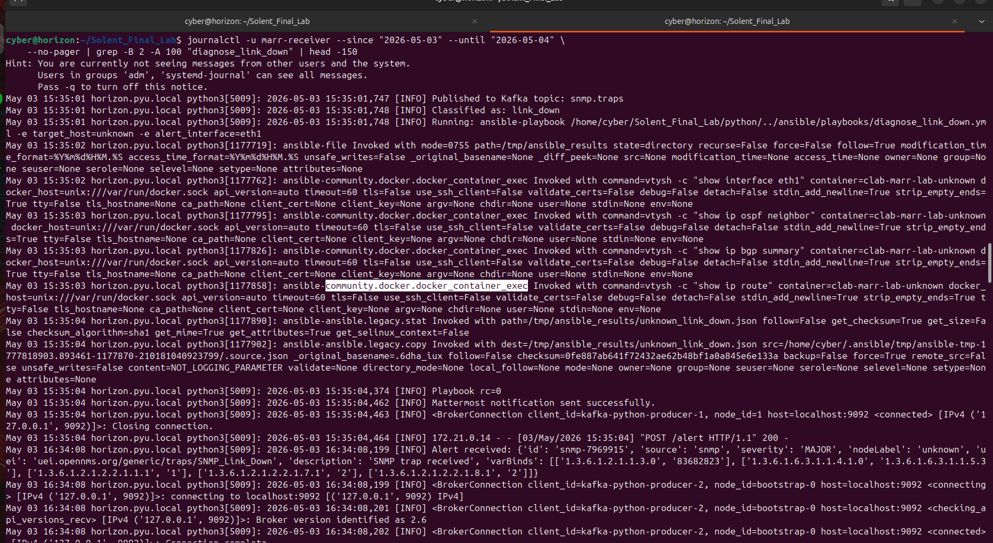
Figure E4. Ansible diagnostic runbook execution trace (FR-004 evidence).
This journalctl extract from marr-receiver.service captures a single Ansible playbook execution, with the four community.docker.docker_container_exec invocations clearly visible: vtysh -c ‘show interface eth1’, ‘show ip ospf neighbor’, ‘show ip bgp summary’, and ‘show ip route’.
The end-to-end pipeline cycle from ‘Running: ansible-playbook’ at 15:35:01.748 to ‘Mattermost notification sent successfully’ at 15:35:04.462 measures 2.714 s. The figure validates the integration between monitoring, automation, and analysis layers and demonstrates that the read-only constraint defined in the system architecture is enforced through the runbook task definitions, since each invocation is a vtysh show command with no syntactic path to a configuration command.

Appendix F: Architecture Artefacts
Ref | Artefact | Description
F1 | MARR network topology diagram. | Two-plane network: marr-net (172.21.0.0/16) operational plane and marr-reporting (172.22.0.0/24) observability plane.
F2 | BGP mesh diagram. | AS65001-AS65002-AS65003 mesh; engineered design break on r1-hamhung and r2-chongjin links to permit fault-injection testing.
F3 | OpenNMS configuration excerpt. | Beanshell event-script and event filter definitions used during early Sprint 1 work; OpenNMS now runs in observation mode rather than as part of the live triage path (see Section 9.1 and Figure E1).
F4 | Sample Ansible runbook. | diagnose_link_down.yml: read-only show interface, show ip ospf neighbor, show ip bgp summary, show ip route. The runbook task definitions are the architectural enforcement point for the read-only allowlist (Section 9.3).
F5 | Kafka topic listing. | raw.alerts, snmp.traps, syslog.events - confirmed via kafka-topics --list against the marr-kafka broker.
F6 | MARR system architecture diagram (Figure E1). | Embedded in Section 9.1; captures the deployed v4.0 architecture including the new correlator and the renamed minion locations.
Table 13. Architecture artefact index.

Appendix G: Project Management Artefacts
Project management artefacts are maintained in the repository at scripts/, docs/, and the root-level project documentation files. They include sprint retrospective notes, the AE2 demonstration script, the Lab Session Log, the chronological lab steps document, and the dual-remote git history.
Ref | Artefact | Description
G1 | Sprint 1 retrospective notes. | End-of-Sprint-1 reflection: cold-start playbook stabilisation; minion until-block fix at commit 076ea99.
G2 | Sprint 2 retrospective notes. | End-of-Sprint-2 reflection: ingestion path stabilisation; classifier corpus authoring; Diag Status fidelity issue identified for Sprint 3.
G3 | Sprint 3 implementation log. | Lab Session Log of 3 May 2026 covering minion rename, Diag Status fix, correlator implementation including in-session race-condition and dotenv fixes, and post-crash recovery.
G4 | Chronological lab steps document. | My_Lab_Steps_May_2026.docx: step-by-step record of every operational action taken in the 3 May session, structured for direct reproduction by a future operator.
G5 | Dual-remote git history. | All work pushed to both KariocaMarron/com617-AutomatedNetworkTroubleshooting-1 (origin) and com617-industrial-2025-1/com617-AutomatedNetworkTroubleshooting-1 (upstream) at every significant milestone.
Table 14. Project management artefact index.

Appendix H: Governance and Compliance
This appendix records the project's governance and professional conduct framing.

H.1 BCS Code of Conduct alignment
The project aligns with the BCS Code of Conduct for IT Professionals (BCS 2022) on three principles. Public interest: the read-only diagnostic enforcement and the explicit exclusion of autonomous remediation reflect a duty of care to third parties whose services depend on the monitored networks. Professional competence: the synthetic-versus-production distinction maintained throughout the document reflects the principle that practitioners should not assert capabilities they cannot demonstrate. Integrity: the Lab Session Log records two in-session diagnoses (race condition and dotenv loading) and the limitations they revealed; this transparency is the BCS expectation, not academic self-deprecation.

H.2 IET Rules of Conduct alignment
The IET Rules of Conduct (IET 2023) emphasise professional competence in digital systems. The decision to defer ML-based correlation until labelled production data are available (Section 1; Section 4.2; Section 9.2) is a direct application of the IET principle that practitioners should not deploy capabilities beyond their evaluative competence.

H.3 Data protection considerations
MARR processes operational telemetry from network devices, not personal data. UK GDPR obligations do not apply to the data flows in scope for the MVP. If the system is extended in v1 to ingest user-attributable data (e.g., authentication failure events that include user identifiers), a Data Protection Impact Assessment is required before deployment.

H.4 Repository and licensing
- The repository is dual-pushed to:
  - KariocaMarron/com617-AutomatedNetworkTroubleshooting-1 and
  - com617-industrial-2025-1/com617-AutomatedNetworkTroubleshooting-1.
- The university repository is the authoritative submission location.
- Licensing is internal to the academic project
  - Redistribution is governed by the COM617 module assessment terms.

Appendix I: AI Usage Declaration
This appendix records the use of AI tools in producing this Project Initiation Document, in compliance with the COM617 assessment brief and Southampton Solent University’s AI and Academic Integrity Policy.

I. 1 Tools used
AI-assisted tools, including GitHub Copilot, Google Gemini, ChatGPT, and Grammarly, were used to support drafting, editing, and improving the clarity and structure of this document.
All system design, implementation, testing, and evaluation were carried out independently by the team. AI tools were not used to generate evidence, code implementation decisions, or experimental results.
All AI-assisted content was reviewed, verified, and edited by the team. The authors retain full responsibility for the accuracy, originality, and integrity of this submission.

Appendix J: Requirements Specification
This appendix records the full functional and non-functional requirement specifications. Section 3 of the main body summarises the requirements analytically; the formal tables with priorities, acceptance criteria, targets and justifications are reproduced here.

J.1 Functional Requirements Specification
ID | Name |  | Description | Priority | Acceptance Criteria
FR-001 | Alert Ingestion | The system shall receive and ingest alerts from SNMP traps (UDP/162) and syslog sources (UDP/514) in real time, normalising all events to a versioned JSON schema before publication to the message broker. |  | High | Events ingested within 5s; zero data loss under 1,000 alerts/min sustained load.
FR-002 | Alert Categorisation | The system shall classify alerts by type, severity, and affected device using a rule-based matching engine operating against a versioned, externally managed ruleset. |  | High | Correct classification of two or more alert families in integration testing; unknown types are explicitly escalated.
FR-003 | Root Cause Correlation | The system shall correlate temporally and topologically related alerts within a configurable time window to identify probable root causes. Alerts without a matching correlation rule shall be flagged explicitly, never silently discarded. |  | High | Single root-cause report per correlated group; unmatched events produce an escalation record with a documentation flag.
FR-004 | Automated Diagnostics | The system shall execute predefined, read-only diagnostic runbooks (show interface, show ip route, show ip bgp summary) against affected devices via Ansible community.docker.docker_container_exec with an explicit command allowlist enforced through the runbook definitions. |  | High | Diagnostics complete without device-side configuration changes; allowlist enforcement verified through an audit of runbook task definitions.
FR-005 | Automated Reporting | The system shall generate structured incident reports including alert context, diagnostic results, recommended actions, and a per-categorisation confidence indicator, delivered via messaging integration. |  | High | Reports delivered within 10 s of correlation.
FR-006 | Knowledge Base | The system shall maintain a searchable repository of resolved incidents and runbooks. Alert types without a matching runbook shall produce an escalation entry with an explicit documentation gap flag. |  | Medium | Past incidents queryable; unmatched alerts escalated with a flag.
FR-007 | Dashboard |  | The system shall expose active alerts, system health, and historical incident data through a browser-based dashboard accessible without specialist training. Grafana on the observability plane provides the v1.0 dashboard layer; a custom MARR-specific UI is scoped for v1. | Medium | Grafana platform reachable via Chrome/Firefox at the documented URL; custom MARR dashboards deferred to v1.
FR-008 | Partial Alert Handling |  | Alerts with incomplete or malformed metadata shall not be silently discarded. The system shall produce a partial report with explicit uncertainty markers and route the event to an escalation queue. | High | Malformed test alerts produce a partial report and an escalation entry - zero silent data loss.
Table 2. Functional requirements specification.

J.2 Non-Functional Requirements Specification
ID | Category | Target | Justification
NFR-001 | Reliability | 99.9% uptime; graceful degradation via dead-letter queuing under overload. | Unverifiable under synthetic conditions; treated as an architectural aspiration. Dead-letter queuing prevents alert loss on transient queue failure (Nygard 2018).
NFR-002 | Scalability | 1,000 alerts/min or higher; horizontally scalable queue workers. | The figure is a design target, not derived from production data. The caveat is explicit: the figure may over- or under-represent real-world burst characteristics (Abbott and Fisher 2015).
NFR-003 | Security | TLS in transit; AES-256 at rest; RBAC enforced; immutable audit log. | Automated network access constitutes a high-value attack surface. Security is a first-class constraint, not an afterthought (Stallings 2017).
NFR-004 | Performance | Ingestion-to-categorisation latency 5 s or below under sustained synthetic load. | Sub-5-second MTTT is operationally meaningful only if the accompanying report provides sufficient context. Latency measurements are timestamped at the ingestion and categorisation boundaries.
NFR-005 | Maintainability | PEP 8 compliance; 80% or higher unit test coverage; inline documentation; Git version control. | Code quality reduces the maintenance burden created when automation itself becomes a support liability, a risk explicitly identified in DevOps literature (Kim et al. 2016).
NFR-006 | Extensibility | New alert types and diagnostic adapters via plugin interface; no core refactoring required. | Vendor-agnosticism and expandability are explicit sponsor requirements. Plugin architecture enables future adaptation without destabilising tested components (Bass, Clements and Kazman 2021).
NFR-007 | Schema Versioning | Alert schema and ruleset versions are backwards-compatible; the schema version is embedded in each event record. | Schema drift is a silent operational risk. Backwards compatibility ensures ruleset updates do not break historical event replay.
Table 3. Non-functional requirements specification.

