COM617 Group 15 - PID AE1 Supplementary Diagrams
Southampton Solent University
School of Technology and Maritime Industries
Computing
MARR System Diagrams
Architecture, Alert Chain, and Reporting Flow
Supplementary deliverable to PID AE1 v10B
Module | COM617 Industrial Consulting Project
Module Leader | Martin Reid
Group | Group 15
Industry Sponsor | James Whale - Cisco Systems
Supporting Tutor | Craig Gallen
Document Type | Supplementary diagrams accompanying the PID
Companion Document | COM617_Group15_PID_AE1_v10B.docx
Diagrams Included | Figure 1 (refreshed system architecture), Figure 2 (alert chain sequence), Figure 3 (Mattermost channel flow)
Date Prepared | 4 May 2026
Version | v1.0
Table 1. Document metadata.

1. Purpose
This document collects three system diagrams produced as supplementary visual material for the COM617 Group 15 Project Initiation Document v10B. The three diagrams complement the prose and tabular evidence already in the PID by addressing distinct visual questions that text alone does not answer well: what the deployed system looks like as a whole, what happens to an individual alert as it traverses the pipeline, and what an engineer sees when consuming the resulting reports.
Each diagram in this document is reproduced at high resolution and is accompanied by a caption identifying its scope and a brief paragraph relating it to the relevant section of the PID. The original SVG sources are available alongside this document so that the diagrams can be re-rendered, edited, or embedded into other deliverables without regeneration.
The three diagrams are structurally distinct and serve different purposes. Figure 1 is a static architecture diagram, Figure 2 is a sequence diagram with two parallel flows, and Figure 3 is a UX-focused mockup of the engineer-facing reporting surface. Reading them together gives a more complete picture of MARR's operational behaviour than any one of them in isolation.

2. Figure 1 - MARR System Architecture (v4.0 lab)
Figure 1 below is a refreshed version of the architecture diagram embedded in PID Section 9.1 (Figure E1). It depicts the deployed v4.0 lab as of 4 May 2026, with two structural updates that distinguish it from earlier renderings.
First, marr-correlator and marr-redis are now drawn as first-class components on the live triage path with a purple 'v4.0 ACTIVE' badge on the correlator service. In earlier project iterations the correlator was either absent or shown as future work; in v4.0 it is the architectural surface that distinguishes per-event from grouped report behaviour, and the diagram reflects this primacy.
Second, the OpenNMS minion containers carry their renamed locations (Solent-1 and Solent-2) shown in green bold text, replacing the original Chongjin and Hamhung location names. The green border on the minion boxes signals that the rename was applied during the 3 May 2026 implementation session and survives crash-recovery cycles. Minion container identifiers (chongjin-minion-01 and hamhung-minion-01) are unchanged from earlier diagrams; only the OpenNMS-recorded location strings differ.
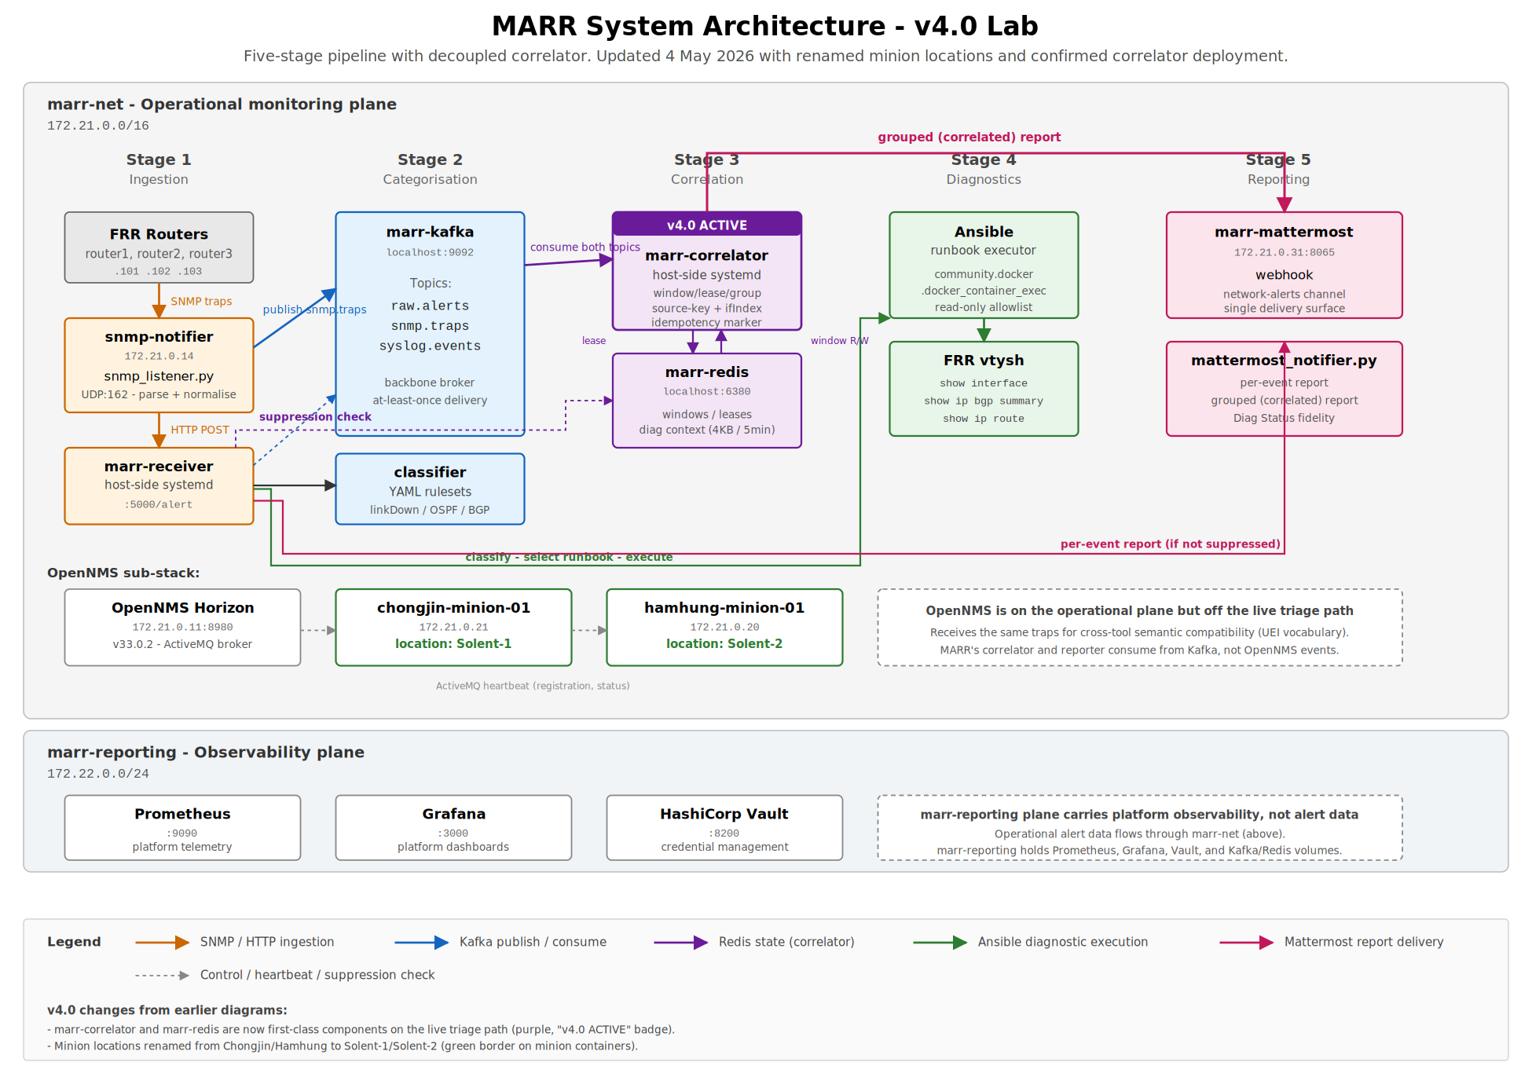
Figure 1. MARR system architecture as deployed in v4.0 lab. Five-stage pipeline across the marr-net operational plane (172.21.0.0/16); marr-reporting plane (172.22.0.0/24) carries platform observability. The 'v4.0 ACTIVE' badge on marr-correlator and the green-bordered minion containers with their Solent-1 and Solent-2 locations are the two visible changes from prior diagrams.
This figure replaces, rather than augments, the original Figure E1 in PID Section 9.1. If embedded into a future PID revision, it should be referenced from the same prose and at the same insertion point.

3. Figure 2 - End-to-End Alert Chain
Figure 2 is a sequence diagram showing two distinct alert flows side by side. The top half (Flow A) traces a single isolated alert from the SNMP trap source through to its eventual per-event Mattermost report, ending with the network-alerts channel rendering. The bottom half (Flow B) traces a cascade of three related alerts that share a source key, illustrating how the correlator engages, how the receiver suppresses redundant per-event reports, and how the lease holder eventually emits a single grouped report.
The visual contrast between the two flows is the diagram's main argument. Flow A is short, linear, and ends with a single Mattermost message; Flow B is longer, contains two distinct decision points where the lease primitive engages, and produces fewer Mattermost messages despite involving more underlying events. The asymmetry between alert volume and report volume in Flow B is the operational benefit that FR-003 (correlation) delivers.
The yellow annotation in the correlator lane in Flow B marks the documented v1.0 architectural limitation: the lease holder's blocking time.sleep means events arriving on the same source key during the wait window are not folded into the current grouped emission. The diagram makes this visible rather than hiding it: trap 3 in Flow B is shown arriving during the lease wait, and the suppression-check arrow correctly produces a HIT, but no arrow connects trap 3 back to the grouped emission. This is the v1.1 work scoped in PID Section 11.1 and Appendix C.1.
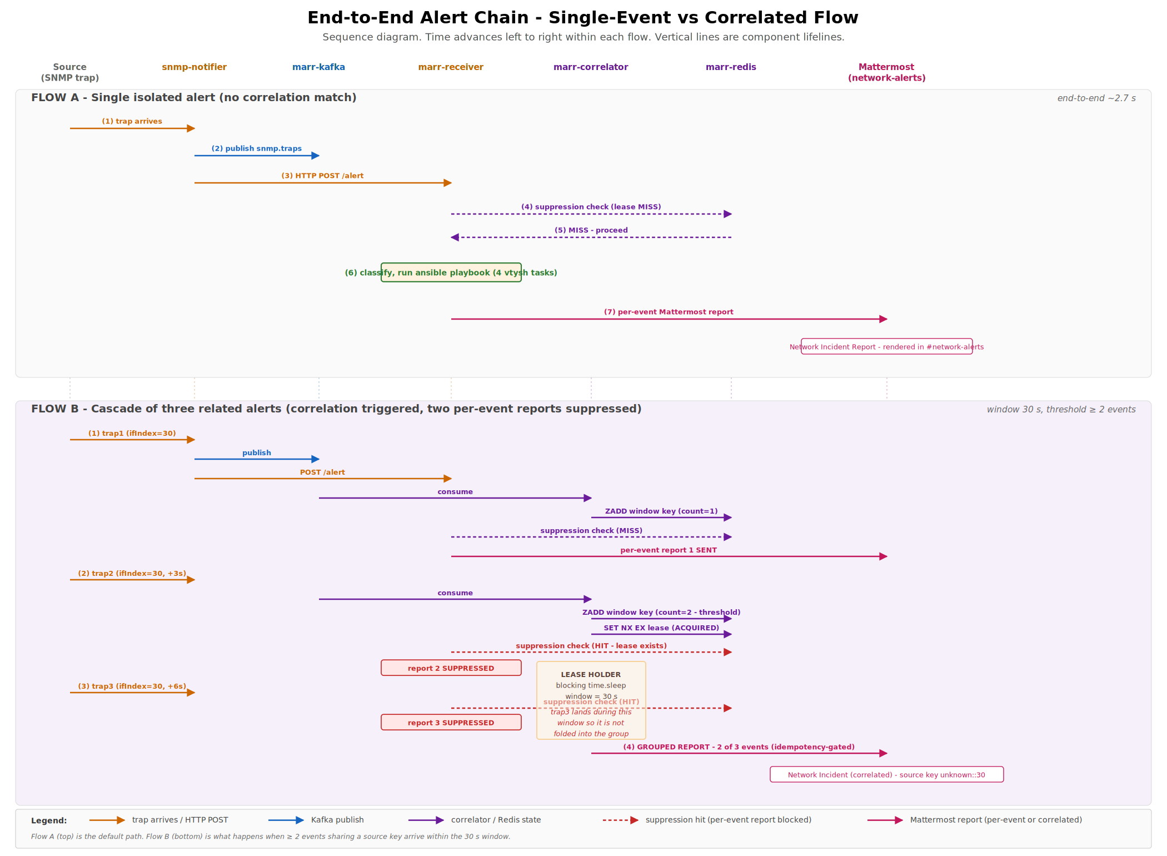
Figure 2. End-to-end alert chain showing single-event flow versus correlated flow. Flow A (top) is the default path for an isolated alert. Flow B (bottom) shows what happens when two or more events sharing a source key arrive within the 30-second window: the correlator acquires a lease, suppresses the redundant per-event reports, and emits a single grouped report. The third event in Flow B lands during the lease holder's blocking wait and is not folded into the group, illustrating the v1.0 architectural limitation.
This figure most naturally belongs in PID Appendix C.1 (Correlator Implementation), where the prose describes the source-key derivation, the SET NX EX lease primitive, the suppression hook in the receiver, and the blocking-emission limitation. A future PID revision could insert the figure between the correctness-properties paragraph and the documented-limitation paragraph in that appendix.

4. Figure 3 - Mattermost network-alerts Channel Flow
Figure 3 is a UX-focused close-up of the reporting layer specifically. It addresses a question that the architecture and sequence diagrams cannot answer directly: what does an engineer actually see when reading the channel? The diagram shows two producers (marr-receiver as Producer A and marr-correlator as Producer B) both posting webhooks to the same marr-mattermost delivery surface, then renders a mockup of the resulting network-alerts channel with three example messages stacked vertically.
The three example messages are deliberately chosen to span the canonical scenarios. The first is a per-event report carrying the post-fix Diag Status output ('2/6 ok, 4 failed (play rc=0)') that distinguishes the v4.0 reporter from earlier versions. The second is a correlated report with the full constituent-events table and the collapsed diagnostic context block. The third is another per-event report on a distinct source key, illustrating that the channel continues to receive per-event reports for alerts that do not match an active correlation lease.
The annotation arrows pointing into the message structures call out the elements that an engineer scans for during triage: severity badge, Diag Status indicator, source key for grouped reports, the constituent-events table, and the collapsed diagnostic context. The bottom note states the design assumption that engineer attention follows badges and indicators rather than reading every line of the diagnostic output linearly. This is consistent with the cognitive-load argument made throughout PID Section 1.
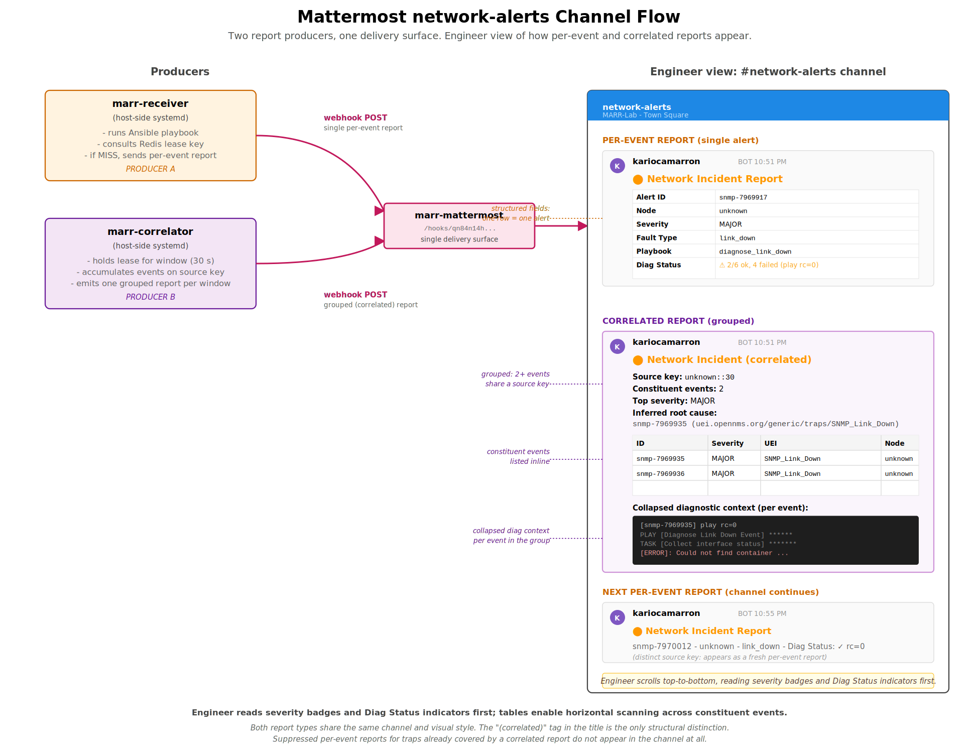
Figure 3. Mattermost network-alerts channel flow. Two producers (marr-receiver and marr-correlator) post via webhook to the same delivery surface; the right-hand panel mocks the engineer's view of the network-alerts channel with three example messages spanning the per-event and correlated reporting paths. Suppressed per-event reports for traps already covered by a correlated report do not appear in the channel.
This figure most naturally belongs in PID Appendix E (Pipeline Test Evidence) alongside the existing Figure E4 (Ansible diagnostic execution) and the captioned references to Figures D2 and D3. A future PID revision could insert it as a new Figure E5 mapping the FR-005 reporting requirement to the engineer-facing surface that the requirement actually produces.

5. Suggested Placement in PID v10C
If a future revision of the PID embeds these diagrams, the recommended placement is as follows. Each placement preserves the v10B figure-numbering convention and would not require renumbering of existing figures.
Diagram | Replaces or augments | PID location | Justification
Figure 1 (this doc) | Replaces Figure E1 | Section 9.1 | Strict upgrade of the existing architecture figure: same layout language, v4.0 state explicit, no renumbering needed.
Figure 2 (this doc) | New figure | Appendix C.1, between the correctness-properties paragraph and the v1.0-limitation paragraph | Visualises the suppression and blocking-emission behaviour described in adjacent prose. Could be numbered Figure C1 to follow the appendix-based prefix convention.
Figure 3 (this doc) | New figure | Appendix E, after Figure E4 | Maps FR-005 (reporting) to the engineer-facing surface. Could be numbered Figure E5 to follow the appendix-based prefix convention.
Table 2. Suggested embedding locations and figure numbering for a future PID v10C revision.
If only one of the three diagrams is to be embedded, Figure 1 is the highest-priority candidate because it strictly improves on an existing figure and preserves the visual-language continuity that markers will recognise from the body of the document. Figures 2 and 3 add new evidence rather than replacing existing content, and are therefore lower-priority but more substantial in their argumentative contribution.

