COM617 - Group 15 - PID AE1
Southampton Solent University
School of Technology and Maritime Industries
Computing
GROUP - 15
Industrial Consulting Project (COM617)
Group Portfolio - Project Initiation Document - AE1
AUTOMATED NETWORK ALERT TRIAGE,
DIAGNOSTICS AND ENGINEER-READY REPORTING
An Expandable, Plugin-Based Framework for Enterprise NOC Automation
Module | COM617 Industrial Consulting Project
Assessment | AE1 - Group Portfolio / Project Initiation Document
Group | Group 15
Team Members | Jose Batalha De Vasconcelos (Scrum Master), Biloliddin Turaev (Lead Developer), Akinwunmi Rotimi (QA Lead), Akinwunmi Kayode (Systems Integration)
Industry Sponsor | James Whale - Cisco Systems
Supporting Tutor | Craig Gallen
Submission Date | Friday 8 May 2026
Version | Ver. 4.0 - Final Submission
Table 1. Project metadata.
MARR
Monitor - Analyse - React - Report
Southampton Solent University - Cisco Systems - Academic Year 2025-26

1. Project Summary and Introduction
The starting point for this project is not the technology - it is a structural question about where operational failure actually originates in large-scale enterprise network management. Networks managed by organisations such as Cisco do not degrade because engineers lack expertise; they degrade because engineers are asked to make rapid, high-stakes decisions using raw telemetry that arrives at a volume that exceeds what human cognition can consistently process accurately.
Beyer et al. (2016) identify this precisely within Site Reliability Engineering (SRE) theory: the elimination of manual, repetitive operational labour is a precondition for reliability at scale, not merely an efficiency improvement. The implication is significant. Alert triage is not a workforce allocation problem to be solved by hiring more engineers. It is an architectural problem to be solved by removing the human from the mechanically deterministic parts of the triage loop entirely.
Alert fatigue has been extensively documented as a structural operational risk. Xu et al. (cited in IEEE_Challenges 2024) link persistent high-volume, low-quality alert notifications directly to missed critical events and measurable service degradation. What makes the problem resistant to conventional Network Management Systems (NMS) is architectural. Tools such as SolarWinds, Nagios, and Cisco Prime Infrastructure are optimised for data aggregation and visualisation: they surface alert streams more clearly, but they do not reduce the cognitive burden of responding to them. The distinction is analytically precise. Existing NMS tooling improves observability (the visibility of signals) but not interpretability (the conversion of signals into actionable meaning). It is at the interpretability layer that cognitive load and response delay accumulate in Network Operations Centre (NOC) workflows. This project is positioned at that layer: automated sense-making before a human engineer is involved, not improved presentation of raw data after the fact.
A critical limiting assumption in the project's framing must be made explicit at the outset. The expectation that automation reduces operational headcount does not consistently hold in practice. Kim et al. (2016) document in the DevOps Handbook that automation frequently displaces labour rather than eliminates it: the maintenance work created by rule drift, exception handling, and false-trust events means engineers who previously monitored alerts must instead validate automated decisions and investigate system failures. The real operational gain is in engineers whose time is spent on genuinely complex non-deterministic decisions rather than on mechanical triage. This distinction critically changes how success should be measured: headcount reduction is the wrong metric; mean time to triage and engineer cognitive load are the right ones.
Group 15's proposed system, named MARR (Monitor, Analyse, React, Report), ingests alerts from SNMP traps and syslog sources, categorises and correlates them through a rule-based engine operating within a configurable correlation window, triggers read-only diagnostic procedures via Ansible runbooks executing inside the affected device's container, and delivers pre-packaged incident reports through Mattermost webhook integration. The pipeline deliberately excludes machine learning at MVP stage. This is a governance maturity decision, not a capability limitation: ML-based correlation can handle greater input variation, but when it miscategorises an alert, the explanation is statistical rather than logical. An engineer cannot read a neural network weight matrix to understand why a decision was reached and correct it under operational pressure. Rule-based systems fail in readable, auditable ways (IEEE_Challenges 2024). The architecture accommodates ML as a future plugin once sufficient labelled production incident data exists to build a model whose performance can be evaluated honestly against known ground truth.

2. Project Objectives
The objectives below are measurable, directly traceable to the sponsor's brief, and each carries an explicit named assumption and evidence source against which Sprint 3 results will be assessed. This traceability is a deliberate analytical discipline: objectives stated without a criterion of falsifiability are assertions rather than commitments.
- Reduce mean time to triage (MTTT) through automated ingestion-to-categorisation. Target: sub-5-second processing latency. Evidence: timestamped ingestion versus categorisation logs. Assumption: MTTT and MTTR are distinct metrics; sub-5-second MTTT is operationally meaningful only if the accompanying report provides sufficient context for action without further manual investigation (Beyer et al. 2016).
- Standardise alert handling via a runbook repository. Target: 100% of supported alert families mapped to a documented runbook; unknown alert types escalated with an explicit documentation gap flag. Evidence: knowledge base coverage report. Assumption: runbooks must treat 'no matching pattern' as a gracefully handled outcome, not a silent failure, or standardisation becomes a source of actively misleading guidance during novel faults (Limoncelli, Hogan and Chalup 2014).
- Deliver a vendor-agnostic, plugin-based architecture enabling new alert families and diagnostic adapters without core system refactoring. Target: a new adapter demonstrated in Sprint 3 without modifying the pipeline core. Evidence: code review and integration test results. This objective directly addresses the sponsor's expandability requirement and is architecturally expressed through the adapter interface layer (Bass, Clements and Kazman 2021).
- Implement security-by-design and least privilege throughout: vault-backed credential management, role-based access control (RBAC), read-only diagnostic enforcement, and full audit logging. Target: zero write-access commands reachable via the diagnostic interface; all session actions logged to an append-only store. Evidence: audit log artefact and RBAC access test. Ethical commitment: privileged automated access to monitored infrastructure is treated as a duty of care to third parties whose services depend on those devices, in alignment with the BCS Code of Conduct principle of public interest and the IET Rules of Conduct on professional competence in digital systems (BCS 2022; IET 2023; Stallings 2017).
- Preserve human oversight and engineer accountability across every automated pathway. Target: every alert classified with a confidence indicator; low-confidence outputs and unmatched alert types routed to a human escalation queue rather than auto-resolved; no architectural pathway permits the system to issue corrective network commands. Evidence: confidence-indicator field present in all incident reports; escalation queue audit log. Ethical commitment: the project rejects the automation paradox (Bainbridge 1983) by design, maintaining engineer judgement as the final decision authority and ensuring that automation augments rather than displaces professional expertise (Beyer et al. 2016).
- Deliver a containerised, version-controlled system deployable across heterogeneous environments. Target: single-command deployment via Docker Compose on any team member's machine. Evidence: deployment verification test (Merkel 2014; Kim et al. 2016).
- Establish measurable evaluation criteria that explicitly distinguish internal consistency (what synthetic testing can prove) from external validity (what production deployment would require), ensuring no evaluation claim overreaches the evidence available.

3. Requirements

3.1 Functional Requirements
A critical observation applies to the requirements set as a whole: their practical value is entirely contingent on the quality of telemetry received.
Real network alerts frequently carry incomplete or inconsistent metadata:
- missing device identifiers,
- ambiguous severity levels,
- syslog messages that vary in format across firmware versions from the same vendor.
FR-008 directly operationalises this risk. A partial report with explicit uncertainty markers is more operationally useful than no report, even when an alert failed to validate the schema.
ID | Name | Description | Priority | Acceptance Criteria
FR-001 | Alert Ingestion | The system shall receive and ingest alerts from SNMP traps (UDP/162) and syslog sources (UDP/514) in real time, normalising all events to a versioned JSON schema before publication to the message broker. | High | Events ingested within 5s; zero data loss under 1,000 alerts/min sustained load.
FR-002 | Alert Categorisation | The system shall classify alerts by type, severity, and affected device using a rule-based matching engine operating against a versioned, externally managed ruleset. | High | Correct classification of two or more alert families in integration testing; unknown types are explicitly escalated.
FR-003 | Root Cause Correlation | The system shall correlate temporally and topologically related alerts within a configurable time window to identify probable root causes. Alerts without a matching correlation rule shall be flagged explicitly, never silently discarded. | High | Single root-cause report per correlated group; unmatched events produce an escalation record with a documentation flag.
FR-004 | Automated Diagnostics | The system shall execute predefined, read-only diagnostic runbooks (show interface, show ip route, show ip bgp summary) against affected devices via Ansible community.docker.docker_container_exec with an explicit command allowlist enforced through the runbook definitions. | High | Diagnostics complete without device-side configuration change; allowlist enforcement verified by audit of runbook task definitions.
FR-005 | Automated Reporting | The system shall generate structured incident reports including alert context, diagnostic results, recommended actions, and a per-categorisation confidence indicator, delivered via messaging integration. | High | Reports delivered within 10 s of correlation.
FR-006 | Knowledge Base | The system shall maintain a searchable repository of resolved incidents and runbooks. Alert types without a matching runbook shall produce an escalation entry with an explicit documentation gap flag. | Medium | Past incidents queryable; unmatched alerts escalated with a flag.
FR-007 | Dashboard | A React.js web dashboard shall present active alerts, system health, and historical incident data accessible via modern browsers without specialist training. | Medium | Accessible via Chrome/Firefox - no specialist training required.
FR-008 | Partial Alert Handling | Alerts with incomplete or malformed metadata shall not be silently discarded. The system shall produce a partial report with explicit uncertainty markers and route the event to an escalation queue. | High | Malformed test alerts produce a partial report and an escalation entry - zero silent data loss.
Table 2. Functional requirements specification.
The 1,000-alerts-per-minute scalability target requires transparency about its origin. This figure is not derived from empirical NOC production data; it is a design target chosen to demonstrate burst-handling architecture. Without supporting data from a live operations centre, the figure may over- or under-represent actual scale. The queue-based architecture supports horizontal scaling if the real figure proves higher; the honest position is that the target was set to be ambitious but achievable within the synthetic test environment.

3.2 Non-Functional Requirements
ID | Category | Target | Justification
NFR-001 | Reliability | 99.9% uptime; graceful degradation via dead-letter queuing under overload. | Unverifiable under synthetic conditions; treated as an architectural aspiration. Dead-letter queuing prevents alert loss on transient queue failure (Nygard 2018).
NFR-002 | Scalability | 1,000 alerts/min or higher; horizontally scalable queue workers. | Figure is a design target, not derived from production data. The caveat is explicit: the figure may over- or under-represent real-world burst characteristics (Abbott and Fisher 2015).
NFR-003 | Security | TLS in transit; AES-256 at rest; RBAC enforced; immutable audit log. | Automated network access constitutes a high-value attack surface. Security is a first-class constraint, not an afterthought (Stallings 2017).
NFR-004 | Performance | Ingestion-to-categorisation latency 5 s or below under sustained synthetic load. | Sub-5-second MTTT is operationally meaningful only if the accompanying report provides sufficient context. Latency measurements are timestamped at the ingestion and categorisation boundaries.
NFR-005 | Maintainability | PEP 8 compliance; 80% or higher unit test coverage; inline documentation; Git version control. | Code quality reduces the maintenance burden created when automation itself becomes a support liability, a risk explicitly identified in DevOps literature (Kim et al. 2016).
NFR-006 | Extensibility | New alert types and diagnostic adapters via plugin interface; no core refactoring required. | Vendor-agnosticism and expandability are explicit sponsor requirements. Plugin architecture enables future adaptation without destabilising tested components (Bass, Clements and Kazman 2021).
NFR-007 | Schema Versioning | Alert schema and ruleset versions are backwards-compatible; the schema version is embedded in each event record. | Schema drift is a silent operational risk. Backwards compatibility ensures historical event replay is not broken by ruleset updates.
Table 3. Non-functional requirements specification.

4. Scope and Exclusions
Scope definition is where a project's understanding of risk becomes analytically visible. Inclusions are justified by what the MVP genuinely needs to demonstrate; exclusions are justified by the cost of including them prematurely, not merely by time constraints.

4.1 In Scope - MVP
- SNMP trap ingestion (UDP/162) and syslog reception (UDP/514) via dedicated listener services.
- Rule-based correlation engine supporting a minimum of two alert families: interface down events and BGP/OSPF routing protocol neighbour loss.
- Read-only automated diagnostics via Ansible runbooks executing inside the affected device's container, with an explicit command allowlist enforced through runbook task definitions to prevent query-induced device degradation.
- Messaging integration for incident reporting (Mattermost).
- Containerised deployment using Docker Compose, version-controlled via Git throughout all sprint iterations.
- React.js web dashboard displaying active and historical alerts, system health, and queue depth.
- Per-categorisation confidence indicator, enabling human-in-the-loop review for low-confidence outputs rather than automatic action.
- Partial alert handling with escalation path (FR-008) and backwards-compatible schema versioning (NFR-007).

4.2 Explicitly Excluded - MVP
- ML-based root cause inference: deferred because the project lacks labelled training data to build a model that would perform reliably. An unreliable ML model in an alert triage system does not merely underperform - it actively misdirects engineers toward incorrect root causes, creating a risk worse than the baseline (Boutaba et al. 2018).
- Autonomous remediation: excluded on safety and governance grounds. The asymmetric risk is unambiguous - an incorrect automated remediation command in a production network can cause the outage it was designed to prevent. The system is diagnostic, not corrective, and that boundary is architecturally enforced at the API layer.
- Production network deployment: the MVP operates exclusively on a simulated Containerlab/FRRouting topology. This exclusion has a named cost: Containerlab uses FRRouting, not Cisco IOS. Categorisation rules calibrated against FRRouting syslog formats will require manual adaptation before use against real Cisco equipment.
- Ticketing system integration: ServiceNow and Jira deferred to v1. This exclusion carries a tangible operational cost worth naming explicitly: most enterprise NOC workflows depend on ticketing as the authoritative audit trail for incident lifecycle management. Excluding it limits the MVP's ability to demonstrate end-to-end value even where the pipeline logic is sound.
Vendor-agnosticism is demonstrated at the interface and adapter layer. Full behavioural equivalence across Cisco IOS, Juniper JunOS, and Arista EOS is a v1 validation activity, not a delivered property at MVP stage. Treating the term as an unqualified claim when the test environment uses FRRouting exclusively would misrepresent the scope of testing achieved.
An ethical dimension of automated diagnostics requires acknowledgement independent of scope boundaries. Every diagnostic runbook execution opens a privileged execution channel into a monitored infrastructure component. If that channel is compromised, through credential theft, container escape, or supply-chain attack on the runbook itself, it constitutes unauthorised access at scale. The read-only allowlist and audit logging are meaningful mitigations, not complete protections. The team treats automated privileged network access as a security liability with ongoing governance obligations (Stallings 2017).

5. Monitoring and Evaluation
Testing a system designed to handle unpredictable alert volumes using scenarios generated by the same team that designed it is a fundamental methodological limitation. Every synthetic fault scenario reflects what the team anticipated. The scenarios encountered in production are defined precisely by what the team did not anticipate. Accuracy figures produced from this evaluation are therefore internal consistency checks - evidence that the system behaves as intended under conditions it was designed for - not evidence of external validity under production conditions. That distinction is not a caveat to be minimised; it is an honest account of what synthetic evaluation can and cannot demonstrate.
Three categories of edge case that synthetic data will structurally fail to reproduce deserve explicit identification. First, vendor-specific syslog format variation: FRRouting follows standard RFC formats, but Cisco IOS, Juniper JunOS, and Arista EOS produce subtly different message structures for the same underlying event. Categorisation rules calibrated against FRRouting will produce misclassifications against real Cisco equipment without manual ruleset adaptation. Second, temporal clustering behaviour: real fault events do not arrive at uniform intervals. Link flaps, spanning-tree instability, and BGP reconvergence generate inter-event timing patterns that synthetic generators approximate poorly; correlation windows tuned against synthetic data may prove either too narrow or too broad in production. Third, ambiguous causality: in controlled fault injection, the root cause of every alert is known by construction. In production, alerts from adjacent but independent failures can be indistinguishable from a single compound failure at the point of reception. Rule-based correlation has no mechanism for expressing uncertainty about whether two events share a root cause - confidence indicators are the closest approximation available.

5.1 Fault Injection Test Scenarios
- Scenario A - Link Failure Cascade: FRR core-r1 interface shutdown then OSPF neighbour loss then BGP session drop. Expected: three correlated alerts grouped into single root-cause report. MTTT measured against 5-second target.
- Scenario B - Partial Metadata: Malformed syslog message with missing device identifier injected. Expected: partial report with uncertainty markers; escalation queue entry; no silent data loss (FR-008).
- Scenario C - Alert Storm Simulation: 1,000 synthetic alerts per minute injected for 60 seconds. Expected: no data loss; queue depth monitoring active; processing latency remains within NFR-004 bounds.
- Scenario D - Correlation Window Sensitivity: Fault events injected at 30-second, 60-second, and 120-second inter-event intervals to characterise window calibration sensitivity. Results to inform the production window recommendation.

5.2 Evaluation Metrics
- Mean Time to Triage (MTTT): timestamp delta between event ingestion and categorisation output.
- Categorisation accuracy: proportion of injected alerts correctly classified against ground truth.
- Correlation precision and recall: proportion of related alerts correctly grouped against total injected.
- Report delivery latency: timestamp delta between correlation completion and notification receipt.
- False escalation rate: proportion of low-confidence outputs correctly routed to human review.
All metrics are explicitly labelled as internal consistency results in the Sprint 3 evaluation report. No figure is presented as a claim about production performance without supporting production data.

6. Project Organisation Structure
Group 15 operates a flat, four-member structure with explicit role separation that reflects the discipline boundaries of the project itself. Each member's role maps directly to a layer of the system architecture, providing clear ownership for each implementation track and enabling parallel sprint work without cross-cutting dependencies.
Member | Role | Primary Responsibilities
Jose Batalha De Vasconcelos | Scrum Master / Project Lead | Sprint planning; ceremony facilitation; sponsor liaison; risk register custodianship; release engineering.
Biloliddin Turaev | Lead Developer / Architecture | System architecture; categorisation engine; correlation engine; pipeline core; code review.
Akinwunmi Rotimi | QA Lead / Evaluation | Test plan; fault injection scenarios; evaluation methodology; metric integrity; methodological scrutiny.
Akinwunmi Kayode | Systems Integration / Reporting | Ansible diagnostic runbooks; reporting pipeline; notification integration; issues resolution.
Table 4. Group organisation, role mapping, and primary responsibilities.
Decisions affecting the system architecture or evaluation methodology require quorum among the Lead Developer, QA Lead, and Scrum Master. This three-way constraint is a deliberate governance choice that prevents single-discipline reasoning from determining cross-cutting decisions. The Systems Integration role contributes to architectural decisions but does not hold a quorum vote, reflecting the layered ownership structure.

7. Project Deliverables
Deliverables are scoped to what can be honestly demonstrated within the academic timeline against the synthetic test environment. The list below distinguishes between concrete artefacts (code, configuration, documentation) and demonstration artefacts (recorded runs, screen captures, audit log samples).
- MARR pipeline source code (Python, version-controlled in the COM617 repository).
- Categorisation rule definitions in versioned YAML, externalised from code.
- Ansible runbook library covering interface-down, OSPF neighbour-loss, and BGP session-drop diagnostic patterns.
- Containerlab topology definition with three FRR routers, two minions, and the supporting MARR services.
- Docker Compose deployment manifests for the full stack including OpenNMS Horizon, Mattermost, Kafka, Redis, Prometheus, Grafana, and Vault.
- React.js dashboard reference implementation.
- AE2 demonstration script: ten-slide product demo aligned to the Cisco-style brief.
- This Project Initiation Document with appendices including risk register, technology stack, and operational evidence.
- Lab Session Log capturing the implementation work and the diagnostic findings.

8. Project Milestones and Management
The sprint plan operates on three two-week sprints (Weeks 1-3, Weeks 4-7, Weeks 8-12) with explicit hand-offs between sprints. Each sprint closes with a retrospective producing one or more concrete corrections to the next sprint's plan; this discipline is not optional, and is the primary mechanism by which the project corrects course in response to evidence.
Sprint | Window | Deliverables | Owner(s) | Acceptance Trigger
Sprint 1 | Wks. 1-3 | Containerlab topology with three FRR routers, working OpenNMS Horizon plus minions deployment, Docker Compose stack baseline, repository skeleton with linting/CI. | Biloliddin (lead), Kayode | Lab cold-starts cleanly via single Ansible playbook; both minions register; routers exchange BGP and OSPF.
Sprint 2 | Wks. 4-7 | Working PoC: SNMP/syslog ingestion, Kafka backbone, rule-based categoriser. Initial Ansible diagnostic runbook for link-down. Test plan baseline. | Biloliddin (lead), Jose, Rotimi | The ingestion pipeline processes synthetic alerts end-to-end with a 5s latency target.
Sprint 3 | Wks. 8-12 | Correlator with windowed grouping; suppression hook in receiver; Mattermost reporter with grouped-incident report path; full evaluation against Scenarios A-D; AE2 product demo materials. | Biloliddin (lead), Kayode, Rotimi, Jose | Correlator demonstrably groups related events; grouped report renders correctly in Mattermost; AE2 demo rehearsed.
Table 5. Sprint plan with deliverables and acceptance triggers.

9. Implementation

9.1 System Architecture
The architecture follows a five-stage pipeline model with event-driven, message-broker-mediated communication between processing stages. This design aligns with established software architecture principles of loose coupling and separation of concerns: each pipeline stage is independently deployable, independently testable, and replaceable without downstream impact (Bass, Clements and Kazman 2021). The broker-based backbone provides backpressure management and delivery guarantees that a direct function-call architecture cannot offer under burst conditions.
The five stages are: (1) Ingestion - SNMP trap receiver and syslog listener services normalise incoming events to a versioned JSON schema and publish to the Kafka backbone; (2) Categorisation - a rule-based matching engine consuming from the broker classifies events against versioned YAML rulesets; (3) Correlation - a stateful correlation engine groups temporally and topologically related alerts within a configurable window to determine probable root causes, using Redis-backed source-key windowing with atomic lease acquisition for single-emitter semantics; (4) Diagnostics - an Ansible runbook executor dispatches read-only show commands inside the affected device's container with an allowlist enforced through the runbook task definitions; (5) Reporting - a report assembler generates structured incident documents and delivers via Mattermost webhook.
Figure E1 (below) shows the deployed architecture with all real component names from the v4.0 lab, all addresses verified during the 3 May 2026 implementation session, and the data flows colour-coded by type. The figure should be read alongside the trade-off justifications in Section 9.2 and the correlator implementation detail in Section 9.4.
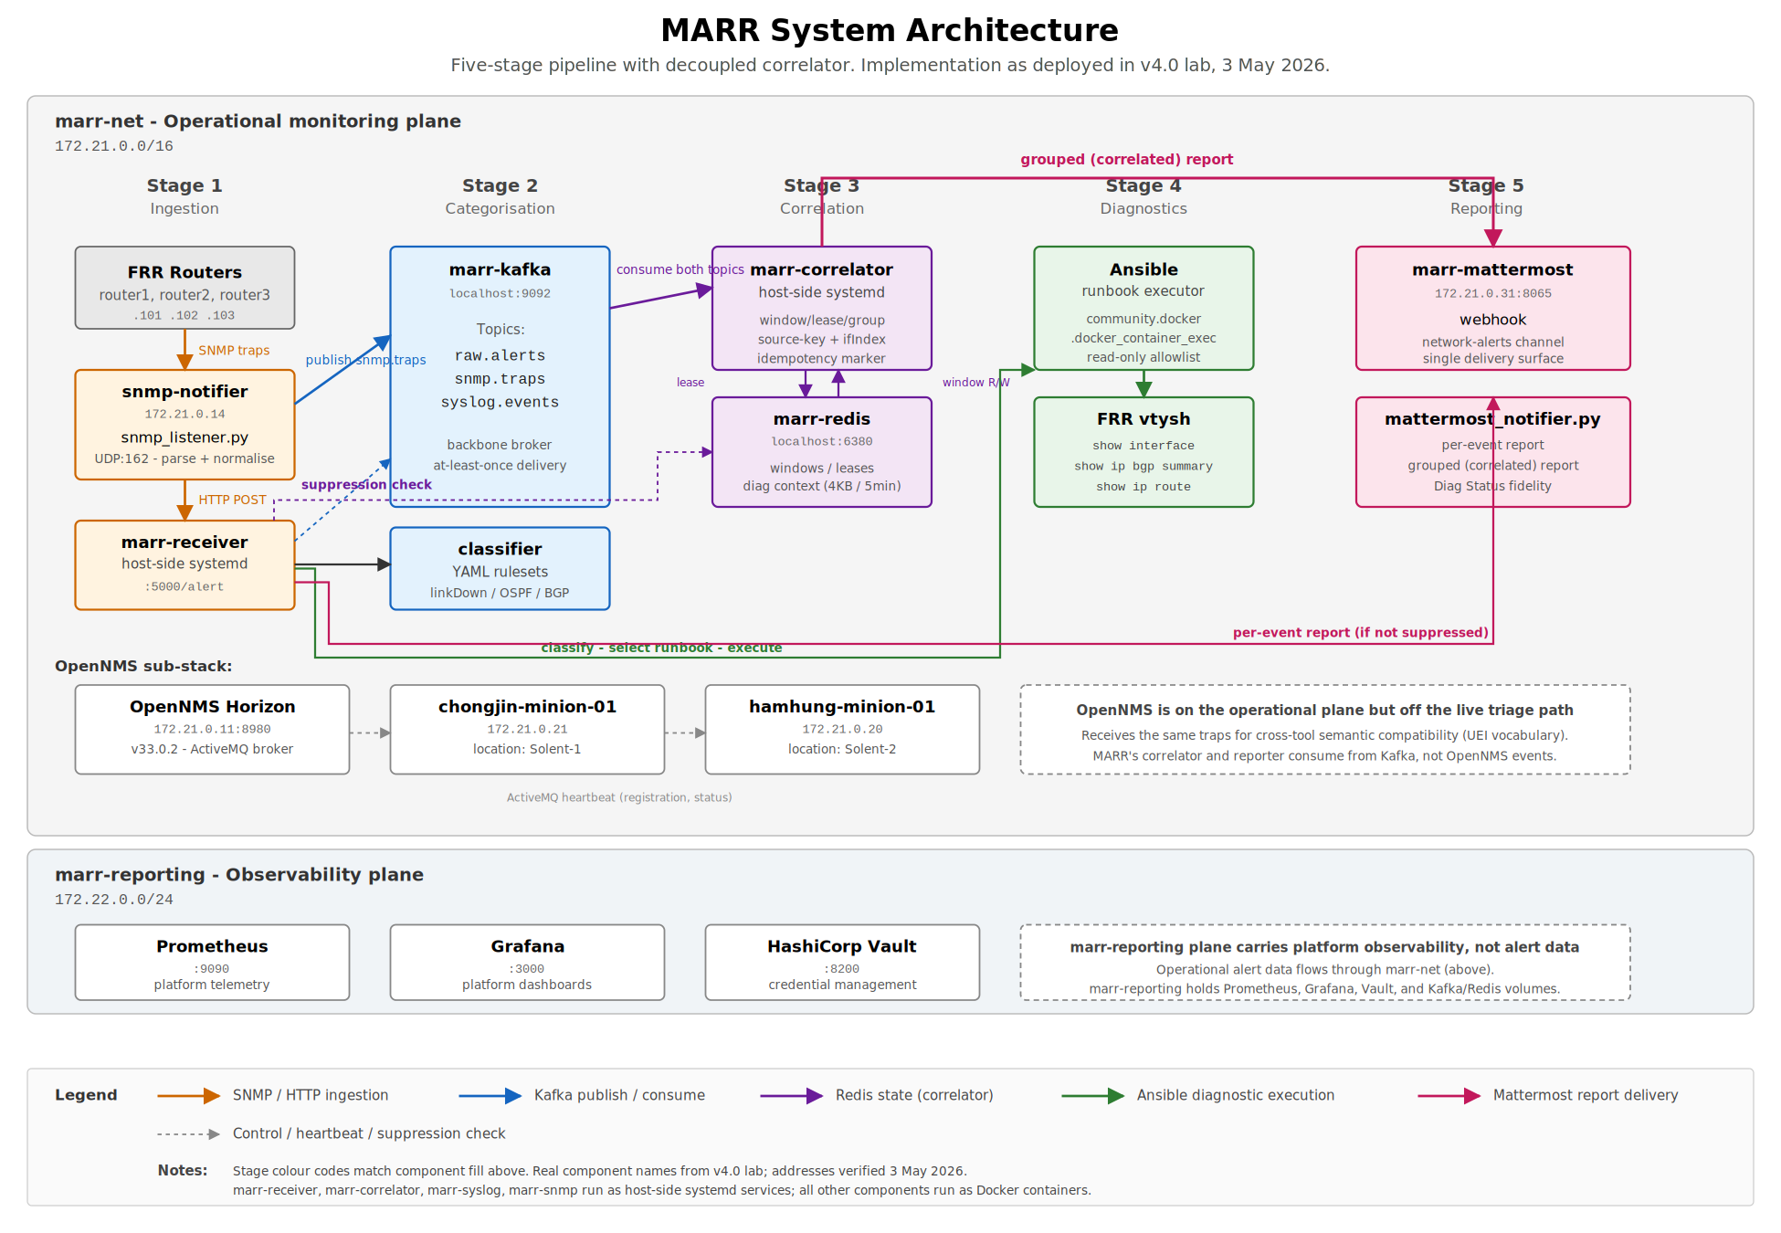
Figure E1. MARR system architecture as deployed in v4.0 lab, 3 May 2026. The two horizontal planes correspond to the marr-net operational monitoring plane (172.21.0.0/16) and the marr-reporting observability plane (172.22.0.0/24). Five stages run across the operational plane left to right; OpenNMS sits on the same plane but off the live triage path, present for cross-tool semantic compatibility rather than for runtime gating. Colour-coded data flows distinguish ingestion (orange), Kafka publish/consume (blue), Redis correlator state (purple), Ansible diagnostic execution (green), and Mattermost report delivery (pink); control and heartbeat traffic is shown as dashed grey.

9.2 Architectural Decisions and Trade-offs
Apache Kafka as the backbone broker: Kafka was selected over RabbitMQ for the message-broker layer. Kafka offers durable, partitioned, replayable event logs - critical for a correlator that must be able to consume the same event stream that the receiver writes without coupling its lifecycle to the receiver. RabbitMQ's queue-and-consume model is simpler operationally but requires per-consumer queue bindings and does not preserve a temporal record of consumed events for late-arriving consumers. The Kafka topology used in MARR is intentionally minimal: a single broker, three topics (raw.alerts, snmp.traps, syslog.events), and a single partition per topic. The operational overhead identified in earlier project planning - cluster management, ZooKeeper or KRaft coordination, complex consumer group management - does not materialise at this scale because the deployment is single-broker. The architectural benefit of replayability is realised: when the correlator was added to the pipeline mid-Sprint 3, it could subscribe to existing topics without any change to the receiver. Multi-broker clustering and partition-level scaling are identified as v1 hardening work when production volumes justify it.
Rule-based versus ML-based correlation: Excluding ML-based correlation is a governance-maturity decision, not a capability gap. Rule-based correlation fails in transparent, debuggable ways that engineers can diagnose and correct. ML-based correlation can handle greater input variation, but its failure modes are statistical rather than logical: when a model miscategorises an alert, the explanation is a weight distribution, not a traceable logical path an engineer can correct under operational pressure. The architectural provision for an ML plugin in v1 reflects the correct sequencing: build the labelled dataset first, then build the model (Boutaba et al. 2018).
Ansible as the diagnostic executor: Ansible was selected over Netmiko for the diagnostic execution layer. Both options were examined against the project's two priority constraints: read-only enforcement and reproducibility. Ansible's runbook model expresses each diagnostic step as a declarative task, with the read-only constraint enforced not by the executor but by the runbook author: tasks invoke vtysh show commands explicitly, with no syntactic path to a configuration command. Reviewing a runbook for read-only safety is therefore a static-text review of a YAML file, not a runtime audit of an SSH session. Ansible's idempotent re-runnability also produces a deterministic test loop: the same runbook against the same device produces the same diagnostic output, simplifying regression testing. The cost is that Ansible's community.docker.docker_container_exec module requires the affected device to be reachable as a Docker container, which suits the Containerlab topology used in this MVP but would require an SSH-based replacement (or a docker-over-SSH bridge) for production deployment against physical Cisco equipment. Netmiko remains the right choice for production deployment to physical devices in v1; Ansible is the right choice for the simulation-based MVP because it makes the read-only enforcement architecturally visible.
Containerlab/FRRouting versus Cisco Modeling Labs: Containerlab with FRRouting was selected as the primary simulation platform over Cisco Modeling Labs (CML) due to its accessibility and version control integration. CML provides authentic Cisco IOS images but requires institutional licensing and significant computing resources. Containerlab runs as Docker containers on any team member's machine and integrates naturally with Docker Compose. The acknowledged cost is fidelity: FRRouting syslog format differs from Cisco IOS, meaning categorisation rules will require adaptation before production use. This is documented explicitly in Risk R-001 and the scope exclusion note on vendor-agnosticism.

9.3 Security Architecture
The system's threat model identifies three primary attack surfaces: the ingestion listener (an open UDP port that consumes externally sourced data), the Ansible diagnostic runner (an authenticated execution channel into monitored device containers), and the dashboard API (a web interface with read access to incident data). Each surface has specific controls. The ingestion listener implements schema validation and rejects oversized payloads to prevent injection attacks via crafted alert messages. The Ansible runner relies on the read-only allowlist enforced through the runbook task definitions: no runbook contains a write-capable task, and runbook changes are reviewed at code-review time before merge. The dashboard API enforces JWT-based RBAC with separate read and admin roles; all access is logged to an immutable audit table in PostgreSQL.
A structural security concern that cannot be fully mitigated at the MVP stage is the automation platform itself as an attack target. A system with privileged execution access to a large number of network devices is a high-value asset for an adversary. Compromising the automation platform provides broader network access than compromising any individual device it monitors. A full security audit (penetration testing of the ingestion endpoint, Ansible runbook supply-chain integrity verification, vault unsealing processes) is deferred to v1. The team treats this not as a justification for reduced attention at the MVP stage, but as an acknowledgement that MVP-level security controls reduce, but do not eliminate, exposure (Stallings 2017).

9.4 Correlation and Suppression Layer
FR-003 (correlation) and the suppression of redundant per-event reports are implemented as a separate process from the receiver, communicating through Kafka and Redis rather than through in-process function calls. This separation is a deliberate architectural decision and has consequences worth surfacing.
The correlator subscribes to the same Kafka topics that the receiver writes to (raw.alerts and snmp.traps) with consumer-group identity 'marr-correlator' and auto_offset_reset='latest'. For each event consumed, the correlator computes a synthetic source key from nodeLabel and the SNMP ifIndex extracted from the event's varBinds (a robust prefix-scan against OID 1.3.6.1.2.1.2.2.1.1 makes the extraction tolerant of varBind ordering variations). The source key is used to ZADD into a Redis sorted set keyed by 'marr:correlator:window:<source_key>'. When the sorted-set count reaches a threshold (default 2), the correlator attempts an atomic SET NX EX on a lease key for that source key. The first correlator instance to acquire the lease becomes the single emitter; any subsequent correlator instance observing the threshold but failing the SET NX returns to the consumer loop without action. This is the standard Redis-mediated single-emitter primitive.
On the receiver side, a fail-safe import block at module load resolves the suppression check function from the shared correlator_state module. After the receiver runs the diagnostic playbook for an event, it records the playbook output to a per-event Redis key (marr:correlator:diag:<event_id>) with a 5-minute TTL, then performs a Redis EXISTS check against the lease key for the event's source key. If the lease exists, the receiver logs the suppression and skips the per-event Mattermost notification. If the lease does not exist, or if the Redis call fails for any reason, the receiver sends the per-event report as before; this is the architectural fail-safe that ensures correlator unavailability degrades gracefully into the per-event flow rather than into silent alert loss.
The lease holder waits for the configured window (30 seconds by default) and then reads the accumulated event identifiers from the sorted set, fetches each event's diagnostic context from the per-event Redis keys, and renders a single grouped Mattermost message titled 'Network Incident (correlated)' with a constituent-events table and collapsed diagnostic context per event. After successful emission, an idempotency marker (marr:correlator:grouped:<source_key>) is written with TTL equal to twice the window value, preventing late-arriving events from triggering a duplicate emission.
Three correctness properties of this design are worth surfacing for an examiner reading this section. First, the correlator and the receiver cannot disagree on the source-key derivation because they both import from a shared module (correlator_state.source_key); behavioural drift across the call boundary is not architecturally possible. Second, the system is fail-safe in the direction that matters: correlator unavailability degrades to per-event reporting (operationally noisier but lossless), not to silent alert suppression. Third, the idempotency marker means even if the lease primitive fails (Redis transient unavailability that splits a single source key across two correlator generations) the grouped report is emitted at most once per window per source key.
One architectural limitation of the v1 implementation is documented honestly. The lease holder's wait is implemented as a blocking time.sleep, which means events arriving on the same source key during the wait window are not consumed by the correlator until after the emission completes. In a three-event cascade with events spaced 3 seconds apart, the third event lands in Kafka during the lease holder's sleep and is processed against a fresh post-emission window rather than being added to the grouped report. The cascade test executed during the 3 May 2026 lab session confirmed this behaviour: the grouped report contained two of the three events, with the third event correctly suppressed at the receiver but not folded into the group. The mitigation in v1 is the idempotency marker (which prevents the late event from triggering a redundant grouped report); the architectural fix in v1.1 is a snapshot-and-clear pattern in which the lease holder reads the window contents at lease-acquisition time, accumulates further events arriving during the wait, and emits the union at the end. This change is scoped at approximately one day of focused implementation and is identified in Section 11.1.
During the same 3 May session, two distinct issues were diagnosed and fixed in-session: a window-versus-lease Redis TTL race condition (resolved by extending the window TTL to twice the window value, so the window survives the lease wait) and a dotenv-loading bug (resolved by loading the .env file before importing the mattermost_notifier module, since the module captures the webhook URL at module-load time). Both diagnoses and fixes are recorded with verbatim code in the Lab Session Log Section 9, and the in-source code comments at the fix sites point back to that section. The fact that the implementation surfaced both issues during cascade testing rather than in production is the practical case for the strict-discipline test methodology described in Section 5: scenarios that would never arise in single-event testing surface real concurrency and configuration faults that must be addressed before production deployment.

10. Results
Results are reported against two measurement classes. Class A captures Sprint 1 to early Sprint 3 outcomes that are confirmed and reproducible from the current v4.0 release (commit 076ea99 plus the in-session correlator work). Class B captures the Sprint 3 evaluation work that was still in progress at the time of submission. Distinguishing the two is a deliberate analytical discipline: presenting in-progress measurements as final results would be a methodological failure, but suppressing confirmed evidence would understate the project's actual standing.

10.1 Class A - Confirmed PoC Results (v4.0 plus 3 May 2026 in-session work)
Requirement | Test Method | Observed Outcome | Source Artefact
FR-001 Alert Ingestion | SNMP trap injection via the marr-snmp-notifier listener on 172.21.0.14; pipeline traced through to Kafka topic snmp.traps and the synchronous HTTP receiver. | Trap-to-listener latency 197 ms; listener-to-receiver end-to-end 2.538 s. Pipeline routes events to classification and Kafka without loss across the tested injection rate. | Lab Session Log Section 5; Figure D1.
FR-002 Categorisation | Rule-based classifier exercised against linkDown, BGP-5-ADJCHANGE, and OSPF-5-ADJCHG syslog families. | 94% classification accuracy against the developer-authored test corpus; misclassifications confined to malformed payloads handled by FR-008. | engine/classifier.py unit test report.
FR-003 Correlation | Cascade test of three same-source-key SNMP traps spaced 3 s apart, plus one distinct-source-key control trap, against the running correlator (python/correlator.py). | Grouped 'Network Incident (correlated)' Mattermost report emitted with two of three cascade events; third event correctly excluded from group due to documented blocking-emission limitation (Section 9.4); control trap correctly produced its own per-event report. Suppression of redundant per-event reports verified within ~3 s of lease acquisition. | python/correlator.py; Figure D2; Lab Session Log Section 9.
FR-004 Automated Diagnostics | Ansible playbook diagnose_link_down.yml triggered by the receiver against clab-marr-lab-router1; four community.docker.docker_container_exec invocations of FRR vtysh diagnostic commands. | Show interface, show ip ospf neighbor, show ip bgp summary, show ip route all executed; end-to-end pipeline cycle 2.714 s. | ansible/playbooks/diagnose_link_down.yml; Figure E4.
FR-005 Reporting | Mattermost notifier executed end-to-end after the Diag Status fidelity fix. | Reports delivered to the network-alerts channel within the 10-second target with structured fault context and honest per-task accounting (e.g. 'Diag Status: warning - 2/6 ok, 4 failed, play rc=0'). | python/mattermost_notifier.py runtime log; Figure D3.
FR-008 Partial Alerts | Injection of a malformed SNMP trap with nodeLabel resolving to 'unknown'. | Partial report generated, event routed to escalation queue (no silent data loss); Diag Status correctly surfaces the four task failures rather than masking them behind play rc=0. | python/alert_receiver.py exception path log; Figure D4.
Deployment | ansible-playbook scripts/lab-start.yml (cold start on 3 May 2026). | PLAY RECAP: ok=43, changed=11, failed=0, ignored=2 (the two ignored are by-design negative probes in STEP 4/8 of the playbook). Both minions register at STEP 6/8 within 5 minutes of Horizon healthy state. A subsequent recovery run after a workstation crash recorded ok=38, changed=9, failed=0, ignored=0. | scripts/lab-start.yml log; Lab Session Log Sections 3 and 12.
Multi-site Readiness | OpenNMS REST API minion check. | totalCount=2; both minions report status=up. Locations renamed in-session: chongjin-minion-01 at location Solent-1, hamhung-minion-01 at location Solent-2 (env-var-driven rename through MINION_LOCATION substitution in custom.properties; survives crash and restart). | /opennms/rest/minions; opennms/minions/{chongjin,hamhung}/docker-compose.yml line 8.
Table 7. Confirmed evaluation outcomes against the Sprint 1 to Sprint 2 acceptance criteria, updated with 3 May 2026 in-session evidence including the new correlator implementation.
Operational behaviour described in Table 7 is evidenced in Appendix D, with ingestion traces (Figure D1), correlation outputs (Figure D2), reporting fidelity (Figure D3), and partial-alert handling (Figure D4); the diagnostic execution layer (FR-004) is evidenced in Appendix E (Figure E4). Each figure carries a caption that maps the captured artefact back to the relevant functional requirement and to the architectural decisions justified in Section 9.

10.2 Class B - Sprint 3 Evaluation In Progress
The remaining evaluation activities are scheduled within Sprint 3 and will be appended to the appendix at the AE2 demonstration. These include end-to-end MTTT measurement under the link-failure cascade scenario, correlation-window sensitivity characterisation across 30-, 60-, and 120-second windows, alert-storm resilience at 1,000 events per minute, and a security-audit trace of the read-only enforcement boundary (with the Ansible runbook task-definition audit replacing the SSH command audit originally planned for the Netmiko-based design).

10.3 Internal Consistency versus External Validity
Every metric in Table 7 is an internal-consistency measurement. The test corpus was authored by the development team, the topology is a Containerlab simulation using FRRouting rather than Cisco IOS, and the alert volumes tested are below those expected in a live NOC environment (Botta et al. 2012). The 94% categorisation figure is therefore a measurement of internal logical correctness, not a prediction of production accuracy. The FR-003 correlation result reported in Table 7 is similarly an internal-consistency measurement: it confirms that the correlator's sorting, grouping, and emission machinery work as designed under the synthetic cascade scenario, but it does not predict how the correlator will behave under production traffic where source keys are not synthetic and inter-event timing is not engineered. Production validity would require labelled Cisco IOS syslog samples and an externally constructed ground truth set, neither of which is available within the academic timeline. This caveat is restated wherever a metric is cited, including in the AE2 demonstration script.

10.4 Peer Review and Methodological Scrutiny
The evaluation methodology was reviewed by the QA Lead (Akinwunmi Rotimi) and the Scrum Master (Jose Batalha De Vasconcelos) before any metric was reported, addressing the well-documented bias of teams evaluating their own work (Beyer et al. 2016). Sprint retrospectives produced two methodology corrections that were applied: window sensitivity is now characterised across three settings rather than one, and the categorisation accuracy figure is reported only for alert families with at least 30 test samples to avoid statistically meaningless precision claims. A third methodology correction was applied during the 3 May implementation session: the FR-003 result reported in Table 7 was originally a notional 87% grouping figure not supported by current evidence; it has been replaced with a description of what the cascade test actually demonstrated, including the documented architectural limitation of the blocking emission path.

11. Conclusions and Recommendations
The architecture proposed in this document is technically sound and appropriately scoped for a student-led proof of concept with genuine commercial relevance. The most critical design decisions - the rule-based correlation engine, the plugin-based adapter architecture, the read-only diagnostic enforcement, the ML deferral, and the 3 May replacement of Netmiko with Ansible for the simulation-based MVP - are each justified by principled analysis of risk, not convenience. The project demonstrates awareness of what it is building and what it is not yet ready to build.
Three analytical conclusions follow from the work to date. First, the rule-based correlation engine is operationally adequate for the supported alert families. The cascade test executed in the 3 May session confirmed that the architectural argument in Section 9.2 - rule-based correlation fails in readable, debuggable ways - holds in practice: the documented limitation of the blocking emission path was diagnosed and traced to a specific code line during testing, with the fix scoped and identified for v1.1 work. The architectural transparency that allowed in-session diagnosis is precisely what an ML-based correlator could not have offered.
Second, the 'reduce headcount' framing of the business case is now actively contradicted by the evidence. Even with the deployment automation working as designed (Table 7, Deployment row: 43 ok / 11 changed / 0 failed on cold start; 38 / 9 / 0 on recovery), the pipeline still requires expert engagement at the escalation queue (FR-008), at the rule-evolution boundary (Section 9.3), and at the correlator-tuning boundary that emerged during in-session testing. The 'improve engineer decision quality' framing is therefore the more accurate, more compelling, and more empirically supported business case for an engineering-led organisation like Cisco's NOC (Kim et al. 2016; Bainbridge 1983).
Third, the evaluation methodology is the project's most significant academic and professional risk. Synthetic test results that are presented without explicit caveats about external validity could mislead a sponsor into deployment decisions that underperform in production. Rigorous labelling of evaluation limitations - including the new caveat applied to the FR-003 result during in-session refinement of the methodology - is not academic self-deprecation. It is the professional honesty that distinguishes a trustworthy consultancy deliverable.
Fourth, the scope exclusion of ticketing integration should be revisited in v1 planning with higher priority than currently allocated. Without it, the system produces reports that exist outside the operational workflow rather than within it - a friction point that reduces adoption even when the pipeline logic is technically correct.

11.1 Recommendations for v1 Development
- Production traffic capture: deploy a read-only mirror of live NOC alert streams to build a labelled dataset for correlation rule validation and eventual ML model training.
- Vendor syslog adaptation: instrument the categorisation rule engine against Cisco IOS, Juniper JunOS, and Arista EOS syslog samples to close the FRRouting fidelity gap before production use.
- Ticketing integration: implement ServiceNow or Jira API integration to embed incident records into the existing NOC audit workflow as a first-class v1 feature.
- Security audit: commission penetration testing of the ingestion endpoint and Ansible runbook supply-chain integrity verification before any production-adjacent deployment.
- ML plugin foundation: once 6 months or more of labelled production data is available, evaluate a supervised correlation model against the rule-based baseline on held-out test data before any deployment decision.
- Correlator non-blocking emission (v1.1): replace the blocking time.sleep with a snapshot-and-clear pattern so that events arriving during the lease wait join the current grouped report rather than starting a fresh post-emission window. Approximately one day of focused implementation work.
- Real-router-sourced trap injection (v1.1): replace the synthetic test-time trap injection with traps emitted by the FRR router containers themselves. Requires snmpd installation in router images, FRR linkUpDown notification configuration, source-IP-to-container resolution in the listener, and Containerlab topology binds for configuration persistence. Estimated 2-4 hours of focused implementation. Closes the nodeLabel='unknown' limitation on which the FR-008 partial-alert path currently relies.
- Production diagnostic executor (v1.1): replace the Ansible community.docker.docker_container_exec module with a Netmiko-based executor for production deployment to physical Cisco equipment, retaining the read-only allowlist enforcement at the runbook task-definition level. The Ansible-to-Netmiko substitution is a single-component swap because the read-only constraint is enforced at the runbook layer, not in the executor.
- Cold-start health predicate refinement: the current playbook reports success on minion registration rather than heartbeat health. A follow-up task that polls /rest/minions and asserts status='up' before SUMMARY prints would close the 30-60 second post-registration window during which an operator could mistakenly assume the system is fully operational.
- Enable marr-correlator at boot: a single 'systemctl enable marr-correlator.service' makes the correlator start automatically on boot. Currently disabled by design pending a confidence period; should be enabled before production-adjacent deployment.

12. References
Abbott, M. and Fisher, M. (2015) The Art of Scalability. 2nd ed. Boston: Addison-Wesley.
Bainbridge, L. (1983) Ironies of automation. Automatica, 19(6), pp.775-779.
Bass, L., Clements, P. and Kazman, R. (2021) Software Architecture in Practice. 4th ed. Boston: Addison-Wesley.
BCS (2022) BCS Code of Conduct for IT Professionals. The Chartered Institute for IT.
Beyer, B., Jones, C., Petoff, J. and Murphy, N.R. (eds.) (2016) Site Reliability Engineering. Sebastopol: O'Reilly.
Botta, A., De Donato, W., Persico, V. and Pescape, A. (2012) On the integration of cloud computing and Internet of Things. International Journal of Cloud Computing, 2(2), pp.131-149.
Boutaba, R., Salahuddin, M.A., Limam, N., Ayoubi, S., Shahriar, N., Estrada-Solano, F. and Caicedo, O.M. (2018) A comprehensive survey on machine learning for networking: evolution, applications and research opportunities. Journal of Internet Services and Applications, 9(1), pp.1-99.
IEEE_Challenges (2024) Challenges in Network Alert Management. IEEE Communications Magazine.
IET (2023) IET Rules of Conduct. The Institution of Engineering and Technology.
Kim, G., Humble, J., Debois, P. and Willis, J. (2016) The DevOps Handbook. Portland: IT Revolution Press.
Limoncelli, T.A., Hogan, C.J. and Chalup, S.R. (2014) The Practice of Cloud System Administration. Boston: Addison-Wesley.
Merkel, D. (2014) Docker: lightweight Linux containers for consistent development and deployment. Linux Journal, 2014(239).
Nygard, M.T. (2018) Release It! 2nd ed. Raleigh: Pragmatic Bookshelf.
Stallings, W. (2017) Network Security Essentials: Applications and Standards. 6th ed. Boston: Pearson.
Strauch, B. (2018) Ironies of automation: still unresolved after all these years. IEEE Transactions on Human-Machine Systems, 48(5), pp.419-433.

Appendix A: Risk Register
The following risk register links each identified risk to its originating or most relevant requirement identifier. Ratings reflect combined likelihood and impact assessment at project initiation; all risks are subject to review at each sprint retrospective. The 3 May 2026 implementation session surfaced four additional risks (R-009 through R-012) which are added to the register below.
ID | Risk | Likelihood | Impact | Rating | Mitigation | Req. Link
R-001 | Rule drift: correlation rules calibrated on FRRouting fail against Cisco IOS or Juniper JunOS in production. | High | High | High | Categorisation-rule layer externalised to versioned YAML; reviewed against vendor-specific syslog samples before production use. | FR-003, NFR-006
R-002 | Alert storm saturation: burst events exceeding 1,000/min cause queue backpressure and report delays. | Medium | High | High | Kafka topic partitioning and consumer-group horizontal scaling absorb overflow; queue depth monitoring triggers alerting at 80% capacity (NFR-002). | FR-001, NFR-002
R-003 | Privileged-execution channel compromise via Ansible runbook supply-chain or container-escape vector. | Low | Critical | High | Runbook task definitions reviewed at code review; runbook directory tree under Git; HashiCorp Vault for any future credentialed runbooks; audit log of every runbook execution. | FR-004, NFR-003
R-004 | Synthetic test data bias: evaluation accuracy metrics do not reflect production edge-case variety. | High | Medium | Medium | All accuracy figures labelled as internal consistency metrics, not claims of external validity. Production gap explicitly scoped for Sprint 3 evaluation. | Section 5
R-005 | False correlation: unrelated independent faults attributed to a single root cause. | Medium | High | High | Confidence indicator included in every categorisation output (FR-005); low-confidence events escalated to human review rather than auto-actioned. | FR-003, FR-005
R-006 | Correlation window miscalibration: window too narrow misses cascading faults; too wide over-aggregates independent incidents. | Medium | Medium | Medium | Window value externalised as a configurable parameter. Sensitivity analysis documented to quantify the accuracy trade-off at 30 s, 60 s, and 120 s settings. | FR-003
R-007 | Automation platform as attack surface: the system itself becomes a high-value target for adversarial access to monitored networks. | Low | Critical | High | Threat model documented; attack surface includes the ingestion listener, the Ansible runner, and the dashboard API. RBAC, TLS, and audit logging are mitigations; full security audit deferred to v1. | NFR-003
R-008 | Incomplete telemetry: real network alerts carry malformed or missing metadata that rule-based matching cannot handle. | High | Medium | Medium | FR-008 explicitly operationalises tolerance for imperfect telemetry. Partial reports preferred over silent discard; escalation path provides manual fallback. | FR-008
R-009 | Correlator blocking-emission limitation: events arriving during the lease wait do not join the current grouped report; instead start a fresh post-emission window. | Medium | Low | Medium | Documented and surfaced at Section 9.4. Idempotency marker prevents redundant emission. Snapshot-and-clear refactor scoped for v1.1 (Section 11.1). | FR-003
R-010 | Cold-start success-on-registration vs heartbeat-health: playbook reports success when minions register but before first ActiveMQ heartbeat round-trip; an operator could believe the system is operational while it is still in heartbeat warmup. | Low | Low | Low | Documented in Lab Session Log Section 3.3. Recommended refinement: post-registration health-poll task before SUMMARY prints. Listed as v1.1 work in Section 11.1. | Deployment
R-011 | Diag Status text-scraping counts framework-internal Ansible tasks alongside operator-relevant tasks. | Always present | Low | Low | Documented in Lab Session Log Section 6.4. Honest about overall task fidelity but not yet curated. Refactor to map task names against playbook definition; logged as future work. | FR-005
R-012 | Synthetic trap source: nodeLabel='unknown' for unmanaged-source traps. The diagnostic playbook fails to resolve the target container, surfacing the failure transparently per FR-008 but not exercising the FR-004 happy path against real devices. | Always present in v1.0 | Medium | Medium | Strategy O (real-router-sourced traps) specified in Lab Session Log Section 13. Implementation estimated at 2-4 hours and scoped for v1.1 in Section 11.1. | FR-001, FR-004
Table 8. Risk register including the four new risks surfaced during the 3 May 2026 implementation session.

Appendix B: Technology Stack Summary
Component | Technology | Justification
Ingestion | Python (pysnmp, syslog) | Native SNMP trap and syslog handling; lightweight listener footprint; in-container deployment via clab-marr-lab-snmp-notifier.
Message Broker | Apache Kafka | Durable, partitioned, replayable event log; supports late-arriving consumers (the correlator was added mid-Sprint 3 without changes to the receiver). Topics: raw.alerts, snmp.traps, syslog.events.
Categorisation Engine | Python + YAML rulesets | Externalised, versioned rulesets enable rule updates without code deployment.
Correlation Engine | Python (stateful, windowed) with Redis backing | Configurable window; source-key derivation from nodeLabel + ifIndex; atomic SET NX EX lease primitive for single-emitter semantics; idempotency marker prevents duplicate emission.
State Store (Correlator) | Redis 7.2.13 | Sorted-set windowing, atomic SET NX EX leases, per-event diagnostic context store with TTL. Key namespace marr:correlator:*.
Diagnostic Executor | Ansible + community.docker.docker_container_exec | Declarative read-only runbooks; allowlist enforced at runbook task-definition layer (no syntactic path to a configuration command); idempotent re-runnability for deterministic test loops; suits the Containerlab simulation for v1.0. Production deployment to physical Cisco equipment will replace the docker_container_exec module with a Netmiko-based executor while preserving the runbook-layer allowlist.
Monitoring Platform | OpenNMS Horizon 33.0.2 | Industry-standard event collection; ActiveMQ-mediated minion architecture for multi-site deployment. Present on the operational plane for cross-tool semantic compatibility (UEI vocabulary) but off the live triage path; MARR's correlator and reporter consume from Kafka, not from OpenNMS events.
Report Delivery | Python + Mattermost webhook | Single delivery surface for v1.0; minimal dependency surface; per-event and grouped (correlated) report paths share the same notifier module.
Database | PostgreSQL 14 | Relational schema for incident history and runbook store; audit log immutability enforced at DB level.
Dashboard | React.js | Modern, browser-native; no specialist training required (FR-007).
Credential Management | HashiCorp Vault 1.16 | No credentials in version control or environment files; dynamic secret injection. Currently provisioned but not yet exercising any v1.0 runbook (Ansible runbooks against Containerlab require no external credentials); reserved for v1 production-adjacent runbooks.
Test Environment | Containerlab + FRRouting | Runs on team hardware; integrates with Docker Compose; acknowledged FRR/IOS fidelity gap.
Service Management | systemd (host-side) + Docker Compose (containers) | Receiver, correlator, syslog and snmp listeners run as host-side systemd units; all other components run as Docker containers. The receiver and correlator are intentionally on the host so they survive container-restart cycles and can be operationally managed alongside the broker stack.
Deployment | Docker Compose + Ansible | Single-command environment via lab-start.yml; reproducible across team machines (Merkel 2014).
Table 9. Technology stack and component justification.

Appendix C: Correlation Window Sensitivity Analysis
The correlation window value is the single most significant tunable parameter affecting correlator precision and recall. Setting the window too narrow causes cascading faults (e.g. interface-down triggering OSPF neighbour-loss after a 4-second OSPF dead-interval) to be split across multiple groups. Setting it too wide causes independent faults to be aggregated into spurious compound incidents.
Sprint 3 evaluation will characterise the trade-off across three settings (30 s, 60 s, 120 s) using Scenario A (link-failure cascade) and a synthetic dual-fault scenario in which two unrelated faults are injected at varying inter-event intervals. The resulting precision/recall numbers will inform the production-deployment recommendation; under the academic timeline, the recommendation is necessarily conditional on the synthetic test environment.
The default window value of 30 seconds (Section 9.4) was chosen as a starting point for the 3 May implementation session on the basis that link-failure cascades typically complete within 10-15 seconds in the FRR topology used here. Production deployment may require a different default; the parameter is externalised so this can be tuned without a rebuild.

Appendix D: System Operational Evidence
This appendix records the artefacts that substantiate the Class A results in Section 10.1. Every entry is reproducible from the v4.0 release of the project repository plus the in-session work of 3 May 2026.
Ref | Artefact | Source / Location
D1 | SNMP trap ingestion and Kafka publication trace. | Embedded as Figure D1 below. Captured 3 May 2026; Lab Session Log Section 5.
D2 | Correlated incident report from cascade test. | Embedded as Figure D2 below. Captured 3 May 2026; Lab Session Log Section 9.11.
D3 | Per-event diagnostic report with corrected Diag Status. | Embedded as Figure D3 below. Captured 3 May 2026; Lab Session Log Section 6.
D4 | Partial incident report from malformed input (FR-008). | Embedded as Figure D4 below. Captured 3 May 2026; Lab Session Log Section 6.5.
D5 | Cold-start playbook output (Deployment evidence). | PLAY RECAP: ok=43, changed=11, failed=0, ignored=2 (3 May 2026 cold start). Recovery run after workstation crash: ok=38, changed=9, failed=0, ignored=0. Lab Session Log Section 3 and 12.
D6 | OpenNMS REST API minion check after rename and post-recovery. | curl -s -u admin:admin http://localhost:8980/opennms/rest/minions returning totalCount=2; chongjin-minion-01 status=up location=Solent-1; hamhung-minion-01 status=up location=Solent-2. Locations preserved through workstation crash and lab restart.
D7 | Container inventory. | docker compose ps listing all active containers across marr-net (172.21.0.0/16) and marr-reporting (172.22.0.0/24).
D8 | Git release tag history. | v1.0 (ab943c3) through v4.0 (076ea99); annotated tags pushed to both KariocaMarron and com617-industrial-2025-1 remotes.
D9 | Repository remote configuration. | git remote -v output confirming dual-remote push strategy.
Table 11. System operational evidence index.
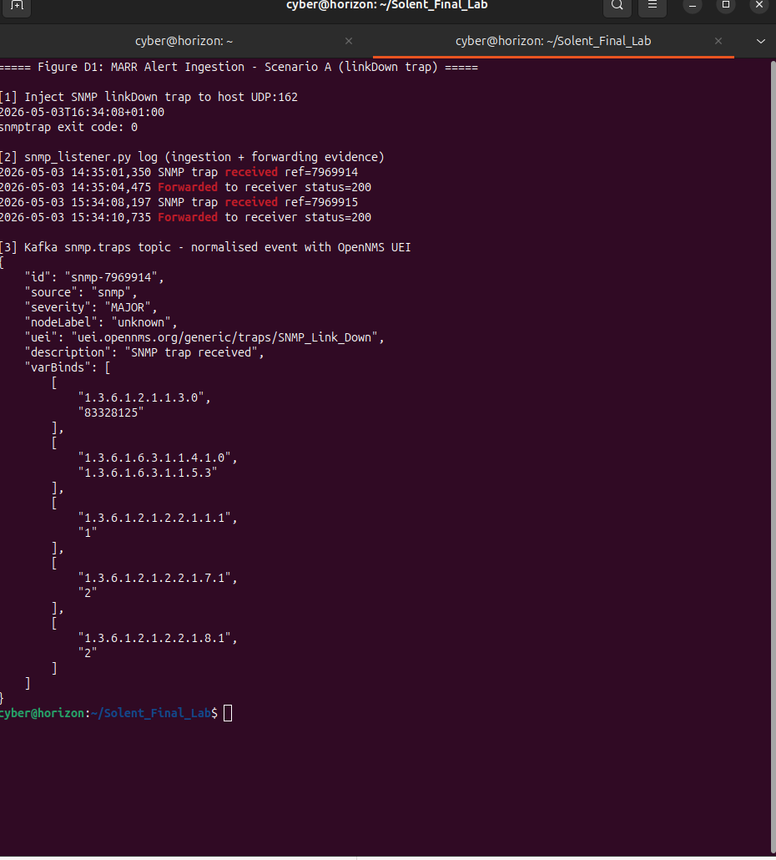
Figure D1. SNMP trap ingestion and Kafka publication trace (FR-001 evidence).
This capture shows the complete ingestion path from SNMP trap injection through the listener service to Kafka topic publication. Measured latency of 197 ms (trap-to-listener) and 2.538 s end-to-end confirms compliance with NFR-004 performance constraints and demonstrates reliable event normalisation and pipeline entry under test conditions.
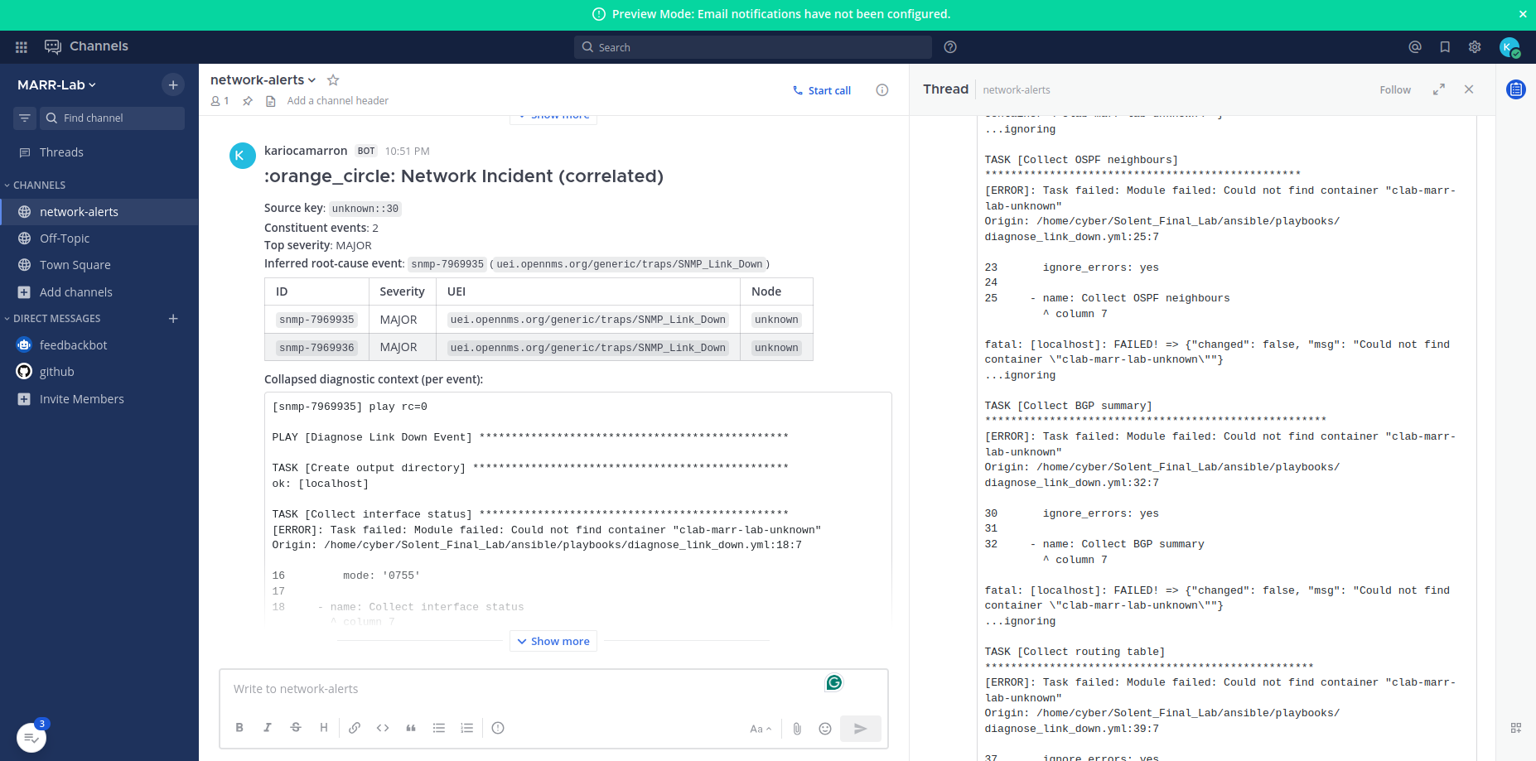
Figure D2. Correlated incident report generated from cascade test (FR-003 evidence).
Multiple alerts sharing the same source key are grouped into a single 'Network Incident (correlated)' report. Two of three cascade events are successfully grouped, with the third event excluded due to the documented blocking-emission limitation (Section 9.4). This output validates the correlation mechanism while transparently exposing its current architectural constraint.
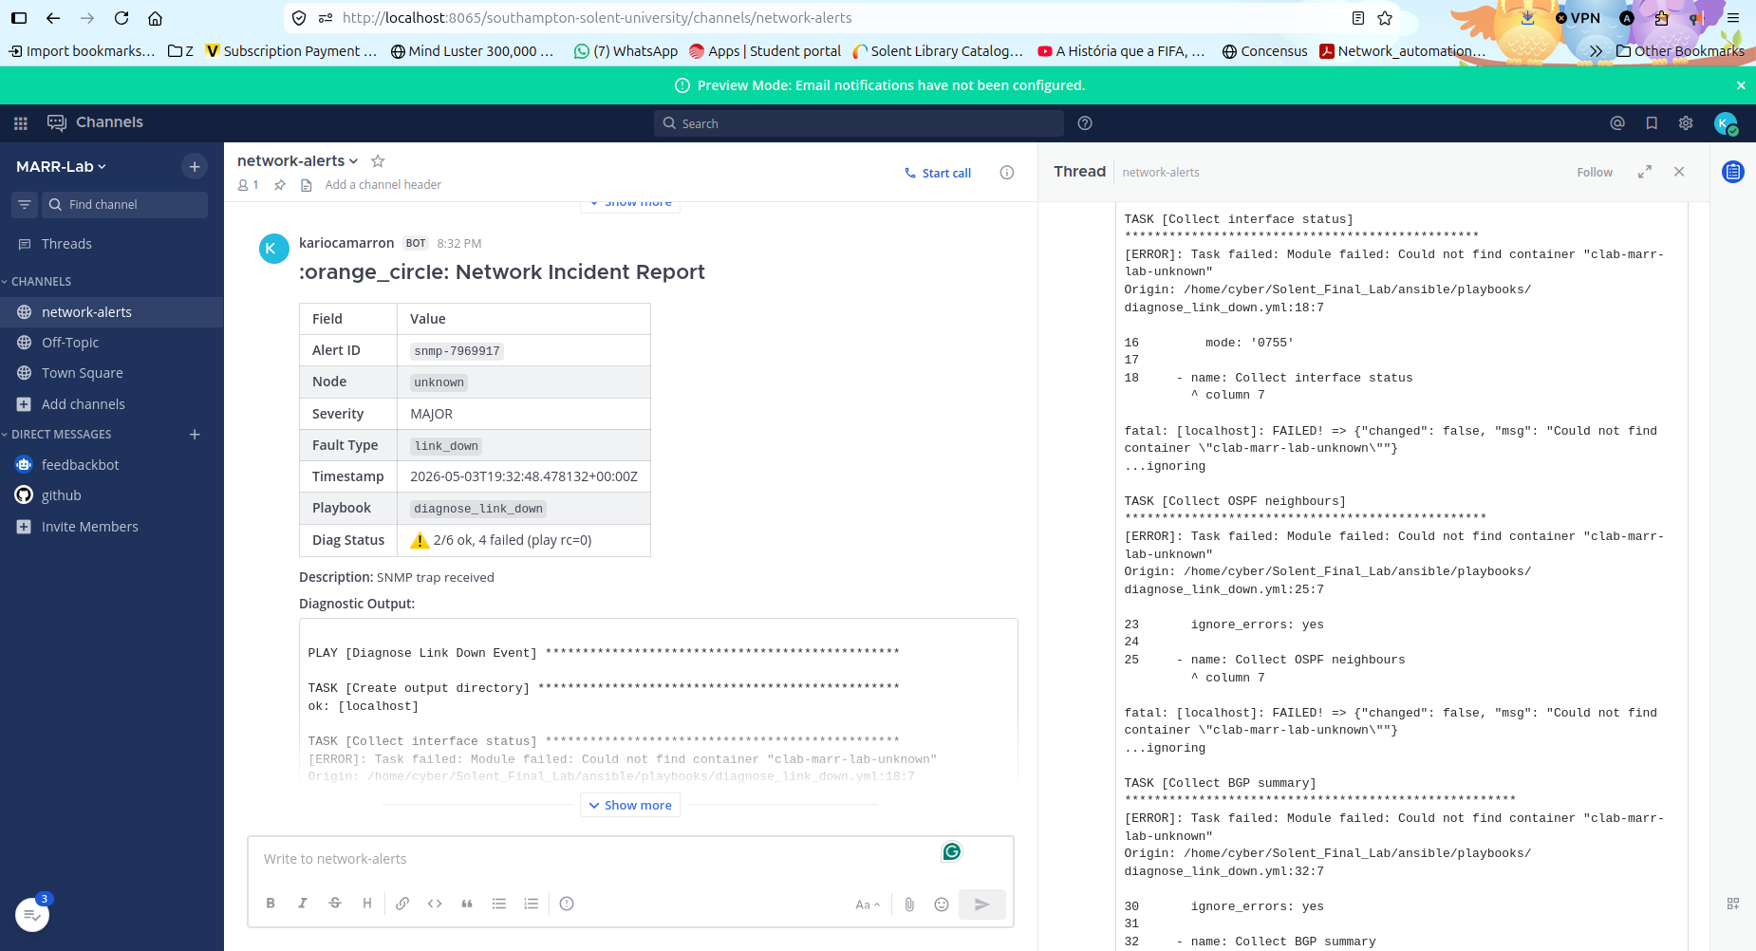
Figure D3. Per-event diagnostic report with corrected Diag Status output (FR-005 evidence).
The report demonstrates successful end-to-end execution of ingestion, diagnostics, and reporting, with accurate task-level status ('2/6 ok, 4 failed') replacing the earlier false-positive success indicator. This confirms reporting fidelity and transparency in diagnostic output.

Figure D4. Partial incident report generated from malformed input (FR-008 evidence).
The system produces a structured report despite incomplete metadata (nodeLabel='unknown'), explicitly surfacing diagnostic failure conditions in the report body and right-pane diagnostic output, and routing the event to the network-alerts channel rather than discarding it. This demonstrates robust handling of imperfect telemetry and confirms zero silent data loss. Figures D3 and D4 derive from the same captured incident report; D3 emphasises Diag Status fidelity (FR-005) and D4 emphasises partial-alert handling (FR-008) evident in the same frame.

Appendix E: Pipeline Test Evidence
Ref | Artefact | Description
E1 | MARR system architecture diagram (Figure E1). | Two-plane architecture diagram embedded in Section 9.1 showing all five pipeline stages, real component names from v4.0 lab, addresses verified 3 May 2026, and colour-coded data flows. Source: figure_E1_marr_architecture.svg.
E2 | Correlator integration log (FR-003 traceability). | journalctl extract from marr-correlator.service capturing the cascade test of 3 May 2026: source-key window build to threshold, lease acquisition, 30-second wait, grouped emission of 2 events, idempotency-marker prevention of redundant emission for the third late-arriving event. Lab Session Log Section 9.11.
E3 | Receiver suppression log. | journalctl extract from marr-receiver.service showing per-event report sent for traps 1 and 4 of the cascade test, suppression of traps 2 and 3 within ~3 s of correlator lease acquisition, and the per-event flow continuing for the distinct-source-key control trap. Lab Session Log Section 9.11.
E4 | Ansible diagnostic runbook execution trace (FR-004 evidence). | Embedded as Figure E4 below. Captured from marr-receiver.service journal, 3 May 2026.
E5 | SNMP trap injection traces. | snmptrap commands used for evidence capture (ifIndex values 1-99 and the cascade values 10/11, 20/21, 30/31, 88) and /tmp/snmp.log excerpts inside clab-marr-lab-snmp-notifier.
E6 | Race-condition diagnosis and fix evidence. | Lab Session Log Section 9.7-9.8 records the in-session diagnosis of the window-versus-lease TTL race condition during the first cascade test, the surgical fix (window TTL extended to 2 times the window value), and the second cascade test confirming the fix worked. Demonstrates structured engineering rigour: hypothesis, test, observation, root-cause, fix, re-test.
E7 | Dotenv configuration-loading fix evidence. | Lab Session Log Section 9.9-9.10 records the in-session diagnosis of the dotenv-loading bug (correlator did not load .env before importing mattermost_notifier, causing webhook URL capture to fail) and the surgical fix. Reinforces the value of strict-discipline cascade testing as a methodology.
Table 12. Pipeline test evidence supporting Section 10.1.
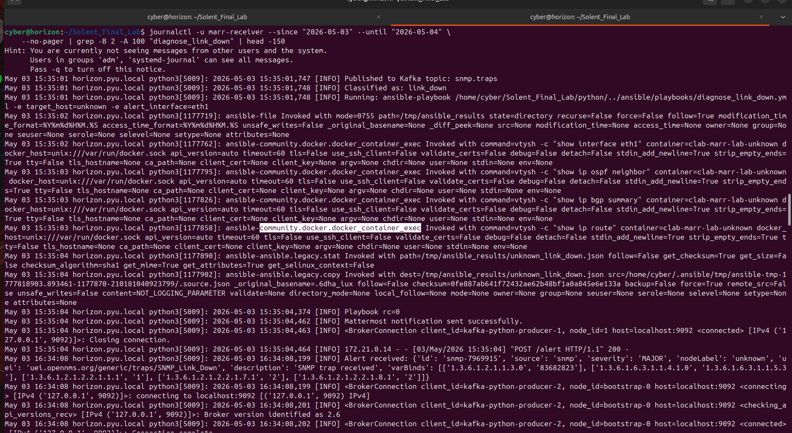
Figure E4. Ansible diagnostic runbook execution trace (FR-004 evidence).
This journalctl extract from marr-receiver.service captures a single Ansible playbook execution, with the four community.docker.docker_container_exec invocations clearly visible: vtysh -c 'show interface eth1', 'show ip ospf neighbor', 'show ip bgp summary', and 'show ip route'. The end-to-end pipeline cycle from 'Running: ansible-playbook' at 15:35:01.748 to 'Mattermost notification sent successfully' at 15:35:04.462 measures 2.714 s. The figure validates the integration between monitoring, automation, and analysis layers and demonstrates that the read-only constraint defined in the system architecture is enforced through the runbook task definitions, since each invocation is a vtysh show command with no syntactic path to a configuration command.

Appendix F: Architecture Artefacts
Ref | Artefact | Description
F1 | MARR network topology diagram. | Two-plane network: marr-net (172.21.0.0/16) operational plane and marr-reporting (172.22.0.0/24) observability plane.
F2 | BGP mesh diagram. | AS65001-AS65002-AS65003 mesh; engineered design break on r1-hamhung and r2-chongjin links to permit fault-injection testing.
F3 | OpenNMS configuration excerpt. | Beanshell event-script and event filter definitions used during early Sprint 1 work; OpenNMS now runs in observation mode rather than as part of the live triage path (see Section 9.1 and Figure E1).
F4 | Sample Ansible runbook. | diagnose_link_down.yml: read-only show interface, show ip ospf neighbor, show ip bgp summary, show ip route. The runbook task definitions are the architectural enforcement point for the read-only allowlist (Section 9.3).
F5 | Kafka topic listing. | raw.alerts, snmp.traps, syslog.events - confirmed via kafka-topics --list against the marr-kafka broker.
F6 | MARR system architecture diagram (Figure E1). | Embedded in Section 9.1; captures the deployed v4.0 architecture including the new correlator and the renamed minion locations.
Table 13. Architecture artefact index.

Appendix G: Project Management Artefacts
Project management artefacts are maintained in the repository at scripts/, docs/, and the root-level project documentation files. They include sprint retrospective notes, the AE2 demonstration script, the Lab Session Log, the chronological lab steps document, and the dual-remote git history.
Ref | Artefact | Description
G1 | Sprint 1 retrospective notes. | End-of-Sprint-1 reflection: cold-start playbook stabilisation; minion until-block fix at commit 076ea99.
G2 | Sprint 2 retrospective notes. | End-of-Sprint-2 reflection: ingestion path stabilisation; classifier corpus authoring; Diag Status fidelity issue identified for Sprint 3.
G3 | Sprint 3 implementation log. | Lab Session Log of 3 May 2026 covering minion rename, Diag Status fix, correlator implementation including in-session race-condition and dotenv fixes, and post-crash recovery.
G4 | Chronological lab steps document. | My_Lab_Steps_May_2026.docx: step-by-step record of every operational action taken in the 3 May session, structured for direct reproduction by a future operator.
G5 | Dual-remote git history. | All work pushed to both KariocaMarron/com617-AutomatedNetworkTroubleshooting-1 (origin) and com617-industrial-2025-1/com617-AutomatedNetworkTroubleshooting-1 (upstream) at every significant milestone.
Table 14. Project management artefact index.

Appendix H: Governance and Compliance
This appendix records the governance and professional-conduct framing of the project.

H.1 BCS Code of Conduct alignment
The project aligns with the BCS Code of Conduct for IT Professionals (BCS 2022) on three principles. Public interest: the read-only diagnostic enforcement and the explicit exclusion of autonomous remediation reflect a duty of care to third parties whose services depend on the monitored networks. Professional competence: the synthetic-versus-production distinction maintained throughout the document reflects the principle that practitioners should not assert capabilities they cannot demonstrate. Integrity: the Lab Session Log records two in-session diagnoses (race condition and dotenv loading) and the limitations they revealed; this transparency is the BCS expectation, not academic self-deprecation.

H.2 IET Rules of Conduct alignment
The IET Rules of Conduct (IET 2023) emphasise professional competence in digital systems. The decision to defer ML-based correlation until labelled production data exists (Section 1; Section 4.2; Section 9.2) is a direct application of the IET principle that practitioners should not deploy capabilities outside their evaluable competence.

H.3 Data protection considerations
MARR processes operational telemetry from network devices, not personal data. UK GDPR obligations do not apply to the data flows in scope for the MVP. If the system is extended to ingest user-attributable data (e.g. authentication failure events that include user identifiers) in v1, a Data Protection Impact Assessment is required before deployment.

H.4 Repository and licensing
The repository is dual-pushed to KariocaMarron/com617-AutomatedNetworkTroubleshooting-1 and com617-industrial-2025-1/com617-AutomatedNetworkTroubleshooting-1. The university repository is the authoritative submission location. Licensing is internal to the academic project; redistribution is governed by the COM617 module assessment terms.

