Project Roadmap

Title
E-Commerce Customer Purchase Behaviour Analysis Using Data Analytics and Visualization

Domain
Data Analytics / Data Science

Dataset
Kaggle E-Commerce Customer Purchase Dataset

Abstract
The rapid growth of e-commerce platforms has generated large volumes of customer transaction data containing valuable information about purchasing behaviour, customer demographics, product preferences, and spending patterns. This project focuses on analyzing e-commerce customer purchase behaviour by performing data cleaning, preprocessing, exploratory data analysis (EDA), demographic analysis, product category analysis, purchase and spending pattern analysis, and visualization using Python libraries such as Pandas, NumPy, Matplotlib, and Seaborn to identify meaningful insights that can support better business decisions.

Architecture Diagram
Raw Dataset
|
Data Cleaning
|
Preprocessing
|
Exploratory Data Analysis
|
Customer & Product Analysis
|
Data Visualization
|
Insights & Conclusions

Research Flow
Benchmark Dataset
|
Data Cleaning
|
Data Preprocessing
|
Exploratory Data Analysis
|
Customer Demographic Analysis
|
Product Category Analysis
|
Purchase Pattern Analysis
|
Visualization
|
Insights & Conclusions

Tools
Python, Pandas, NumPy, Matplotlib, Seaborn, Jupyter Notebook/Google Colab

EDA Recommendation
Include at least 10–12 analytical techniques in the Exploratory Data Analysis (EDA) section rather than limiting it to basic plots. This provides a deeper understanding of the dataset and aligns more closely with standard analytical workflows.
Suggested EDA techniques:
• Dataset Overview
• Data Quality Assessment
• Descriptive Statistics
• Missing Value Analysis
• Duplicate Record Detection
• Outlier Detection
• Univariate Analysis
• Bivariate Analysis
• Multivariate Analysis
• Correlation Analysis
• Feature Engineering
• Feature Selection

ARCHITECTURE DIAGRAM:

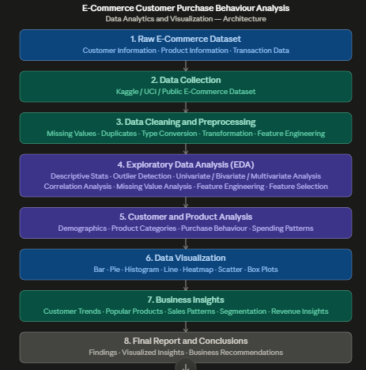

Note
The selected e-commerce dataset combination is suitable for customer purchase behaviour analysis because it covers customer demographics, product categories, purchasing behaviour, and spending patterns. It enables meaningful business insights and supports current research in Data Analytics, Business Intelligence, and Data Science.
This project is well suited for the DAV (Data Analytics and Visualization) course under the Data Science and Big Data Analytics specialization and will strengthen a resume by demonstrating practical skills in data preprocessing, exploratory data analysis, visualization, and insight generation.

