🟢 Level 1 — Simplest (Recommended for you)

Simple CNN Encoder-Decoder for Depth
Build a basic U-Net style architecture from scratch.
Input RGB Image
↓
CNN Encoder (your own conv blocks)
↓
Bottleneck
↓
Decoder (upsample + skip connections)
↓
Depth Map Output
What you build yourself:
- Conv blocks with BatchNorm + ReLU
- Encoder (downsampling path)
- Decoder (upsampling path)
- Skip connections
- Loss function (L1 or SSIM)
Train on: NYU Depth V2 (indoor, smaller, faster) Supervision: Fully supervised — use the ground truth depth maps directly
This is honest, clean, understandable, and very explainable in a viva.

🟡 Level 2 — Moderate

Add an Attention Gate to your U-Net
Same U-Net as above but add a simple attention gate at skip connections — it learns which spatial regions to focus on.
This teaches you attention mechanisms without the complexity of full transformers.

🟠 Level 3 — Stretch Goal

Self-supervised version (like Monodepth2 but yours)
Instead of using ground truth depth labels, train using photometric loss between consecutive video frames. Much harder to implement but closest to real research.

Architecture
Let's build it step by step and visualize the architecture first!Here's the full U-Net architecture for monocular depth estimation, explained visually and layer by layer!
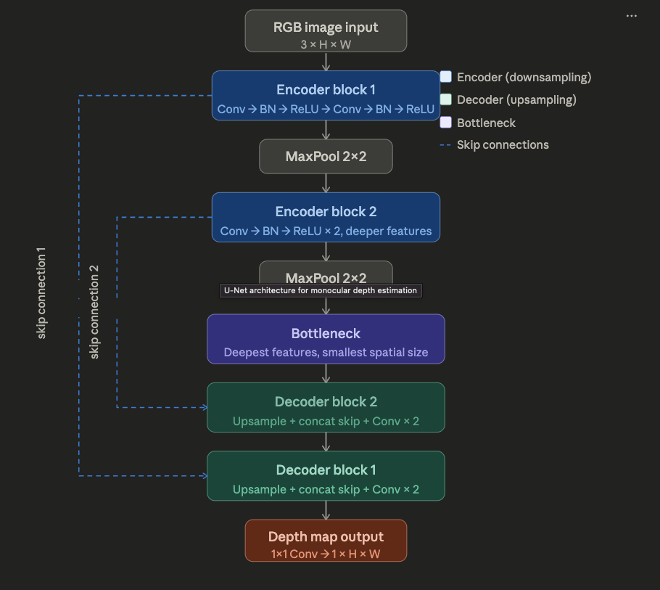
You can click on any block to ask about it! Now let me explain each part clearly:

🔵 Encoder (Left/Down path) — "What does the scene look like?"
Think of it as a compressor. Each block does:
- Two Conv2D layers — detect features like edges, textures, shapes
- BatchNorm — stabilizes training
- ReLU — adds non-linearity
- MaxPool — halves the spatial size (shrinks the image)
As you go deeper, the image gets smaller but richer — fewer pixels but more abstract features.

🟣 Bottleneck — "The brain"
The smallest, deepest representation. Here the network understands what is in the scene globally — but has lost precise where information. That's okay — the skip connections fix that.

🟢 Decoder (Right/Up path) — "Where exactly is everything?"
Each block does:
- Upsample — doubles spatial size back up (transposed conv or bilinear)
- Concatenate with the skip connection from the encoder
- Two Conv2D layers — refine the combined features
🔷 Skip Connections — The key idea!
This is what makes U-Net special. They directly connect encoder blocks to decoder blocks, passing fine-grained spatial detail that would otherwise be lost in the bottleneck. Without them, your depth map would be blurry.

🔴 Output
A single 1×1 Conv reduces channels to 1, giving you a grayscale depth map — same resolution as the input image, where each pixel value = predicted depth.

