**Assignment: Use the Q-learning example given as a basis for your homework and develop a SARSA learning algorithm instead of Q-learning.**

**SARSA Learning Algorithm:**

#!/usr/bin/env/ python

"""

sarsa_learner.py

An easy-to-follow script to train, test and evaluate a SARSA-learning agent on the Mountain Car

"""

import gym

import numpy as np

MAX_NUM_EPISODES = 50000

STEPS_PER_EPISODE = 200 # This is specific to MountainCar. May change with env

EPSILON_MIN = 0.005

max_num_steps = MAX_NUM_EPISODES * STEPS_PER_EPISODE

EPSILON_DECAY = 500 * EPSILON_MIN / max_num_steps

ALPHA = 0.05 # Learning rate

GAMMA = 0.98 # Discount factor

NUM_DISCRETE_BINS = 30 # Number of bins to Discretize each observation dim

class SARSA_Learner(object):

def __init__(self, env):

self.obs_shape = env.observation_space.shape

self.obs_high = env.observation_space.high

self.obs_low = env.observation_space.low

self.obs_bins = NUM_DISCRETE_BINS # Number of bins to Discretize each observation dim

self.bin_width = (self.obs_high - self.obs_low) / self.obs_bins

self.action_shape = env.action_space.n

# Create a multi-dimensional array (aka. Table) to represent the

# Q-values

self.Q = np.zeros((self.obs_bins + 1, self.obs_bins + 1,

self.action_shape)) # (51 x 51 x 3)

self.alpha = ALPHA # Learning rate

self.gamma = GAMMA # Discount factor

self.epsilon = 1.0

def discretize(self, obs):

return tuple(((obs - self.obs_low) / self.bin_width).astype(int))

def get_action(self, obs):

discretized_obs = self.discretize(obs)

# Epsilon-Greedy action selection

if self.epsilon > EPSILON_MIN:

self.epsilon -= EPSILON_DECAY

if np.random.random() > self.epsilon:

return np.argmax(self.Q[discretized_obs])

else: # Choose a random action

return np.random.choice([a for a in range(self.action_shape)])

def learn(self, obs, action, reward, next_obs):

discretized_obs = self.discretize(obs)

discretized_next_obs = self.discretize(next_obs)

td_target = reward + self.gamma * (self.Q[discretized_next_obs][action])

td_error = td_target - self.Q[discretized_obs][action]

self.Q[discretized_obs][action] += self.alpha * td_error

def train(agent, env):

best_reward = -float('inf')

for episode in range(MAX_NUM_EPISODES):

done = False

obs = env.reset()

total_reward = 0.0

while not done:

action = agent.get_action(obs)

next_obs, reward, done, info = env.step(action)

agent.learn(obs, action, reward, next_obs)

obs = next_obs

total_reward += reward

if total_reward > best_reward:

best_reward = total_reward

print("Episode#:{} reward:{} best_reward:{} eps:{}".format(episode,

total_reward, best_reward, agent.epsilon))

# Return the trained policy

return np.argmax(agent.Q, axis=2)

def test(agent, env, policy):

done = False

obs = env.reset()

total_reward = 0.0

while not done:

action = policy[agent.discretize(obs)]

next_obs, reward, done, info = env.step(action)

obs = next_obs

total_reward += reward

return total_reward

if __name__ == "__main__":

env = gym.make('MountainCar-v0')

agent = SARSA_Learner(env)

learned_policy = train(agent, env)

# Use the Gym Monitor wrapper to evalaute the agent and record video

gym_monitor_path = "./gym_monitor_output"

env = gym.wrappers.Monitor(env, gym_monitor_path, force=True)

for _ in range(1000):

test(agent, env, learned_policy)

env.close()

SARSA Learning Results:

Total number of Episodes: 50000

Best Reward: -84

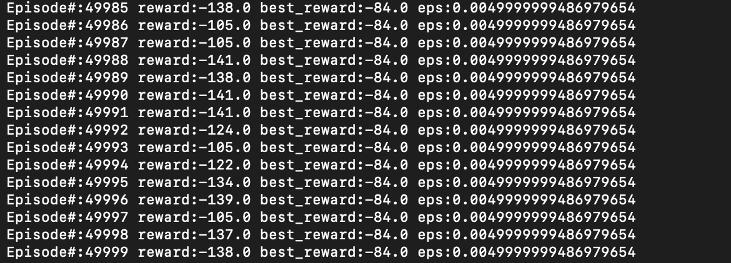

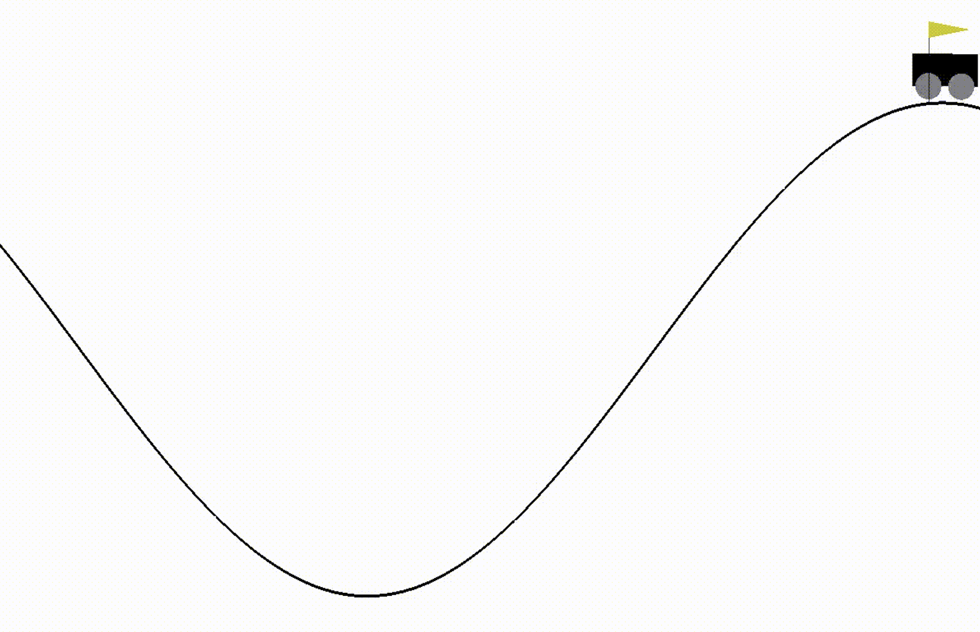

**Q-Learner Algorithm**

**#!/usr/bin/env/ python**

**"""**

**q_learner.py**

**An easy-to-follow script to train, test and evaluate a Q-learning agent on the Mountain Car**

**problem using the OpenAI Gym. |Praveen Palanisamy**

**# Chapter 5, Hands-on Intelligent Agents with OpenAI Gym, 2018**

**"""**

**import gym**

**import numpy as np**

**#MAX_NUM_EPISODES = 500**

**MAX_NUM_EPISODES = 50000**

**STEPS_PER_EPISODE = 200 # This is specific to MountainCar. May change with env**

**EPSILON_MIN = 0.005**

**max_num_steps = MAX_NUM_EPISODES * STEPS_PER_EPISODE**

**EPSILON_DECAY = 500 * EPSILON_MIN / max_num_steps**

**ALPHA = 0.05 # Learning rate**

**GAMMA = 0.98 # Discount factor**

**NUM_DISCRETE_BINS = 30 # Number of bins to Discretize each observation dim**

**class Q_Learner(object):**

**def __init__(self, env):**

**self.obs_shape = env.observation_space.shape**

**self.obs_high = env.observation_space.high**

**self.obs_low = env.observation_space.low**

**self.obs_bins = NUM_DISCRETE_BINS # Number of bins to Discretize each observation dim**

**self.bin_width = (self.obs_high - self.obs_low) / self.obs_bins**

**self.action_shape = env.action_space.n**

**# Create a multi-dimensional array (aka. Table) to represent the**

**# Q-values**

**self.Q = np.zeros((self.obs_bins + 1, self.obs_bins + 1,**

**self.action_shape)) # (51 x 51 x 3)**

**self.alpha = ALPHA # Learning rate**

**self.gamma = GAMMA # Discount factor**

**self.epsilon = 1.0**

**def discretize(self, obs):**

**return tuple(((obs - self.obs_low) / self.bin_width).astype(int))**

**def get_action(self, obs):**

**discretized_obs = self.discretize(obs)**

**# Epsilon-Greedy action selection**

**if self.epsilon > EPSILON_MIN:**

**self.epsilon -= EPSILON_DECAY**

**if np.random.random() > self.epsilon:**

**return np.argmax(self.Q[discretized_obs])**

**else: # Choose a random action**

**return np.random.choice([a for a in range(self.action_shape)])**

**def learn(self, obs, action, reward, next_obs):**

**discretized_obs = self.discretize(obs)**

**discretized_next_obs = self.discretize(next_obs)**

**td_target = reward + self.gamma * np.max(self.Q[discretized_next_obs])**

**td_error = td_target - self.Q[discretized_obs][action]**

**self.Q[discretized_obs][action] += self.alpha * td_error**

**def train(agent, env):**

**best_reward = -float('inf')**

**for episode in range(MAX_NUM_EPISODES):**

**done = False**

**obs = env.reset()**

**total_reward = 0.0**

**while not done:**

**action = agent.get_action(obs)**

**next_obs, reward, done, info = env.step(action)**

**agent.learn(obs, action, reward, next_obs)**

**obs = next_obs**

**total_reward += reward**

**if total_reward > best_reward:**

**best_reward = total_reward**

**print("Episode#:{} reward:{} best_reward:{} eps:{}".format(episode,**

**total_reward, best_reward, agent.epsilon))**

**# Return the trained policy**

**return np.argmax(agent.Q, axis=2)**

**def test(agent, env, policy):**

**done = False**

**obs = env.reset()**

**total_reward = 0.0**

**while not done:**

**action = policy[agent.discretize(obs)]**

**next_obs, reward, done, info = env.step(action)**

**obs = next_obs**

**total_reward += reward**

**return total_reward**

**if __name__ == "__main__":**

**env = gym.make('MountainCar-v0')**

**agent = Q_Learner(env)**

**learned_policy = train(agent, env)**

**# Use the Gym Monitor wrapper to evalaute the agent and record video**

**gym_monitor_path = "./gym_monitor_output"**

**env = gym.wrappers.Monitor(env, gym_monitor_path, force=True)**

**for _ in range(1000):**

**test(agent, env, learned_policy)**

**env.close()**

Q Learning Results:

Total number of Episodes: 50000

Best Reward: -87

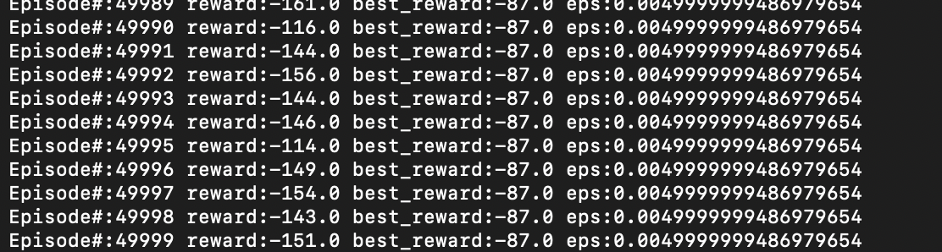

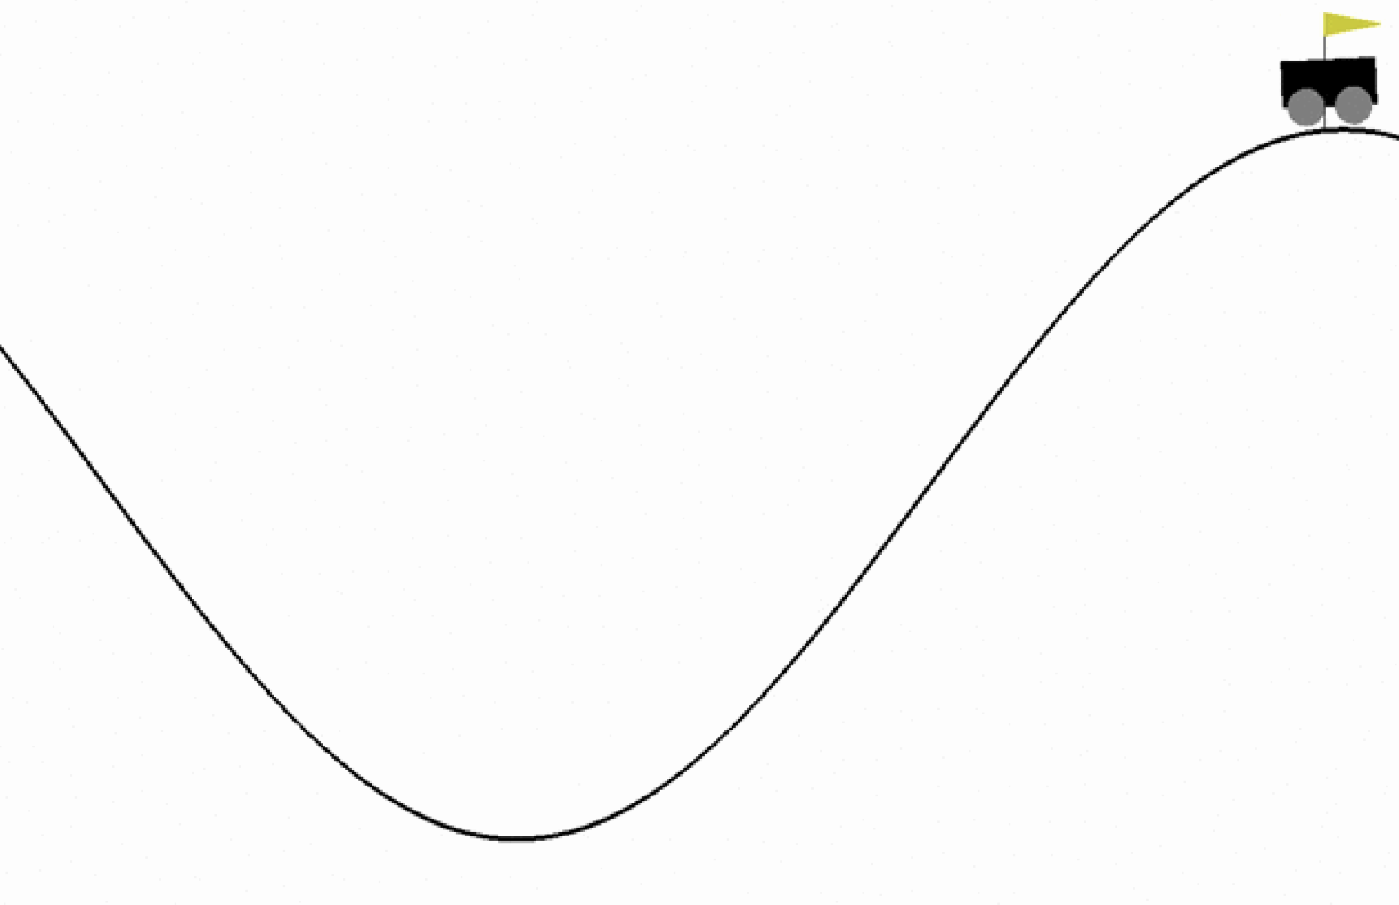

**Inference**

As a result of both the algorithms it's clear that the best reward converges to higher value in case of Q-learning (-87) as compared to SARSA(-84) as the episodes increase. This is due to the selection of action in case of Q-learning where we select the maximum Q-value. This results in getting the largest reward in long run.