Logo Redesign Report – Starbucks Coffee Shop: “Brewed to perfection”

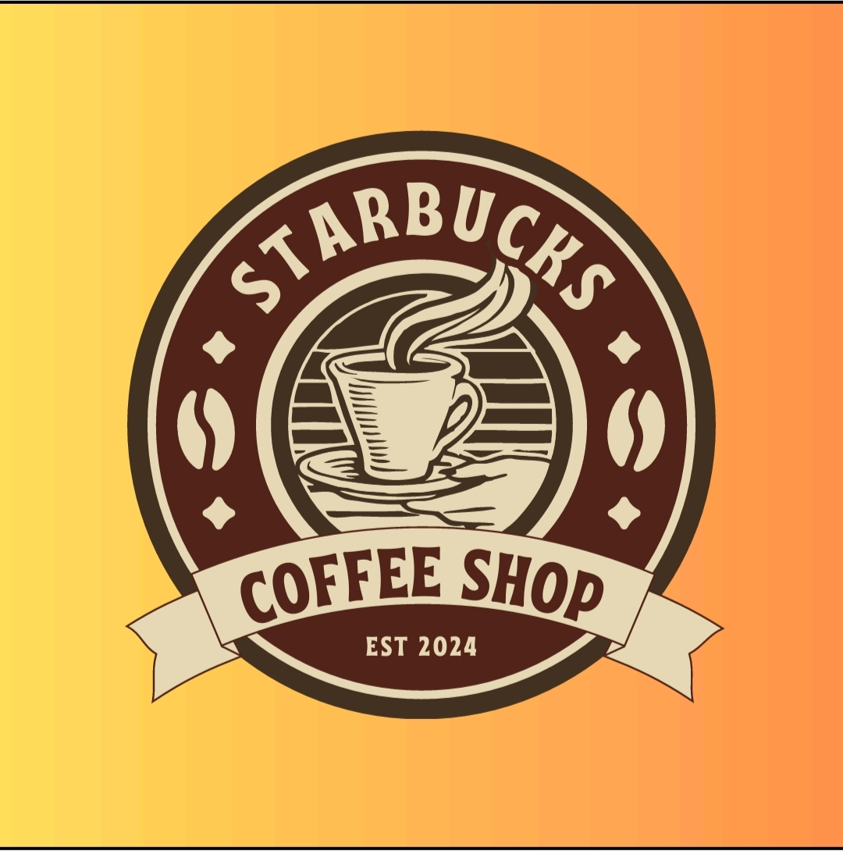

Name: Karishma Mohammad

College: Anil Neerukonda Institute of Technology and Sciences

# 📌 Objective

The aim of this task is to redesign the existing logo of the “Starbucks Coffee Shop” to give it a fresh, modern look while retaining its original identity and charm. The redesign should follow current design standards and trends, and result in a flexible logo suitable for both digital and print use.

# 🔍 Existing Logo Description

The current logo is a vintage-style badge logo designed in circular form. Here's a breakdown of its elements:

- Shape: Circular badge logo with ribbon banner at the bottom

- Typography: Serif fonts used for “Starbucks” and “Coffee Shop”

- Imagery: A steaming coffee cup with a stylised hand and stripe background

- Icons: Coffee beans and diamond shapes in the border

- Establishment Year: “EST 2024” mentioned at the base

- Colours: Shades of brown and beige on a warm yellow-orange gradient background

# ✅ Brand Identity to Preserve

While modernising the logo, it is essential to preserve the core brand elements which customers might already associate with the Starbucks Coffee Shop name:

- Cup of Coffee: Represents warmth, aroma, and the product itself.

- Circular Emblem: Suggests tradition and heritage.

- “Coffee Shop” & “EST 2024”: Indicates it’s a newly established but serious café.

- Coffee Beans Icon: Symbolic of freshness and quality.

# ✨ Redesign Goals

To make the logo look more modern, minimal and versatile, the redesign will focus on the following goals:

- 🎨 Visual Appeal: Simplify the design and use clean lines, making it look professional and fresh

- 📱 Digital Friendliness: Ensure the logo works well on websites, mobile apps, and social media icons

- 🔁 Scalability: It should remain clear and identifiable even in small sizes like a mobile icon

- 🎭 Style Consistency: Maintain a cohesive look that works with the café’s interior, packaging, and branding

- 🆚 Variations: Create a few alternate versions for different use-cases – banner, profile, black & white, etc.

# 🔮 Modern Design Trends to Follow

- Flat Design: Remove unnecessary shadows and textures.

- Minimalism: Focus on key icons and keep the design clean.

- Rounded Fonts: Use soft, readable, and trendy sans-serif fonts.

- Neutral Colour Palette: Use elegant coffee tones like mocha, espresso, cream, and beige.

- Responsive Layout: Ensure the logo adapts for horizontal/vertical/mobile layouts.

# 🧪 Proposed Logo Variations

- 🔘 Full Badge Logo: Modernised version of current logo – circle with icons and text

- ☕ Cup Icon Logo: Only the coffee cup & steam – usable as a mobile app icon or watermark

- ➖ Horizontal Logo: Coffee cup on left + “Starbucks Coffee Shop” on the right – ideal for banners

- 🌑 Dark Mode Version: High-contrast version for use on black/dark backgrounds

# 🧠 Design Logic Behind Each Version

1. Full Badge Logo:  
- Keeps the circular shape for brand recall.  
- Simplifies the coffee cup illustration to a flat icon.  
- Replaces serif font with a modern rounded font.  
- Coffee beans and “EST 2024” retained in neater form.

2. Cup Icon Logo:  
- Shows just the cup and steam.  
- Great for mobile app icons, coasters, stickers etc.  
- Clean and recognisable even without text.

3. Horizontal Layout:  
- Designed for use in headers, websites, and packaging.  
- Allows text to sit beside icon, improving readability on narrow spaces.

4. Dark Mode Logo:  
- For use on dark UI themes, posters or evening events.  
- White/beige text and icons on deep brown or black backgrounds.

# 📁 Final Deliverables

- ✅ SVG, PNG, JPG: For digital and print use

- ✅ PDF Style Guide: Document with colours, fonts, and logo usage rules

- ✅ Prototype Showcase: Screens showing how the logo looks on cup, app, website

- ✅ Light & Dark Modes: Ensures versatility across all platforms

# 🧾 Conclusion

This redesign approach focuses on making the logo:  
- Fresh and Modern  
- Simple yet Memorable  
- Adaptable for all digital and physical mediums  
  
By respecting the core identity of the brand while modernising the visual appeal, this redesign ensures Starbucks Coffee Shop stands out in a competitive market, especially among youth and digital-first consumers.