Karishma Sukhwani – Maths Quiz Lab

Output:

Page 1: Asking name.

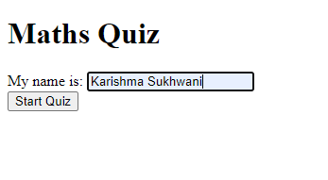

Page 2: Quiz questions.

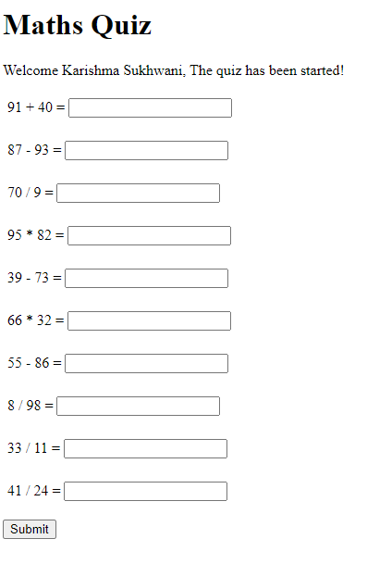

Page 3: correct answers color – green, false answer color – red.

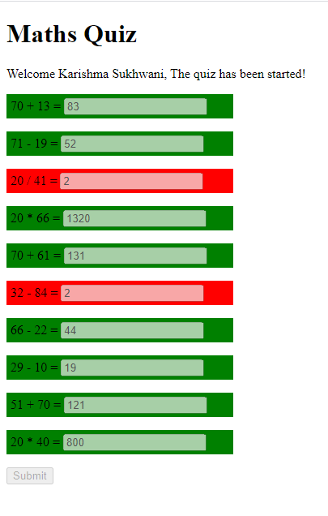

Explanation:

HTML structure is having paragraphs with id element as **q1, q2, q3, …** Then JS runs and removes the previous content and displays quiz with greeting. When user clicks submit quiz then JS changes the class of container question i.e. **q1, q2,..** based on whether question is true or false**,** then CSS handles color using class selector.