**Practical 1. : Introduction and contribution to wikipedia**

1. ***Description about Wikipedia and its features :***

Wikipedia is a free, open content online encyclopedia created through the collaborative effort of a community of users known as Wikipedians. Originally, Wikipedia was created to provide content for Nupedia.

* Basic features of Wikipedia:

1.Create a page

2. Edit a page

3. linking between pages: Linking between Wiki pages makes it easier for readers to find secondary materials they may need, especially as your Wiki grows.

1. ***Creating Account on Wikipedia :***

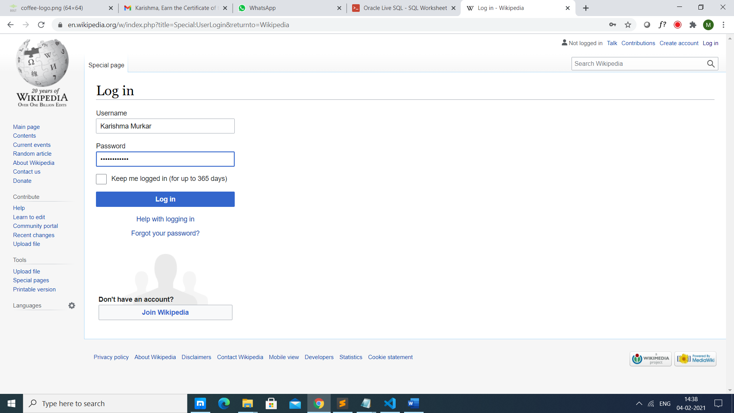

1. *If you have an account you can directly log in to access Wikipedia by your account*
2. *If you don’t have an account then click on join Wikipedia to create an account.*

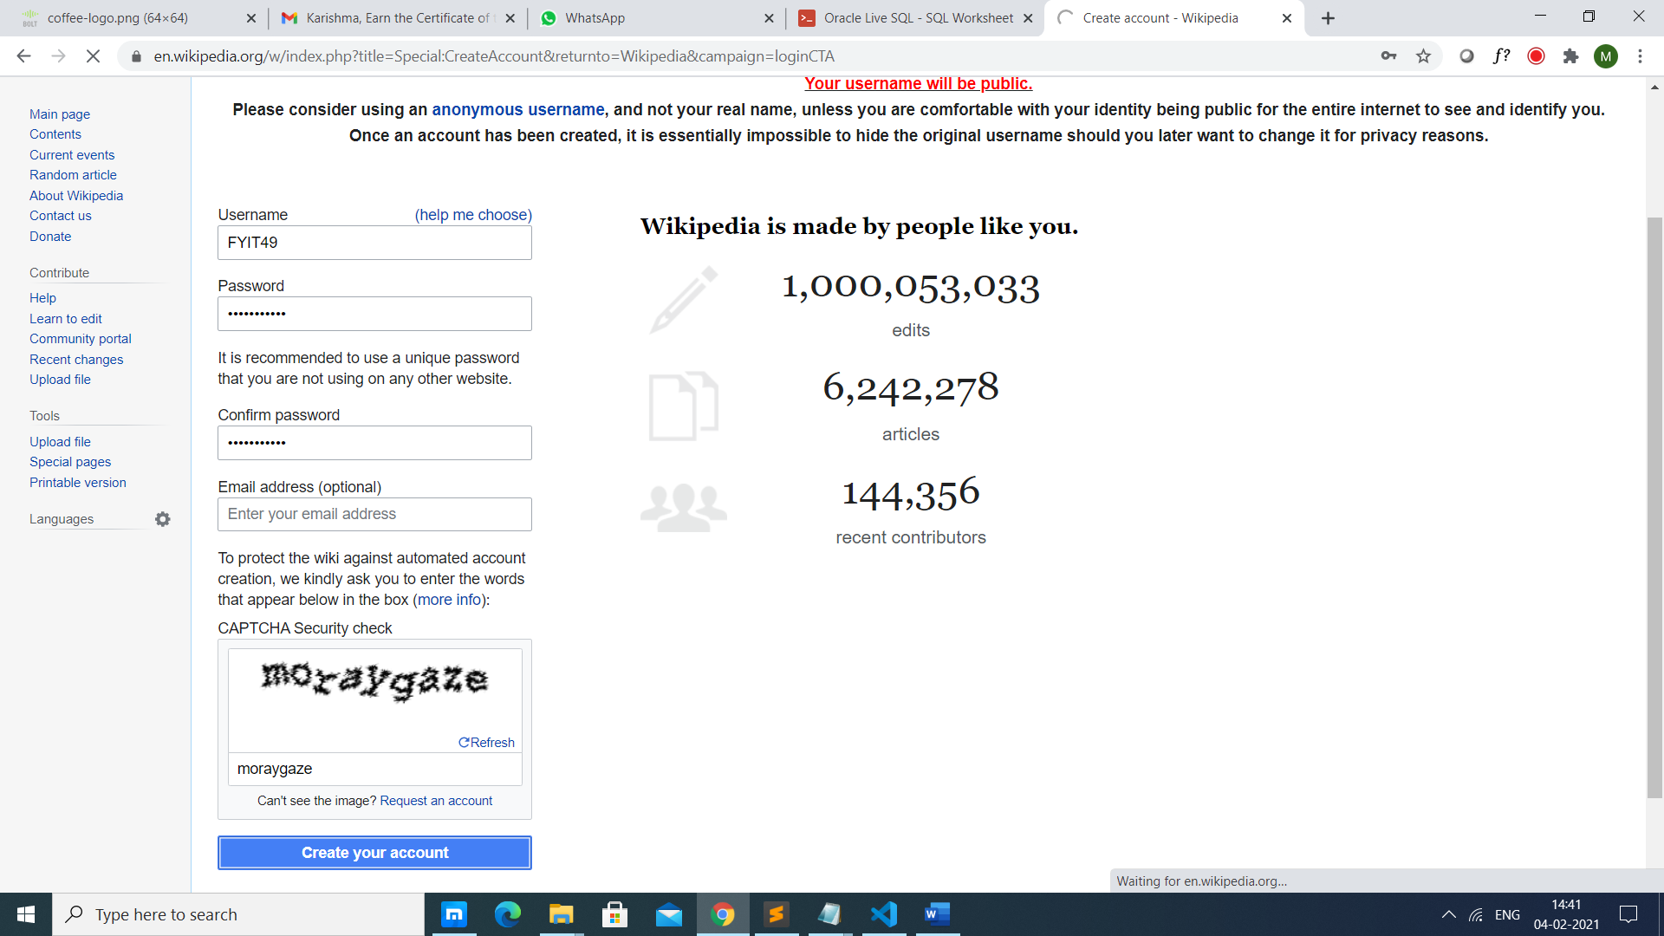

1. *Fill the information and click on Create your account after that your page will be created.*

***c) Creating your page on Wikipedia:***

1. *click on Create source to create your page.*

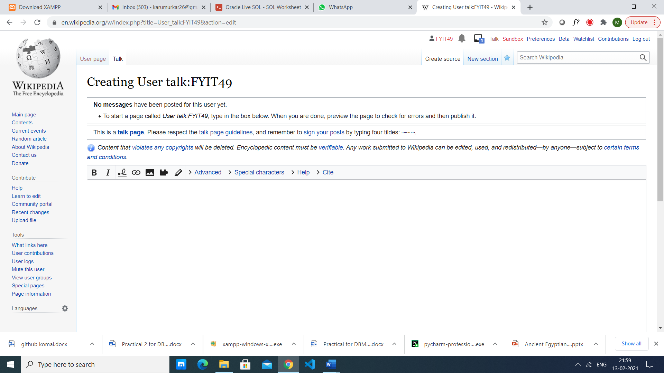*2 .add your content and then click on publish changes to publish your page on wikipedia.*

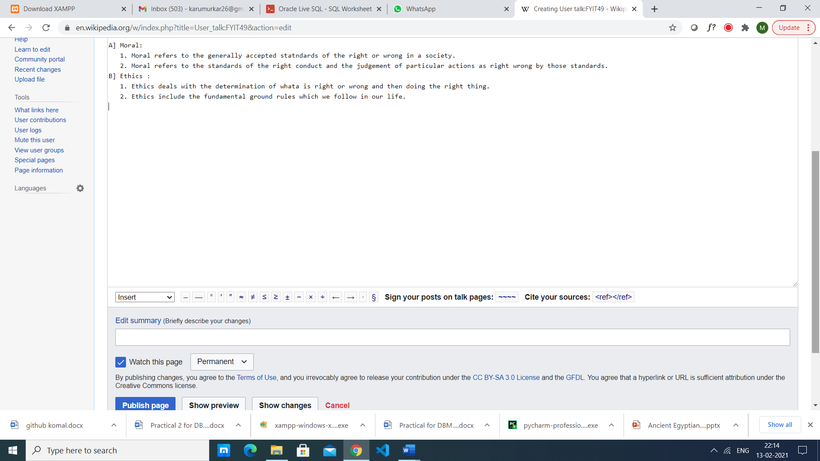

1. ***Editing your page on Wikipedia :***

*1.click on edit source to edit your page.*

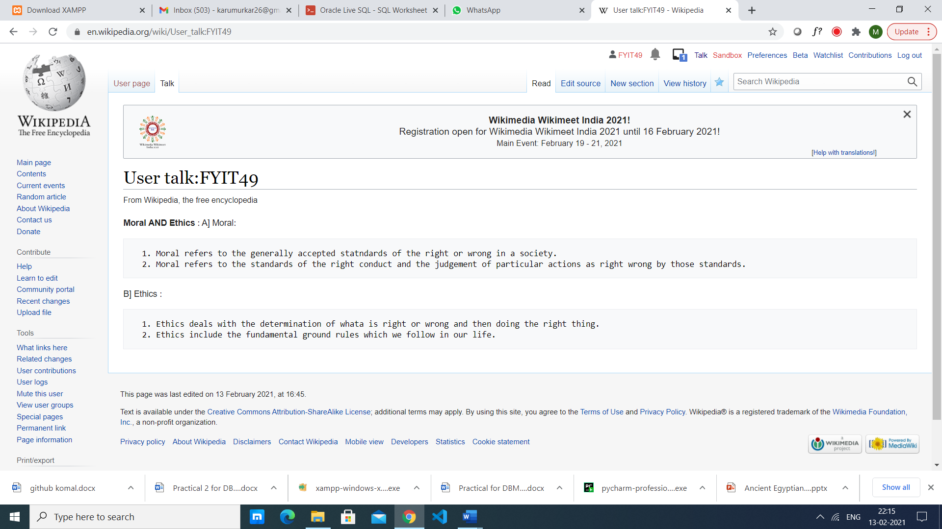

*2.edit your changes and then click on publish changes to confirm your edits.*

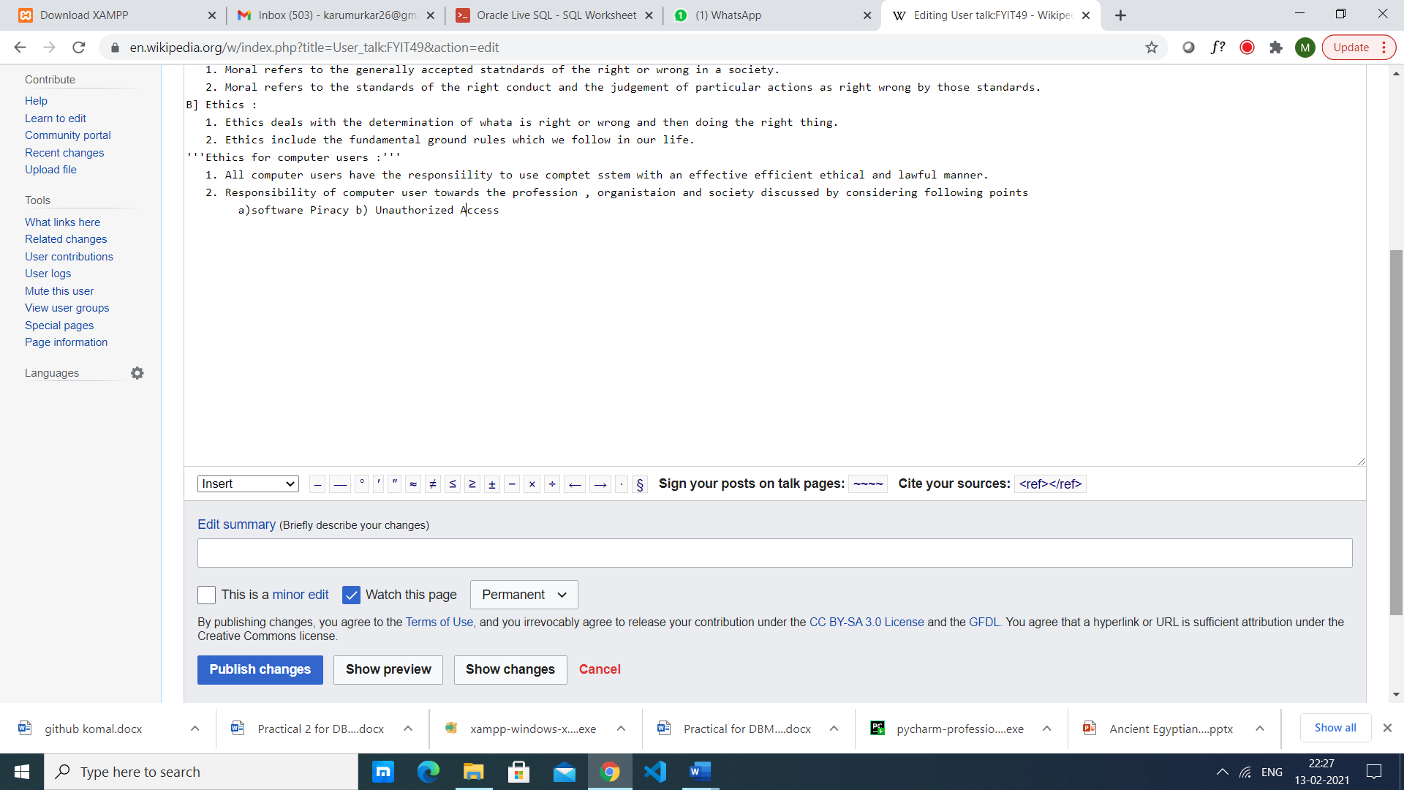

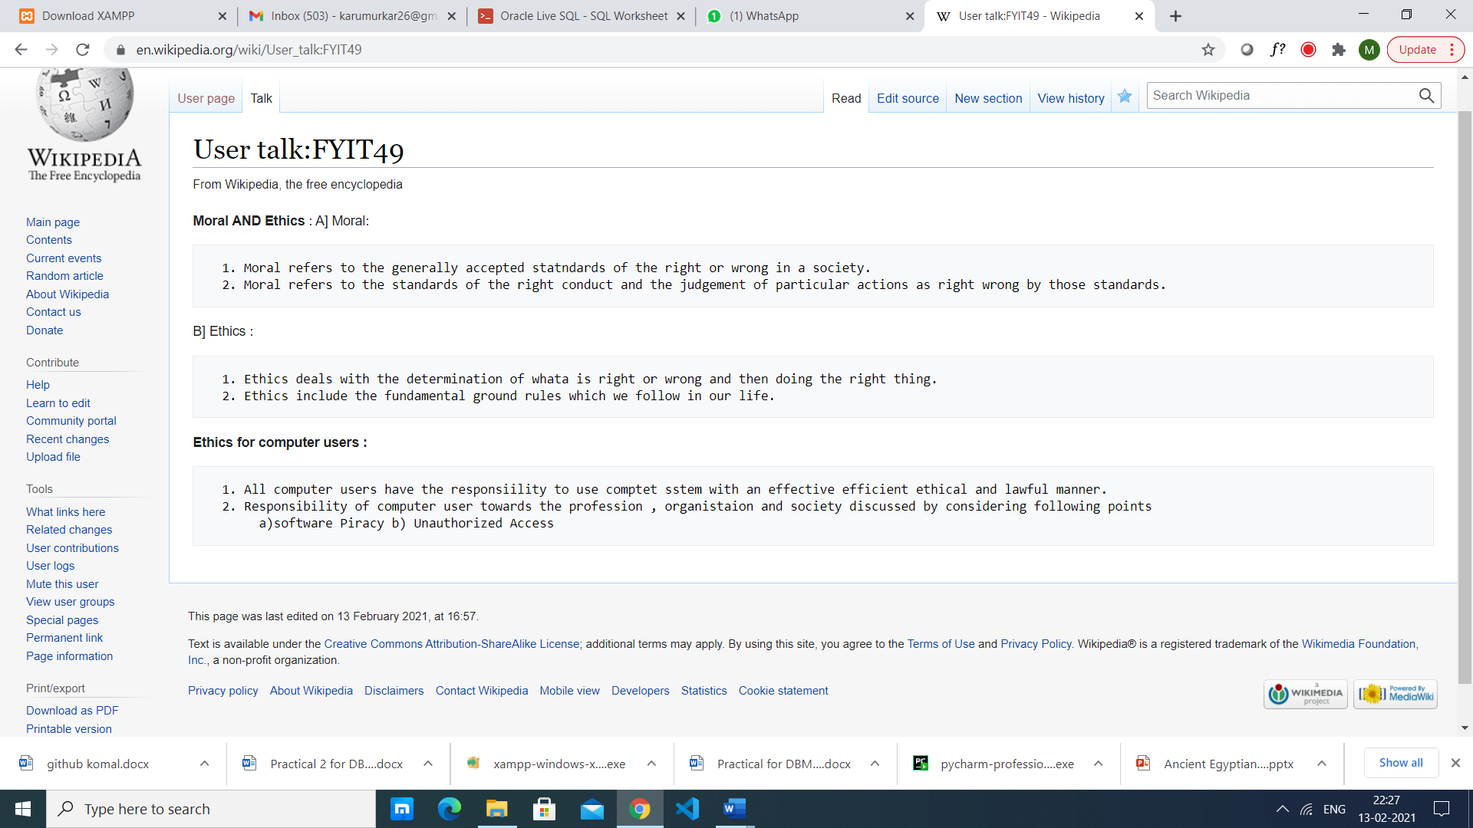

*3.Your page will be displayed with the changes.*

