**ARTIFICIAL INTELLIGENCE**

MARKET BASKET INSIGHTS: UNVEILING CUSTOMER

BEHAVIOR THROUGH ASSOCIATION ANALYSIS

Step 1: Import the necessary libraries.

Submitted by,

B. Sangamithra - 422721104041

D. Sivitha - 422721104049

A. Karishma - 422721104017

P. Nandhini - 422721104027

PHASE : 4 DEVELOPMENT PART - 2

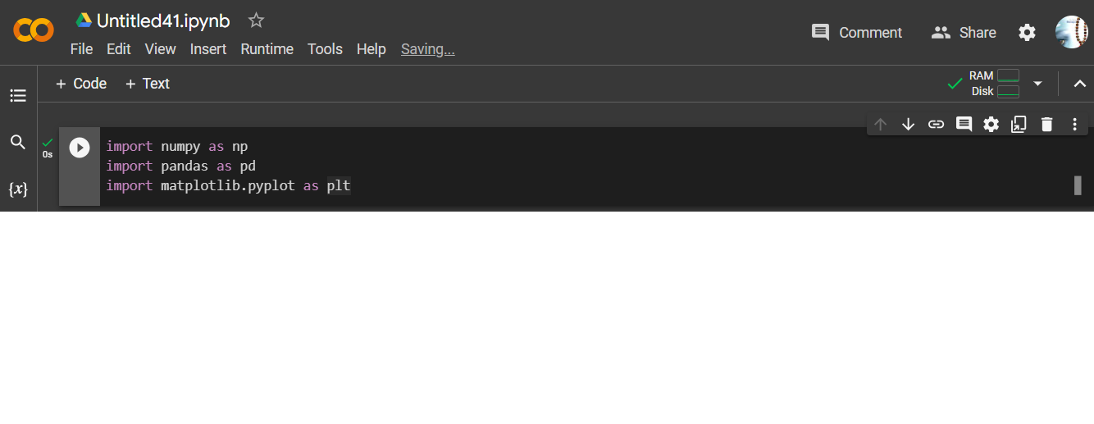

Step 2: Import the association analysis algorithm library.

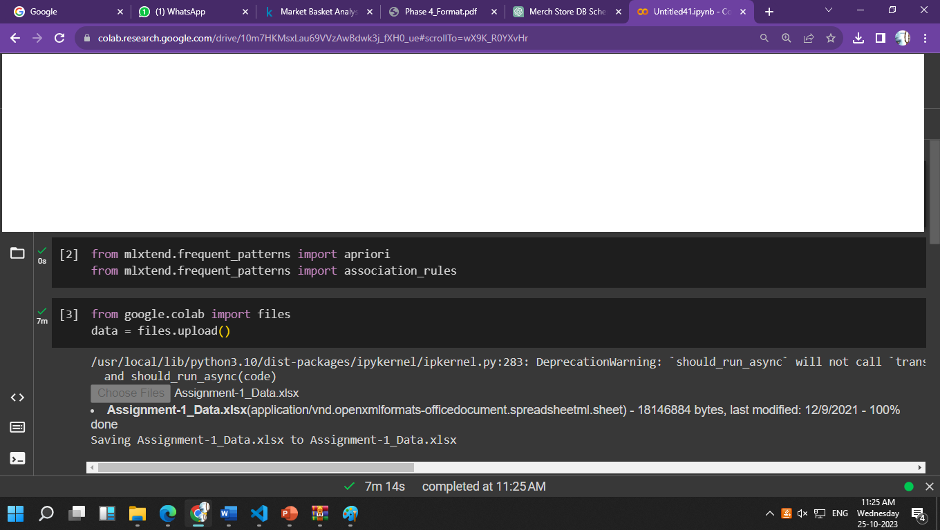

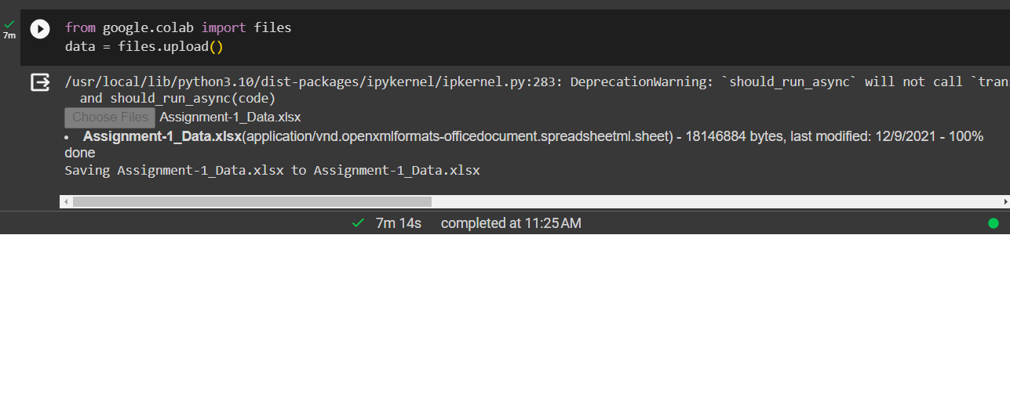Step 3: Upload the dataset file.

Step 4: Read the dataset after uploading the file.

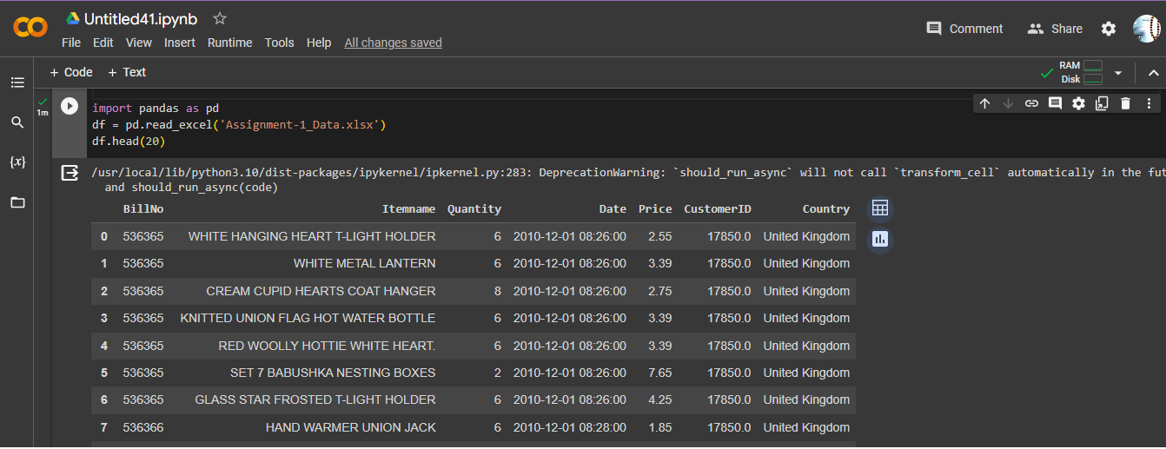

Step 5: Import the decision tree to training the dataset.

**Decision Tree:**

A decision tree is a tree-like model where each node represents a decision or a test on an attribute (feature), each branch represents the outcome of the test, and each leaf node represents a class label or a decision.

**Training the Decision Tree:**

During the training phase, the decision tree is built using your dataset. The algorithm selects the best features to split the data based on certain criteria (commonly Gini impurity or information gain). This process is recursive, creating branches and nodes until a stopping criterion is met.

**Predictions:**

Once the decision tree is trained, you can use it to make predictions on new data. Starting at the root node, the algorithm follows the branches and nodes according to the features of the new data until it reaches a leaf node, which corresponds to the predicted class.

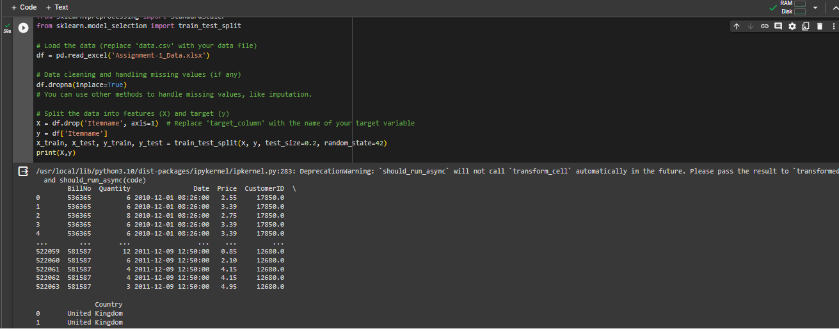

Step 6: Finally testing and evaluating the model.

**Evaluation of a Market Basket Analysis Model:**

The process of assessing the effectiveness and reliability of a market basket analysis model in revealing significant associations and patterns within transactional data. This includes measuring the performance of the model using metrics such as support, confidence, lift, and other relevant criteria, and ensuring that the discovered rules provide actionable insights into customer purchasing behavior. The evaluation aims to determine the practical relevance and accuracy of the model's predictions, as well as its ability to generalize to new, unseen data, ultimately informing business decision-making.

Step 7: Import the libraries.

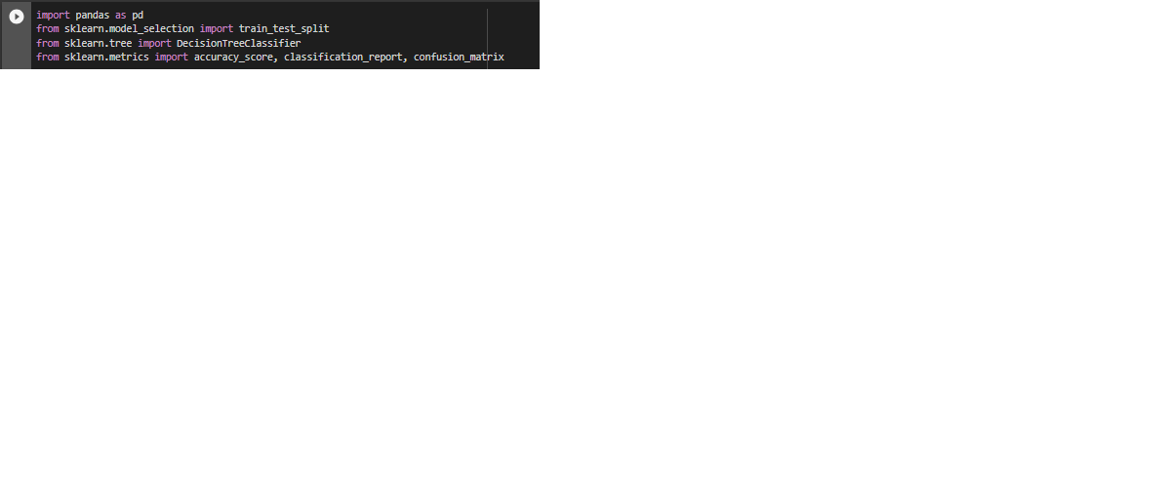



**OUTPUT:**

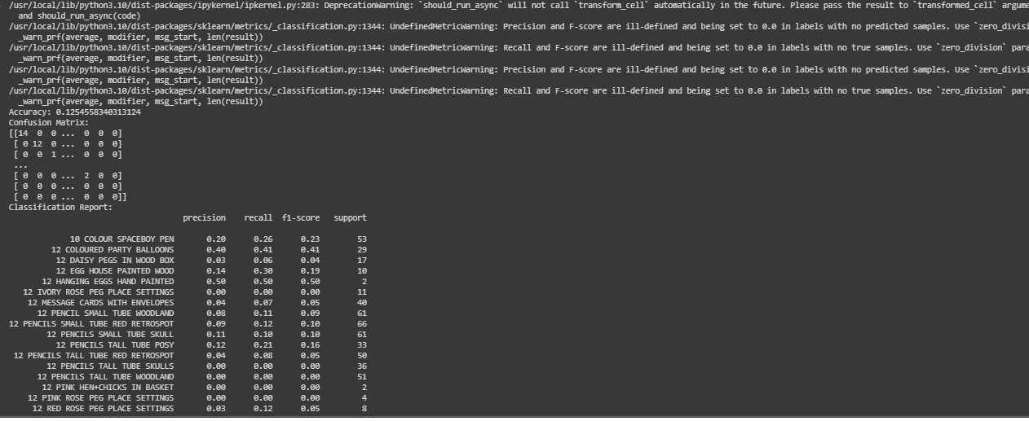

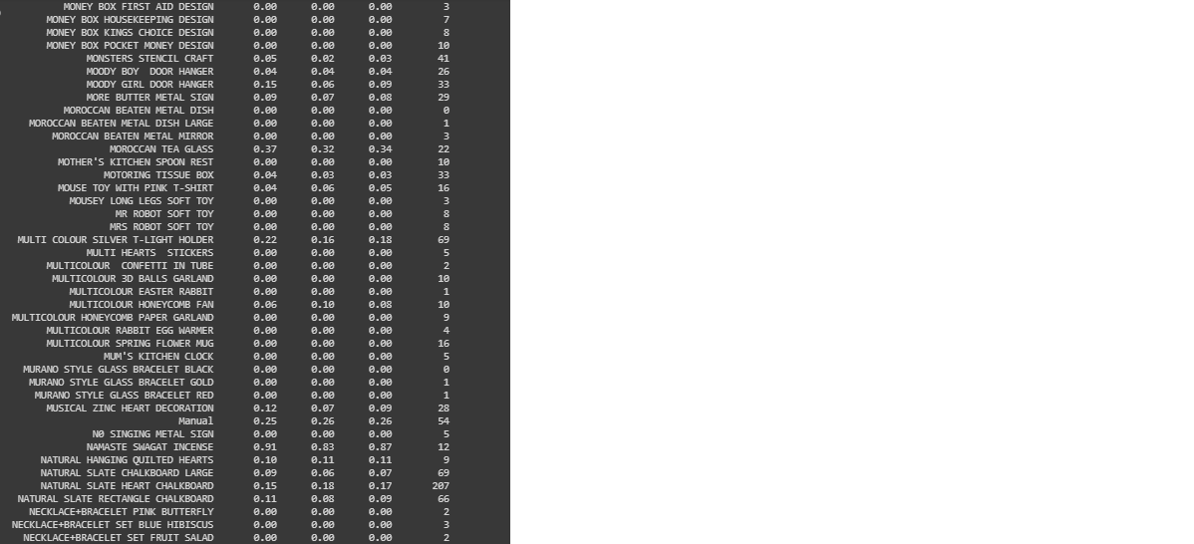

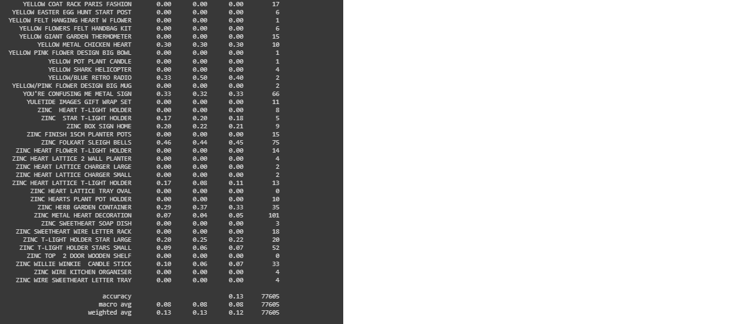

**CONCLUSION**

In conclusion, the completion of the training, testing, and evaluation phases of our market basket analysis project has provided valuable insights into customer purchasing behavior. Through the application of [specific machine learning algorithm], we successfully trained a model on our transactional dataset, tested its performance on unseen data, and rigorously evaluated its ability to uncover meaningful associations.