1. Display the number of countries present in data

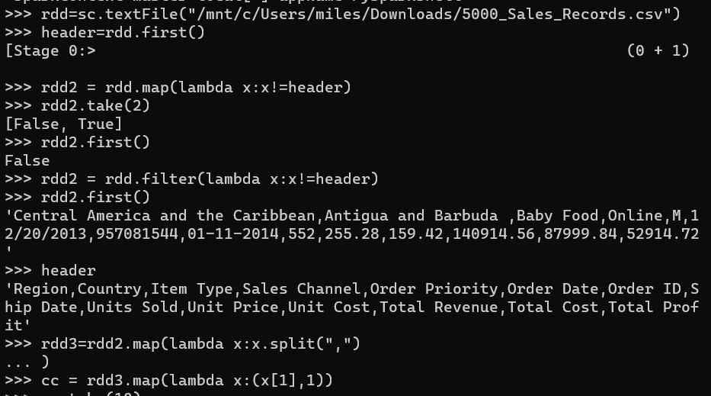

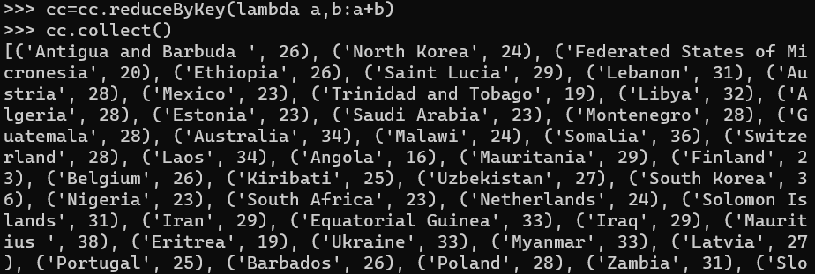

1. Display the number of units sold in each region

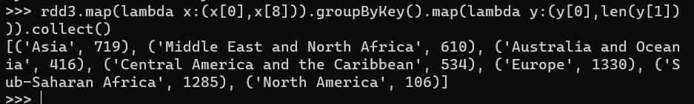

1. Display 10 most recent sales

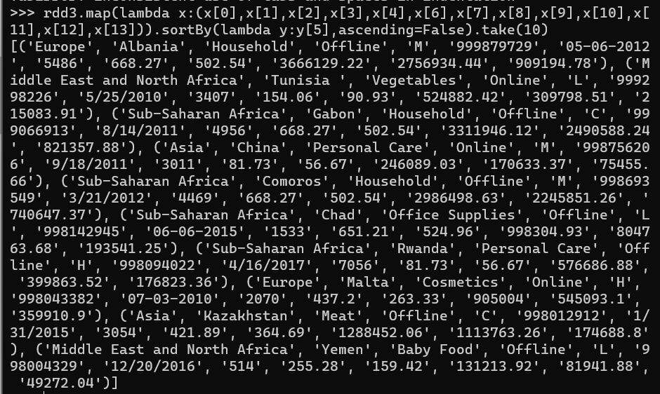

1. Display the products with atleast 2 occurences of ‘a’



1. Display country in each region with highest units sold

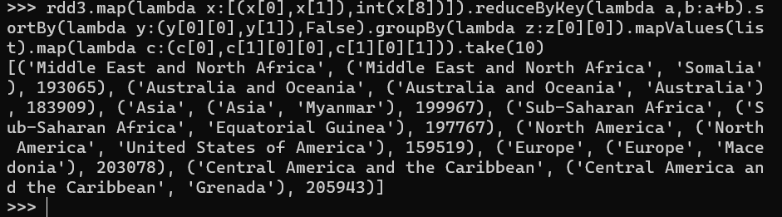

1. Display the country with highest sale

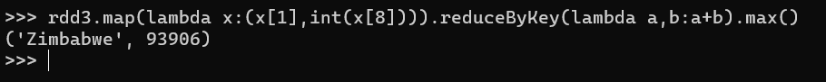

1. Display the number of orders for each item

