ELIXIR

# A MINI-PROJECT REPORT

***Submitted by***

Dhanya Shree M (715521106012)

Karishma Kaine T (715521106021)

Lokesh Dhanvanthri K S (715521106026)

Sarathsuriya V (715521106307)

**BACHELOR OF ENGINEERING**

# in

ELECTRONICS AND COMMUNICATION ENGINEERING



# PSG INSTITUTE OF TECHNOLOGY AND APPLIED RESEARCH, COIMBATORE-641 062

**BONAFIDE CERTIFICATE**

Certified that this project report **“WATER CONSERVATION AND QUALITY CONTROL”** is the bonafide work of **DHANYA SHREE M(715521106012), KARISHMA KAINE T (71552110602), LOKESH DHANVANTHIRI (715521106026) and SARATHSURIYA V (715521106307)** who carried out the project work under my supervision.

# SIGNATURE SIGNATURE

Dr. P. Vijayakumar M.E., Ph.D Dr. D. Selvakumar M.Tech., Ph.D

# HEAD OF THE DEPARTMENT SUPERVISOR

**Professor Associate Professor**

ECE Department, ECE Department,

PSG Institute of Technology PSG Institute of Technology

And Applied Research, And Applied Research,

Coimbatore-641 062 Coimbatore-641 062

Submitted for the **Project Expo – Embedded Systems Design** (2025 batch) held on 03/05/2024

# **ACKNOWLEDGEMENT**

We would like to thank the Management of PSG Institute of Technology and Applied Research for providing us with excellent facilities for the completion of this Project.

We are grateful to our Principal **Dr. N. Saravannkumar, B.E. (Hons), M.Tech, Ph.D,** for providing us an excellent opportunity to carry out our project with the best infrastructure and facilities.

We are thankful to **Dr. P. Vijaykumar, M.E, Ph.D,** Professor and Head, Department of Electronics and Communication Engineering, for his excellent guidance and encouragement to complete our project.

It is our pleasure to thank our Project Guide **Dr. D. Selvakumar M.Tech., Ph.D** Assistant Professor, Department of Electronics and Communication Engineering for her valuable and timely assistance in completing our project.

We would also like to thank all the faculty and staff members of the Electronics and Communication Engineering Department for their kind co-operation and encouragement during the course of this work.

## ABSTRACT

# Inefficient management of water resources poses significant challenges, including maintaining water quality, managing weekly flow rates effectively, and implementing water conservation measures. Existing systems often lack integration, real-time monitoring, and proactive alerting mechanisms, leading to suboptimal utilization of water resources. To address these challenges, this project aims to develop a comprehensive water management system integrating turbidity, flow, and DHT11 sensors. The system will accurately detect water quality, monitor flow rates, and provide real-time data via Blynk cloud integration. By analyzing weekly flow rate comparisons and implementing proactive water conservation measures, the system will enable informed decision-making and enhance overall water resource management efficiency. Ultimately, this solution strives to promote sustainable water usage practices, mitigate risks to water quality, and contribute to the conservation of this vital resource.

# **LIST OF CONTENTS**

|  |  |  |
| --- | --- | --- |
|  | **TITLE** | **PAGE NO.** |
|  | **ABSTRACT** | **iv** |

|  |  |  |
| --- | --- | --- |
|  | **CHAPTER 1**   * 1. Introduction   2. Need for the project   3. Problem Statement   4. Objective | **2**  2  3  5  6 |
|  | **CHAPTER 2**   * 1. Literature Survey | **8**  8 |
|  |  |  |
|  | **CHAPTER 3**  HARDWARE DESCRIPTION   * 1. ESP32   2. High Precision Water flow sensor YF-S401   3. TS-300B turbidity sensor   4. DHT11 temperature and humidity sensor   5. PH450C PH meter | **11**  11 |

|  |  |  |
| --- | --- | --- |
|  | **CHAPTER 4** | **26** |
|  | 4.1 Hardware setup  4.2 Software setup  4.3 Code | 26 |
|  |
|  |
| **5** | **CHAPTER 5**   * 1. Result | **36**  36 |
|  |
| **6** | **CHAPTER 6**   * 1. Future Scope | **37**  37 |
|  | **REFERENCES** | **38** |

|  |  |
| --- | --- |
|  |  |
|  |  |
|  |  |
|  |  |
|  |  |
|  |  |
|  |  |
|  |  |
|  |  |
|  |  |
|  |  |
|  |  |
|  |  |
|  |  |
|  |  |
|  |  |
|  |  |
|  |  |
|  |  |

**CHAPTER 1**

**1.1 INTRODUCTION**

Water pollution occurs when harmful substances enter water bodies like ponds, rivers, lakes, seas, and oceans, either dissolving, suspending, or depositing in the water. This degradation of water quality poses significant challenges in ensuring pure and safe water due to various sources of chemicals and contaminants. Industrial waste discharge and urban sewage are primary causes, while pollutants from soil, rain, and groundwater also contribute. These pollutants include viruses, bacteria, fertilizers, parasites, pharmaceuticals, pesticides, nitrates, fecal waste, phosphates, radioactive substances, and plastics. Despite not always altering water color, they can be harmful contaminants.

Regular testing of water samples and marine life helps determine water quality. Deteriorating water quality, as highlighted by David Malpass, President of the World Bank, not only impacts health and the environment but also stalls economic growth and exacerbates poverty. If organic pollution, measured by biological oxygen demand, exceeds a threshold, GDP growth in affected areas can decrease significantly. Consequences of water pollution include biodiversity loss, contaminated food chains, scarcity of drinkable water leading to health issues, and high infant mortality rates due to waterborne diseases.

Water quality monitoring involves collecting data on physical, chemical, and microbial properties at designated intervals to assess current conditions. Smart monitoring systems aim to measure key quality metrics, detect deviations for timely warnings, and provide real-time analysis and corrective measures. User involvement and attention to hygiene, environmental sanitation, disposal, and storage are essential for maintaining water quality.

Rapid urbanization worsens global water scarcity as groundwater levels decline. To address this, IoT-driven water conservation systems are proposed. These systems, integrating sensors into household water meters, monitor real-time consumption. Predefined usage thresholds trigger automatic adjustments to alleviate pressure on dwindling resources.

In urban and rural areas, poor water quality poses health risks from contaminated consumption. Early detection is vital, using parameters like conductivity and pH. Collected sensor data undergoes cloud-based analysis, employing decision tree classification to predict water quality and optimize resource management.

**1.2 NEED FOR THE PROJECT**

1. Precision Water Quality Monitoring:

To ensure accurate assessment, reliable sensors and equipment are indispensable for measuring essential parameters such as pH levels, dissolved oxygen, turbidity, temperature, and the presence of contaminants.

2. Robust Data Collection and Analysis:

Establishing a system for systematic data collection and thorough analysis of weekly water quality records is imperative for identifying patterns, anomalies, and potential issues.

3. Flow Rate Measurement Precision:

Accurate measurement of weekly flow rates necessitates deploying sophisticated flow meters or similar devices capable of accurately monitoring water volume over time.

4. Real-time Decision Support Framework:

Developing a decision-making framework based on real-time water quality data is essential to assess water suitability for various applications and to trigger appropriate responses if quality standards are compromised.

5. Water Conservation Strategies Implementation:

Implementing an effective water alerting system is vital for detecting leaks, abnormal usage patterns, or instances of deteriorating water quality, thus contributing to water conservation efforts.

6. Seamless Integration and Connectivity:

Ensuring seamless communication between sensors, data recording systems, decision support tools, and alerting systems requires leveraging IoT technologies and cloud-based platforms.

7. User-Friendly Interface Design:

Designing an intuitive interface accessible across different devices is crucial to enable easy access to data, decision support tools, and alerts for various stakeholders.

8. Scalability and Adaptability Framework:

Designing a system capable of scaling with future expansions, upgrades, and changes in monitoring requirements is essential, utilizing modular components and adaptable infrastructure.

9. Compliance with Regulations and Standards:

Adherence to pertinent regulations and standards governing water quality monitoring, data management, and conservation efforts is paramount to ensure project success and legality.

10. Maintenance and Support Planning:

Establishing comprehensive plans for regular maintenance, calibration, and technical support is essential to guarantee the continuous and reliable operation of the water management system.

**1.3 PROBLEM STATEMENT**

Inefficient management of water resources poses significant challenges to maintaining water quality, managing weekly flow rates effectively, making informed decisions based on water quality data, and implementing water conservation measures. Existing systems often lack integration, real-time monitoring, and proactive alerting mechanisms, leading to suboptimal utilization of water resources. Therefore, there is a critical need to develop a comprehensive water management system that seamlessly integrates weekly water quality records, flow rate data, and decision-making processes. This system should enable timely analysis of water quality parameters, facilitate informed decision-making based on the available data, and implement proactive water conservation measures through an alerting system. By addressing these challenges, the proposed solution aims to enhance overall water resource management efficiency, promote sustainable water usage practices, and mitigate potential risks to water quality and availability.

**1.4 OBJECTIVE**

1. Accurate Water Quality Monitoring: Develop a system capable of consistently and accurately monitoring water quality parameters on a weekly basis.

2. Reliable Weekly Flow Rate Measurement: Implement a flow rate measurement system that provides reliable data on a weekly basis to understand the volume and rate of water flow.

3. Data Analysis for Decision Making: Establish algorithms and analytical methods to interpret the collected water quality data, enabling informed decision-making regarding water management and usage.

4. Integration of Water Quality Information for Decision Support: Integrate the collected water quality data into a decision support system that assists stakeholders in making informed choices related to water usage and conservation.

5. Efficient Water Conservation Strategies: Design and implement a water alerting system that notifies users of potential water quality issues or excessive consumption, enabling proactive conservation measures.

6. Optimization of Water Resource Management: Utilize the gathered data and insights to optimize water resource management practices, ensuring sustainable usage and conservation efforts.

7. User-Friendly Interface Development: Develop an intuitive and user-friendly interface for accessing and visualizing water quality and flow rate data, facilitating easy interpretation and decision-making for stakeholders.

8. Continuous Monitoring and Improvement: Establish protocols for continuous monitoring of the system's performance and effectiveness, with a focus on iterative improvements to enhance reliability and accuracy over time.

9. Compliance with Regulatory Standards: Ensure that the developed system complies with relevant regulatory standards and guidelines governing water quality monitoring and conservation practices.

10. Education and Awareness: Conduct outreach and educational initiatives to raise awareness among stakeholders about the importance of water quality monitoring, conservation, and sustainable usage practices.

**CHAPTER-2**

**2.1 LITERATURE SURVEY**

Pasika and Gandla proposed a monitoring system using sensors to measure quality parameters like turbidity, pH, water level, dampness, and temperature. Data is processed by a Microcontroller Unit (MCU) and sent to a Personal Computer (PC) via IoT for cloud-based monitoring. Future work includes analyzing additional parameters like nitrates and dissolved oxygen.

Mukta et al. developed an IoT-based Smart Water Quality Monitoring (SWQM) system using sensors for pH, temperature, turbidity, and conductivity. Data is processed using a fast forest binary classifier to determine water potability.

Konde and Deosarkar proposed a Smart Water Quality Monitoring (SWQM) system with reconfigurable sensors using IoT, FPGA, and Zigbee communication. Parameters like turbidity, pH, humidity, and CO2 are monitored in real-time, aiming to ensure water safety and environmental balance.

Amruta and Satish proposed a Solar-Powered Water Quality Monitoring system with wireless sensor networks (WSN). Sensors measure parameters like turbidity, oxygen levels, and pH, sending data to a base station for analysis and display, promoting sustainability and resource efficiency.

Sughapriya et al. developed a water quality monitoring system using IoT and various sensors for pH, turbidity, conductivity, and temperature. The system alerts authorities and users about water pollution, aiming for easy installation and accurate real-time monitoring.

Unnikrishna Menon et al. proposed a wireless sensor network-based system for continuous pH monitoring in rivers. The system employs low-power components and wireless communication for remote and continuous water quality monitoring.

Prasad et al. developed a smart water quality monitoring system in Fiji using remote sensing and IoT. Parameters like Oxidation-Reduction Potential (ORP) and pH are monitored, with GSM technology for real-time alerts and automated analysis using Neural Networks.

Jerom B. proposed a Smart Water Quality Monitoring System based on IoT and Deep Learning. Sensors measure various contaminants, with data sent to the Cloud for analysis and prediction of water potability.

Geetha and Gouthami developed a low-powered IoT-based solution for in-pipe water monitoring, focusing on parameters like turbidity, conductivity, and pH, with alerts for quality deviations.

Sengupta et al. proposed a cost-effective IoT-based system for real-time water quality monitoring, controlling water flow based on sensor data processed by Raspberry Pi, ensuring efficient and automated monitoring.

Kumar and Samalla designed a Raspberry Pi-based IoT system for real-time water quality monitoring using various sensors, ensuring efficient monitoring and control of water parameters.

Demetillo et al. developed a real-time water quality monitoring system using a microcontroller, sensors, and wireless communication, with a focus on remote monitoring and data analysis.

Anuradha et al. developed a sensor-based Water Quality Monitoring System using Raspberry Pi, measuring parameters like pH, turbidity, and TDS, with advantages of high mobility and low power consumption.

S.A. Hamid et al. designed a Smart Water Quality Monitoring System for swimming pools using IoT, ensuring continuous monitoring and automatic adjustment of pH levels.

Gupta et al. proposed an IoT-based model for water quality monitoring using ESP32 for underwater communication, machine learning for analysis, and high-speed Wi-Fi for data transmission, ensuring continuous and efficient monitoring.

**CHAPTER-3**

**HARDWARE DESCRIPTION**

**3.1 ESP32:**

ESP32 is a single 2.4 GHz Wi-Fi-and-Bluetooth combo chip designed with the TSMC low-power 40 nm technology. It is designed to achieve the best power and RF performance, showing robustness, versatility and reliability in a wide variety of applications and power scenarios

The ESP32 series of chips includes ESP32-D0WD-V3, ESP32-D0WDR2-V3, ESP32-U4WDH, ESP32-S0WD , ESP32-D0WDQ6-V3 , ESP32-D0WD , and ESP32-D0WDQ6 , among

which,

* ESP32-S0WD , ESP32-D0WD , and ESP32-D0WDQ6 are based on chip revision v1 or chip revision v1.1.
* ESP32-D0WD-V3, ESP32-D0WDR2-V3, ESP32-U4WDH, and ESP32-D0WDQ6-V3 are based on

chip revision v3.0 or chip revision v3.1.

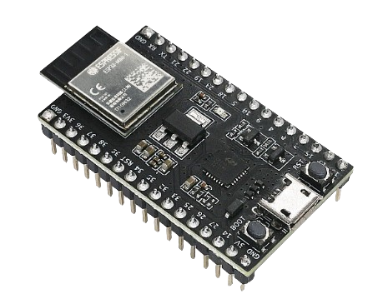

## Features

Wi-Fi

* 802.11b/g/n
* 802.11n (2.4 GHz), up to 150 Mbps
* WMM
* TX/RX A-MPDU, RX A-MSDU
* Immediate Block ACK
* Defragmentation
* Automatic Beacon monitoring (hardware TSF)
* Four virtual Wi-Fi interfaces
* Simultaneous support for Infrastructure Station, SoftAP, and Promiscuous modes

Note that when ESP32 is in Station mode, performing a scan, the SoftAP channel will be changed.

* Antenna diversity

Bluetooth®

* Compliant with Bluetooth v4.2 BR/EDR and Bluetooth LE specifications
* Class-1, class-2 and class-3 transmitter without external power amplifier
* Enhanced Power Control

• +9 dBm transmitting power

* NZIF receiver with –94 dBm Bluetooth LE sensitivity
* Adaptive Frequency Hopping (AFH)
* Standard HCI based on SDIO/SPI/UART
* High-speed UART HCI, up to 4 Mbps
* Bluetooth 4.2 BR/EDR and Bluetooth LE dual mode controller
* Synchronous Connection-Oriented/Extended (SCO/eSCO)
* CVSD and SBC for audio codec
* Bluetooth Piconet and Scatternet
* Multi-connections in Classic Bluetooth and Bluetooth LE
* Simultaneous advertising and scanning

CPU and Memory

* Xtensa® single-/dual-core 32-bit LX6 microprocessor(s)
* CoreMark® score:
  + 1 core at 240 MHz: 504.85 CoreMark/Mhz

-- 2 cores at 240 MHz: 994.26 CoreMark; 4.14 CoreMark/MHz

* 448 KB ROM
* 520 KB SRAM
* 16 KB SRAM in RTC
* QSPI supports multiple flash/SRAM chips

Clocks and Timers

* Internal 8 MHz oscillator with calibration
* Internal RC oscillator with calibration
* External 2 MHz ~ 60 MHz crystal oscillator (40 MHz only for Wi-Fi/Bluetooth functionality)
* External 32 kHz crystal oscillator for RTC with calibration
* Two timer groups, including 2 × 64-bit timers and 1 × main watchdog in each group
* One RTC timer
* RTC watchdog

Advanced Peripheral Interfaces

* 34 programmable GPIOs
  + Five strapping GPIOs
  + Six input-only GPIOs
  + Six GPIOs needed for in-package flash/PSRAM (ESP32-D0WDR2-V3, ESP32-U4WDH)
* 12-bit SAR ADC up to 18 channels
* Two 8-bit DAC
* 10 touch sensors
* Four SPI interfaces
* Two I2S interfaces
* Two I2C interfaces
* Three UART interfaces
* One host (SD/eMMC/SDIO)
* One slave (SDIO/SPI)
* Ethernet MAC interface with dedicated DMA and IEEE 1588 support
* TWAI®, compatible with ISO 11898-1 (CAN Specification 2.0)
* RMT (TX/RX)
* Motor PWM
* LED PWM up to 16 channels

Power Management

* Fine-resolution power control through a selection of clock frequency, duty cycle, Wi-Fi operating modes, and individual power control of internal components
* Five power modes designed for typical scenarios: Active, Modem-sleep, Light-sleep, Deep-sleep, Hibernation
* Power consumption in Deep-sleep mode is 10 *µ*A
* Ultra-Low-Power (ULP) coprocessors
* RTC memory remains powered on in Deep-sleep mode

Security

* Secure boot
* Flash encryption
* 1024-bit OTP, up to 768-bit for customers
* Cryptographic hardware acceleration:
  + AES
  + Hash (SHA-2)
  + RSA
  + ECC
  + Random Number Generator (RNG)

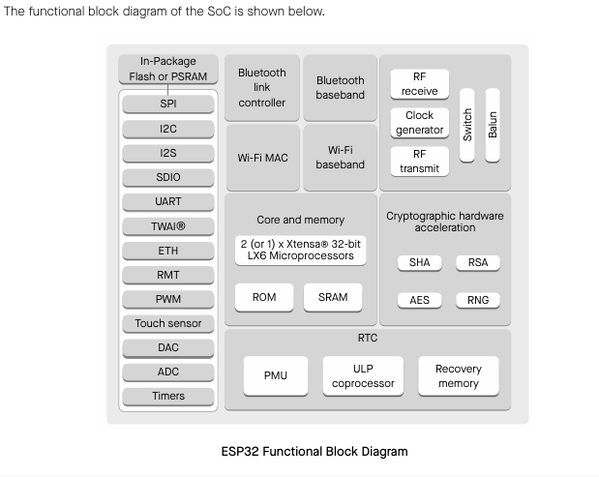BLOCK DIAGRAM

## Applications

With low power consumption, ESP32 is an ideal choice for IoT devices in the following areas:

* Smart Home
* Industrial Automation
* Health Care
* Consumer Electronics
* Smart Agriculture
* POS machines
* Service robot
* Audio Devices
* Generic Low-power IoT Sensor Hubs
* Generic Low-power IoT Data Loggers
* Cameras for Video Streaming
* Speech Recognition
* Image Recognition
* SDIO Wi-Fi + Bluetooth Networking Card
* Touch and Proximity Sensing

3.2 High Precision PVC Water Flow Sensor YF-S401

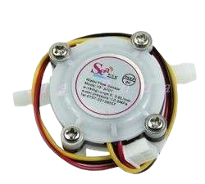

Water flow sensor consists of a PVC body, a water rotor, and a hall-effect sensor. When water flows through the rotor, rotor rolls. Its speed changes with different rate of flow. The hall-effect sensor outputs the corresponding pulse signal. This one is suitable to detect flow in water dispenser or coffee machine.

# Features

* Compact, Easy to Install
* High Sealing Performance
* High Quality Hall Effect Sensor
* RoHS Compliant

# Specifications

* Mini. Working Voltage: DC 4.5V
* Max. Working Current: 15mA (DC 5V)
* Working Voltage: DC 5V~24V
* Water resistant 0.35MPa
* Flow Rate Range: 1~ 5L/min
* Load Capacity: ≤10mA (DC 5V)
* Operating Temperature: ≤80襖
* Liquid Temperature: ≤120襖
* Operating Humidity: 35%~90%RH
* Water Pressure: ≤1.75MPa
* Storage Temperature: -25~+ 80襖
* Storage Humidity: 25%~95%RH
* Internal diameter: 1.2mm;
* Error: +/-2L/min;
* Insulation resistance > 100Mっ
* Output pulse duty cycle 50% ± 10%
* Output pulse high level > DC 4.7V (input voltage DC 5V)

one pulse characteristics F = (98 * Q) ± 2% Q = L / MIN

# Other Features

* Light weight, small, easy to install;
* With stainless steel axis in the wheel, abrasion resistant;
* Sealing ring would never leak water;
* All material meets RoHS standard

# Application

* Suitable for water heater, automatic water dispenser, coffee machine etc.

# Caution

* Non-violent shocks and chemical erosion.
* Non-throwing or collision.
* Install it in vertical, inclination should not beyond 5 degree;
* Medium temperature should not exceed 120'C.
* Frequency: F = 98 * Q (L / Min) Error: ± 2% ,voltage :3.5-24VDC, current can not exceed 10mA,

# Connector Details

* Red : IN positive
* Yellow : OUT signal output
* Black : GND negative

# Dimensions / Weight

* Dimensions : 2.28 in x 1.38 in x 1.06 in (5.8 cm x 3.5 cm x 2.7 cm)
* Weight : 0.88 oz (25 g)

# Other Features

* Light weight, small, easy to install;
* With stainless steel axis in the wheel, abrasion resistant;
* Sealing ring would never leak water;
* All material meets RoHS standard

# Application

* Suitable for water heater, automatic water dispenser, coffee machine etc.

# Caution

* Non-violent shocks and chemical erosion.
* Non-throwing or collision.
* Install it in vertical, inclination should not beyond 5 degree;
* Medium temperature should not exceed 120'C.
* Frequency: F = 98 * Q (L / Min) Error: ± 2% ,voltage :3.5-24VDC, current can not exceed 10mA,

# Connector Details

* Red : IN positive
* Yellow : OUT signal output
* Black : GND negative

# Dimensions / Weight

* Dimensions : 2.28 in x 1.38 in x 1.06 in (5.8 cm x 3.5 cm x 2.7 cm)
* Weight : 0.88 oz (25 g)

**3.3 TS‑300B Turbidity Sensor**

The TS‑300B Turbidity Sensor Module Digital Liquid Sewage Water Quality Tester Set detects water quality by measuring the levels of turbidity or opaqueness. It uses light to detect suspended particles in water by measuring the light transmittance and scattering rate. Which changes with the amount of total suspended solids (TSS) in water. As the TTS increases the liquid turbidity level increases. This liquid sensor provides analogue and digital signal output modes. The threshold is only adjustable when in digital signal mode

Features:

* The Working Voltage: 5.00V DC
* Working Current: 40 MA (maximum)
* Response Time: < 500 MS
* Insulation Resistance: 100 MΩ (minimum)
* Output Mode: Analog output: 0-4.5V, Digital Output: High/Low-level signal (you can adjust the threshold value by adjusting the potentiometer).
* Operating Temperature: – 20℃ ~ 90℃
* Sensor Interface: XH2.54
* Adapter Dimensions: 38mm x 28mm x 10m.mm

## Turbidity Sensor working Principle:

The sensor uses the optical principle to comprehensively determine the turbidity by the transmittance and scattering rate in the solution. Inside the sensor is an infrared pair tube. When light passes through a certain amount of water, the amount of light transmitted depends on the degree of contamination of the water. The dirtier the water, the less light is transmitted. The light receiving end converts the transmitted light intensity into a corresponding current magnitude, and the transmitted light is large, and the current is large, and the transmitted light is small, and the current is small.

**TURBIDITY SENSOR**

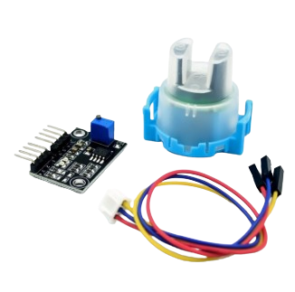

## **Function:**

The module has an analog and digital output interface. The analog quantity can be sampled by the microcontroller A/D converter to know the current water contamination. The digital quantity can be adjusted by the potentiometer on the module. When the turbidity reaches the set threshold, the D1 indicator will be illuminated, the sensor module output will change from high level to low level, and the microcontroller will monitor the level change.

## ****Applications****

* Washing machines,
* Dishwashers,
* industrial site control,
* environmental sewage collection
* Water quality monitoring using IOT
* Oil quality monitoring

3.4 DHT11 Humidity & Temperature Sensor

DHT11 Temperature & Humidity Sensor features a temperature & humidity sensor

complex with a calibrated digital signal output. By using the exclusive digital-signal-acquisition technique and temperature & humidity sensing technology, it ensures high reliability and excellent long-term stability. This sensor includes a resistive-type humidity measurement component and an NTC temperature measurement component, and connects to a high- performance 8-bit microcontroller, oﬀering excellent quality, fast response, anti-interference ability and cost-eﬀectiveness.

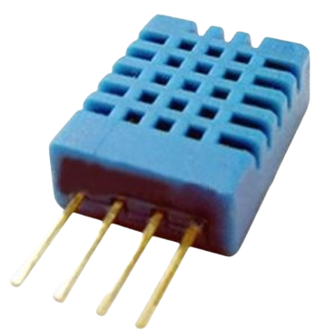

# Technical Specifications:

## Overview:

|  |  |  |  |  |  |
| --- | --- | --- | --- | --- | --- |
| Item | Measurement  Range | Humidity  Accuracy | Temperature  Accuracy | Resolution | Package |
| DHT11 | 20-90%RH  0-50 ℃ | ±5％RH | ±2℃ | 1 | 4 Pin Single Row |

**Detailed Specifications:**

|  |  |  |  |  |
| --- | --- | --- | --- | --- |
| **Parameters** | **Conditions** | **Minimum** | **Typical** | **Maximum** |
| **Humidity** | | | | |
| **Resolution** |  | 1%RH | 1%RH | 1%RH |
|  | 8 Bit |  |
| **Repeatability** |  |  | ±1%RH |  |
| **Accuracy** | 25℃ |  | ±4%RH |  |
| 0-50℃ |  |  | ±5%RH |
| **Interchangeability** | Fully Interchangeable | | | |
| **Measurement Range** | 0℃ | 30%RH |  | 90%RH |
| 25℃ | 20%RH |  | 90%RH |
| 50℃ | 20%RH |  | 80%RH |
| **Response Time (Seconds)** | 1/e(63%)25℃， 1m/s Air | 6 S | 10 S | 15 S |
| **Hysteresis** |  |  | ±1%RH |  |
| **Long-Term**  **Stability** | Typical |  | ±1%RH/year |  |
| **Temperature** |  |  |  |  |
| **Resolution** |  | 1℃ | 1℃ | 1℃ |
|  | 8 Bit | 8 Bit | 8 Bit |
| **Repeatability** |  |  | ±1℃ |  |
| **Accuracy** |  | ±1℃ |  | ±2℃ |
| **Measurement**  **Range** |  | 0℃ |  | 50℃ |
| **Response Time**  **(Seconds)** | 1/e(63%) | 6 S |  | 30 S |

## Attentions of application

### Operating conditions

Applying the DHT11 sensor beyond its working range stated in this datasheet can result in a 3%RH signal shift/discrepancy. The DHT11 sensor can recover to the calibrated status gradually when it gets back to normal operating condition and works within its range. Please refer to (3) of

this section to accelerate its recovery. Please be aware that operating the DHT11 sensor in non-normal working conditions will accelerate the sensor’s aging process.

### Attention to chemical materials

Vapor from chemical materials may interfere with DHT’s sense of elements and debase its sensitivity. A high degree of chemical contamination can permanently damage the sensor.

### Restoration process when (1) & (2) happen

Step one: Keep the DHT sensor at the condition of Temperature 50~60Celsius, humidity <10%RH for 2 hours;

Step two: K keeps the DHT sensor at the condition of Temperature 20~30Celsius, humidity

>70%RH for 5 hours.

### Temperature

Relative humidity largely depends on temperature. Although temperature compensator technology is used to ensure accurate measurement of RH, it is s strongly advised to keep the humidity and temperature sensors working under the same temperature. DHT11 should be mounted at the place as far as possible from parts that may generate heat.

### Light effect

Long exposure to strong sunlight and ultraviolet may debase DHT’s performance.

### Connection wires

The quality of connection on wires will affect the quality and distance of communication and high-quality shielding wire is recommended.

### Other attentions

* Welding temperature should be below 260Celsius and contact should take less than 10 seconds.
* Avoid using the sensor under dew conditions.
* Do not use this product in safety or emergency stop devices or any other occasion that failure of DHT11 may cause personal injury.
* Storage: Keep the sensor at the temperature of 10-40℃, humidity <60%RH.
  1. **PH450C PH METER**

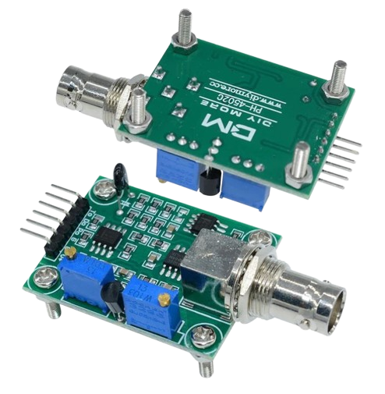

* Heating voltage: 5+-0.2V (AC - DC)
* Working current: 5-10mA
* The detection concentration range: PH0-14
* The detection range of temperature: 0-80 centigrade
* The response time: ≤ 5S
* Stability time: ≤ 60S
* Power consumption: ≤ 0.5W
* The working temperature: -10-50 centigrade (the nominal temperature 20 centigrade)
* Working humidity: 95%RH (nominal humidity 65%RH)
* Service life: 3 years
* Size: 42mm x 32mm x 20mm
* The output: analog voltage signal output

##### Pinout

* TO – Temperature output
* DO – 3.3V pH limit trigger
* PO – PH analog output
* Gnd – Gnd for PH probe
* Gnd – Gnd for board
* VCC – 5V DC
* POT 1 – Analog reading offset (Nearest to BNC connector)

**CHAPTER-4**

**4.1 HARDWARE SETUP**

**Acquisition:** Acquire the necessary hardware components including ESP32, DHT11 temperature sensor, flow sensor, turbidity sensor, ph sensor, male-female wires, and a breadboard.

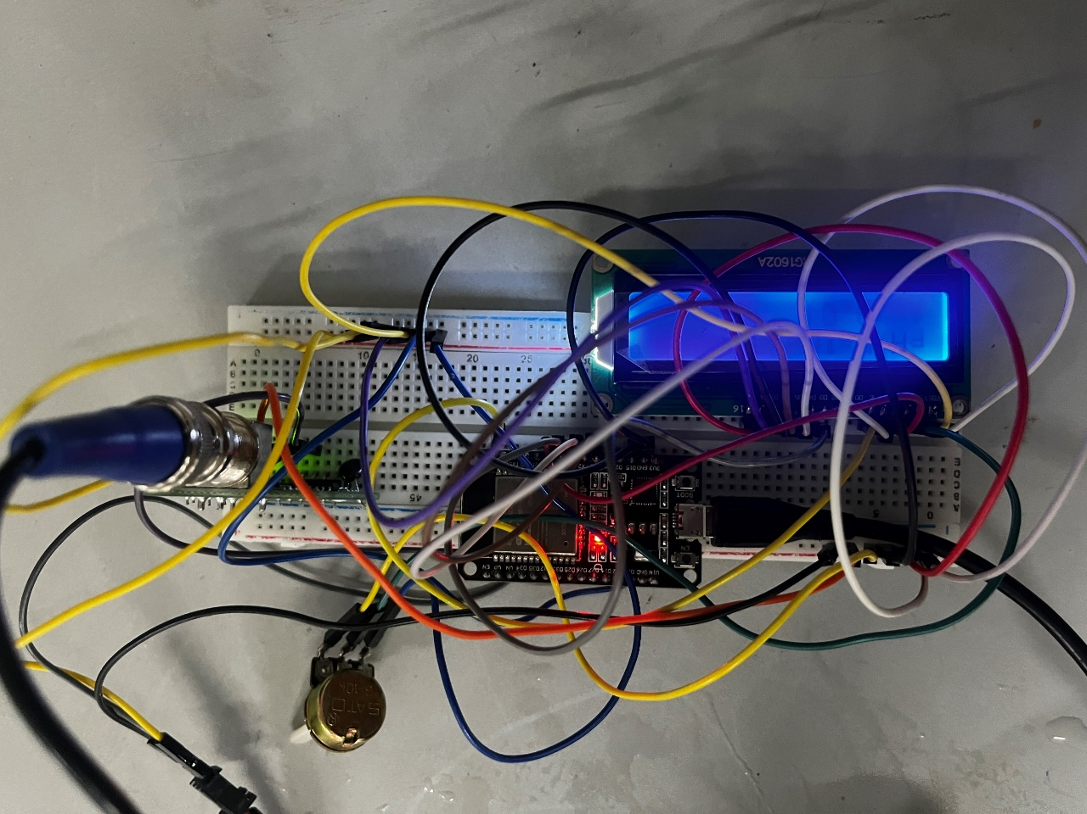**Connection:** Follow the provided connections to set up the circuit on the breadboard, ensuring proper connections between sensors, Arduino Uno, and the ESP8266 module.

Fig 4.11 Top view of Breadboard setup

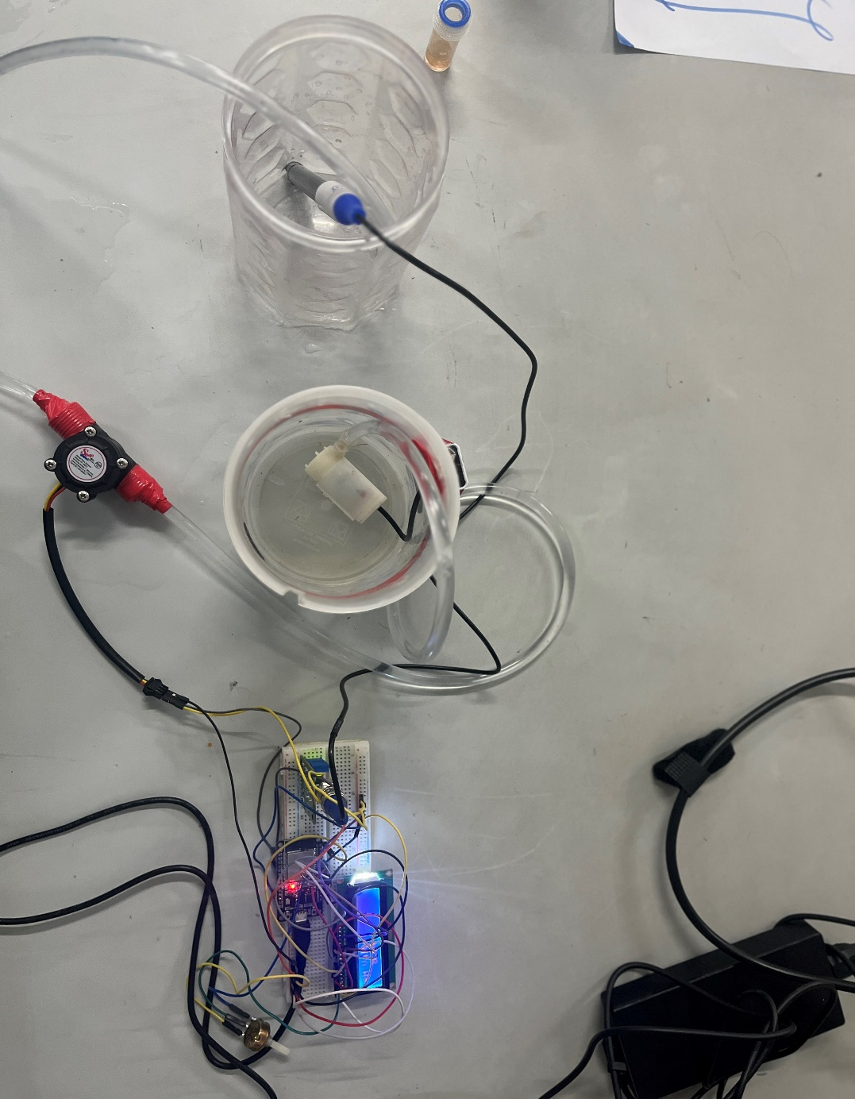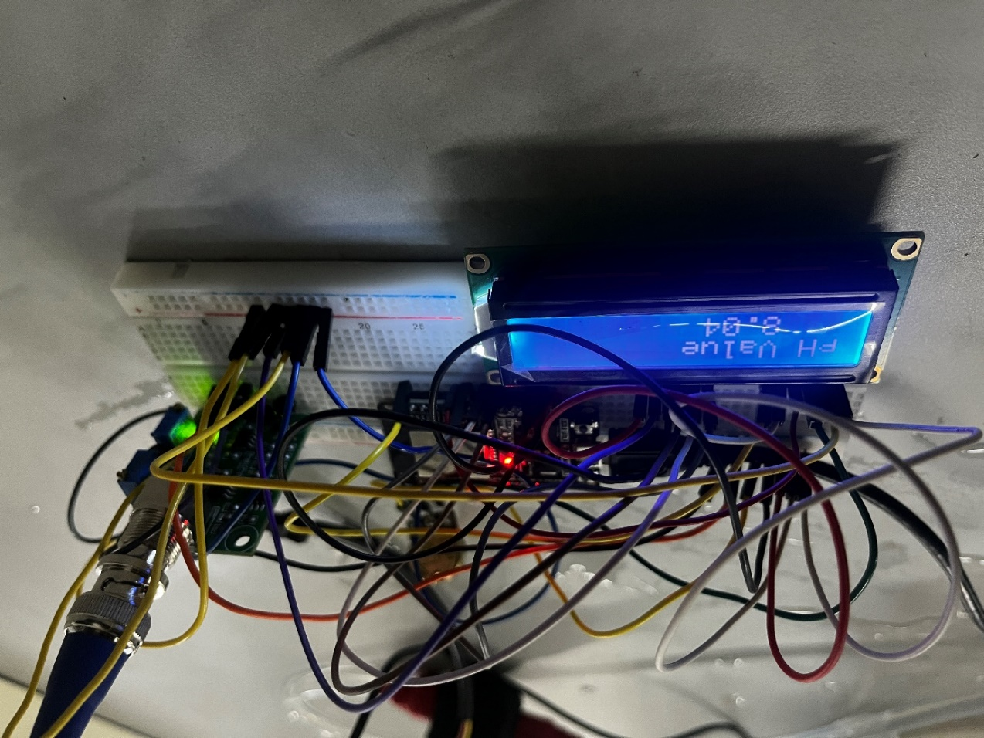

Fig 4.12 Side view of hardware setup

Fig 4.13 Top view of the overall setup

**4.2 SOFTWARE SETUP**

Software Setup Report for pH and Water Flow Monitoring System with ESP32 and Blynk

1. Introduction

- The software setup involves developing a pH and water flow monitoring system using an ESP32 microcontroller, pH sensor, water flow sensor, an LCD display, and integrating data with the Blynk cloud platform for remote monitoring and control.

2. ESP32 Programming Environment Setup

- Install the Arduino IDE on your computer from the official Arduino website.

- Open the Arduino IDE and navigate to "File" > "Preferences." In the "Additional Board Manager URLs" field, add the ESP32 board manager URL: `https://dl.espressif.com/dl/package_esp32_index.json`.

- Go to "Tools" > "Board" > "Boards Manager," search for "ESP32," and install the ESP32 board manager.

- Select the appropriate ESP32 board variant (e.g., ESP32 Dev Module) from the "Tools" > "Board" menu in the Arduino IDE.

3. Library Installation

- Install the necessary libraries for sensor modules (e.g., pH sensor and water flow sensor) and LCD display control.

- Use the Library Manager in the Arduino IDE to search for and install the LiquidCrystal library for interfacing with the LCD display.

- Additionally, install the Blynk library for ESP32 to enable communication with the Blynk cloud platform.

4. Hardware Connections

- Connect the pH sensor to an analog pin on the ESP32 board for pH sensor data reading.

- Connect the water flow sensor to a digital pin on the ESP32 board for flow rate measurement.

- Connect the LCD display to the appropriate GPIO pins on the ESP32 board as specified in the LiquidCrystal constructor.

5. Code Explanation

- Develop the Arduino sketch to initialize variables, configure pin modes, and set up interrupt handling for pulse counting from the water flow sensor.

- Implement functions to read sensor data, calculate pH values, calculate flow rates, and display information on the LCD screen.

- Utilize the Blynk library for ESP32 to establish Wi-Fi connectivity and integrate data with the Blynk cloud platform.

- Configure the Blynk app with widgets to visualize and control sensor data remotely.

6. Testing and Verification

- Upload the code to the ESP32 board using the Arduino IDE and ensure that all hardware components are connected properly.

- Test the system by varying pH levels and observing the corresponding readings on the LCD display.

- Simulate water flow events to verify the accuracy of flow rate calculations and display on the LCD.

- Use the Blynk app to monitor sensor data remotely and test control functionalities (if implemented).

7. Conclusion

- The software setup enables the ESP32 microcontroller to monitor pH levels and water flow rates, display sensor data on an LCD, and integrate data with the Blynk cloud platform for remote monitoring and control.

- Testing and verification ensure the accuracy and reliability of the system in real-time sensor data acquisition, display, and cloud integration with Blynk.

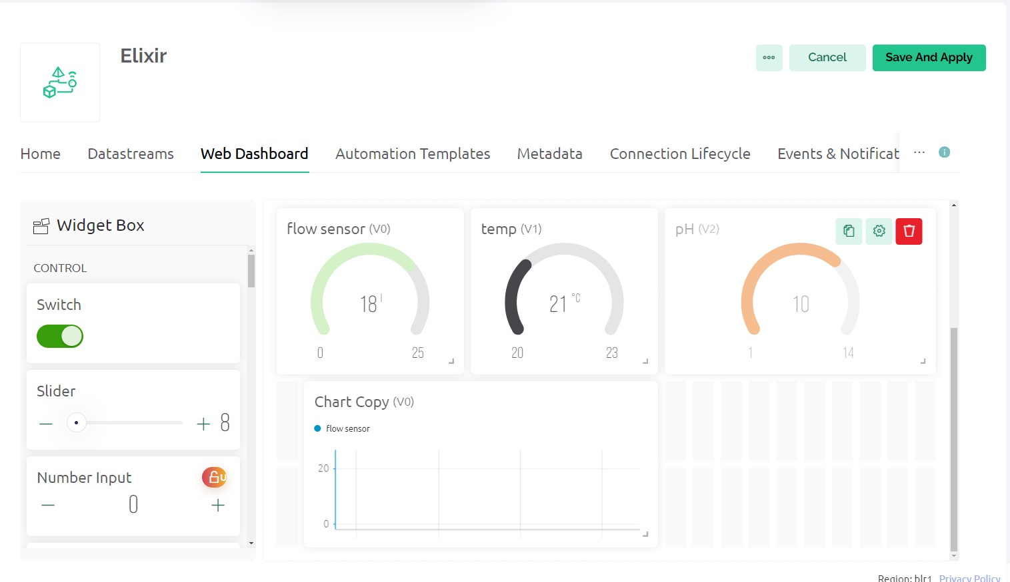

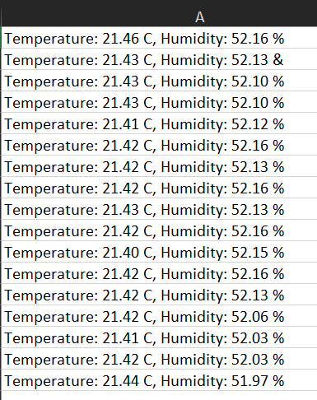Fig 4.21 Blynk dashboard

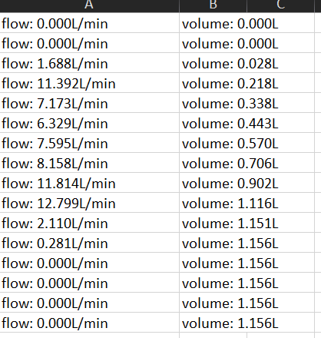

Fig 4.22 Data collected

**4.3 CODE**

#include <LiquidCrystal.h>

const int analogInPin = 33; // Pin for pH sensor

const int pumpPin = 32; // Replace pumpPin with your actual pin number for controlling the pump

const int LED_BUILTIN = 2; // Built-in LED pin

const int SENSOR = 34; // Water flow sensor pin

LiquidCrystal lcd(19, 23, 18, 17, 16, 15); // Assuming your LCD is 16x2 and connected to these pins

long currentMillis = 0;

long previousMillis = 0;

int interval = 1000;

boolean ledState = LOW;

float calibrationFactor = 4.5;

volatile byte pulseCount;

byte pulse1Sec = 0;

float flowRate;

unsigned int flowMilliLitres;

unsigned long totalMilliLitres;

void IRAM_ATTR pulseCounter()

{

pulseCount++;

}

void setup()

{

Serial.begin(115200);

pinMode(LED_BUILTIN, OUTPUT);

pinMode(SENSOR, INPUT_PULLUP);

pinMode(33, OUTPUT);

lcd.begin(16, 2); // Assuming your LCD is 16x2

attachInterrupt(digitalPinToInterrupt(SENSOR), pulseCounter, FALLING);

pulseCount = 0;

flowRate = 0.0;

flowMilliLitres = 0;

totalMilliLitres = 0;

previousMillis = 0;

lcd.clear();

lcd.setCursor(0, 0);

lcd.print("Measure pH ");

lcd.setCursor(0, 1);

lcd.print("Value ....... ");

delay(2000);

lcd.clear();

lcd.setCursor(0, 0);

lcd.print("WELCOME TO ");

lcd.setCursor(0, 1);

lcd.print("OUR PROJECT");

delay(2000);

lcd.clear();

lcd.setCursor(0, 0);

lcd.print(" ELIXIR ");

lcd.setCursor(0, 1);

lcd.print(" !!!!!!! ");

delay(2000);

lcd.clear();

}

void loop()

{

// Water flow sensor part

currentMillis = millis();

if (currentMillis - previousMillis > interval)

{

pulse1Sec = pulseCount;

pulseCount = 0;

flowRate = ((1000.0 / (millis() - previousMillis)) * pulse1Sec) / calibrationFactor;

previousMillis = millis();

flowMilliLitres = (flowRate / 60) * 1000;

totalMilliLitres += flowMilliLitres;

Serial.print("Flow rate: ");

Serial.print(int(flowRate));

Serial.print("L/min");

Serial.print("\t");

Serial.print("Output Liquid Quantity: ");

Serial.print(totalMilliLitres);

Serial.print("mL / ");

Serial.print(totalMilliLitres / 1000);

Serial.println("L");

// pH sensor part

int sensorValue = 0;

unsigned long int avgValue = 0;

int buf[10], temp = 0;

for (int i = 0; i < 10; i++)

{

buf[i] = analogRead(analogInPin);

delay(10);

}

for (int i = 0; i < 9; i++)

{

for (int j = i + 1; j < 10; j++)

{

if (buf[i] > buf[j])

{

temp = buf[i];

buf[i] = buf[j];

buf[j] = temp;

}

}

}

for (int i = 2; i < 8; i++)

avgValue += buf[i];

float pHVol = (float)avgValue * 5.0 / 1024 / 4.3;

float phValue = -5.70 * pHVol + 22.8;

phValue = 14.2 - phValue;

Serial.print("sensor = ");

Serial.println((phValue / 10) - 7);

lcd.clear();

lcd.setCursor(0, 0);

lcd.print("pH Value");

lcd.setCursor(3, 1);

lcd.print((phValue / 10) - 7);

delay(900);

}

}

**CHAPTER 6**

**6.1 RESULT**

The results section of this project showcases the performance of our integrated monitoring system in accurately detecting water quality, monitoring flow rates, and providing real-time data. Through thorough data analysis, graphs, and charts, the system's effectiveness is illustrated, highlighting its contribution to enhancing water management efficiency. In the conclusion, we summarize the key findings, emphasizing the importance of the integrated monitoring system in promoting sustainable water usage practices and contributing to environmental conservation efforts. By addressing critical needs in water quality monitoring, flow rate management, decision support, and conservation, our project aims to develop a comprehensive water management system. Through collaboration and innovation, we aspire to contribute significantly to sustainable water resource management and environmental resilience.

**CHAPTER 7**

**7.1 FUTURE SCOPE**

Moving forward, the project's future scope involves advancing the integrated monitoring system by exploring cutting-edge sensor technologies, refining data analysis algorithms, and incorporating machine learning techniques for predictive analytics. Moreover, expanding the system's capabilities to handle larger volumes of data from diverse sources and geographical areas will amplify its applicability and effectiveness. Collaborative efforts with stakeholders and ongoing research and development endeavors will drive the continuous evolution of the system, enabling it to adapt to increasing data inputs and emerging challenges. This iterative process will further bolster its role in sustainable water resource management and environmental resilience on a broader scale.

**REFERENCE**

[1] S. Pasika, S.T. Gandla, Smart water quality monitoring system with cost-effective using IoT, Heliyon 6 (7) (2020), doi:10.1016/j.heliyon.2020.e04096.

[2] M. Mukta, S. Islam, S.D. Barman, A.W. Reza, M.S. Hossain Khan, "Iot-based smart water quality monitoring system, in Proceedings of the IEEE 4th International Conference on Computer and Communication Systems (ICCCS), 2019, pp. 669–673, doi:10.1109/CCOMS.2019.8821742.

[3] S. Konde, S. Deosarkar, IOT-based water quality monitoring system, in Proceedings of the 2nd International Conference on Communication & Information Processing (ICCIP), 2020 2020, doi:10.2139/ssrn.3645467.

[4] M.K. Amruta, M.T. Satish, Solar powered water quality monitoring system using wireless sensor network, in Proceedings of the International Mutli-Conference on Automation, Computing, Communication, Control and Compressed Sensing (iMac4s), 2013, pp. 281–285, doi:10.1109/iMac4s.2013.6526423.

[5] T. Sugapriyaa, S. Rakshaya, K. Ramyadevi, M. Ramya, P.G. Rashmi, Smart water quality monitoring system for real-time applications, Int. J. Pure Appl. Math. 118 (2018) 1363–1369.

[6] K.A. Unnikrishna Menon, D. P., M.V. Ramesh, Wireless sensor network for river water quality monitoring in India, in Proceedings of the Third International Conference on Computing, Communication and Networking Technologies (ICCCNT’12), 2012, pp. 1–7, doi:10.1109/ICCCNT.2012.6512437.

[7] A.N. Prasad, K.A. Mamun, F.R. Islam, H. Haqva, Smart water quality monitoring system, in: Proceedings of the 2nd Asia-Pacific World Congress on Computer Science and Engineering (APWC on CSE), 2015, pp. 1–6, doi:10.1109/APWCCSE.2015.7476234.

[8] A. Jerom B., R. Manimegalai, R. Manimegalai, An IoT-based smart water quality monitoring system using cloud, in Proceedings of the International Conference on Emerging Trends in Information Technology and Engineering (ic-ETITE), 2020, pp. 1–7, doi:10.1109/ic- ETITE47903.2020.450. 2020doi:.

[9] S. Geetha, S. Gouthami, Internet of things enabled real-time water quality monitoring system, Smart Water 2 (1) (2016), doi:10.1186/s40713-017-0005-y.

[10] B. Sengupta, S. Sawant, M. Dhanawade, S. Bhosale, Water quality monitoring using IoT, Int. Res. J. Eng. Technol. 6 (2019) 695–701.

[11] M.J.V. Kumar, K. Samalla, Design and Development of water quality monitoring system in IoT, Int. J. Recent Technol. Eng. (IJRTE) Volume-7 (Issue-5S3) (2019) 2277–3878 ISSNFebruary 2019.

[12] A.T. Demetillo, M.V. Japitana, E.B. Taboada, A system for monitoring water quality in a large aquatic area using wireless sensor network technology, Sustain. Environ. Res. 29 (2019) 12, doi:10.1186/s42834-019-0009-4.

[13] B. Anuradha, R. Chaitra, D. Pooja, IoT based low cost system for monitoring of water quality in real time, Int. Res. J. Eng. Technol. (IRJET) Volume: 05 (Issue: 05) (2018) May-2018.

[14] S.N. Shivappriya, M. Priyadarsini, A. Stateczny, C. Puttamadappa, B.D. Parameshachari, Cascade object detection and remote sensing object detection method based on trainable activation function, Remote Sens. 13 (2) (2021) 200.

[15] S.N. Shivappriya, S. Karthikeyan, S. Prabu, R. Pérez de Prado, B.D. Parameshachari, A modified ABC-SQP-based combined approach for the optimization of a parallel hybrid electric vehicle, Energies 13 (17) (2020) 4529.

[16] S.A. Hamid, A.M.A. Rahim, S.Y. Fadhlullah, S. Abdullah, Z. Muhammad, N.A.M. Leh, IoT based water quality monitoring system and evaluation, in: Proceedings of the 10th IEEE International Conference on Control System, Computing and Engineering (ICCSCE), 2020, pp. 102–106, doi:10.1109/ICCSCE50387.2020.9204931. 2020.

[17] C. Puttamadappa, B.D. Parameshachari, Demand side management of small scale loads in a smart grid using glow-worm swarm optimization technique, Microprocess. Microsyst. 71 (2019) 102886.

[18] T.N. Nguyen, B.H. Liu, S.I. Chu, D.T. Do, T.D. Nguyen, WRSNs: toward an efficient scheduling for mobile chargers, IEEE Sens. J. 20 (12) (2020) 6753–6761.

[19] S. Gupta, M. Kohli, R. Kumar, S. Bandral, IoT based underwater robot for water quality monitoring, IOP Conf. Ser. Mater. Sci. Eng. 1033 (2021) 012013, doi:10.1088/1757-899x/1033/1/012013.

[20] P.N. Hiremath, J. Armentrout, S. Vu, T.N. Nguyen, Q.T. Minh, P.H. Phung, MyWeb Guard: toward a user-oriented tool for security and privacy protection on the web, in Proceedings of the International Conference on Future Data and Security Engineering, Springer, 2019, pp. 506–525. Cham.