­­



**Tribhuvan University**

**Texas International College**

**Internship Report**

**Under the Supervision of**

**Mr. Rom Kant Pandey**

**Lecturer**

**Texas International College**

**Submitted To:**

**Department of Computer Science and Information Technology**

**Texas International College**

**In partial fulfillment of the requirement for the bachelor’s degree in**

**Computer Science and Information Technology**

**Submitted By:**

**Karishma (15578/074)**

**July, 2022**

Mentor’s Recommendation

I hereby recommend that this internship report prepared under my supervision by **Karishma (15578/074)** in partial fulfillment of the requirement for the degree of B.Sc. in Computer Science and Information Technology of Tribhuvan University be processed for the evaluation.

……………………………..

**Mr. Anish Panta**

Team Lead

Senior Developer

CloudTech Services

Thapathali, Kathmandu

Supervisor’s Recommendation

I hereby recommend that this internship report prepared under my supervision by **Karishma (15578/074)** in partial fulfillment of the requirement for the degree of B.Sc. in Computer Science and Information Technology of Tribhuvan University be processed for the evaluation.

……………………………..

**Mr. Prabin Khadka**

Project Supervisor

Faculty

Texas International College

Chabahil, Kathmandu

letter of approval

This is to certify that this project report prepared by **Karishma (15578/074)** in partial fulfillment of the requirement for the degree of B.Sc. in Computer Science and Information Technology has been well studied. In our opinion it is satisfactory in the scope and quality as a project for the required degree.

|  |  |  |
| --- | --- | --- |
| ……………………………..  **Mr. Prabin Khadka**  Project Supervisor  Faculty  Texas International College  Chabahil, Kathmandu |  | ……………………………..  **Mr. Kumar Poudyal**  HOD, CSIT  Texas International College  Chabahil, Kathmandu |
| ……………………………..  **Mr. Hikamat Rokaya**  External Supervisor  Prof.  CDCSIT, Tribhuvan University  Kirtipur, Nepal |  |  |

Acknowledgement

I would like to express our deepest appreciation to all those who provided us the possibility to complete the entire internship project execution. I would like to express my special gratitude to our project supervisor, Mr. Prabin Khadka, whose contribution in stimulating suggestions and encouragement, helped for better coordination and to write this report.

I offer my best regards and gratitude to all our colleagues, fellow workers and others who supported us in any respect during the completion of the project.

Last but not leastwe would like our deep sense of gratitude towards our parents for their love and support, their valuable guidance and suggestion motivates us to achieve our goal**.** Any omission in this brief acknowledgement does not mean lack of gratitude.

Thanking You,

Karishma (T.U. Exam Roll No. 15578/074)

Abstract

The information in this report includes specifics on the tasks completed throughout the three-month internship.

CTS can help if you need to send and receive files containing a lot of personal information. The end-to-end encryption and inclusion of 2FA for any downloads make the secure file transmission system among the best in the world.

Solutions for electronic file transfer improve an organization's cybersecurity. By making it accessible to automatic audits and tracking, supplying the most recent security procedures and controls, and making sure that files are secured both in-transit and at rest, this is accomplished. Additionally, this gives enterprises the luxury of strong security measures that let them establish password policies, confirm individuals using identity and access tools, and grant full members to limit unauthorized administrators and users. With this capability, firms may identify any outside user attempting to change confidential company information.

Secondly, also utilized is billing solution. It can be difficult to manage invoices, but with CTS's Billing Services, a user can do it with the simple press of a button. Additionally, we produce around 2,000 group-based bills and over 20,000 user-based invoices each month. Since of the knowledge and training, one can be confident that handling the expenses will go smoothly for you. Even though invoice production and upgrading are automatic operations, they still grant the admin the power to handle invoices as needed.

Table of Contents

Mentor’s Recommendation i

Supervisor’s Recommendation ii

letter of approval iii

Acknowledgement iv

Abstract v

Table of Contents vii

List Of Figure ix

List of Abbreviations xi

Chapter 1: Introduction 1

1.1 Introduction 1

1.2 Why this internship? 1

1.3 Objective 1

1.4 Scopes and Limitations 2

1.4.1 Scope 2

1.4.2 Limitations 2

1.5 Report Organization 3

Chapter 2: Organization Detail And Literature Review 4

2.1 Introduction To Intern Organization 4

2.2 Organization Hierarchy 5

2.3 Working Domain of Organization 5

2.4 Description of Intern Department 6

2.5 Literature Review 6

Chapter 3: Internship Activities 9

3.1 Roles and responsibilities 9

3.2 Weekly Log 10

3.3 Description of the Project 12

3.4 Requirement collection 13

3.5 System Requirement 13

3.5.1 Functional Requirements 13

3.5.1.1 Admin Module 14

3.5.2 Non Functional Requirements 15

3.6 Activities Done 16

3.7 Problem Faced 17

3.8 Task Performed 18

Chapter 4: Conclusion And Learning Outcome 29

4.1 Learning Outcome 29

4.1.1 Job Oriented Learning 29

4.1.2 Skills Oriented Learning 29

4.1 Conclusion 29

References 31

Appendix I 32

List Of Figure

Figure 22: Dashboard Integration 7

Figure 23: Dashboard Integration 7

Figure 24: API dispute list 8

Figure 25: API dispute list 8

Figure 26: Calendar Sync 9

Figure 27: multiple select one time 9

Figure 28: multiple select one time 10

Figure 29: multiple select one time 10

List of Abbreviations

**CSS -** Cascading Style Sheet

**HTML -** Hypertext Markup Language

**ICT -** Information’s And Communications Technology

**UI -** User Interface

**CTS** - CloudTech Services

**SQL -** Structured Query Language

**PHP -** Preprocessor Hypertext

**IT**  - Information Technology

**SEO -** Search Engine Optimization

**IOS**  - iPhone Operating System

**US -** United States

**USA -** United States Of America

# Introduction

## Overview

The internship experience is expected to assist the students to face complex real world problems. Going to a college or university is a critical step, but one can greatly enhance their classroom learning by gaining real world experience through college student internships. In addition to gaining great experience to complete our classroom learning, college internships allow us to beef up our portfolio or résumé and make valuable industry contacts that can be essential to landing the ideal job upon graduation.

During this internship my major task was server side web development along with some work on client side. This report consists of the details of the work that I performed during my internship period in CTS. During the internship period, the major projects that I worked on were Insurance company software and this report mentions how they are implemented and some of the testing mechanisms. The report also discusses the knowledge I gained during my time in the organization.

## Why this internship?

Among different internship available to work on, web development stand on top having more pros over the cons. Opportunity for growth, high earning potential, and its flexibility are usually top of mind for most of people to get into the industry. I choose this internship on web development because of my prior knowledge on web development through my academic study in college and could dive into real time project through this internship without being to train first from Company like in general internship program.

## Objective

Internship programs help students to evaluate theoretical knowledge with practical experience. It not only gives students a taste of professionalism but also helps to know about the organization and its working world. It will also help to develop creativity and managerial skills for students. The objective of internship is to develop skills, conceptual and analytical knowledge to the student regarding the organization.

The other specific objectives of internship as follows:

* To learn about the real working environment of an organization.
* To build a better resume as more experience and accomplishment makes students more attractive.
* To analyze the real world problem and find the solution using knowledge obtained.
* To integrate frontend (VueJS) , backend (Laravel) and database(SQL) for building scalable web app.
* To build reporting system for different users and comapnies based on their different attributes on insurance company system.
* To know and understand how production of online systems we use in daily life are built with teamwork for real life scenario.

## Scopes and Limitations

### Scope

To familiarize oneself to the professional working environment, working as a team by establishing a good relationship with mentors along with team members acquiring further skills and experience was primary scope of this internship.

This internship helps to gain real world perspective of web developing by covering the workflow throughout internship period. It teach me about agile web development process through daily standup meeting and managing tasks through Zoho project management system as well as teach about test driven development.

HTML is still a valuable language for expressing information and driving the expansion of the Web. It's essential for HTML to grow and evolve so that it can enable forms that are both content- and layout-driven in sensitive locations. In an ideal society, HTML would have a more straightforward syntax and coherent semantics for material flow. Utilizing web development technologies, a Laravel developer creates and maintains cutting-edge and contemporary web applications. Additionally, they create secure blocks of code and construct and test reuse, effective PHP modules.

### Limitations

The limitations of the system are:

* Economic details of the project have not been mentioned due to confidentiality issues.
* Different steps on development processes like:- planning , design ,deployment, testing and interaction with clients are not describe in this report as some of them do not fall under my domain of work in this internship and some couldn’t be mention due to privacy agreement between client and company about disclosure.

## Report Organization

The project is organized in following manner:

**Chapter 1: Introduction**

The first chapter describes the internship report briefly with its, overview, why this internship, scope and limitation.

**Chapter 2:** **Organization Details and Literature Review**

The second chapter studies about the organization’s introduction, working domain and organizational hierarchy. It also contains different department and description of intern unit.

**Chapter 3: Internship Activities**

In this chapter, it consists of all the roles and responsibilities of the author as an intern. The detailed description of the works done during the internship and log with technical activities are listed here.

**Chapter 4:** **Conclusion and Learning Outcomes**

The final chapter includes conclusion of the overall internship and list of learning outcomes as an intern to complete the report.

# Organization Detail And Literature Review

## Introduction To Intern Organization

CTS is an ever-growing community of passionate and brilliant people. This exceptional team has every solution to their clients' biggest and most complicated problems. This organization services are offered both on and offshore, and delivered with pride and passion. This organization is a group of young, motivated, skilled people whose main goal is to provide their clients with an innovative solution regarding web development and software development.

The company is led by a strong management team and knowledgeable computer engineers and IT knowledge workers with experience in various areas of the information and communication technology (ICT) industry covering software development, data analyzing and reporting , e- Business applications solutions and others internet related systems.

CTS has combined a set of products and services that meet the immediate information technology needs of a small as well as big business: Basic and enhanced hosting services, Web design, software development and Intranet applications. With the experience, CTS be able to help its customers to define and implement their e-business strategies successfully.

This organization is driven towards providing the best of the technology era through solutions locally and globally with excellence quality forever.

Their mission is to help equip small businesses with tools that helps them not only grow their businesses but also become the leader in their industry

.

Table 1:Organization Details

|  |  |
| --- | --- |
| **Name** | Cloudtech Services |
| **Type** | Private Limited |
| **Location** | Thapathali, Kathmandu |
| **Website** | <https://www.cloudtechservice.com/> |
| **Email** | info@cloudtechservice.com |
| **Phone** | (+977) 9617970043 |

## Organization Hierarchy

The organization structure or form of an organization has evolved in order to perform the various roles of the organization and also to provide the services efficiently and effectively. CTS also has a functional organization structure. The structure facilitates all the functions carried out by the whole organization. The company has departments to facilitate the business process which also has good coordination amongst each other. The organization has a line of authority that flows from the top to the bottom of the organizational hierarchy however the flow of information and knowledge is bidirectional which helps to tackle challenges that occur in organization easier to tackle.

In Technology Division, CTS comprises of an administrative team along with interns, junior and senior programmers and web designers who collaborate with each other to produce quality applications.

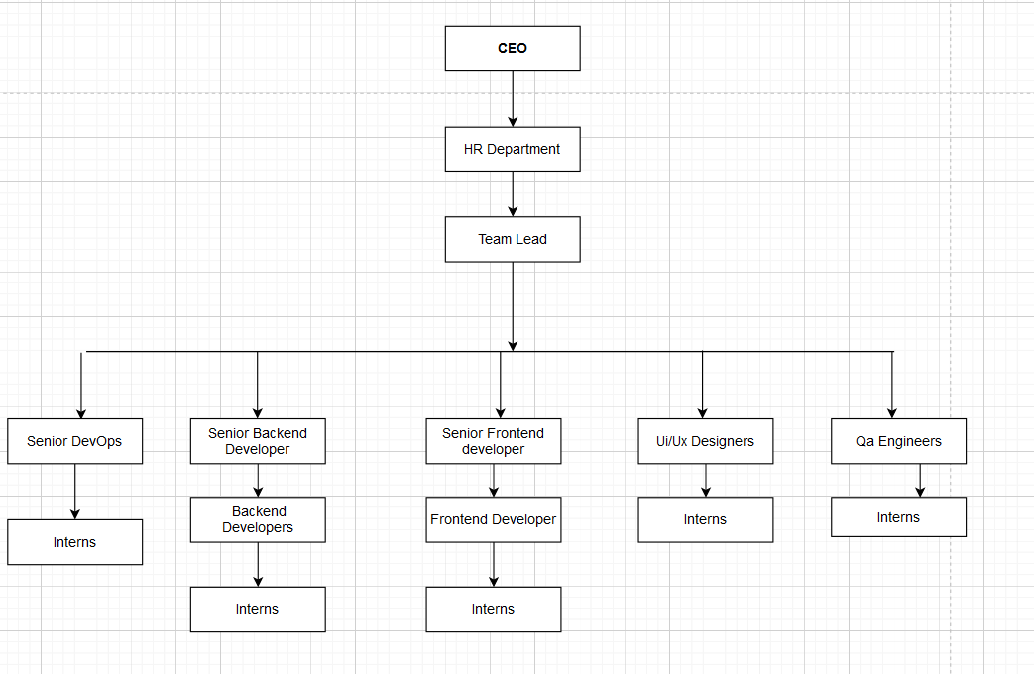

Figure 1:Organization Hierarchy of CTS

## Working Domain of Organization

CloudTech Services provides multiple services in the area of website design and development. The areas of expertise of the organization are:

1. Software Development
   1. PHP/MySQL
   2. Android
   3. IOS application
   4. Laravel
   5. Vuejs
2. Database Management
   1. MySQL
3. IT Consulting and Training
   1. Digital Marketing
   2. SEO
   3. Web Consulting
   4. Software Consulting
   5. DevOps Training

## Description of Intern Department

During the internship period mentor were assigned to each intern so that intern can gain knowledge of various platforms and programming languages. The target was to deliver a fully-fledged web-based system by using different tools and frameworks such as Laravel, VueJS etc. Hence, to meet that objective, this internship required the extensive preliminary studies about the core PHP, VueJS before actually analyzing the actual requirement of the system. The study was required not only to understand the subject under study but also to realize the solutions to the existing problems and implementing the findings from the study was another bigger challenge.

Interns working in this company were assigned a mentor. Mentor would provide guidelines for interns if needed and assign a task for a day. During a day intern could ask for help in task they are provided with mentor or senior developer. And day will end by logging the activities done through a day in Zoho Project Management Tool as well as Skype group consisting of project members.

Table 2:Internship Details

|  |  |
| --- | --- |
| **Start Date** | 17th May, 2022 |
| **End Date** | 17th August 2022 |
| **Position** | Full-Stack Developer |
| **Mentor** | Mr. Anish Pant |
| **Supervisor** | Mr. Prabin Khadka |
| **Working Hours** | 9:30 am to 6:30 pm |
| **Working Days** | Monday to Friday |

## Literature Review

Insurance Company site was developed using Laravel and VueJS framework and MySQL as a database. This site works as mediator for new customer and company as well as for existing customer and the company. This site helps the customers to make an inquiry, get insurance plan, contact immediately, get notification etc.

Website front: the area of the Web app tha­t is accessed by visitors at very beginning. Category, plans, and other pages (e.g. search, offers, etc.) are dynamically generated by the software based on the information saved in the system database. The look of the webapp front displays navigation link to different pages, perks of having insurance, products, strengths, awards and recognition, testimonial, calculator link and footer.

The American healthcare system is structured in an intricate bureaucracy. The majority of clinics and hospitals in the US are owned by privately owned non-profit organizations, in contrast to the rest of the globe where health clinics are primarily held by states or by enterprises from the private industry. Health insurance is not a requirement for residents of the United States, nor is it that the government provides for all citizens. Although it is voluntary, it is strongly advised because medical services are more expensive than in any other nation in the world. In the US, there are two varieties of health insurance: private and public. The majority of people combine the two. Medicare, Medicaid, and the Children's Health Insurance Program are the three public health insurance programs in the US. International students' dependents are covered by health insurance.

In today’s scenario we can see that people have become very busy with their lives. In this busy life the main problem for people is finding the right insurance product in a right time. People usually doesn’t find what they are actually looking for. Travelling to different insurance companies and searching the right plan are waste the time and money. Usually, people have to compromise with the similar plan they find rather than finding the right plan. Due to lack of time knowledge and experience people have to spend more money than the actual price in the same insurance plan so this site enables customers to know details wide variety of products and services related to insurance more clearly.

Some insurance companies have been integrating with finance companies and products companies like car companies for increasing their customer reach and gaining new customers. And information about policies plans is very necessary to convince customers where this kind of website comes in use with transparency and clarification of every service, plans and products.

With the advancement of technology, website has the huge scope in all the areas. In today’s world many people depend on internet for carrying out their work. 29.78% people use the internet services in Nepal. Among those users many of them uses internet for information search. The use of this website helps the viewers to get details about different insurance product and plans with the aim that viewer can subscribe best fit products for them from the company

This system can deliver emails, push notifications, push sms for commission billing, tickets, filesystem access, and Purenroll apps. Anish Panta was my team lead out of the company's four team leads. The team also includes frontend developers and backend developers. Conenroll system has three different user types: Groups, Reps (Agents) and Member

The main benefits of this type of website us that customers/viewers can view the company details with ease and get required details easily whenever required. It is accessible to clients 24 X 7, all over the world. This expands our geographical and customer reach, as our business is not limited to just clients or customers around our immediate physical location (USA only). Building an insurance company website that is user-friendly and available to a vast number of clients is also helpful because it provides easier delivery of information. Rather than calling to for basic queries or more information about our company, our catalogue software can display information, promotions, sales and real- time data on our products or services.

# Internship Activities

## Roles and responsibilities

Besides study of, Laravel and VueJS, other major activities carried out during internship was extensive study of current system, presentati­ons of study analysis and practical implementations, and most importantly the team discussions to analyze the procedure to complete project.

Firstly standup meeting would start a day which included interaction between project members and follow up on task assigned for each individual in project. Mentor would check the performance and progress on previous day task and review code as well as merge them in a single version control system (git) and provide guidelines for improvement in code and approach to solve problem to interns if needed and assign a task for a day.

During a day intern could ask for help in task they are provided with mentor or senior developer. Intern should also had to ask for access and permission of different resources needed to complete the task.

## Weekly Log

Table 3:Weekly log

|  |  |
| --- | --- |
| Week | Major Tasks |
| 1 (May 17 - May 23) | * System Overview * Studying various systems and learning about them in the health insurance domain. * Learning about agents, members and groups in Insurance and their respective roles. * Learning about Message center application and working  of emails, push notification and sms * Learning Headless approach and Api integration in MVC application. * Learning about version control and repository management. |
| 2 (May 24 -Jun 8) | * Learning Vuejs framework and api integration * Planning and documenting for doing the task * Integration of Emails count(Success and failed) * Integration of Sms count and Push Notification(success and Failed) * Integration about the Blacklisted Information(Sms and Emails) * Integration of overall count of dashboard email, sms and push notification in graphs |
| 3 (jun 8 - Jun 9) | * Checking overall Ui of message center * Listing the error and correction need on those Ui * Improving the message center Ui |
| 4(Jun 10 - Jun 11) | * New demo site work planning and reviewing * Testing the demo site for any possible error * Fixing the backend and frontend logics in errors |
| 6 (June 12 - Jun 17) | * Researching about different calendar * Syncing and connecting the google calendar, 365 , outlook and icloud calendar with each other to sync the event occurred) * Documenting the information |
| 7 (Jun 18 - Jun 21) | * Researching about Vue composition api * Creating the document for the summary and giving presentation |
| 8 (Jun 22 - Jun 29) | * Setup the Repository from git * Knowing about the storage in local driver in laravel and other driver integration within the MVC application * Learning about Amazon s3 bucket integration for storage in laravel * Setup the configuration in env and filesystem in laravel * Implementing the s3 bucket on the system |
| 9 (June 30 - July1) | * Planning and creating step to solve the task * Implementing the feature to select in input to selecting the multiple files |
| 10(July 2 - July 3) | * Planning and reviewing code for the enroll rode not sent in save and continue feature in benefit store * Need to move the system to message center |
| 11 (July 3 - July 4) | Issue to submit button of date and time is not visible   * Implemented the fixing the button of date and time in Send Email |
| 12 (July 5 - July 9) | * Planning and documenting step to do task * Created the Sql query in work bench for providing list of dispute * Created the api for list of dispute and details of particular month and years |
| 13 (July 10 - July 29) | * Created Api for overall count, Success and failure count each type of users(Member, groups , and agents) * Created api for Invalid email for top 10 domain for groups, members and agents * Created api for Invalid email for top 10 subject for groups, members and agents * Created api for email bounced for top 10 domain for groups, members and agents * Created api for Invalid email for top 10 subject for groups, members and agents * Created api for email in blacklisted for top 10 domain  and top 10 subjects for groups , members and agents * Created api for counting Recurring Scheduled count, Currently Scheduled count and total blacklisted count |
| 14(July 30 - August 6) | * Changing in the database * Adding save as draft button in Ui part * Implementing the save as draft by chaning send api by added publishing parameters * Created the view file to see draft emails * Add the action button in the file |
| 15 (August 7 - August 9) | * Planning and documenting the about the task * Adding feature list of plans * Implementing type and select custom tags * Checking database from Workbench and implementing query * Creating the api for list of plan and integrating that api |
| 16 (August 10 - August  11) | * Added the multi select at once in select option in knowledge base * Edited the api for adding plan id |
| 17 (August 12 - August 15) | * Checking every table of message center * Implementing different queries in database to check message center output and database data * Changing different api for listing in descending order * Implementing that inthe system. |
| 18 (August 16 - August  17) | * Rebranding the sso and message center . * Replacing the links in the email template for new system * Rebrand the header footer and login screen * Edited the email template ui |

As per the requirements of the B.Sc. in Computer Science and Information Technology curriculum, one has to complete an eight weeks internship period in the workplace as per their partial fulfillment of B.Sc. in Computer Science and Information Technology program according to their specialization subject. The internship started effectively from 1st May to 13th July via online medium.

## Description of the Project

This web application allows customers and viewers to get details about various insurance plans and premiums with the details of their types. It also has additional details about products and services.

The new user can easily register and become our customer by getting a plan for their assets.

The user can view their profile and other insurance related details that is associated with the company like their plans, renewal date, prices, offers etc.

CTS can help if you need to send and receive files containing a lot of personal information. The end-to-end encryption and inclusion of 2FA for any downloads make the secure file transmission system among the best in the world.

Solutions for electronic file transfer improve an organization's cybersecurity. By making it accessible to automatic audits and tracking, supplying the most recent security procedures and controls, and making sure that files are secured both in-transit and at rest, this is accomplished. Additionally, this gives enterprises the luxury of strong security measures that let them establish password policies, confirm individuals using identity and access tools, and grant full members to limit unauthorized administrators and users. With this capability, firms may identify any outside user attempting to change confidential company information.

Secondly, also utilized is billing solution. It can be difficult to manage invoices, but with CTS's Billing Services, a user can do it with the simple press of a button. Additionally, we produce around 2,000 group-based bills and over 20,000 user-based invoices each month. Since of the knowledge and training, one can be confident that handling the expenses will go smoothly for you. Even though invoice production and upgrading are automatic operations, they still grant the admin the power to handle invoices as needed.

## 3.3.1 Requirement collection

One of the most crucial tasks in developing a new service for this project is gathering requirements. In order to satisfy the needs of the client, it is crucial to determine the major elements of this application. However, a methodical approach to gathering requirements that ensures their completeness and clarity enables the proposed project to be planned and carried out quickly and precisely.

The description of the project's scope is the first step in the requirements gathering procedure. To better understand requirements, traditional requirements collecting techniques are employed. Describe the challenges of project management for managers. We collected and recorded the requirements, then carefully analyzed the outcomes to be sure they were accurate. We used data from focus groups, documents, and research papers to do a qualitative content analysis on insurance companies in order to develop conclusions. Part of the analysis involved ranking categories of technical, operational, functional, and implementation needs. Before moving further with project development, the final step in gathering requirements entailed examining results, design, feasibility, and several other factors with supervisors. Once the project got underway, this helped remove doubts and misunderstandings.

## 3.3.2 System Requirement

## 3.3.2.1 Functional Requirements

**i. Registration**  
The user must first register in order to view this page. Registration requires a first name, last name, username, email address, password, and confirmation password.

Member Details as input

Output: details of a completed registration

Processing: Checking user information. Password constraints are validated in accordance with the db.

**ii. Member Login**  
Users are able to log in to the system.

A username and password are needed to access the user profile page.

Username and password required

User Dashboard as output

Processing: The system verifies the user's entry and, if the user is found to be valid, directs him to his dashboard; otherwise, the user must enter his password again.

**iii. Forgot Password**  
The system allows users to log in.

Your user profile page can only be accessed with a login and password.

required username and password

Utilize a dashboard as an output

Processing: The system checks the user's input for validity and sends it to the dashboard if it is. If not, the user will need to input the password again.

**iv. Logout**

Member has a logout option on the website.

Enter the opt-out choice here.

System Logoff is the output.

EDIT: Set the status of the database user to inactive.Agent Module

**Agent commission**

Agent can view their commission using this section.

**ii. Agent dashboards**

The agent can view the details using the dashboard and keep track of the records.

### Admin Module

**i. Adding Client**

Users of the system can add clients to it.

Customers' data is required.

Input: Client Information

Output: Customer Dashboard

Processing: The system checks the customer information, and if it is accurate, the customer is added.

**ii. Adding Project**

Users of this system can add customer projects.

Customer and project information is required.

Details on the client and the project are needed.

Output: Task Dashboard

Processing: The system validates project and client information. The customer's project is added to the system if data is submitted and enabled.

## 3.5.2 Non Functional Requirements

**i. Performance Requirements:**

* The system is dependable
* If the request cannot be processed, an appropriate error message is displayed
* Web pages and application load in a matter of seconds

**ii. Safety Requirements**

* It is necessary to keep track of its specifics.
* Authentications of users is required
* Database is backed up on a regular basis

**iii. Security Requirements**

* The user can view his profile after providing his password and user id.
* The information of the users is kept safe and secure.
* Details are not shared.

## 3.4 Task Performed

The following are the task that I performed and the issues that I resolved are shown below:

The following are the task that I performed and the issues that I resolved are shown below:

Task is done in several sprint over the course of 3 month.

* **Task 1: System Overview**

In this task, I was given to review the existing system. Learning about various Health insurance domain in US. The health insurance has three respective roles agents. members and groups. I was mainly working in message center department

. Message center controls all the emails, push notification and sms controls in overall system in this software. I was also learning about headless approach and Api integration in MVC application . As, in this organization main domain of web development is Vuejs and laravel. I was also learning about repository

management and version control using git and github.

* **Task 2: Dashboard Integration for message center dashboard**

The required Api was already developed for the dashboard integration for message center. I was given the task to integrate those Api with UI developed in Vuejs. The Api were of email, sms, push notification total count ,yearly count and monthly count. I have implemented Axios and Vue lifecycle hooks to integrate dashboard.

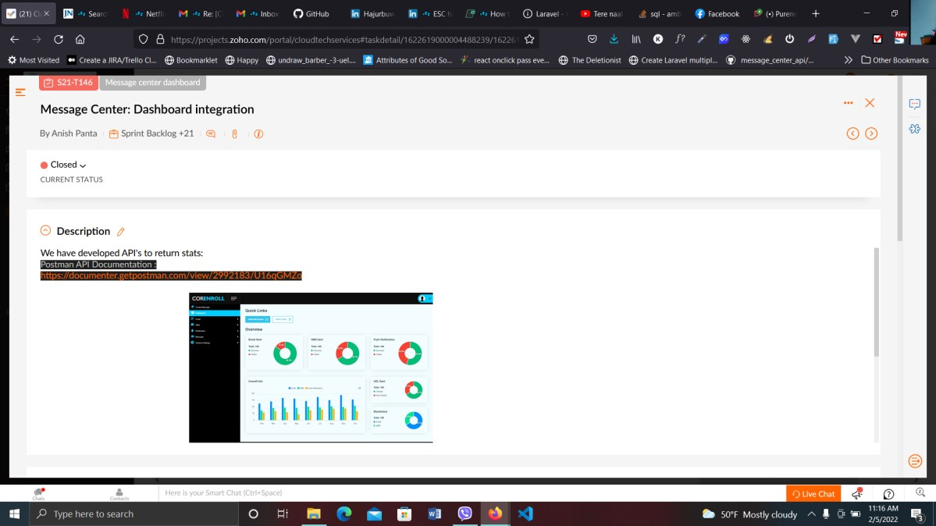

Figure 2:Dashboard Integration for message center dashboard

* **Task 3: Revamp of message center**

In this task, the message center refinement is required. The UI element is checked and the errors in the message center are listed. the issues like link, button position, logos and other listing errors are solved during the task.

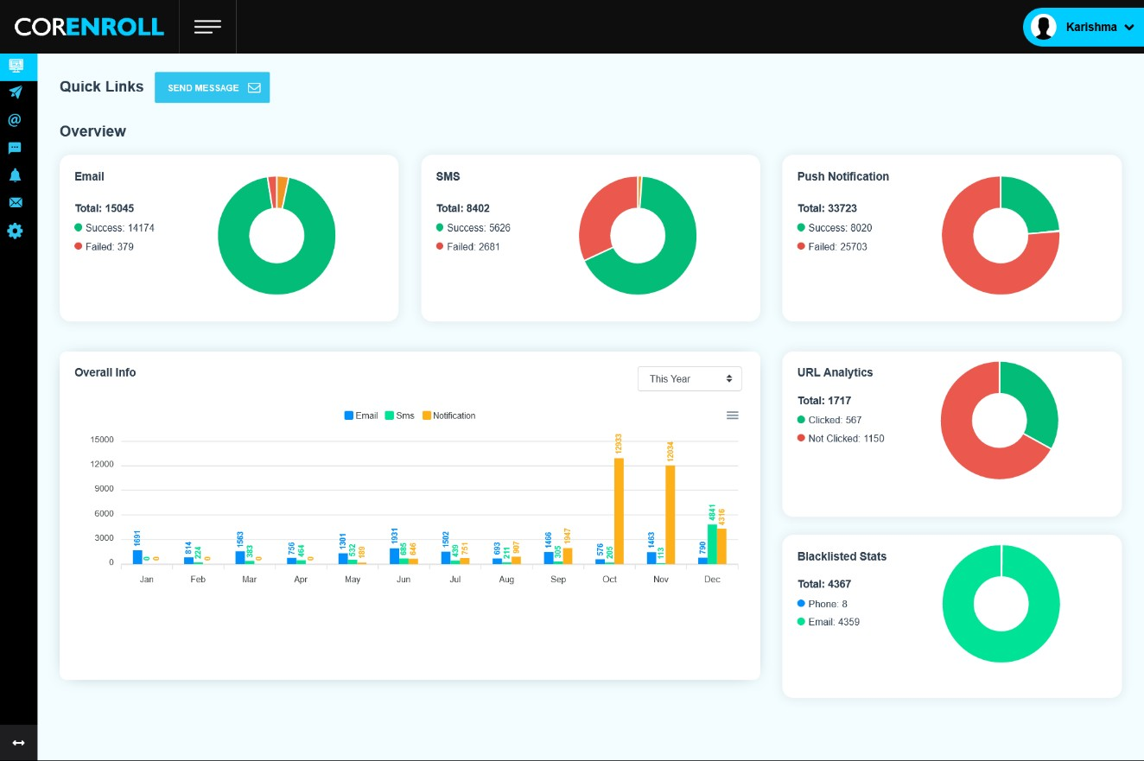

Figure 3:Revamp of message center

* **Task 4: demo site fix and Test.**

The new system have been developed from the existing system. I was given the task to fix the demo site and issues that has been occurred during the setup of the system. During the setup of system are different email template and links of previous system those were removed.

* **Task 5:Calendar sync research (how to sync or connect different google calendar, 365, outlook, icloud calendar)**

In this task, I was given to research different calenders and how they sync and connect with each other. The different calendar like google calendar , 365, outlook and icloud calendar syncing and connecting features were researched and the information were documented .

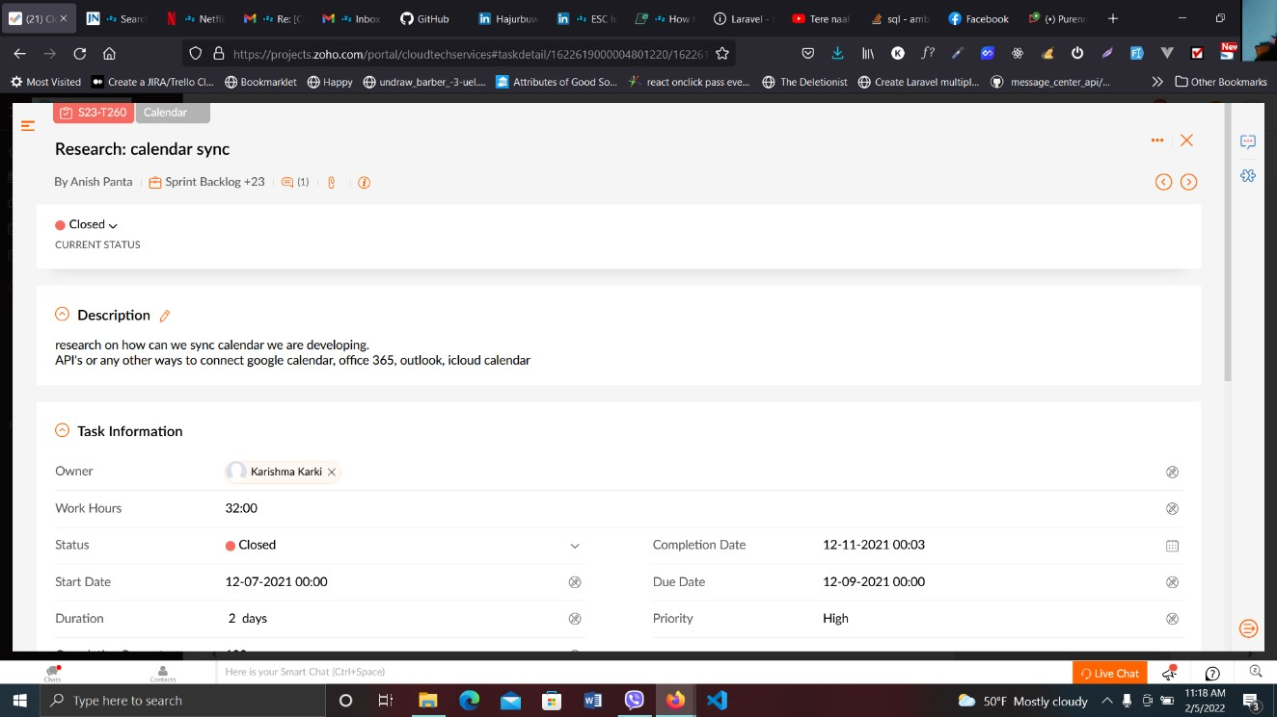

Figure 4:Calendar Sync

* **Task 6: file to s3** (changing knowledge base file upload to s3 moving file storage to s3))

In this task I was given to change the storage in local driver to s3 driver integration within the mvc application. I learned about the amazon s3 bucket integration for storage in laravel. Learning about different amazon services and their storage mechanism. The setup of the configuration were kept in env files and the required integration for the driver were put in the filesystem.php file. After that the logic were written in controller and the storage to s3 was implemented.

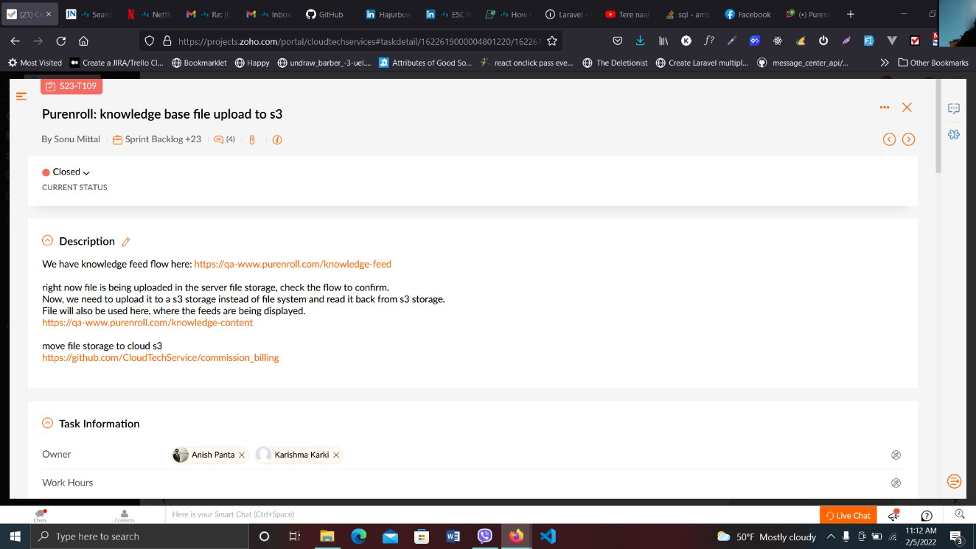

Figure 5:File to s3

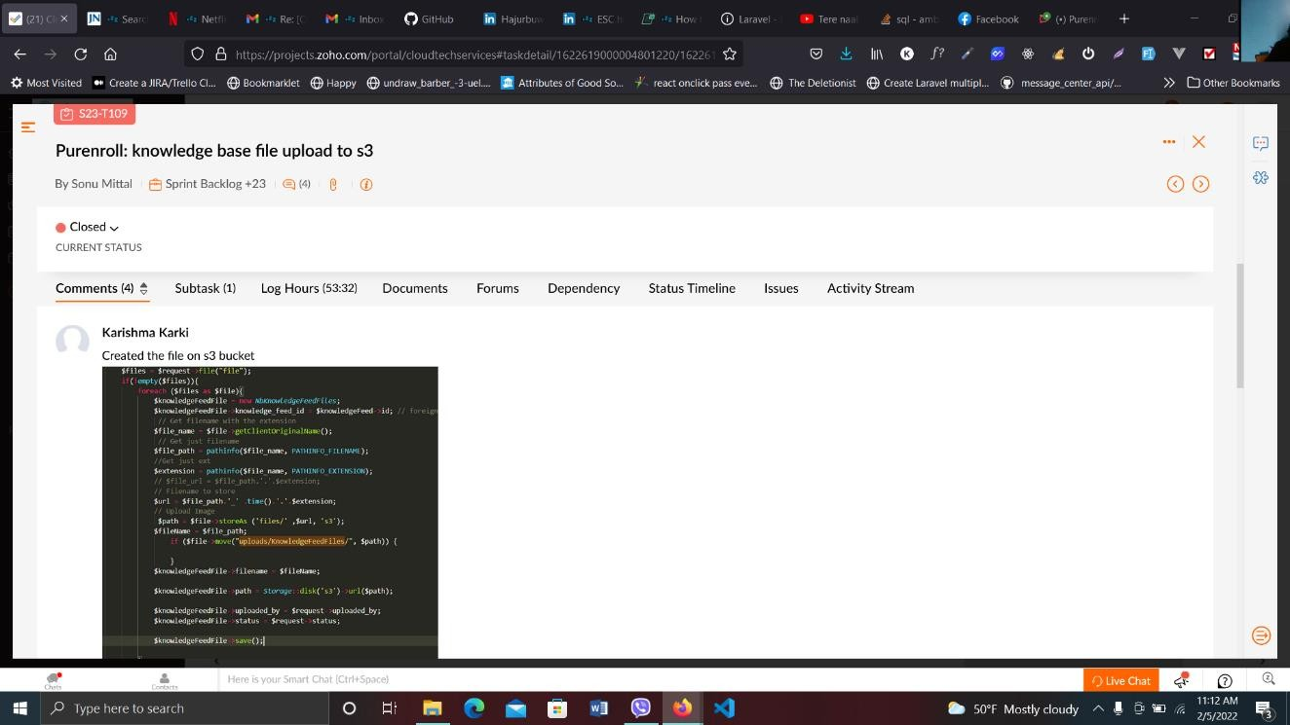

Figure 6:File to s3

**Task 7: API creation for dispute list (need API for all dispute list and detail of particular month and year)**

In this task ,I was given the task to create Api for the dispute for the payments . The details of the particular month and year were also shown in this api. The SQL query was tested in workbench to get all the information required. The information of dispute reason, payment_id, invoice_id with last updated date is also shown in api details

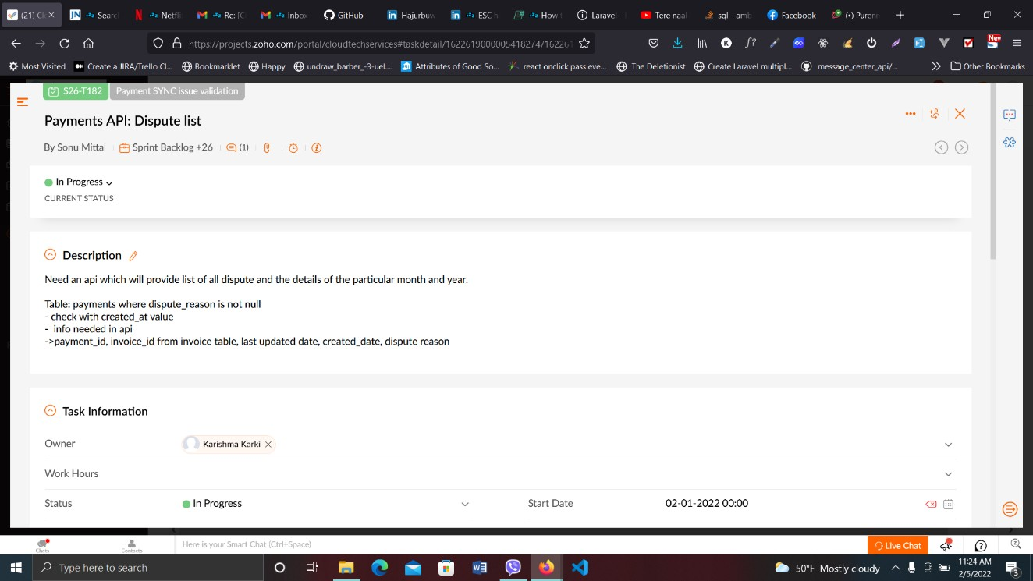

Figure 7:Api to dispute list

* **Task 8: API creation for email analytics**

In this task, api was created for the for the email analytics. The informations like overall count like Success, and failure count of each type of users like member, agents and groups. The email analytics also consisted of invalid email, email bounced, email blacklisted count of top 10 domains and top 10 subjects. Thse api of Scheduled count nad total blacklisted count was also created.

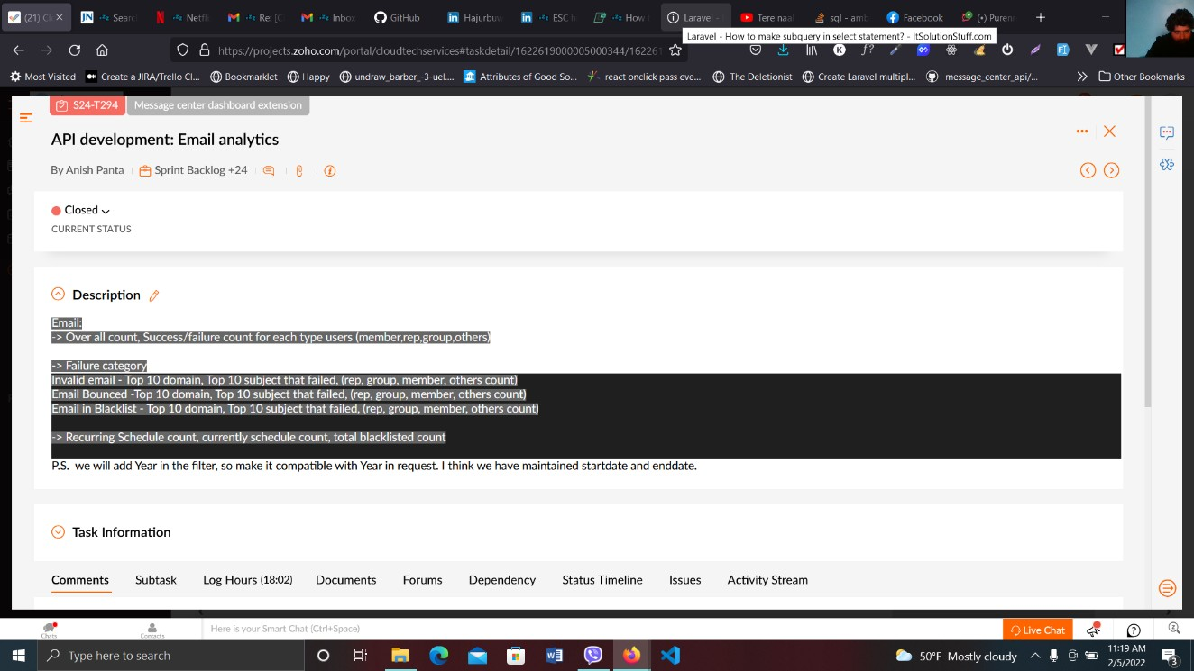

Figure 8:Api Creation for dashboard Analytics

* **Task 9: Working on save as draft feature**(worked on save as Draft in email scheduling flow)

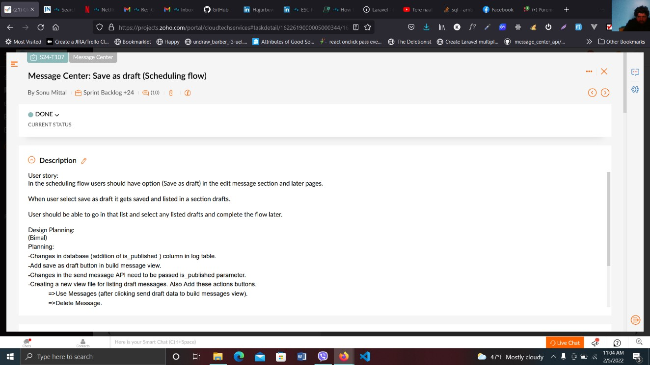

Figure 9:Working on save as draft feature

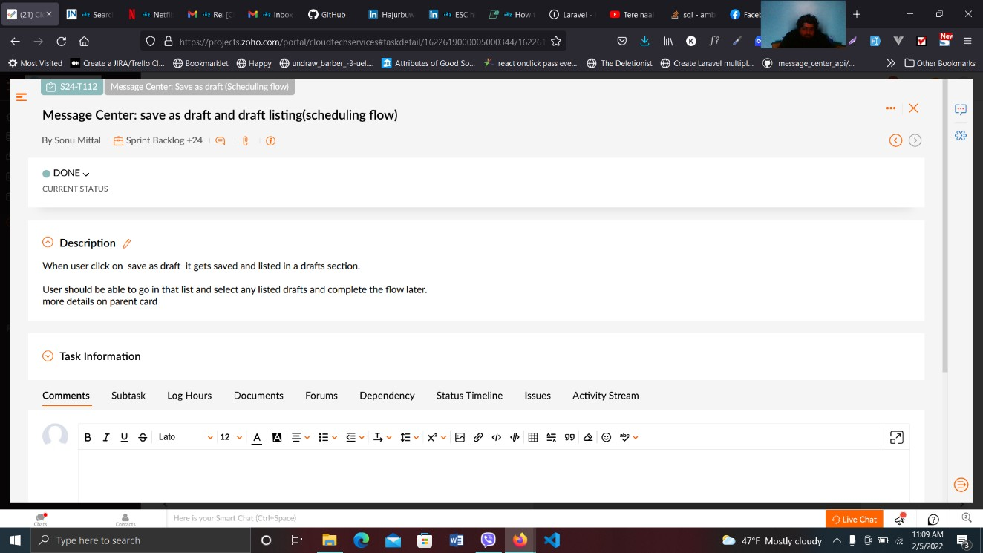

**Issues Fixed**

Figure 10:Working on save as draft feature

* Issue cannot select multiple data at once (user cannot select multiple file one by one)

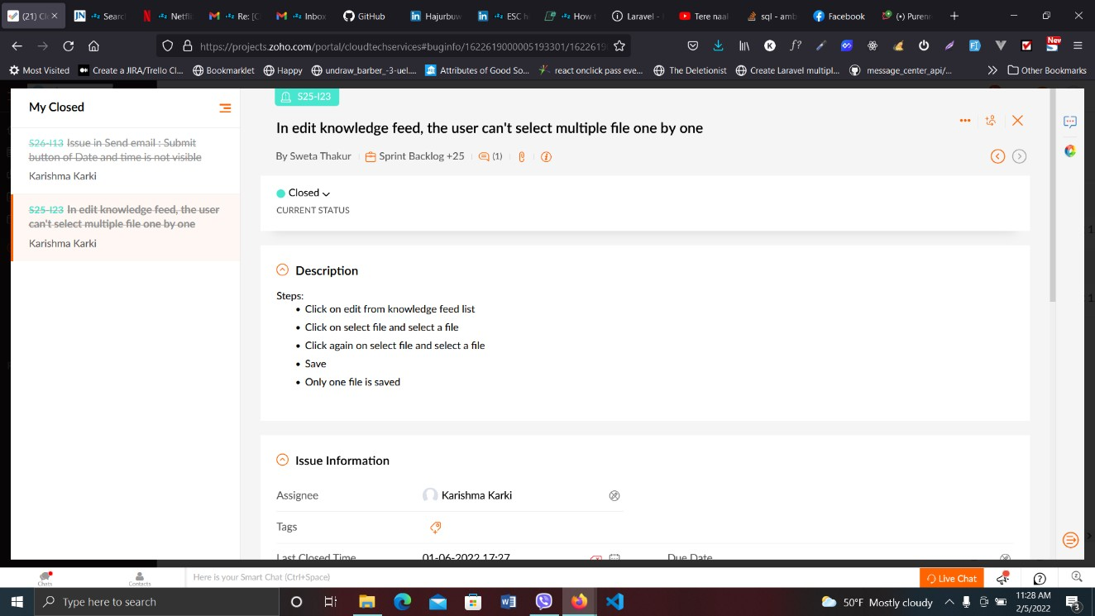

Figure 11:Issue cannot select multiple data at once

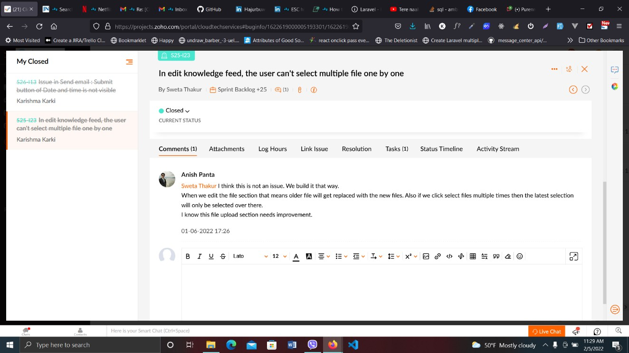

Figure 12:Issue cannot select multiple data at once 2

* Enroll code email activities are not tracked in email log

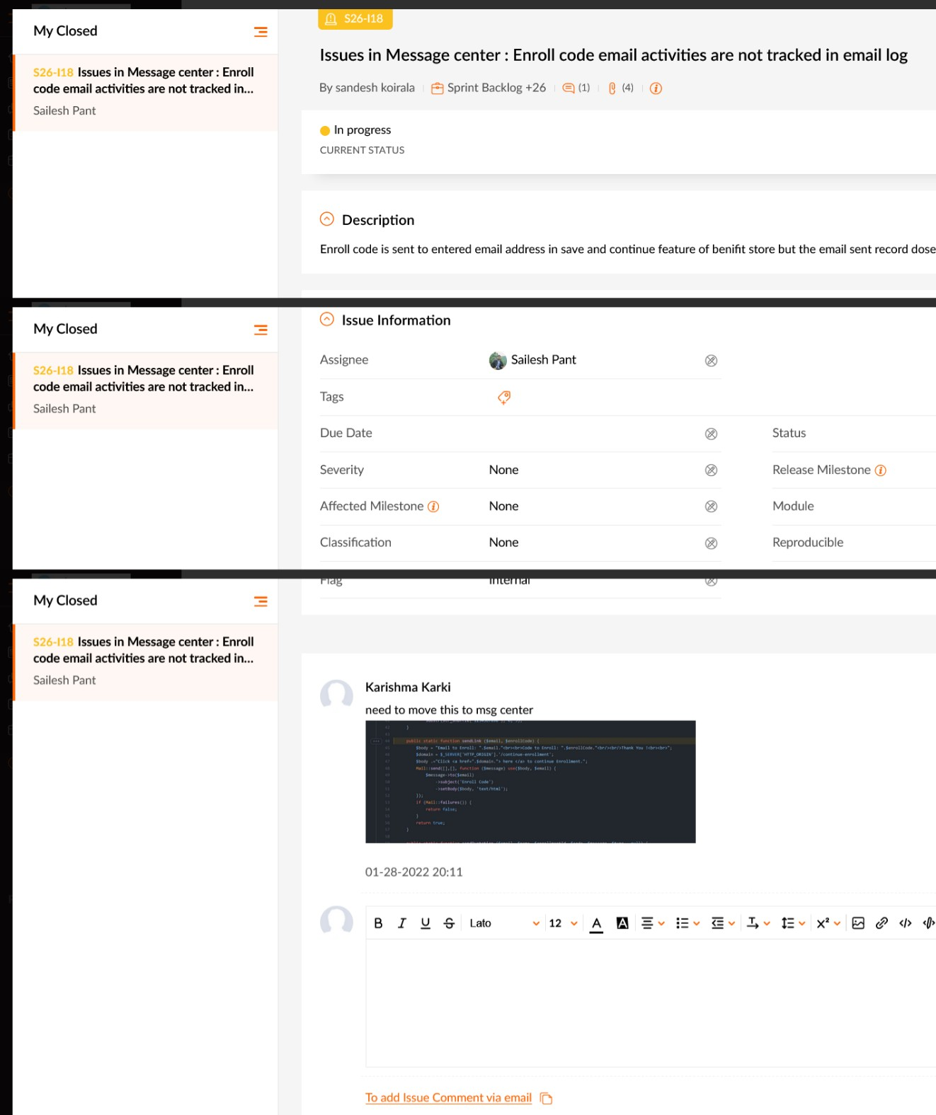

Figure 13:Enroll code email activities

* Issue to submit button of date and time is not visible

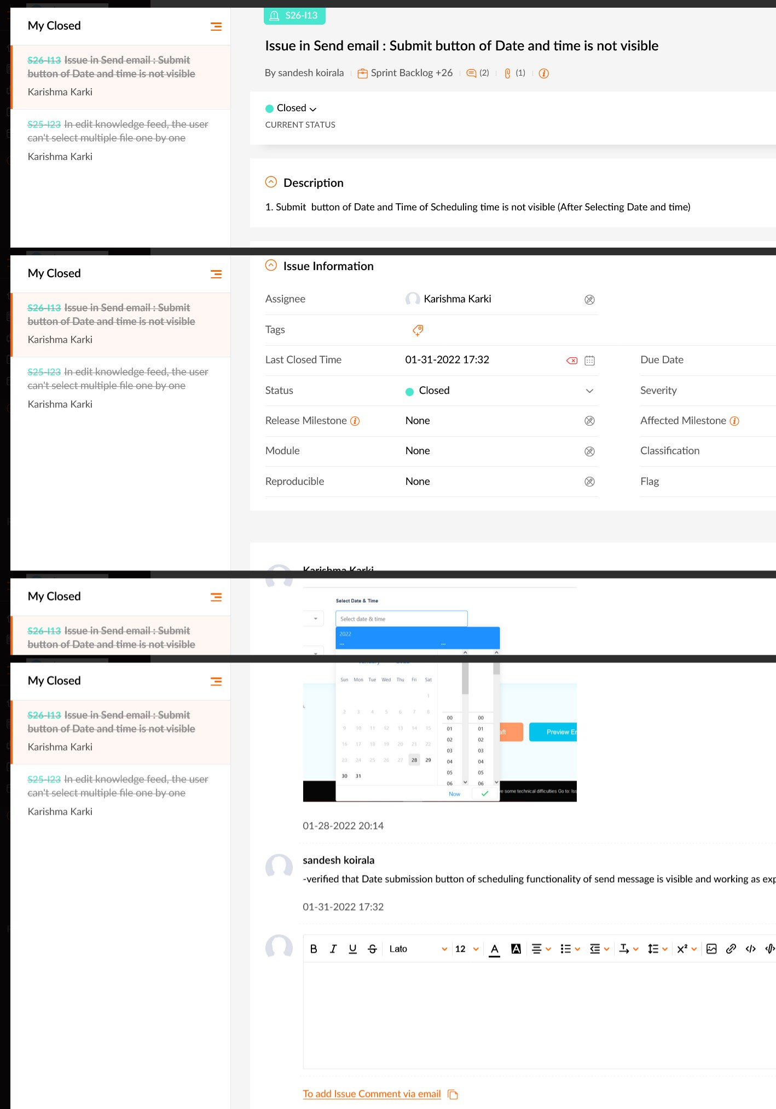

Figure 14:submit and date picker not visible

# Chapter 4: Conclusion And Learning Outcome

## Learning Outcome

Working at CloudTech Services also helped me broaden my technical knowledge in the programming field. I only had basic knowledge about web programming language before my involvement as an intern. During my stay in the organization, I also got to broaden my knowledge about various JavaScript framework. I also learnt some basic system engineering and database design during the internship.

### 4.1.1 Job Oriented Learning

* Learned about web development and related topics.
* Learned the use of various technologies such as VueJS, Slack, etc.
* Learned more about coding, assets structuring, testing & debugging.
* Learned to operate various theoretical aspects into real life work.
* Learned to create various work related documents such as graphics descriptions.

### 4.1.2 Skills Oriented Learning

* Effective communication & collaboration.
* Leadership
* Teamwork.
* Time management.
* Development of problem solving skills
* Development of knowledge implementation skills.

## Conclusion

This internship has been a fantastic and fruitful experience. An internship is a great approach to bridge the gap between our academic experience and the professional world. It gives individuals essential workplace experience as well as opportunity for skill development. Interns not only provide the real working environment but also help to gain knowledge and interpersonal skills. The internship report is submitted as per the requirement of the Bachelor of Information management course.

Working as an intern at CloudTech Services was a great experience for me. This was my first crack at working in a professional environment. Before being involved as an intern in the organization, I only had an outside view and an insight as an observer as to how a professional organization functioned. But after completion of my internship, I got an inside view of professional surroundings and gained experience by being involved in the day-to-day activities directly. The IT industry is one of the leading industries in Nepal today. The internship program helped me learn about the growth of this industry and gain further knowledge about it.

I was able to increase my programming technical expertise by working at Cloudtech Services. I had just little experience of web development languages prior to beginning my internship. Additionally, I was able to increase my understanding of numerous JavaScript frameworks while I was employed by the company. I also acquired fundamental system technology and database design during my internship.

Overall, the internship program helped me develop skills such as handling real-world problems, working under the rules and regulations of an organization, working under a deadline and working under pressure. It helped me gain technical knowledge as well as professional experience which will be very helpful throughout my professional career.

# References

Martin, R. C. (2010). *Clean code a handbook of agile software craftmanship.* Upper Saddle River [Etc.] Prentice Hall.

GitHub. (2018). *GitHub*. GitHub. <https://github.com/>

*Quick Start | Vue.js*. (n.d.). Vuejs.org. Retrieved September 17, 2022, from <https://vuejs.org/guide/quick-start.html#using-vue-from-cdn>

*Laravel - The PHP Framework For Web Artisans*. (n.d.). Laravel.com. <https://laravel.com/docs/9.x>

Green, M. A. (2017). *Understanding health insurance : a guide to billing and reimbursement*. Cengage Learning.

‌Ramadhany, S. E., & Azwir, H. H. (2020). Developing Database System for Managing Medical Insurance Claims in the Human Resource Department. *Performa: Media Ilmiah Teknik Industri*, *19*(2). <https://doi.org/10.20961/performa.19.2.43965>

Ebad, S. A. (2017). Regulatory Rules for Security Requirements of Financial Information Systems: Attempt to Formalize. *European Journal for Security Research*, *2*(2), 97–117. https://doi.org/10.1007/s41125-017-0017-5

‌

‌

‌

# Appendix I

**System Highlights:**

**Dashboard integration**

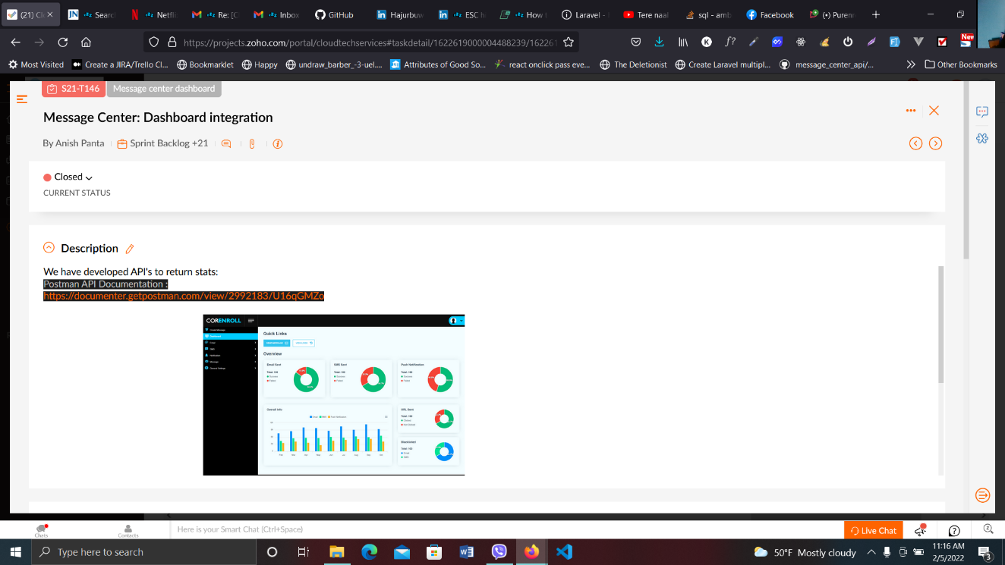

Figure 15: Dashboard Integration

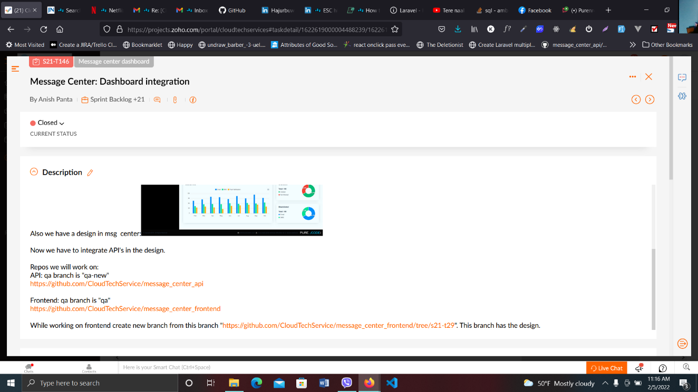

Figure 16: Dashboard Integration

**API dispute list**

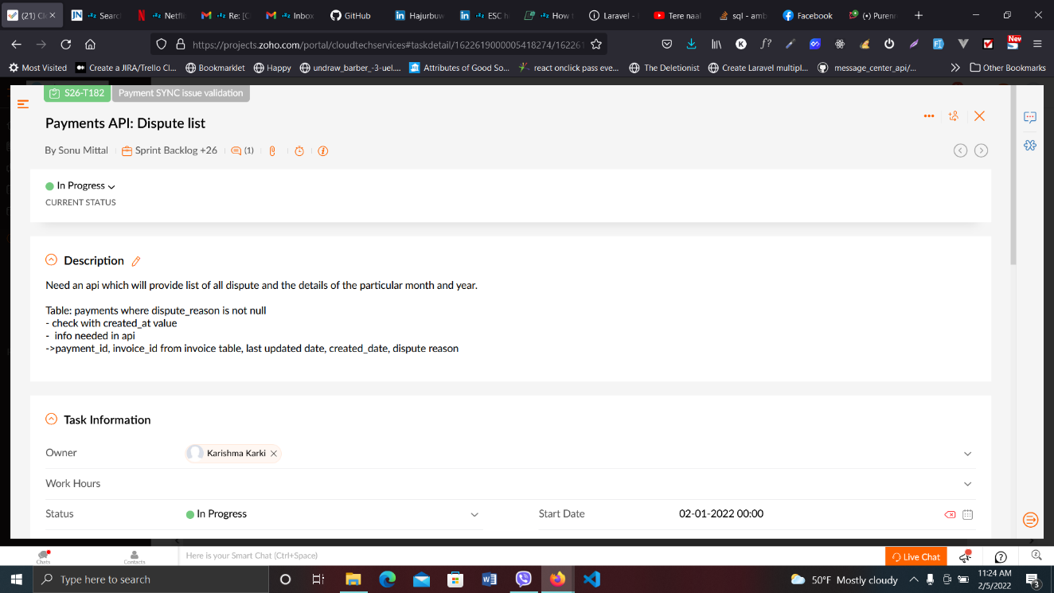

Figure 17: API dispute list

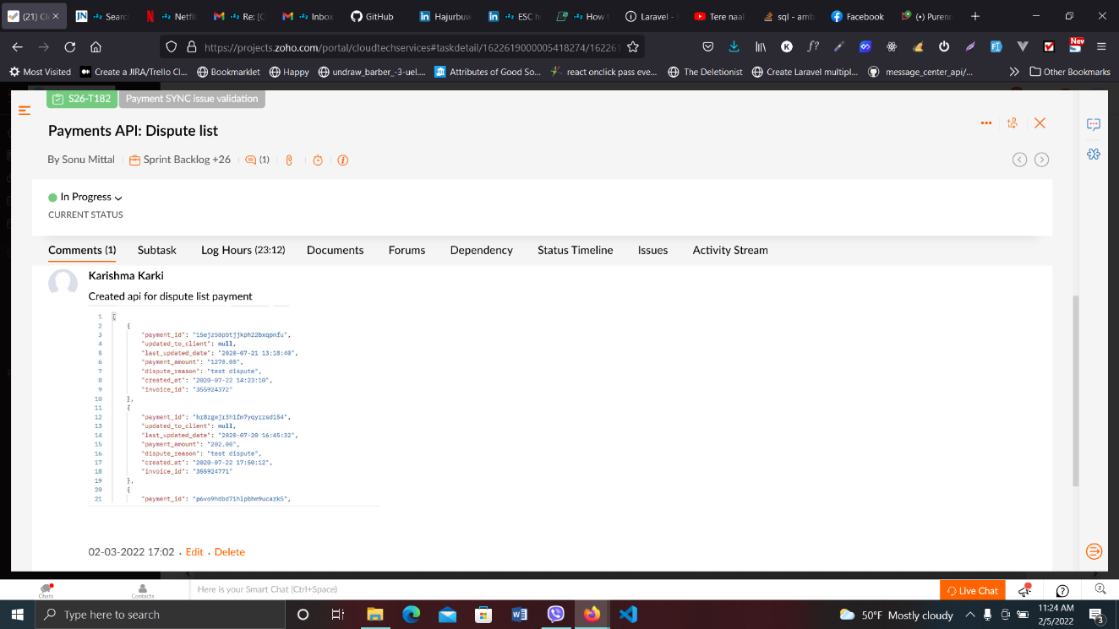

Figure 18: API dispute list

**Calendar sync**

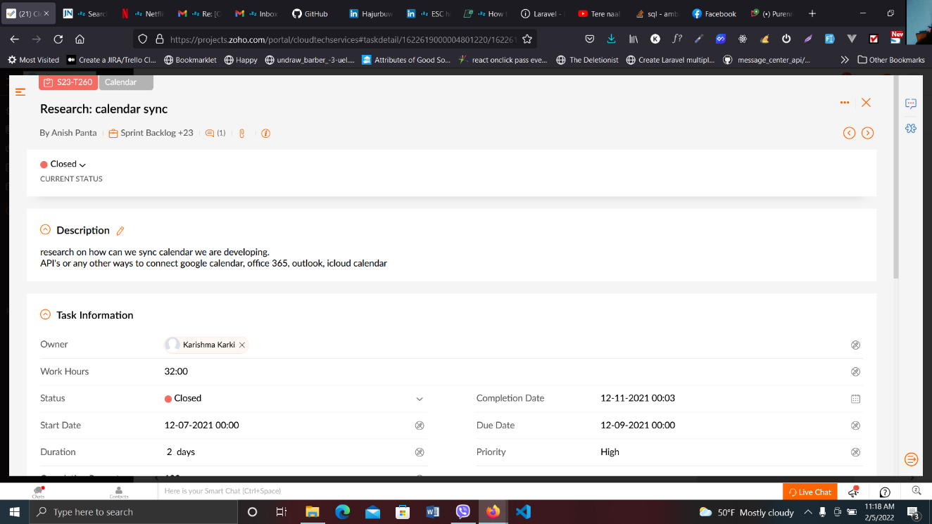

Figure 19: Calendar Sync

**Multiselectonetime**

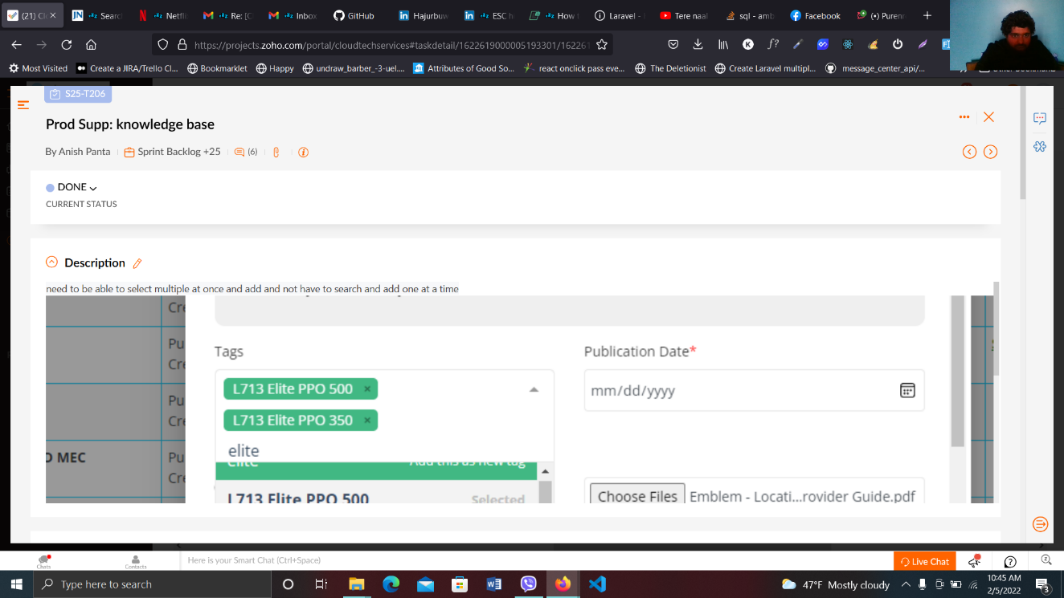

Figure 20: multiple select one time

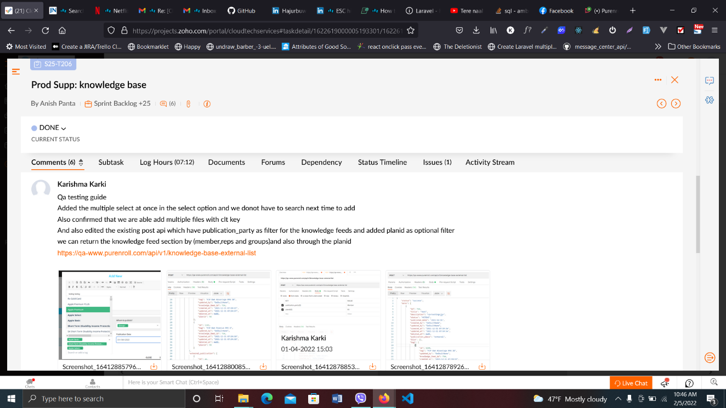

Figure 21: multiple select one time

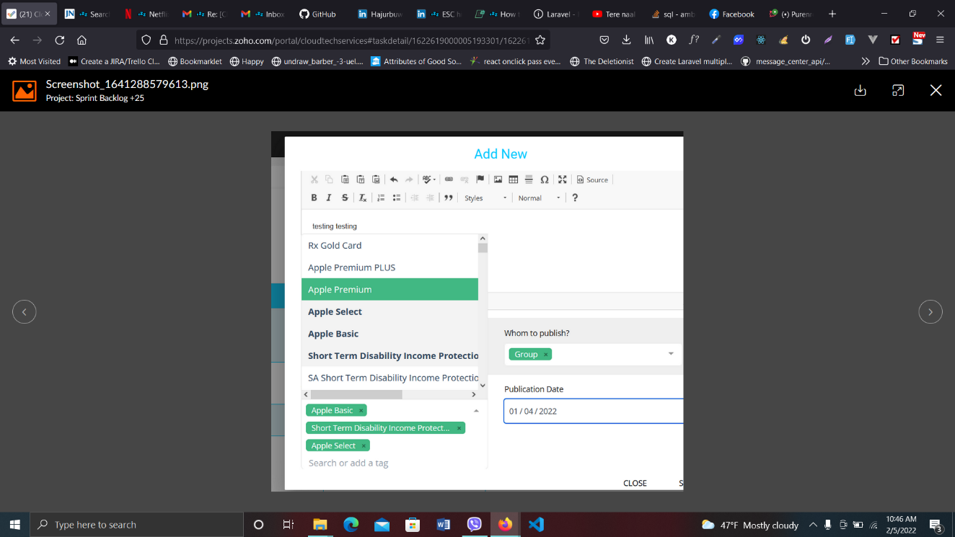

Figure 22: multiple select one time