R PROJECT ASSIGNMENT
ANALYSIS OF GENE SPLICING DATA
ABSTRACT-
Alternative gene splicing is a crucial biological process that enables a single gene to produce multiple protein variants. The project explores the relationship between the splicing factors and their associated splicing event expressions using a synthetic dataset. The dataset contains 3 splicing factors – Splicing Factor 1, Splicing Factor 2 and Splicing Factor 3; and Splicing event expression for each Subject.
Sample size – 100 subjects.

- Data Exploration – Distribution | Central Tendency | Variability
The dataset was explored using descriptive statistics and performing the correlation matrix.
- Splicing Factors 1 and 3 are relatively symmetric and less variable which suggests that there is consistent expression across subjects, because the mean and median values for both factors are close.
Factor1: mean 5.09 ≈ median 5.062 → slightly symmetric
Factor3: mean 4.096 ≈ median 4.029 → slightly symmetric
- Splicing factor 2 is slightly right skewed and more variable, indicating some subjects express it much higher while Factor 3 is the most consistent (IQR for Factor 3 = 1.036)
Factor2: mean 7.839 > median 7.661 → slight right skew
Factor2: 12.862 - 4.920 = 7.942 → wider spread, more variability
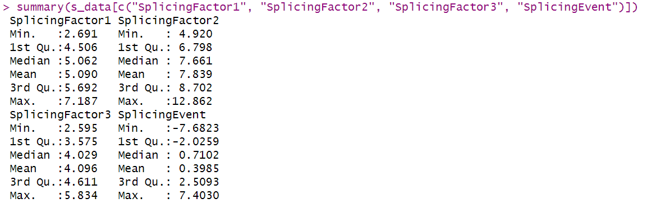
Insights on Splicing Event correlations:
- Factor 1: 0.52
Moderate positive correlation. It promotes the splicing event.
- Factor 2: -0.63
There is negative correlation with splicing events. It seems to inhibit the splicing event.
- Factor 3: -0.005
There is no meaningful correlation of factor 3, splicing event doesn’t seem to influence this splicing event.
Insights on Inter Factor correlations: The three splicing factors are largely independent of each other, which is good for studying their separate effects on the splicing event.
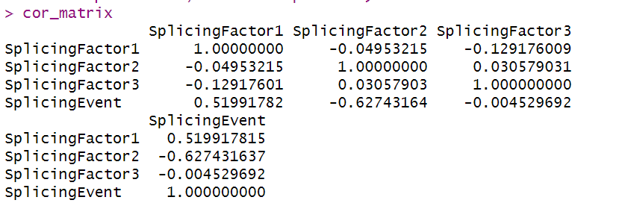
- Data Visualizations
- The distribution of the data can also be visualized using histograms and boxplots:
- Histograms reveal that all variables are approximately normally distributed, with slight skewness in SplicingEvent and SplicingFactor2, but there are no indications of severe non-normality. Most groups display moderate kurtosis and a bell-shaped appearance, highlighting the suitability of parametric statistical testing for these data.
- SplicingEvent displays a broad range of values centered near zero, indicating a mix of positive and negative expression levels with some outliers and moderate spread.
- SplicingFactor1 and SplicingFactor3 have relatively symmetric distributions clustered around 5 and 4, respectively, with less extreme outliers and more concentrated spread.
- SplicingFactor2 stands out with the highest median and a wider range, indicating higher overall expression and greater variability among its values.
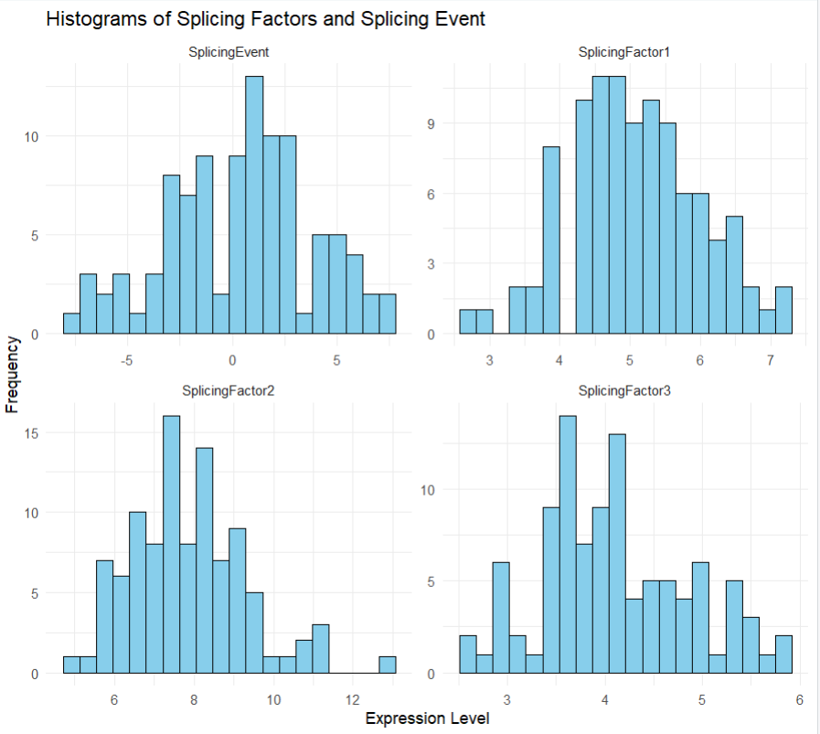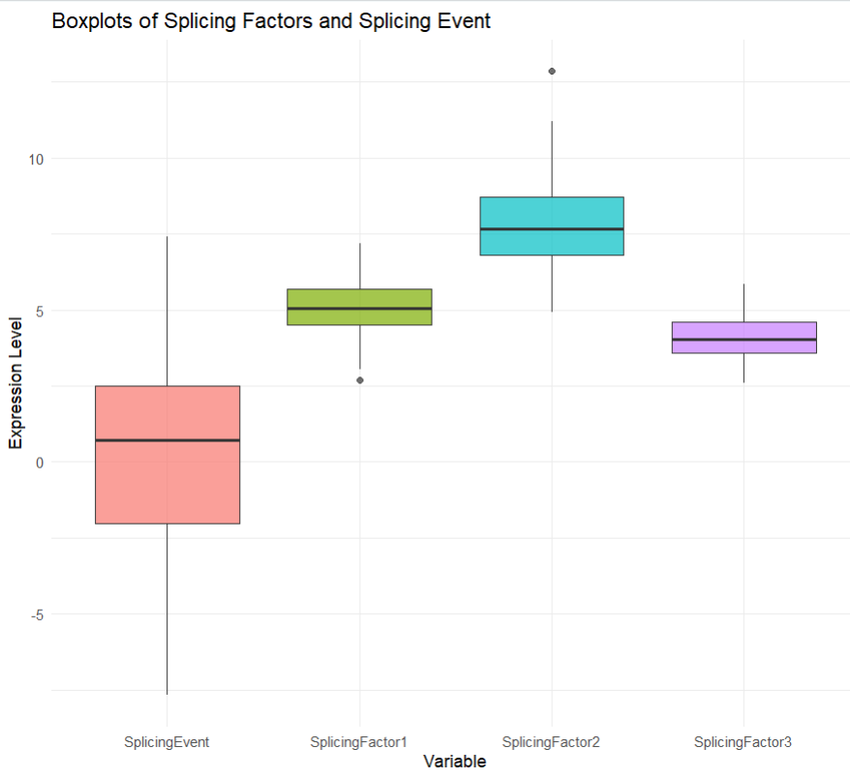
- To explore the relationship between each splicing factor and the splicing event:
- The scatterplot and regression line in the provided image illustrate a positive linear relationship between SplicingFactor1 expression and SplicingEvent expression. The fitted regression line indicates that this association is statistically supported.
- The scatterplot presents a negative linear relationship between SplicingFactor2 expression and SplicingEvent expression. This is visually confirmed by the downward-sloping regression line with a shaded confidence region, suggesting a statistically significant inverse correlation.
- The scatterplot shows a negligible or no linear relationship between SplicingFactor3 expression and SplicingEvent expression. The data points are widely dispersed with no clear upward or downward trend, and the regression line is nearly flat with a broad confidence interval.
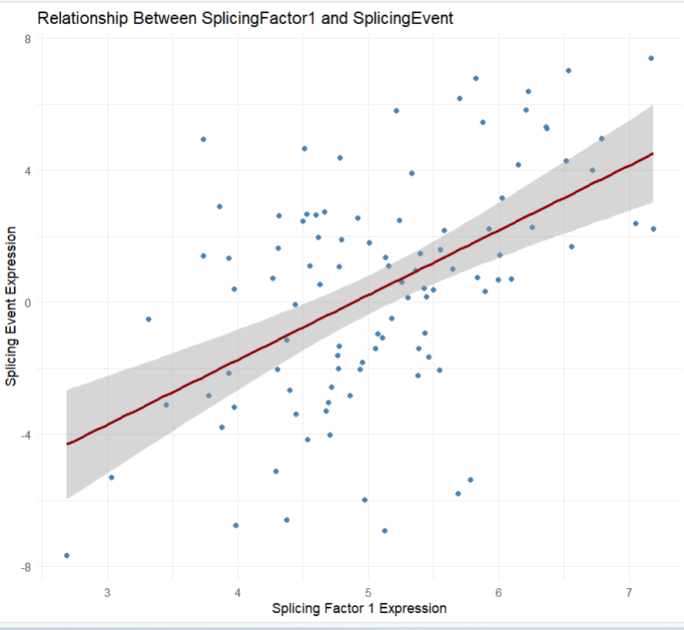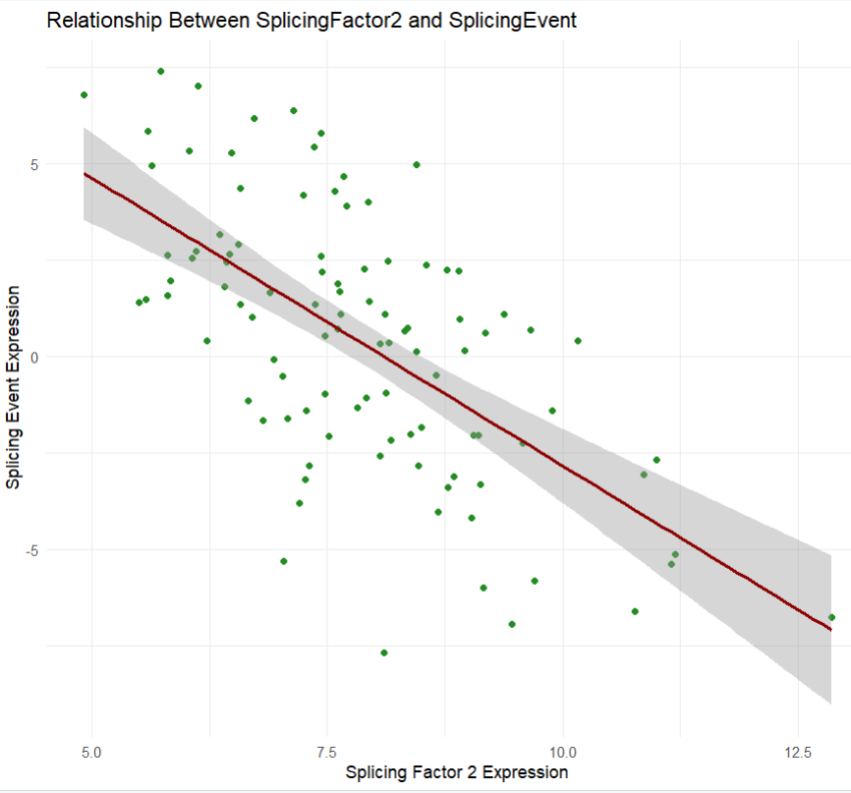

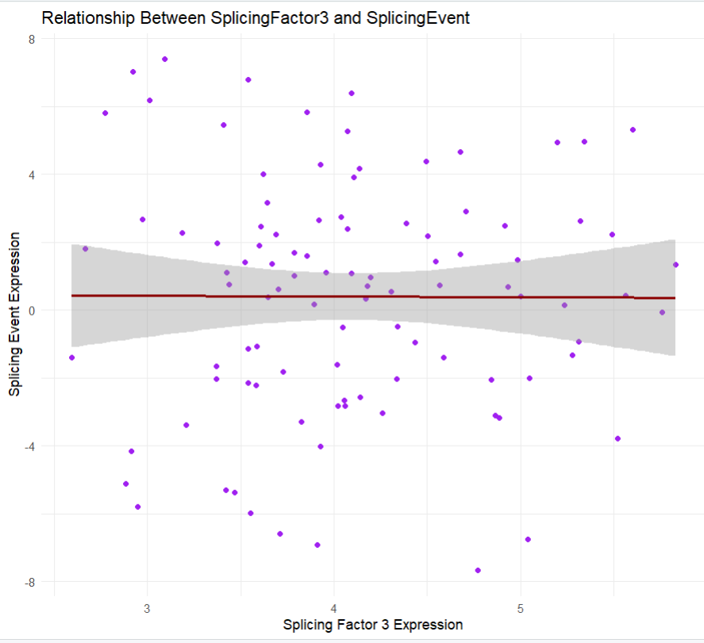

- Predictive Modeling – Multiple Linear Regression Model
Model: Splicing Event ~ Splicing Factor 1 + Splicing Factor 2 + Splicing Factor 3
R² = 0.627
Adjusted R² = 0.61
- The model explains ~62.7% of the variability in the splicing event, which is strong for biological expression data.
Interpretation of Coefficients:
- Splicing Factor 1 (Beta = 2.047, p<0.001) → Promotes the splicing event.
It is a strong positive predictor. For each 1-unit increase in Factor 1, the event is expected to increase by ~2.047 units, holding other values constant.
Highly significant p= 8.80e-10
This matches with the correlation matrix – that Factor 1 is positively corelated with the splicing event (r=0.52)
- Splicing Factor 2 (Beta = -1.316, p<0.001) → Suppresses the splicing event.
It is a strong negative predictor. For each 1-unit increase in Factor 2, the event is expected to decrease by ~1.32 units, holding other values constant.
Highly significant p= 4.82e-11
This matches with the correlation matrix – that Factor 2 is negatively corelated with the splicing event (r = -0.63)
- Splicing Factor 3 (Beta = 0.317, p = 0.344) → Likely not involved in this specific splicing regulation.
It is a weak positive effect indicating that Factor 3 does not meaningfully contribute to predicting the splicing event.
Not significant.
This matches with the correlation matrix – that Factor 3 has zero correlation with the splicing event (r = -0.005)
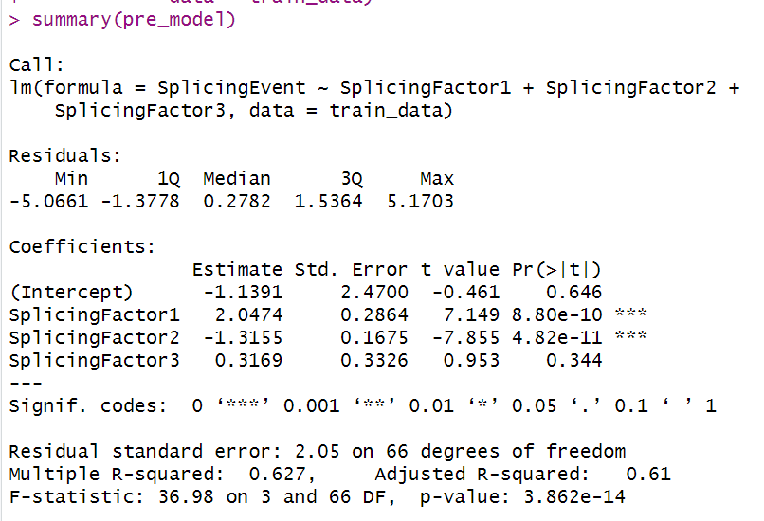
Model Performance (on the Testing Set) – The model has reasonable predictive accuracy
- MSE = 5.1346
A lower MSE indicates that there is moderate predictive error.
- RMSE = 2.265
It indicates that predictions are off by ~2.27 units from the true value.
- MAE = 1.712
It indicates that predictions are off by ~1.71 units
These values indicate that the model has reasonable predictive accuracy.
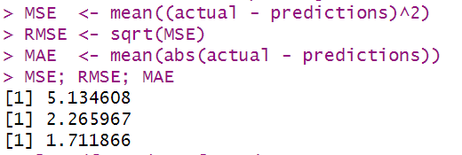

- Conclusions and Recommendations
- Conclusion
- In this study, we examined how three splicing factors relate to a specific splicing event using exploratory data analysis and a multiple linear regression model.
- The analysis revealed that SplicingFactor1 and SplicingFactor2 are the strongest predictors of the splicing event, showing significant positive and negative associations, respectively, while SplicingFactor3 contributed minimally.
- The predictive model demonstrated solid performance, explaining approximately 63% of the variability in the splicing event, and the predicted–actual visualization confirmed that the model captures the overall trend well, despite some scatter and reduced accuracy at the extreme values.
- Recommendations
- Based on these findings, future work should focus on experimentally validating the opposing regulatory roles of SplicingFactor1 and SplicingFactor2.
- Additional modeling approaches such as regularized regression or non-linear methods may further improve prediction accuracy.
- Collecting more biological variables or a larger sample size would also strengthen understanding of the splicing mechanisms and help refine the model’s predictive power.

