17-07-2024

Wednesday

Name: Karishma Wanchoo

**DSA using Cpp Test**

LEETCODE

QUES 4: Two Sum

Given an array of integers nums and an integer target, return indices of the two numbers such that they add up to *target*.

You may assume that each input would have **exactly one solution**, and you may not use the same element twice.

You can return the answer in any order.

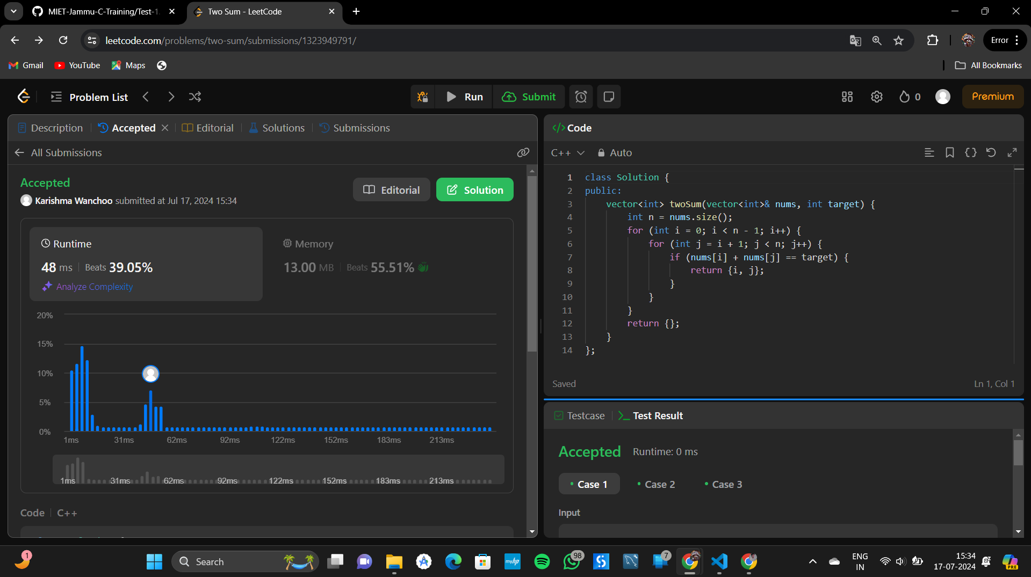Solution: