ProSafe Smart Helmet
UI Requirements & Backend Functions Implementation Guide
Implementation reference for the MERN web application, backend services, ML-driven safety state, alerts, helmet management and analytics

Source basis: This guide is derived from "UI and backend functions.docx" for the intended screens/wireframes and "ProSafe_Processing_Architecture.docx" for sensor processing, worker baselines, environmental ranges, ML predictions, alert lifecycle, dashboard data, LED control and emergency handling.

Interpretation rule: Where the source UI document is incomplete, this guide adds a recommended implementation and marks it as such. Safety-state logic remains backend-owned and follows the processing architecture rather than being reimplemented in the browser.

Version 1.0 | 30 August 2026

Contents
- 1. Purpose and scope
- 2. Architecture-to-UI mapping
- 3. Application-wide UI and UX requirements
- 4. Role and access-control matrix
- 5. Authentication: Login
- 6. Admin Dashboard / Home
- 7. Worker Dashboard / Home
- 8. Account dropdown and Profile view
- 9. Notifications and Alert popups
- 10. Users list
- 11. User / Worker detail view
- 12. Body Temperature detail popup
- 13. Heart Rate detail popup
- 14. Sound Level detail popup
- 15. Ambient Temperature detail popup
- 16. Gas / PPM detail popup
- 17. UV Light detail popup
- 18. Safety Prediction detail popup
- 19. Add User
- 20. Edit User
- 21. Delete User
- 22. Helmets list
- 23. Add Helmet
- 24. View Helmet
- 25. Delete Helmet
- 26. Analytics
- 27. Settings
- 28. Cross-cutting backend/API requirements
- 29. Backend function catalog
- 30. Implementation priorities and open decisions

1. Purpose and scope
This document turns the available ProSafe UI concepts into implementation-ready requirements. It describes what each view must show, who can access it, how it behaves, which backend data it needs, which functions must exist, and the important loading/error/empty states that should be handled.
- The web application must support two account roles: Administrator and Worker.
- Only workers are assigned smart helmets. Administrators are management users and do not receive helmet sensor data as their own physiological record.
- Normal helmet packets are expected every 60 seconds. Emergency packets are sent immediately and bypass the normal schedule.
- The frontend displays processed backend results. It must not independently run the XGBoost model, calculate final risk state, or clear an emergency.
- Personalized physiology applies to heart rate and body temperature. Environmental values use configured ranges.
- Emergency is a direct worker request for help and remains separate from SAFE / WARNING / CRITICAL ML classification.
Recommended implementation: Use REST APIs for CRUD and historical queries, plus WebSocket or Server-Sent Events for live dashboard/alert updates. The architecture defines a real-time dashboard goal but does not prescribe the transport mechanism.

2. Architecture-to-UI mapping
Backend / stored data | UI usage
Worker | Authentication identity, profile, role, user list, worker detail.
Helmet | Helmet management, assignment, online/offline state, last seen.
Worker Baseline | Heart-rate/body-temperature baseline shown in personalized sensor popups.
Processed Sensor Reading | Latest sensor values and historical sensor views.
Prediction + Prediction History | Current safety prediction, confidence and daily prediction trend.
Current Worker Risk State | SAFE/WARNING/CRITICAL status cards and dashboard counts.
Alerts | Dashboard alert list, alert popup, acknowledgement/read state and resolution.
Emergency State | EMERGENCY status and supervisor Reset Emergency workflow.
GPS / Location | Worker location in user view and alert popup.
Exposure-Duration State | Backend safety processing and analytics; not a feature of the currently trained model.
Helmet Command / LED State | Operational status and reset/LED reconciliation; generally not edited by normal UI.
Model / Version Metadata | Safety Prediction popup and implementation traceability.

Important model constraint: The current trained model uses the confirmed 10-feature vector and does not include exposure-duration features. The UI may report exposure duration in analytics, but should not describe it as a current XGBoost input unless the model is retrained.

3. Application-wide UI and UX requirements

3.1 Visual consistency
- Use the approved ProSafe Dashboard as the master visual language: near-black/navy background, dark translucent glass panels, restrained cyan/teal borders, ProSafe green accents, white primary text and muted blue-gray secondary text.
- Reuse the exact approved ProSafe logo asset. Do not redraw, simplify, recolor or replace it on secondary pages.
- Preserve the same sidebar width, header height, corner radii, navigation spacing, search field style, notification bell, account profile block, System Status card and dotted-wave background treatment.
- Warning should use amber/yellow, Critical should use orange/red, Emergency should use strong red, and Safe should use green. The exact CSS tokens should be centralized rather than copied between components.
Recommended design tokens: If a shared CSS theme has not yet been created, start with deep navy surfaces (#020B11 / #061B25), cyan borders (#168FB5 / #37C6E8), ProSafe green (#1ED760 to #20E96B), warning amber (#F5C518), critical orange-red (#FF5A1F), emergency red (#FF2D2D), white text and cool gray secondary text. Use existing implemented values if they already differ.

3.2 Global application shell
Area | Admin | Worker
Sidebar | Dashboard, Users, Helmets, Analytics, Settings, Logout | Dashboard, User/My Profile, Settings, Logout
Header search | Search workers, helmets, IDs and alerts where supported | Optional/limited to own information; may be hidden if not useful
Notification bell | All relevant safety alerts and system notifications | Only notifications/alerts relevant to the logged-in worker
Profile menu | View Account, Logout | View Account, Logout
System Status | Show backend/system operational state | Show simple operational state if retained in worker shell

3.3 Global interaction rules
- Every data-driven card must support Loading, Loaded, Empty/Unavailable and Error states.
- Never display invalid sensor readings as 0. Display N/A or Sensor unavailable and retain the validity semantics from the backend.
- Show a last-updated timestamp for live sensor/state data. With a 60-second packet interval, the user should be able to tell when the latest packet was received.
- Use toast notifications for successful/failed CRUD operations. Success and failure messages must describe the action, not just say Done.
- Destructive actions require an explicit confirmation modal.
- Emergency reset must show an intermediate state such as Reset requested until the backend/helmet confirmation path is complete. The UI must not immediately claim the emergency is cleared.
- Mark as Read / Acknowledge does not mean Resolve. An alert is resolved by the backend risk-state recovery flow, while acknowledgement only records that a supervisor has seen it.
- Use the server timestamp as the authoritative record for persisted events. Present time consistently in the deployment timezone.

4. Role and access-control matrix
Feature / view | Admin | Worker | Notes
Login | Yes | Yes | Role is resolved after authentication.
Admin dashboard | Yes | No | Worker receives a reduced dashboard.
Worker dashboard | No | Yes | Weather + own alerts, per source UI requirement.
Users list | Yes | No | Worker can view only their own profile/details.
View worker details | Yes | Own record only | Sensor data only when a worker is assigned a helmet.
Add/Edit/Delete users | Yes | No | Admin-only management.
Helmet management | Yes | No | All helmet-related management is admin-only.
Analytics | Yes | No | Download/export is admin-only.
Alert popup | Yes | Own alerts may be visible | Emergency reset is admin/safety-officer action.
Settings | Yes | Yes | System-wide safety config should not be exposed as ordinary settings.

Security requirement: Role checks must exist on the backend/API, not only by hiding buttons in React. A Worker calling an admin endpoint directly must still receive an authorization failure.

5. Login
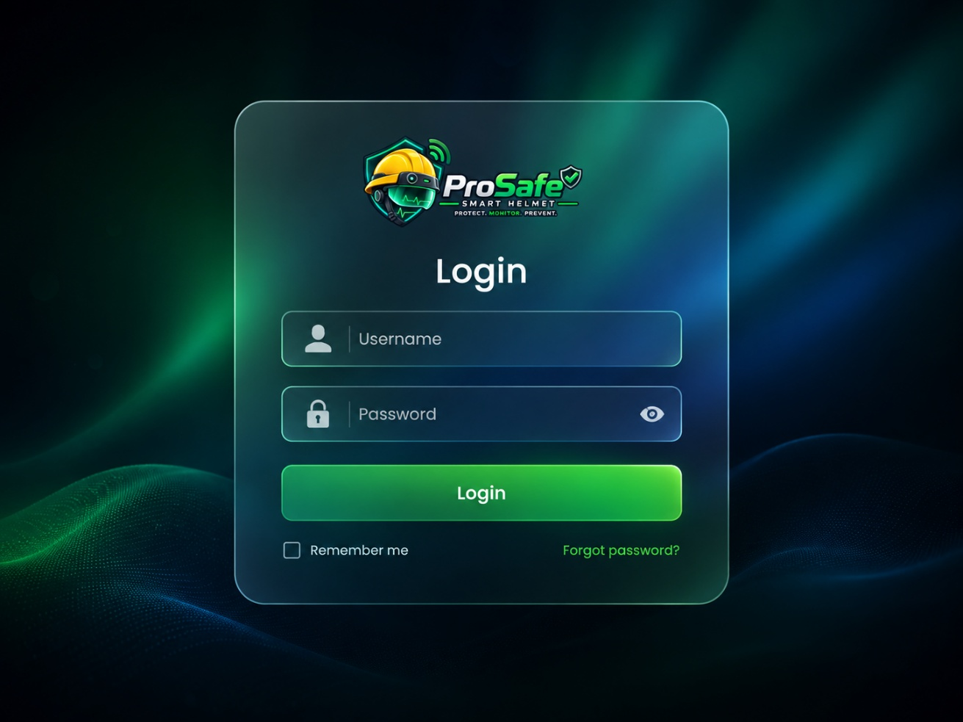
Source UI reference for Login. The wireframe/screenshot defines content; the approved Dashboard visual language remains the style reference.
Requirement | Definition
Purpose | Authenticate Admin or Worker accounts, establish a session and redirect the user to the correct role-based dashboard.
Visibility | Admin and Worker
Suggested route | /login
Data authority | Backend is the source of truth. The frontend must not independently recalculate risk classifications or emergency state.

UI requirements
- Show the original ProSafe logo, Username/Email field, Password field, password visibility toggle, Login button, Remember me and Forgot password if the reset workflow is implemented.
- On submit, disable the Login button while the request is in progress and show a clear authentication error without revealing whether a specific account exists.
- After successful authentication, retrieve the current user/role and redirect Admin to the admin Dashboard and Worker to the worker Dashboard.
- Remember me should only alter session persistence. It must not store a plain-text password in browser storage.
- If Forgot password is displayed, it must lead to a working reset flow. Otherwise remove/disable the control for the MVP rather than leaving a dead link.

States and validation
- Invalid credentials: stay on login and show a generic error.
- Account disabled/deleted: deny access and show an account unavailable message.
- Existing valid session: optionally redirect directly to the correct dashboard.
- Expired session during use: return to login and preserve a safe redirect target if appropriate.

Functions needed
Function | Type | Purpose | Suggested API / Trigger
login(credentials) | Backend | Validate credentials, create session/JWT context and return the authenticated user role. | POST /api/auth/login
getCurrentSession() | Backend | Return the currently authenticated account for route guards and header/profile data. | GET /api/auth/me
logout() | Backend | Invalidate the current session/token and clear authentication state. | POST /api/auth/logout
refreshSession() | Backend | Refresh or extend an authenticated session when the chosen auth design requires it. | Auth middleware
requestPasswordReset() | Optional | Start password-reset workflow when Forgot password is implemented. | POST /api/auth/forgot-password

Minimum acceptance criteria
- Worker cannot reach admin routes after login.
- Admin and Worker sessions survive normal page navigation and are invalidated on logout.
- No protected page is rendered before authorization is resolved.

6. Admin Dashboard / Home
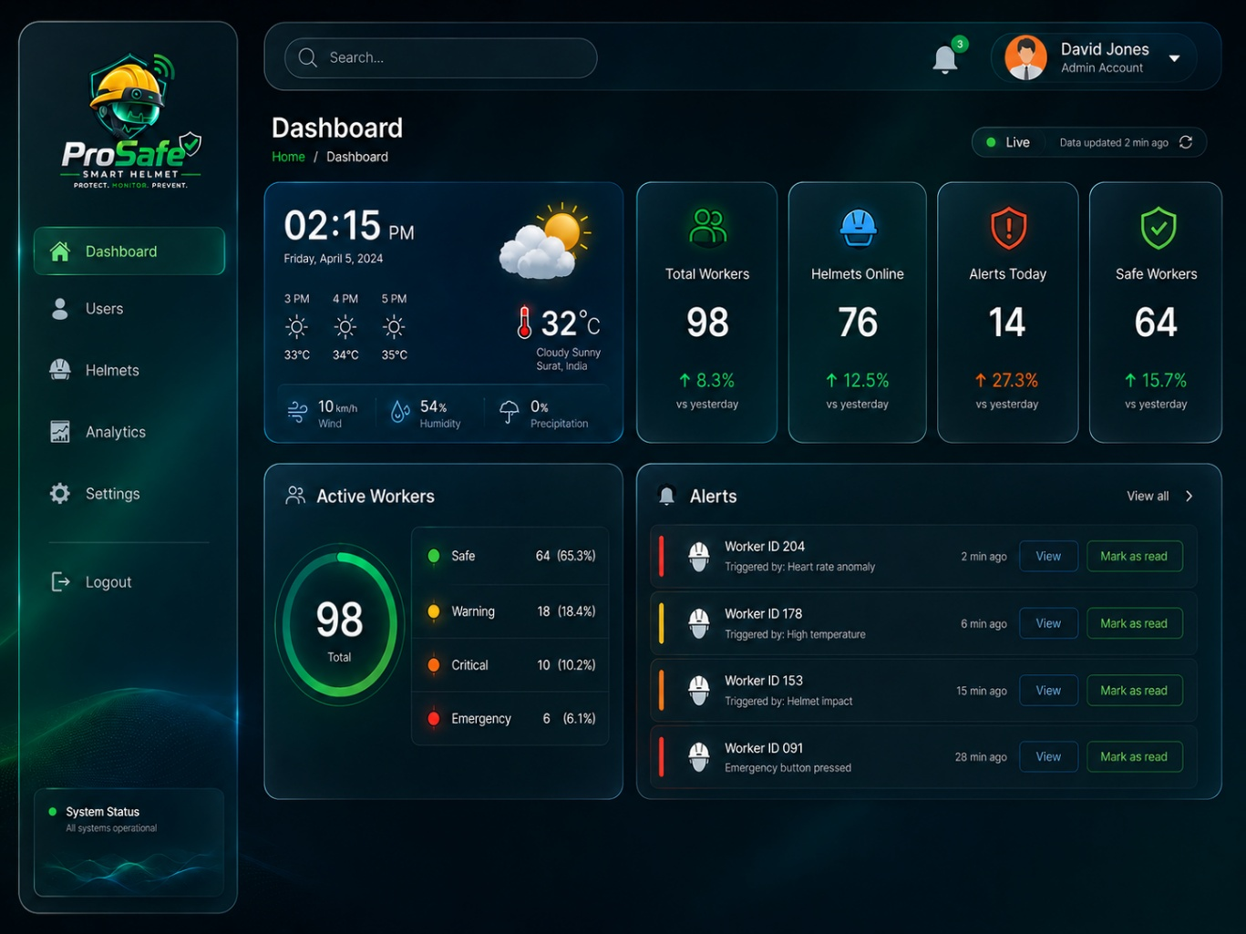
Source UI reference for Admin Dashboard / Home. The wireframe/screenshot defines content; the approved Dashboard visual language remains the style reference.
Requirement | Definition
Purpose | Provide administrators with the current operational picture: workers, helmets, safety states, alerts, weather and latest system activity.
Visibility | Admin only
Suggested route | /dashboard
Data authority | Backend is the source of truth. The frontend must not independently recalculate risk classifications or emergency state.

UI requirements
- Keep the approved dashboard shell and layout. Main widgets: weather, Total Workers, Helmets Online, Alerts Today, Safe Workers, Active Workers risk-state distribution and Alerts list.
- Total Workers should come from active worker accounts. Helmets Online should use backend online/offline logic based on last packet time.
- Active Workers distribution must use the authoritative current state: SAFE, WARNING, CRITICAL or EMERGENCY.
- Alerts list should show newest active/recent alerts with worker identity, trigger, time, severity indicator, View and Mark as read actions.
- The dashboard should expose the latest update timestamp and live connection state. Normal sensor state may change only as new backend packets are processed, while Emergency can appear immediately.
- Weather is separate from helmet sensor data. It can use a site/location-based weather provider and should be treated as informational context.

States and validation
- No active alerts: show a positive empty state, not a blank panel.
- Helmet offline: do not erase its last risk state. Show Offline/last seen distinctly.
- Worker in EMERGENCY: Emergency visually overrides the normal ML state in dashboard status.

Functions needed
Function | Type | Purpose | Suggested API / Trigger
getDashboardSummary() | Architecture | Aggregate counts and current worker/helmet status for dashboard cards. | GET /api/dashboard/summary
getActiveAlerts() | Architecture | Return active/open alerts, optionally paginated. | GET /api/alerts?status=open
getLatestWorkerStatus() | Architecture | Return the authoritative current worker state. | Dashboard aggregation
getLatestSensorReadings() | Architecture | Supply latest sensor context where shown in alert/dashboard detail. | Dashboard aggregation
checkHelmetOnlineStatus() | Architecture | Calculate Online/Offline from last packet timestamp. | Dashboard aggregation
acknowledgeAlert() | Architecture | Mark alert as read/acknowledged without resolving it. | PATCH /api/alerts/:id/acknowledge
getWeatherSummary() | Recommended | Fetch current weather for the configured site/location. | GET /api/weather
subscribeDashboardUpdates() | Recommended | Push state/alert changes to React without waiting for a manual refresh. | WebSocket/SSE

Minimum acceptance criteria
- A newly generated Warning/Critical alert appears without a full page reload when live transport is enabled.
- Emergency events appear immediately and are not delayed by the 60-second normal packet cycle.
- Dashboard counts and list items are derived from the same backend state and do not contradict each other.

7. Worker Dashboard / Home
Requirement | Definition
Purpose | Provide a simplified home view for a worker, limited to information relevant to that worker.
Visibility | Worker only
Suggested route | /dashboard
Data authority | Backend is the source of truth. The frontend must not independently recalculate risk classifications or emergency state.

UI requirements
- Use the same ProSafe shell but reduce navigation to Dashboard, User/My Profile, Settings and Logout.
- Per the source requirements, the main dashboard should show the weather card and alerts relevant to the logged-in worker only.
- Do not expose global worker counts, helmet fleet information, user management, analytics or other workers' alerts.
- Each worker alert may be opened to show its own details. Worker acknowledgement can be supported, but worker must not receive Emergency Reset authority unless the project explicitly changes the role policy.

Functions needed
Function | Type | Purpose | Suggested API / Trigger
getWorkerDashboard() | Recommended | Return worker-specific weather/context and own alerts in one payload. | GET /api/worker/dashboard
getActiveAlerts(workerId) | Architecture | Return only alerts belonging to the authenticated worker. | GET /api/alerts?mine=true
getLatestWorkerStatus() | Architecture | Return own current risk/emergency state if used on the worker dashboard. | Worker dashboard aggregation
getWeatherSummary() | Recommended | Provide weather context. | GET /api/weather

Minimum acceptance criteria
- A Worker cannot change the workerId in a request to retrieve another worker's data.
- Admin-only widgets and navigation are absent and backend-protected.

8. Account dropdown and Profile view
Requirement | Definition
Purpose | Allow the logged-in user to view account identity details and access logout/account actions.
Visibility | Logged-in Admin or Worker
Suggested route | Header dropdown / /account
Data authority | Backend is the source of truth. The frontend must not independently recalculate risk classifications or emergency state.

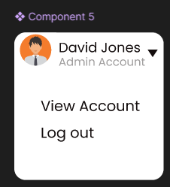  Figure reference: account dropdown | 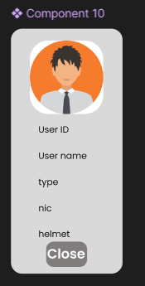  Figure reference: profile details

UI requirements
- Header dropdown shows the current user's avatar, name and account role, with View Account and Logout.
- Profile view/popup shows User ID, name, role/type, NIC, email, phone and helmet assignment state where relevant.
- Helmet field rules: Admin = Not applicable; Worker = assigned helmet ID or Not assigned.
- Profile view is read-only. Editing personal details belongs in Settings or the admin Edit User view depending on permissions.

Functions needed
Function | Type | Purpose | Suggested API / Trigger
getCurrentUserProfile() | Recommended | Return account details for the current logged-in user. | GET /api/me
getUserById() | Recommended | Admin variant for viewing another user's basic profile. | GET /api/users/:id
logout() | Backend | End the current session. | POST /api/auth/logout

Minimum acceptance criteria
- Profile never exposes password/hash.
- Worker can view only their own account from this flow.

9. Notifications and Alert popups
Requirement | Definition
Purpose | Surface risk-state events and emergencies, provide context, acknowledgement and authorized emergency reset.
Visibility | Admin; workers may see their own alert notifications
Suggested route | /alerts/:id or modal
Data authority | Backend is the source of truth. The frontend must not independently recalculate risk classifications or emergency state.

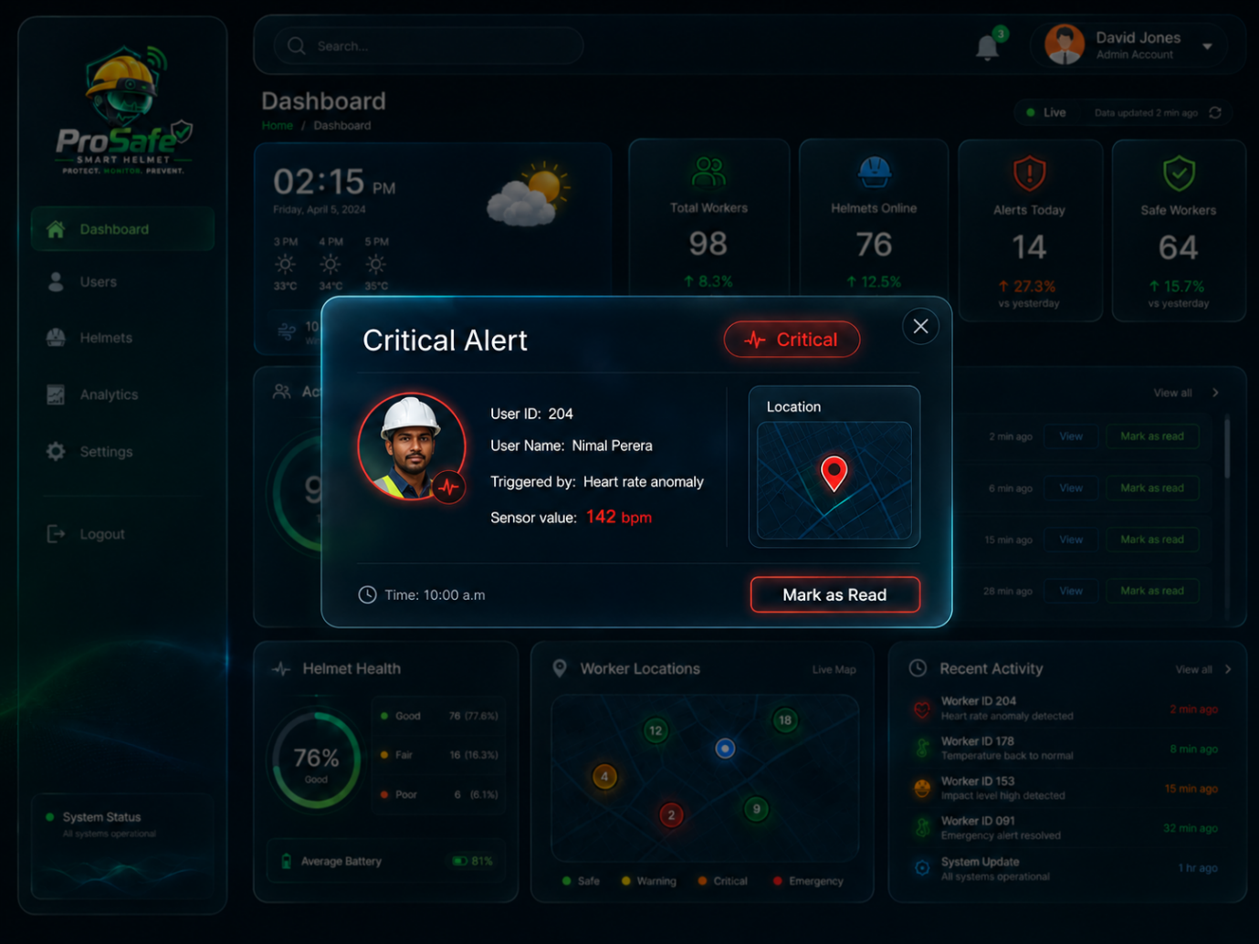  Critical alert reference | 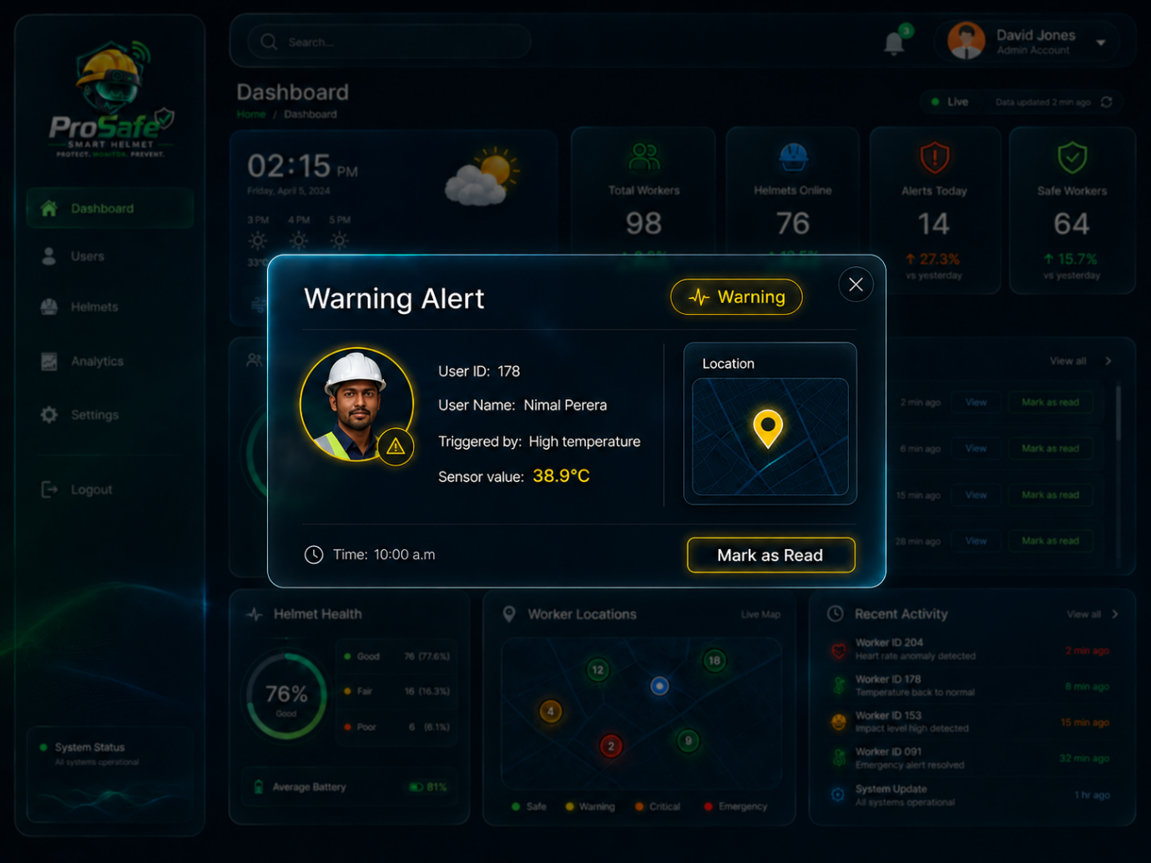  Warning alert reference | 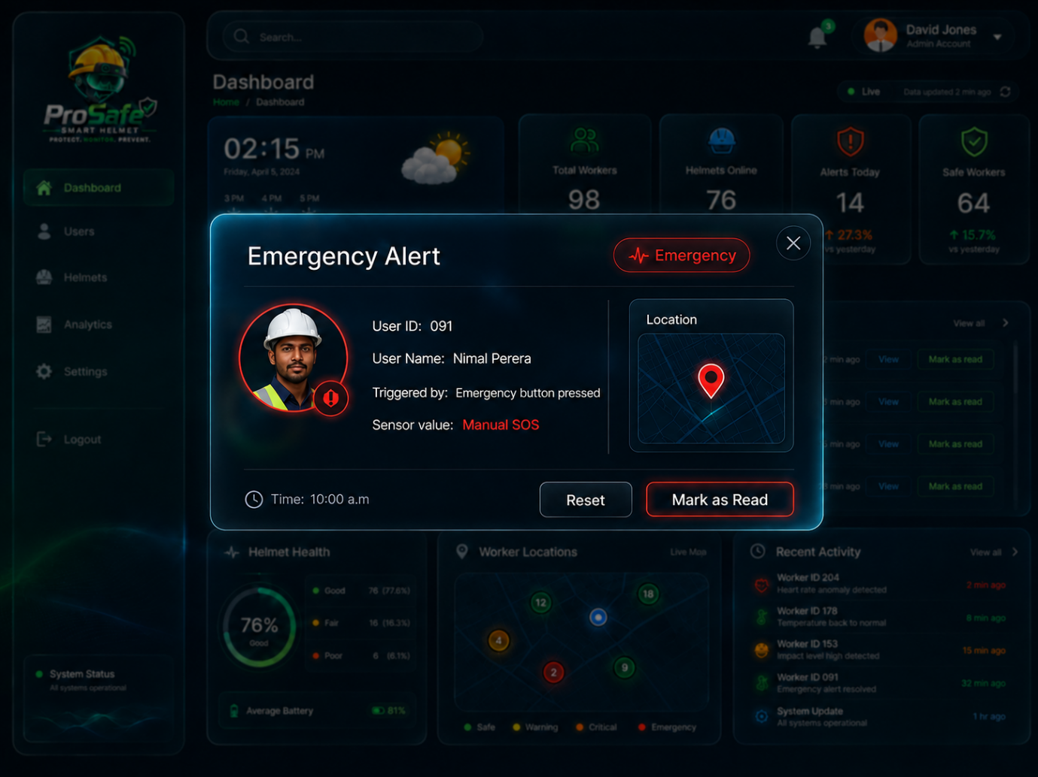  Emergency alert reference

UI requirements
- The alert modal overlays and darkens the current Dashboard, using the same dark glass/cyan edge style as existing ProSafe modals.
- Warning uses amber/yellow emphasis. Critical uses orange/red emphasis. Emergency uses strong red and must be visually unmistakable.
- Show alert severity, User ID, worker name, triggering condition, relevant sensor value(s), event time and map/location when valid GPS is available.
- Mark as Read maps to acknowledgement. It must not close or resolve the risk event.
- Emergency alert adds Reset Emergency. After click, show Reset requested / waiting for helmet confirmation until the backend confirms the emergency has cleared.
- Notification bell shows unread count and a dropdown/list of recent notifications. Clicking one should open the corresponding alert/user context.

States and validation
- Alert already resolved while modal is open: update modal to Resolved rather than leaving stale controls.
- GPS unavailable/stale: show Location unavailable / last known location with stale label instead of a fake pin.
- Emergency reset failed or helmet offline: keep Emergency active and explain that reset could not yet be confirmed.

Functions needed
Function | Type | Purpose | Suggested API / Trigger
getAlertById() | Recommended | Return full alert snapshot for the modal. | GET /api/alerts/:id
getActiveAlerts() | Architecture | Populate dashboard/notification lists. | GET /api/alerts
acknowledgeAlert() | Architecture | Record admin/worker acknowledgement. | PATCH /api/alerts/:id/acknowledge
resolveAlert() | Architecture | Backend lifecycle function when risk recovers to SAFE; normally not a direct UI action. | Risk pipeline
getWorkerLocation() | Architecture | Return latest valid/known location. | GET /api/workers/:id/location
getEmergencyState() | Architecture | Return current emergency lifecycle state. | GET /api/emergencies/:workerId
resetEmergency() | Architecture | Authorized supervisor action to issue emergency reset. | POST /api/emergencies/:workerId/reset
getNotifications() | Recommended | Return unread/recent notification items. | GET /api/notifications
markNotificationRead() | Recommended | Mark notification UI item read. | PATCH /api/notifications/:id/read

Minimum acceptance criteria
- Acknowledging an alert does not change worker SAFE/WARNING/CRITICAL/EMERGENCY state.
- Duplicate packets for an ongoing event do not create duplicate alert cards.
- Emergency remains active until backend lifecycle says it is cleared.

10. Users list
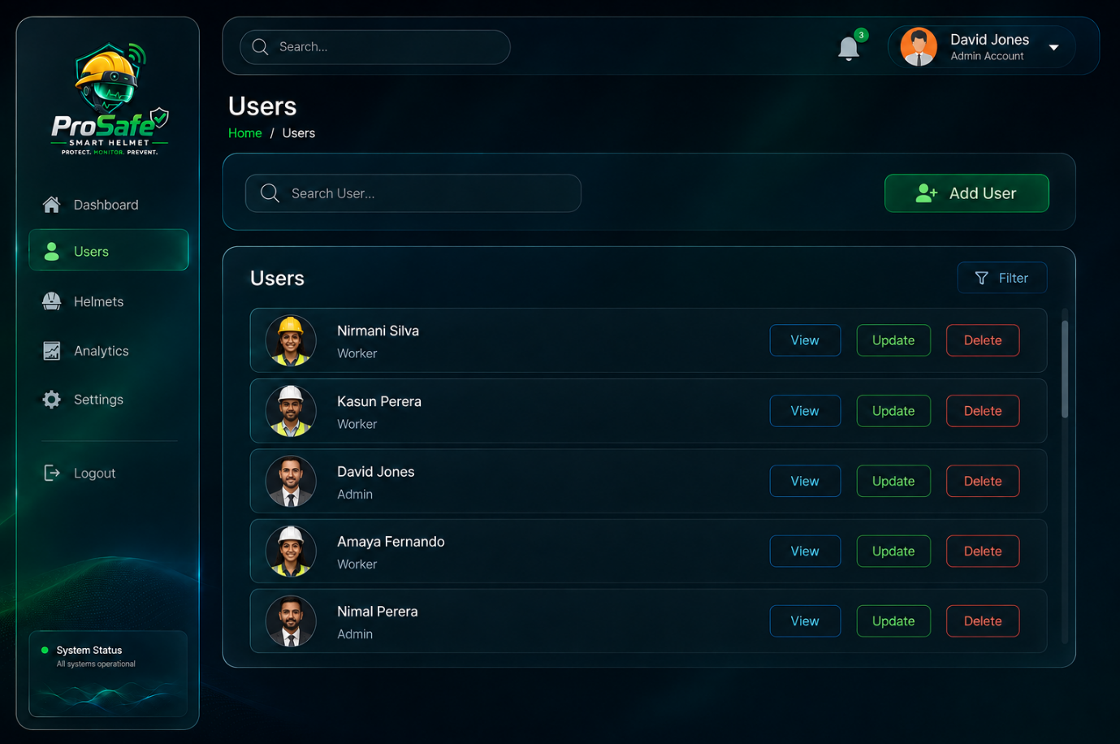
Source UI reference for Users list. The wireframe/screenshot defines content; the approved Dashboard visual language remains the style reference.
Requirement | Definition
Purpose | Allow administrators to search, filter and manage system users.
Visibility | Admin only
Suggested route | /users
Data authority | Backend is the source of truth. The frontend must not independently recalculate risk classifications or emergency state.

UI requirements
- List active users with avatar, name and role. Keep View, Update and Delete actions compact and consistent with the approved Users page.
- Search must support at least user name, user ID, email or NIC. Filter should support Role (Admin/Worker) and may optionally support helmet assignment state.
- Add User opens/navigates to the full Add User view.
- Pagination or virtual scrolling should be added when the dataset grows; the current visual can initially use a contained scroll area.
- Workers must not be able to open this list. Their User navigation goes directly to their own detail view.

Functions needed
Function | Type | Purpose | Suggested API / Trigger
getUsers(filters) | Recommended | Search/filter/paginate users for admin management. | GET /api/users
getUserById() | Recommended | Open View User. | GET /api/users/:id
createUser() | Recommended | Called by Add User. | POST /api/users
updateUser() | Recommended | Called by Edit User. | PATCH /api/users/:id
deleteOrDeactivateUser() | Recommended | Called after delete confirmation. | DELETE /api/users/:id

Minimum acceptance criteria
- Filtering and search can be combined.
- Delete action is never executed without confirmation.
- Role-based backend middleware denies access for Worker accounts.

11. User / Worker detail view
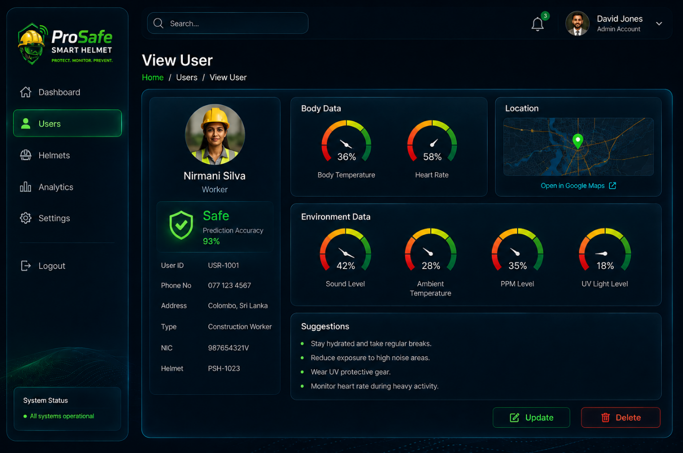
Source UI reference for User / Worker detail view. The wireframe/screenshot defines content; the approved Dashboard visual language remains the style reference.
Requirement | Definition
Purpose | Show identity information and, for workers with a helmet, the latest safety state, sensor readings, location, suggestions and drill-down views.
Visibility | Admin for any user; Worker for self only
Suggested route | /users/:id
Data authority | Backend is the source of truth. The frontend must not independently recalculate risk classifications or emergency state.

UI requirements
- Admin user record: show identity/profile data. Because Admin users are not helmet-assigned, do not show live helmet sensor panels for an Admin account.
- Worker with assigned helmet: show profile, assigned helmet ID, current safety state/prediction accuracy, Body Data, Environment Data, location and Suggestions.
- Worker without assigned helmet: show identity plus a clear No helmet assigned state. Do not display fabricated sensor cards.
- Body Data includes Body Temperature and Heart Rate. Environment Data includes Sound Level, Ambient Temperature, Gas/PPM and UV Light.
- The current screenshot uses gauges. For implementation, a compact value-first card is acceptable and may improve clarity: icon + current value + unit + state. Avoid percentages when the real sensor unit is °C, BPM, dB, ppm or UV index.
- Sensor labels are clickable and open the correct detail modal. Personalized physiological modals differ from environmental range-based modals.
- Suggestions should be short, actionable safety messages based on current conditions. Do not present them as medical diagnosis.
- Admin view shows Update/Delete. Worker self-view should be read-only here; personal account changes belong in Settings.
Recommendation engine: For the first implementation, use a deterministic rule/template mapping from backend triggering conditions and risk state to categories already named in the architecture, such as Hydration Reminder, Take Rest, Reduce Exposure and Seek Medical Attention. This is easier to validate than sending safety-critical sensor data to a general LLM. A model/API can be evaluated later.

Functions needed
Function | Type | Purpose | Suggested API / Trigger
getUserById() | Recommended | Return identity and role details. | GET /api/users/:id
getLatestWorkerStatus() | Architecture | Return SAFE/WARNING/CRITICAL/EMERGENCY and state-entered time. | GET /api/workers/:id/status
getLatestSensorReadings() | Architecture | Return latest valid processed readings. | GET /api/workers/:id/sensors/latest
getWorkerLocation() | Architecture | Return latest valid/stale-aware GPS. | GET /api/workers/:id/location
getWorkerBaseline() | Architecture | Provide HR/body-temperature baseline for personalized views. | GET /api/workers/:id/baseline
getLatestPrediction() | Recommended | Return latest model class, probabilities/confidence and model version. | GET /api/workers/:id/prediction/latest
generateSafetyRecommendation() | Architecture | Return recommendation based on current risk/conditions. | GET /api/workers/:id/recommendations
subscribeWorkerUpdates() | Recommended | Update sensor/state cards when new processed packets arrive. | WebSocket/SSE

Minimum acceptance criteria
- If the worker's latest sensor field is invalid, the UI shows unavailable rather than zero.
- Emergency state visually overrides the ML state while still allowing the latest ML prediction to remain stored in backend.
- Worker self-access cannot be changed to another user ID through URL manipulation.

12. Body Temperature detail popup
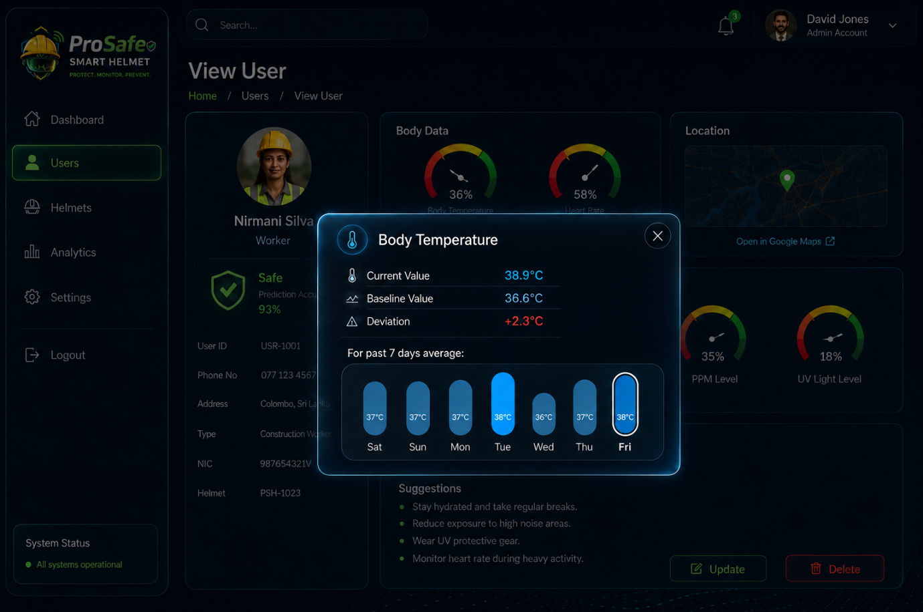
Source UI reference for Body Temperature detail popup. The wireframe/screenshot defines content; the approved Dashboard visual language remains the style reference.
Requirement | Definition
Purpose | Show personalized body-temperature details: current value, worker baseline, deviation and seven-day averages.
Visibility | Admin viewing a worker; Worker viewing self
Suggested route | Modal over /users/:id
Data authority | Backend is the source of truth. The frontend must not independently recalculate risk classifications or emergency state.

UI requirements
- Open when the user clicks the Body Temperature label from the Worker detail view. Keep the underlying View User page visible but darkened/disabled.
- Show Current Value in the real unit (°C), Baseline Value from the worker's personalized baseline and Deviation from the backend calculation.
- Show a seven-day daily-average visualization for valid readings. Each day's average must be calculated from valid stored readings only; missing days display N/A/gap rather than 0.
- Display the current timestamp/last updated time and a clear Normal/abnormal context if the backend provides one.
- Do not calculate the authoritative deviation in React. The backend should return the same deviation used by the processing pipeline.
- If the worker has no baseline yet, show Baseline not registered and Deviation unavailable rather than inventing a population baseline.

Functions needed
Function | Type | Purpose | Suggested API / Trigger
getLatestSensorReadings() | Architecture | Return current Body Temperature value. | GET /api/workers/:id/sensors/latest
getWorkerBaseline() | Architecture | Return personalized baseline used for Body Temperature. | GET /api/workers/:id/baseline
calculatePhysiologicalDeviations() | Architecture | Backend pipeline calculation; expose persisted/current result to UI. | Processing pipeline
getWorkerSensorHistory() | Architecture | Return historical valid readings for the selected sensor. | GET /api/workers/:id/sensors/body-temperature/history?days=7
getSensorDailyAverages() | Recommended | Aggregate valid readings into one average per calendar day. | History service

Minimum acceptance criteria
- Current value, baseline and deviation come from the same worker and same backend context.
- No baseline produces an explicit unavailable state.
- Seven-day chart labels all seven days and handles missing data honestly.

13. Heart Rate detail popup
Requirement | Definition
Purpose | Show personalized heart-rate details: current value, worker baseline, deviation and seven-day averages.
Visibility | Admin viewing a worker; Worker viewing self
Suggested route | Modal over /users/:id
Data authority | Backend is the source of truth. The frontend must not independently recalculate risk classifications or emergency state.

UI requirements
- Open when the user clicks the Heart Rate label from the Worker detail view. Keep the underlying View User page visible but darkened/disabled.
- Show Current Value in the real unit (BPM), Baseline Value from the worker's personalized baseline and Deviation from the backend calculation.
- Show a seven-day daily-average visualization for valid readings. Each day's average must be calculated from valid stored readings only; missing days display N/A/gap rather than 0.
- Display the current timestamp/last updated time and a clear Normal/abnormal context if the backend provides one.
- Do not calculate the authoritative deviation in React. The backend should return the same deviation used by the processing pipeline.
- If the worker has no baseline yet, show Baseline not registered and Deviation unavailable rather than inventing a population baseline.

Functions needed
Function | Type | Purpose | Suggested API / Trigger
getLatestSensorReadings() | Architecture | Return current Heart Rate value. | GET /api/workers/:id/sensors/latest
getWorkerBaseline() | Architecture | Return personalized baseline used for Heart Rate. | GET /api/workers/:id/baseline
calculatePhysiologicalDeviations() | Architecture | Backend pipeline calculation; expose persisted/current result to UI. | Processing pipeline
getWorkerSensorHistory() | Architecture | Return historical valid readings for the selected sensor. | GET /api/workers/:id/sensors/heart-rate/history?days=7
getSensorDailyAverages() | Recommended | Aggregate valid readings into one average per calendar day. | History service

Minimum acceptance criteria
- Current value, baseline and deviation come from the same worker and same backend context.
- No baseline produces an explicit unavailable state.
- Seven-day chart labels all seven days and handles missing data honestly.

14. Sound Level detail popup
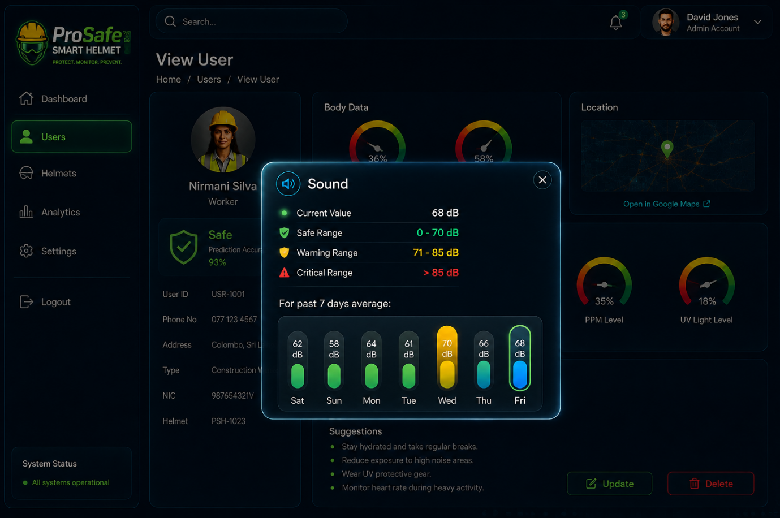
Source UI reference for Sound Level detail popup. The wireframe/screenshot defines content; the approved Dashboard visual language remains the style reference.
Requirement | Definition
Purpose | Show current environmental noise, configured safety ranges and seven-day daily averages.
Visibility | Admin viewing a worker; Worker viewing self
Suggested route | Modal over /users/:id
Data authority | Backend is the source of truth. The frontend must not independently recalculate risk classifications or emergency state.

UI requirements
- Open when the user clicks the Sound Level label from the Worker detail view. Keep the View User screen as a dimmed background.
- Show Current Value in dB, plus Safe, Warning and Critical ranges. These are environmental thresholds, not worker-specific baselines.
- The UI should preferably receive the backend classification/range labels rather than reimplement threshold logic locally, so UI and processing cannot drift apart.
- Show seven-day daily averages using valid processed readings. Missing data is shown as N/A.
- Color the current state using Safe green, Warning amber or Critical orange/red. Do not color every chart bar red/yellow/green if all readings are normal.
Range | Current architecture value
Safe | < 80 dB
Warning | 80-85 dB
Critical | 85-90 dB

Open threshold point: The current architecture table specifies Critical as 85-90 dB and does not explicitly state a separate band above 90 dB. The UI should display the backend classification and configured ranges rather than inventing its own rule. Confirm the final production threshold table before hard-coding labels.

Functions needed
Function | Type | Purpose | Suggested API / Trigger
getLatestSensorReadings() | Architecture | Return latest Sound Level value. | GET /api/workers/:id/sensors/latest
evaluateSoundLevelRange() | Architecture | Authoritative backend Safe/Warning/Critical classification. | Processing pipeline
getWorkerSensorHistory() | Architecture | Return historical Sound Level readings. | GET /api/workers/:id/sensors/history?type=sound-level&days=7
getSensorDailyAverages() | Recommended | Return one valid-reading average for each day. | History service
getConfiguredEnvironmentalRanges() | Recommended | Expose the currently configured labels/ranges for display. | GET /api/config/environmental-ranges

Minimum acceptance criteria
- No worker baseline is shown in environmental popups.
- Displayed state matches backend classification.
- Seven-day values are valid-data averages, not one arbitrary reading per day.

15. Ambient Temperature detail popup
Requirement | Definition
Purpose | Show current ambient temperature, configured environmental ranges and seven-day daily averages.
Visibility | Admin viewing a worker; Worker viewing self
Suggested route | Modal over /users/:id
Data authority | Backend is the source of truth. The frontend must not independently recalculate risk classifications or emergency state.

UI requirements
- Open when the user clicks the Ambient Temperature label from the Worker detail view. Keep the View User screen as a dimmed background.
- Show Current Value in °C, plus Safe, Warning and Critical ranges. These are environmental thresholds, not worker-specific baselines.
- The UI should preferably receive the backend classification/range labels rather than reimplement threshold logic locally, so UI and processing cannot drift apart.
- Show seven-day daily averages using valid processed readings. Missing data is shown as N/A.
- Color the current state using Safe green, Warning amber or Critical orange/red. Do not color every chart bar red/yellow/green if all readings are normal.
Range | Current architecture value
Safe | < 27 °C
Warning | 27-35 °C
Critical | > 35 °C

Functions needed
Function | Type | Purpose | Suggested API / Trigger
getLatestSensorReadings() | Architecture | Return latest Ambient Temperature value. | GET /api/workers/:id/sensors/latest
evaluateAmbientTemperatureRange() | Architecture | Authoritative backend Safe/Warning/Critical classification. | Processing pipeline
getWorkerSensorHistory() | Architecture | Return historical Ambient Temperature readings. | GET /api/workers/:id/sensors/history?type=ambient-temperature&days=7
getSensorDailyAverages() | Recommended | Return one valid-reading average for each day. | History service
getConfiguredEnvironmentalRanges() | Recommended | Expose the currently configured labels/ranges for display. | GET /api/config/environmental-ranges

Minimum acceptance criteria
- No worker baseline is shown in environmental popups.
- Displayed state matches backend classification.
- Seven-day values are valid-data averages, not one arbitrary reading per day.

16. Gas / PPM detail popup
Requirement | Definition
Purpose | Show current MQ2 gas/smoke concentration, configured ranges and seven-day daily averages.
Visibility | Admin viewing a worker; Worker viewing self
Suggested route | Modal over /users/:id
Data authority | Backend is the source of truth. The frontend must not independently recalculate risk classifications or emergency state.

UI requirements
- Open when the user clicks the Gas / PPM label from the Worker detail view. Keep the View User screen as a dimmed background.
- Show Current Value in ppm, plus Safe, Warning and Critical ranges. These are environmental thresholds, not worker-specific baselines.
- The UI should preferably receive the backend classification/range labels rather than reimplement threshold logic locally, so UI and processing cannot drift apart.
- Show seven-day daily averages using valid processed readings. Missing data is shown as N/A.
- Color the current state using Safe green, Warning amber or Critical orange/red. Do not color every chart bar red/yellow/green if all readings are normal.
Range | Current architecture value
Safe | < 150 ppm
Warning | 150-300 ppm
Critical | > 300 ppm

Functions needed
Function | Type | Purpose | Suggested API / Trigger
getLatestSensorReadings() | Architecture | Return latest Gas / PPM value. | GET /api/workers/:id/sensors/latest
evaluateGasPPMRange() | Architecture | Authoritative backend Safe/Warning/Critical classification. | Processing pipeline
getWorkerSensorHistory() | Architecture | Return historical Gas / PPM readings. | GET /api/workers/:id/sensors/history?type=gas-/-ppm&days=7
getSensorDailyAverages() | Recommended | Return one valid-reading average for each day. | History service
getConfiguredEnvironmentalRanges() | Recommended | Expose the currently configured labels/ranges for display. | GET /api/config/environmental-ranges

Minimum acceptance criteria
- No worker baseline is shown in environmental popups.
- Displayed state matches backend classification.
- Seven-day values are valid-data averages, not one arbitrary reading per day.

17. UV Light detail popup
Requirement | Definition
Purpose | Show current UV index, configured ranges and seven-day daily averages.
Visibility | Admin viewing a worker; Worker viewing self
Suggested route | Modal over /users/:id
Data authority | Backend is the source of truth. The frontend must not independently recalculate risk classifications or emergency state.

UI requirements
- Open when the user clicks the UV Light label from the Worker detail view. Keep the View User screen as a dimmed background.
- Show Current Value in UV index, plus Safe, Warning and Critical ranges. These are environmental thresholds, not worker-specific baselines.
- The UI should preferably receive the backend classification/range labels rather than reimplement threshold logic locally, so UI and processing cannot drift apart.
- Show seven-day daily averages using valid processed readings. Missing data is shown as N/A.
- Color the current state using Safe green, Warning amber or Critical orange/red. Do not color every chart bar red/yellow/green if all readings are normal.
Range | Current architecture value
Safe | < 3 UV index
Warning | 3-8 UV index
Critical | > 8 UV index

Functions needed
Function | Type | Purpose | Suggested API / Trigger
getLatestSensorReadings() | Architecture | Return latest UV Light value. | GET /api/workers/:id/sensors/latest
evaluateUVLightRange() | Architecture | Authoritative backend Safe/Warning/Critical classification. | Processing pipeline
getWorkerSensorHistory() | Architecture | Return historical UV Light readings. | GET /api/workers/:id/sensors/history?type=uv-light&days=7
getSensorDailyAverages() | Recommended | Return one valid-reading average for each day. | History service
getConfiguredEnvironmentalRanges() | Recommended | Expose the currently configured labels/ranges for display. | GET /api/config/environmental-ranges

Minimum acceptance criteria
- No worker baseline is shown in environmental popups.
- Displayed state matches backend classification.
- Seven-day values are valid-data averages, not one arbitrary reading per day.

18. Safety Prediction detail popup
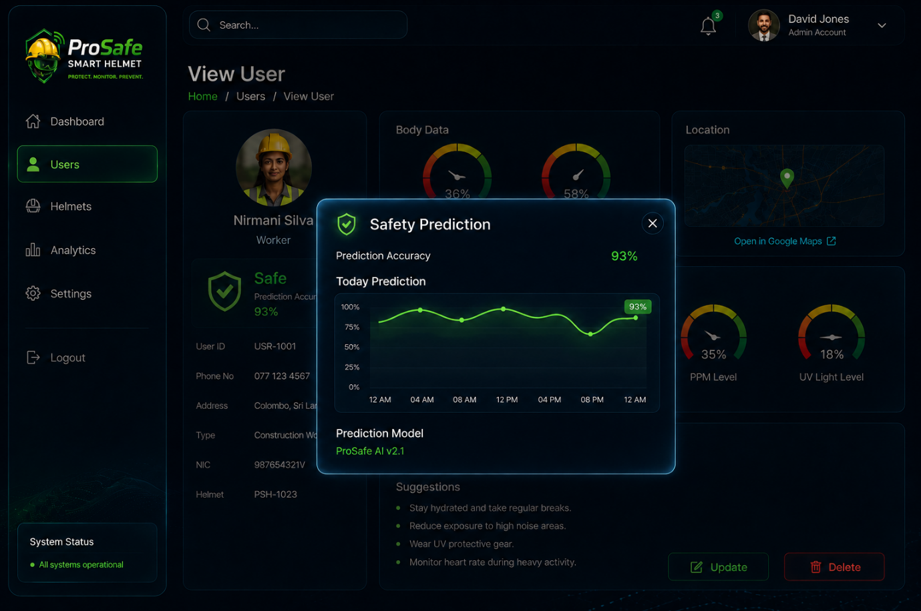
Source UI reference for Safety Prediction detail popup. The wireframe/screenshot defines content; the approved Dashboard visual language remains the style reference.
Requirement | Definition
Purpose | Explain the current ML prediction context and show how accepted prediction confidence/state has changed through the day.
Visibility | Admin viewing worker; Worker viewing self
Suggested route | Modal over /users/:id
Data authority | Backend is the source of truth. The frontend must not independently recalculate risk classifications or emergency state.

UI requirements
- Open when the safety prediction/status card is selected on the Worker detail page.
- Show current accepted prediction state and Prediction Accuracy/Confidence from the latest accepted model output.
- Show a Today Prediction trend. Recommended chart: x-axis = time, y-axis = accepted prediction confidence 0-100%; color each point/segment by the predicted state (Safe/Warning/Critical).
- An optional advanced view may plot all three class probabilities, but the primary view should stay readable.
- Show Prediction Model name/version from Model / Version Metadata. The current architecture identifies XGBoost as the selected model.
- Emergency is not an ML prediction. If Emergency is active, show an Emergency override note rather than pretending the model predicted EMERGENCY.

Functions needed
Function | Type | Purpose | Suggested API / Trigger
getLatestPrediction() | Recommended | Return latest class, probabilities, accepted confidence and model version. | GET /api/workers/:id/prediction/latest
getPredictionHistory() | Recommended | Return today's accepted prediction history for charting. | GET /api/workers/:id/predictions?range=today
storePrediction() | Architecture | Persist class/probabilities for smoothing and history. | Processing pipeline
smoothPredictions() | Architecture | Produce stable final state from accepted predictions. | Processing pipeline
getLatestWorkerStatus() | Architecture | Return final worker state shown outside the modal. | GET /api/workers/:id/status

Minimum acceptance criteria
- Chart does not claim Emergency is a model class.
- Prediction confidence is not displayed as sensor accuracy or sensor quality.
- Model version is available for traceability if more than one model artifact is deployed.

19. Add User
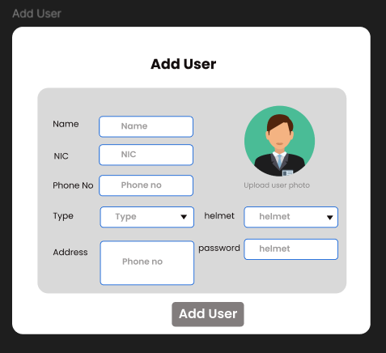
Source UI reference for Add User. The wireframe/screenshot defines content; the approved Dashboard visual language remains the style reference.
Requirement | Definition
Purpose | Create an Admin or Worker account and optionally assign an available helmet to a Worker.
Visibility | Admin only
Suggested route | /users/new
Data authority | Backend is the source of truth. The frontend must not independently recalculate risk classifications or emergency state.

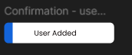
Source success-toast reference. Use the current ProSafe toast style rather than the wireframe styling.

UI requirements
- Use the full approved application shell. The source wireframe defines the form only, not a new page style.
- Required fields: Name, Email, NIC, Phone Number, Role/Type, Address and Password. Photo upload is optional unless the implementation requires it.
- Helmet field is conditional: visible/enabled for Worker, hidden or Not applicable for Admin. The dropdown must contain only available/unassigned helmets.
- User ID is backend-generated or controlled by a consistent server-side ID policy, not manually typed unless the project explicitly requires manual IDs.
- After successful creation, show a success toast and navigate to the new user or Users list. On failure, retain entered safe form data and show field-specific errors.
Recommended worker onboarding: Creating a Worker account and creating a physiological baseline are separate concerns. After worker creation, show Baseline status: Pending until supervised baseline capture is completed. Do not silently create a baseline from arbitrary first readings.

Functions needed
Function | Type | Purpose | Suggested API / Trigger
createUser() | Recommended | Validate and create Admin/Worker account; hash password; enforce unique identifiers. | POST /api/users
getAvailableHelmets() | Recommended | Return helmets not currently assigned to another worker. | GET /api/helmets?assignment=unassigned
assignHelmetToWorker() | Recommended | Create/update one active worker<->helmet assignment. | POST /api/users/:id/helmet-assignment
uploadUserPhoto() | Optional | Store user avatar/photo if supported. | POST /api/users/:id/photo
validateUserUniqueness() | Recommended | Check email/NIC/user ID uniqueness server-side. | Inside createUser()

States and validation
- Role changes in form: switching to Admin clears/disables any selected helmet.
- No helmets available: allow Worker creation without assignment and show No available helmets.
- Duplicate email/NIC: show field-specific validation failure.

Minimum acceptance criteria
- Passwords are never stored or logged in plain text.
- Admin account cannot be assigned a helmet.
- Only unassigned helmets are selectable.

20. Edit User
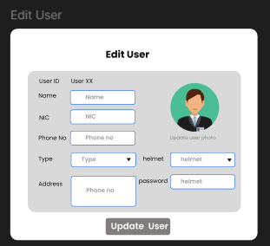
Source UI reference for Edit User. The wireframe/screenshot defines content; the approved Dashboard visual language remains the style reference.
Requirement | Definition
Purpose | Update an existing user while protecting immutable IDs, role rules, helmet assignments and historical safety data.
Visibility | Admin only
Suggested route | /users/:id/edit
Data authority | Backend is the source of truth. The frontend must not independently recalculate risk classifications or emergency state.

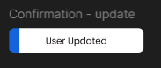
Source update-toast reference.

UI requirements
- Pre-fill editable fields using current server data: Name, Email, NIC, Phone, Address, Role and helmet assignment where applicable.
- User ID is read-only.
- Password is never pre-filled. Provide an optional Reset/Change password action if needed.
- Changing helmet assignment must unassign the previous helmet and assign the new helmet atomically so a helmet cannot be assigned to two workers.
- Changing Worker to Admin must require confirmation and remove any active helmet assignment. Consider restricting role changes if historical/account rules make them unsafe.
- Show success/failure toast after update.

Functions needed
Function | Type | Purpose | Suggested API / Trigger
getUserById() | Recommended | Load form data. | GET /api/users/:id
updateUser() | Recommended | Persist editable identity/account fields. | PATCH /api/users/:id
changeHelmetAssignment() | Recommended | Atomically update worker<->helmet assignment. | PATCH /api/users/:id/helmet-assignment
resetUserPassword() | Optional | Set temporary password/reset flow without exposing existing password. | POST /api/users/:id/password-reset

Minimum acceptance criteria
- Helmet assignment remains one-to-one.
- Role transition cannot leave a helmet assigned to an Admin.
- Historical alerts/readings stay associated with the historical worker record.

21. Delete User
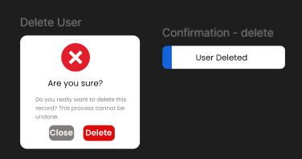
Source UI reference for Delete User. The wireframe/screenshot defines content; the approved Dashboard visual language remains the style reference.
Requirement | Definition
Purpose | Confirm and perform user account removal/deactivation without destroying required historical safety/audit records.
Visibility | Admin only
Suggested route | Confirmation modal
Data authority | Backend is the source of truth. The frontend must not independently recalculate risk classifications or emergency state.

UI requirements
- Open a dark ProSafe confirmation modal over the current page. Show the user's name/ID so the administrator can confirm the correct record.
- Explain the effect before deletion. Do not provide only a generic Are you sure? message.
- If the user has an assigned helmet, the delete/deactivate transaction must release that active assignment.
- After success, show a toast and remove the user from the active Users list.
Recommended data policy: Use soft delete/deactivation for user accounts so historical sensor readings, alerts, predictions and audit records remain traceable. Hard-deleting all related safety history would undermine the architecture's audit/reprocessing goals.

Functions needed
Function | Type | Purpose | Suggested API / Trigger
deleteOrDeactivateUser() | Recommended | Disable/remove user account while preserving required history. | DELETE /api/users/:id
unassignHelmet() | Recommended | Release active helmet assignment as part of delete transaction. | Inside delete operation
revokeUserSessions() | Recommended | Terminate active sessions for a deleted/deactivated user. | Inside delete operation

Minimum acceptance criteria
- Deleted/deactivated account cannot log in.
- Historical safety records remain queryable for authorized audit/analytics use.
- Assigned helmet becomes available after successful deletion/deactivation.

22. Helmets list
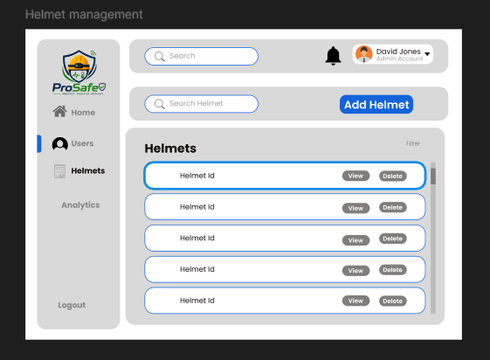
Source UI reference for Helmets list. The wireframe/screenshot defines content; the approved Dashboard visual language remains the style reference.
Requirement | Definition
Purpose | List registered helmets, assignment state and operational status for administrators.
Visibility | Admin only
Suggested route | /helmets
Data authority | Backend is the source of truth. The frontend must not independently recalculate risk classifications or emergency state.

UI requirements
- Use the approved ProSafe shell, not the gray wireframe styling.
- List Helmet ID as the primary field. Also show Assignment (worker name or Unassigned), Online/Offline and Last Seen because these are directly supported by the processing architecture and are operationally useful.
- Actions: View and Delete. Add Helmet is a primary action. Assignment can remain managed through Worker Add/Edit unless a separate assignment action is later desired.
- Search by Helmet ID and optionally assigned worker.

Functions needed
Function | Type | Purpose | Suggested API / Trigger
getHelmets(filters) | Recommended | Return registered helmets with assignment and last-seen/online state. | GET /api/helmets
checkHelmetOnlineStatus() | Architecture | Compute online/offline from packet reception time. | Helmet list aggregation
getHelmetById() | Recommended | Open helmet detail modal. | GET /api/helmets/:id
createHelmet() | Recommended | Register new helmetId. | POST /api/helmets
deleteOrDeactivateHelmet() | Recommended | Remove/deactivate after dependency checks. | DELETE /api/helmets/:id

Minimum acceptance criteria
- Unknown/unregistered helmet packets are rejected by backend ingestion.
- Online/offline is based on server last-received packet state, not a frontend timer alone.

23. Add Helmet
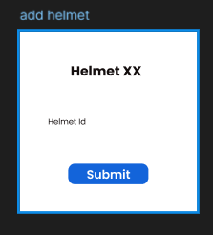
Source UI reference for Add Helmet. The wireframe/screenshot defines content; the approved Dashboard visual language remains the style reference.
Requirement | Definition
Purpose | Register a new helmet so the backend recognizes its helmetId and can later assign it to a worker.
Visibility | Admin only
Suggested route | Modal over /helmets
Data authority | Backend is the source of truth. The frontend must not independently recalculate risk classifications or emergency state.

UI requirements
- Modal contains Helmet ID as the only required manual input, matching the source requirement.
- Created At is assigned automatically by the backend. Initial assignment is Unassigned. Initial online state is Offline until a valid packet is received.
- Validate allowed ID format and uniqueness before creation. Use the ProSafe ID convention consistently, e.g. PS-H-001.
- Show success/failure toast after Submit.

Functions needed
Function | Type | Purpose | Suggested API / Trigger
createHelmet() | Recommended | Register helmet ID and metadata. | POST /api/helmets
validateHelmetId() | Recommended | Validate format and uniqueness. | Inside createHelmet()

Minimum acceptance criteria
- Duplicate helmet ID is rejected.
- Newly created helmet appears in the list as Unassigned and Offline until telemetry arrives.

24. View Helmet
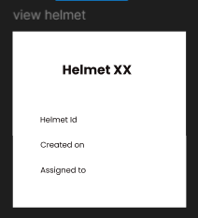
Source UI reference for View Helmet. The wireframe/screenshot defines content; the approved Dashboard visual language remains the style reference.
Requirement | Definition
Purpose | Show registered helmet identity, assignment and current operational status in a modal.
Visibility | Admin only
Suggested route | Modal over /helmets
Data authority | Backend is the source of truth. The frontend must not independently recalculate risk classifications or emergency state.

UI requirements
- Show Helmet ID, Created On and Assigned To as required by the wireframe.
- Recommended additions: Online/Offline, Last Seen and current desired LED state. These are already available in the architecture and materially help operations.
- If unassigned, show Unassigned clearly. If never seen, show Last seen: Never.

Functions needed
Function | Type | Purpose | Suggested API / Trigger
getHelmetById() | Recommended | Return helmet registration and assignment metadata. | GET /api/helmets/:id
checkHelmetOnlineStatus() | Architecture | Return operational connectivity state. | Helmet detail aggregation
getDesiredHelmetLEDState() | Architecture | Return current backend-desired LED state when displayed. | Helmet detail aggregation

Minimum acceptance criteria
- View modal is read-only.
- Assignment displayed matches the same backend assignment table used to validate incoming packets.

25. Delete Helmet
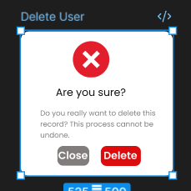
Source UI reference for Delete Helmet. The wireframe/screenshot defines content; the approved Dashboard visual language remains the style reference.
Requirement | Definition
Purpose | Confirm removal/deactivation of a helmet while protecting assignment and historical data integrity.
Visibility | Admin only
Suggested route | Confirmation modal
Data authority | Backend is the source of truth. The frontend must not independently recalculate risk classifications or emergency state.

UI requirements
- Show Helmet ID and assignment status in the confirmation.
- If the helmet is currently assigned, either block deletion until it is unassigned or explicitly unassign within one controlled transaction. Blocking is safer for the first implementation.
- Preserve historical packet/readings/alerts that reference the helmet for auditability.
- Show success/failure toast.
Recommended deletion rule: Do not hard-delete a helmet with historical telemetry. Deactivate the helmet registry record and prevent future packet acceptance, while keeping historical foreign-key references intact.

Functions needed
Function | Type | Purpose | Suggested API / Trigger
deleteOrDeactivateHelmet() | Recommended | Deactivate helmet after assignment/dependency checks. | DELETE /api/helmets/:id
getHelmetAssignment() | Recommended | Verify the helmet is unassigned before destructive action. | Delete pre-check

Minimum acceptance criteria
- Assigned helmet cannot disappear silently from a worker record.
- Packets from a deactivated helmet are rejected/logged as unregistered/inactive.

26. Analytics
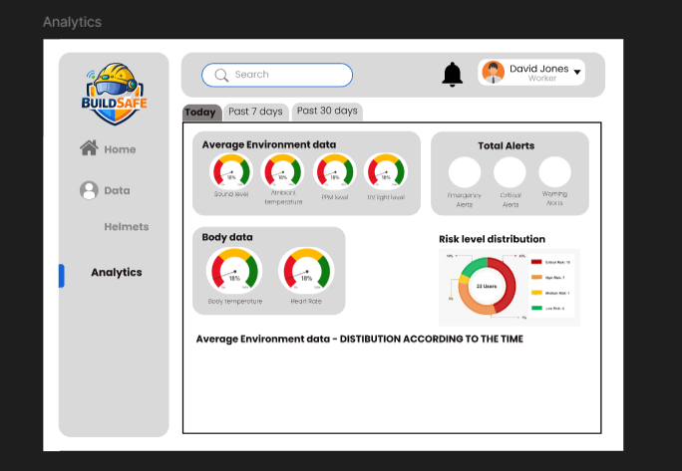
Source UI reference for Analytics. The wireframe/screenshot defines content; the approved Dashboard visual language remains the style reference.
Requirement | Definition
Purpose | Turn stored safety data into meaningful trends for supervisors, with filters and downloadable reports.
Visibility | Admin only
Suggested route | /analytics
Data authority | Backend is the source of truth. The frontend must not independently recalculate risk classifications or emergency state.

UI requirements
- Use Today / Past 7 Days / Past 30 Days / Custom date range filters. Every chart and KPI must use the same active range.
- Top KPIs: Total Alerts, Warning/Critical/Emergency counts, affected workers, Safe Worker rate and Helmet Online rate.
- Risk State Distribution: current or time-range distribution of SAFE/WARNING/CRITICAL/EMERGENCY.
- Alert Trend: alerts over time, stacked/split by severity.
- Environmental Trends: ambient temperature, noise, gas/PPM and UV. Use aggregates based on valid readings only.
- Physiological analytics should emphasize personalized deviation percentages rather than comparing raw heart rate/body temperature across workers as if everyone has the same normal.
- Exposure Analytics: total/average time in warning/critical environmental bands can be shown because exposure-duration state is tracked in the backend, but label it as exposure analytics, not an ML feature.
- Top Hazard Sources: rank the conditions most often contributing to alerts (heat, noise, gas, UV, physiological deviation).
- Worker Risk Summary: workers with the most Warning/Critical/Emergency events in the selected period, with drill-down to User View.
- Helmet Connectivity: online/offline count and helmets with repeated missing-packet periods.
- Download selected analytics as CSV and a human-readable PDF/report. Export must include the selected date range and generated timestamp.

States and validation
- No data for selected period: show No data for this period, not zero-filled misleading charts.
- Partial sensor validity: aggregates exclude invalid values and may display sample count/coverage.
- Large time ranges: aggregate on backend rather than sending every raw packet to the browser.

Functions needed
Function | Type | Purpose | Suggested API / Trigger
getAnalyticsSummary() | Recommended | Return KPI values for selected range. | GET /api/analytics/summary
getAlertTrend() | Recommended | Aggregate alerts by time and severity. | GET /api/analytics/alerts
getRiskStateDistribution() | Recommended | Return state distribution. | GET /api/analytics/risk-distribution
getSensorTrendAggregates() | Recommended | Aggregate valid environmental/physiological data. | GET /api/analytics/sensors
getExposureAnalytics() | Recommended | Aggregate exposure-duration state/history. | GET /api/analytics/exposure
getWorkerRiskRanking() | Recommended | Rank workers by significant events for drill-down. | GET /api/analytics/workers
getHelmetConnectivityAnalytics() | Recommended | Summarize online/offline and missing-packet history. | GET /api/analytics/helmets
exportAnalyticsReport() | Recommended | Generate CSV/PDF export from the same server-side query definition. | GET /api/analytics/export
getWorkerSensorHistory() | Architecture | Underlying historical readings source. | Analytics service
getActiveAlerts() | Architecture | Underlying alert data source, extended to historical queries. | Analytics service

Minimum acceptance criteria
- All analytics respect selected date range and role permissions.
- Raw invalid sensor values are excluded rather than interpreted as zero.
- Exported data matches the filters visible on screen.

27. Settings
Requirement | Definition
Purpose | Provide account/security/notification preferences without exposing safety-critical configuration casually.
Visibility | Admin and Worker
Suggested route | /settings
Data authority | Backend is the source of truth. The frontend must not independently recalculate risk classifications or emergency state.

Source gap: The source UI document contains only the Settings heading and does not define its contents. The following is a recommended minimal implementation so the navigation item is functional without turning it into a large system-administration module.

UI requirements
- Profile: avatar/photo, display name, email and phone where the user's role permits self-editing.
- Security: change password; show active session information if sessions are tracked centrally; provide Logout all other sessions if implemented.
- Notifications: in-app notification preferences and optional email/push preferences only for channels that are actually implemented.
- Admin may see a read-only System Information block: active ML model version, expected packet interval and backend status. Do not expose these as editable controls by default.
- Do not make occupational thresholds, model confidence threshold or emergency behavior casually editable in the normal Settings page. Those are safety-critical configuration decisions requiring project validation and audit controls.

Functions needed
Function | Type | Purpose | Suggested API / Trigger
getMySettings() | Recommended | Return current account/preferences. | GET /api/me/settings
updateMyProfile() | Recommended | Update self-editable account details. | PATCH /api/me/profile
changePassword() | Recommended | Verify current password and set a new hash. | POST /api/me/change-password
getActiveSessions() | Recommended | List current account sessions/devices when centralized sessions are used. | GET /api/me/sessions
revokeSession() | Recommended | Invalidate a selected session. | DELETE /api/me/sessions/:id
getNotificationPreferences() | Recommended | Return notification preferences. | GET /api/me/notification-preferences
updateNotificationPreferences() | Recommended | Persist preferences for implemented channels. | PATCH /api/me/notification-preferences
getSystemStatus() | Recommended | Admin read-only operational metadata. | GET /api/system/status

Minimum acceptance criteria
- Worker settings cannot change role, helmet assignment or another user's record.
- Password change invalidates/revokes sessions according to the chosen security policy.

28. Cross-cutting backend/API requirements

28.1 Recommended API response shape
Use a consistent envelope so React can handle success, validation errors and server errors predictably. A typical response can contain: success, data, message, errors and serverTimestamp. Sensor payloads should keep value, unit, valid, timestamp and classification where relevant.

28.2 Real-time updates
- Normal monitoring data originates from 60-second helmet packets and changes after backend processing.
- Emergency packets bypass the 60-second schedule and must be pushed to the UI immediately.
- Use one event stream/channel for alert/state changes rather than opening separate sockets per card.
- When the live connection is lost, show Disconnected/Reconnecting and continue to display last-known data with its timestamp.

28.3 Session and authorization
- All protected APIs require an authenticated session/token.
- Admin-only endpoints require role middleware.
- Self-service Worker endpoints resolve worker identity from the authenticated session instead of trusting a workerId supplied by the browser.
- Use secure, HttpOnly cookies for session/refresh credentials where possible in the MERN deployment model. Avoid storing long-lived sensitive tokens in localStorage.

28.4 Data consistency and audit
- Frontend never rewrites risk state from sensor thresholds. It displays backend classification and state.
- CRUD actions that change helmet assignment should be transactional/atomic.
- User and helmet deletion should preserve historical safety records through soft-delete/deactivation.
- Every alert acknowledgement and emergency reset should record the acting user and timestamp.
- Historical chart queries must ignore readings explicitly marked invalid.

28.5 Data mapping for UI developers
UI field | Backend source
Current risk card | Current Worker Risk State / Emergency State
Prediction accuracy/confidence | Latest accepted Prediction
Body temperature / HR current | Processed Sensor Reading
Body temperature / HR baseline | Worker Baseline
Body temperature / HR deviation | Calculated/Persisted physiological deviation
Environmental state labels | Backend environmental range evaluators
7-day averages | Processed Sensor Reading history aggregated by day
Location | GPS / Location record with stale validity
Suggestions | generateSafetyRecommendation() output
Alert modal | Alerts + sensor snapshot + location
Helmet online/offline | Last packet timestamp via checkHelmetOnlineStatus()
Safety Prediction graph | Prediction History + Model/Version Metadata

29. Backend function catalog
The following catalog combines backend functions already defined in the Processing Architecture with UI-facing functions required by the views in this guide. Architecture functions should retain their existing behavior; UI-specific functions can be thin controllers/services that compose those lower-level functions.
Function | Source | Primary responsibility
receiveSensorPacket() | Architecture | Ingest helmet packet.
validatePacketSchema() | Architecture | Validate packet structure.
validateSensorValues() | Architecture | Server-side field validation.
resolveHelmetWorker() | Architecture | Validate helmet<->worker assignment.
storeRawSensorReading() | Architecture | Persist raw packet.
getWorkerBaseline() | Architecture | Retrieve HR/body-temperature baseline.
calculateHeartRateDeviation() | Architecture | Calculate personalized HR deviation.
calculateBodyTemperatureDeviation() | Architecture | Calculate personalized temperature deviation.
calculatePhysiologicalDeviations() | Architecture | Orchestrate physiological deviation calculations.
evaluateAmbientTemperatureRange() | Architecture | Classify ambient temperature.
evaluateNoiseRange() | Architecture | Classify sound/noise.
evaluateGasRange() | Architecture | Classify gas/PPM.
evaluateUVRange() | Architecture | Classify UV.
getExposureState() | Architecture | Load timer state.
updateNoiseExposureDuration() | Architecture | Update noise exposure timer.
updateTemperatureExposureDuration() | Architecture | Update ambient-temperature exposure timer.
updateGasExposureDuration() | Architecture | Update gas exposure timer.
updateUVExposureDuration() | Architecture | Update UV exposure timer.
updatePhysiologicalAbnormalDuration() | Architecture | Update physiological abnormal-duration timer.
resetOrPauseExposureTimer() | Architecture | Shared timer hysteresis helper.
generateFeatureVector() | Architecture | Assemble the current 10-feature model input.
loadMLModel() | Architecture | Load model artifact/version.
runRiskPrediction() | Architecture | Perform XGBoost inference.
checkPredictionConfidence() | Architecture | Accept/reject low-confidence prediction.
storePrediction() | Architecture | Persist class/probabilities.
smoothPredictions() | Architecture | Prediction smoothing.
determineFinalRiskState() | Architecture | Determine final stable state.
getPreviousRiskState() | Architecture | Load stored worker state.
detectRiskStateChange() | Architecture | Detect transition type.
updateWorkerRiskState() | Architecture | Persist current state.
createAlert() | Architecture | Create a new risk alert.
updateAlert() | Architecture | Update ongoing alert.
acknowledgeAlert() | Architecture | Record acknowledgement/read.
resolveAlert() | Architecture | Close alert after recovery.
getActiveAlerts() | Architecture | Read active alerts.
getLatestWorkerStatus() | Architecture | Read current state.
getLatestSensorReadings() | Architecture | Read latest processed sensor values.
getWorkerSensorHistory() | Architecture | Read historical readings.
getWorkerLocation() | Architecture | Read latest GPS.
getDashboardSummary() | Architecture | Aggregate dashboard data.
sendLEDCommand() | Architecture | Issue LED state.
getDesiredHelmetLEDState() | Architecture | Read desired LED state.
handleHelmetCommandAcknowledgement() | Architecture | Record helmet LED apply confirmation.
receiveEmergencyPacket() | Architecture | Emergency ingestion.
activateEmergencyState() | Architecture | Activate emergency.
getEmergencyState() | Architecture | Read emergency status.
resetEmergency() | Architecture | Issue authorized reset.
getEmergencyResetCommand() | Architecture | Serve helmet reset poll.
clearEmergencyState() | Architecture | Finalize emergency reset.
generateSafetyRecommendation() | Architecture | Generate rule-based safety recommendation category/text.
checkHelmetOnlineStatus() | Architecture | Evaluate online/offline.
handleMissingPackets() | Architecture | Pause exposure timers on missing telemetry.
logProcessingError() | Architecture | Central structured error/audit logging.

29.2 UI/API functions to add
Function group | Purpose
login(), logout(), getCurrentSession() | Authentication/session lifecycle
requestPasswordReset() | Optional forgot-password workflow
getUsers(), getUserById(), createUser(), updateUser(), deleteOrDeactivateUser() | User CRUD
getAvailableHelmets(), assignHelmetToWorker(), changeHelmetAssignment(), unassignHelmet() | Worker/helmet assignment
getHelmets(), getHelmetById(), createHelmet(), deleteOrDeactivateHelmet() | Helmet management
getLatestPrediction(), getPredictionHistory() | Safety Prediction popup
getSensorDailyAverages() | Seven-day sensor popups
getConfiguredEnvironmentalRanges() | Keep UI range labels synchronized with backend configuration
getAlertById() | Full alert modal data
getNotifications(), markNotificationRead() | Notification-bell UI
getWeatherSummary() | Weather card integration
subscribeDashboardUpdates(), subscribeWorkerUpdates() | Real-time push to browser
getAnalyticsSummary(), getAlertTrend(), getRiskStateDistribution() | Analytics summary/trends
getSensorTrendAggregates(), getExposureAnalytics(), getWorkerRiskRanking() | Analytics deeper views
getHelmetConnectivityAnalytics(), exportAnalyticsReport() | Connectivity analytics and report export
getMySettings(), updateMyProfile(), changePassword() | Settings/account
getActiveSessions(), revokeSession() | Session management
getNotificationPreferences(), updateNotificationPreferences() | Notification preferences
getSystemStatus() | System Status/read-only admin operational data

30. Implementation priorities and open decisions

30.1 Recommended implementation order
- Authentication, sessions and backend RBAC.
- Core User and Helmet database models plus one-to-one active assignment logic.
- Helmet packet ingestion and current-state processing pipeline from the Processing Architecture.
- Admin Dashboard with live alerts/state counts.
- Users list + User View + sensor-history popups.
- Alerts acknowledgement and Emergency Reset lifecycle.
- User/Helmet CRUD views and toast/error states.
- Worker Dashboard and self-only access.
- Analytics aggregation/export.
- Settings and optional notification channels.

30.2 Open/confirm before production
- Final environmental threshold configuration, especially the Sound Critical range above 90 dB.
- Numeric CONFIDENCE_THRESHOLD for accepting predictions.
- Exact prediction smoothing queue size within the documented 3-5 range.
- Exact backend-to-helmet LED command delivery mechanism.
- Whether optional email/SMS/push notifications are in the MVP.
- Whether worker baseline registration receives a dedicated UI flow or is handled through a separate supervised process.
- Exact weather provider/site location configuration.
- Whether user/helmet deletion is formally soft-delete/deactivation (recommended) or hard delete.
- The full Settings page scope, because it was not specified in the source UI document.
Implementation principle: If a UI requirement conflicts with the Processing Architecture, keep the processing/backend rule authoritative and adjust the UI. The browser should describe and operate the safety system, not become a second independent decision engine.

