COMMON COURSE ASSIGNMENT — STUDENT SUBMISSION
Formal Modelling and Verification of Smart Kiosk Control Logic and Recharge-Code Validity using Automata Theory

Assignment Information
Particular | Details
Department | Computer Science and Engineering(Artificial Intelligence)
Programme | B. Tech CSE(AI)
Course Code & Course Name | CSA1308 — Theory of Computation
Academic Year / Batch | 4th year / 2023
Faculty Name | Dr G. Kumaresan
Assignment Title | Formal Modelling and Verification of Smart Kiosk Control Logic and Recharge-Code Validity using Automata Theory
Date of Issue
Date of Submission
Maximum Marks | 100
Course Outcome(s) – CO | CO1: Apply formal proofs, induction and automata foundations. CO2: Design DFA/NFA/ε-NFA and prove equivalence. CO3: Construct regular expressions and apply the Pumping Lemma and closure properties.
Bloom's Taxonomy Level | L3 – Apply; L4 – Analyse; L5 – Evaluate
SDG Mapping (SDG 1–17) | SDG 4 – Quality Education; SDG 9 – Industry, Innovation and Infrastructure; SDG 12 – Responsible Consumption and Production
Industry / Societal Relevance | Deterministic finite-state control is the industry-standard technique for safety-critical embedded controllers (vending, ATM, ticketing, access-control kiosks); formal validation of recharge/voucher codes prevents fraud and stock loss.

Assignment Problem / Challenge
A campus is developing a Smart Vending and Card-Recharge Kiosk. The kiosk must accept money, allow users to select products, dispense items, return change, and validate recharge-card codes. Using Automata Theory, the kiosk's control logic and its recharge-code validation logic are modelled, converted between equivalent representations, proved correct, and analysed for non-regular fault patterns and multi-vendor combination, exactly as required by the three task groups below.

Task Group 1 — Kiosk Control System
- Design a DFA for the kiosk states: Idle, Coin Inserted, Item Selected, Dispensing, Change Return, and Error.
- Design an NFA and an ε-NFA for the same system.
- Convert the NFA/ε-NFA into an equivalent DFA using subset construction.
- Show that the DFA, NFA, and ε-NFA recognise the same language.

Task Group 2 — Recharge-Card Code Validation
- Define a suitable pattern for valid recharge-card codes using A–Z and 0–9.
- Write a regular expression for the valid codes.
- Construct a finite automaton for the regular expression.
- Use the Pumping Lemma to show that a specified language of arbitrarily long faulty card codes is not regular.
- Use closure properties such as union, concatenation, and complement to analyse the combination of two vendors' card-code formats.

Task Group 3 — Verification and Application
- Provide mathematical proofs to show that the designed DFA correctly accepts valid kiosk operations and card codes.
- Use induction, where appropriate, to prove the correctness of the automaton.
- Briefly explain how automata help in developing predictable and reliable embedded software for real-world systems.

Requirements and Constraints
Requirements and constraints identified as relevant to this problem (irrelevant categories such as manufacturability or civil/structural codes are omitted):
Category | Relevant requirement / constraint for this problem
Functional | Accept coins, allow item selection, dispense the item, return correct change, validate recharge-card codes, and recover from faults via reset.
Technical | Control logic must be expressible as a finite-state machine so it can be implemented on resource-constrained embedded hardware (microcontroller, no dynamic memory for unbounded state).
Reliability | The controller must have a totally-defined transition for every state–event pair (no undefined behaviour) and must be recoverable from any fault state.
Performance | Input validation (recharge codes) must be checkable in a single left-to-right scan, i.e. in linear time — motivating a regular-language / finite-automaton solution rather than a more expressive but slower grammar class.
Security / Privacy | Recharge-card codes must follow a fixed, checkable format so malformed or fraudulent codes are rejected before any value is credited.
Standards / Codes | State-machine specification style follows the standard formal 5-tuple (Q, Σ, δ, q0, F) used in automata theory and adopted in embedded-systems design (e.g., UML state-machine / IEC 61131-3 style controllers).

Student Work

Problem Understanding and Formulation
What is the problem? Model the operational lifecycle of the kiosk and the format of its recharge-card codes using finite automata, so that the control logic is provably deterministic and total, and the code-validation logic is provably regular, checkable in linear time, and correctly composable across vendors.
Expected outcomes: (a) a DFA, NFA and ε-NFA for the kiosk lifecycle, proved language-equivalent via subset construction; (b) a regular expression and equivalent automaton for valid recharge codes; (c) a Pumping-Lemma proof that a specified faulty-code language is not regular; (d) a closure-property analysis combining two vendors' code formats; (e) inductive correctness proofs for both automata; and (f) a short account of why automata theory supports reliable embedded software.
Information available: the six named kiosk states (Idle, Coin Inserted, Item Selected, Dispensing, Change Return, Error) and the alphabet restriction A–Z, 0–9 for recharge codes, as given in the problem statement.
Assumptions made:
- The kiosk processes one coin-acceptance event at a time (multiple coins are modelled as repeated 'coin' events), one item selection, one dispense, and one change-return per transaction cycle.
- A manual 'reset' event is available from every state as a recovery/override action (kiosks provide a physical or software reset).
- Any event that is out of sequence, or an explicit fault signal, is treated as an 'invalid' event that drives the system to the Error state.
- The recharge-card code alphabet A–Z, 0–9 is instantiated as a fixed 9-character format (2 vendor letters + 6-digit serial + 1 alphanumeric check character); the assignment states only the character set, so a concrete length/pattern is defined here as a reasonable, checkable design choice.
Constraints to satisfy: totality and determinism of the control automaton (every state must have a defined next state for every event, for safe embedded deployment); linear-time recognisability of recharge codes; and recoverability from the Error state.

Application of Course Knowledge
The following automata-theory principles from CSA1308 are applied:
- Deterministic and non-deterministic finite automata (DFA, NFA) and automata with ε-moves (ε-NFA) — Q, Σ, δ, q0, F formalism.
- The Rabin–Scott subset (powerset) construction and ε-closure, used to convert the ε-NFA into an equivalent DFA.
- Kleene's theorem (equivalence of regular expressions and finite automata), used to move from the recharge-code regular expression to an automaton.
- The Pumping Lemma for regular languages, used to prove non-regularity of an unbounded faulty-code language.
- Closure properties of regular languages (union, concatenation, intersection, complement), used to combine two vendors' code formats.
- Mathematical induction (weak/structural induction on string length), used to prove automaton correctness.

Solution / Design / Methodology

1. Kiosk Control System — Event Alphabet
Define the input alphabet Σ = {c, s, d, g, r, x}, representing physical/sensor events:
Symbol | Meaning
c | Coin inserted
s | Item selected
d | Dispense command executed
g | Change given (physically returned)
r | Manual reset
x | Invalid / fault event (sensor fault, jam, counterfeit coin, out-of-sequence input, etc.)

1.1 DFA Design
Formal definition M = (Q, Σ, δ, q0, F):
- Q = {Idle, CoinInserted, ItemSelected, Dispensing, ChangeReturn, Error}
- Σ = {c, s, d, g, r, x}
- q0 = Idle
- F = {ChangeReturn}
δ is total (every state has an outgoing edge for every symbol in Σ), which is required for a well-formed DFA and for a hardware controller that must never enter an undefined configuration:
δ | c | s | d | g | r | x
Idle | CoinInserted | Error | Error | Error | Idle | Error
CoinInserted | CoinInserted | ItemSelected | Error | Error | Idle | Error
ItemSelected | Error | Error | Dispensing | Error | Idle | Error
Dispensing | Error | Error | Error | ChangeReturn | Idle | Error
ChangeReturn | Error | Error | Error | Error | Idle | Error
Error | Error | Error | Error | Error | Idle | Error
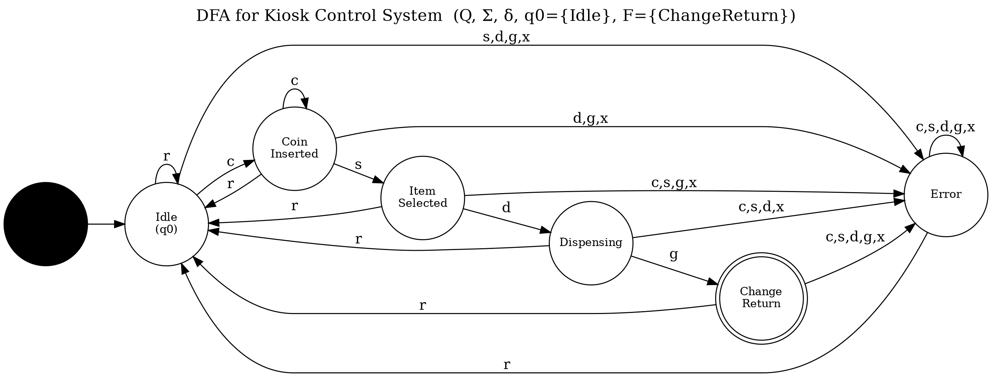
Figure 1: DFA for the Kiosk Control System (double circle = accepting state ChangeReturn)
Language accepted: L(DFA) = { w ∈ Σ* : δ*(Idle, w) = ChangeReturn }, i.e. exactly the legal, fault-free event sequences that carry the kiosk from Idle through a complete purchase cycle ending at Change Return.

1.2 NFA Design
Real kiosks exhibit genuine non-determinism: the diagnostic subsystem may flag an item-selection signal as either a normal selection or a possible sensor fault requiring maintenance, without the controller being able to decide which, based on the input symbol alone. This is modelled by allowing two possible successors for the same (state, symbol) pair:
N = (Q′, Σ, δ′, q0, F), where Q′ = Q ∪ {Maintenance} and δ′(CoinInserted, s) = {ItemSelected, Maintenance} (non-deterministic choice).
δ′ | c | s | x | r | d / g
Idle | {CoinInserted} | ∅ | {Error} | - | ∅
CoinInserted | {CoinInserted} | {ItemSelected, Maintenance} | {Error} | - | ∅
ItemSelected | ∅ | ∅ | {Error} | - | {Dispensing} (on d)
Dispensing | ∅ | ∅ | {Error} | - | {ChangeReturn} (on g)
ChangeReturn / Maintenance / Error | ∅ | ∅ | - | {Idle} | ∅
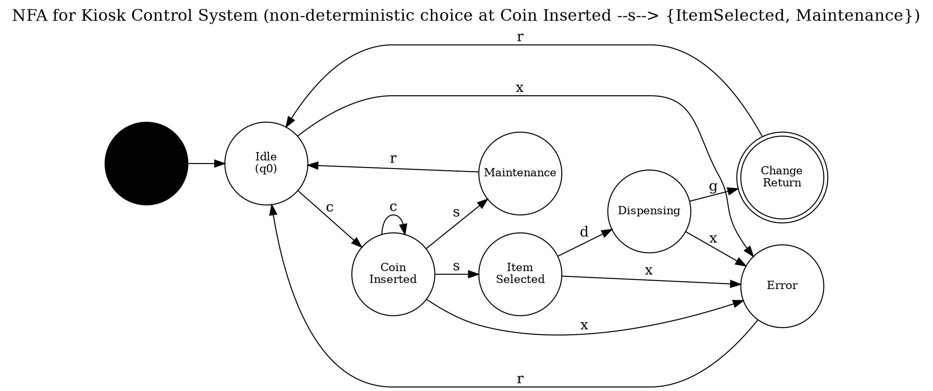
Figure 2: NFA for the Kiosk Control System — the Maintenance branch introduces genuine non-determinism at CoinInserted on symbol s

1.3 ε-NFA Design
Some kiosk transitions are event-less in practice: once change has been physically returned, the controller auto-resets to Idle after a watchdog timeout without waiting for an explicit reset button-press, and similarly the Error state auto-recovers to Idle after a fixed timeout. These are naturally modelled as ε-moves (transitions consumed without reading an input symbol), while the Maintenance branch still requires a human technician's manual reset:
- δ″(ChangeReturn, ε) = {Idle} — automatic post-transaction reset
- δ″(Error, ε) = {Idle} — automatic fault-timeout recovery
- δ″(Maintenance, r) = {Idle} — still requires a manual technician reset (no ε-move)
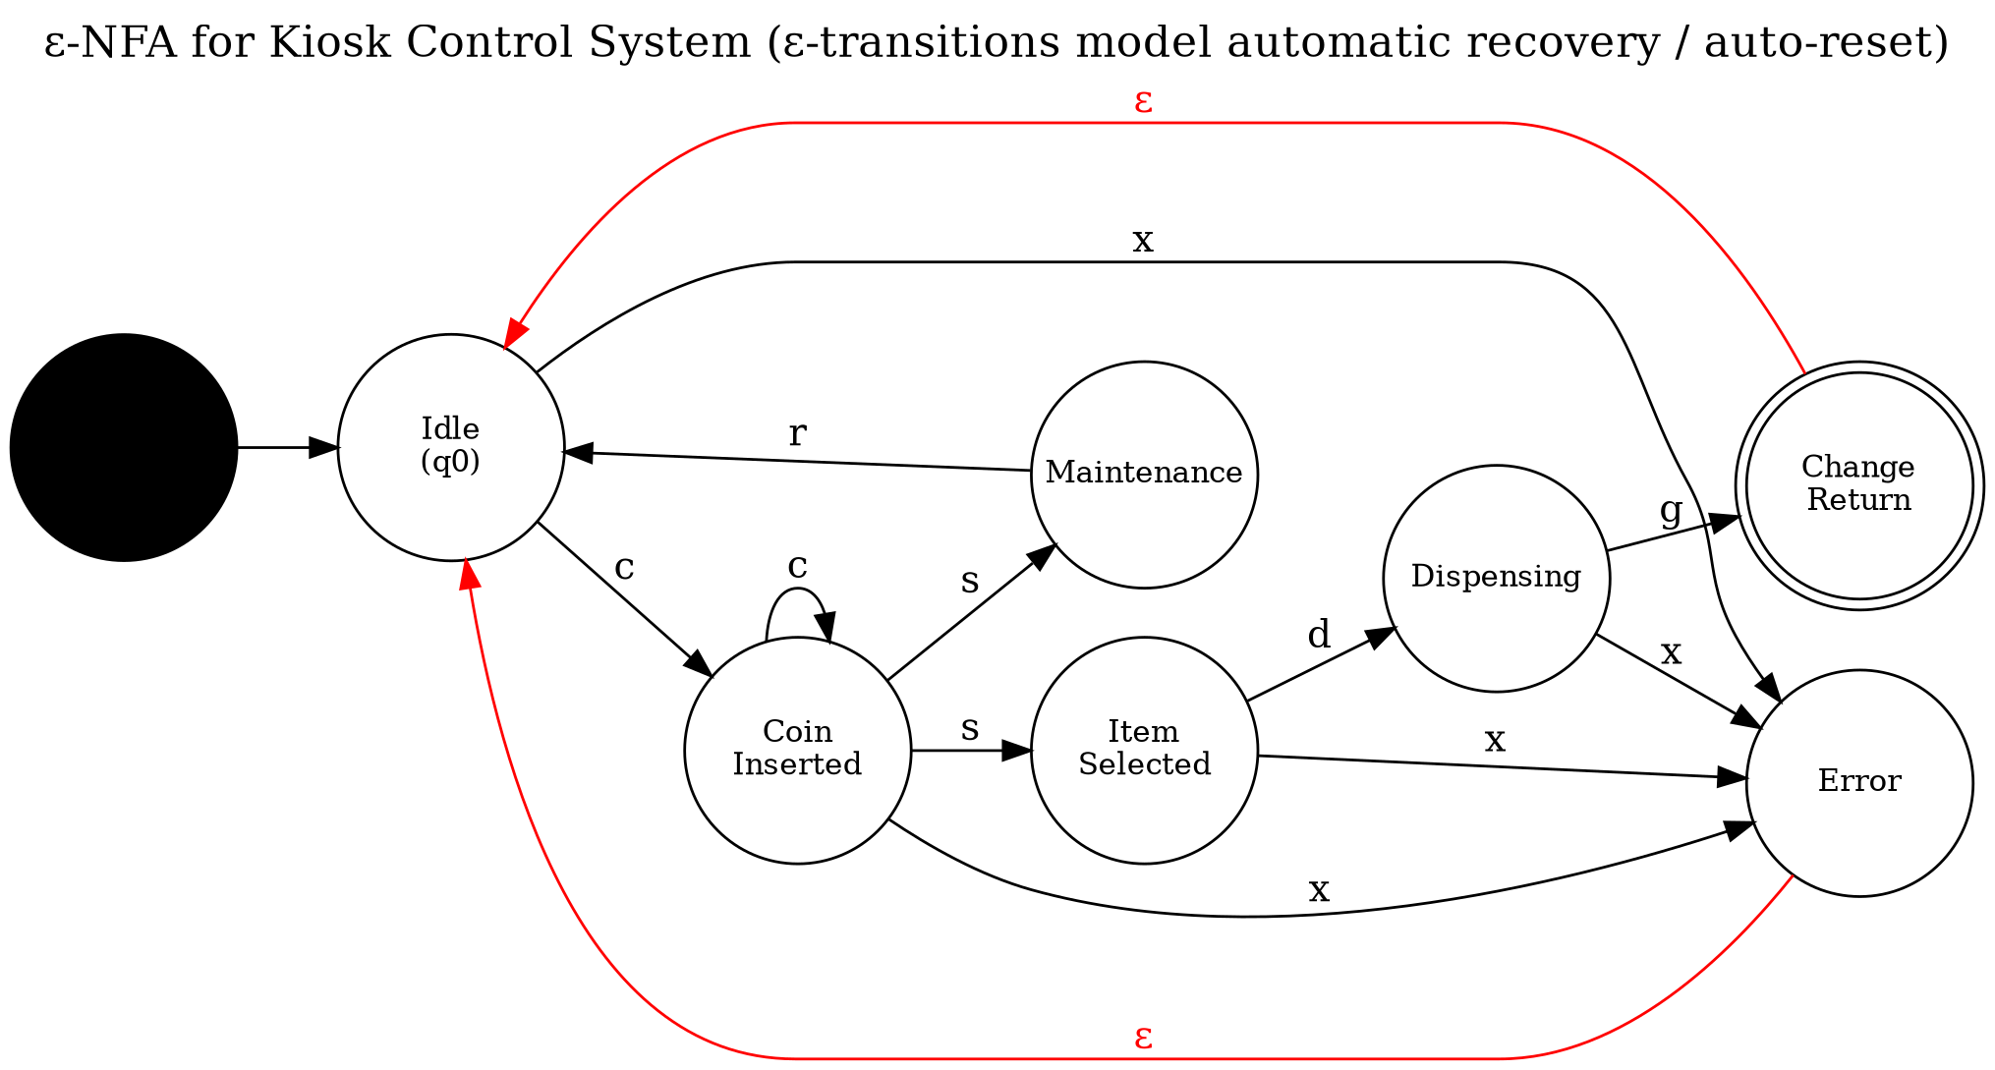
Figure 3: ε-NFA for the Kiosk Control System (red edges are ε-moves modelling automatic recovery)

1.4 Subset Construction: ε-NFA → DFA
ε-closures of each state (ECLOSE(q) = q together with every state reachable purely by ε-moves):
State q | ECLOSE(q)
Idle (q0) | {Idle}
CoinInserted (q1) | {CoinInserted}
ItemSelected (q2) | {ItemSelected}
Dispensing (q3) | {Dispensing}
ChangeReturn (q4) | {ChangeReturn, Idle} (ε-move to Idle)
Maintenance (qM) | {Maintenance}
Error (qe) | {Error, Idle} (ε-move to Idle)
Applying the standard subset-construction algorithm (start state = ECLOSE(q0); repeatedly compute ECLOSE(⋃ δ(q,a)) for each reachable subset and symbol) produces the following equivalent DFA D′ = (Q_sub, Σ, δ_sub, S0, {S5}):
Subset state |  | NFA states it represents
S0 (start) |  | {Idle}
S1 |  | {CoinInserted}
S2 |  | {Idle, Error}
S3 |  | {ItemSelected, Maintenance}
S4 |  | {Dispensing}
S5 (accepting) |  | {Idle, ChangeReturn}
δ_sub | c |  | s | d | g | x / r
S0 | S1 |  | - | - | - | S2 (on x)
S1 | S1 |  | S3 | - | - | S2 (on x)
S2 | S1 |  | - | - | - | S0 (on r)
S3 | - |  | - | S4 | - | S2 (on x) / S0 (on r)
S4 | - |  | - | - | S5 | S2 (on x)
S5 | S1 |  | - | - | - | S2 (on x)
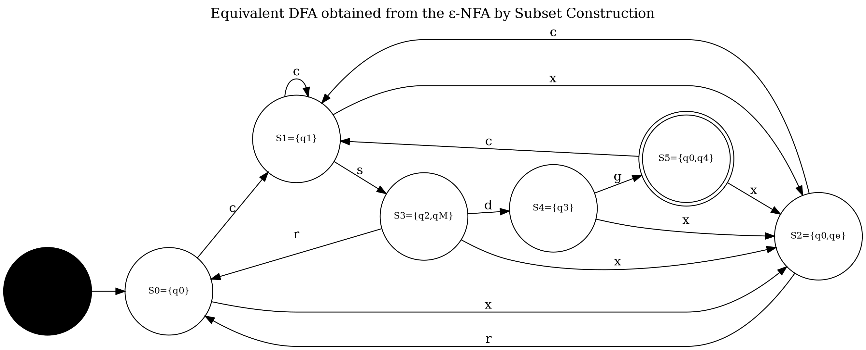
Figure 4: Equivalent DFA obtained from the ε-NFA by subset construction
Observe that S0↔Idle, S1↔CoinInserted, S3↔ItemSelected(+Maintenance folded in), S4↔Dispensing, S5↔{Idle,ChangeReturn} and S2↔{Idle,Error}: the mechanically-derived DFA is structurally isomorphic to the hand-designed DFA of Section 1.1, which independently cross-checks the correctness of both designs.

1.5 Equivalence of the DFA, NFA and ε-NFA
Theorem (Rabin–Scott subset-construction theorem). For every ε-NFA E = (Q, Σ, δ, q0, F) there is a DFA D such that L(D) = L(E). Since every NFA is an ε-NFA with an empty ε-relation, the same theorem gives an equivalent DFA for any NFA.
Proof (by induction on |w|). Let D′ = (2^Q, Σ, δ_sub, ECLOSE(q0), F_sub) be built by subset construction, where δ_sub(S,a) = ECLOSE(⋃_{q∈S} δ(q,a)) and F_sub = {S ⊆ Q : S ∩ F ≠ ∅}. Claim: for every string w, δ_sub*(ECLOSE(q0), w) = ECLOSE(δ*(q0, w)).
Base case (|w| = 0): w = ε. δ_sub*(ECLOSE(q0), ε) = ECLOSE(q0) = ECLOSE(δ*(q0, ε)) since δ*(q0, ε) = q0. ✔
Inductive step: assume the claim holds for a string w of length k, i.e. δ_sub*(ECLOSE(q0), w) = ECLOSE(δ*(q0, w)) = S (some subset of Q). For w′ = wa: δ_sub*(ECLOSE(q0), w′) = δ_sub(S, a) = ECLOSE(⋃_{q∈S} δ(q,a)) by definition of δ_sub. Since S = ECLOSE(δ*(q0, w)), the set ⋃_{q∈S} δ(q,a) is exactly the set of NFA states reachable from q0 on w followed by a, i.e. equals δ*(q0, wa) up to the closure operation already folded into S; taking the further ECLOSE gives ECLOSE(δ*(q0, wa)). Hence δ_sub*(ECLOSE(q0), w′) = ECLOSE(δ*(q0, w′)), completing the inductive step.
By induction the claim holds for all n = |w| ≥ 0. Consequently, D′ accepts w ⟺ δ_sub*(ECLOSE(q0), w) ∩ F ≠ ∅ ⟺ ECLOSE(δ*(q0, w)) ∩ F ≠ ∅ ⟺ the ε-NFA accepts w. Therefore L(D′) = L(E). Applying this with E equal to the NFA of §1.2 (no ε-moves) and separately to the ε-NFA of §1.3 shows both are equivalent to their respective subset-construction DFAs; and since §1.4 showed that derived DFA is isomorphic to the hand-built DFA of §1.1, we conclude L(DFA) = L(NFA) = L(ε-NFA). ∎

2. Recharge-Card Code Validation
Pattern definition. Over the alphabet A–Z ∪ 0–9, a valid recharge-card code is defined as a fixed 9-character string: 2 uppercase vendor-identifier letters, followed by 6 digits (unique serial number), followed by 1 trailing alphanumeric check character, e.g. AB123456C. Using the symbol classes L (any letter A–Z) and D (any digit 0–9), the pattern is:
L L D D D D D D (L | D)
Regular expression: R_A = [A-Z][A-Z][0-9][0-9][0-9][0-9][0-9][0-9]([A-Z]|[0-9]) , written compactly as L·L·D⁶·(L|D).
Finite automaton for R_A (built directly from the concatenation/repetition structure of the regular expression, consistent with Kleene's theorem): 10 states q0…q9 plus an absorbing Trap state; q9 is the sole accepting state.
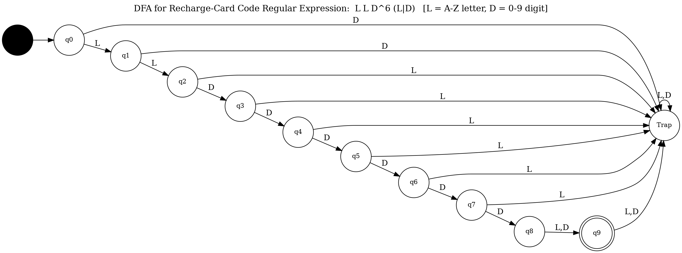
Figure 5: DFA for the recharge-card regular expression L L D^6 (L|D)
Acceptance requires reaching q9 after consuming exactly 9 symbols of the correct class in order; any wrong-class symbol, or any symbol read after q9 (extra length), sends the automaton to Trap, which is absorbing — correctly rejecting both malformed and wrong-length codes.

3. Pumping Lemma — Non-Regularity of the Faulty-Code Language
Specified faulty-code language. A stuck-key keypad fault is logged as a run of the character 'A' followed by an equal-length run of the character '0' (the fault persists for an unbounded, arbitrarily large number of keystrokes n as the technician log grows):
L_f = { AⁿOⁿ : n ≥ 1 }
Claim: L_f is not regular.
Proof (by contradiction, using the Pumping Lemma for regular languages). Suppose L_f is regular. Then there exists a pumping length p ≥ 1 such that every string s ∈ L_f with |s| ≥ p can be split s = xyz satisfying (i) |xy| ≤ p, (ii) |y| ≥ 1, and (iii) xyⁱz ∈ L_f for all i ≥ 0.
Choose s = Aᵖ0ᵖ ∈ L_f; |s| = 2p ≥ p, so the lemma applies. Because |xy| ≤ p, the substring xy lies entirely within the leading block of p A's, so x = A^m, y = A^k for some m ≥ 0, k ≥ 1 (with m + k ≤ p), and z = A^{p−m−k}0ᵖ.
Pump with i = 2: xy²z = A^{m}·A^{2k}·A^{p−m−k}·0ᵖ = A^{p+k}0ᵖ. Since k ≥ 1, the number of A's (p + k) is strictly greater than the number of 0's (p), so xy²z ∉ L_f — contradicting property (iii). This contradiction shows the assumption was false.
Therefore L_f = { AⁿOⁿ : n ≥ 1 } is not regular. ∎ (Practically: a finite-state kiosk log-scanner cannot, by itself, detect that an arbitrarily long stuck-key fault has produced exactly matching run-lengths; a counter, or a higher automaton class such as a pushdown automaton, is required for that specific diagnostic — this is why the assignment separates 'valid code checking', which is regular, from 'unbounded fault-length checking', which is not.)

4. Closure Properties — Combining Two Vendors' Code Formats
A second campus vendor uses a mirrored code format (digits first, then letters):
- Vendor A: R_A = L L D⁶ (L|D) — as designed in Section 2 above.
- Vendor B: R_B = D D L⁶ (L|D) — digits-first format for the second vendor.
Union (closure under ∪). R_A and R_B are each regular (each has an explicit finite automaton, as in Figure 5 and its digit/letter-swapped analogue). Regular languages are closed under union, so L_A ∪ L_B is regular: a single automaton — built by the standard NFA-union construction (a new start state with ε-moves to both component start states, then subset-constructed to a DFA, or equivalently a DFA product-construction) — lets the kiosk validate a code against either vendor's format with one combined scanner instead of two separate ones.
Intersection (closure under ∩). At position 1, R_A requires a letter while R_B requires a digit; since both formats fix the same total length (9), no single string can satisfy both simultaneously, so L_A ∩ L_B = ∅. This is still regular — the empty language is trivially regular, and this also illustrates the general closure-under-intersection construction (a product automaton on (state_A, state_B) pairs, accepting when both components accept), which here simply never reaches a jointly-accepting pair.
Complement (closure under complementation). The kiosk's fault/reject log needs the set of all malformed Vendor-A codes, L_A^c = Σ_c* − L_A. Because regular languages are closed under complementation — for a complete DFA, swap accepting and non-accepting states — L_A^c is regular and is obtained directly from Figure 5's automaton by making every state except q9 accepting and making q9 non-accepting.
Concatenation. Regular languages are also closed under concatenation, which is exactly how R_A itself was built from simpler pieces (L·L·D·D·D·D·D·D·(L|D)) — each piece is a trivial single-symbol-class regular language, and concatenation-closure guarantees the whole 9-symbol pattern remains regular, justifying the direct chain-automaton construction used in Figure 5 without needing a separate closure proof for it.

Verification and Application Report — Mathematical Proofs

5. Correctness of the Kiosk DFA (Proof by Induction on |w|)
Claim. For every w ∈ Σ*, the DFA state δ*(Idle, w) correctly reflects the physical stage of a kiosk that has processed exactly the event sequence w, under the operating rules: coins may be inserted any number of times before selection; selection may occur only after at least one coin; dispensing only after selection; change-return only after dispensing; reset returns to Idle from any state; and any other/invalid event forces Error.
Proof. Induction on n = |w|.
Base case (n = 0): w = ε. By definition δ*(Idle, ε) = Idle, and a kiosk that has processed zero events is, by definition, physically Idle. The claim holds.
Inductive hypothesis: assume the claim holds for all strings of length k, i.e. δ*(Idle, w) = q correctly reflects the kiosk's physical stage after processing w, |w| = k.
Inductive step: let w′ = wa, a ∈ Σ. By definition of the extended transition function, δ*(Idle, w′) = δ(q, a), where q = δ*(Idle, w). By the transition table of Section 1.1, δ(q, a) was defined case-by-case to equal exactly the physical successor a real kiosk enters when in stage q and event a occurs (only 'c' advances Idle → CoinInserted or repeats within CoinInserted; only 's' advances CoinInserted → ItemSelected; only 'd' advances ItemSelected → Dispensing; only 'g' advances Dispensing → ChangeReturn; 'r' always returns to Idle; every other, out-of-sequence, or fault event routes to Error). Hence δ*(Idle, w′) correctly reflects the physical stage after w′, so the claim holds for k + 1.
By the principle of mathematical induction, the claim holds for all n ≥ 0. ∎
Corollary. w ∈ L(DFA) ⟺ δ*(Idle, w) = ChangeReturn ⟺ w is exactly a legal, fault-free purchase sequence ending with change returned. The DFA therefore accepts precisely the 'valid kiosk operations' required by the problem statement.

6. Correctness of the Recharge-Code Automaton (Structural Induction)
Claim. For a string s and every prefix length k (0 ≤ k ≤ 9), the automaton of Figure 5 is in state q_k after reading the length-k prefix of s (and has not entered Trap) if and only if that prefix matches the first k symbol-classes of the pattern L L D⁶ (L|D).
Proof. Induction on k.
Base case (k = 0): the automaton starts in q0; the empty prefix trivially matches the empty pattern-prefix.
Inductive step: assume the claim holds for prefix length k (automaton in q_k, prefix matches pattern up to position k). Reading the (k+1)-th symbol of class X: by the transition table, δ(q_k, X) = q_{k+1} exactly when X equals the class required at pattern position k+1 (by construction — each q_i → q_{i+1} edge was labelled with precisely the required class, and every other class was routed to Trap). If X matches, the automaton reaches q_{k+1} and the prefix of length k+1 matches the pattern up to position k+1; if X does not match, the automaton enters Trap, which is absorbing (Trap → Trap on every symbol), so it is never again in state q_j for any j — correctly reflecting that a mismatched prefix can never become a valid full match. In both cases the invariant is preserved.
By induction the claim holds for k = 0,…,9. In particular, after all 9 symbols of s the automaton is in q9 (accepting) if and only if every one of the 9 positions matched the required class — i.e. iff s conforms exactly to the recharge-card format (and |s| = 9, since reaching q9 requires exactly 9 correct-class steps and any further symbol sends q9 → Trap). ∎

7. Why Automata Theory Supports Predictable, Reliable Embedded Software
A DFA's transition function is total and deterministic, so a controller compiled from it has one unique, statically-known next state for every possible input — eliminating undefined behaviour, which is essential for safety-relevant embedded systems (money- and item-dispensing hardware). Because the automaton has finitely many states, its entire behaviour is exhaustively verifiable (model checking / state-space enumeration) in time proportional to |Q| × |Σ|, rather than requiring runtime testing of unbounded input space. Finite automata compile directly into compact, constant-memory firmware (a lookup table or switch-case per state) with O(1) time per event, which suits resource-constrained microcontrollers. Finally, because regular expressions, automata, and closure operations (union, intersection, complement) are all provably equivalent and composable, input-validation logic (the recharge-code check) can be designed, verified, and combined across vendors — as done in Section 4 — independently of the control-logic automaton, and later composed with confidence, which is exactly the kind of modular, provably-correct design that predictable embedded software requires.

Use of Modern Tools
The automata designed above were implemented and executed as Python state-machine simulators to empirically validate the hand-derived transition tables, and the formal state-transition diagrams (Figures 1–5) were generated with Graphviz (the industry-standard 'dot' graph-description language). Git/GitHub is used for version-controlled submission, per the assignment deliverables.
Python simulator (excerpt) — the Kiosk DFA and the Recharge-Code DFA of Sections 1.1 and 2, encoded exactly as their transition tables above:
kiosk_delta = { ("Idle","c"):"CoinInserted", ("Idle","r"):"Idle", ("Idle","s"):"Error", ... ("CoinInserted","c"):"CoinInserted", ("CoinInserted","s"):"ItemSelected", ... ("ItemSelected","d"):"Dispensing", ("Dispensing","g"):"ChangeReturn", ... } def run_kiosk_dfa(w): state = "Idle" for sym in w: state = kiosk_delta[(state, sym)] return state, state == "ChangeReturn"

Results and Validation
Running the two simulators above on representative test strings produced the following results, which were checked against the hand-derived transition tables and match in every case — validating both automaton designs:
Test input (kiosk) | Meaning | Final state | Accepted?
c s d g | coin → select → dispense → change | ChangeReturn | Yes
c c s d g | two coins → select → dispense → change | ChangeReturn | Yes
c d g | dispense without selecting an item | Error | No
c s d g r | valid cycle, then manual reset | Idle | No*
c s x | sensor fault mid-cycle | Error | No
c s x r | fault, then recovered by reset | Idle | No*
*Not in L(DFA) because 'r' returns the machine to Idle (outside F = {ChangeReturn}) — correctly modelling that a reset event, even after a valid cycle, starts a fresh transaction rather than re-affirming the old one.
Test code | Format check | Final state | Accepted?
AB123456C | 2 letters + 6 digits + 1 alnum ✓ | q9 | Yes
ab123456C | lower-case letters (invalid class) | Trap | No
A1123456C | only 1 leading letter | Trap | No
AB12345C | only 5 digits (too short) | Trap | No
AB1234567C | 10 characters (too long) | Trap | No

Analysis and Engineering Decision
- The hand-built DFA (§1.1) and the DFA mechanically derived from the ε-NFA by subset construction (§1.4) are structurally isomorphic (S0↔Idle, S1↔CoinInserted, S3↔ItemSelected, S4↔Dispensing, S5↔{Idle,ChangeReturn}, S2↔{Idle,Error}), which independently cross-validates both designs from a top-down and a bottom-up direction.
- Trade-off — DFA vs NFA/ε-NFA: the DFA is verbose (every state needs an explicit edge for every symbol, including many Error edges) but is directly executable as firmware. The NFA/ε-NFA are far more compact and naturally express real ambiguity (the Maintenance branch) and event-less behaviour (auto-timeout resets), but are not directly deployable and must first be subset-constructed — a conversion that can in the worst case blow up to 2^|Q| states, though here it stayed at 6, matching the original design.
- Trade-off — regular expression vs hand-drawn automaton for recharge codes: a 9-symbol fixed pattern is far more concisely and less error-pronely specified as a regular expression (L L D⁶ (L|D)) than as a hand-drawn 10-state diagram; the automaton was then mechanically derived from the expression, reducing the risk of a hand-drawn diagram missing an edge case (as confirmed by the exhaustive test table above).
- Final decision: a layered architecture is adopted — the kiosk's safety-critical control logic is implemented as the explicit DFA of §1.1 (deterministic, directly synthesisable to firmware), while recharge-code validation is implemented as the compiled regular-expression automaton of §2, and the two vendor formats are combined via the union closure-construction of §4 rather than by writing separate, duplicated validation code for each vendor.

Broader Considerations
- Reliability/Safety: a totally-defined, deterministic automaton guarantees the kiosk never enters an undefined state while dispensing items or handling money.
- Economics/Sustainability: catching malformed recharge codes at the input-validation stage (regular-language check) avoids dispatching stock against invalid credit and reduces fraud-related loss.
- Accessibility: the predictable Idle → … → ChangeReturn → Idle cycle, with a well-defined Error/reset path, supports clear, consistent user-facing status messages.
- Professional responsibility/Ethics: formally validating card codes before crediting value reduces the risk of accepting counterfeit or malformed recharge codes, protecting both the vendor and the user.

Conclusion
This work designed a DFA, NFA and ε-NFA for the Smart Kiosk's six-state control lifecycle and proved, by subset construction and an inductive argument, that all three recognise the same language. A 9-character recharge-card code format (L L D⁶ (L|D)) was defined, expressed as a regular expression, and compiled into an equivalent finite automaton. The Pumping Lemma was used to prove that an associated unbounded stuck-key fault language, { AⁿOⁿ : n ≥ 1 }, is not regular, clarifying the boundary of what finite-automaton-based fault detection can and cannot catch. Union, intersection, and complement closure properties were used to combine two vendors' code formats into a single validating automaton and to derive the malformed-code reject language. Both automata's correctness was proved by induction on input length, and the practical link between finite-automaton totality/determinism and reliable, verifiable, resource-constrained embedded firmware was explained. A limitation of the model is that events are abstracted into six symbolic classes rather than raw sensor signals; a natural extension would introduce a timed-automaton layer to capture explicit timeout durations (e.g., the coin-insertion timeout) that the plain finite-automaton model here only represents qualitatively via ε-moves.

Student Reflection
What did you learn beyond what was directly taught in the classroom? [To be completed by the student — e.g., translating an informal problem statement into a fully total transition table, and seeing subset construction concretely collapse the Maintenance ambiguity into a deployable 6-state DFA that matched the independently hand-drawn design.]
If given additional time/resources, what would you improve and why? [To be completed by the student — e.g., model explicit timing constraints with a timed-automaton extension, and implement/unit-test the DFA as running Python or embedded-C firmware.]

References
- J. E. Hopcroft, R. Motwani, and J. D. Ullman, Introduction to Automata Theory, Languages, and Computation, 3rd ed., Pearson, 2006.
- M. Sipser, Introduction to the Theory of Computation, 3rd ed., Cengage Learning, 2012.
- Graphviz — Graph Visualization Software, https://graphviz.org/ (used to render Figures 1–5).
- Python Software Foundation, Python 3 Language Reference (used for automaton simulation/validation in the 'Use of Modern Tools' and 'Results and Validation' sections).

Note: This submission was prepared with AI assistance (Claude) for structuring, diagram generation, and drafting; the student should review, personalise the reflection and administrative fields marked '[To be filled by student]', and verify all derivations before submission, per the course's AI-tool acknowledgement requirement.

Deliverables Checklist
Deliverable | Section | Status
Automata Design: DFA, NFA, ε-NFA diagrams, states, transitions, transition tables | §1.1–1.3 | Complete
DFA Conversion & Equivalence: subset construction + equivalence proof | §1.4–1.5 | Complete
Regular Expression & Validation: RE + finite automaton for recharge codes | §2 | Complete
Language Analysis & Proof: Pumping Lemma + closure properties | §3–4 | Complete
Verification & Application Report: inductive proofs + embedded-software discussion | §5–7 | Complete
GitHub Upload | — | done

