SIMATS ENGINEERING
ASSESSMENT TOOL III – ERROR ANALYSIS TASK (LOW)
Course Name: | Code: | CO: CO2
Duration: 90 min Date: | Total Marks: | Reg. No / Name:  k. sai kumar(192372080)
CO2: Execute footprinting in social engineering such as DNS analysis, competitive intelligence gathering, and attack simulations to collect relevant information for identifying potential security risks. (BL3)
Assessment Tool Weightage: 35%
Instructions: Answer all questions. Each question carries 10 marks.
Question 1
A student performs footprinting using Google dorks but constructs queries without operators like “site:”, “filetype:”, or quotation marks. As a result, the search results include unrelated websites and irrelevant documents. The student proceeds with analysis using this incorrect data. Identify the error in query formulation and explain why improper search syntax leads to inaccurate footprinting. Demonstrate how to correct the search query using proper operators and refine results for accurate intelligence gathering.
1. Error Identified
The student's core mistake is treating a search engine query like a plain natural-language sentence instead of a precise, structured query. By omitting scoping operators (site:, filetype:, intitle:, inurl:) and quotation marks for exact phrases, the search engine's crawler-matching algorithm falls back to broad keyword relevance across the entire web index rather than the target organization's domain. This is a query-formulation error, not a tooling error — the search engine worked correctly; it was simply never told what to restrict itself to.
2. Root Cause – Why This Leads to Inaccurate Footprinting
Search engines rank results using relevance and popularity signals across billions of indexed pages. Without operators to constrain the search space, the query becomes ambiguous, causing several downstream problems:
- Domain leakage: Without site:, results are pulled from any website that happens to share the same keywords, not the target organization's own domain or subdomains.
- File-type noise: Without filetype:, the search mixes HTML pages, blog posts, and irrelevant PDFs/slides from unrelated organizations, instead of isolating the organization's own exposed documents.
- Loss of exact-phrase matching: Without quotation marks, the engine treats each word independently and may match pages containing the words in a completely different context or order, breaking the intended meaning of the query (e.g., searching for a job title or internal system name).
- Analytical error propagation: Since the student proceeds to analyze this noisy data as if it were valid, any conclusions about the target's attack surface, exposed files, or infrastructure will be based on false positives — wasting effort and potentially producing an inaccurate security assessment report.
3. Correction – Rebuilding the Query with Proper Operators
The query should be rebuilt step-by-step, adding one operator at a time so its effect on result precision is clear. Assume the goal is to find exposed configuration or credential-related documents belonging to “example.com”:
Incorrect (unstructured): example company employee list config file
Step 1 – restrict to the target's domain:
site:example.com
Step 2 – restrict to a relevant file type:
site:example.com filetype:pdf
Step 3 – narrow using title/URL keywords:
site:example.com filetype:pdf intitle:"employee directory"
Step 4 – use exact phrase matching for precision:
site:example.com filetype:xls "password" OR "config"
Each operator progressively removes irrelevant pages: site: eliminates unrelated domains, filetype: eliminates non-matching document formats, intitle:/inurl: focuses on pages whose title or address matches the intent, and quotation marks force an exact-phrase match instead of a loose keyword scatter. The result is a small, high-confidence set of pages that are genuinely relevant to the target organization, giving accurate and actionable footprinting intelligence rather than noise.
Question 2
While conducting competitive intelligence, a student gathers company data from blogs and unofficial forums without verifying authenticity. The collected information includes outdated employee details and incorrect organizational structure. Identify the mistake in source validation and explain why unreliable data affects decision-making. Recommend methods to verify information using official sources such as company websites, LinkedIn, and government databases.
1. Error Identified
The mistake is a failure of source validation — the student accepted information at face value from low-authority, user-generated sources (blogs, unofficial forums) without cross-checking it against any authoritative reference. In OSINT and competitive-intelligence work, the credibility of a source is just as important as the information itself; unofficial community content is often outdated, speculative, or written by individuals with no direct connection to the organization.
2. Root Cause – Why Unreliable Data Affects Decision-Making
- Staleness: Forum posts and blogs are rarely updated after publication, so employee names, titles, and org charts described in a 2-year-old post may no longer reflect the current structure.
- Lack of accountability: Anonymous or pseudonymous forum contributors have no obligation to verify accuracy, and content may be intentionally misleading, speculative, or based on rumor.
- Compounding errors: If the flawed data feeds into a security assessment or business strategy, every decision built on top of it — such as identifying key personnel for a social-engineering risk review — inherits the same inaccuracy, potentially targeting the wrong individuals or misjudging organizational risk.
- False confidence: Because the data appears specific and detailed, analysts may treat it as verified fact rather than an unverified claim, skipping further validation and increasing the chance of a flawed final report.
3. Recommended Verification Methods
To ensure competitive intelligence is accurate and defensible, information should always be cross-verified using authoritative, primary sources:
- Official company website: The “About Us,” “Leadership,” or “Newsroom” sections provide the organization's own current statements about structure, leadership, and key personnel.
- LinkedIn (company and individual profiles): Cross-check employee names, titles, and reporting structure against their self-maintained professional profiles, which are typically kept more current than third-party posts.
- Government and regulatory databases: Corporate registries, SEC/annual filings, or company-registrar databases provide legally filed, verifiable details on ownership, directors, and registered organizational structure.
- Press releases and verified news outlets: Established, reputable news organizations typically fact-check organizational changes such as leadership appointments or restructuring before publishing.
- Cross-source triangulation: Treat any single source, especially an unofficial one, as a hypothesis rather than a fact — confirm it independently across at least two or three authoritative sources before including it in a final report.
Question 3
A student directly starts active scanning on a target organization without performing passive footprinting such as WHOIS lookup and search engine analysis. This results in detection alerts being triggered. Identify the mistake in reconnaissance methodology and explain why passive reconnaissance is critical. Suggest the correct sequence of footprinting steps.
1. Error Identified
The student skipped the passive reconnaissance phase entirely and jumped straight into active scanning (e.g., port scanning or service enumeration) against live systems. This is a sequencing error in the reconnaissance methodology — active techniques directly interact with the target's systems and are inherently detectable, whereas passive techniques gather the same (and often more) foundational intelligence without ever touching the target's infrastructure.
2. Root Cause – Why Passive Reconnaissance Is Critical
- Stealth: Passive techniques (WHOIS, DNS lookups, search engine queries, social media review) use only publicly available third-party sources, generating no traffic to or alerts on the target's own network.
- Risk of detection: Active scanning sends packets directly to target hosts, which intrusion detection/prevention systems (IDS/IPS) and firewalls are specifically designed to flag — exactly what happened in this scenario.
- Wasted effort and inefficient targeting: Without passive recon first, the student has no prior knowledge of which IP ranges, subdomains, or systems are actually relevant, leading to scanning being broader, noisier, and slower than necessary.
- Legal and engagement-scope risk: In a real penetration test, unplanned active scanning without first confirming scope (often informed by passive recon of WHOIS/registration data) can violate the rules of engagement.
3. Correct Sequence of Footprinting Steps
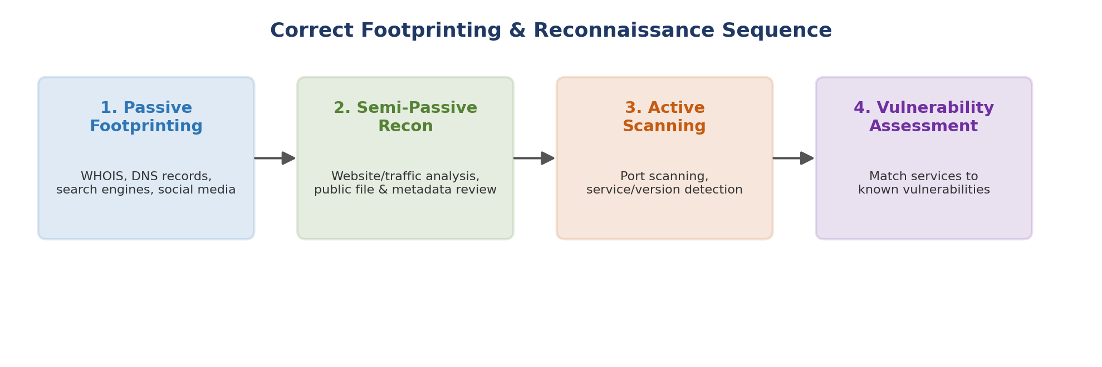
Figure 1: Correct order of reconnaissance — passive steps must precede any active interaction with the target.
- Step 1 – Passive Footprinting: WHOIS lookups, DNS record review, search-engine (Google dork) analysis, social media and job-posting review — all using third-party public sources only.
- Step 2 – Semi-Passive Reconnaissance: Reviewing the target's own public website content, cached pages, and publicly posted documents/metadata — still without directly probing internal systems.
- Step 3 – Active Scanning: Only after building a solid picture from Steps 1–2, begin controlled, scoped port scanning and service/version detection against confirmed, in-scope targets.
- Step 4 – Vulnerability Assessment: Match the identified services and versions against known vulnerability databases to determine actual security weaknesses.
Following this sequence ensures each active action is deliberate, scoped, and informed by prior intelligence — minimizing the chance of triggering unnecessary detection alerts while maximizing the quality of the final assessment.
Question 4
A student performs WHOIS lookup but only records domain name and registrar details, ignoring expiry date, administrative contacts, and name servers. Identify the missing components and explain how these fields provide useful security insights. Suggest how proper WHOIS analysis can reveal vulnerabilities.
1. Missing Components Identified
The student captured only a partial WHOIS record — domain name and registrar — while ignoring several fields that carry significant security value:
- Expiry / renewal date of the domain registration
- Administrative contact details (name, email, phone)
- Technical contact details
- Name servers (NS records) associated with the domain
- Organization name and registered address
2. Security Insights from Each Missing Field
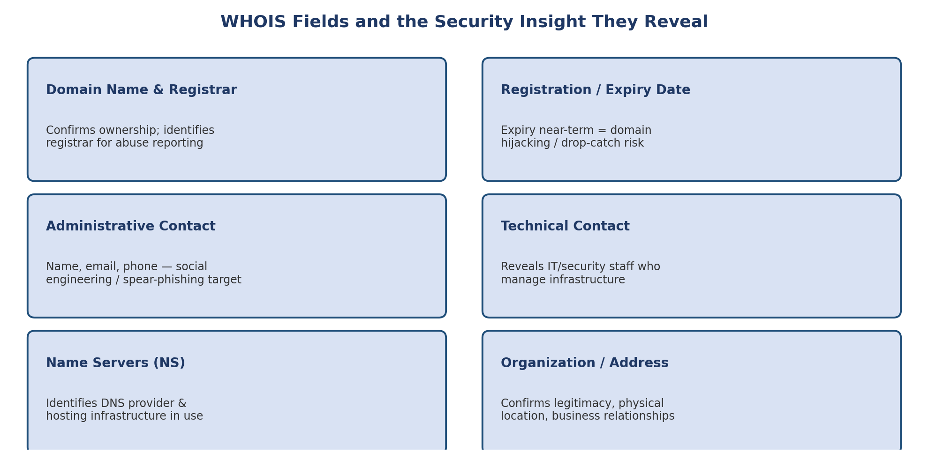
Figure 2: WHOIS fields and the corresponding security insight each one provides.
- Expiry date: A domain nearing its expiry date is at risk of domain hijacking or “drop-catching,” where an attacker registers the domain the moment it lapses — potentially intercepting email or impersonating the organization.
- Administrative contact: This is often a real employee's name, email, and phone number, making it a direct target for spear-phishing or pretexting attacks; it can also reveal the organization's email-naming convention.
- Technical contact: Frequently belongs to IT or infrastructure staff, indicating who manages the organization's servers and DNS — valuable for targeted social engineering aimed at gaining infrastructure access.
- Name servers: Reveal which DNS provider or hosting company the organization relies on, which can hint at the broader hosting/cloud ecosystem in use and any shared-infrastructure risks.
3. How Proper WHOIS Analysis Reveals Vulnerabilities
Reviewing the complete WHOIS record — not just the domain and registrar — allows a security analyst to proactively identify weaknesses that a partial lookup would miss:
- Detecting soon-to-expire domains that need urgent renewal to prevent hijacking
- Identifying personal contact information that is inadvertently exposed and should be replaced with privacy-protected/proxy WHOIS registration
- Mapping third-party DNS/hosting dependencies that may introduce supply-chain or shared-infrastructure risk
- Cross-referencing contact names against other OSINT sources to assess the organization's exposure to social engineering
In short, a complete WHOIS analysis transforms a simple registration lookup into a genuine risk-assessment input, whereas a partial record (as the student produced) leaves major, easily preventable risks undiscovered.
Question 5
A student downloads publicly available documents from an organization’s website but focuses only on the visible content while ignoring embedded metadata. As a result, important details such as author names, software versions, and internal usernames are missed. Identify the mistake in the student’s footprinting process and explain how metadata can provide valuable intelligence. Describe the correct method to extract metadata using appropriate tools. Suggest how this information could be used ethically to identify potential security risks.
1. Mistake Identified
The student treated documents purely as sources of visible textual content, overlooking that every file (PDF, DOCX, XLSX, JPG, etc.) carries embedded metadata generated automatically by the software used to create or edit it. This is an incomplete-analysis error: by only reading the surface content, the student missed an entire hidden layer of intelligence that is often more revealing than the visible text itself.
2. Why Metadata Provides Valuable Intelligence
Metadata is data about the document, silently embedded by the authoring software, and can include:
- Author name and organizational username, often matching or hinting at the corporate email/naming convention
- Software name and version used to create the file (e.g., a specific version of Word, Acrobat, or a scanner/printer model), which can be checked against known vulnerabilities
- Creation and last-modified timestamps, revealing document freshness and internal editing activity
- Internal file paths or folder structures showing how the organization organizes its network drives
- Operating system and, for images, GPS/location data if geotagging was enabled
Collected across many documents, this metadata can reveal internal usernames (useful for guessing email formats), the specific software versions in use (useful for identifying unpatched vulnerabilities), and even the organization's internal folder/network naming conventions — all without ever touching the organization's actual network.
3. Correct Method to Extract Metadata
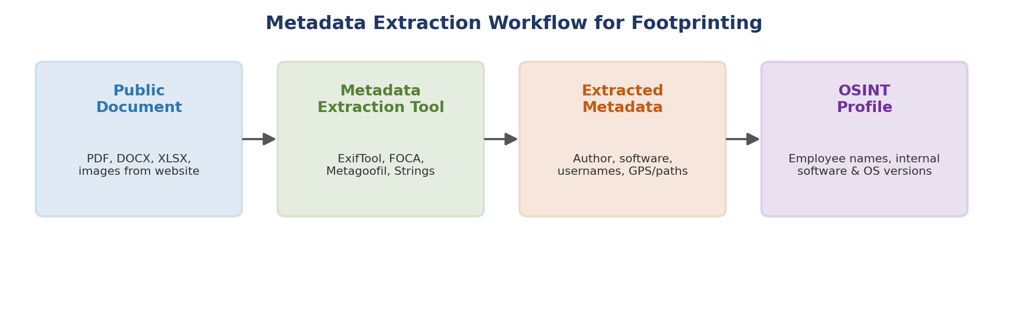
Figure 3: End-to-end metadata extraction workflow, from public document to an OSINT profile.
- Step 1: Collect publicly accessible documents from the organization's website (PDFs, Office files, images).
- Step 2: Run a dedicated metadata-extraction tool such as ExifTool (images and most file types), FOCA (bulk document metadata harvesting and correlation), or Metagoofil (automates search-engine discovery plus metadata extraction) against the collected files.
- Step 3: Parse the extracted fields — author, software/version, timestamps, internal paths, usernames — into a consolidated spreadsheet or OSINT database for analysis.
- Step 4: Correlate findings across multiple documents to identify patterns, such as a consistent internal username format or a single outdated software version used organization-wide.
4. Ethical Use of This Information to Identify Security Risks
When performed as part of an authorized security assessment, metadata analysis should be used constructively rather than for exploitation:
- Report exposed usernames and internal file-path patterns to the organization so they can be scrubbed from future public documents
- Flag outdated software versions found in metadata as a patching/upgrade priority before an attacker can exploit known vulnerabilities in that version
- Recommend a document-publishing policy that automatically strips metadata (using built-in “remove properties” features or dedicated sanitization tools) before files are placed on the public website
- Include findings only in the authorized assessment report, ensuring any personal information (author names, usernames) is handled in line with the engagement's confidentiality and data-protection agreements
Used this way, metadata analysis becomes a proactive defensive tool — helping the organization close an information-leakage gap before a malicious actor can take advantage of it.
Code of Conduct:

I (k. sai kumar(192372080)) certify that this submission is my original work and that I have adhered to the guidelines specified for this assessment. I understand that any violation of academic integrity rules will result in disciplinary action.
Signature of the student:
RUBRICS FOR CALCULATION
Criteria | Weightage | Level 4 – Exemplary | Level 3 – Proficient | Level 2 – Developing | Level 1 – Beginning
Error Identification | 20%
Root Cause Analysis | 30%
Correction & Justification | 25%
Application of Concepts | 15%
Clarity & Presentation | 10%

Criteria | Error Identification (2) | Root Cause Analysis (3) | Correction & Justification (2) | Application of Concepts (2) | Clarity & Presentation (1) | Total
Q1
Q2
Q3
Q4
Q5

