**Artificial Intelligence Lab Programs**

**By: Karkala Gaurav Prabhu**

**USN: 1BM17CS136**

1. Tic-tac-toe AI

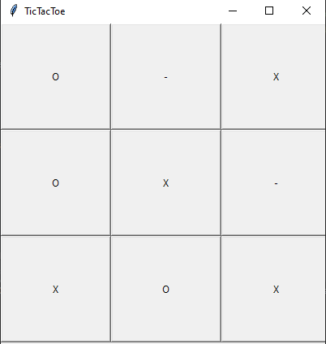

1. 8 Puzzle Problem



1. Vacuum Cleaner Agent

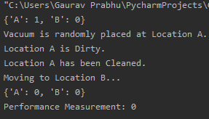

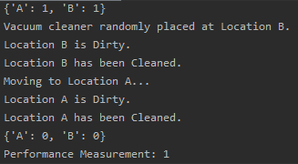

1. A* Search Algorithm

[0, 1, 7]

[8, 2, 4]

[3, 6, 5]

R

[1, 0, 7]

[8, 2, 4]

[3, 6, 5]

D

[1, 2, 7]

[8, 0, 4]

[3, 6, 5]

R

[1, 2, 7]

[8, 4, 0]

[3, 6, 5]

U

[1, 2, 0]

[8, 4, 7]

[3, 6, 5]

L

[1, 0, 2]

[8, 4, 7]

[3, 6, 5]

D

[1, 4, 2]

[8, 0, 7]

[3, 6, 5]

R

[1, 4, 2]

[8, 7, 0]

[3, 6, 5]

D

[1, 4, 2]

[8, 7, 5]

[3, 6, 0]

L

[1, 4, 2]

[8, 7, 5]

[3, 0, 6]

L

[1, 4, 2]

[8, 7, 5]

[0, 3, 6]

U

[1, 4, 2]

[0, 7, 5]

[8, 3, 6]

R

[1, 4, 2]

[7, 0, 5]

[8, 3, 6]

D

[1, 4, 2]

[7, 3, 5]

[8, 0, 6]

R

[1, 4, 2]

[7, 3, 5]

[8, 6, 0]

U

[1, 4, 2]

[7, 3, 0]

[8, 6, 5]

L

[1, 4, 2]

[7, 0, 3]

[8, 6, 5]

U

[1, 0, 2]

[7, 4, 3]

[8, 6, 5]

R

[1, 2, 0]

[7, 4, 3]

[8, 6, 5]

D

[1, 2, 3]

[7, 4, 0]

[8, 6, 5]

D

[1, 2, 3]

[7, 4, 5]

[8, 6, 0]

L

[1, 2, 3]

[7, 4, 5]

[8, 0, 6]

L

[1, 2, 3]

[7, 4, 5]

[0, 8, 6]

U

[1, 2, 3]

[0, 4, 5]

[7, 8, 6]

R

[1, 2, 3]

[4, 0, 5]

[7, 8, 6]

R

[1, 2, 3]

[4, 5, 0]

[7, 8, 6]

D

[1, 2, 3]

[4, 5, 6]

[7, 8, 0]

1. 8 Puzzle Iterative Deepening Search

0 1 2

3 4 5

6 7 8

1 0 2

3 4 5

6 7 8

0 1 2

3 4 5

6 7 8

1 4 2

3 0 5

6 7 8

1 0 2

3 4 5

6 7 8

0 1 2

3 4 5

6 7 8

1 4 2

0 3 5

6 7 8

1 4 2

3 0 5

6 7 8

1 0 2

3 4 5

6 7 8

0 1 2

3 4 5

6 7 8

1 4 2

6 3 5

0 7 8

**.**

**.**

**.**

**.**

1 4 2

6 3 0

7 8 5

1 4 2

6 3 5

7 8 0

1 4 2

6 3 5

7 0 8

1 4 2

6 3 5

0 7 8

1 4 2

0 3 5

6 7 8

1 4 2

3 0 5

6 7 8

1 0 2

3 4 5

6 7 8

0 1 2

3 4 5

6 7 8

Total number of moves: 945

Total searching time: 6.60 seconds

1. Create a Knowledge base using Prepositional Logic and show that the given query entails the knowledge base or not.

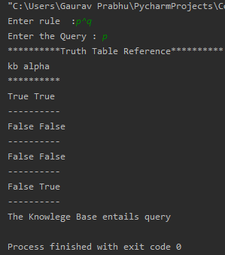

1. First Order Logic to Conjunctive Normal Form.

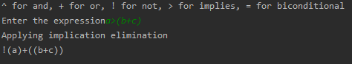

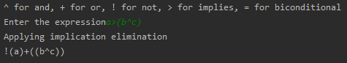

1. Unification

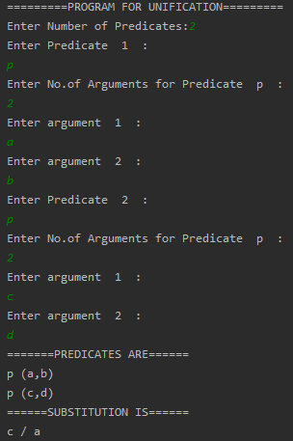

1. Forward Reasoning

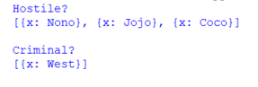

1. Decision Tree Learning

