

**KAUNO TECHNOLOGIJOS UNIVERSITETAS**

**INFORMATIKOS FAKULTETAS**

**DUOMENŲ STRUKTŪROS**

**2 LABORATORINIS DARBAS**

**Atliko Karolis Stasaitis IFF8-9**

**Pagrindinė Klasė:**

package edu.ktu.ds.lab2.cpu;  
  
import edu.ktu.ds.lab2.utils.Ks;  
import edu.ktu.ds.lab2.utils.Parsable;  
  
import java.util.Comparator;  
import java.util.NoSuchElementException;  
import java.util.Random;  
import java.util.Scanner;  
  
public class CPU implements Parsable<CPU> {  
  
 private String CPU_NAME;  
 private int CPU_RELEASE_YEAR;  
 private int CPU_CORES;  
 private double CPU_BASE_MIN;  
 private double CPU_BASE_MAX;  
 private double CPU_PRICE;  
  
 private static String *CPU_REG_PREF* = "ID";  
 private static int *CPU_NUMBER* = 100;  
 private static String *CPU_ID*;  
  
  
 public CPU()  
 {  
 *CPU_ID* = *CPU_REG_PREF* + (*CPU_NUMBER*++);  
 }  
 public CPU(String data)  
 {  
  
 }  
 public CPU(Builder builder) {  
 CPU_NAME = builder.Name;  
 CPU_RELEASE_YEAR = builder.Year;  
 CPU_CORES = builder.Core;  
 CPU_BASE_MIN = builder.Base_Min;  
 CPU_BASE_MAX = builder.Base_Max;  
 CPU_PRICE = builder.Price;  
 // validate();  
 }  
 public CPU(String cpu_name, int cpu_release_date, int cpu_core, double cpu_base_min, double cpu_base_max, double cpu_price)  
 {  
 CPU_NAME = cpu_name;  
 CPU_RELEASE_YEAR = cpu_release_date;  
 CPU_CORES = cpu_core;  
 CPU_BASE_MIN = cpu_base_min;  
 CPU_PRICE = cpu_price;  
 CPU_BASE_MAX = cpu_base_max;  
 }  
 public boolean validateYear(int minRelease, int maxRelease) {  
 if (CPU_RELEASE_YEAR < minRelease || CPU_RELEASE_YEAR > maxRelease) {  
 return false;  
 }  
 return true;  
 }  
 public boolean validatePrice(int minPrice, int maxPrice)  
 {  
 if (CPU_PRICE < minPrice || CPU_PRICE > maxPrice) {  
 return false;  
 }  
 return true;  
 }  
 @Override  
 public void parse(String dataString) {  
 try{  
 Scanner p = new Scanner(dataString).useDelimiter(",");  
 CPU_NAME = p.next();  
 CPU_RELEASE_YEAR = p.nextInt();  
 CPU_CORES = p.nextInt();  
 CPU_BASE_MIN = Double.*parseDouble*(p.next());  
 CPU_BASE_MAX = Double.*parseDouble*(p.next());  
 CPU_PRICE = Double.*parseDouble*(p.next());  
 }  
 catch (NoSuchElementException e)  
 {  
 Ks.*ern*("Not enough data about CPU" + dataString);  
 }  
 }  
 /*  
 @Override  
 public int compareTo(CPU car) {  
 return Get_Cpu_Id().compareTo(car.Get_Cpu_Id());  
 }  
 */  
 @Override  
 public String toString()  
 {  
 return String.*format*("%s %d %d %.2f %.2f %.2f", CPU_NAME, CPU_RELEASE_YEAR, CPU_CORES, CPU_BASE_MIN,CPU_BASE_MAX, CPU_PRICE);  
 }  
 /*  
 public final static Comparator byPrice = (obj1, obj2) -> {  
 double price1 = ((CPU) obj1).Get_Cpu_Price();  
 double price2 = ((CPU) obj2).Get_Cpu_Price();  
  
 double new_price = Math.sqrt(price1);  
 double new_price1 = Math.sqrt(price2);  
 if (new_price < new_price1) {  
 return -1;  
 }  
 if (new_price > new_price1) {  
 return 1;  
 }  
 return 0;  
 };  
 */  
 @Override  
 public int compareTo(CPU o) {  
 double Price = o.CPU_PRICE;  
  
 if(this.CPU_PRICE > Price)  
 {  
 return 1;  
 }  
 else if(this.CPU_PRICE < Price)  
 {  
 return -1;  
 }  
 return 0;  
 }  
 public String Get_Cpu_Name(){return CPU_NAME;}  
 public int Get_Cpu_Release_Year() {return CPU_RELEASE_YEAR;}  
 public int Get_Cpu_Cores(){return CPU_CORES;}  
 public double Get_Cpu_Base_Min(){return CPU_BASE_MIN;}  
 public double Get_Cpu_Price(){return CPU_PRICE;}  
 public double Get_Cpu_Base_Max(){return CPU_BASE_MAX;}  
 public String Get_Cpu_Id() { return *CPU_ID*;};  
 public static class Builder {  
  
 private final static Random *RANDOM* = new Random(1949); // Atsitiktinių generatorius  
 private final static String[][] *MODELS* = { // galimų automobilių markių ir jų modelių masyvas  
 {"Intel", "Quad-Core", "I3", "I5", "I7"},  
 {"AMD", "Ahtlon", "Razen"}  
 };  
 private String Name = "";  
 private int Year = -1;  
 private int Core = -1;  
 private double Base_Min = -1.0;  
 private double Base_Max = -1.0;  
 private double Price = -1.0;  
  
 public CPU build() {  
 return new CPU(this);  
 }  
  
 public CPU buildRandom() {  
 int ma = *RANDOM*.nextInt(*MODELS*.length); // markės indeksas 0..  
 int mo = 1 + *RANDOM*.nextInt(*MODELS*.length - 1);  
 int serie = 100 + *RANDOM*.nextInt(9000);  
 return new CPU(*MODELS*[ma][0] + " " + *MODELS*[ma][mo] + '-' + serie,  
 1990 + *RANDOM*.nextInt(25),// metai tarp 1990 ir 2009  
 1 + *RANDOM*.nextInt(8),// rida tarp 6000 ir 228000  
 2.5 + *RANDOM*.nextDouble() * 4.5,  
 4.5 + *RANDOM*.nextDouble() * 6.0,  
 200 + *RANDOM*.nextDouble() * 2000);// kaina tarp 800 ir 88800  
 }  
  
 public Builder Year(int year) {  
 this.Year = year;  
 return this;  
 }  
  
 public Builder model(String model) {  
 this.Name = model;  
 return this;  
 }  
 public Builder Core(int core)  
 {  
 this.Core = core;  
 return this;  
 }  
 public Builder Base_Min(double base)  
 {  
 this.Base_Min = base;  
 return this;  
 }  
 public Builder Base_Max(double base)  
 {  
 this.Base_Max = base;  
 return this;  
 }  
 public Builder price(double price) {  
 this.Price = price;  
 return this;  
 }  
 }  
  
}

**Avl Klasės realizuoti metodai:**

*/**  
 * Pašalinamas elementas iš aibės.  
 *  
 \** ***@param*** *element  
 */*@Override  
public void remove(E element) {  
 if(size == 0 || element == null) {  
 throw new UnsupportedOperationException("Element is null or size is zero");  
 }  
 root = removeRecursive(element, (AVLNode<E>)root);  
}  
  
private AVLNode<E> removeRecursive(E element, AVLNode<E> n) {  
 if (n == null) {  
 return n;  
 }  
  
 int h = c.compare(element, n.element);  
  
 //System.out.println(h + " " + element + " " + n.element);  
  
 // System.out.println(element);  
  
 if(h < 0)  
 {  
 n.setLeft(removeRecursive(element, n.getLeft()));  
 if ((height(n.getLeft()) - height(n.getRight())) == 2) {  
 int cmp2 = c.compare(element, n.getLeft().element);  
 n = (cmp2 < 0) ? rightRotation(n) : doubleRightRotation(n);  
 }  
 }  
 else if(h > 0)  
 {  
 n.setRight(removeRecursive(element, n.getRight()));  
 if ((height(n.getRight()) - height(n.getLeft())) == 2) {  
 int cmp2 = c.compare(n.getRight().element, element);  
 n = (cmp2 < 0) ? leftRotation(n) : doubleLeftRotation(n);  
 }  
 }  
 else if(n.getLeft() != null && n.getRight() != null)  
 {  
 System.*out*.println("dis");  
 BstNode<E> Max = getMin(n.getRight());  
  
 n.element = Max.element;  
  
 n.setRight(removeRecursive(n.element, n.getRight()));  
 }  
 else  
 {  
 System.*out*.println("No child" + element);  
 n = (n.getLeft() != null) ? n.getLeft() : n.getRight();  
 size--;  
 if(n == null)  
 {  
 return n;  
 }  
 }  
 n.height = Math.*max*(height(n.getLeft()), height(n.getRight())) + 1;  
 return n;  
  
}

**Klasės Bst realizuoti metodai**

**pollFirst()**

public BstNode<E> pollFirst()  
{  
 if(root == null)  
 {  
 return null;  
 }  
 BstNode<E> min = getMin(root);  
 remove(min.element);  
 return min;  
}

**removeAll(BstSet<?> set)**

public boolean removeAll(BstSet<E> c)  
{  
 if(root == null)  
 {  
 return false;  
 }  
 IteratorBst iterator = new IteratorBst(false);  
 Iterator<E> iterator1;  
 while(iterator.hasNext())  
 {  
 E e = iterator.next();  
 iterator1 = c.descendingIterator();  
 while(iterator1.hasNext())  
 {  
 E ee = iterator1.next();  
 int equal = this.c.compare(e, ee);  
 if(equal == 0)  
 {  
 remove(e);  
 break;  
 }  
 }  
 }  
 return true;  
  
}

**SortedSet Metodai:**

@Override  
public SortedSet<E> headSet(E element) {  
 if (element == null) {  
 throw new IllegalArgumentException("Element is null");  
 }  
 SortedSet<E> set = new BstSet<>();  
 IteratorBst iterator;  
 iterator = new IteratorBst(false);  
 while(iterator.hasNext())  
 {  
 E e = iterator.next();  
 int cmp = c.compare(e, element);  
 System.*out*.println("Cmp" + cmp);  
 if(cmp < 0)  
 {  
 set.add(e);  
 }  
 }  
 return set;  
}  
  
*/**  
 * Grąžinamas aibės poaibis nuo elemento element1 iki element2.  
 *  
 \** ***@param*** *element1 - pradinis aibės poaibio elementas.  
 \** ***@param*** *element2 - galinis aibės poaibio elementas.  
 \** ***@return*** *Grąžinamas aibės poaibis nuo elemento element1 iki element2.  
 */*@Override  
public SortedSet<E> subSet(E element1, E element2) {  
 if (element1 == null || element2 == null) {  
 throw new IllegalArgumentException("Element is null");  
 }  
 SortedSet<E> set = new BstSet<>();  
 IteratorBst iterator;  
 iterator = new IteratorBst(false);  
 while(iterator.hasNext())  
 {  
 E e = iterator.next();  
 int cmp = c.compare(e, element1);  
 System.*out*.println(cmp);  
 int cmp1 = c.compare(element2, e);  
 System.*out*.println(cmp1);  
 if(cmp >= 0 && cmp1 > 0)  
 {  
 set.add(e);  
 }  
  
 }  
 return set;  
}  
  
*/**  
 * Grąžinamas aibės poaibis iki elemento.  
 *  
 \** ***@param*** *element - Aibės elementas.  
 \** ***@return*** *Grąžinamas aibės poaibis nuo elemento.  
 */*@Override  
public SortedSet<E> tailSet(E element) {  
 if (element == null) {  
 throw new IllegalArgumentException("Element is null");  
 }  
 SortedSet<E> set = new BstSet<>();  
 IteratorBst iterator;  
 iterator = new IteratorBst(true);  
 while(iterator.hasNext())  
 {  
 E e = iterator.next();  
 int cmp = c.compare(e, element);  
 if(cmp >= 0)  
 {  
 set.add(e);  
 }  
 }  
 return set;  
}

**Realizuotas Iteratoriaus remove metodas(Nepilnai veikiantis)**

@Override  
public void remove() {  
 if(!stack.isEmpty()) {  
 BstNode<E> node = stack.peek();  
 int compare = c.compare(parent.element, node.element);  
  
 if (compare > 0) {  
 root = removeRecursive(parent.left.element, root);  
 } else {  
 root = removeRecursive(parent.right.element, root);  
 }  
 }  
}

**JUNIT5 Testo Klasė**

package edu.ktu.ds.lab2.cpu;  
  
import org.junit.jupiter.api.BeforeAll;  
import org.junit.jupiter.api.DisplayName;  
import org.junit.jupiter.api.Test;  
import static org.junit.jupiter.api.Assertions.*assertTrue*;  
  
public class JUNIT {  
  
 static CPU_Generator *generator* = new CPU_Generator();  
 static CPU[] *CPU_List*;  
 static CPU *cpu* = new CPU();  
 @BeforeAll  
 public static void Create()  
 {  
 *CPU_List* = *generator*.generateShuffle(30,10, 0.8);  
 *cpu* = *generator*.takeCpu();  
 }  
 @DisplayName("Checking Year")  
 @Test  
 public void Check_Year()  
 {  
 *assertTrue*(*cpu*.validateYear(2019, 2020), String.*format*("Error year is too low or too high %d", *cpu*.Get_Cpu_Release_Year()));  
 }  
 @DisplayName("Checking Price")  
 @Test  
 public void Check_Price()  
 {  
 *assertTrue*(*cpu*.validatePrice(1999, 2000), String.*format*("Error price is out of bound %.2f", *cpu*.Get_Cpu_Price()));  
 }  
}

**JAVAFX:**

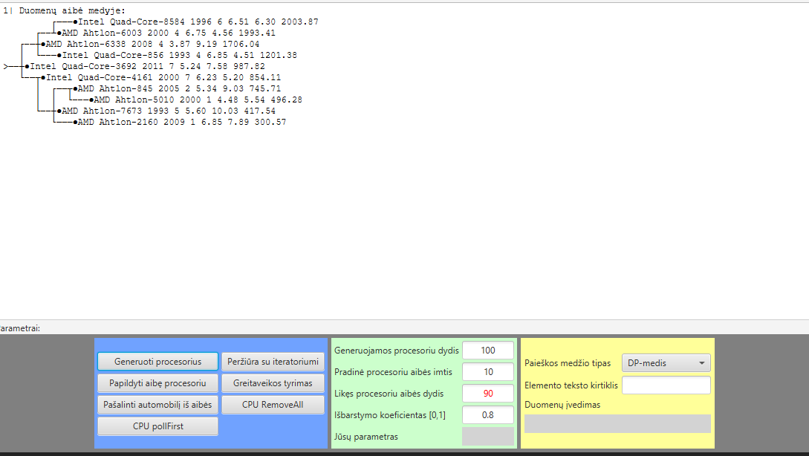

**Greitaveikos rezultatai:**

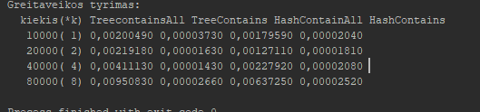

Hash metodai atlieka greičiausiai, treeSet metodams užima 0(Log n), o hashset 0(1).

Išvados

Medžiai atlieka metodus žymiai efektyviau. JUNIT klasė yra patogi priemonė sutaupyti laiko programuotojui bei atrasti klaidas žymiai greičiau.