Tilt-up & Pre-cast Construction

Tilt-Up concrete construction is not new; it has been in use since the turn of the century. More recently it has been developed into a preferred method of construction for many types of buildings and structures and it is one of the fastest growing industries in Australia. It combines reasonable cost with low maintenance, durability, speed of construction, and minimal capital investment.
A successful tilt-up project begins long before concrete is poured. As with any project, the key is thorough planning. An experienced tilt-up contractor can be successful on a wide variety of projects.
Site evaluation - Planning begins with an evaluation of the site. Evaluate the site with regard to slab layout and the movement of materials and equipment around the slab. If the site is tight around the building, consider sequencing the pouring of slabs and panels from within the building.
Engineering - Engineering is a critical phase of tilt-up projects. Consult an engineer with experience or familiarity with tilt-up construction and current design methods. 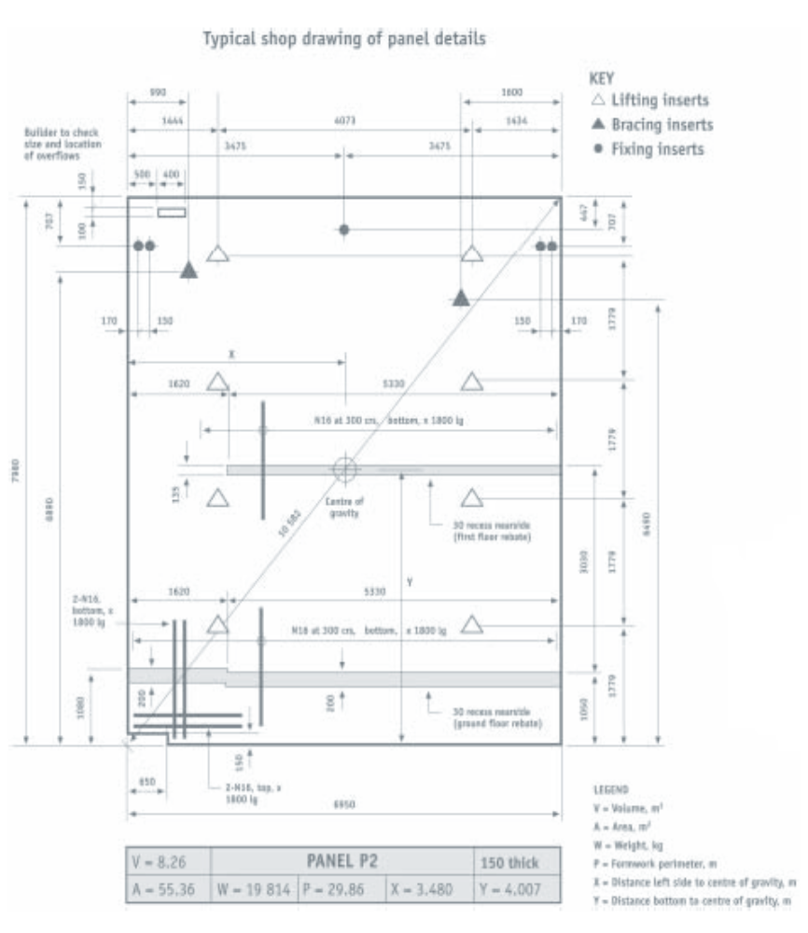
Footings and Floor Slabs - Once planning is complete, construction can begin on the floor and footings. Install footings as level as possible.
Footing locations, heights, and dimensions should be checked and verified for correctness. (Crane time is expensive and setting a panel down after it has been lifted interrupts the construction schedule.)
Panel Forming - There are a number of ways to form individual panels. Laying out panels on the floor slab is the standard practice. There are several ways to form individual panels. One way is to form the perimeter of a series of panels. Form door and window openings after framing the panel perimeter. Brace the interior of the openings to prevent bowing or movement. If an opening is close to a panel edge, a strongback may be needed for additional support during panel lifting and placement.
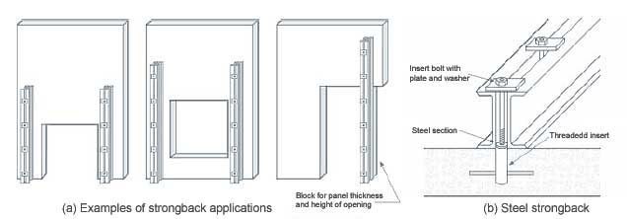
Apply form release agent and bond breaker to the slab and forms as recommended by the manufacturer. A wide variety of materials are available. Compatibility between bond breakers, form release agents, and paints or coatings used on the panels is critical. Check compatibility by consulting with the product suppliers.
Surface treatments - Patterns or texture can easily be added to the face of Tilt-Up panels.
Reinforcing - The use of plastic support chairs instead of steel chairs is recommended to avoid rusting. Reinforcement must comply with AS 3600 and approved shop drawings.
Embeds and Inserts - The next step is to install embeds and inserts. Embeds are pre-fabricated steel plates with lugs that are cast into the panel to attach it to the footing, other panels, or the roof system, or for attachment of building accessories after the shell is completed. They can be attached to the side forms if they are on the panel edges, or they can be wired to the reinforcing.
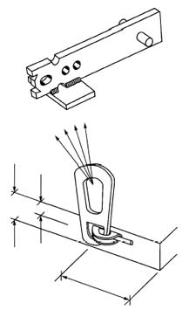
Inserts provide the attachment points for lifting hardware and braces. Install inserts according to engineer’s and/or manufacturer's recommendations.
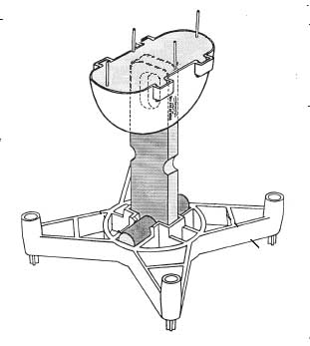
Concrete Placement - Before placing concrete for Tilt-Up panels, clean the base slab. Use compressed air to blow away dirt, leaves, and other loose debris. Also, remove any standing water on the slab. Concrete placement methods for Tilt-Up panels are the same as those for floor slabs. Vibrate the concrete to ensure good flow around the reinforcing steel. A trowel finish is suitable for most projects.
If it looks like rain, delay the pour or have a suitable covering material available. On hot or windy days, be prepared to cure the panels.
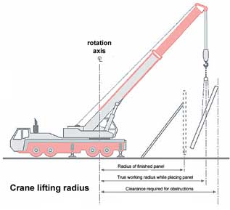
Panel Lifting - The erection sequence should be determined well in advance, but it's a good idea to review it immediately before panel erection. Discuss crane operation, bracing and anchorage details, cable releases, and job communication.
Attach braces before lifting the panels and don't remove braces until after the roof and decking are installed.
Panel Finishing - The finish of a panel is limited only by the creativity of the architect and the abilities of the contractor.

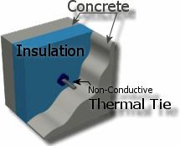
Insulated Panels - Insulated Tilt-Up panels are a rapidly growing market providing new opportunities to experienced and new Tilt-Up contractors. The basic forming and pouring process must be modified slightly to accommodate the sandwich wall systems. Higher side forms are needed to accommodate the insulation, and some systems require concrete placement on separate days. Tilt-Up sandwich panels with as much as 100 mm of insulation and R values of 28 can be built.

WorkSafe Code of Practice

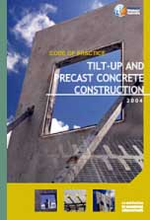
The Code of Practice for Tilt-up and Precast Concrete Construction applies to all workplaces in Western Australia covered by the Occupational Safety and Health Act 1984 where concrete wall panels, whether precast on or off-site, or other precast concrete elements are used in the building and construction industry.
It covers the areas of tilt-up and precast concrete construction where safety is a concern including casting of panels and other precast elements, handling, storage, transportation, lifting by crane, rigging systems and bracing and securing of panels.
You can download a copy of the Code of Practice in Adobe Portable Document Format
http://www.safetyline.wa.gov.au/pagebin/pg003147.htm

On page four (4) is the Table of contents of the Code of Practice for the TILT-UP AND PRECAST CONCRETE CONSTRUCTION reproduced
INTRODUCTION  PART 1: GENERAL  • Purpose  • Scope  • Regulations  • Relationship to Australian Standards  • Referenced documents and further reading  PART 2: TRAINING, SUPERVISION AND HAZARD MANAGEMENT  • General  • Training and supervision  • Safety and health  • Hazard management  PART 3: MATERIALS, COMPONENTS AND EQUIPMENT  • General - compatibility of components  • Concrete and reinforcement specifications  • Curing compounds and release agents  • Lifting, bracing and fixing inserts  • Re-usable lifting equipment  • Braces and props  • Levelling pads and shims  • Crane and rigging equipment  • Proprietary documentation  PART 4: DESIGN  • General  • Preplanning  • Design loads  • Building stability  • Structural design  • Specification of concrete  • Design for manufacture and erection  • Panel thickness  • Slenderness effects  • Panel supports  • Fixing inserts  • Joints  • Brace footings  • Connections  • Strongbacks  PART 5: DOCUMENTATION  • Structural design drawings  • Panel documentation  • Lodgement of shop drawings with local government | PART 6: CASTING  • General  • Preplanning and layout  • Casting bed  • Formwork  • Tolerances  • Reinforcement  • Manufacturer's statement and inspection  • Placement and compaction of concrete  • Curing and release agents  • Lifting, bracing and fixing inserts  • Element identification  • Stripping and repair  PART 7: HANDLING, STORAGE AND TRANSPORT  • General  • Handling and storage of site-cast concrete panels  • Handling and storage of factory manufactured  • concrete elements  • Transport  PART 8: ERECTION TO TEMPORARY BRACED CONDITION  • General  • Planning the construction and erection sequence  • Work method statement  • Exclusion zones  • Crane standing area  • Planning cranage requirements  • Operating near overhead power lines  • Operating near braces and panels  • Working at height  • Strongbacks  • Erection crew  • Rigging  • Erection of concrete panels  • Modifications  PART 9: TEMPORARY BRACED CONDITION  • Installation and inspection of temporary bracing  • Superimposed loads  • Levelling pads and shims  • Grouting of the base  PART 10: INCORPORATION INTO FINAL STRUCTURE  • Fixing to final structure  • Inspection prior to and removal of braces  APPENDICES  • APPENDIX A: Definitions of terms used in this code  • APPENDIX B: Sample documents, schedules and shop drawing  • APPENDIX C: Referenced documents and further reading
Accident Reports, or Significant Incident Summaries (SIS)
2 Fake Bolts in Tilt-Up Construction: SIS 13/20008
4 Tilt-up Panel Falls Over: SIS 4/19996
6 Tilt-Up Panel Collapses : SIS 51/19995
7 Code of Practice: Tilt-up and Precast Concrete Construction4
9 Wrong Bracing Inserts Cause Tilt-Up Panel Collapse: SIS 33/20004
10 Accredited Training Courses: Course in 'Contribute to Safe Tilt-up3
17 Collapse of a Tilt-up Concrete Structure : SIS 7/20022
18 Precast Concrete Panel Falls Over: SIS 13/20012
Bracing requirements

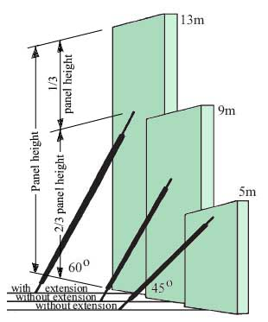
Bracing should be installed in accordance with AS 3850 and the approved shop drawings
Braces are usually installed at an angle of 45° to 60° and square to the line of the panel
Generally two (2) braces are used to support each panel
Where a single brace is used (eg on narrow panels) to brace a panel particular care is required.

Buried concrete blocks ‘deadmen’ are commonly used to anchor braces and prevent panels falling over due to wind loads or other factors.
A deadman relies both on its mass and cohesion with the ground to resist wind loads tending to pull the deadman out of the ground (i.e. wind
blowing on to the back face of the panel).

Brace Types
The fixing of the brace to the floor slab should be in accordance with the bolt manufacturers requirements and a complete record of all installation torques be kept including regular in-place checks after installation.

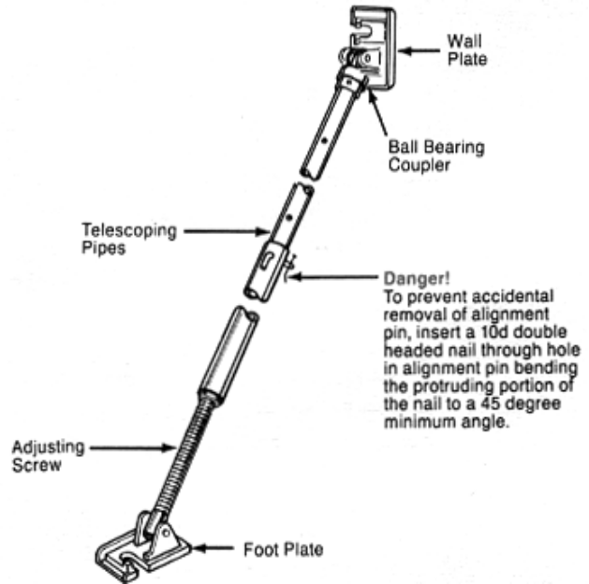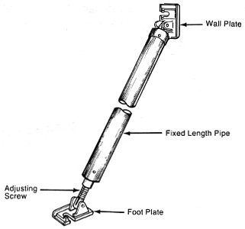

To fix the brace to the footing or panel bolts or nuts with washers of the correct grade and size must be used. The anchor bolt and washer combination on the foot of the brace should have adequate bearing capacity. Sometimes the bolt head and washer are too small for the slot size on the brace foot. This can cause the washer to collapse and the panel to move. As a general principle the slot width on the brace foot should not exceed the diameter of the thread or sleeve on the anchor bolt by more than 2 mm - unless otherwise stated by the anchor supplier.

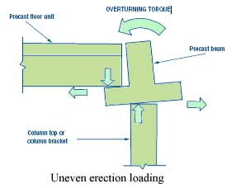
Precast beams and floors
Where beams are to have floor systems placed on them prior to the beams being fully built into the structure, allowance should be made for uneven loading on the beam during construction. With floor units placed only on one side of a beam, additional temporary propping may be required to each edge of the beam (see figure 8.5).

Face and Edge lifting

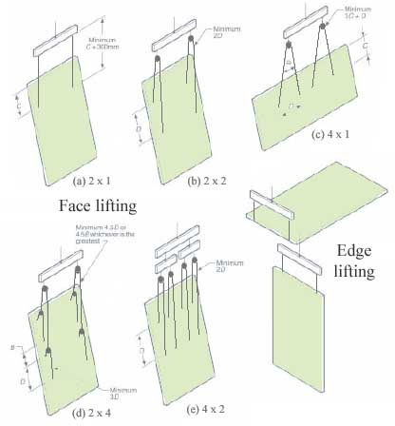
The rigging configuration, spreader bar length and sling lengths are specified in AS 3850. The crane size and boom lengths are determined by the crane company.
Before the panels are cast, have the crane company representative assist in the layout to ensure that the panels can be lifted in the sequence cast.

