Tilt-up construction
Framework or roof structure
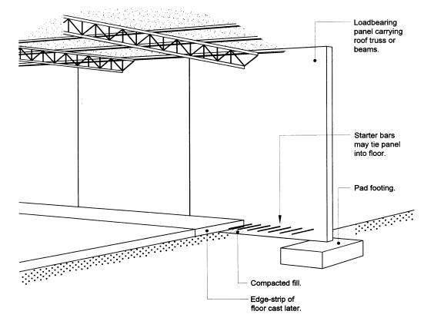
must pull the panel inwards.
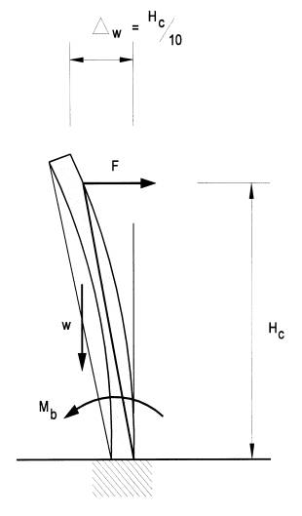

Infill strip

The value for outward displacement
of one tenth of the panel's height is
based on observations of deflections
on buildings during a fire.

