Stability of free standing walls

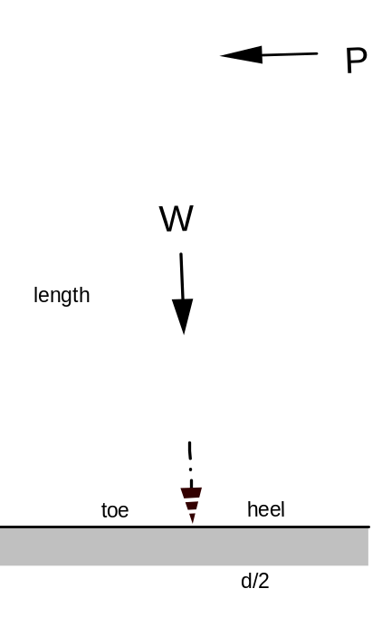Free standing walls subjected to a lateral force need special attention. They can easily fail. Usually they have quite a sufficient resistance to sliding, but lateral forces may overturn it about the toe.
The overturning moment due to the lateral force shown in Figure 1 (P x l) must be balanced by the moment due to the weight of the wall (W x d/2)
P x length < W x d/2
In practice a safety factor of 1.5 to 2 is needed to provide adequate stability. That means the overturning effect of the lateral force equals  to ½ respectively of the balancing moment of the wall.

Brick fences are a problem in high wind loading areas as the following example will show.
Figure 1

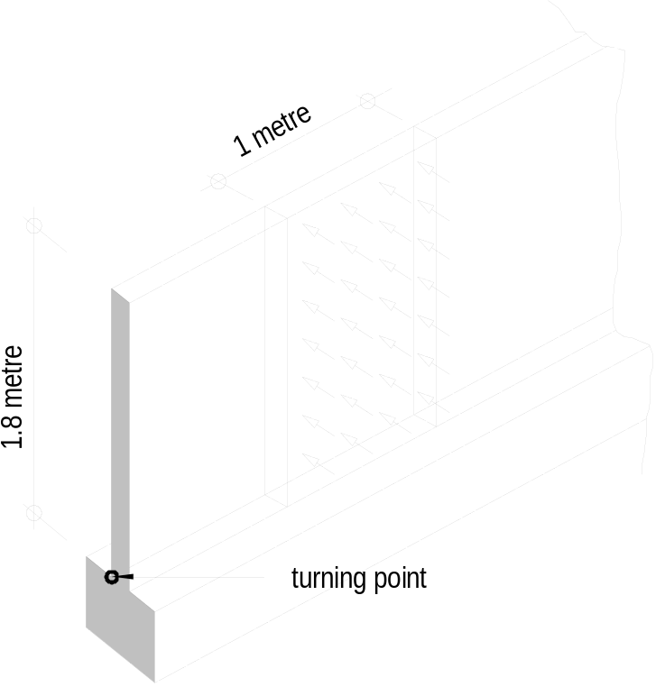Example
A boundary brick wall 1.8 metre high and 110 mm thick as shown in Figure 2 is subjected to a wind pressure of 400 N/m².
(weight of brickwork is 20 kN/m³)
Calculate the factor of safety against overturning. Neglect the bond between the brickwork and the footing.

Solution
Weight of wall (1 metre strip)
W = 1.80 × 1.00 × 0.11 × 20
= 3.96 kN
Figure 2

Wind pressure (1 metre strip)
Convert 400 N/m² to 0.4 kN/m²
Wind load = 1.80 × 1.00 × 0.4
= 0.72 kN
The resultant wind pressure can be taken as acting at the centre of the height of the wall (1.8/2 = 0.9 m).
Moment due to the weight = 3.96 × 0.110/2
=0.218 kNm
Moment due to wind = 0.72 × 1.80/2
=0.648 kNm
Factor of safety
against overturning = 0.218/0.648
= 0.336

The factor of safety is less than 1.0, therefore the wall will not withstand the wind loading. The weight of the wall must be increased.
Lets increase the thickness to 230 mm and see whether this wall is strong enough to resist the wind load.
Weight of wall = 1.80 ×1.00 × .230 × 20
= 8.28 kN
Moment due to weight = 8.28 × 0.230/2
= 0.952 kNm

Factor of safety
against overturning = 0.952/0.648
= 1.469

Now the wind resisting moment of the wall is 68% greater than the moment due to the wind.

As can be seen the stability of a free standing wall needs to be considered very carefully.

