Soil properties

Soil consists of a mass of solids particles separated by spaces or voids. The voids of a soil are usually a mixture of air and water (soil is partially saturated). In certain circumstances the voids may be completely filled with water or air only. If only air is present the soil is dry and if only water is present the soil saturated. The Figure1 shows a cross-section through a granular soil.
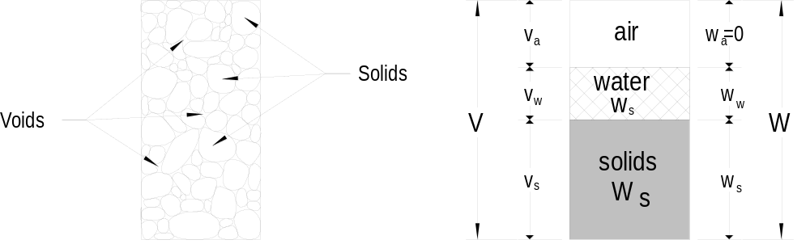

Figure 1 Cross-section through granular soil

In order to study the properties we will adopt the idealised form of the diagram shown in Figure 1.

The soil mass has a total volume V, containing a volume of solid particles V_{s} and a volume of voids V_{v}. In most cases the void volume exists of a mixture of water (V_{w)} and air (V_{a)}.

The designation for the weight is W and the weight of water is W_{w} and the weight of air is zero as shown on the right side in Figure 1 (b).

Figure 2 shows the three cases in diagrammatic form soil with water and air contents and a mixture of both.

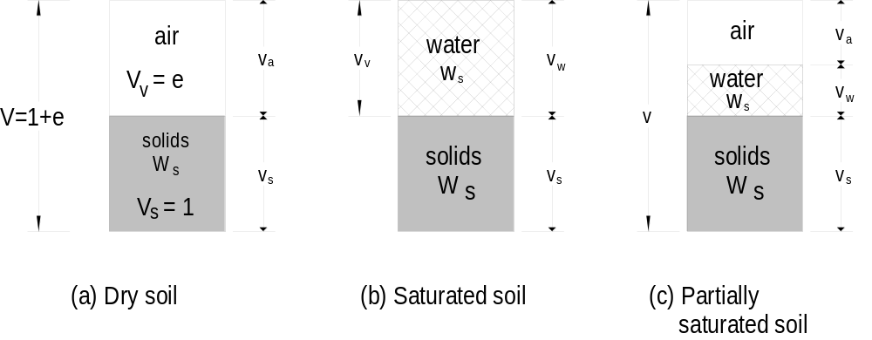

Figure 2 Water and air contents in a soil
Void ratio (e)

The volume of voids, V_{v}, is obviously equal to V - V_{s}.
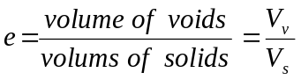

For ease of calculating we will assume that all solids are compressed together and their volume considered equal to a unit volume as shown in Figure 1 and Figure 2.

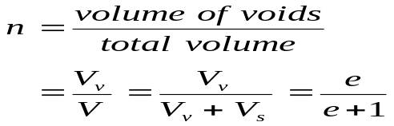Porosity (n)

Degree of saturation (S_{r})

When both air and water are present the soil is said to be partially saturated. The degree of saturation is simply
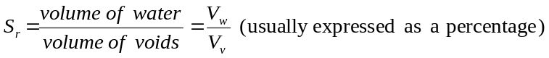

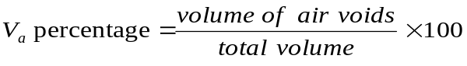Percentage air voids

The ratio of the volume of air to the total volume of soil is known as the percentage air voids.

Density (ρ) and unit weight ()

We can express the amount of material in a given volume , v, in two ways:
the amount of mass, M, in the volume, or
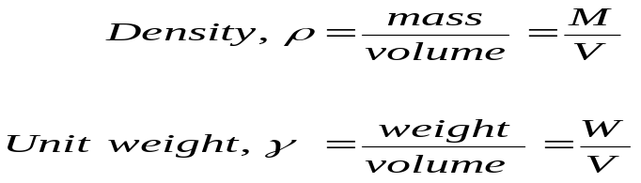 the amount of weight, W, in the volume, or

The weight is:

weight = mass × gravitational acceleration

[Gravitational acceleration = 9.81 m/s² (for ease use 10 m/s²)]

The unit for the force or weight is the newton (N) ∴(1 N = 1kg × 1 m/s²)
∴the weight of 1 kg = 10 N

Density of water at 4°C, ρ_{w} = 1000 kg/m³ = 1 Mg/m³; hence the weight of water, γ_{w} ≈ 10,000 N/m³ = 10 kN/m³. (1 Mg/m³ = 1 Tonne/m³)
(Where γ_{w} = unit weight of water at 4°C)

Specific gravity (G_{s})

The specific gravity of a material is the ratio of the weight or the mass of a volume of the material to the weight or mass of an equal volume of water.
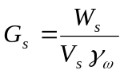

Unit weight of soil

The unit weight of a material is its weight per unit volume. In soil work the most important unit weights are as follows:

Bulk unit weight (γ_{b})
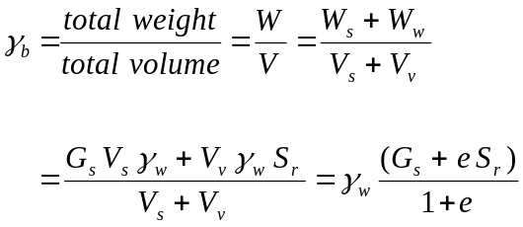This is the natural in-situ unit weight of a soil

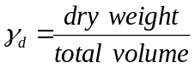Dry unit weight (γ_{d})

Example calculation

A soil sample has a weight of 0.7 kg and the volume was found to be
3.5 × 10⁻⁴ m³. After drying out the weight was reduced to 0.6 kg. The particle specific gravity test gave 2.6. Determine the following:
- Moisture content  - Dry density  - Bulk density | - Void ratio  - Porosity  - Degree of saturation

- Moisture content

Weight of water is 0.7 kg – 0.6 kg = 0.1 kg
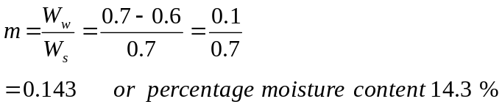

- 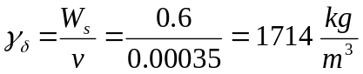Dry density

- Bulk density
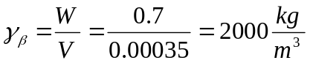

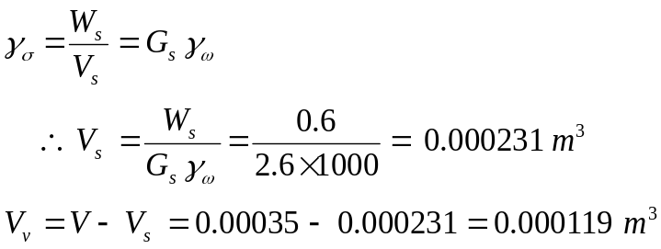To calculate the void ratio we must first calculate the density of particles

- 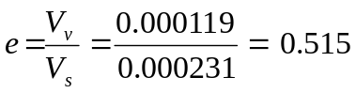Void ratio

- Porosity
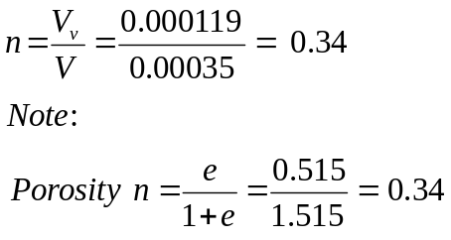

(f) Degree of saturation
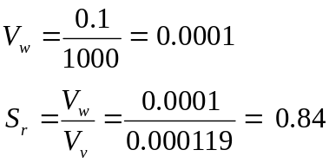

Formula - Summary

