Plasticity

Consistency limits
Liquid limit (LL) is when the soil represents a near liquid state. This occurs at very high water contents when the soil behaves as a viscous liquid in that it flows and will not hold a specific shape. In other words the soil will flow under its own weight.

Plastic limit (PL) is the lowest water content at which the soil exhibits plastic behavior. It is the minimum moisture content at which the soil can be rolled into a thread of 3mm diameter without breaking up.

Shrinkage limit (SL) is the water content at which there is no more volume change in the soil due to reduction in water. In other words the maximum moisture content at which further loss of moisture does not cause a decrease in the volume of the soil.

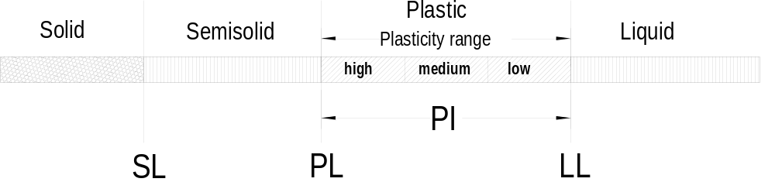Plasticity index (PI) is the range of moisture content in which the soil is plastic; the finer the soil the greater is the plasticity index.

Plasticity index = liquid limit – plastic limit
PI = LL - PL

