Rock Formation

IGNEOUS ROCKS

Examples ⇒ Granite, Basalt, Obsidian, Pumice
Igneous rocks are formed from molten magma or lava. The word, igneous means, "fire". All igneous rock starts deep in the earth as hot, molten magma.
If the magma cools and hardens inside the earth it is called "intrusive" rock. These rocks cool slowly and have large crystals. When the magma comes out of the earth's crust through a volcano, it is called "extrusive". It cools off quickly, and the crystals that form are very small.
Molten, or hot, liquid rock is called MAGMA when it is still inside the earth, but once it comes out through a volcano it is called LAVA.

SEDIMENTARY ROCKS

Examples ⇒ Limestone , Jasper, Gypsum, Conglomerate, Sandstone
Every minute of every day, rocks are being worn down by wind and rain. Tiny grains of dirt, sand, mud and clay are worn off and washed into streams, rivers, lakes and oceans. When these tiny bits of sand and dirt settle to the bottom of the water, they are called sediment.
Minerals in the water and microscopic, or very tiny sea animals also get mixed in with the dirt and sand to form the sediment. Every day more sediment piles on top of what is already there.
After.thousands and millions of years we end up with a really deep pile of sediment. The weight and pressure from all the stuff on top turns the sediment on the bottom into sedimentary rock!

METAMORPHIC ROCKS
Example ⇒ Quartz, Amethyst, Marble, Slate, Gneiss, Graphite, Coal
Metamorphic rocks are formed when other kinds of rocks are changed by great heat and pressure inside the earth.
The word "metamorphic" means changed. Think of metamorphic rocks as recycled rocks. When igneous, sedimentary or even metamorphic rocks get buried deep beneath the surface of the earth, over millions of years the heat and pressure inside the earth change them into something else.
Limestone can be changed to marble, sandstone can be changed into quartzite, and shale can be changed to slate. It's just another example of how the earth is constantly changing!
Topographic Maps
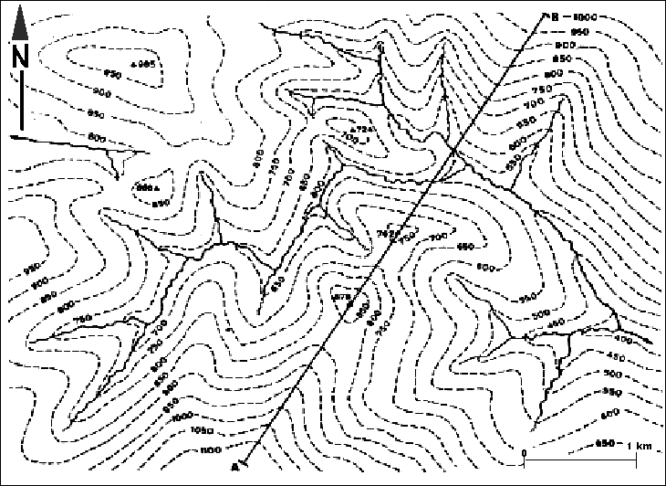
Particular features can be recognised from the contour pattern, thus allowing a mental picture of the topography to be constructed. Studying the natural features such as rivers, lakes, marshes, cliffs and coasts, which are shown in topographic maps, helps to identify the hills and valleys which together form the topography of an area.

Geological Maps

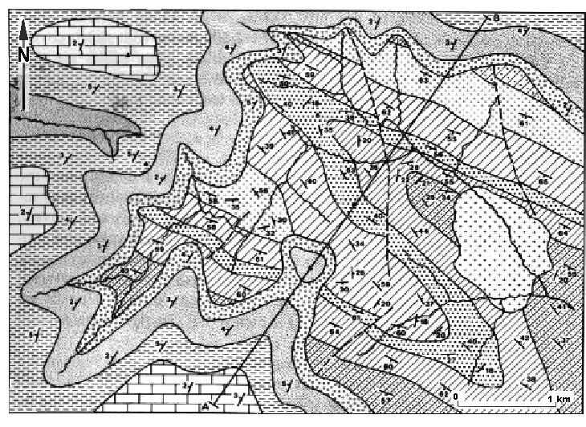
Geological maps show the distribution of the superficial deposits (glacial sands and gravel, boulder clay, alluvial sands and gravel etc) and the underlying solid rocks at the earth’s surface. The distribution of the solid rocks in a particular region is shown by means of geological boundaries, drawn as lines in the geological map.

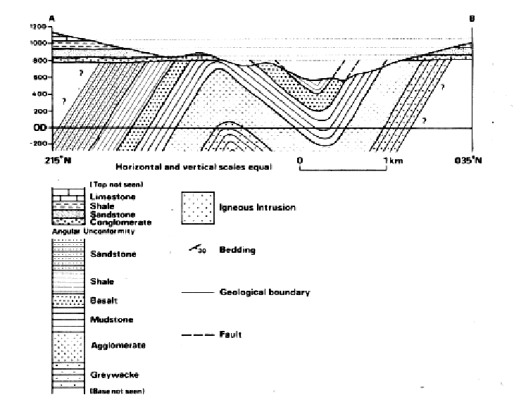
Stratigraphic column showing in chronological order the sequence of geological formation shown in Figure 2

Geological maps are generally accompanied by vertical cross-sections, a stratigraphic column, a legend or key showing the structural symbols, ornament and colours used on the map, and a brief description of the geology.
Vertical cross-sections are drawn across the map to illustrate the geological structure of the rocks, as shown in the above cross-section.

Soil properties

Soil consists of a mass of solids particles separated by spaces or voids. The voids of a soil are usually a mixture of air and water (soil is partially saturated). In certain circumstances the voids may be completely filled with water or air only. If only air is present the soil is dry and if only water is present the soil saturated. The Figure1 shows a cross-section through a granular soil.
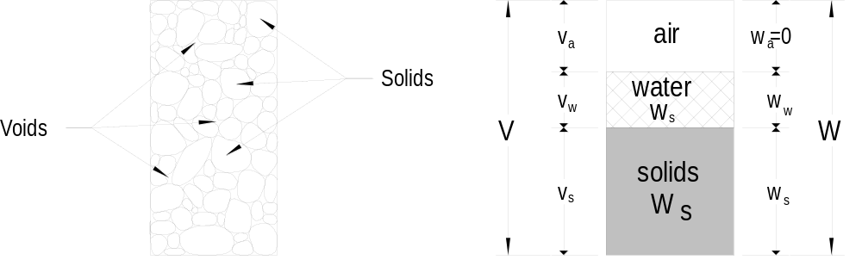

Figure 1 Cross-section through granular soil

In order to study the properties we will adopt the idealised form of the diagram shown in Figure 1.

The soil mass has a total volume V, containing a volume of solid particles V_{s} and a volume of voids V_{v}. In most cases the void volume exists of a mixture of water (V_{w)} and air (V_{a)}.

The designation for the weight is W and the weight of water is W_{w} and the weight of air is zero as shown on the right side in Figure 1 (b).

Figure 2 shows the three cases in diagrammatic form soil with water and air contents and a mixture of both.

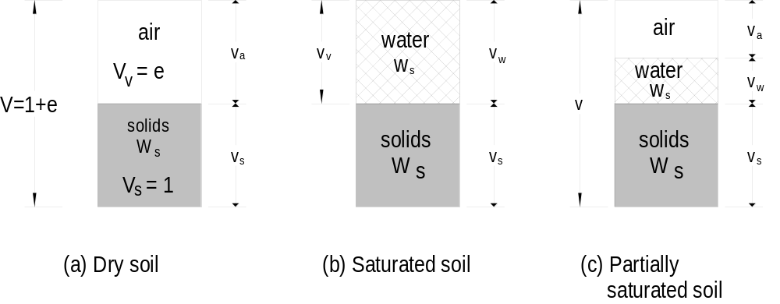

Figure 2 Water and air contents in a soil
Void ratio (e)

The volume of voids, V_{v}, is obviously equal to V - V_{s}.
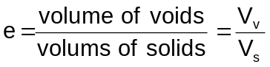

For ease of calculating we will assume that all solids are compressed together and their volume considered equal to a unit volume as shown in Figure 1 and Figure 2.

Porosity (n)
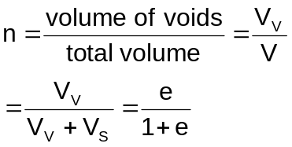

Degree of saturation (S_{r})

When both air and water are present the soil is said to be partially saturated. The degree of saturation is simply
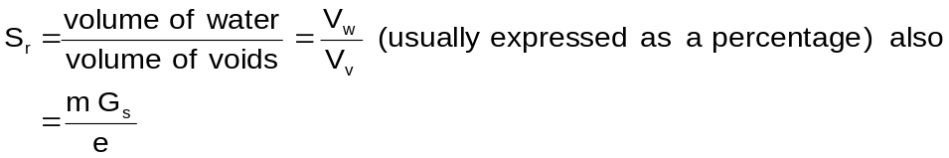

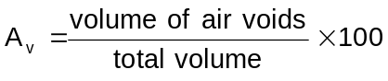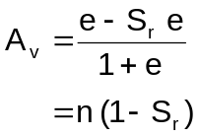Air void ratio (Percentage air voids)

Also

The ratio of the volume of air to the total volume of soil is known as the percentage air voids.

Density (ρ) and unit weight ()

We can express the amount of material in a given volume , v, in two ways:
the amount of mass, M, in the volume, or
the amount of weight, W, in the volume, or

The weight is:

weight = mass × gravitational acceleration

[Gravitational acceleration = 9.81 m/s² (for ease use 10 m/s²)]

The unit for the force or weight is the newton (N) ∴(1 N = 1kg × 1 m/s²)
∴the weight of 1 kg = 10 N

Density of water at 4°C, ρ_{w} = 1000 kg/m³ = 1 Mg/m³; hence the weight of water, γ_{w} ≈ 10,000 N/m³ = 10 kN/m³. (1 Mg/m³ = 1 Tonne/m³)
(Where γ_{w} = unit weight of water at 4°C)

Specific gravity (G_{s})

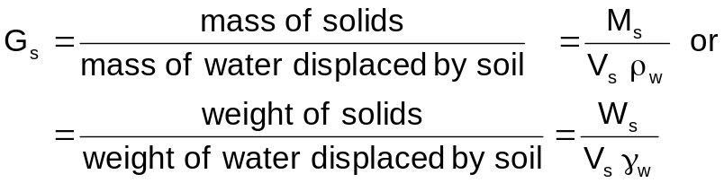The specific gravity of a material is the ratio of the weight or the mass of a volume of the material to the weight or mass of an equal volume of water.

Bulkdensity (ρ)
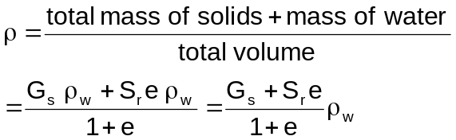

Dry density (ρ_{d})
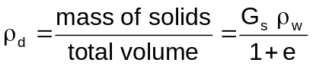

Unit weight of soil

The unit weight of a material is its weight per unit volume. In soil work the most important unit weights are as follows:

Bulk unit weight (γ_{b})
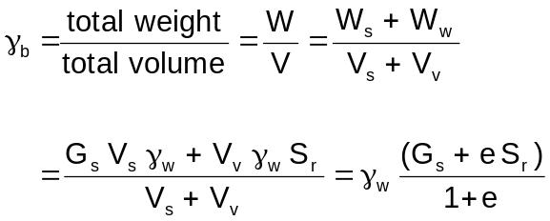This is the natural in-situ unit weight of a soil

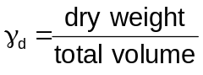Dry unit weight (γ_{d})

Example calculation

A soil sample has a weight of 0.7 kg and the volume was found to be 3.5 × 10⁻⁴ m³. After drying out the weight was reduced to 0.6 kg. The particle specific gravity test gave 2.6. Determine the following:
- Moisture content  - Dry density  - Bulk density | - Void ratio  - Porosity  - Degree of saturation

- Moisture content

Weight of water is 0.7 kg – 0.6 kg = 0.1 kg
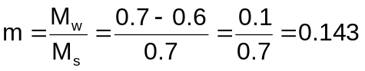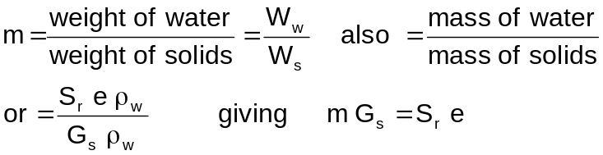

- 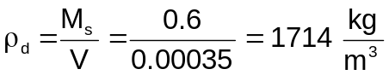Dry density

- Bulk density
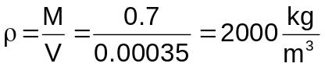
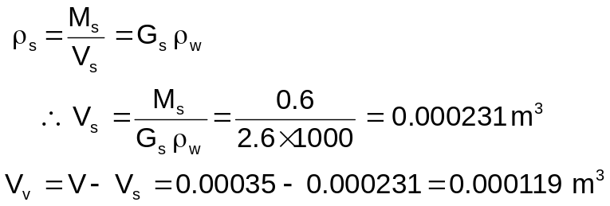To calculate the void ratio we must first calculate the density of particles

- 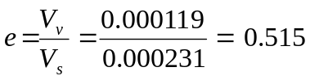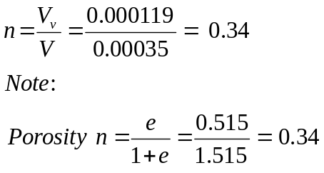Void ratio

- Porosity

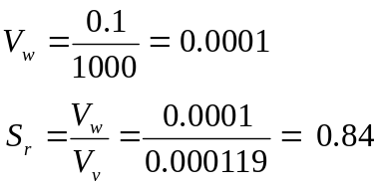 (f) Degree of saturation

Classification and Soil Properties

Soils usually are classified according to their grain size. We have coarse-grained non-cohesive and fine-grained cohesive and organic soils. The grain of the various soils are all different. Table 1 below shows the range of particle sizes

Table 1 Particle size limits
Type | Range of particle size  in millimeter
Cobbles  Coarse gravel  Medium gravel  Fine gravel  Coarse sand  Medium sand  Fine sand  Coarse silt  Medium silt  Fine silt  Clay | 200 – 60  60 –20  20 – 6  6 – 2  2 – 0.6  0.6 – 0.2  0.2 – 0.06  0.06 – 0.02  0.02 – 0.006  0.006 – 0.002  Less than 0.002

The distribution of the particles is determined by sieving. The chart shown in Figure 1 is used for the sieve analysis. The percentage of a sample greater than a given size is determined for coarse soils. For fine soils the particle sizes are meaningless. The distinction between silt and clay is made not on the basis of an arbitrary size distinction but on their behaviour in the present of water. The consistency of fine soil varies with the amount of water present.

Particle size distribution

In the graph shown in Figure 1, curve 1 presents a well graded silty sand (high percentage of silt fraction), curve 2 a uniform fine sand (with a high percentage of equal grain sizes), and curve 3 a well graded sand.

Figure 1 Particle size distribution

Consistency limits
Liquid limit (LL) is when the soil represents a near liquid state. This occurs at very high water contents when the soil behaves as a viscous liquid in that it flows and will not hold a specific shape. In other words the soil will flow under its own weight.

Plastic limit (PL) is the lowest water content at which the soil exhibits plastic behavior. It is the minimum moisture content at which the soil can be rolled into a thread of 3mm diameter without breaking up.

Shrinkage limit (SL) is the water content at which there is no more volume change in the soil due to reduction in water. In other words the maximum moisture content at which further loss of moisture does not cause a decrease in the volume of the soil.

Plasticity index (PI) is the range of moisture content in which the soil is plastic; the finer the soil the greater is the plasticity index.

Plasticity index = liquid limit – plastic limit
PI = LL – PL

Figure 2 shows the different stages of a plastic soil and the volume changes due to moisture content.
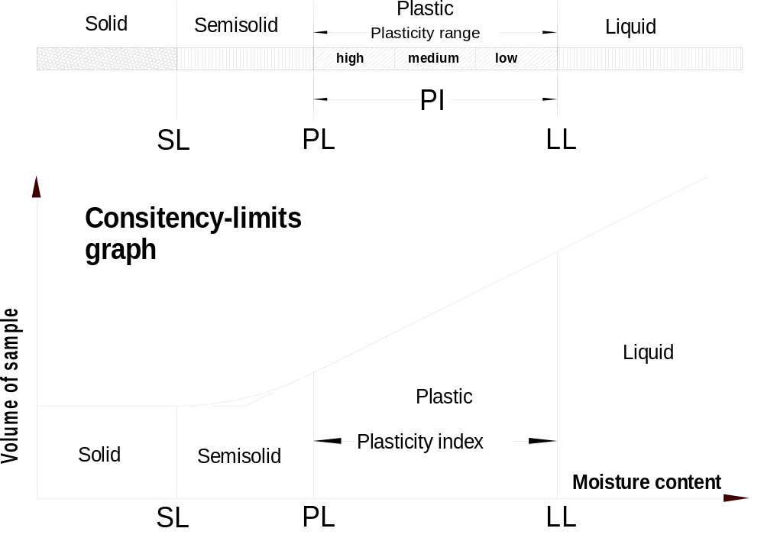

Figure 2

Soil classification

As stated before natural soil consists usually of a mixture of sand, silt and clay. If a soil contains mostly sand and some clay then we would call it clayey sand. There exists an international texture classification that refers to the descriptive names of the soil. In this classification the descriptive names refer to a percentage composition with the following size limitations:

Sand 2.0 to 0.05 mm diameter

Silt 0.05 to 0.002 mm diameter
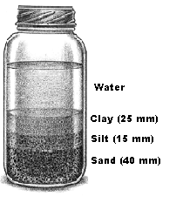
Clay smaller than 0.002 mm diameter

The find the percentage distribution of sand, silt and clay a soil sample from the site should be taken. Fill a container with water and add the soil sample to it. Shake the container vigorously and leave it standing until the soil particles have settled. Then measure the layer thickness of each layer as shown in Figure 2. All layers add up to 80 mm. We find the percentage of the different layers by dividing the single layer thickness by the total thickness of all layers (that is 80 mm.). The percentages are shown below.

Percentage of clay = 25/80 = 31.25 %

Percentage of silt = 15/80 = 18.75 %

Percentage 0f sand = 40/80 = 50.00 %

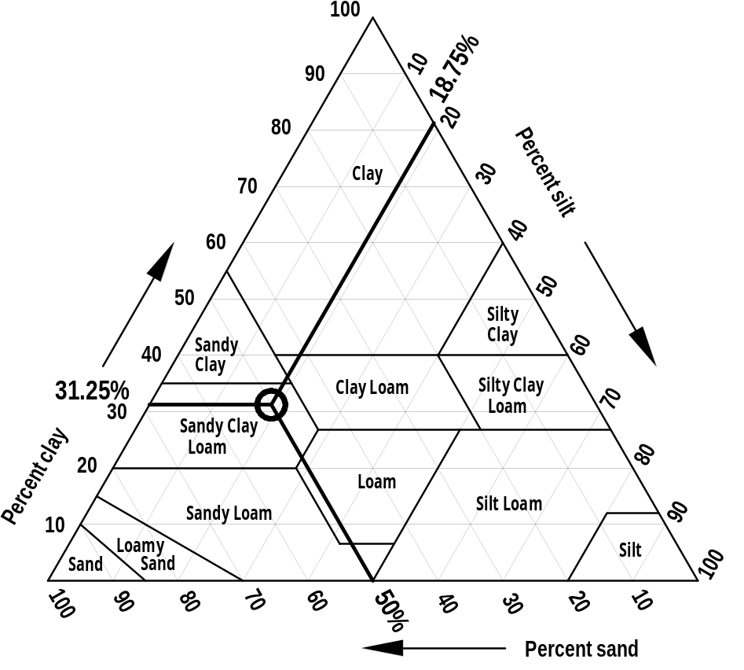The textural classification chart is shown in Figure 3.

Figure 3

