BEARING CAPACITY OF SOILS

The bearing capacity depends on the behaviour of the ground under a building and its interaction with the foundation. (Do not get mixed up with footings and foundation.) The structural load of a building must be safety and economically transferred to the ground without unacceptable settlement.

A site investigation should be carried out to find out what type of structure it supports, its loading and the amount of movement that can be tolerated. For large building constructions a geotechnical site investigation according to AS 1726-1993 should be carried out. The requirements for the classification of a site and the design and construction of a footing system for a single dwelling house, townhouse or the like are found in AS 2870-1996 Residential slabs and footings-Construction.

The ultimate bearing capacity for a typical foundation base is the average vertical pressure on the ground that leads to failure by shear, in other words the average contact pressure between the foundation and the soil that will produce shear failure in the soil.

The maximum safe bearing capacity is the maximum value of contact pressure to which the soil can be subjeted without risk of shear failure. This is based entirely on the strength of the soil and is the ultimate bearing capacity divided by an appropriate factor of safety.

The allowable bearing pressure is according AS2870-1996 (Residential slabs and footings-Construction) the maximum bearing pressure that can be sustained by the foundation from the proposed footing system under service loads over the design range of soil moisture conditions. Allowable bearing pressure shall be taken into consideration both the site conditions and the ability of the building system to accommodate settlement.

Pressure distribution in soil

The pressure at depth h in a foundation is due to the weight of the building and the self-weight of the soil above the depth h.
Figure 1 illustrates the theory of pressure distribution within the foundation. The soil mass acts as an elastic medium. The circular footing load placed on the soil mass will induce stresses within the soil. The circles, known as bulbs of equal pressure, give an indication of the vertical pressure below the foundation. As can be seen the pressure from the building load decreases (see lower diagram in Figure 1) while the pressure from the self-weight of the soil increases.
From the bulb pressure you will get some idea of the depth of soil affected by a footing.
The width of a footing determines at what depth the pressure from the building is reduced to a neglected value. The pressure should be followed up to a depth of 2B to 3B (B = footing width)
Study Figure 1 carefully and make sure that the principle of pressure distribution within the foundation material is understood.
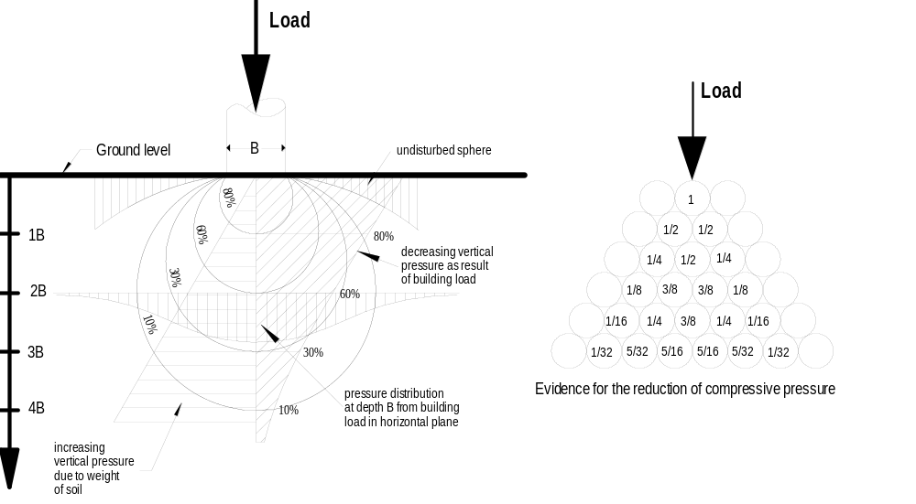
Figure 1

As can be seen from Figure 2 it is important to investigate the site to a greater depth. The depth at which the soil pressure needs to be considered depends on the width of the proposed footings.

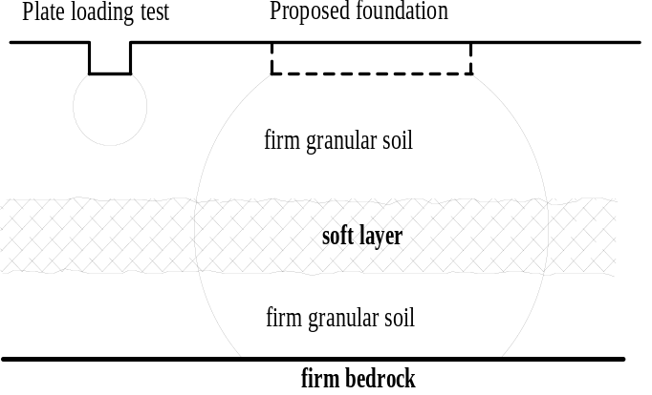A ‘plate loading test’* can give misleading results if the proposed footing width is much lager than the plate size.

Bore holes should therefore be taken down to a depth of 1.5 to 2 times the width of the footing.
* Plate bearing test are used for estimating the allowable loadbearing pressure.

Figure 2

Bearing capacity of soils

Consider an element of soil under a foundation Figure 3. The vertical downward pressure of the footing, q, is a major principle stress causing a corresponding lateral active earth pressure, p.

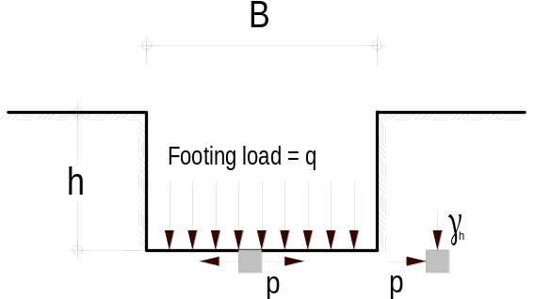For particles beyond the edge of the foundation this lateral stress can be considered as a major principal stress (i.e. passive resistance) with its corresponding vertical minor principal stress γ_{z} (the weight of the soil).

Figure 3

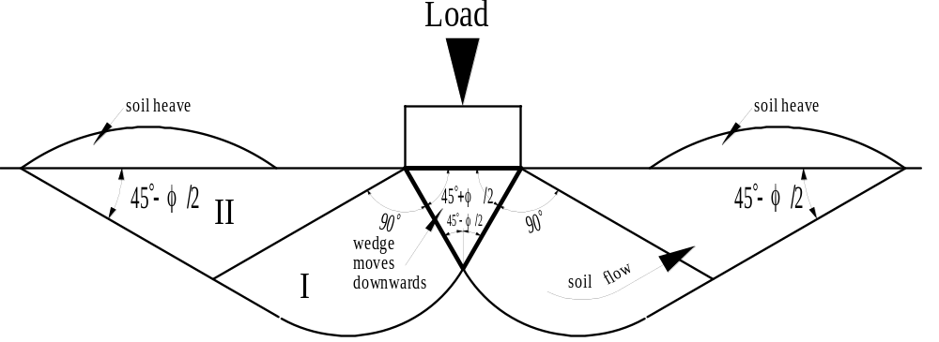A number of analyses have been carried out to find the ultimate bearing capacity of the soil, q_{u}, when the footing is at the surface as shown in Figure 4.

Figure 4

The footing is moving downwards into the soil with no attendant rotation. The triangular wedge of soil immediately below the footing goes down with the footing and suffers no deformation, and creates an area of plastic flow (I) that is prevented from moving outwards by the passive resistance of wedge (II).

Another theory is the slip circle method as shown in Figure 5 (a). With slip circle methods the foundation fails by rotating about some slip surface. The slip surface is taken as the arc of a circle. Almost all foundation failures showing rotational effects. The actual centre of rotation is slightly above the base of the foundation and to one side of it as shown in figure 5 (b).

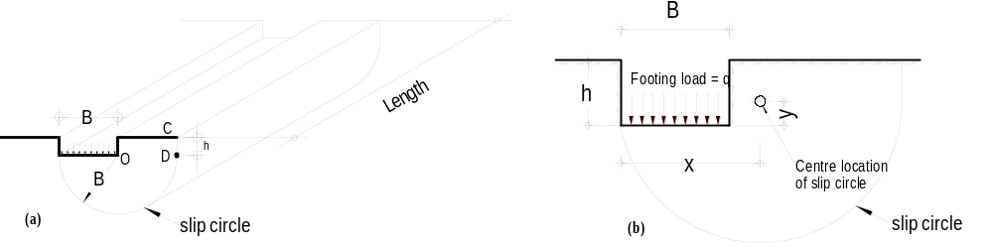Figure 5

This is shown to provide you with some theoretical background knowledge. The derivation of all equations for the different theories is beyond the scope of this subject.

Table 1
Properties of cohesive clay soils
Material | State | SPT (No) | CPT (Mpa) | C (kPa) | ABP (kPa)
Alluvial clays | soft | 2 - 4 | 0.3 - 0.5 | 20 - 40 | < 75
 | firm | 4 - 8 | 0.5 - 1 | 40 -75 | 75 -150
Till and tertiary clays | stiff | 8 - 15 | 1 - 2 | 75 - 150 | 150 - 300
 | very stiff | 15 - 30 | 2 - 4 | 150 - 300 | 300 - 600
 | hard | > 30 | >4 | > 300 | > 600

Table 2
Properties of sands
Packing | RD | SPT | CPT | φ | SBP
very loose | <0.2 | < 5 | < 2 | < 30 | < 30
loose | 0.2 - 0.4 | 5 - 10 | 2 - 4 | 30 - 32 | 30 - 80
med. Dense | 0.4 - 0.6 | 11 - 30 | 4 - 12 | 32 - 36 | 80 - 300
dense | 0.6 - 0.8 | 31 - 50 | 12 - 20 | 36 - 40 | 300 - 500
very dense | > 0.8 | > 50 | >= 20 | >= 40 | >= 500

According to the BCA footings must be at least 300 mm below the ground level, see dimension h in Figure 3. AS 2870 p29 give dimension D_{s} for different site classes. The pressure increases with the depth similar to hydrostatic pressure. The particles beyond the edge of the foundation provide lateral resistance (passive earth pressure).
A foundation will usually fail by rotating about one edge. This is illustrated in Figure 2 with a foundation at depth z below the surface.

RETAINING WALLS

Liquid pressure
From diving experience we know that the pressure in a liquid (e.g. water) becomes greater the deeper we dive. Consider the vertical surface A-B of the wall in Figure 1. The cube situated at depth h exerts a pressure of w× h (kN) on all its surfaces. If one face of the cube is touching the wall it will exert a pressure onto the wall.
The density of water, ρ_{w} = 1000 kg/m³ = 1Mg/m³.
The weight of 1000 kg mass is 1000 × 9.806 = 9806 N. (weight = mass × gravitational acceleration) Hence the unit weight of water, γ_{w}, is 9806 N/m³ = 9.81 kN/m³. Instead of using the exact figure for the gravitational acceleration we approximate this figure to 10 m/s². This provides a safety margin of approximately of 2% and on the other hand it suits the decimal system and eases the calculations.
w is the equivalent density of water which in our case, will always be 10 kN/m³. In the right diagram of Figure 1 the pressure at the surface is zero and at depth h is w× h. The average pressure of the ‘wetted area’ between A and B is ½ w× h (kN/m²).
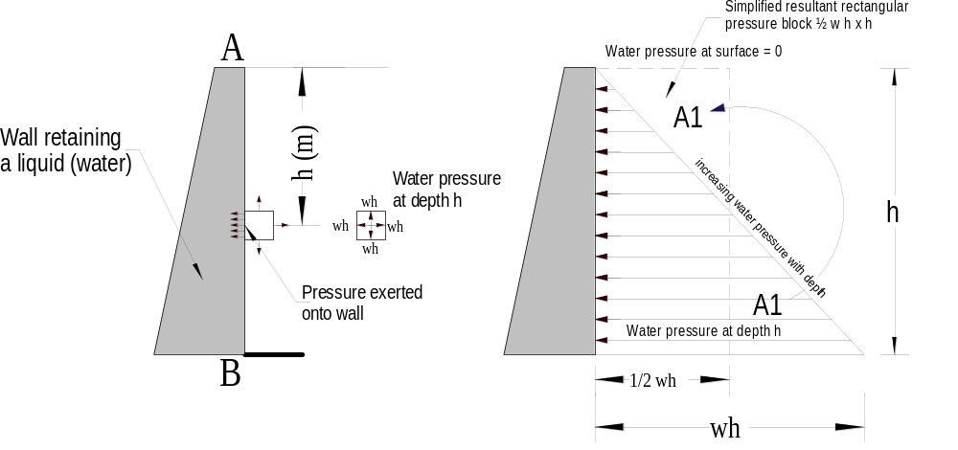
Figure 1

In structures, it is convenient to consider the forces acting on a metre length of member, as shown in Figure 2.

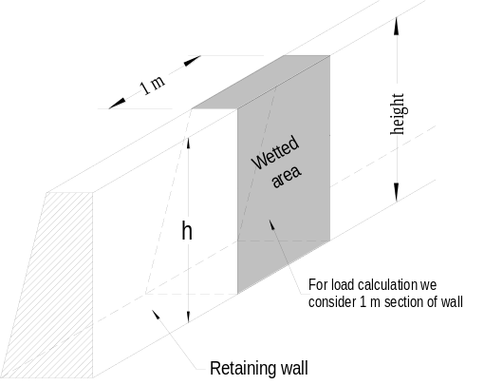Therefore the ‘wetted area’ is h m². The total force caused by the water pressure on one metre strip of wall is:
‘Wetted area’ × average rate of pressure
= h × ½ w h

= ½ × w h² (kN)
As can be seen from Figure 1 the forces range from
zero at the top to wh at the base.

Figure 2

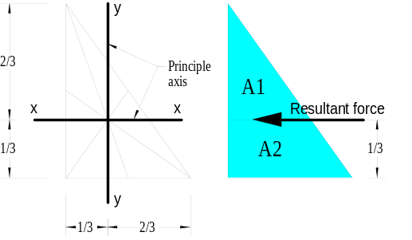The opposite diagram shows the centre of gravity in relation to the principle axis. The centre of gravity for all triangles is at a rd from the base. (Any side of the triangle can be the base.) A parallel line from the base at rd of the height divide the area of the triangle into equal parts (A1=A2). The resultant force (½ × w h²⁾ (kN) will therefore act at a point rd of h from the base. If the liquid does not reach the top of the wall then the resultant force is calculated with h as the depth of the liquid and not as the height of the wall.
Figure 3

Example 1
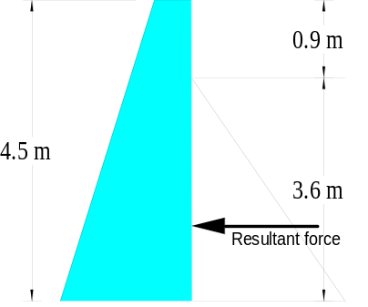
A dam retains water on its vertical surface as shown in Figure 3. The dam has a height of 4.5 metre, and the water level is 0.9 metre below the top of the dam.
What is the resultant water pressure per metre run of dam?

Solution
The equivalent density w of water = 10 kN/m³
P = ½ × w × h²
= ½ × 10 × 3.6²
= 64.8 kN
Figure 4

Soil pressure

There is some similarity between the calculation of the lateral pressure in water and soil. However, it is apparent that pressures on vertical surfaces from retained soils cannot be determined with the same accuracy as with water. Soils vary in character and weight and behave quite differently under these varying conditions. There are a number of soil pressure theories for the calculation of soil pressure but only the Rankine’s theory will be dealt with.
As the density of soil can vary there will be a number of different unit weight figures and not only one as for water. Instead of using w as for the density of water, γ will be used for the density of soil (see also properties of soil).
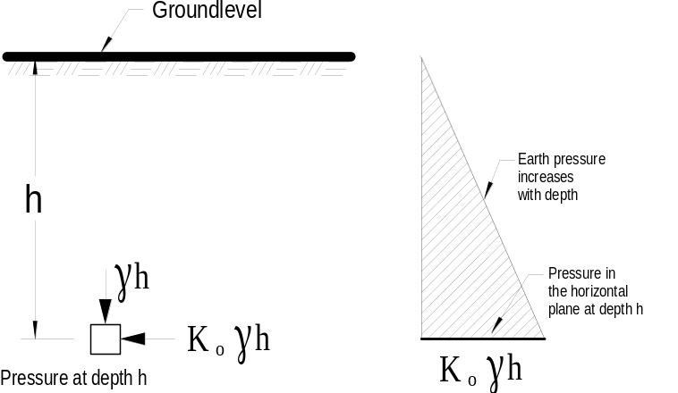Consider a mass of soil with a horizontal upper surface and let the soil be completely at rest, undisturbed by any forces other than its on weight. If the unit weight of the soil is γ then an element at a depth h below the surface will be subjected to a vertical pressure γ × h. This stress is a major principal stress is, i.e. σ₁ = γ h (multiplying sign omitted). There is of course also a lateral stress or minor principal stress σ₃. The ratio between the σ₁/σ₃ for Figure a soil at rest is given the symbol K_{o} and is
Figure 5 called the coefficient of earth

pressure at rest. The lateral pressure in a soil at rest is = K_{o} γ h

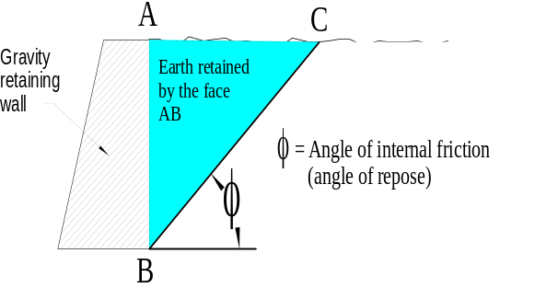Consider, for example, the soil retained by the vertical face AB in Figure 5. If the wall (retaining face AB) was removed, then some of the soil would probably collapse. After the soil has collapsed it would assume a line BC as shown. The angle φ made between the horizontal and the line BC will vary with different types of soil. This angle is called the Angle of repose or the angle of internal frictionof the soil. It can be said that only part
of the soil in fact being retained by the wall
Figure 6 and was exerting pressure on the wall. It follows that the amount of pressure on the wall depends upon the angle of repose for the type of soil concerned.

Active and passive earth pressure
Contemplate a smooth vertical wall supporting a mass of soil at rest in which the lateral pressure on the wall is = K_{o} γ h. If the wall is allowed to yield, i.e. move forward slightly, there will be an immediate reduction in the value of lateral stress, but if the wall is pushed slightly into the soil there will be an increase in the value of the lateral pressure.
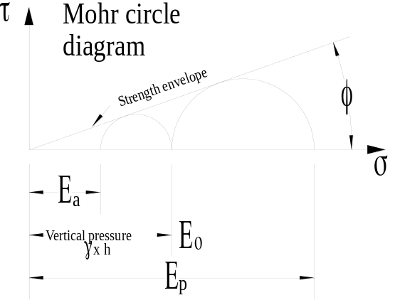If the vertical pressure remains unchanged at γ h, then the minimum and maximum values of lateral earth pressure that will be achieved can be obtained from the Mohr circle. The lateral pressure can be reduced to a minimum value at which the stress circle is tangential to the strength envelopeof the soil. The minimum value is known as the active earth pressure (E_{a}), and the value equals K_{a} γ h where K_{a} = the coefficient of active earth pressure.
The lateral pressure can rise to a maximum value (with the stress circle again tangential to the strength envelope) known as passive earth pressure (E_{p}), which equals Kp γ h where K_{p} = the coefficient of passive earth pressure.

Figure 7

It can be seen from Figure 6 that when considering active pressure the vertical pressure due to the soil weight (γ h) is a major principal stress and that when cosidering passive pressure the vertical pressure due to the soil weight (γ h) is a minor principal stress.

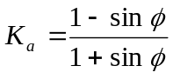In short Rankine’s theory states in general terms that the active earth pressure coefficient is:

And the passive earth pressure coefficient is

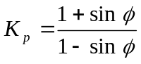
The active earth pressure per square metre at a depth h (m) due to a level fill of soil is therefore
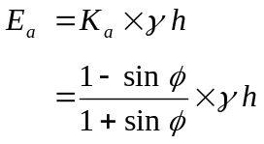
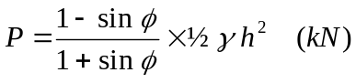The soil acts at this average rate on an area of h m² of wall, so the total resultant force per metre run of wall is

Example 2
A soil weighing 19 kN/m³ and having an angle of repose φ of 34°, exerts a pressure on a 3.6 metre high vertical face of a wall.
What is the resultasnt horizontal force per metre run of wall?

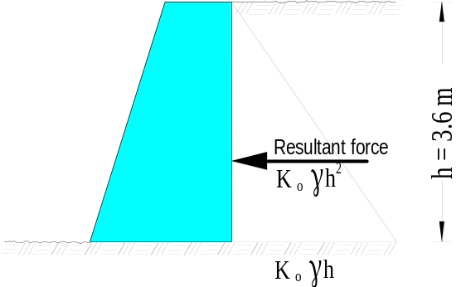

Solution
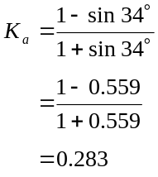
E_{a} = 0.283 × 19 × 3.6
= 19.34 kN/m
The total horizontal force from the raetained earth acting on the wall surface is
P = 19.34 × ½ 3.6
=.34.84 kN
It is of advantages to calculate the individual
Figure 8 components, especially if you need to know the E_{a} figure. Compare this result with the liquid pressure in Example 1. As you can see the force due to hydrostatic (liquid) pressure is much less than the force due to earth pressure. This results from the internal friction (φ higher in sand than in clay) between the grains of the soil represented by the K_{a} figure.

It is beyond the scope of this subject to derive the
The maximum

outwards on all its six surfaces.increases with depth Consider an element of soil under a foundation Figure 1. The vertical downward pressure of the footing, w, is a major principle stress causing a corresponding lateral active earth pressure, p. According to the BCA footings must be at least 300 mm below the ground level, see dimension z. The pressure increases with the depth similar to hydrostatic pressure. The particles beyond the edge of the foundation provide lateral resistance (passive earth pressure).
A foundation will usually fail by rotating about one edge. This is illustrated in Figure with a foundation Figure at depth z below the surface.

Overburden

Settlement depends largely on the compressibility of the soil, and correlates with the bearing capacity of the soils.

Settlement due to consolidation of the foundation is an important consideration in assessing the allowable bearing pressure. We will investigate the causes of settlement and its effect on the structure regarding the total and differential movements.

The settlement of a structural foundation consists of three parts:
- Immediate settlement
- Consolidation settlement
- Secondary settlement

