Classification and Soil Properties

Soils usually are classified according to their grain size. We have coarse-grained non-cohesive and fine-grained cohesive and organic soils. The grain of the various soils are all different. Table 1 below shows the range of particle sizes

Table 1 Particle size limits
Type | Range of particle size  in millimeter
Cobbles  Coarse gravel  Medium gravel  Fine gravel  Coarse sand  Medium sand  Fine sand  Coarse silt  Medium silt  Fine silt  Clay | 200 – 60  60 –20  20 – 6  6 – 2  2 – 0.6  0.6 – 0.2  0.2 – 0.06  0.06 – 0.02  0.02 – 0.006  0.006 – 0.002  Less than 0.002

The distribution of the particles is determined by sieving. The chart shown in Figure 1 is used for the sieve analysis. The percentage of a sample greater than a given size is determined for coarse soils. For fine soils the particle sizes are meaningless. The distinction between silt and clay is made not on the basis of an arbitrary size distinction but on their beaviour in the present of water. The consistency of fine soil varies with the amount of water present.

Consistency limits
Liquid limit (LL) is when the soil represents a near liquid state. This occurs at very high water contents when the soil behaves as a viscous liquid in that it flows and will not hold a specific shape. In other words the soil will flow under its own weight.

Plastic limit (PL) is the lowest water content at which the soil exhibits plastic behavior. It is the minimum moisture content at which the soil can be rolled into a thread of 3mm diameter without breaking up.
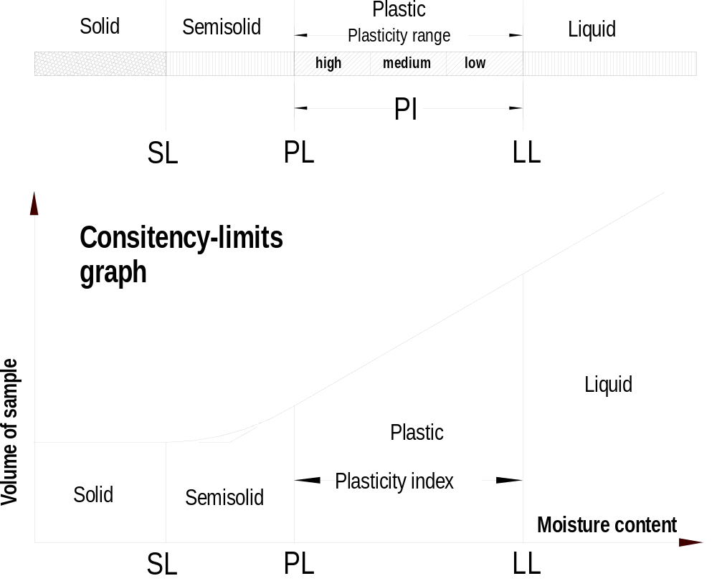Shrinkage limit (SL) is the water content at which there is no more volume change in the soil due to reduction in water. In other words the maximum moisture content at which further loss of moisture does not cause a decrease in the volume of the soil.

Plasticity index (PI) is the range of moisture content in which the soil is plastic; the finer the soil the greater is the plasticity index.

Plasticity index = liquid limit – plastic limit
PI = LL – PL

Particle size distribution

In the graph shown in Figure 1, curve 1 presents a well graded silty sand (high percentage of silt fraction), curve 2 a uniform fine sand (with a high percentage of equal grain sizes), and curve 3 a well graded sand.

Soil classification

As stated before natural soil consists usually of a mixture of sand, silt and clay. If a soil contains mostly sand and some clay then we would call it clayey sand. There exists an international texture classification that refers to the descriptive names of the soil. In this classification the descriptive names refer to a percentage composition with the following size limitations:

Sand 2.0 to 0.05 mm diameter

Silt 0.05 to 0.002 mm diameter
Clay smaller than 0.002 mm diameter

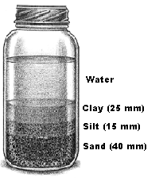

The find the percentage distribution of sand, silt and clay a soil sample from the site should be taken. Fill a container with water and add the soil sample to it. Shake the container vigorously and leave it standing until the soil particles have settled. Then measure the layer thickness of each layer as shown in Figure 2. All layers add up to 80 mm. We find the percentage of the different layers by dividing the single layer thickness by the total thickness of all layers (that is 80 mm.). The percentages are shown below.

Figure 2

Percentage of clay = 25/80 = 31.25 %

Percentage of silt = 15/80 = 18.75 %

Percentage 0f sand = 40/80 = 50.00 %

The textural classification chart is shown in Figure 3.

