http://physics.uwstout.edu/geo/geomech9.htm
Geomechanics Activity #9
Effective Pressure
Exercise #1 Suppose you have a soil profile that looks like the one below.
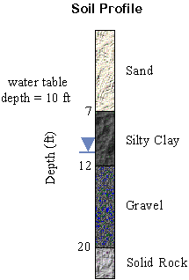
The soil layers have the following unit weights: γ_{sand} = 105 pcf (1 pcf = 1 lb/ft³), γ_{silty clay} = 125 pcf, γ_{gravel} = 95.0 pcf. Determine the total pressure, water pressure, and effective pressure at the boundary between each soil type. The effective pressure is the pressure that is acting to push the soil particles together.
Soil Settlement
Exercise #2: You plan on building a structure on top of a 4.0 m layer of SM soil (USCS group symbol) that is underlain by bedrock. The total expected primary consolidation for this footing load is 14 cm.
A) If the soil takes 1 year to settle 70%, determine coefficient of consolidation (c_{v}) in units of cm²/min.
B) How many days will it take to settle 90%?
Exercise #3: You have been called upon to estimate the expected settlement of the foundation for a grain silo (as shown to the right). Suppose the concrete foundation is circular with a radius of 20 ft. From an itemized list of static loads and live loads, it is determined that the average weight to be supported by the foundation (at the base of the concrete) is 8,100 kips (1 kip = 1,000 lb).  From subsurface explorations (boring samples) it is known that the first 15 ft of soil is a heavy sand content with C_{c}/(1+e_{o}) = 6x10⁻³ and γ = 115 pcf.  The next 10 ft of depth consist of darker clay with the properties C_{c}/(1+e_{o}) = 9.5x10⁻² and γ = 120 pcf.  A) Estimate the total expected settlement by dividing the subsurface into 5 layers each being 5 ft thick. (You may want to reference the example of settlement analysis that is on the web.) Assume no water table.  B) If the water table is at a depth of 15 ft, calculate the total expected settlement for the clay and compare this to the settlement for this layer without the water table. | 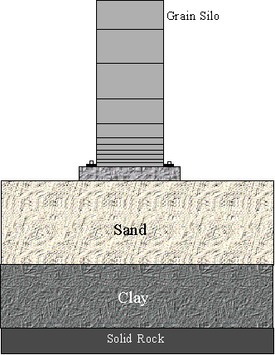
Exercise #4: The Woodland Spire is a steel sculpture that is beside Micheel's Hall here on campus. It looks like the following sketch:
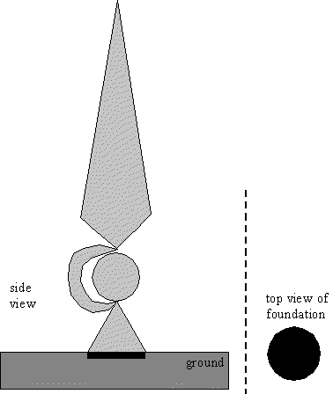

Suppose the sculpture has a total weight of 15,200 N and is 8 m tall. Also assume the sculpture's foundation to be circular with a radius of 0.4 m. The soil beneath the foundation is 4 m deep (drained only in one direction) and consists of silt with the laboratory measurements of C_{c}/(1+e_{o}) = 7x10⁻², γ = 17.5 kN/m³, and c_{v}=1.3x10⁻² cm²/min. The center of mass of the structure is not directly above the center of the foundation. This produces uneven pressures beneath the foundation and differential settlement. Split the circular foundation into a left half and right half. Let the halves move up and down independently. If 2/3 of the total weight acts on the left half and 1/3 of the total weight acts on the right half, calculate the settlement of the soil beneath each half after 5 years. What is the angle of tilt after 5 years?
Bearing Capacity
Exercise #5: The foundations supporting the pillars for the new Stout sports complex are in place. You can see the rectangular pillars driving down South Broadway. Suppose the soil beneath these pillars has the same characteristics as those listed in exercise #4. In addition, it has an angle of internal friction of 21º and a cohesion of 1.1 tsf. If the base of the foundation is square with each side having 4 ft, determine the maximum weight that can be placed onto this foundation before the soil beneath it fails. (Assume the depth of the base of the foundation to be 12 inches. Be careful of units.)

OBJECTIVES:
The main objective of this course is to give students a basic understanding of soil mechanics and its engineering applications. On completion of this course, students should be able to:
- explain the nature of soils, physical and plastic properties, compaction and laboratory measurement techniques;
- apply Darcy's Law to simple soil structures and find permeability characteristics from the provided test data;
- describe the procedures involvedin constructing flow nets;
- describe the concept of effective and total stresses in saturated soils;
- explain the elastic behaviour of soils; calculate the stress distribution due to external loads, and employ influence charts for calculating vertical pressures;
- calculate the consolidation settlement under a single footing using the concept of one dimensional consolidation theory;
- calculate elastic settlement under a variety of external loading systems;
- describe the general concept of shear in soil; discuss the Mohr-Coulomb failure criteria and determine the shear strength parameters via laboratory test results;
- discuss the methods involved in the stability analysis of soil structures; explain the steps in calculating a limit equilibrium solution;
- calculate the lateral earth pressure behind gravity and cantilever retaining walls;
- determine the factor of safety of earth slopes;
- determine the ulitmate bearing capacity of shallow foundations.

TOPICS:

Description Weighting (%)
1. Introduction and Physical Properties of Soils 10.00
2. Permeability 7.50
3. Flow Nets 7.50
4. Effective Stress Concept 5.00
5. Stress Distribution in Soil 10.00
6. Consolidation of Soil 7.50
7. Settlement of Structures 7.50
8. Shear Strength of Soil 10.00
9. Stability Analysis and Limit Equilibrium Method 5.00
10. Lateral Earth Pressure 10.00
11. Stability of Slopes 10.00
12. Bearing Capacity of Shallow Foundation 10.00

Lecture 8 Elements of Soil Mechanics
Topics
Phase relationships of earth materials
Effective stress
Shear strength
Settlement and consolidation
Soil mechanics concerns with the action of forces on soil masses. It involves the understanding and prediction of soil behaviors for engineering designs or uses as construction materials. Soil mechanics is a major component of the field of study known as Geotechnical Engineering. Here we deal only with a few basic elements of it. Examples and derivations are given in the lectures.
Phase relationships of earth materials (pp 106-113)
Earth materials have a three-phase system, including solid, water, and air. Water and air occupy voids between solid particles. For soils, the physical weight volume relationship between these phases are particularly important. The relationship can be examined using a schematic solid-water-air phase diagram.
Effective stress (pp. 129-132)
Effective stress is an important concept, which has many applications in Geology. Consider a layer saturated with water beneath the surface. The total stress produced by the overlying layers is opposed from below by both the stress transmitted through the solid grains of the layer and the hydrostatic pore fluid pressure. Thus the stress acting between the solid grains (called effective stress) in effect is the total stress subtracted by the pore pressure.
Shear strength of soils (pp. 133-139)
The strength of a soil indicates the stress that the soil can sustain until failure (displacement or excessive deformation). In soil mechanics, the shear strength is the main concern because most failures result from excessive shear stresses. The shear strength of a soil determines its ability to support the load of a structure or remain stable on a slope.
Settlement and consolidation (pp. 143-145)
It is not very common for external loads to overcome the strength of the soils to cause failures. But soils do deform under external loads. The usual response is a volume decrease beneath the foundation. Consolidation is the reduction in volume of a soil under load as water drains from the pores. Settlement is the vertical subsidence of the building as the soil is compressed. Excessive settlement, particularly when it is unevenly distributed, can result in serious damage to the structure.
Typically, the void ratio is plotted against the log of the effective consolidation pressure. The slope of this compression curve is called compression index of the soil.
Introduction
The principle of effective stress is the single most important concept in soil mechanics. The effective stress σ′ is related to the total vertical stress σ and the pore water pressure u by the simple equation:

σ′ = σ − u

The behaviour of saturated soils is governed by this equation as all measurable effects of a change in stress such as compression and a change in shear strength are due exclusively to changes in effective stress. Students will often experience difficulty in applying the principle to simple problems and some seem at a loss with problems involving changes in total stress and pore pressure particularly in cohesive soils. For many students these problems are not properly redressed by the traditional learning environment of lectures and complementary tutorials where there is limited scope for students to shape and pace their learning style or to interact with the lecturer. In essence, the support for the students tends to be more summative than formative where interaction tends to be more one-way with limited opportunities for immediate feedback.

http://fbe.uwe.ac.uk/public/geocal/SoilMech/basic/soilbasi.htmp
http://fbe.uwe.ac.uk/public/geocal/simulations/CONSOL_G/Default.htm Run this Program
Print this

http://www.cee.odu.edu/abet/ce335.php

