DEMOLITION

Preparation of documents for demolition.

 Check whether building is classified by the National Trust or is on the National Heritage List.

 In the Perth City Council area a planning approval for the future development of the site must be obtained before a demolition licence can be issued. Preliminary plans must accompany the application.

 Drawings and specifications need to be produced to show the exact extent of the demolition work. Clearly indicate in the drawings which parts are to be demolished. A plan must be included showing the exact location of the services like water supply, sewerage, electricity, gas, telephone, etc. to be terminated (accidental disruption must not occur).

 Specification must contain all information which are not shown on the drawings, such as:
insurance, public safety (fences, scaffolding etc.), protection of adjoining buildings, ownership of materials, material to be reused, restricted time, noise restriction, health regulations, compliance with relevant authority regulation etc.

 Records should be made of what is actually done on site, as such information may be needed for future work or in case something goes wrong.

AUTHORITIES

 LOCAL AUTHORITY
Building Department demolition licence
Health Department rodent eradication
septic tanks
Parking meters to be removed or hooded

 WATER AUTHORITY
water disconnection
sewer disconnection
temporary services

 WESTERN POWER & ALINTA-GAS
Western Power - electricity disconnection
AlintaGas - gas disconnection

 TELECOM - OPTUS
telephone disconnection

 FIRE BRIGADES
fire alarm disconnection
fire service

 DOSHWA
Construction Safety Regulations

 MINES DEPARTMENT
explosive permits

 POLICE DEPARTMENT
traffic control (if required)

PRELIMINARIES, APPLICATIONS, APPROVALS

Before commencing any demolition a contractor must:
 Apply for a demolition licence.
 Treat the building for rodents and provide the Local Authority with a certificate to show this has been done.
 Notify the Local Authority of any septic tank on the site 7 days before it is emptied and removed.
 Lodge a footpath deposit with the Local Authority.
 The contractor must leave the site clean and tidy and complete the demolition within 90 days to the satisfaction of the Local Authority.

INSPECTION OF ADJACENT BUILDINGS

It is the responsibility of the contractor to ensure that demolition work does not cause any damage to adjacent buildings.
He/she should do a thorough survey of buildings before commencing work to determine the state of the buildings and any existing damage.
The survey should contain a written description of the condition, drawings showing location and extent of existing cracking (to be measured) and photographs should be taken.
This survey should be organised with agreement of the owners of the adjacent buildings and copies of the survey given to them prior to the commencement of any work.
Hopefully this will avoid any litigation.
The demolition contractor will still have to make good any damages caused.

UNDERPINNING

Every year in Australia a substantial amount of money is spent on the repair of cracks and distortion in homes. Much of the damage arises from foundation movement caused by problems such as subsidence and heave of the ground, and landslip. Some money is spent on underpinning the foundations of houses and blocks of flats. Underpinning usually involves deepening foundations; it may sometimes involve providing a new, different form of foundation.

WHAT IS UNDERPINNING?

The object of underpinning is to transfer the load carried by an existing footing to a new footing at a lower depth.

Underpinning usually involves the extension of the existing foundations downwards to reach stiffer or more stable ground. There are several methods:

Mass concrete Figure 2
Pier-and-beam Figure 3
Pile-and-beam Figure 4
Pile Figure 5

The mass concrete method accounts for the majority of all underpinning work, followed by pier-and- beam underpinning.

The principal reasons for choosing a particular method of underpinning concern the extent of the underpinning required, the nature of the ground and the cost, including the degree of disturbance to the building occupants. Whatever method is used, underpinning is applied either to part or to the whole of the foundation. Which is appropriate will depend on the scale of the problem and the ground conditions. Partial underpinning is employed when only localised foundation movements have occurred and where the stabilising of only part of the foundation will not have a detrimental influence on the remainder. An example is where a house has been built partly over the site of an old, infilled pond. Most of the foundation is perfectly stable so that underpinning only of the part over the old pond will be satisfactory. The vast bulk of underpinning projects involve partial work only. Total underpinning may be performed when an entire building is found to be settling, perhaps on soft, peaty ground, or when an additional storey is to be added to the building, requiring all foundations to be extended down to stiffer ground.

WHEN IS UNDERPINNING NEEDED?

Underpinning may be necessary for a number of reasons -

1. To allow the level of adjacent ground to be lowered e.g. when constructing a new basement. (Adjoining owners consent must be given.)
2. To increase the load-bearing capacity of the footing (for additional storeys or allowance for increases in super-imposed loads).
3. Settlement of the existing footing has occurred.

Before commencing any underpinning, the structure of the building should be thoroughly examined for weaknesses. It may be necessary, at this stage, to strengthen the building by grouting cracks or inserting tie rods.

Adjoining properties should be inspected to record any existing cracking or damage, and to avoid claims for rectifying any faults which were obvious prior to underpinning.

Careful records are vital in case a dispute should arise. These should show the exact condition of floors, walls, etc., including the levels of floors and walls, the plumb of walls, the existence of cracks, their position and size, and any other defects. Tell-tale marks each side of cracks will help to show the extent of any movement.

Investigations of the ground below the structure should always be made before underpinning work is commenced. When settlement has occurred, such investigations should aim at discovering the soil conditions responsible so that the appropriate underpinning measures can be taken. If underpinning is required only to carry the foundations to a lower level, the ground investigation. should ascertain the nature of the material through which the underpinning is to be carried and the stratum on which it is to be founded.

The structure to be underpinned should be carefully examined for indications of settlement and inherent weaknesses which may be accentuated during the process of underpinning, and the structure should be temporarily supported, or strengthened where necessary, to avoid consequential damage.

Before excavation is commenced the load on the wall or structure should be reduced as much as practicable, the adjoining owner's consent where necessary being obtained. In isolated foundations (e.g. bridge piers) it may be necessary to remove some portion of the superstructure or its filling prior to the commencement of the underpinning, or temporarily support the superstructure, if possible, clear of the underpinning work.

When underpinning high walls, heavy plumb bobs should be suspended from the highest part of the building. Readings of these should be taken at frequent intervals until the underpinning operation is complete. Periodic level checks should also be made.

WHO DESIGNS AND CONSTRUCTS UNDERPINNING?

Underpinning can be obtained in several ways:

From a chartered civil or structural engineer who will design a suitable scheme and supervise the contractor who performs the underpinning.
Directly from a specialist underpinning contractor: there are many of these currently in operation and most offer a variety of methods to fit individual circumstances.
From a normal building contractor; much partial, mass concrete underpinning can be carried out by builders, though it is advisable, firstly, to appoint an engineer or building surveyor to ascertain that the underpinning is strictly necessary and, secondly, to ensure it is sufficiently extensive and correctly applied.

There has recently been an increasing trend for insurance companies and their loss adjusters to employ consulting engineers, with expertise in foundation engineering, to investigate claims and,
where appropriate, design and supervise underpinning work. This has led to better assessments of the need for underpinning and is a contributing factor in the fall in the total cost of underpinning.

PRECAST AND INSITU CONCRETE

Insitu

Concrete sections are formed, reinforced, poured and cured in place on the site.

Precast

Concrete Sections are manufactured either:

 away from the site, transported to the site and erected
or
 manufactured on site, but not in their final position, then lifted into final position,

TYPES OF PRECAST CONCRETE

Precast concrete is suitable for a wide range of different applications as follows:

Individual items or units are manufactured for installation as separate parts such (as slabs, sleepers, lintels etc.) which do not require special structural connections.

Structural components are separate elements which require connections on site to form the concrete frame of a building, soffit elements for composite beams and slabs, and panel walling.
Structural assemblies include a variety of simple and complex structures prefabricated for rigid and portal frames, roof shapes and trusses, and wall assemblies.

Panel construction comprises large areas of thin-walled concrete claddings and suspended floor slabs, which include the processes of tilt-up, lift-slab and battery-casting on Site.

Incremental or Elemental construction refers to the precasting of individual elements which form into a continuous structural framework, by post-tensioning techniques, applied to provide monolithic function and appearance to bridges, overpasses and large projects.

Composite construction involves the application of precast concrete as the permanent formwork for insitu concrete - as in hollow-column casings, and soffit elements for beams and suspended floors.

Modular Construction is the term applied to large elements which are designed to conform with a predetermined planning grid or module for dimensional co-ordination. Large box-shaped structures can be stacked to form the rooms or separate flats of precast concrete buildings.

ADVANTAGES OF PRECAST CONCRETE

the versatility of precast concrete provides numerous advantages, and the principle ones to be derived are as follows:

 A significant reduction in time in the construction schedules can be achieved with the delivery of approved elements, tested and ready for installation.

 Economics in on-site requirements of: labour, formwork, plant and scaffolding, when concrete is cast away from the site.

 Considerable reductions in site congestion, with fewer activities involved and less workmen required.

 Reduced shrinkage in the structure because of the installation of cured precast components.

 Improved architectural finishes and textured surfaces available from controlled situations involving specialised workers casting horizontal surfaces.

 Increased quality of products manufactured in fabrication workshops with specialised plant and equipment.

 The ability to adhere to casting programs regardless of the external environment for example, bad weather avoids delays on the site.

 Standards of technical control are more easily supervised in situations involving skilled workers on a permanent basis of employment.

 The use of standard forms and long-line casting beds which eliminates the need for constructing complex arrangements of formwork on each construction site.

 The ability to advance curing in steam autoclaves, and ensure the inspection and testing of hardened concrete prior to delivery of acceptable units to the site.

DISADVANTAGES OF PRECAST CONCRETE

Disadvantages applying to Precast Concrete include:

 The prevalence of numerous joints requiring structural connections and weather-proofing.

 The necessity to adhere rigidly to relatively fine tolerances in dimensioning the construction within a precasting yard and on the site project.

 Additional costs involved in precasting concrete and effecting adequate connections.

 The risks involved in repeated handling and transportation of precast concrete before it is finally installed on site.

 The limitations imposed on precast production in workshops due to the restrictions on sizes suitable for transportation.

 The difficulty of obtaining continuity in structural members involving numerous connections between precast elements.

 The limitations imposed on freedom of design in an effort to reduce precasting costs by standardising components to achieve an economical repetition of production.

CONSIDERATIONS FOR AN INVESTIGATION INTO THE VIABILITY OF USING PRECAST CONCRETE FOR A FUTURE PROJECT

Design considerations

1 Cost Cost of design - could be higher due to additional detailing.
Cost of production and transport.
Refer to QS to Cost of erection and finishing.
determine costs. Cost savings due to reduced site costs.
Cost savings due to reduced contract period, therefore earlier income potential

2 Architectural Can tbe overall building concept
Design and be achieved in precast concrete.
Aesthetics Precast concrete appears bulky, is this acceptable.
Jointing is often very apparent, can it be expressed or disguised.
Special surface finishes may be available which would not be able to be done with insitu.
Coloured finishes are more readily achievable in precast concrete.
Study of similar jobs may be useful.

3 Structure Refer to structural engineer for advice.
Can building be designed structurally in precast concrete to withstand the loads to be imposed.
Will required elements interfere with the architectural requirements.
Can the precast elements be prestressed if required.
Can the building be completely done in precast concrete or will parts have to be done insitu. If so what percentage.
Can the structural connections be achieved.

4 Services Mechanical lifts
escalators
airconditioning.
Electrical
Plumbing
Other special services.
Refer to appropriate consultants for advice.
Can these various services be effectively provided in a precast concrete building.
Is the system able to accept all the openings required for services.
Will the units have to be specials or will they be cut on site.

PRODUCTION CONSIDERATIONS

1 Casting Refer to builders and precast concrete specialists for advice.
Location On site or off site.

2 Casting Is there a yard capable of undertaking the work.
Yards Will the yard be available when required to do the job.
Is the yard capable of satisfactory quality control.
Production capacity.

3 Transport Is the yard convenient to the site.
Can the required precast units be transported on a truck
(weight, size, heigth, width, length).
Is there sufficient transport available, ie number of trucks.

4 Formwork Time required to make forms.
Cost of forms.
Sufficient reuse to be economical.
Adjustable for many units

5 Lead Time Can sufficient lead time be provided to enable units to be made prior to commencing the building.

SITE ERECTION CONSIDERATIONS

1 Lifting Crane capable of lifting the weight.
Crane with adequate jib radius to get all units in position.

2 Site Access Access for large trucks.
Storage of units.
Access times possible time restrictions for access during peak hours.

3 Site Can the connections be simple enough to avoid specialised labour.
Connections Can the connections be done quickly to avoid using the crane for an excessive amount of time.

PRESTRESSED CONCRETE

Prestressing is the action of placing a stress in a structural element (member) in the opposite direction to that which will occur due to the normal working loads.

In the working environment a compressive stress is applied to the parts of the element where tensile stresses will occur due to the service loads. This action will reduce the final tensile stresses in the element.

In reinforced concrete cracks will occur in the tensile zones due to the deflection created by the loads. By applying the compressive prestress the extent of cracking is reduced or even eliminated.

The compressive prestress is obtained by installing tensioned high strength steel tendons into the concrete prior to the working loads being applied.
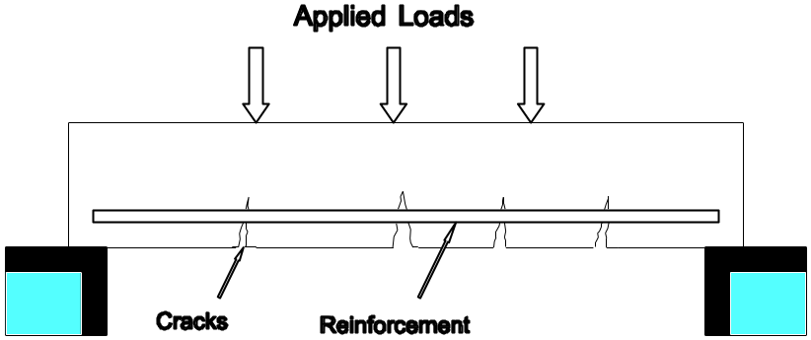
Normal Reinforced Concrete
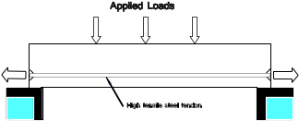
Prestressed Concrete
ADVANTAGES OF PRESTRESSED CONCRETE

The action of prestressing enables the applied loads to be balanced by the uplift force so that practically no deflection occurs. This results in longer spans and greater load capacity without an increase in the depth of the section.

Most prestressed concrete projects combine the benefits of controlling deflection and cracking by the prestressing with the economies of reinforced concrete.

A common example of floor slab design uses prestressed and beams with a reinforced concrete slab.

Other advantages are:

(i) Reduction in the quantity of reinforcement and concrete.
(ii) Reduction of labour to fix reinforcement.
(iii) Less shrinkage cracking.
(iv) Improved resistance to fatigue cracking.
V) Better waterproofness of slabs giving greater durability.

METHODS OF PRESTRESSING

Pre-Tensioning

Used for precast concrete units. High tensile wires are positioned in the mould and tensioned against the end abutments. The concrete is placed around the wires and allowed to cure until a bond is obtained between the concrete and the wires. When the element is released from the mould the wires attempt to return to their original length inducing a compressive stress in the concrete. The efficiency of this method relies on the bond between the wires and the concrete.
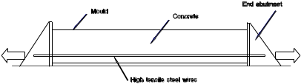
Pretensioning
Post-Tensioning

Used for slabs and beams cast in-situ. Ducts and end anchorages are positioned along with the normal reinforcement prior to placing the concrete. When the concrete has been placed and reached a sufficient strength to withstand the precompression, high tensile strands are threaded through the ducts, tensioned and wedged in the end anchorages. Following this the strands are grouted, ie grout is pumped into the duct, filling the voids, creating a bond between the stands and the concrete. The grout also prevents water accumulating in the duct which will lead to corrosion of the strands.

An advantage of post-tensioning is that the cables can be draped to follow the line of maximum tension in the concrete, i.e. in the bottom of the slab at mid span to the top of the slab over supports.
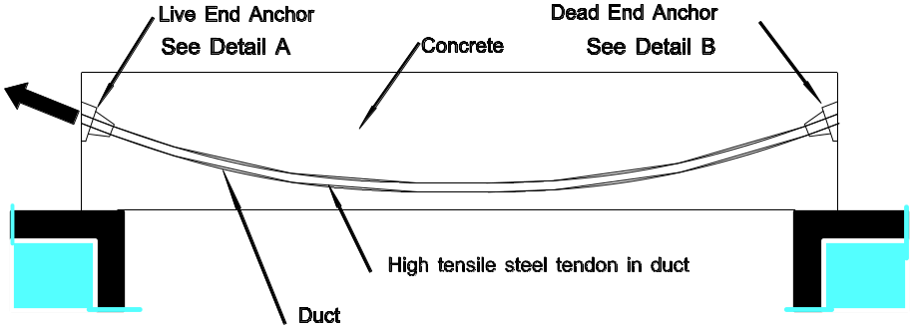
Post - Tensioning
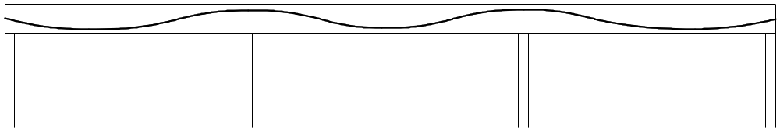
Cable Location

COMPONENTS

Wire A single steel wire with ultimate strength up
to 1200 MPa.

Strand A number of wires laid together to form a strand of 12-7 mm diameter.
The strand normally consists of seven wires.

Cable In buildings, four or five strands together in one duct.

Duct A sheet steel flat tube to contain the strands in a post-tensioned system

Anchor A cast steel fitting placed at the end of the cable to provide a fixing for the strands.

Live End Anchor

The end of the cable at which the stressing jack is applied. This may be one or both ends of a cable dependent on the length of the cable and the tensile force required.

Dead End Anchor

The end of the cable at which no jacking is applied. The strands are wedged in place before the stress is applied at the live end.

Loop Dead End Anchor

The strand projects out from the end of the duct, is formed into a loop and cast into the concrete. In this case the strand must be placed prior to the concrete being poured.

Wedges

Internally serrated, split and tapered collets to grip strand and prevent relaxation of the prestress.

Grout

Sand/cement mix pumped into the ducts.

Grout Vent

A plastic tube fitted to the duct at the high point of the duct. The tube projects through the surface of the slab and allows air to escape as the grout is pumped in.

VEHICULAR PAVING AND ROAD CONSTRUCTION

SELECTION OF PAVEMENT TYPE

Selection of the type of pavement depends on the use, location, loading and traffic volu me.

Bituminous paving (flexible paving) is widely used in Western Australia as it is cost effective. Generally the loads and traffic volumes on the roads do not warrant the use of concrete (rigid) paving.

Country Roads Lightly used country roads are left unsealed, sealed roads are generally sealed by the sprayed method as they are too far away from a premix plant.

Urban Roads Sealed using the asphalt (bituminous concrete) method.

Parking Areas Generally sealed with asphalt although sprayed work is sometimes used . For truck parking areas a heavier base is required. Brick paving can be used for car parks. For parking areas where trucks have access precast concrete units should be used.

Access Roads As for parking areas except brick paving is not generally used.

Loading Bays Also heavy vehicle parking and loading, heavy vehicle servicing (particularly tracked vehicles), service station forecourts, forklift truck areas, areas of high abrasion, areas subject to chemicals ie wash down bays, steeply sloped access roads.

Use a concrete slab. Thickness and reinforcement to be designed by an engineer.

VEHICULAR PAVEMENTS

The basic function of a pavement is to support the applied traffic loading within acceptable limits of riding quality and derriorationover its design life. To du this the pavement must, under peak and cumulated traffic loads:

 reduce subgrade stressessuch that the subgrade does not deform excessively;
 reduce pavement stesses such that the pavement courses do not crack or deform excessively
 protect the pavement structure and the subgrade from the effects of the environment, particularly moisture

The first two requirements are achieved by using the pavement layer thickness to disperse the concentrated surface load (see Figure below) to stress levels acceptable to the various materials encountered.
A pavement structure is composed of a number of horizontal courses. The courses used in a pavement are themselves sub-divided into layers, where the layer is that portion of a course which is placed and compacted as an entity. Major common terms used to define the road and its structure are illustrated in the figure below.
The prime purpose of the wearing or surface courses is to carry the local effects caused by wheel loads and withstand the atmospheric environment. The base course is the main load carrying course within the pavement. The sub-base is a course whose prime purpose is to protect and separate the basecourse from the subgrade and vice versa. For example, it may act as a filter layer or prevent subgrade fines from entering the basecourse or provide a working platform over weak subgrades. In concrete pavements, it may be used to reduce the pumping of subgrade fines by traffic action on the slab. The subgrade is the natural or fill formation on which the pavement structure is constructed.
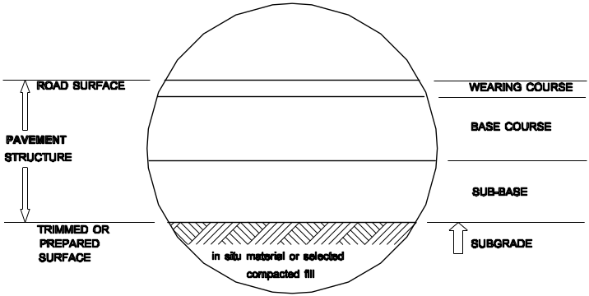
COMMONLY USED ROAD TERMS

TYPE OF PAVEMENT

Pavements are classified as either rigid or flexible, depending on their stiffness relative to that of the subgrade. A 'rigid' pavement is not, of course, actually rigid and the terminology is merely an arbittrary attempt to distinguish between pavement types. The relatively stiff rigid pavement produces a relatively uniform distribution of stresses on the subgrade, whereas the flexible pavement deforms and concentrates its subgrade effect (see Figure below).

RIGID

Rigid pavements may be either unreinforced, reinforced or prestressed. Unreinforced pavements are usually constructed with joints, whereas reinfoced pavements rarely require the provision of joints. In prestressed pavements, the slab is placed in compression to improve it tensile strength.

Concrete block pavements perform similarly to flexible pavements.

Rigid pavements are usually reinforced concrete slabs on the ground. The slab may be poured onto the compacted subgrade (soil) or if the soil does not have a sufficient bearing capacity a base of crushed limestone can be provided.

Movement joints are provided at regular intervals (new thought suggests joints not needed). Thickness can vary from 100 mm to 150 mm depending on loading.

insert Picture
Generally designed by an Engineer.

PRECAST PAVING UNITS

Interlocking precast concrete blocks are laid on a 30 mm compacted bedding sand base course. The bedding layer may be placed directly on the compacted subgrade or if the subgrade is not sufficiently strong a sub-base of crushed limestone may be used.

Edge restraint must be provided to prevent displacement of the blocks as they are not fixed in place. This can be done with extruded or precast concrete kerbs or beams or pavers set in concrete. The opposite Figure shows a edge restraint with a large drainage channel.

Concrete edge restraint

Thickness of the paving units is 80 mm for heavy loadings and 50 mm for lighter loadings.

FLEXIBLE PAVEMENT

Flexible pavements are built up of layers of aggreagates with a surface seal to resist deterioration, resist vehicle abrasion and provide a smooth surface.

Loads on the pavement are spread through the layers to the foundation soil.
Pavements are designed by an engineer.

Minimum to not exceed bearing capacity

insert picture

Depth is related to width A. ie The greater depth D, the greater the width A, therefore reducing pressure on subgrade.

Subgrade

The soil beneath the pavement. Compaction is normally required to give the desired bearing capacity, uniform bearing and constant moisture content to avoid differential volume changes.

Sub-base

Thickness and compaction depend on design loading. A layer of crushed limestone or gravel thickness 150 300 mm after compaction.

Base Course

A layer over the sub-base to act as a base to the seal. The base course is -road base+ which is crushed aggregate and quarry fines. Thickness is generally 50 - 75 mm.

Surfacing - Seal Coat or Wearing Surface

The surfacing can be either sprayed work or asphalt work.

SPRAYED WORK
Bitumen is sprayed and aggregate spread on top, the bitumen acts as a binder. Common application is:
spray 1.1 -1.3 l/m²
spread 14 mm aggregate
roll
spray
spread 7 mm aggregate
roll

ASPHALT WORK
Asphalt/bituminous concrete/ is a mixture of aggregate, fillers and bitumen produced in a mixing plant. The mix is transported to the site and laid using a laying machine whilst still in the hot condition and then rolled. Thickness generally 25 mm.

ROAD CONSTRUCTION

See OHT.

Note crossfall (camber) each way from the crown of the road. At corners the fall becomes a one way fall from the outside of the corner to the inside.

Kerbs are provided on suburban roads to control drainage and prevent deterioration of the shoulders. Concrete strips are poured on to the edge of the seal surface. They are poured continuously and cut later to provide expansion gaps.

PARKING AREAS

Parking areas constructed in a similar method to roads except that generally they do not have to be as heavy as roads as they are only taking light car loads.Kerbing is usually precast concrete placed after the base course is constructed and before the seal coat.

DRAINAGE

Falls should be provided to run the storm water to collection points. Fall should be not less than 1 in 200, preferably 1 in 100. At the low point a soakwell is provided if the soil is free draining, if not a silt pit is provided with connecting drain pipe to an external drainage system, eg council system. Traffic lids are provided over the well orpit.insert picture

SUSPENDED CEILINGS.

DEFINITION: A membrane suspended below a structural floor or roof to provide a flat or sloping soffit.

It's primary function is to improve the appearance of the ceiling area by concealing or integrating other services.

Features or characteristics of a suspended ceiling can include: Fire resistance.

Acoustic control.

Thermal control.

Integration of air conditioning & lighting.

APPLICATIONS:

In new buildings: Conceal engineering services. Easy access to services.

In older buildings: Reduce ceiling level.

Conceal old ceilings.

Increase fire rating.

Acoustic insulation.

Thermal insulation.

SUSPENSION SYSTEM:

Suspension system made of pressed galvanised metal or aluminium.

Suspension system designed to carry the dead weight of the ceiling only - ie. 6kg/m² - 1Okg/m₂ ceiling lining & suspension system.

TYPES:

Suspension systems classed as:

1. FLUSH SYSTEM:

One or two way suspension system.

No suspension system exposed.

Sheet plaster lining to underside of framing.

Monolithic finish, no access - manholes.

Secure system - lining acts as diaphragm for tying together.

May be fire rated 1 Hour - 2x13 thick firecheck.

2 Hour - 2x16 thick firechecl. See manufacturers instr.

CSR - Gyprock. BORAL - Plasterglass.

2. FULLY CONCEALED SYSTEM:

Panellised ceiling system.

Individual panels visible but suspension system concealed.

Panels conceal suspension system

One or two way system, difficult to gain access to ceiling space - damage of panels.

3. SEMI CONCEALED SYSTEM:

Two way system - one way exposed. Usually the "T" Bar. Difficult to remove panels, although better than fully concealed system.

4. EXPOSED SYSTEM:

One or two way system all exposed. Easiest access to ceiling space. Least damage to panels.

COMPONENTS:

Hangers: fixed to structure over.

clipped to carrier rails.

may be 6 dia rods, hoop iron straps, Folded PGI angle or M/S angle.

Suspension members: Two way system.

Primary suspension: Supported by hangers. Approximately 1200 cts - refer to manufacturer instructions. Usually channel section, 'T' bar or furring channel.

Secondary suspension: Hung off primary suspenslon members.

Centres to suit tile layout or support centres for flush ceilings. Connection between hangers and suspension members (see details).

Adjustment: Usually takes place in the hanger.

Adjustment is important as tolerance for suspended ceilings is  2mm from level.

Banana clip internal only.

Subject to problems with varying air pressures.

threaded rod double locking nuts secure better.

CEILING MATERIALS:

Panels: Sheet plaster boards.

Two way system using 'T' bars; Smooth finish - painted; Economical; easy access 1200 x 600; Easily damaged when removing.

Plaster tiles: Purpose made acoustic tiles.

Fully concealed system, one or two way exposed; More expensive but still reasonable; Better acoustics; Smaller panels 600 x 600; Variety of surface finishes; Panels likely to damage but better than plaster panels; Usually painted. ( Manufacturer: Bradys)

Stramit: Two way system.

Range of finishes; Large panels; Good acoustics and fire resistance. (Manufacturer- KH Stramit).

Fibre Board: Canite

Ecomonical; good acoustics; smaller panels; tends to sag under own weight.

Metal Pans: One way system.

Best quality, Expensive; very robust; Acoustics - perforations with fibreglass behind; Good access, large panels; Variety of finishes.

Linear Strip Ceilings: Manufacturer- Hunter Douglas.

Illuminated Ceilings: Manufacturer- Intallite.

SERVICES:

Air conditioning registers and light troughes are built into the systems. Extra suspension hangers often supplied. Flexible locations for services.

SUSPENDED CEILINGS Page No. 8.

PART B - SUSPENDED CEILINGS

A ceiling framework and lining system which is not in direct contact with a structural floor deck or roof, is referred to as a 'suspended' or 'false ceiling'. These ceiling systems suspend from a structural support on mctal_ rods or stlnl)s, wllich al-C generally adjustable for heigllt aligmne Suspended ceilings provide enclosures to conceal projecting floor beams or ducts and pipes connecting building services. They are also the most economical method of attaching the lining materials under widely spaced roof trusses. Suspended ceilings are frequently installed in large shopping complexes, in landscaped office areas, and many commercial and industrial situcltiolls. 22.5 TYPES OF SUSPENDED CEILING SYSTEMS The principal types of suspended ceiling systems can be classified under the following headings: Jointless or flush Modular panel Strip panel. These different systems will be studied individually, but should be compared according to particular functional requirements, which could include the following: demountability and access acoustic properties fire resistance moisture resistance mass (or weight) finish cos t . THE JOINTLESS SYSTEM Several methods have been adopted for attaching flush-jointed sheeting to a suspended ceiling framework. The gyprock system comprises modular metal channels to which gyprock sheeting is fixed at 300 mm centres. Angle trims, attached to the walls, support the edges of the sheets and provide a flush or recessed bead effect. Refer to Figure 21.5. 22.]1 Figure 22 . 7 (Courtesy of CSR uilding aterials.) STRIP PANEL SYSTEMS A modern concept of suspended ceilinE (lesigrl incorporates linear panels of narrow profiled metal or timber, fixed to horizontal carrier rails. The strength derived fro continuous panel and rail construction enables large areas of ceilings to be covered. The system also provides for illumination to be incorporated by providing light boxes, diffusers and suitable trimming materials. The lining panels can be solid, perforated or acoustic-padded metal, or profiled timber. Provision is made for the insertion of a narrow closure strip between the panels, and for a fibreglass facing sheet and acoustic quilt behind the panels. Refer to Figure 22.8 for typical details of strip ceiling systerns. 22.6 COMPARISON OF CluRACTERISTICS AND ENCTIONS DEMOUNTABILITY AND ACCESS The most easily accessible system is the modular panel. With a few exceptlons the modular size is either 300 or 600 nun square. Most panels can be removed without too much difficulty, unless the top surface has been covered with a thermal or acoustic insulating material. If accessibility is of maor importance, it is worth studying modular ceilings in more detail to determine the relative ease of accessibility of the various systems. Strip ceilings are less accessible because the removal of several strips of room length may be necessary to gain access to one point; however the strips are usually easy to remove and much will depend on the layout of the services above the ceiling. If cables, etc., are laid in the same direction as ttle ceiling strips, it may be possible to gain access to the wl-o]e lengtl- of cable by the removal of one strip. Where jointless ceilings are fitted and access is require(l, the position of points of access will have to be determined beforehand and they can then be incorporated. If the space above the ceiling is heavily serviced, jointless ceilings will probably be impracticable; however, if only one of two access points are required in fixed position, there should be no problem in providing them. ACOUSTIC PROPERTIES Ceilings often have to be sound absorbers and sometimes insulators as well. The insulating properties of the structural ceiling will usually be very much greater than the suspended ceiling and an important reason for insulating the ceiling will be to prevent the transmission of sound over the top of partitions. If both absorption and insulation are required, then heavy insulating material may be faced with an absorbent material. This will not produce perfect absorption or perfect insulation, but usually an adequate degree of both can be obtained. Ceilings which are sound absorbers are usually of lightweight material or perforated if insulation is also required, the top of the ceiling can be lined with material of high superficial density, such as lead. FIRE RESISTANCE The best fire resistance is afforded by plaster or metal tray panels, or fibrous cement panels. There should be little practical difficulty in obtaining a ceiling with up to 2 hours rating or more, while still retaining acoustic and other necessary properties. 22.16 MOISTURE In conditions of heavy humidity, the main factor governing the choice of a ceiling may be its resistance to moisture. Plaster and fibrous cement panels are good, but cork panels are by far the most effective although these may be difficult to obtain. If very heavy condensation is expected, the most effective solution is to insulate the ceiling thermally by lining it on the top surface with suitable materials. Wk'IGlT Jointless ceilings are the heaviest of the systems - usually about 55 to 60 kg per square metre - because they are usually based on plaster; an exception is the stretched plastic membrane type of ceiling which is lighter than any other. Most panel ceilings are in the range of 5 to 10 kg per square metre, though a few may be heavier. Strip ceilings are the lightest and average 2 to 3 kg per square metre. FINISH The range of finishes available in suspended ceilings is limited mostly to variations in texture. Perforations made for acoustic absorption may be laid out in different patterns or the holes may be of different sizes. Embossed or profiled panels are also obtainable. It may not be possible to paint or effectively clean some types of ceiling, particularly those which are moisture resistant or sound absorbers. Jointless ceilings can accept the widest range of finishes because they are not restricted by the demountability of panel and strip ceilings. The ease of cleaning may be an important factor - not only in particularly dirty surrounds but, - also where strong air movements within a room are likely to cause staining. COST As with partitions, the cost of a ceiling system will depend largely on the complexity of the ceiling. The cheapest types are those consisting of lath and plaster; of the modular systems, the cheapest are those manufactured from fibre board. 13Owever, the aesthetics and low-maintenance characteristics of ceiling systems outweight the slight advantage of cost for many situations. 22.7 ACCESSORIES AND SERVICES The firms supplying suspended ceilings produce a range of accessories which allow rapid erection schedules and attraCtive surface finishes. The following details are indicative of the range of products available, although the design of patentS ay vary with individual firms. Different methods of attachment to the structural framework are provided to suit the particular types of materials encountered. Metal brackets have been designed for attachment to most types of materials, as illustrated in Figure 22.9. In addition, explosive power tools have a range of threaded and perforated fixing pins which can be discharged into concrete, masonry and metal supports. Alternatively, terrier bolts, loxins and tiger bolt expansion fasteners could be utilized. Methods of Anchorage Figure 22 . 9 Several methods have been designed for providing rapid means of height adustment to ensure the alignment of suspended ceilings. Figure 22.10 illustrates a suspension spring clip and threaded rod with locking nuts. 22.18

