crane quandary
When lifting tilt-up panels, should you operate the crane on or off the floor slab? A general contractor tackling his first tilt-up job discusses how difficult it is to evaluate the pros and cons of each option. One of his main concerns on his project was minimizing floor cracking that might occur as a result of the crane entering and exiting the floor slab and operating on the slab. For most tilt-up jobs, the foundation elevation is anywhere from 4 to 18 inches below the finished-floor elevation, leaving the slab edge virtually unsupported. After weighing many factors, he opted to use a truck-mounted crane and operate it off the floor slab to lift stack-cast panels on the floor perimeter.
http://www.tilt-up.com/LearningCenter/Default.asp

is it time to lift?
Before erecting tilt-up concrete panels, you must allow them to gain enough strength to withstand lifting stresses. Erecting panels before they achieve the proper strength can lead to damage, costly repairs and even serious accidents. Because concrete gains strength more slowly in cold weather and more quickly at higher temperatures, curing time alone isn't an accurate method for determining in-place concrete strength. Only reliable testing can produce accurate estimates of in-place concrete strength. The most common testing method makes use of field-cured cylinders. Unlike laboratory-cured cylinders that are used for acceptance of a concrete mix, field-cured specimens are left onsite until testing. To provide a good estimate of in-place concrete strength, however, field-cured cylinders must be handled properly.

tilt-up piers distinguish award winning overpass
When handling heavy tilt-up panels, crews need to take special safety precautions to prevent accidents. Some of these precautions need to be taken even before panel construction begins.
This safety checklist, developed by the Tilt-Up Concrete Association, provide guidelines covering the entire tilt-up process:
  - Before panel construction
  - Before erection day
  - At the safety meeting
  - During the lift
  - After the lift

32 Pointers for Tilt-Up Design & Construction
1. Should it be a tilt-up building?
For most effective use of tilt-up the building should be at least 10,000 sq. ft. – the larger the better – and the exterior wall surface divisible into as many same-size panels as possible. Preferably one-story, but two, three or four stories can be economical. The exterior wall surface should be at least 60% solid (no windows).
2. Limit weight of individual panels to about 40 tons.
This results in economical crane use; however, where large panels must be used they can be 50 to 60 tons, but require a heavier (more costly) crane. Example: A 7¼" solid panel, 24 ft. wide x 36 ft. high weighs approximately 39 tons.
3. Avoid "L" and "T" shaped panels.
They are difficult to erect, usually requiring strong backs.
4. Keep door and window openings at least 18" from the edges of panels and a similar minimum distance between openings. If less, there can be structural problems.
5. Keep the ratio of height to width of solid panel between openings to less than 4:1.
For greater ratios, the code requires additional reinforcing requirements.
6. Avoid concentrated loads, such as from roof and floor beams, from occurring within about two feet from the edge of a panel.
Causes concentration of stress at edge of panel and possible shearing problems in continuous footing.
7. Never have architectural elements project from the exterior of the building.
Since the exterior side is nearly always cast down, it would require a depression of floor slab to achieve this.
8. Use reveals sparingly, and limit their depth to ¼".
This weakens the bending capacity of the panel and can require additional reinforcing or thickening of the entire panel to compensate.
9. Consider where panels will be cast and how they will be erected.
The available floor area for casting should be at least 25% greater than the area of the wall panels, otherwise the panels will need to be case on exterior, disposable casting slabs or a second placement of panels will be required after the first are erected. Occasionally, panels can be stacked to conserve space.
10. Check panels thickness’ and joint sealents for fire ratings.
Property line conditions can require thicker panels for 2, 3, and 4-hour ratings, requiring special joint sealents.
11. Determine what happens at corners.
Corners can be either overlapping or mitered. This must be detailed on the plans. When overlapped, be sure one panel is shorter to allow for the overlap.
12. Specify correct joint width between panels.
Use ½ inch up to about 24 ft. high and ¾ inch for taller panels.
13. Proper sub-grade preparation is essential.
Ninety percent (90%) compaction is a minimum. The floor slab will only be as good as the sub-grade under it.
14. Select proper floor slab thickness, but at least five inches.
Construction loads (concrete trucks and cranes) require at least a five inch slab thickness. Most tilt-up floors are now 6 inches. More for heavy storage rack loading.
15. Specify proper spacing and type of joints in floor slab.
A rule of thumb is three times the slab thickness, wider if reinforcing is used (for example, #3 at 18" on center each way). Early-entry, sawed, crack control joints are recommended.
16. Specify concrete slump not to exceed four inches.
This will help control shrinkage problems
17. Specify flatness criteria for the floor slab.
The f-number system is commonly used.
18. Use continuous footings under panels rather than pads under joints.
Nearly all tilt-up contractors find this more economical.
19. Consider temporary erection leads on footings.
Where pad footings are used, or other conditions, a 40-ton panel set on one side, before the abutting panel is placed, can cause excessive soil pressure and tilt the footing pad.
20. When setting panels, use intermediate shims to distribute panel weight along the continuous footing.
If setting pads are only at panel ends, the footing can bow up prior to placing grout beneath the panels. Recommend setting bearing pads one-fourth in from ends.
21. Place grout under panels as soon as possible.
As soon as possible after the panels are erected dry pack or stiff grout should be placed under the panels (usually a one-inch space) and vibrated so full bearing is achieved.
22. When two layers of reinforcing are required, such as at jambs of openings, specify chairs such that the desired separation is achieved.
Since the design is based on this separation, it must be specific and enforced.
23. A rule of thumb for required panel thickness is to divide the unsupported height in feet by four, to give the required thickness in inches. This is equivalent to an h/t ratio of 48.
For example, an unsupported height (floor slab to roof ledges) of 22 ft. would require approximately a 5.5 inch panel. Round it off to the next higher form lumber size when available.
24. Remember that minimum panel reinforcing ratios are .0012 for horizontal bars and .002 for vertical bars.
UBC '94 1914.3.8 permits this interchanging.
25. Panel reinforcing should be #4 or #5 bars.
Additional sizes may be required for jambs or other special conditions, but not larger than #7 for practical placements. Spacing of bars cannot exceed 18", per code, and should not be closer than about 10" so workmen can step between the bars.
26. Add two #5 bars at the bottoms of panels, with hooked or 90º bends.
this can minimize the likelihood of diagonal cracks at the lower corners of panels.
27. Delay welding of connections between panels as long as possible.
the longer the delay, the more shrinkage will take place in the panels, and the less chance for shrinkage cracks at the connections.
28. When bottoms of panels must be stepped (such as for sloping grades), the step upward should not be more than about one-third in from a panel edge.
Since panels are lifted by tilting along their lower edge, this edge should be at least two-thirds of the panel width.
29. Prepare panel elevations as part of the structural drawings.
It is standard practice to draw interior elevations of each line of panels, showing all dimensions, reinforcing, embedments, openings, and other items.
30. Carefully edit "standard details" used in the plans.
Most offices have a library of standard tilt-up details, but when used they should be carefully edited for applicability to the project.
31. Add note on drawings "Wherever there is conflict between details, or two details applying to the same condition, the most restrictive, as determined by the engineer, shall apply."
This will quickly resolve disputes.
32. CHECK DRAWINGS CAREFULLY BEFORE RELEASING TO CONTRACTOR!
All dimensions must be carefully checked, particularly for coordination between architectural and structural drawings. The contractor will build from the structural engineer’s panel elevations, therefore all openings and other information shown on these elevations must compare with the architectural drawings. Dimensional errors can be costly (to the perpetrator!) if not caught.

Section C Fire Resistance
Specification C1.11 PERFORMANCE OF EXTERNAL WALLS IN FIRE
Deemed-to-Satisfy Provisions
3 General requirements for external wall panels
Intent
To provide general requirements for external wall panels which will minimise the risk of them collapsing in a fire and causing death and/or injury.
The concrete shear cone is the element of a panel that provides the bulk of the interconnection or fixing load capacity of the panel to the main structure. The aim of Clause 3(a) is to provide some attachment to the panel after the concrete shear cone has failed during a fire. See Figure Spec C1.11(3).
Figure Spec C1.11(3)
TYPICAL ANCHOR BARS FOR INSERTS
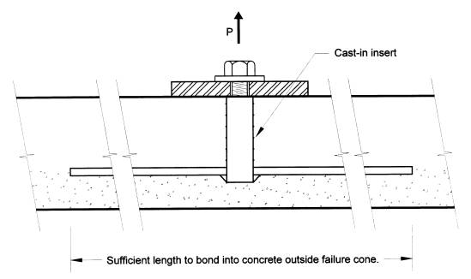
Clause 3(b) sets out the strength capacity required for top inserts or fixings so that the collapsing framework or roof structure will pull the panel inwards. See Figure Spec C1.11(4). The value for outward displacement of one tenth of the panel's height is based on observations of deflections on buildings during a fire.
Figure C1.11(4)
FORCES TO PULL PANEL INWARDS
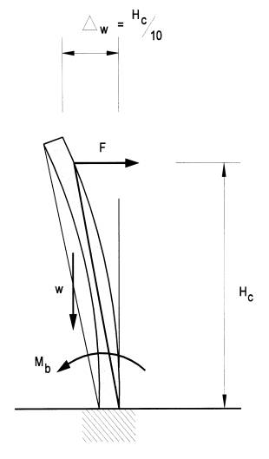
Drilled-in inserts and clips will suffer a greater strength loss from exposure to fire than cast-in inserts. The difference between the factor of two given in Clause 3(b) and of six in Clause 3(c) is based on engineering principles.
The lateral supporting members referred to in Clause 3(d), for 'tilt-up type buildings', may be roof beams or trusses.
Where the wall panels are supported by eaves tie members, Clause 3(d) requires that calculation of the forces in the eaves tie take into account the geometry of the deformations of the eaves tie. Figure Spec C1.11(5) illustrates this requirement.
Figure Spec C1.11(5)
FORCES IN EAVES TIE
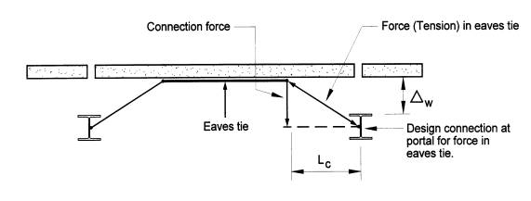
When applying the provisions of Clause 3(e), panels used in a group have to be actually 'designed to act as one unit'. It is not enough for the designer just to nominate the number of panels that are to act together.
While Specification C1.11 mostly applies to vertically spanning panels, Clause 3(f) addresses specific provisions applicable to horizontally spanning panels.
CP5
'Tilt-up construction'
CP5 is intended to overcome a problem observed when a fire has occurred in a building of 'tilt-up construction', and the panels have collapsed outwards, either during the fire or shortly after with little or no warning, endangering public safety, health, amenity and fire fighting operations.
A wide variety of structural systems and materials are possible to achieve this.
CP5 is only applicable to walls that could collapse as complete panels and, therefore, is not applicable to concrete and clay masonry walls, and the like, because such walls tend to fail in portions, rather than as complete panels.
The height limitation of 2 storeys is based upon the observation that the problem only seems to occur in low-rise buildings. This is due to taller buildings usually having fire rated floors and other building elements to restrain wall panels during a fire.

Section C Fire Resistance
Specification C1.11 PERFORMANCE OF EXTERNAL WALLS IN FIRE
Deemed-to-Satisfy Provisions
2 Application
Intent
To clarify that Specification C1.11 applies only to buildings with a rise in storeys of 2 or less, where those buildings have concrete external walls that could collapse as complete panels.
Specification C1.11 applies only to buildings with a rise in storeys of 2 or less, where the external walls are constructed using tilt-up and precast concrete panels.
Figures Spec C1.11(1) and Spec C1.11(2) illustrate some of the types of construction covered by Specification C1.11.
Figure Spec C1.11(1)
TYPICAL NON-LOADBEARING PANELS REQUIRED TO COMPLY WITH SPECIFICATION C1.11 (PANELS MAY BE FULL BAY, MULTIPLE VERTICALLY OR HORIZONTALLY SPANNING)
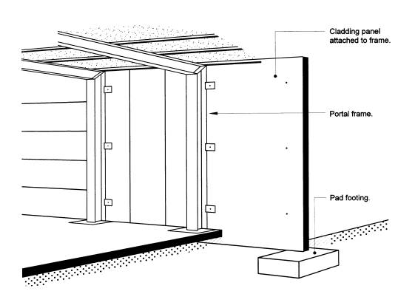

Figure Spec C1.11(2)
TYPCIAL LOADBEARING PANELS REQUIRED TO COMPLY WITH SPECIFICATION C1.11
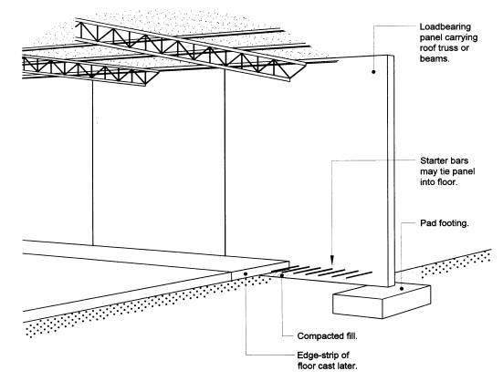

BCA Volume One
Section C Fire Resistance
Section C FIRE RESISTANCE
Part C1 FIRE RESISTANCE AND STABILITY (Deemed-to-Satisfy Provisions)
C1.11 Performance of external walls in fire
Concrete external walls that could collapse as complete panels (eg. tilt-up and precast concrete), in a building having a rise in storeys of not more than 2, must comply with Specification C1.11.

