W5904 APPLY SURVEY PROCEDURES
LOT 63 AREAS and VOLUMES

Revision TEST

- Calculate the RL’s for Station A to E
- Calculate the Cut and Fill
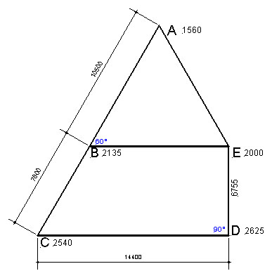
- Calculate the amount of soil needed or carried away

Staff readings at Stations
A = 1560
B = 2135
C = 2540
D = 2625
E = 2000

Figure 2

Calculate the area of figure ABCDEA
(Figures given are horizontal measurements)
If the readings off the staff are those shown on the diagram for each station, how much cut or fill is required if the RL for Station E will be the finish bench level?
Pythagoras: Hyp² =Base² + P.Ht.²
Triangle Area: 0.5 Base x Perp. Ht.
Rhombus Area: Av Length Sides x Perp. Ht.
Prism Volume: Area x Av. Depth
Rhombus Prism Volume: Area x Av. Depth

WS904 APPLY SURVEY PROCEDURES Session 6

Station | Back- | Inter- | Fore- | Rise | Fall | Reduced | Distance | Remarks
Station | sight | mediate | sight | Rise | Fall | level | Distance | Remarks
A |  |  |  |  |  | 5.000
B
C
D
E

CALCULATION

