W59041W9255 or 4018 APPLY SURVEY PROCEDURES Session 6
Perform calculations Element 1
Calculate volume Element 3
Construct longitudinal sections Element 4

Practice Exercise LOT 61 Apply measuring techniques Determine differences in heights and R.L.'s Construct longitudinal sections

Practice Exercise LOT 62 Determine differences in heights Calculate areas and volumes

Practice Exercise LOT 63 Apply measuring techniques Determine differences in heights Calculate areas and volumes
1
W5904 APPLY SURVEY PROCEDURES Session 6
LOT 61-SECTIONS AT SITE BOUNDARIES
Using the "Rise and Fall Method" and the information given on LOT 61 SITE
PLAN below,
- Book the given staff readings, check the results.
- Use assumed Reduced Level 10.000 at Station "A" to calculate Reduced Levels for each station in alphabetical order.
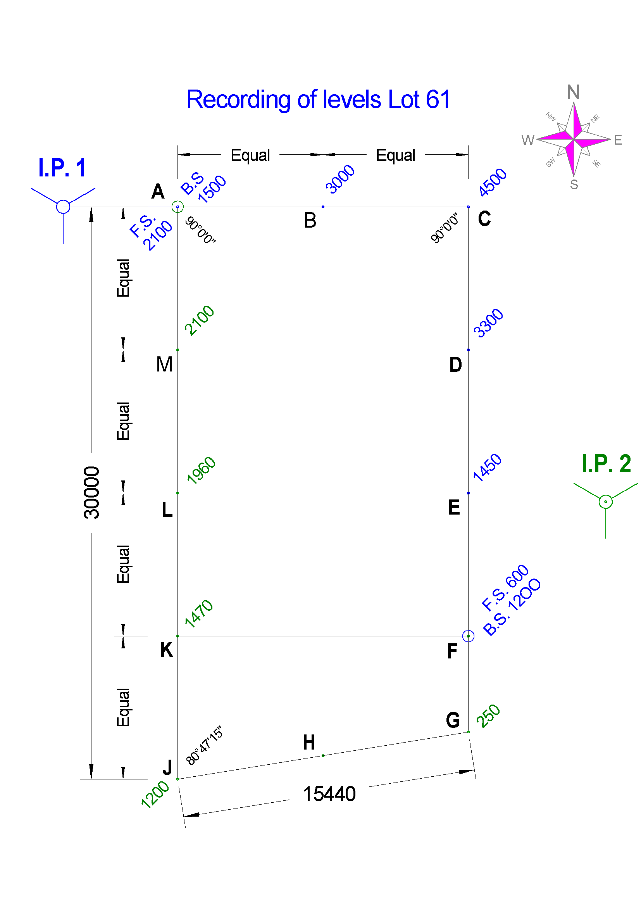
- Draw Section views of the site boundaries' ground profile, using horizontal scale of 1:200, vertical scale of 1:50 and, baseline of R.L. 6.000.

2
WS904 APPLY SURVEY PROCEDURES Session 6
Station | Back- | Inter- | Fore- | Rise | Fall | Reduced | Distance | Remarks
Station | sight | mediate | sight | Rise | Fall | level | Distance | Remarks

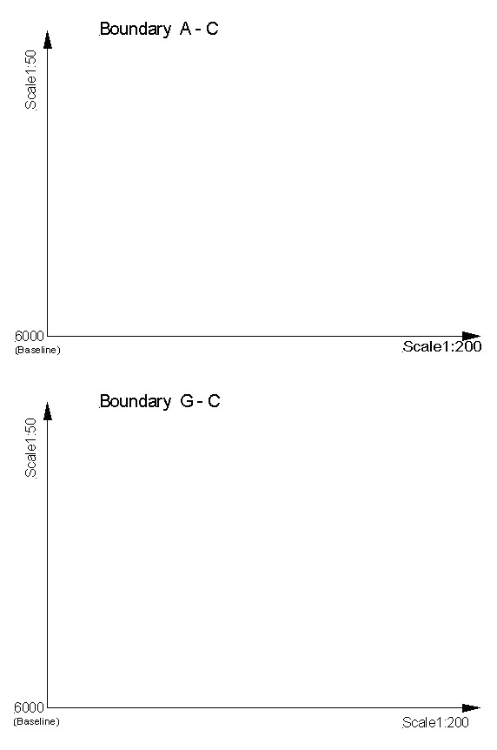

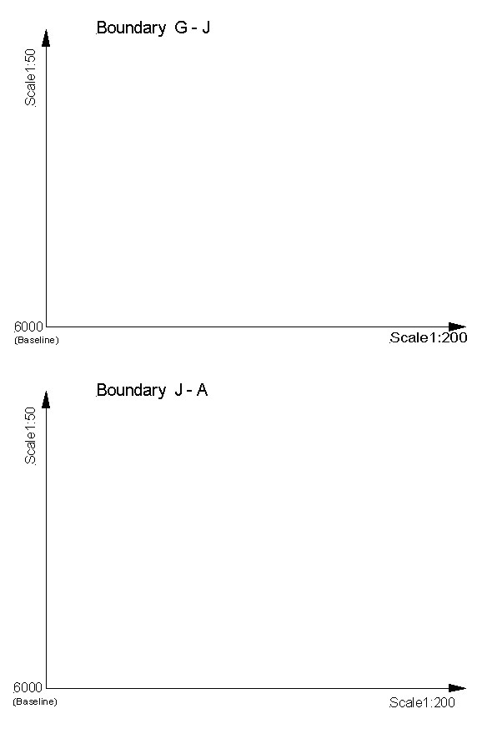

W5904 APPLY SURVEY PROCEDURES Session 6

LOT 62 MEASURMENT FROM GRID SPOT LEVELS

This method of measurement can be applied to most earthwork problems of a localised nature, such as those occurring during the formation of sports fields, the construction of factories, shopping centres and residential site works. The field work consists of dividing up the site of the work into a number of squares and observing the reduced level (RL) at each comer of those squares. The length of the side of each square depends upon the topography of the terrain and the accuracy required.
Figure 1. illustrates a small section of a grid. The total area is to be excavated to a formation level of 25m for the purpose of a residential construction. It is to be assumed that the sides of the excavation are vertical. The solid formed by each grid square is a vertical truncated prism.
The volume of a truncated prism = (Mean Height) x (Area of Base).

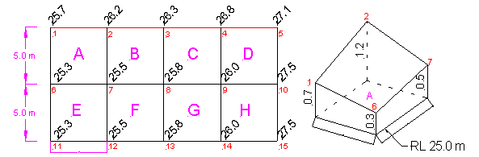
Part of a Grid Plan with RL’s Typical Grid Square projected to Suitable Level Plane

(a) (b)

Figure 1
W5904 APPLY SURVEY PROCEDURES Session 6

LOT 62 AREAS and VOLUMES

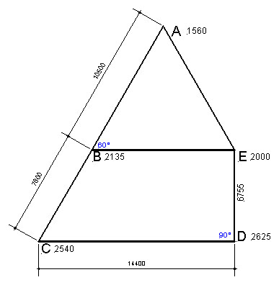

Figure 2

Calculate the area of figure ABCDEA
(Figures given are horizontal measurements)
If the readings off the staff are those shown on the diagram for each station, how much cut or fill is required to produce a level surface from the surface reading of 2.000 at station E for the figure enclosed by the line ABCDEA.
Pythagoras: Hyp² =Base² + P.Ht.²
Triangle Area: 0.5 Base x Perp. Ht.
Rhombus Area: Av Length Sides x Perp. Ht.
Prism Volume: Area x Av. Depth
Rhombus Prism Volume: Area x Av. Depth

