Practical Project 2

Instrument Level checking (2 Peg test)
Candidates Name:
TAFE ID Number:
Date of Assessment:

Team Member’s Name:

Setup and test the Instrument ( Inst. No.__________ )

0.0 m 40.0 to 50 m Difference
Recording from centre spot : 1 ________ 2 ________ ________

Recording from 5 or 45 m spot : 1 ________ 2 ________ ________
(For each field exercise a level check is required. This check must be carried out each time before you do levelling.)

PROJECT 2

Two students form a group to do a straight level run. Datum for Station A is 10.000 meter and for the reverse readings take the RL from the last reading (forsight of student 1) as Datum. To clarify: Student 1 does the level run from Station A (i.e. first RL on the R&F sheet) to the last Station and the student 2 goes back from that last Station (i.e. the first RL on your R&F sheet) to Station A
Think about the position of the instrument. You need to shift the level (change point F/S & B/S remember the staff stays on the same point).

1) Record the levels of each of the coloured stations Take Station 1 as datum 10.000 and convert staff readings to Reduced Levels, using the rise and fall method. One student does the level run from Station A to 9 (the Station at the wall end) and the other student does the return level run from Station 9 to A. The RL’s first student has calculated

3) Measure the horizontal distance of all stations in baseline dimensions (i.e. linear distance of all stations relative to a single base reference. Station A to last reading (F/S) and Station last reading (B/S) to A. Slope measurements must be converted to horizontal distances; show all calculations, (must be logical set out and easy to check).
4) Draw profiles on page 3 of the project report from Station A to Station (end of level run) using a horizontal scale of 1:200 and a vertical scale of 1:50 (requirements as shown on page 4 of the project report)

5) A report need to be written up using the outline provided (cover in detail all points in the project report).

Class attendance is critical to successful completion of this course

Project 2 Location Plan

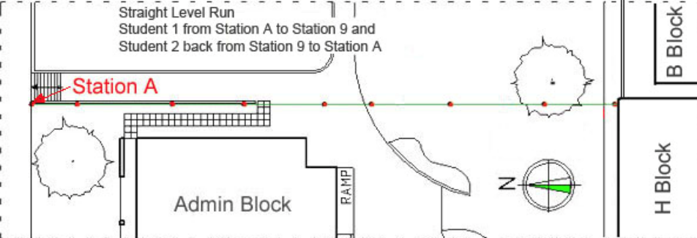

Setup the instrument
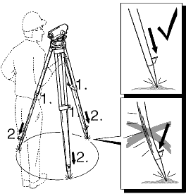
- Loosen screws of tripod legs, pull out to required length and tighten screws.
- In order to guarantee a firm foothold sufficiently press the tripod legs into the ground. When pressing the legs into the ground note that the force must be applied along the legs.
- Check all screws and bolts for correct fit.
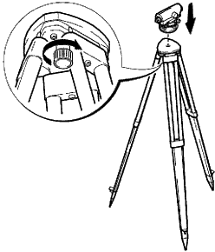

When setting up the tripod pay attention to a
horizontal position of the tripod plate. Minor
inclinations of the tripod can be corrected with
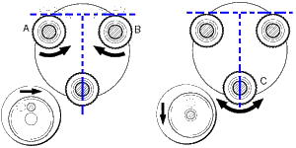
the footscrews of the tribrach.

- Place level onto tripod head. Tighten central fixing screw of tripod.
- Turn footscrews A and B simultaneously in opposite directions until bubble is in the centre (on the imaginary "T").
- Turn the instrument 90° and then turn the foot screw C until bubble is centred.

