Practical Project 1

Instrument Level checking (2 Peg test)
Candidates Name:
TAFE ID Number:
Date of Assessment:

Team Member’s Name:

Setup and test the Instrument ( Inst. No.__________ )

0.0 m 40.0 to 50 m Difference
Recording from centre spot : 1 ________ 2 ________ ________

Recording from 5 or 45 m spot : 1 ________ 2 ________ ________
(For each field exercise a level check is required. This check must be carried out each time before you do levelling.)

PROJECT 1

This is a straight level run. Datum for Station A is 10.000 meter and for the reverse run take the RL reading from Station 9 as Datum. To clarify: one student does the level run from Station A (i.e. first RL on the R&F sheet) to Station 9 and the other student going back from Station 9 (i.e. first RL on R&F sheet) to Station A
Think about the position of the instrument. You need to shift the level once.

1) Record the levels of each of the BLUE stations 1 to 9 (station 9 is on the Wall). Take Station 1 as datum 10.000 and convert staff readings to Reduced Levels, using the rise and fall method. One student does the level run from Station A to 9 (the Station at the wall end) and the other student does the return level run from Station 9 to A. The RL’s first student has calculated

3) Measure the horizontal distance of all stations in baseline dimensions (linear distance of all stations relative to a single base reference (Station A to 9 and Station 9 to A). Slope measurements must be converted to horizontal distances; show all calculations, which must be logical set out and easy to check.
4) Draw profiles from Station A to Station 9 using a horizontal scale of 1:500 and a vertical scale of 1:50.

Your report must cover all of the above four points.

Practical Projects Requirements
1. Student Field notes
Field notes must be prepared for all of your surveying projects. They should provide evidence of all the conditions at the time of the survey projects. Field notes have to be recorded at the time the fieldwork is being done.
Field notes should contain: the date, the weather conditions, group members doing the survey, identification of the instruments & equipment, data collection etc., a brief description of the site and/or location details, north arrows on all sketches and any other notations which assist in clarification of the field and site conditions.
2. Project Submission RequirementsAll projects must include the following:
- Assignment Attachement form. (do not forget to sign the decaration)
- Standard cover sheet (see outlay below).
- Create a digital version of data Rise & fall from field notes. Transferred this data onto excel sheet to calculate RL's.
- A brief description of the exercise including some information from the field notes like weather conditions, group members and anything that you would like to name. Was it easy to perform the activity and did you had have sufficient technological skills to submit it in digital form? Where there any problems with computer (usage of word & excel)? Did you gain valuable skills in data recording, reading, measuring distances, and group work?
- Drawings/sketches (profiles, contours etc.)neatly drawn to scale. Profile layouts in accordance with the hand out sheet.
- All original field notes must be attached.

Cover sheet layout
Central Institute of Technology
Apply site surveys and set out procedures
to building and construction project

Project No
◄ Left side margin > 2.5 cm
Student Name: | ID:
Group No: | Group leader:
Date:  of field work | Date:  of submission: ;

Class attendance is critical to successful completion of this course

Setup the instrument
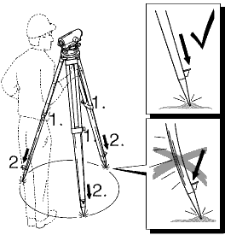
- Loosen screws of tripod legs, pull out to required length and tighten screws.
- In order to guarantee a firm foothold sufficiently press the tripod legs into the ground. When pressing the legs into the ground note that the force must be applied along the legs.
- Check all screws and bolts for correct fit.
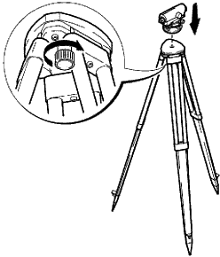

When setting up the tripod pay attention to a
horizontal position of the tripod plate. Minor
inclinations of the tripod can be corrected with
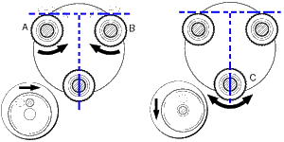
the footscrews of the tribrach.

- Place level onto tripod head. Tighten central fixing screw of tripod.
- Turn footscrews A and B simultaneously in opposite directions until bubble is in the centre (on the imaginary "T").
- Turn the instrument 90° and then turn the foot screw C until bubble is centred.

