Central Institute of Technology
Building Studies
Campus Leederville

Practical Project 2

Instrument Level checking (2 Peg test)
Candidates Name:
TAFE ID Number:
Date of Assessment:

Team Member’s Name:

Setup and test the Instrument (Inst. No.__________)

0.0 m 40.0 to 50 m Difference
Recording from centre spot : 1 ________ 2 ________ ________

Recording from 5 or 45 m spot : 1 ________ 2 ________ ________
(For each field exercise a level check is required. This check must be carried out each time before you do levelling. )
(This information must be on field notes)

Instruction for PROJECT 2
1) Setup the grid points, marked in the area shown on the "Location Plan". Record the levels of each grid point. Take Station 1 as datum 10.000 and convert staff readings to Reduced Levels, using the rise and fall method.

2) Grid three (3) equal spaces between walls and five (5) spaces of approximately five (5) metre down (20 grid points, see sketch below). Prepare a grid-sketch showing the dimensioned between the grid lines.

3) Prepare a scaled sketch (1:100) and display all 24 RL's. Then draw contours lines at 0.2 m intervals. Calculate the distances for all contour line intersection with grid lines

4) Calculate the volume of fill required if the ground will be levelled to a RL of 10.000 m). Two methods of volume calculations, rectangular prisms and grid levels, must be done in MS Excel format. Compare the results. .All other calculations must be clearly and logical set out (state formulas for all calculations.

Remember to make a copy of the field notes for group members to enable students to write a personal report. Your report must cover all of the above four points.

Project 2 Location Plan
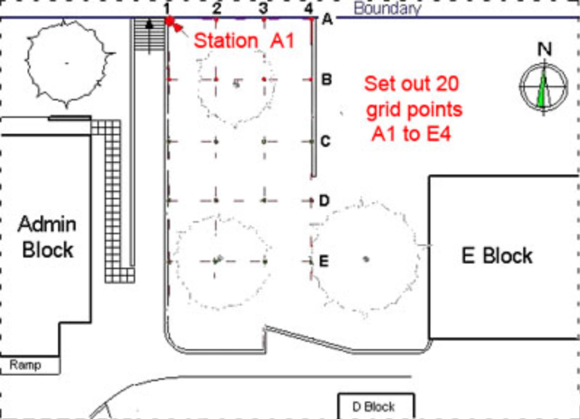

General considerations
Before you start the project think about the task and consider the site condition. The vegetation on the site will determine the position of the level. Place the instrument in a location from where you can read all staffs positions. The R&F sheet should not have the station column filled in, to enabling you to label your own grid points.
Is the clipboard ready for recording all necessary field notes? Make sure the work between the group members is equally distributed.
Return all equipment to Level 4 when you have finished the exercise.

Submission requirements:
Refer to submission requirements for surveying projects.
Submission date: As soon as possible; but needs to be handed in before you can do the next project.

