Central Institute of Technology
Building Studies
Campus Leederville

Project No: 2
Task Notes

Candidates Name:
TAFE ID Number:
Date of Assessment:

Instrument Level checking (2 Peg test)
The 2 peg test is compulsory and must be recorded on the Project Field Notes

Instruction for Project Task
1) Setup and record the levels of each of the grid points, marked in the area shown on the "Location Plan". Take Station A1 as datum 10.000 and convert staff readings to Reduced Levels, using the rise and fall method.

2) Peg out 20 Grid Points as mentioned in the Project

3) Record the spot levels onto the attached R & F sheet.

4) Draw contours lines at 0.2 m intervals on the attached Contour Line Plan.

5) Calculate the volume of fill required to to the datum at Station 1 (RL=10.000 m)
Use two (2) methods of volume calculations,
1) rectangular prisms method using the Volume Calculation Template
2) grid level method (use Excel-template form the website& provide the printed sample
Compare the results. .All calculations must be clearly and logical set out.

6) Submit all documents on the due date (including this practical project with the attachments.

Remember to make a copy of the field notes for group members to enable students to write the personal report. Your report must written on the project submission sheet.

Project Location Plan
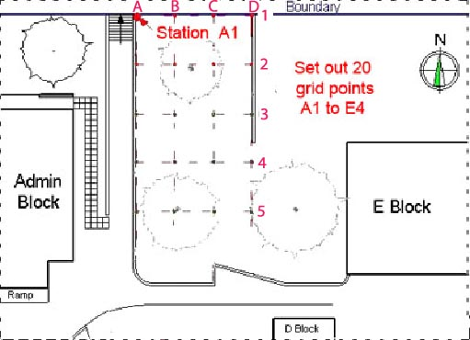

Submission date: ► refer to your Learning Plan or as indicated by your lecturer.
Project Submission Requirements
Refer to the project task notes and field notes for the scope of the practical project.
Project No 3 must include the following:
- Assignment Attachment form. (do not forget to sign the declaration)
- Standard cover sheet (see outlay below).
- Project Task Notes including:
  - Rise & Fall sheet
  - Contour Line Plan
  - Volume Calculation Template (rectangular prism)
  - Volume Calculation Grid Level (website Excel-sheet)
- The Project Field Notes
- Attach additional Drawings/sketches (Autocad hand out sheets.
Group | mobile | First Name | Surname | Proposed  Date

Project 2 - Rise & Fall Sheet
Station |  | Back- | Inter- | Fore- | Rise | Fall | Reduced | Distance | Remarks
 |  | sight | sight | sight | Rise | Fall | level | Distance | Remarks
A | 1
A | 2
A | 3
A | 4
A | 5
B | 1
B | 2
B | 3
B | 4
B | 5
C | 1
C | 2
C | 3
C | 4
C | 5
D | 1
D | 2
D | 3
D | 4
D | 5
E | 1
E | 2
E | 3
E | 4
E | 5
Comments

